**CAPITAL AREA FIRE DISTRICTS ASSOCIATION**

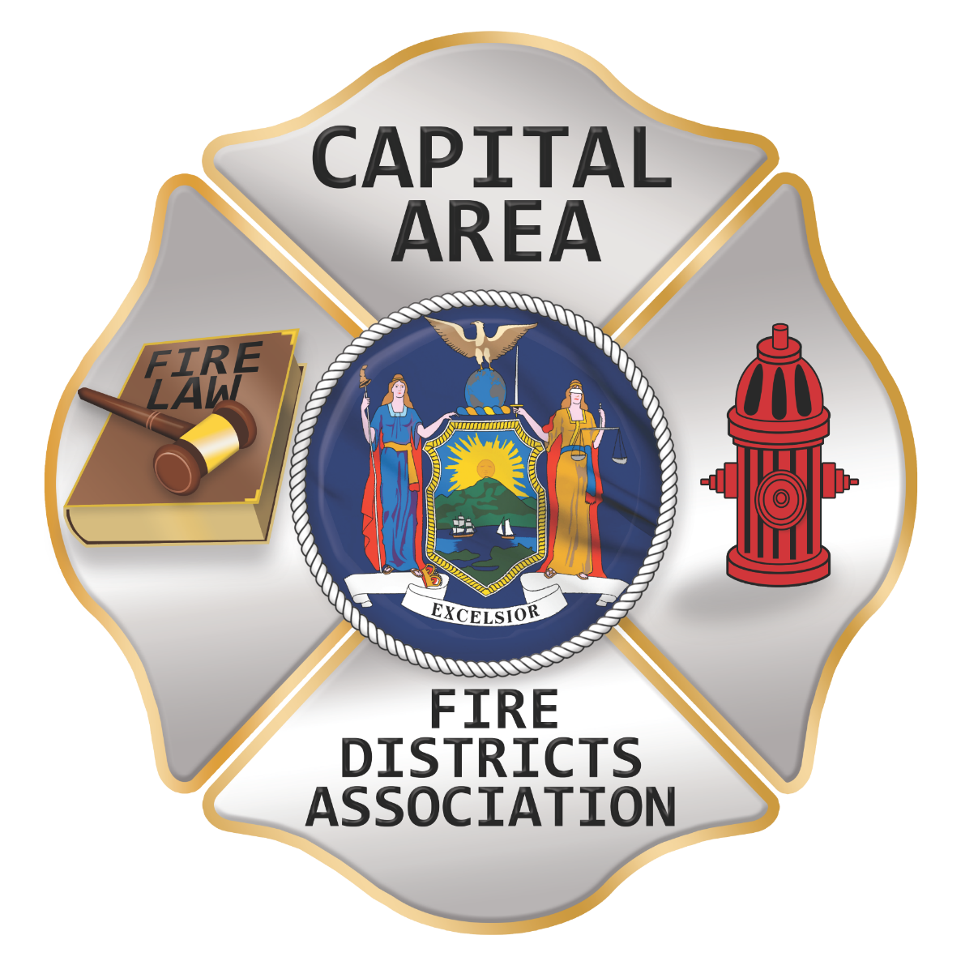

**Bulletin**

**your fire district news source**

**june 10th, 2023**

***Editor – Tom Rinaldi***

[***tom@rinaldi1.com***](mailto:tom@rinaldi1.com)

***Information to make you think and to learn from others!!***

**the capital calendar:** [**www.afdca.org**](http://www.afdca.org)

Thursday July 13th Board of Director’s Meeting 7PM

**August, No Meeting**

Thursday September 14th, General Membership Meeting 7PM

Thursday October 12th General Membership/Nominations for Officers & Directors

Thursday November 9th, 7:00pm general membership dinner served at 6PM/Elections

**December, No Meeting**

***Printable Calendar – See Last Page***

**capital area fire districts assoc. news:** [**www.afdca.org**](http://www.afdca.org)

##### Secretary and Treasurer’s Positions Split

We wish to welcome Terry Briscoe as the Secretary of the Capital Area Association, she can be reached at: [caaofd@gmail.com](mailto:caaofd@gmail.com)

Tony Hill did a wonderful job as Secretary & Treasurer but now has just one responsibility as Treasurer and can be reached at : [cafdatreasurer@gmail.com](mailto:cafdatreasurer@gmail.com), CAFDA PO Box 42, East Schodack, NY 12063

##### Long Way to Travel to Meetings? Join remotely using Zoom!

***It’s our desire that every member district have the opportunity to attend Capital Area meetings. We know we cover a large area, in 8 counties and beyond and wish to give all of our members a chance to participate in the general membership meetings. You have a voice and we would like to hear it. Join us at our next meeting either in person or via Zoom. The link will be sent via constant contact prior to each general membership meeting. Thank you for being a member and we hope you will join us.***

##### CAFDA FALL WORKSHOP: Put it on your calendar

**Saturday, November 4th, 2023 8:00 AM Fall Workshop Verdoy Fire Department**

**SUBJECTS TO BE COVERED:**

**Harassment Challenges – Discipline in the Volunteer Department**

**How to SHOP for insurance, What Coverage Should We Have?**

**Ask the experts: CPA, VFBL, Attorney, Insurance, Candle Stick Maker**

***We want to thank the Clifton Park – Halfmoon Fire District for allowing us to use their facility for the Capital Area meetings.***

##### You Are Invited to Become a Member of the Capital Area Association!

**The Capital Area Association has voted to amend its By-laws to allow both individual and regional or county Fire District Associations to join. The updated By-laws are posted to the AFDCA.org website.**

**Individual membership fee will be $50 annually, fire district association fees will be $300 annually.**

**Download THE APPLICATION HERE:** [**https://afdca.org/wp-content/uploads/2022/08/2022-Application.doc**](https://afdca.org/wp-content/uploads/2022/08/2022-Application.doc)

**Benefits of membership include meeting attendance, receiving the Bulletin, access to legal advice**

***The Capital Area has logo ware available, long and short sleeve polo shirts. Contact Secretary/Treasurer Tony Hill to purchase shirts.***

***If nothing else read the articles PRECEDED by* \*\***

**Capital shorts:**

* **It is with profound sadness that I announce the passing of my friend and fellow State Association officer Ken Preston. Ken has fought the good fight with the enemy cancer and has been received into the hands of his Lord God. Ken was dedicated to his family, to the fire service and to his duties with the State Association, always a gentleman and a problem solver. Ken was one of the hardest working people I know and I’m not sure where his energy came from. His smiling face will be truly missed by all. Our deepest sympathies to his wife Donna, his children, his family, friends and his fire department brothers and sisters. Rest in eternal peace my friend and be free from your earthly pain.**
* **Fire Department Breakfasts are back, Gansevoort Fire Department holds theirs on the 3rd Sunday of each month except for July and August. Clifton Park Fire Department is every other month with the next breakfast on the first Sunday of October. (IF ANY OTHER DEPARTMENT WOULD LIKE TO NOTIFY READERS OF THEIR ACTIVITIES PLEASE LET US KNOW THROUGH THE OFFICERS OR DIRECTORS.)**

***If you no longer wish to receive the Capital Bulletin you have the option to “unsubscribe” at the bottom of the introductory email.***

**mutual aid help request**

* The Averill Park Fire District is looking for a template for a medical leave policy. Email Commissioner Ron Berti at rberti@nycap.rr.com
* The Wilton Fire District is looking for policies regarding Driver Certification, send to Megan Washburn, District Administrator at [mwashburn@wiltonfiredept.org](mailto:mwashburn@wiltonfiredept.org). Thank you.
* The Arvin Hart Fire Co is looking to see if anyone has a written swift water mutual aid agreement on top of their county mutual aid agreement, holding the other participants harmless?
* The Northumberland Fire District (Gansevoort FD) is looking for a template for a contract between the fire district and the fire company for service. Reply to [tom@rinaldi1.com](mailto:tom@rinaldi1.com)

**state association news:** [**www.afdnys.org**](http://www.afdnys.org)

##### **Helping our Own

##### It has been very distressing for all of us to hear that the Association’s Immediate Past President, Ken Preston is dealing with a very aggressive kidney cancer and now has home hospice. Ken has served his community and the State Association for many years, and this has been difficult news for all of us who have worked with Ken. Please keep Ken, his immediate family and his extended fire service family in your thoughts and prayers.

##### State Fire Districts Announces a move back to a Fall Annual Meeting

***Another change of venue***, the Fall Conference for 2024 will be held at Turning Stone on a Sunday - Wednesday time frame October 20 – 23 in 2024.

**chaplain’s corner**

Chaplain, Fred Richards

During our Thursday, June 8th Capital Area Fire District Association meeting President Tom Rinaldi conveyed to us, “ the sad news that Kenneth B. Preston (age 78), the Immediate Past President of the Association of Fire Districts State of New York and a dear friend of many in our Association had , on June 7th, succumbed to his battle with kidney cancer”. President Tom continued his brief words regarding Ken’s passing stating, “This fine gentlemen will always be remembered for his dedication and earnest work on behalf of all fire districts. We extend our condolences and earnest prayers to his wife Donna and the Preston family for their loss“.

It has been conveyed to this Chaplain that Ken was a “faith-filled Christian” of Catholic persuasion. The Holy Word confirms to each believer that personal faith remains the foundation for one’s blessed hope. This is clearly proclaimed in such verses as: Psalms 31:24 “Be of good courage, and He shall strengthen your heart, all you that hope in the LORD”; and, Titus 3:7 “That being justified by his grace, we should be made heirs according to the hope of eternal life.”

Ken Preston reportedly provided over 60 years of service to his community, 32 of which were served as a Fire Commissioner for the North Greece Fire District. During his life time Ken was Past President of several organizations including the North Greece Fire Department, the Monroe County Fire District Officers Association, and the North Greece Exempts. Ken Preston’s full obituary can be found at: https://www.democratandchronicle.com/obituaries/rdc185309

Cards of condolence may be sent to:

The family of Kenneth Preston

435 Meadowbriar Rd

Rochester, NY   14616

Chaplain Gene Preston thanks all of you for your kind thoughts, prayers, and cards that were sent to his family.  Your expressions of faith were an encouragement to everyone.

**training appropriate for your entire board/secretary/treasurer**

**Mark your calendar for Saturday, November 4th 2023 for the Capital Area Fall Leadership Workshop, being held at the Verdoy Fire Station on Troy-Schenectady Road. Tentative subjects are Harassment in the Fire Service and Applying Discipline, How to SHOP insurance for your fire district, Expert’s Panel.**

##### Barista pouring cup of coffee Upcoming Coffee with Commissioners

[**Thursday, June 29th @ 7:00pm** Understanding Vehicle Values and Insurance](https://archcapgroup.zoom.us/webinar/register/8916842583708/WN_JHD9DqWwQqavzfFLXATQ5g)

[**Saturday, July 22nd @ 9:00am** Firefighter Behavioral Health with Jill Holland](https://archcapgroup.zoom.us/webinar/register/2016842584304/WN_jq1MG16BRxKUHFOvUNB1-w)

[**Thursday, August 31st @ 7:00pm** Fire District Budget Process](https://archcapgroup.zoom.us/webinar/register/2416842585089/WN_dPKTjF5sSrWjQJHqL-boVA)

[**Saturday, September 23rd @9:00am**Current Trends and Concerns](https://archcapgroup.zoom.us/webinar/register/7616842585656/WN_yJaEaok5R0mUDkvjhozf_A)

***Click on Each Announced Date to Register***

**THE LATEST FROM ALBANY**

##### The 2023 legislative session has ended, please view the Score Card to see the results. Remember that bills introduced for the 2023 session will carry over to the 2024 session when it begins in January.

##### $31.5 Million In State Budget For Volunteer Firefighters

New York State's 2023-2024 budget includes significant funding for volunteer firefighters. Of the total, $25 million was allocated for departments' capital upgrades to equipment and facilities. $6.5 million has been allotted for firefighter training stipends.

The firefighter training stipends are given out in either $750, $1,000 or $1,250 increments after completion of training. The amount given out is dependent on the status of the volunteer, whether that's firefighter 1, firefighter 2, or fire officer training. This will allow firefighters to be compensated for spending time off work attending classes. We will have to watch OFPC for any developments in rules or regulations.

**THE LATEST FROM WASHINGTON**

##### REPS. MOLINARO AND KUSTER INTRODUCE VOLUNTEER FIREFIGHTER TAX DEDUCTION BILL

Rep. Marc Molinaro (R-NY) and Ann Kuster (D-NH) introduced **H.R. 3104**, the Helping Our Heroes Act. This bill would establish an “above the line” tax deduction for the time volunteer firefighters donate to their communities.

Specifically, the Helping Our Heroes Act allows volunteer emergency responders, including firefighters, ambulance services, civil air patrol, and search and rescue services, to treat each hour of service or training as a $20 charitable contribution for the purpose of a tax deduction. This deduction would be available for up to 300 hours per year. Additionally, this deduction would be an above the line deduction, meaning that even those who don’t normally itemize their tax returns would still be eligible for this deduction.

Regarding this bill’s introduction, National Volunteer Fire Council (NVFC) chair Steve Hirsch said, “The NVFC thanks Rep. Molinaro for his leadership in introducing the Helping Our Heroes Act. Many volunteer fire departments struggle to recruit and retain firefighters. This can be attributed to a number of factors, including the COVID 19 pandemic and increased mental and physical pressures due to a significant rise in call volumes. Between 2010 and 2020 the number of volunteer firefighters in the United States dropped by 12%. The ’above the line’ tax deduction created by this important legislation would serve as a key incentive to recruit and retain volunteers and reverse this trend.”

The NVFC looks forward to working with Reps. Molinaro and Kuster to advance this important bill.

##### [Bicameral FIRE STATION Act Introduced To Upgrade Fire, EMS Facilities Nationwide](https://www.dailydispatch.com/DDR/index.aspx?st=NY&ddv=1&ddid=172037&typ=1&it=946300)

##### UPDATE: NO BILL NUMBER ASSIGNED YET, They are just blowing their horns so far!!

With a ***proposed*** $750 million grant program, the newly introduced FIRE STATION Act (Facilitating Investment Required for Emergency Services to All Towns in Our Nation Act), put forth by U.S. Sens. Chris Van Hollen (D-MD) and Lisa Murkowski (R-AK), as well as U.S. Rep. Bill Pascrell (D-NJ), pushes for modifications, upgrades and build-up of fire and EMS facilities across the country. "Our firefighters deserve the best possible facilities so they can be ready with everything they need to spring into action when duty calls," Van Hollen said. "Yet nearly half of the fire stations across America require major repairs – with some even posing serious health hazards to the men and women who protect our communities. ***This bipartisan bill will unlock more funding to ensure our fire and EMS heroes have modern, safe, and mission-ready facilities***."

**The attorney’s office**

##### Who Owns the Fire Station Facebook Page?

Curt Varone

**Our fire department has its own Facebook page and several stations (including mine) have created our own pages. Please correct me if I am wrong, but doesn’t the Facebook page belong to the creators, not the fire department? In other words, the fire chief cannot make us get rid of the station page, can she?**

Determining the legal ownership of a Facebook page is not going to answer your question. Facebook may indeed consider the creators of a page to be the lawful owners so long as the creators are not misrepresenting their identity. The more important question is whether the fire department can limit firefighters from posting on social media in such a way that they are representing themselves as being part of a fire station within the fire department.

To answer that question, more information is needed. The first question: Are the individual fire stations part of the fire department or are they separate entities? What I mean is, are the individual fire stations independent entities, such as volunteer fire companies, who in turn are part of a larger county fire department or fire district? If a separate entity controls the individual fire station, the fire department’s ability to control the station’s social media activities will be a function of the political and administrative leverage that can be brought to bear.

Based on your question, I am going to assume your fire station is part of the same fire department and not independent. As such, it follows that you and your colleagues at the station level are subject to the fire department’s chain of command, and hence subject to the fire department’s policies.

The next question, and perhaps the most important determination that must be made, is whether the fire department is a governmental entity. If it is, then the fire department must respect the First Amendment rights of its members. If the fire department is non-governmental, the problem is much easier to solve. Non-governmental entities are not constrained by the First Amendment. Therefore, the fire department leadership can prohibit members from associating themselves with the fire department on social media as long as such actions are in accordance with its bylaws, charter and any other applicable law. Non-governmental entities have a greater ability to restrict social media activities than governmental entities.

If the fire department is a governmental entity, or due to its close connection to a governmental entity is considered to be a “state actor” for purposes of the First Amendment, it still has the right to control members from holding themselves out on social media as “spokespersons” for the department. However, the situation is more nuanced and must not infringe upon members’ protected speech.

While public-employee firefighters generally have a First Amendment right to speak as a private citizen on matters of public concern, they do not have a right to hold themselves out to the public as an official source of information for the department, nor post on matters that are not a matter of public concern. They also cannot engage in speech that causes actual harm or disruption to the mission and function of the employer. That is where your department’s social media policy comes into play.

It is essential that a government agency’s social media policy be drafted in a way that respects the First Amendment rights of its members while reserving the right to limit unprotected speech. Careful wording of the policy is necessary because even well intentioned and commonly used expressions such as “members shall not disparage the department” or “members shall not bring discredit to the department” will run afoul of the First Amendment.

Given the number of poorly worded policies out there, adopting another fire department’s policy could be inviting a trip to federal court should a member decide to challenge it. However, if done properly the department can control the social media activities of individual fire stations provided it does so in a manner that is consistent with the First Amendment.

Apart from First Amendment considerations, in departments where firefighters have a right to engage in collective bargaining, the social media policy must be implemented and enforced in a manner that respects the employees’ rights to engage in concerted activities. They key, once again, is the language used in the policy. In a collective bargaining environment, the policy cannot infringe upon the employees’ rights to engage in concerted activities for their mutual protection.

So to summarize, the answer to your seemingly simple question will turn on:

1. Whether your fire department has the administrative reach to control station-level activities
2. Whether your fire department is governmental
3. Whether your fire department has a social media policy that is enforceable under the First Amendment and any collective bargaining laws that may apply

For information only and not for the purpose of providing legal advice. The opinions expressed are the opinions of the individual author at the time the facts were presented and based on the law then applicable. The information contained in these opinions is not guaranteed to be up to date. The information provided is not legal advice. Since legal advice must be tailored to the specific circumstances of each case, and laws are constantly changing, nothing on this site should be used as a substitute for the advice of competent legal counsel. The authors assume no responsibility to any person who relies on information contained herein and disclaim all liability in respect to such information. You should not act upon information in this publication without seeking professional counsel from an attorney admitted to practice in your jurisdiction.

**STEP into tHE CHIEF’S Office:**

##### What Do We Do Next?

Calen Maningas

An exceptional leader must be strong enough to question “everything,” determined enough to change all the “things,” and bold enough to kill any of the “things.”

**Create or Kill**

As I write, I am holding my 2-year-old daughter while she colors. This makes me reflect on where our ultimate authority and leadership responsibility rests. Would you do things differently if one of the most valuable things in your life was in your immediate response area? Have you done everything to prepare yourself personally and professionally, beyond just understanding the fire/EMS fight? *Have you prepared your organization for steps into the future with multiple generations, lack of workforce, and decrease in funding?* Have you taken personal responsibility of your direct response area as your own subcommunity of your city? On top of all these questions, add the unknown of leading out of a global crisis.

*Harvard Business Review* has stated that a life span of an organization has dropped from 67 years to 15 years (Hill, 2018). That case is not necessarily true for the fire service. What about an organization, such as mine, that has existed since 1886? Our organizations will continue on their way even if they have no way. We will continue on, providing a service to our community, but that doesn’t mean we are working in any specific direction.

***Instead of asking what we should do, let’s reframe the question and ask what we should not do***. All too often we create, create, create, leading to process problems that we treat as people problems. We create potential solutions that then need other potential solutions. Soon the content of the program or process does not match the intent of why we created it in the first place.

Before we create, the challenge is to ask, “What should we kill?” I have heard it put like this: **“*We cannot expect to solve today’s problems with yesterday’s solutions and expect to exist tomorrow.”*** It’s time for a full reboot as the fire service. Instead of asking “what” we should do, let’s ask “who” we should be.

**Crisis and Critical Times**

Every department is experiencing an increase in responsibilities and a decrease in time, funding, and personnel. We can no longer pile on and expect to handle the future, coming out of a crisis, with our current structure and leadership to handle the present. Let’s define who we want to be personally, professionally, as a crew, even as an organization.

There is a difference in leading in crisis times and leading out of crisis times. Leading in the crisis times means that we are trying to continue, sustain, and maintain what we have done. ***Leading out of them means we are challenging, creating, killing, understanding that we can no longer do what we have always done*** (Groeschel C., 2023).

The fire service was changing prior to 2019 and now it has been thrust into a critical state. We must now lead out of our current situation, not through it. Whether we knew it or not, leading through the past few years was easy, even though it felt hard. What is to come will be much worse.

Previously, we had to pivot, move, and be fluid but could ultimately blame all mistakes on the state of the world–we were just victims of circumstance. Leading out of these times, we have lost that privilege. We must be innovative and creative and challenge tradition. It will take much longer to lead out of our current situation than it did leading through it.  We must rethink and reattack everything. If we return to what we were doing, how we were operating, we will be failing.

We still need to respond to calls and mitigate disaster. The impactful event, responding to and caring for our communities, is still there. But the calls we respond to, why and how we respond, and how we allocate resources should be examined. Should we run the call or eliminate it before it happens?

Right now, we are reacting, only focusing on what’s urgent in front of us. Urgent takes up all our time because it feels like it matters now. Whatever time we have left we spend on the important issues that matter the most in our current state. Where we fail, where we never put any time and energy, is in the things that matter the longest. Things that matter the longest translate into work that is significant and provides lasting effects.

This creates a work paradox. The urgent things we spend most of our time on rarely have a significant impact in the longevity of our organization, and the things that have significant impact rarely get what limited time we have because they don’t feel urgent in the moment.

**Why?**

Why is this important? **Why should we question everything and kill most things?** Why must we now start with defining who we want to be? Our world has changed, our employees have changed, our board game of Risk has changed. We expect to play Risk with canons and flags, only to find a Monopoly thimble, top hat, and car in our game box.

If we can define who we want to be as a leader, crew, or organization, we can then define what to do next. “Who” we want to be will dictate “what” we do next. With constant tensions of what to do and what comes first, we cannot create more time. Leadership author and speaker Craig Groeschel has put it like this, **“We can’t create more time for things, so we need to choose more of the right things”** (Groeschel C., 2023).

Crisis has further clouded our “who” over the past few years, resulting in uncertain leaders. In turn, if we are uncertain about who we are in these changing times, then we are making followers who are unsettled and uneasy. If we are uncertain about the future direction of our organization, we still must not be unclear about who we are as an organization. This is like trying to find the seat of a fire in a large smoke-filled structure. The destination is the fire, but the direction must pivot constantly to unknown and new information. Our destination, our “who,” will not change overnight but our direction can alter, change, and grow.

A clearly defined “who” will allow us to “do” the right things. Here is an oversimplified example: If you and your crew decide that you are a healthy/fit crew, then everything you do next will stem from that. You will cut and sacrifice the good things to prioritize the best things, the who you are. If you are aggressive all-in firefighters, then you will take the extra and inconvenient times to train. If your organization decides that it wants to be cancer-free, then it will take the extra time to have clean stations, care for members, make legislation, etc.

**What Do You Value?**

Defining “who” we are as an organization or as individual leaders sounds easy and simple, but it is not. All too often, we allow our values to define who we are on paper. How many of your firefighters truly exhibit your organizational values? If you were to audit how you act with what you say you value, will they align? If your values weren’t drilled into recruits during academy, would they know your values? The generation before us asserted the values, we assume them, we are now boarding on the next generation abandoning our values.

**Land the Plane**

**It’s time to land the plane. There’s no sense in flying around in the theoretical thought bubble without a runway of application to touch down on.**

How do we get to our “who” we want to be? We must audit our values and identify truly if what we say matches what we do. The next step is the hardest. It’s time to change, time to align what we value with what we do. If you say you value the community but put more effort into reactively responding then proactively reducing the risk and incidents from occurring, do you truly value what you say***? If you say you value loyalty but you have a high rate of turnover, then either you don’t value loyalty, you are not providing something to be loyal to, or you are not hiring those who share your values.***

Stop and question everything. For each piece of your organization, ask why are you doing it. Does the content of what you doing match the intent of why you wanted to do it in the first place? ***Kill those things that are not working before trying to create things to work.***

Define your who. Align your leaders, and decide who you, as the organization, crew, shift, and department, want to be. This can be done for an individual, a crew of two, or the whole organization. Are you forward-thinking, go-for-broke, aggressive dragon slayers? Are you all in on caring for your members? Are you a crew that builds leaders of leaders, not just for your station but for the whole community? You no longer do these things because it is what you do; it is now who you are.

Decide what you truly value and don’t lie to yourself. Audit your values and truly define what your organization, crew, shift, or department values. Remember that our behavior as a crew, shift, or department will stem from the beliefs we hold as a crew, shift, or department.

Make those values actionable, not just words. One of the things that defines my team;s “who” is “we are one shift.” That means that we are not a conglomerate of separate stations competing against each other but a team of many stations moving in one direction, caring for each other. Of the values we have, we state, “We value our members.” Instead of saying we value teamwork or professionalism, we say, “We will be hot, cold, uncomfortable, inconvenienced, or displaced to build each other. We take every opportunity.” If professionalism is your value, you can’t “professionalism” something, but you can provide above-expectation services, holding yourself in a manner above reproach.

***Prioritize what you value and be bold enough to eliminate small things to better enrich the significant things***. Who you are and what you value will provide the road map for what’s worth doing. *This will not be easy; it requires you to kill the good things for the better things and sacrifice the better things for the best things.*

A leader must be strong enough to question “everything,” determined enough to change all of the “things,” and bold enough to kill any of the “things.” ***As stated by other leaders, we can no longer do in the present what we have done in the past and expect to succeed in the future.*** We are in danger of continuing on a way with having a way. Let’s stop all the “things” and restart by defining “who” we want to be and what we truly value. Our “who” will define what we do and our values will guide us there.

**fire district finances…..Its taxpayer’s money!!**

Nothing this week.

**our changing fire service –challenges & opportunities!**

##### OPPORTUNITIES:

##### GA Company Reimbursing Fire Departments for Damaged Firefighter Gear

Michael Hall

Brunswick GA - Pinova is reimbursing area fire departments for damages to equipment and overtime in the aftermath of a massive fire at the plant on April 15.

The Glynn County Commission on Thursday accepted a check for $37,560.74 from the wood resin-producing company.

Fire chief Vincent DiCristofalo said the money will be used to replace damaged turnout gear and a five-inch, large-capacity hose. Turnout gear is the equipment firefighters wear when actively fighting a fire.

“They have taken care of any equipment that was damaged,” DiCristofalo said. “They’re doing that for all the departments that sustained damages.”

More than a dozen fire departments and emergency agencies responded to the fire at 2801 Cook St. The blaze burned for hours, sending a thick black plume of smoke over the marshes and St. Simons Island and prompting shelter-in-place and evacuation orders.

“The city and fire officials showed up when we needed them most and all parties worked together to contain the fire,” said Ron Kurtz, senior director of operations at Pinova. “We have been working through the costs together and intend to reimburse the county and city for materials and equipment used.”

The Brunswick Fire Department, which is tasked with primary fire protection duties at the plant, will be reimbursed for damaged turnout gear and also for overtime, of which Brunswick fire chief Tim White said there was plenty.

“We basically had a whole second shift on with the shift that was on duty at the time,” White said. “Then for three or four weeks after the fire we had people out there monitoring it.”

White said the final bill is still being tallied by the city department.

Some turnout gear local firefighters wore during the fire was rendered useless either because of chemicals and substances that were burning or that were used to put out the fire, White and DiCristofalo said.

DiCristofalo also said he has been impressed with Pinova’s efforts after the fire to ensure that any damages the blaze caused to firefighting equipment is replaced.

“They are doing their absolute best to be good community partners,” he said.

The plant, which produces a terpene resin from pine stumps, has not operated since the April 15 fire. White said staff at the plant has been doing a thorough investigation of all processes and equipment before it begins operating again. Pinova employs about 230 people.

“We’re on standby to help anyway we can,” White said.

Kurtz said the cause of the fire is still under investigation and that they are working with multiple government agencies to understand what happened and to ensure the safety of employees and the community going forward. They warned the investigation will not be a speedy process.

“Pinova is still conducting a thorough investigation and is working closely with the Georgia Environmental Protection Division, city and county fire departments and other government agencies to identify what may have caused this incident,” Kurtz said in a statement Thursday. “At this point, we are not able to confirm the time needed, or the ability to repair the damaged parts of the plant. Neither can we project a timeline for the safe restart of the remaining parts of the plant. The health and safety of our employees and the local community is of utmost importance to us.”

The fire first sparked early on April 15 and was put out quickly by Brunswick firefighters. As the fire squads went to restock their firefighting equipment at around 2 p.m., the fire reignited, this time more intensely. It burned until nearly 10 p.m. and required firefighting foam applications from the ground and the air to extinguish.

##### [Agencies Break Ground On First-Responder Housing Project In Idaho](https://www.dailydispatch.com/DDR/index.aspx?st=NY&ddv=1&ddid=174576&typ=1&it=956946)

The development partners of an eight-unit housing project for Wood River Valley first responders have commenced construction and anticipate the project will be completed by the end of the year. Sun Valley City Administrator Jim Keating announced the news in a project update to the Sun Valley City Council and Mayor Peter Hendricks on Thursday. Keating gave the update before council members voted 4-0 to disburse $984,000 to pay for the second of two orders for four prefabricated homes to be installed at a site immediately south of the Greenhorn Fire Station in the mid-valley, adjacent to state Highway 75. Four units had already been ordered from Utah-based manufacturer Zip Kit Homes, through Idaho Falls-based Mountain Valley Prefab.

The developers of the project—the city of Sun Valley and the North Blaine County Fire District—expect the first four units to be assembled and installed by the end of September, Keating said. The second set of four units is expected to be installed by late December.

Infrastructure work at the site has already started. Work on site preparation, foundations and utility connections is planned to continue into the fall, with the first units being assembled in September.

The project includes six two-bedroom, two-bathroom homes and two one-bedroom, one-bathroom homes, each approximately 850 square feet in size. The final phase of the project—planned for next spring—calls for installation of an eight-bay detached garage structure.

The total cost of approximately $3.2 million is being funded through the city, the district, federal American Rescue Plan Act funds from Blaine County, and private contributions. The district and its partners have raised about $2.2 million, the district stated in a June 1 news release, including $1 million in private philanthropy and $350,000 each from the North Blaine County Fire District, the city and Blaine County. The balance is being funded through an “appropriation lease”—a type of investment financing—that the partners plan to raise additional money for and pay back as soon as possible, Keating said Monday.

The city of Sun Valley is acting to allocate the funds for the project. The city manages the North Blaine County Fire District—formerly the Ketchum Rural Fire Protection District—through a contract established in 2019.

The land is being leased to the district and the city by the Idaho Transportation Department.

Pursuant to results of a May ballot initiative, the city on July 1 will start collecting funds from a new 0.5% local-option tax designated to support affordable-housing projects.

The city and the North Blaine County Fire District—which provides fire protection and emergency services to unincorporated Blaine County from the mid-valley to its northern border—have planned a formal ground-breaking ceremony at the project site at 3 p.m. Wednesday, June 7.

“Moving the dirt demonstrates that this new housing is going to be here soon,” said Jed Gray, chairman of the North Blaine County Fire District. “Having housing for first responders supports the district’s mission of providing 24-hour protection at the highest level of public safety services for our community and visitors.”

***Priority to live in the units will be given to full-time and volunteer firefighters contracted with the North Blaine County Fire District and the city of Sun Valley, the district stated***. Firefighters and paramedics from other jurisdictions will be considered as space is available, the district stated, the same policy for the six existing units it oversees at the Greenhorn Fire Station.

##### CHALLENGES:

##### Ford Urges Some Lincoln SUV Owners: Park Outdoors Due to Fire Risk

Ford is telling owners of more than 140,000 SUVs in the U.S. to park them outside because they can catch fire even when the engines are turned off.

The company is recalling certain Lincoln MKC SUVs from the 2015 to 2019 model years. Ford says a short-circuit can develop in the 12-volt battery monitor sensor. It can overheat and cause an engine compartment fire while parked or in motion.

Owners are urged to park away from structures until the recall repair is made. The sensors can be damaged when the battery or related electrical parts are serviced.

**maintaining the fleet…**

##### 8 Steps For Keeping Your Fire Apparatus Cool This Summer

Robert Avsec

Keeping your fire apparatus maintained in good working condition is important year-round, but summer heat can present extra challenges for your truck’s engine cooling system, as well as other less obvious mechanical systems.

As summer temperatures rise into the triple digits, don’t leave yourself and your truck steaming!

Here are eight steps for your department’s personnel that can keep your fire apparatus operating properly in summer’s heat.

**1. KNOW IF YOUR FIRE TRUCK MODEL IS PRONE TO OVERHEATING**

Many heavy trucks – and that’s what your fire truck is – overheat more than other similar models. This tip is important because it highlights the need to be extra-vigilant.

If you suspect your model of truck is prone to overheating, the first thing you should do is call your dealership to see if there are any outstanding warranties or service bulletins on your truck. This one action on your part may identify if there's a known flaw, like a poorly designed head gasket, that’s causing the problem.

**2. TRAIN YOUR FIREFIGHTERS TO PAY ATTENTION TO THEIR GAUGES**

Seems like rather elementary advice, no? But realistically, too few drivers – especially younger drivers who don’t have experience operating any vehicle bigger than a car or light truck – make a habit of monitoring their truck's engine gauges, especially the temperature gauge.

Aside from the temperature gauge, the engine oil pressure reading, battery charge indicator and the boost and vacuum gauges (if your truck has a turbocharged engine) are also important for monitoring your truck’s performance during hot weather.

Make sure your operators know what the normal operating temperature for their truck’s engine is. They should learn to note what the temperature gauge is showing on several different occasions after the truck's engine has had a chance to run for a while. The engine operating temperature should remain stable, or consistently fall within a certain range, if the truck’s engine cooling system is operating properly.

When those temperature readings begin to increase rapidly, you may have a problem. That’s the time to have the engine cooling system evaluated by your department’s maintenance folks. Early intervention can be the key factor in avoiding a catastrophic engine failure.

**3. LOOK FOR OBVIOUS LEAKS IN THE FIREHOUSE BAYS**

Engine coolant fluid, oil, transmission fluid, brake fluid and transfer case fluid are meant to stay sealed inside your engine until their intentionally drained and replaced. Finding fluid beneath your parked fire apparatus is never a good sign. When your operators find fluid under their vehicle, it should serve as a red flag that requires further investigation on their part to identify the leak.

In the past, an engine coolant leak could easily be identified as most vehicles used a similar engine coolant fluid that was bright green in color and had a sticky/sweet smell. Today’s engine coolant fluids for heavy trucks come in a variety of colors including red, orange and even pink. Your vehicle operators need to be familiar with the fluids used in their truck so they know what to look for.

**TRAINING FOR YOUR MEMBERS AND OFFICERS: PASS IT FORWARD!!**

##### THE COMPANY OFFICER “The Keys to Success”

Presenter: FDNY Lieutenant Retired, Tim Klett

This class will take the student through the transition from firefighter to company level officer and discuss the attributes that every Officer must strive to attain. It will cover areas such as discipline, training, and the everyday duties of a company officer. This class covers the many key decisions made before, during and after any fire incident. These decisions can ultimately make or break the operation and put lives at risk. Knowing your firefighters’ strengths and weaknesses will make your decisions more effective and productive. Both Engine and Truck company fireground decisions will have a direct impact on the success of the operation with most of these decisions falling on the shoulders of the Company Level Officer, making him a key player on the fireground.

***Seminar offered Sunday, June 18, 2023, 8:30 a.m. – 12:00 p.m. Breakfast sandwiches & Coffee served at 8:00 a.m. This seminar is Free but donations will be accepted to offset the cost of the speaker. Location: Union Fire Company, Station #2. Register by Department no later than June 11,2023 email Captain Dubois @ ufccapt@bsfd.org. This class is open to current officers or those interested in becoming future officers.***

##### REGISTRATION IS OPEN FOR THE NYSAFC 117TH ANNUAL CONFERENCE & FIRE 2023 EXPO!

**June 14-17 • The Oncenter • Syracuse, NY** With exhibits, fire and EMS classes, Hands-On Training, and networking events for personnel of all ranks, there’s something for everyone at the premier fire industry, rescue, and EMS conference and expo in the Northeast!

**CLASSROOM EDUCATION**

More than **35 classes**will be presented by some of the most respected leaders in the industry from Wednesday – Saturday for Conference Full Term registrants. **EMS CME** classes will be delivered, and special training for **codes** personnel and **commissioners** will be available. The schedule of classes is coming soon!

**ATTENDEE REGISTRATION**

[**REGISTER IN ADVANCE**](https://r20.rs6.net/tn.jsp?f=001_Avem7rVTxzgKm4ytii2JEL-N6F5a4AfagO6VxsBws4DNeTTpV6bVKkO3525jg0Q8QxqyCRIGO6hiUvaZiJ5dcFZGnYgyQh5XXzLdnE08203CBQCPku5kQSqQKpkXTkOl78Ksg0c4es9kyYTsDo3UBlLoOZ1ZypDDyq0y5VaqVVQgXSg7559ug==&c=oV44MlMzhIisIuDfDlZ0SQ3mgAwYw-cvrPV02bDc6U3LYhT7Iot6Iw==&ch=KWEvmfecsDjAuK0NJAuoBl3Vxdxi8sO3vJUl8RLXs-HOrDQNTBpeGA==) or at the door! **New** – online registration is available for single registrants! Those registering groups must use the PDF form.

**ONE DAY TICKETS (EXPO ONLY)**

Pre-Registration: $25 (per person, includes 3 tickets)

On-Site: $10 (per person, per day)

**FULL TERM REGISTRATION (EXPO & CLASSES)**

NYSAFC Individual Member: $100 (per person)

Non-Member: $175 (per person)

##### NYSAFC 2023 Seminar Series, “Truck Skills Beyond the Textbooks”

*Early in our firefighting orientation, we’re taught basic skills and tactics from textbooks. In addition, we’ll drill and be tested on many of these skills at fire academy buildings to attain our firefighting certifications. It’s a good process, but our learning shouldn’t stop there because we haven’t been exposed to many of the situations we’ll encounter at fires and emergencies. Plus, the buildings in the academy aren’t conducive to allowing us to operate with tools to open the walls and ceilings, pull suspended ceilings, remove baseboard and window trim, or even cut open tongue and groove sheathed roofs. This*[*interactive lecture*](https://r20.rs6.net/tn.jsp?f=001EsY9Y0Mlhb8U3sTOoJ2X2ZwXQs20TsIJ78T_NrcsBBup0-vPRncGIR9Ic4wvqOdm-LxIDvGHKchVF-GNAdfhAmSF-1_Qe38hgNwl6Ct-kHd34FkxZ0nVwrYErVPJ4TNvLDkAtBkimVbSrRlti-9IKKA7FARWsZ_cZ7f0GO7RlQtegXpCr_njdA==&c=cS-DhHo8pIAiMvUn6WtmJ9oa_j9PHq9pJ-huQyj09NI1y3sQodzVhg==&ch=RwihzGwwa2p6HQeuU98tWrSHvDFWNIPmU5Tg4o0knuTpDR6M6Qd1qQ==)*strives to go beyond textbook learning and bring alive street skills, tips, and tactics of truck work in: portable ladders, overhaul, forcible entry, roof ventilation, tool use, and more.*

**Registration (per person):**

**$35** – NYSAFC members

**$50** – non-members

*Pre-registration encouraged.*

**Albany Co. October/23/23, Fulton Co. September/7/23, Saratoga Co. October/24/23**

REGISTER AT THIS LINK: https://www.nysfirechiefs.com/2023seminarseries

##### University Provides a Wealth of Training Opportunities UPDATED FOR 2023

##### VFIS TRAINING AND RESOURCE CATALOG 2023

<https://afdca.org/wp-content/uploads/2023/02/2023-ETC-Resource-Catalog-VFIS.pdf>

##### VFIS UNIVERSITY – USERS GUIDE

<https://afdca.org/wp-content/uploads/2023/02/VFIS-University-User-Guide-3.pdf>

##### VFIS TRAINING OFFICER USERS GUIDE

<https://afdca.org/wp-content/uploads/2023/02/VFISU-Training-Officer-User-Guide.pdf>

##### VFIS RESPONDER HELP FLYER

<https://afdca.org/wp-content/uploads/2023/02/2023-VFIS-Responder-Help-Flyer.pdf>

**Health – safety & LODDs – taking care of our members!**

IN 2023 WE HAVE SADLY EXPERIENCED30 FIRE FIGHTER LODD’S

***According to FirefighterCloseCalls.com\****

***In 2022 we experienced 101 LODDs reported nationally.!***

##### You Just Never Know!

* Fire Chief Dylan Riedel was listed in fair condition after he was airlifted to a Wichita hospital after a structure fire and explosion in a detached garage in the City of Russell, Kansas.
* Assistant Fire Chief Brian Belcher of Marrowbone, Kentucky died Wednesday when the vehicle he was driving overturned.
* Georgia forest ranger 26, suffers fatal medical emergency at wildland fire, while walking a fire break.

##### 3 Steps To Creating A Successful Peer Support Team In The Fire Service

Linda Willing

The concept of peer support has been around for a long time, but formal peer support teams in the fire service are relatively new. These teams are intended to fill a space between informal interactions among coworkers and formal interventions like employee assistance programs (EAPs) or mental health counseling. When they are well trained and supported by department leaders, such teams can provide a critical link for assisting department members through times of stress or loss.

Unfortunately, these teams are not always optimally functional and may not be valued or used in the best possible ways. A recent FireRescue1 survey found that most respondents knew how to access these support teams. However, that same survey showed that only 38% felt their department’s teams were well trained.

**HOW TO CREATE A SUCCESSFUL PEER SUPPORT TEAM**

Peer support teams depend on three factors for their success: the selection of team members, the training of those members, and ongoing support and longevity for members of the team.

**1. Team member selection.**Selection of team members can happen in several ways. The two most common ways are for individuals to either volunteer or be recruited to join. Of course, any member of a special team should be a willing participant, but there can be issues with only accepting volunteers for these types of teams. In many organizations, the same people may tend to volunteer for things, and from a peer support standpoint, those people may not always be able to represent or reach all members of the department.

Even when teams entirely depend on volunteers, it never hurts to do a little recruitment. All department members should be aware, not only that peer support teams exist, but how they function and exactly what team members do. Current team members can talk about their experiences, the challenges they have faced and the potential rewards from involvement. When doing this outreach, it is especially important to include people that might be underrepresented within the department.

Some departments have taken a creative approach to building peer support teams. One mid-sized department asked every member to confidentially respond to this question:

If you had a tough personal problem or issue, who is the one person on the department you would most want to talk to?”

The results were tallied, and the top 12 members were contacted by department leadership and told they had been nominated as members of the peer support team. The department required those people to attend training, which was compensated with overtime, but did not require them to join the team. However, after completing the required training, only one person ultimately decided not to join.

**2. Training peer support team members.**Training is critical for successful peer support teams. The necessary skills – empathetic listening, open-ended questioning, issues related to confidentiality – are not often included in regular firefighter training. Training must also recognize the special concerns that firefighters have, therefore it’s important that peer support training be grounded in firefighter culture and experience. Trainers with a general counseling background can be great but must be paired with firefighters who have actual experience as peer support team members.

And training is never a one-shot deal. There is a basic level of knowledge and expertise that must be attained before someone becomes a peer support team member, but ongoing training opportunities are important for keeping team members current and engaged with their role. Team members will have questions as unique issues crop up during their peer support tenure, and departments must have ways of addressing these concerns.

**3. Ensuring longevity.** Longevity is an issue that should be top-of-mind for every successful peer support team. You want people to come onto the team and stay long enough to gain a sense of competence and reward from membership. But you don’t want people to stay too long. It can be tempting to assign identities to people based on their departmental commitments and allow a small group of individuals to be the only ones expected to fill those roles. But being a peer support team member can be hard and burnout is a real danger. Current members should be encouraged to mentor potential new members and then feel good about stepping aside while they are still positively engaged, versus quitting because of feeling overwhelmed or burned out.

**NURTURE PEER SUPPORT TEAMS TO ENSURE SUCCESS**

Peer support teams can do so much good, but they are not something that can be created and then left alone. All department members need to understand the role these teams can play, and members must be trained and supported through the difficult and important work they do.

##### Va. FD Fined Nearly $20K Over Ffs Injured In Apartment Fire

Bill Carey

The Hampton Fire Department has been fined nearly $20K for safety violations after an investigation into an apartment fire that injured eight firefighters on Oct. 21, 2022.

The city has paid almost $19,978 in penalties for occupational safety and health violations, [WTKR](https://www.wtkr.com/investigations/hampton-fined-almost-20k-for-safety-violations-after-fire-injured-8-firefighters) reported.

In the fire, a man called 911 saying his mother’s electric blanket caught fire. The man moved the blanket to the shower and the other things that were burning were taken to the apartment balcony. The man was able to get everyone out of his apartment, but the fire was rapidly growing and spreading to other apartments.

Firefighters went inside the home with an uncharged hose line. Putting the fire out was further delayed after communication issues prevented crews from getting more water when they called for it

**The city was fined $9,989 for failing to provide a safe work environment.**

The Virginia Department of Labor and Industry report states, “The employer failed to furnish to each of his employees safe employment and a place of employment free from the recognized hazards that were causing or likely to cause serious physical harm to employees in that the employees were exposed to the hazards of thermal burns, smoke inhalation, asphyxiation, from an apartment structural fire where the incident commander immediately entered the structure, failing to ensure that the one firefighter left outside the danger zone properly charged the hand hose brought in for fire attack and search and rescue.”

**Another fine of $9,989 was levied for communication problems during the fire. The report stated a firefighter providing water supply was not on the same tactical radio frequency as the crew who went inside the building.**

“The firefighter responsible for providing the water at Engine 10 was also unable to see the stairwell where the initial entry crew entered from his position. He was unaware the entry firefighters were injured until it was reported to him later after they had been transported. The water supply to the hand hose was not properly charged and no water was flowing to the interior firefighting crew. The use of the primary radio channel, TAC 2 channel, and TAC 6 channel for the incident caused confusion and overlapping safety-sensitive transmission to the Battalion Chief once in command.”

***The city was also cited, but not fined for a firefighter inadequately trained in how to use a hoseline and for some helmets having stickers that blocked reflective stickers and could have made them hard to see.***

**living with lithium-ion batteries**

##### GM to Donate Specialized Blankets to Columbia (TN) Fire for Electric Vehicle Fires

Columbia Fire & Rescue is partnering with General Motors to provide up-to-date safety measures for drivers encountering electric and hybrid vehicle fires, ColumbiaDailyHerald.com reported.

Later this month, Columbia City Council will vote to accept a donation from the automobile manufacturer of five specialized containment blankets to be used in the event of an electric vehicle fire, the report said. A fire official said these blankets will provide a great addition to the department, because an electric battery fire is something that is “not friendly to water,” the report said.

The blankets will be stored at Columbia Fire Station 5, located near the GM Plant and Ultium electric battery facility, the fire official said in the report. This will provide training in close proximity where electric vehicles are being built and manufactured.

The approximate value of the blankets is about $7,250, the report said. The department is working toward each station having this equipment ready, according to the report. For now, the first step is training firefighters on how to properly use them.

##### Lithium-Ion Batteries: Are You Ready for Safety Stand Down?

David Bullard

Every year during the third week of June, the Firefighter Safety Stand Down highlights critical safety, health, and survival issues for fire and emergency services personnel. This year the focus is on lithium-ion batteries, a potential risk for first responders during fire incidents. Fire departments are encouraged to use the week to focus on firefighter training and education relating to the theme. This year’s event will take place June 18-24 with the theme, “Lithium-Ion Batteries: Are You Ready?” As lithium-ion batteries become more prevalent in every aspect of society, it is critical that responders understand the hazards and the unique considerations when responding to a call involving a lithium-ion battery.

To help departments break this overarching theme down, each day during Safety Stand Down will feature a specific topic related to responder safety during incidents involving lithium-ion batteries.

* **Monday:** Recognition of hazards
* **Tuesday:** Firefighting operations
* **Wednesday:**Firefighter safety
* **Thursday:** Postincident considerations
* **Friday:** Public education

When planning your fire department’s activities to participate, start with an approach of fully understanding the problem. Whether your department has experienced a fire that has been caused or worsened by the involvement of lithium-ion batteries or not, the potential certainly exists. To develop buy-in for the week, include operations, training, inspections, and fire prevention personnel. Each one of those groups has an interest and role in preventing or mitigating these incidents.

While the week is designed with a different message each day, you can lay out how your department approaches the training based on your schedule. A career department may combine multiple topics into training on each shift. A volunteer department may combine topics to cover a few drill nights. As part of the public education focus area, you may even consider collaborating with civic organizations, other local safety entities, and your local government.

The next step is to gather training and resources that you can use during Safety Stand Down. The good news is that you don’t have to reinvent the wheel. A plethora of resources are already available that you can incorporate into your activities.

Safety Stand Down is a joint initiative of the International Association of Fire Chiefs’ Safety, Health and Survival Section; the National Volunteer Fire Council; the National Fire Protection Association; the Fire Department Safety Officers Association; and the International Association of Fire Fighters. Through this unified effort, resources and trainings from the host organizations and other stakeholders are made available via the Safety Stand Down web site at no cost to local departments. This includes fact sheets on each daily topic, webinars and courses you can incorporate into your training activities, sample policies and procedures you can use to update your department’s operating guidelines, an interactive quiz to challenge your members on their knowledge of lithium-ion battery safety and response, and more. Visiting www.SafetyStandDown.org is the best place to start your planning process.

You can also visit the lithium-ion battery page of the U.S. Fire Administration’s web site to find tip sheets and social media graphics to use for public education. The UL Fire Safety Research Institute offers a free online training module on Science of Fire and Explosion Hazards from Lithium-Ion Batteries.

With the number of fires caused by or worsened by the presence of lithium-ion batteries, this year’s Safety Stand Down is a significant and timely topic. Please incorporate it into your agency’s training and make full use of the resources available.

##### Burning E-Bikes, Batteries In Storage Cause Evacuation In San Diego Neighborhood

Karen Kucher

A fire in a storage container holding construction equipment, e-bikes and lithium-ion batteries caught fire early Thursday, prompting the evacuation of a nearby home and the closure of all lanes of state Route 94 heading into downtown before the blaze was extinguished.

The fire was reported just before 4:45 a.m. on F Street near 17th Street in the East Village, and it briefly threatened a home and a nearby high-rise structure, officials said. It took crews about 20 minutes to knock down the flames. The fire incident commander requested the off-ramp from state Route 94 near F Street be shut down while crews were fighting the fire.

Caltrans reported on Twitter that all lanes of westbound SR-94 at 17th Street were blocked and traffic was being diverted to northbound Interstate 5, which caused a backup on the freeway. The lanes reopened around 6:30 a.m., Caltrans said.

No injuries were reported.

"There was a 25-foot (container) that was fully engulfed with construction equipment inside, e-bicycles, lithium-ion batteries. We could hear cracking, we could hear popping," San Diego Fire-Rescue Battalion Chief Chris Babler told OnScene TV. "We evacuated seven residents from that two-story structure. It is an old wood structure, that was the immediate threat."

Babbler said hazardous materials teams responded because the fire involved lithium-ion batteries. Red Cross was assisting residents from the nearby home, providing temporary housing, because the fire had been throwing off "toxic smoke," he said.

He said firefighters were sampling the air to see if it was safe.

"Those ion batteries can re-ignite 36 hours later, they are really caustic and they produce a lot of heat. So we are being cautious right now," he said.

##### Lithium-Ion Battery Fire Guts Hazleton (PA) Apartment

Amanda Christman

A fire sparked by a lithium battery displaced two people in a city apartment building. Firefighters and EMS responded to 711 N. Church St. (Route 309) after an 8:41 a.m. dispatch there from Luzerne County 911 reporting a commercial structure fire.

Brown smoke billowed from a door that leads to the basement apartments on West 11th Street when firefighters arrived. Deputy Fire Chief Shawn Jones said a man living inside apartment 10, on the basement level, reported hearing a noise from a charging lithium ion battery for a small motorcycle before it exploded inside his apartment. He, and the other tenants living there, evacuated the building before firefighters arrived.

Firefighters extinguished the flames and called upon a Pennsylvania State Police fire marshal to investigate. No injuries were reported. Fire gutted apartment 10 and caused smoke damage to neighboring apartment 9, so firefighters called upon the American Red Cross

**BUILDING & FIRE CODE ISSUES – Why are they important to you? WEEKLY FIRE FATALITY DATA AS REPORTED BY THE MEDIA**

***Home builders and realtors already “drive” legislation with a history of disregard for life safety and a disgusting misinformation campaign about the cost of residential fire sprinklers, deaths are an awfully expensive price to pay to save money. Stop the carnage, install residential sprinklers. Residential sprinklers are a component of the plumbing system, with approximately 1 head per room. The purpose of residential sprinklers is to allow time for the occupants to escape. Residential sprinklers are designed for quick response and only one at the most two heads may be triggered. With residential sprinklers present, the civilian death rate is 89% LOWER. Residential sprinklers will assist responding firefighters to do their jobs and save firefighters lives also, especially since everyone is short staffed!!***

***CHIEFS NEED TO SPEAK UP: This fire would not have been as bad if there were residential sprinklers!!***

|  |  |
| --- | --- |
| **HOME FIRE FATALITIES BY THE MEDIA FROM THE US FIRE ADMINISTRATION** | |
| **Fire Deaths in 1&2 Family Dwellings in NYS** | **45+0 = 45** |
| **Last fire death 5/23/23 Herricks, Nassau Co. female, 60** | |
| **Fire Deaths in any type of Dwelling in NYS** | **78+3 = 81** |
| **Fire Deaths in 1&2 Family Dwellings Nationally** | **642 + 17= 659** |
| **Top Three State with the most 1&2 Family Deaths** | **1 NY = 45** |
|  | **2 PA & OH= 38** |
|  | **3 TN = 33** |
| **There has been a total of 1086 civilian home fire fatalities in 2023**  **There were a total of 2251 residential fire fatalities reported in 2022 in the US media.** | |
| **Both the states of Maryland and California require sprinklers in residential dwellings** | |

**In 2022 in New York State 77 residents perished in fires in 1 & 2 family occupancies.**

**grants that may help!**

##### USDA Community Facility Grants for Rural Development

**GRANT WEB SITE**: <https://www.rd.usda.gov/programs-services/community-facilities-direct-loan-grant-program>

**GRANT GUIDELINES**: <https://offices.sc.egov.usda.gov/locator/app?state=us&agency=rd>

Grant Deadline: This program accepts applications on an ongoing basis.

For Rural Areas and Small Towns up to 20,000 in Population

Community Programs provide grants to assist in the development of essential community facilities in rural areas and towns of up to 20,000 in population. Grants are authorized on a graduated scale.

Grant funds may be used to:

* Assist in the development of essential community facilities.
* Construct, enlarge, or improve community facilities for health care, public safety, and community and public services.
* This can include the purchase of equipment required for a facility’s operation.

**WHAT THIS GRANT DOES FOR YOUR AGENCY**

Applicants located in small communities with low populations and low incomes will receive a higher percentage of grants. Grants are available to public entities such as municipalities, counties, and special-purpose districts, as well as non-profit corporations and tribal governments. In addition, applicants must have the legal authority necessary for construction, operation, and maintenance of the proposed facility and also be unable to obtain needed funds from commercial sources at reasonable rates and terms.

Only a limited number of grants will be awarded.

**GRANT ELIGIBILITY**

These grant funds are for rural areas and towns of up to 20,000 in population.

**THE LIGHTER SIDE!**

**Common sense is a flower that doesn’t grow in everyone’s garden!!!!**

**Classified**

**POST YOUR CLASSIFIED ANNOUNCEMENTS HERE!**

Officers of the capital area association of fire districts

***2023 OFFICERS AND DIRECTORS***

***President: Tom Rinaldi, Commissioner Stillwater/Saratoga***

***1st VP: John Meehan, Commissioner West Crescent/Saratoga***

***2nd VP: Art Hunsinger, Commissioner Clifton Park Halfmoon/Saratoga***

***Board of Directors: Les Bonesteel Commissioner Burnt Hills/Saratoga, Tom Wood Commissioner Northumberland/Saratoga, Joyce Petkus Treasurer Greenfield/Saratoga, Ed Woehrle Commissioner Niskayuna #1/Schenectady and Mike Podolec Commissioner West Glenville/Schenectady***

***Secretary: Terry Briscoe***

***Treasurer: Tony Hill***

***Sargent at Arms: Tom Wood***

***Chaplain: Fred Richards***

***Legal Council: Greg Serio***

***The Capital Area Association represents fire district officials from the fire districts in Albany, Schenectady, Rensselaer, Warren, Washington, Saratoga, Fulton and Montgomery Counties***

***Fire District Officials include Commissioners, Treasurers, and Deputy Treasurers***

***Secretaries and Chiefs are also invited to participate!***

***The Capital Area Association wants to take this opportunity to thank all the Fire Districts who continue to support the local Capital Area Association as members for 2023.***

***Please advise your secretaries that all correspondence go to the Capital Area Association Mailing Address at:***

***AFDCA PO Box 242 East Schodack, NY 12063***

***EMAIL SECRETARY:*** [***CAAOFD@GMAIL.COM***](mailto:CAAOFD@GMAIL.COM)

***EMAIL TREASURER: CFDATREASURER@GMAIL.COM***

***518-407-5020***

fire district resources - -the back page - - for you to follow up!

***What are the duties and responsibilities of a Commissioner?***

***The Answer is posted on our web site at www.AFDCA.org***

***Vital Statistics on the State Association Regions – the break out is on our web site.***

**Capital Area BUSINESS PARTNER’S**

***PLEASE SUPPORT THOSE WHO SUPPORT US!!***

**Business Partner Applications Available At:** [**WWW.AFDCA.ORG**](http://WWW.AFDCA.ORG)

**Welcome Back all of our Business Partners for 2023**

***We invite our business partners to submit educational information to be included in this Bulletin for district commissioners and chief officers***

***Write me at tom@rinaldi1.com***

**Please Support Those Who Support Us!!**

***If you have information on new products you wish to showcase or is educational and informative for fire districts, please submit it and we will use it in this Bulletin under the appropriate heading.***

INSURANCE

ARCHITECT/

ENENGINEERS

LEGAL SERVICES

**Young, Fenton, Kelsey & Brown, PC**

General Practice Matters plus -

Fire Service Attorneys

1881 Western Ave. Suite 140

Albany, N.Y. 12203

518.456.6767

**Architecture/Engineering/Code Services**

Melissa Smith

Senior Marketing Manager

518-439-8235

4 British American Blvd

Latham, NY 12110

www.labellapc.com



Specializing in insurance for Fire Districts and Departments

D**ave Meager**

31 Church Street Saratoga Springs, NY

518-584-5300x3243 dmeager@amsureins.com

**HANNIGAN LAW FIRM PLLC**

388 Kenwood Avenue

Delmar, New York 12054

P: (518) 869-9911

F: (518) 869-9915

www.hannigan.pro

Fire/EMS –Municipal Law





**Mitchell Associates Architects**

518-765-4571

*Specializing in Fire Stations*

www.mitchell-architects.com

John Caputo

Marketing Manager

One Blue Hill Plaza – 16th Floor

PO Box 1609

Pearl River, NY 10965

845.8855 X7011

Cell 631.601.5305

[jcaputo@fdmny.com](mailto:jcaputo@fdmny.com)

VFBL/Workers’ Comp Coverage

**The D’Amato Law Group LLP**

**Gregory Serio, Partner**

**111 Washington Ave Suite 600**

**Albany, NY 12210**

**518.426.3800**

**Email: gserio@dlgny.com**

**damatolawgroup.com**

Architects & Engineers

3 Lear Jet Lane, Suite 205

Latham, NY 12110

518-765-5105

Dennis Ross, Dir of Emergency Services Market

www.H2M.com

**Haughey Insurance Agency**

850 State Route 50

Burnt Hills, NY 12027

518-399-1583

www.haugheyagency.com

**Ducharme, Clark & Sovern, LLP**

**Jack Clark, Fire District Attorney**

646 Plank Rd. Clifton Park, NY 12065

518-373-1482

Ducharmeclark.com



**Contact Linda Flanagan**

**110 Main Street**

**Poughkeepsie, NY 12601**

**845-331-2255 X2768**

*“Insurance for First Responders”*

*https://marshallsterling.com/linda-flanagan*

**BANKING**

**COMPUTER EQUIP &MGMT**



**JOHN M. LESNIEWSKI**

*Assistant Vice President and*

*Senior Business Banking Officer*

**Fulton/Montgomery Markets**

**12 Fremont Street, Gloversville, NY 12078**

**P: 518.775-5205 | M: 518.848-0612**

**NMLS ID 915694**

[**www.nbtbank.com**](http://www.nbtbank.com/)

**Bob Dignum**

**98B Troy Road**

**East Greenbush, NY 12061**

**518-479-2004**

[**www.dignuminc.com**](http://www.dignuminc.com)

**bob.dignum@nfp.com**



INSURANCE



David Farstad, Municipal Banking Officer

652 Albany-Shaker Road, Albany NY 12211

P/F: 518-730-3120

M: 518-506-0075

farstadd@pioneerbanking.com

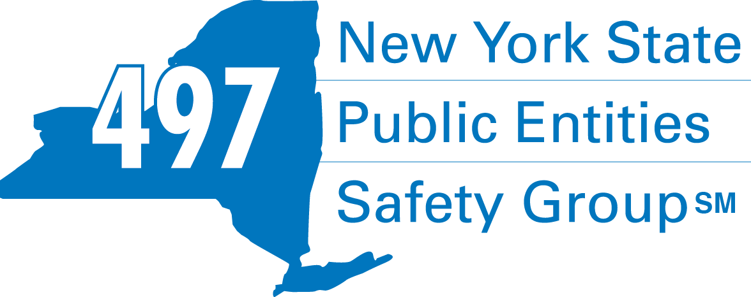

**Fleury Risk Management**

**28 Corporate Drive, Suite 104**

**Clifton Park, NY 12065**

**518.478.6314**

[**https://www.fleuryrisk.com/nysgroup497**](https://www.fleuryrisk.com/nysgroup497)

***VFBL Insurances Services***

**FIRE EQ TESTING**



**Don McCormack**

425 Main Street Catskill, NY 12414

[www.tbogc.com](http://www.tbogc.com)

**518.943.2600 X2109**

[donaldm@tbogc.com](mailto:donaldm@tbogc.com)

Specializing in Fire Service Financing

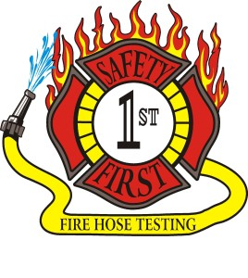**Safety First Equipment Testing**

99 Glass Lake Road

Averill Park, NY 12018

518-674-8363

**www.safetyfirstfirehose.com**

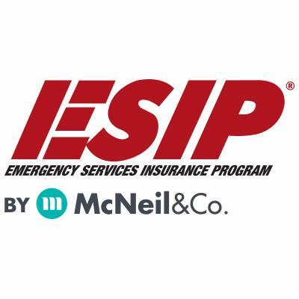

Carla West, Territory Sales Mgr

800-822-3747 ext 138

cwest@mcneiland company.com

**LOSAP MANAGEMENT**

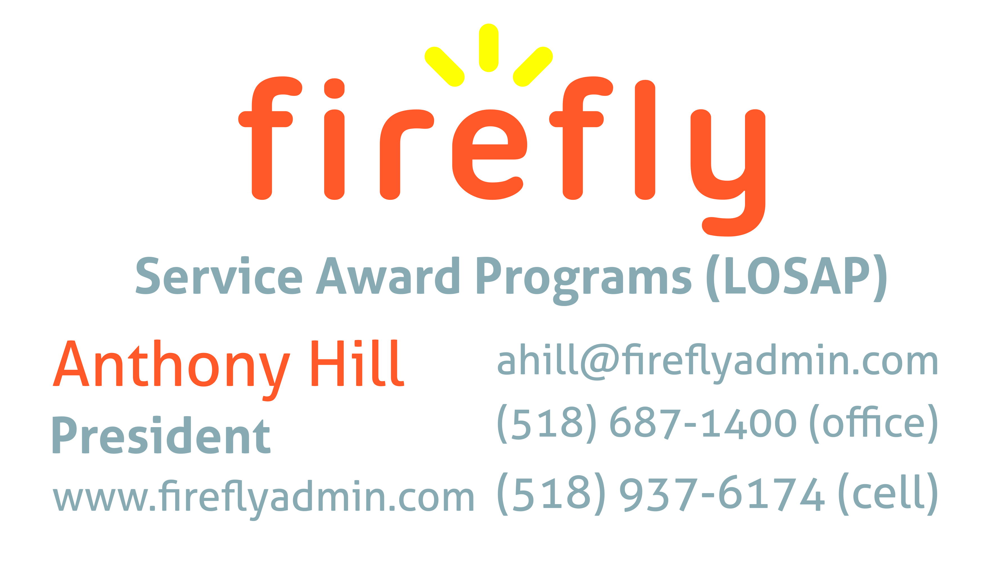

Pat Daglio

[pdaglio@vfis.com](mailto:pdaglio@vfis.com)

717.819.3072

**SCBA COMPRESSOR**

**SERVICE**

Breathing Air Comp Maintenance

Air Quality Tests and Repairs

Chris Jeffreys

315-729-6071 Cell

315-699-4533 Office

**FIRE APPARATUS**

UBS Financial Advisors

Ralph Lemme, CFP

8 Southwoods Blvd Suite 207

Albany, NY 12211

518.445.1667



**DRYER VENT CLEANING**

**DRYER VENT WIZARD**

**JORDAN CATINO**

**8 NAPA COURT, SCHENECTADY, NY 12309**

**518-344-0664**

**SARATOGADRYERVENT.COM**

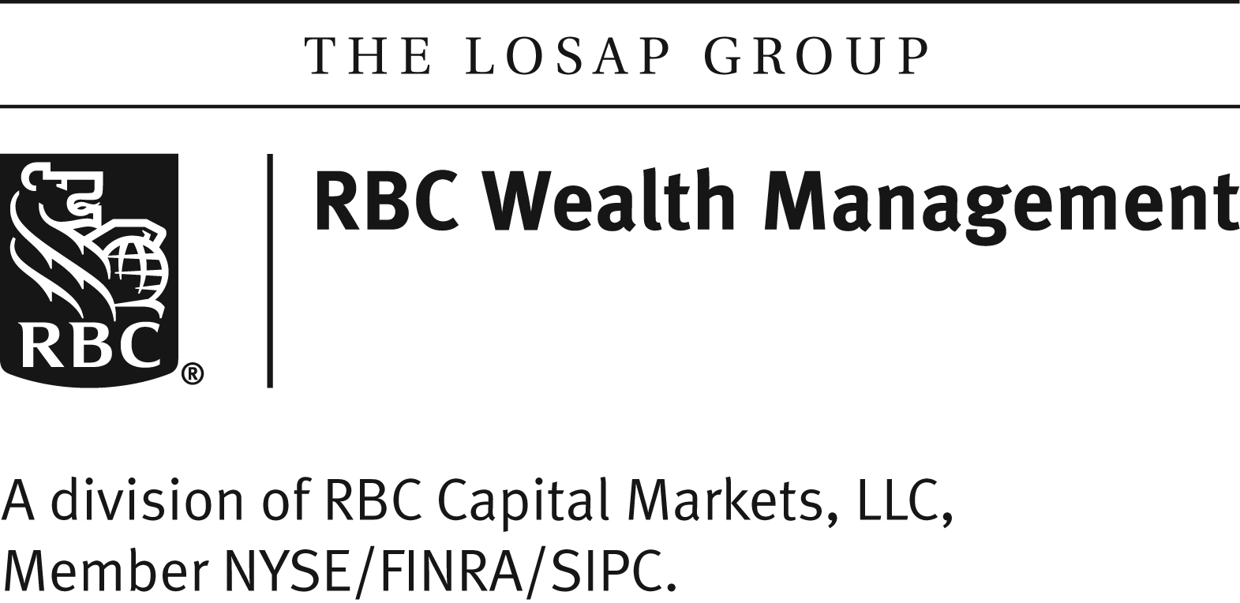

518-432-5087

838-433-7304 cell

www.thelosapgroup.com,

**WARNING PACKAGES/REPAIRS**

**BODY SHOP**



**Vehicle Repair, Warning Packages, Body Shop**

**78 Freemans Bridge Road, Glenville**

**518-377-5555**

*Veteran Owned Business*

Nicole Meeker

Manager of Business Development & Accts

**518-394-7894**

**Cell 607-423-4811**

[www.penflexinc.com](http://www.penflexinc.com)

nmeeker@penflexinc.com

**FIRE COMPANY FUND RAISING**

**FIRE STATION PEST CONTROL**

**Lloyd Fox, Account Executive**

**34 Garner Road, Averill Park, NY 12018**

[**Lfox8@nycap.rr.com**](mailto:Lfox8@nycap.rr.com)

**518-810-7819**

**www.funddrive.com**

**518-300-4732**

**431 New Karner Rd Suite 170**

**Albany, NY 12205**

**https://foxpest-albany.com**

**FIRE DISTRICT CPA/AUDITS/FINANCIAL SERVICES**

Zoriana M. Stawnychy

973.283.0024

zoriana@stawnychyfinancial.com

135 Kinnelon Road Suite 101

Kinnelon, NJ 07405

Serving fire districts in New York State



**518.459.6700**

**10 British American Blvd, Latham NY 12110**

[**www.bstco.com**](http://www.bstco.com)

**Brendan Kennedy ext 356**

**Robert V. Gramuglia, CPA**

1 Pine West Plaza Suite 107, Albany NY 12205

518.452.8055 or 518.859.5851cell

Email: rgramuglia@BGCPA.net



11 British American Blvd, Latham, NY 12110

518-785-0134

Queensbury Office 518-792-6595

<http://www.mmbaccounting.com>

Alan W. Clink, CPA [aclink@mmb-co.com](mailto:aclink@mmb-co.com)

Heather R. Lewis, CPA hlewis@mmb-co.com

***The Capital Bulletin is reaching well over 400+ fire district members and now other members of the fire service on a regular basis. Since the Capital Area Association covers an area the size of Connecticut it is difficult to meet in person to exchange information and ideas.***

***This is a service of the Capital Area Association through the effort of Tom Rinaldi who can be reached at*** [***tom@rinaldi1.com***](mailto:tom@rinaldi1.com) ***for comments or content contributions are always welcome.***

***MEMBERSHIP IN THE CAPITAL AREA FIRE DISTRICTS ASSOCIATION (CAFDA)***

Would you like to join Capital Area Fire Districts Association along with 75 members in 8 counties? Individuals, fire district associations, fire protection districts and Village departments are all eligible for membership.

Annual dues (January 1st to December 31st) shall be as follows and shall be based on the annual budget of the Fire District/Organization;  
$0 to $200,000: $50   
$200,001 to $400,000: $100   
$400,001 to $600,000: $200   
$600,001 plus: $300

Individuals $50.00 and Other Associations $300 annually.  
***Business Partners: $100.00 annual member fee***



**2023 Events Calendar**

|  |  |  |  |
| --- | --- | --- | --- |
| **Date** | **Time** | **Type** | **Location** |
| Thursday, July 13, 2023 | 7:00 PM | Board Meeting | Clifton Park |
| **August 2023** | **NO MEETING** |  |  |
| Thursday, September 14, 2023 | 7:00 PM | General Membership | Clifton Park |
| Thursday, October 12, 2023 | 7:00 PM | General Membership | Clifton Park |
| Saturday, November 4, 2023 | 8:00 AM | Fall Workshop | Verdoy Fire Dept |
| Thursday, November 9, 2023 | 7:00 PM | General Membership | Clifton Park |
| **December 2023** | **NO MEETING** |  |  |
| Saturday, January 6, 2024 | 9:00 AM | Organizational Meeting | TBD |

**For General Membership meetings food is served 1 hour prior to the start time of the meeting, usually 6pm.**