CAPITAL AREA

FIRE DISTRICTS ASSOCIATION

Representing The counties of
Albany, Essex, Fulton, Montgomery, Rensselaer, Saratoga, Schenectady,
Schoharie, Warren, Washington

www.AFDCA.org
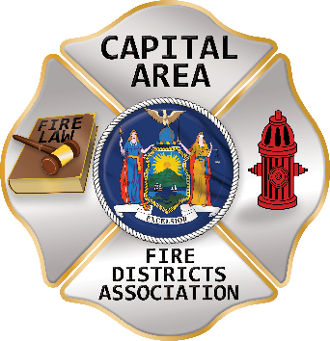

Invites you to attend

The Annual Officers’ Reception

When: Saturday, March 9, 2024
Where: The Century House
997 New Louden Road
Latham, NY 12110
518-785-0834
Time: 5:00 PM to 9:00 PM
Fee: $75 for an Individual or $120 for a Couple
Note: the cost is a legal Fire District expense
Attire: Business Casual
RSVP: March 1, 2024
The Officers’ Reception is a great opportunity to network, discuss common issues with other local fire
district officials and representatives from across New York State. You will enjoy a fabulous buffet dinner, complimentary beverages and entertainment throughout the evening.
-----------------------------------------------------------------------------------------------------------------------------------------------
(CUT HERE and submit with payment)
Please make Checks payable and mail to: CAFDA
PO Box 242
East Schodack, NY 12063
Please print clearly:
Name of Fire District:

Reservations: Officer with Guest x $120 = Single x $75 =

Total enclosed

Please print the names of those attending:

