Capital Area Fire Districts AssociaTion

SAve the dates!
CAFDA has been busy, and 2025 is shaping up to be a great year!

commissioner training
AVERILL PARK FIRE DISTRICT | Saturday, February 1, 2025 Snow Date: Sunday, February 2, 2024
CLIFTON PARK FIRE DISTRICT | Saturday, March 1,2025 Snow Date: Sunday, March 2, 2024
BERKSHIRE FIRE DISTRICT | Saturday, March 29, 2025 Snow Date: Sunday, March 30, 2024
WARRENSBURG FIRE DISTRICT | Saturday, April 5, 2025 Snow Date: Sunday, April 6, 2024

Miscellaneous training
FINANCIAL TRAINING FOR FIRE DISTRICT OFFICIALS | Fulton-Montgomery Community College Thurs – Fri. March 13-14, 2025 Johnstown
FINANCIAL TRAINING FOR FIRE DISTRICT OFFICIALS | Stay tuned for a second 2025 date!
CAFDA CONFERENCE | Fort William Henry Hotel & Thurs – Sat. April 10-12, 2025 Conference Center, Lake George
ANNUAL FALL WORKSHOP | Verdoy Fire District, Latham Saturday, November 1, 2025

social events
OFFICER INSTALLATION DINNER | Century House, Latham Saturday, March 8, 2025
DAY AT THE RACES! | Saratoga Race Course, Saratoga Springs Friday, August 8, 2025

meetings – Clifton Park Fire District & Zoom
General Membership Meeting | 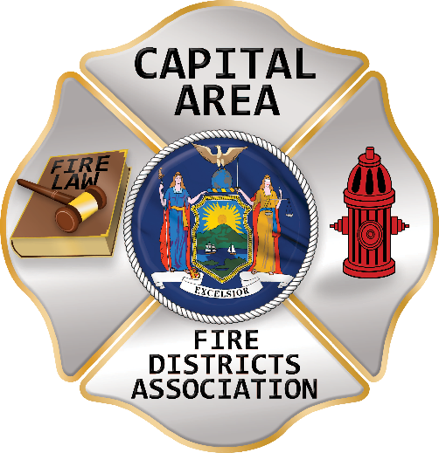  Saturday, January 4, 2025
General Membership Meeting | Thursday, February 13, 2025
General Membership Meeting | Thursday, March 6, 2025
Board of Directors Meeting | Thursday, April 3, 2025
General Membership Meeting | Thursday, May 8, 2025
General Membership Meeting | Thursday, June 12, 2025
Board of Directors Meeting | Thursday, August 14, 2025
General Membership Meeting | Thursday, September 11, 2025
General Membership Meeting | Thursday, October 9, 2025
General Membership Meeting | Thursday, November 13, 2025

visit often for more information
Website | www.CAFDA.net

