Capital shorts:
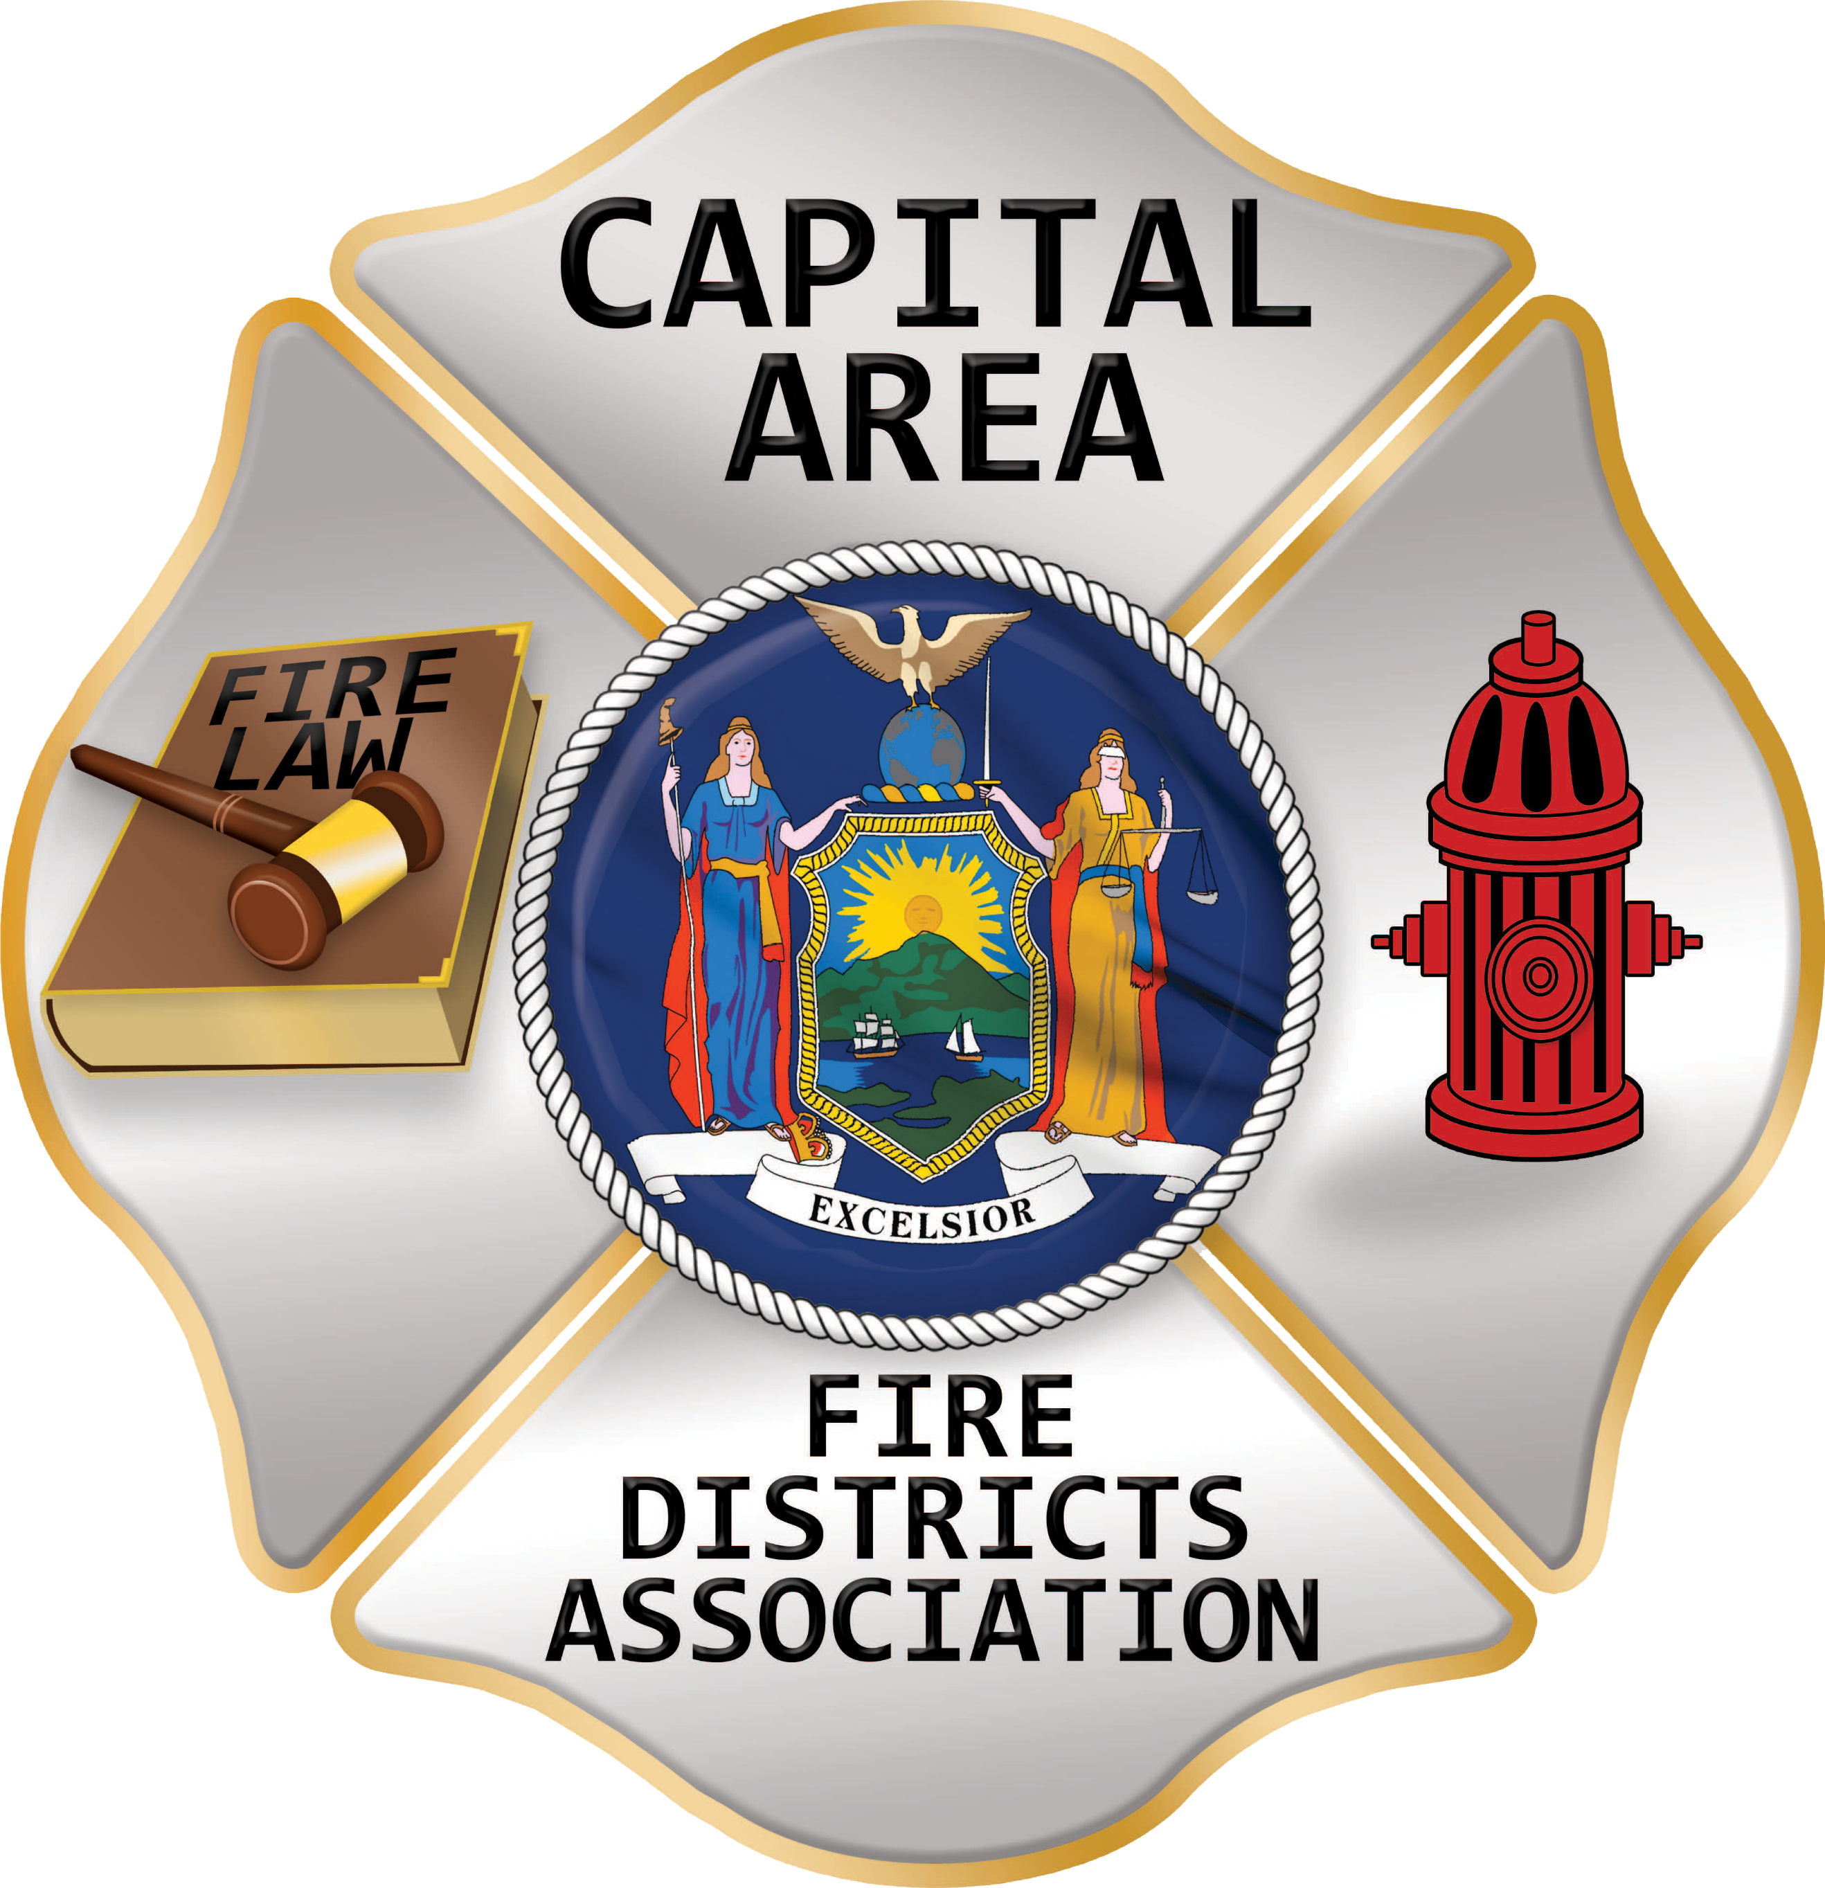
Capital Area Fire District’s Association
The Weekly CAFDA
BULLETIN
May 10th, 2025
Editor, Tom Rinaldi, Tom@rinaldi1.com
Serving the fire service community since 2004
- Happy Mother’s day to all the moms that support us in what we do.
- See the new OSHA information in the Supplement!!
- Just a reminder, the annual Burn Ban is in place until May 14th. With the record rainfall, I’m for an amendment to the law that the DEC Commissioner can shorten or lengthen the burn ban.
- CAFDA is happy to announce the dates for Conference ’26 in historic Lake George, April, 9th, 10th and 11th, 2026 plan on joining us.
- Does your fire district interview their chiefs prior to electing them, or prior to approving them? If not, why not?
stuff for your benefit, need to know! www.CAFDA.NET

GENERAL MEMBERSHIP MEETING Thursday June 12th, in person or Zoom in. 7PM.

SAVE THE DATE: CAFDA FALL TRAINING SEMINAR, Saturday November 1st at Verdoy Fire Department
All correspondence & Capital Area Fire Districts Association Mailing Address should be directed to:
CAFDA PO Box 242 East Schodack, NY 12063 or EMAIL: SECRETARY@CAFDA.NET
Financial issues should be addressed to: TREASURER@CAFDA.NET

CAFDA is happy to announce the dates for Conference ’26 in historic Lake George, April, 9th, 10th and 11th, plan on joining us.
THE LATEST FROM THE STATE CAPITAL

Legislative Scorecard Win!
Governor Hochul and the Senate and Assembly finalized the State Budget, which included addressing two important Legislative Scorecard issues - a future ban on potentially harmful PFAS, forever chemicals in new firefighter turnout gear and a five-year extension of the EMS Cost Recovery law.

Legislative Commentary
Here is what the NYS Fire Service has gotten through legislation so far this session; changed the use of the term moped to limited use motorcycle, the commissioner of agriculture now sits on the Code Council, and new construction now requires EV charging where parking is provided. The Fire Service is obviously not the priority of those controlling the legislature. With the number of session days dwindling, the chances of getting significant bills past grows dimmer each day. Bills introduced by Republicans is even slimmer. Perhaps because most of the state voted Republican in previous elections with the exception of NYC. Of the 150 Assembly members, 65 are from New York City, do you believe they care about the volunteer fire service in upstate NY?

Bills affecting the operation of the fire service are being Introduced for the 2025/26 Legislative Session the latest ScoreCard will keep you informed about pending legislation.

When you see ** it’s a recommended read!!
THE LATEST FROM WASHINGTON
Sanity is slowly returning to the swamp.

9/11 Health Workers Rehired After Outcry Forced Trump to Reverse Cuts
Dave Goldiner – NY Daily News
NEW YORK — Federal workers who help run the health program for Sept. 11 first responders and survivors have been rehired after a bipartisan outcry forced the Trump administration to reverse deep cuts that threatened to hobble the program, lawmakers said Wednesday.
Almost all of the estimated 16 fired World Trade Center Health Program workers have been told this week they are being reinstated, following weeks of uncertainty over the draconian cuts by the White House and Elon Musk’s Department of Government Efficiency.
“This is good news … but there are still major questions about the status of the program,” warned Ben Chevat of Citizens for the Extension of the James Zadroga Act, a 9/11 advocacy group that plans to protest in Washington D.C. next week to demand more answers.
The reversal of the cuts was confirmed by program director Dr. James Howard, who praised HHS in a statement for “swift action to address these notices and return critical program staff to work to help assist and provide ongoing services,” The action appears for now to end the chaotic budget cuts imposed on the program by the Trump administration. Howard and several staffers were fired in March as part of a wide effort spearheaded by Musk’s DOGE to downsize the federal government. After a flurry of bipartisan outcry, the White House said at the time that it was reversing the staffing cuts and reinstating Howard.
But it didn’t actually take action until last week, when a front page Daily News scoop revealed that Howard’s status had been left in limbo, new participants were not being enrolled in the program and treatment plans were not being approved. Three FDNY employees were unable to get treatment plans approved for recent cancer diagnoses. After the fresh round of criticism, the health program resumed enrollments and treatment approvals. Howard was fully reinstated to his post. Now, the workers, amounting to nearly 20% of the program’s staff, have been told they will not be fired after all.
The program provides health services to about 137,000 first responders and survivors who suffered injuries and illnesses caused by the toxins that swirled around Ground Zero during 9/11 and the weeks that followed.
About 83,000 have at least one certified 9/11 illness from their exposure during and after the terror attacks on the World Trade Center, as well as the hijacked plane crashes near Shanksville, Pa., and at the Pentagon.

📌DHS Secretary Noem Testifies Before Congress. U.S. Secretary of Homeland Security Kristi Noem testified before the House Appropriations Committee. She will testify before the Senate Appropriations Committee on Thursday. Similarly, Cameron Hamilton, the Senior Official Performing the Duties of FEMA Administrator, will testify before the House Appropriations Committee on Wednesday. These hearings will be an excellent opportunity for the Administration to outline its priorities for the Department of Homeland Security and the Federal Emergency Management Agency in the upcoming fiscal year. To watch the hearings, click the links above.

📌President’s Budget for Fiscal Year 2026 Released. President Trump has released his proposed budget for fiscal year (FY) 2026. The President’s Budget Request (PBR) is an annual document that indicates the Administration’s priorities for the fiscal year. As expected, President Trump’s budget includes a variety of proposed cuts and other modifications to agencies, including:
- The PBR proposes a consolidation of the Department of Interior and the federal wildland fire management responsibilities of the U.S. Department of Agriculture (specifically, the U.S. Forest Service) to create a new Federal Wildland Fire Service. Details on the plan are limited.
- The budget indicates that FEMA’s Preparedness Grants will remain active but details remain scarce.

ONE PAGER: HIGH RISE FIRE SPRINKLER INCENTIVE ACT
With tax reform discussions heating up, use CFSI’s High Rise Fire Sprinkler Incentive Act One Pager to ask your members to cosponsor the bill.
An advocacy one-pager is a concise, single-page document that highlights a key issue, your position, and a clear call to action—perfect for sharing with policymakers to quickly inform and inspire action.
To learn how to effectively use a one pager in meetings and emails, watch our new One-Minute Advocate video below!
NEW VIDEO: Using Advocacy One Pagers or go to: https://www.youtube.com/watch?v=HzgitJnu6_c
FIRE DISTRICT FINANCES

NYS-OSC Audits
Caledonia Volunteer Fire Department, Inc
AUDIT OBJECTIVE
Did the Caledonia Fire Department (Department) Board of Directors (Board) provide adequate oversight of financial operations?
AUDIT PERIOD
January 1, 2023 – January 8, 2025
UNDERSTANDING THE PROGRAM
The Board must provide oversight to ensure financial operations are properly managed. This includes ensuring comprehensive records are maintained, duties are appropriately segregated or compensating controls are implemented to safeguard funds and reviewing records and reports to detect discrepancies.
The Department is composed of volunteer members and is governed by its bylaws and seven-member Board. The Board is responsible for managing the Department’s financial activities.
The Treasurer is responsible for maintaining custody of, disbursing, depositing and accounting for the Department’s financial activities and preparing financial reports. The booking coordinator oversees hall rentals and certain fundraising events.
The Department’s disbursements totaled $174,302 from January 1, 2023 through May 31, 2024.
AUDIT SUMMARY
The Board did not provide adequate oversight of financial operations. In addition, our previous audit report, Caledonia Fire Department – Internal Controls Over Financial Operations (2013M-356), released March 2014 had similar findings and recommendations concerning the Board’s lack of oversight. Because the Board did not implement adequate corrective action to address these findings, the same deficiencies exist.
The Board did not:
- Ensure that the financial review committee conducted an annual review of the Treasurer’s financial records or that all 325 claims paid between January 1, 2023 and May 31, 2024 totaling $174,302 were reviewed, approved and properly supported. The Board also did not ensure that the Treasurer:
  - Maintained accurate and complete financial records,
  - Provided the Board with adequate financial reports, bank statements, canceled check images and bank reconciliations to monitor operations.
- Ensure that officials safeguarded and properly supported hall rental and fundraising revenues. From January 1, 2023 through May 31, 2024 deposits, including those for hall rentals and fundraising, totaled $211,917.
- Adopt:
  - Written financial policies to establish a system of internal controls that ensure oversight of financial activities, transactions are authorized and properly reviewed and Department resources are adequately safeguarded,
  - The required code of ethics policy to establish reasonably expected standards of conduct, or
  - A conflict-of-interest policy that requires officials to disclose any interests that conflict with official duties.
The lack of oversight of financial operations increases the risk of theft, potential liability and waste of Department resources.
The report includes 11 recommendations that, if implemented, will improve the Board’s oversight of financial operations.
Department officials agreed with our recommendations and indicated they have initiated corrective action.
THE FULL REPORT CAN BE DOWNLOADED HERE: www.osc.ny.gov/files/local-government/audits/2025/pdf/caledonia-volunteer-fire-department-inc-2025-12.pdf

Local Government and School Accountability Contact Information:
Phone: (518) 474-4037; Email: localgov@osc.ny.gov
Address: Office of the State Comptroller, Division of Local Government and School Accountability
110 State Street, 12th Floor; Albany, NY 12236
step into the chief’s office

Leadership Is Not for Everyone
Sal Scarpa
The title of this article may sound strange. After all, leadership is as much a part of the fire service as it is a part of the corporate world. In individuals, leadership is that characteristic that exudes confidence and inspires action. It’s a quality that workers seek out and strive to exude on their own. We all know people who have leadership qualities; we’re drawn to them. But leadership is often recognized as much for its absence as its presence.
Referring to the top management in an organization, leadership sets the tone and drives the pace in any organization. In this sense, leadership is seen as the forefront of organizational initiatives. In the fire service, the leadership role can be that of a company or chief officer. But the position of leadership is not for everyone.
SOME DON’T WANT TO LEAD
Not everyone is called, desires, or deserves to be in a leadership role. Some members of the fire service are perfectly comfortable in a nonleadership position. When presented the opportunity, they may actually decline to “study for promotion” or apply for a role in management, because are satisfied in their current assignment. Some would argue this is a sign of laziness or an unhealthy organization. “You must not be motivated” if you don’t want to lead.
I would argue that perhaps the reason is more pragmatic. Being comfortable in your role is okay if you realize that leadership is not for you. Perhaps you’re simply not interested in leading people and would rather be directed (rather than directs). Perhaps your job satisfaction comes from being a backseat firefighter or engineer—two absolutely critical roles that every agency needs. Maybe you enjoy being in more of a support function and would rather stay away from the limelight.
As a fire-EMS chief, I have absolutely no problem with members who choose not to pursue a leadership role; but there’s a catch. If you choose not to pursue leadership roles, I ask only two things. First, be the best at your role. Whether you’re a firefighter, educator, inspector or any other critical position—hone your craft to be the best at it. Take classes, go to school, learn from others—whatever it takes, perform to you fullest capability. And secondly, be willing to teach others. Use your skill and expertise to train the next generation so they, too, can be the best.
ANOTHER TAKE
There is some truth to the idea that if people in an organization shy away from leadership roles, there may be an unhealthy culture in the department (or maybe just some lazy individuals). If an organization finds itself in a predicament where no one is putting in for promotional exams to leadership positions, there could be a problem. If members are barely coming in the front door (recruitment) or fleeing out the back door (resigning/retiring) but not promoting, that is indeed a sign of a cultural issue—a toxic atmosphere, poor leadership, failure to see the vision, etc.
These types of challenges are indicative of a larger predicament and are often the symptoms of underlying issues. Such difficulties require a more focused evaluation of the department and the undercurrent that may be plaguing an organization. You may need a new direction and a fresh way of thinking. A thorough introspection is necessary, and the agency would likely benefit from a third party (unbiased) evaluation.
SOME SHOULDN’T LEAD
If you’ve been in the fire service long enough (or any profession for that matter), you’ll soon come to the realization that some people in leadership positions should not be serving in that role. Again, leadership is not for everyone. There are some in our service who achieved a leadership position because of a faulty promotional process. If your promotional processes focus on only one element (like time on the job) and not the ‘body of work’ of an individual, you may be promoting individuals who are not best suited to lead in your department.
We all know people who were really good firefighters but poor officers. Generally, experience in firefighting is an important prerequisite for promoting to a company officer position. But it shouldn’t be the only requirement. Skill sets like interpersonal dynamics, decision-making under duress, multi-tasking, prioritization, time management, etc., are all critical elements that also make good firefighters even better officers. Company and chief officers need to be well rounded and versed in a wide variety of areas if they are to be successful and perceived as good leaders.
I believe the same argument holds true for those promoting from company officer to chief officer. Not everyone wants to be a chief (or the chief). And that’s okay; not everyone can be. Again, there are some members in our organizations who make good officers but would not do well in a chief officer position. A chief officer often has far more administrative responsibilities than most folks would be interested in. If managing projects, engaging with other entities, or administering discipline is not something that appeals to you, perhaps a chief officer position is not the right fit.
Crossing that threshold from “us” to “them” is sometimes negatively perceived by department members who struggle with officers going from “buddy” to “boss.” It can indeed be difficult, especially when administering discipline or writing performance reviews, in light of your changed relationships. However, gaining a wider perspective and better understanding the overall direction of the department can help prospective chief officers lead effectively. Relations between traditional labor groups and management do not have to be antagonistic. Members on both sides who are mutually committed to the mission and the membership can foster an incredibly satisfying and productive work environment.
I WANT TO BE THE CHIEF
Statically speaking, there are not a lot of firefighters these days who are seeking that top position in a fire department—the fire chief. Some new recruits may come into your organization and espouse that as a long-term goal. More often, somewhere along the way that once-idyllic aspiration loses its appeal, and members settle in somewhere in the department that seems most appropriate for their skill sets, work-life balance, and personal satisfaction. Leadership is not for everyone!
The role of the fire chief may sound appealing and can certainly be an attainable goal or aspiration for many. As fire service leaders, we not only have a responsibility to prepare the next generation of leaders, but we must also paint a realistic picture of what that role looks like on a day-to-day basis. This is as true for the role of fire chief as it is for a new firefighter. We often relate dramatic images of large fires or technical rescues to recruit new members, then wonder why they leave disillusioned after a year or so on the job with only a handful of working fires. They were sold a “bag of goods.” The reality for most firefighters is that they will spend far more time running medical calls than fighting fires.
In a similar vein, the lofty expectations often associated with the role of a fire chief can differ greatly from the reality of the job. It’s unlikely that anyone fully explained the complex, interconnected challenges that many fire chiefs face. How many fire chiefs truly understood the weight of responsibility placed on their shoulders before stepping into the role? Consider the new and emerging threats—such as advancements in technology, climate change, and others—that fire chiefs may not have been trained to handle and must learn to navigate on the fly. That’s not even counting the challenges of navigating an ever evolving and demanding political landscape. Do you think these factors shift their perspective or alter the plans and goals they had when they first assumed leadership of the department?
The job and capability of the fire chief varies somewhat depending on the size of the department and the budget afforded to the agency. In smaller agencies, the chief may be actively engaged in daily operations, including incident command or apparatus response. In larger agencies, the chief may be more of a figurehead or administrator. The impacts of budget appropriations also may directly affect what the chief is able to accomplish in the department. Without the appropriate resources, fleet and facilities fall into disrepair. Staffing shortages create logistical challenges. Firefighters try to manage without crucial equipment. All these shortfalls impact department morale.
As a department head, the fire chief should be the department’s lead advocate—supporting the firefighters and building an agency framework that ensures everyone goes home. I believe it is the responsibility of the fire chief to lobby for the data-supported needs of the department. The role of leadership is to set the tone and point the way. The fire chief should be able to articulate a vision of the organization and assemble an empowered team of leaders to execute that vision in a cohesive and collaborative environment. That should be the embodiment of leadership.
IS LEADERSHIP FOR YOU?
Leadership in the fire service is a unique and multifaceted challenge, requiring a balance of technical expertise, emotional intelligence, and strategic foresight. While not everyone is suited or inclined to lead, those who step into leadership roles, particularly as fire chiefs, bear significant responsibilities that demand resilience, adaptability, and a commitment to growth. The success of a department often hinges on the ability of its leaders to navigate complexities, inspire their teams, and advocate for their organization amid ever-changing circumstances.
For those willing to embrace the mantle of leadership, the rewards can be profound. However, it is equally vital to recognize and respect those who choose to contribute in other, nonleadership capacities, as their roles are just as essential to the overall success of the department. Ultimately, leadership is not for everyone, and that’s okay. What matters most is that everyone within the fire service brings their best to the table, working together toward the shared mission of protecting and serving their communities with professionalism, integrity, and excellence.
THE ATTORNEY’S OFFICE

Former Fallston (MD) Volunteer Fire Chief Indicted on Felony Theft Charges
Matt Hubbard – Baltimore Sun
The former chief of the Fallston Volunteer Fire and Ambulance Company has been indicted on five felony theft charges for allegedly stealing thousands from the department.
Daniel McKinney, 37, was arrested Wednesday and faces five felony theft charges ranging from theft of $1,500, to $100,000 as well as one misdemeanor embezzlement charge, according to court documents.
The documents indicate that after his arrest, McKinney posted an unsecured bond of $25,000.
According to an emailed statement from fire company president Christopher Gibbons, the Board of Directors “discovered some irregular purchases on an issued company credit card” and an investigation revealed “possible criminal activity.” The company turned over evidence to the Harford County Sheriff’s Office detectives who then turned over their findings to the Harford County State’s Attorney’s Office.
According to the indictment the alleged thefts took place between July 2019 and the end of January 2025.
The statement said McKinney is no longer a member of Fallston Volunteer Fire and Ambulance Co. Inc., as he “was separated from membership” on Feb. 2.

Lawsuit Accuses SC Fire Department of Fatal Mistakes in Irmo Firefighter’s Death
Ted Clifford – The State
James Muller was still in high school when he knew that he wanted to be a firefighter.
By 25, he was married, the father to a young son and serving with the Irmo Fire District. On May 26, 2023, he was killed while assisting the Columbia-Richland Fire Department in battling an apartment fire at the Tropical Ridge Apartments near the Riverbanks Zoo in Columbia, South Carolina.
While fighting the fire at its source inside of a second-floor kitchen, Muller and three other Irmo firefighters were buried by debris when the two floors above collapsed on top of them. According to a lawsuit filed by Muller’s widow, the collapse was caused when the Columbia Fire Department had turned their powerful “deck guns” on the roof, unleashing “enormous” amounts of water on the fire-weakened building.
Once trapped, Muller’s Mayday call was lost amid busy radio traffic and simple misunderstandings. Muller died of “mechanical asphyxiation” after remaining trapped under debris for at least 45 minutes, according to the lawsuit.
The lawsuit filed April 23 by Emma Muller against the City of Columbia and Richland County alleges that Muller’s death was caused by inadequate training, miscommunications between personnel and a failure to maintain clear channels of communication during the fire.
Emma Muller’s attorney, Brian Barnwell of Columbia law firm Rikard & Protopapas, LLC, told The State they didn’t wish to comment on the lawsuit.
The legal action comes roughly two weeks after the National Institute of Occupational Safety and Health (NIOSH) released a report outlining how critical miscommunications at the scene of the fire led to Muller’s death.
The fatal blaze was started by a grease fire inside of a kitchen located at the back of a second-floor apartment. Muller and other firefighters from the Irmo Fire District were responding to the two-alarm fire as part of an automatic aid agreement. While the fire was in the Columbia Fire Department’s jurisdiction, the agreement allowed the closest fire department to respond to an emergency.
At Tropical Ridge, the Columbia Fire Department assumed command over the scene because the fire was in their jurisdiction. As a result, they were responsible for “organizing the emergency response efforts and maintaining safety,” according to the lawsuit.
Representatives for the Columbia-Richland Fire Department and the city of Columbia said they were unable to comment on pending litigation. Richland County didn’t immediately respond to The State’s request for comment.
The Irmo Fire District was not named as a defendant in the lawsuit and similarly declined to comment. The South Carolina Occupational Safety and Health Administration also issued a number of citations and fines, totaling $3,600, against both the Irmo Fire District and the Columbia-Richland Fire Department. Irmo is contesting those fines.
WHAT HAPPENED AT THE TROPICAL RIDGE FIRE?
Fires were not uncommon at the Tropical Ridge apartments. Three other units at the apartment complex, located at 167 Stoneridge Drive in Columbia, had previously been destroyed in fires.
The Columbia Fire Department responded to fires at the apartment complex in 2013 and again in 2017, when two firefighters were injured. The apartments, made up of units connected by open breezeways, were built with lightweight wooden construction. Floors were supported by parallel wooden trusses that allow fire to rapidly spread horizontally and can collapse in as little as five minutes after being exposed to an open flame, according to the NIOSH report.
The lawsuit additionally described how the building had “open chimney chases,” which did not have any fire stops.
“The construction of the apartment complex allowed for rapid and unrestricted fire spread,” according to the lawsuit. “This information was known or should have been known by the Columbia Fire Department Incident Command.”
As Muller and other Irmo firefighters prepared to swap in for a team of Columbia firefighters, the team they were replacing inside of the building warned them that the floor was sagging. This information was not clearly communicated with supervisors, according to the lawsuit.
Around 4:44 p.m., while Muller and three other Irmo firefighters fought the fire inside of the kitchen, a team of Columbia firefighters on the floor above were knocking down walls to try and stop the spread of the flames while debris began to fall from the building, according to the NIOSH report.
As the two teams of firefighters worked inside, the deck guns, water cannons mounted to fire engines, turned their powerful jets on the weakened building. Soon, the weight of the water brought the top two floors down on the firefighters.
“These deck guns should not have been used while people were in the building,” according to the lawsuit.
Both teams of firefighters sent out Mayday calls, the lawsuit says, but in the chaos, Muller’s call was ignored. For a time, he remained conscious and talking while waiting for help.
The NIOSH report fills in many of the details of the confusing scene. Following the building’s partial collapse, neither team of firefighters were aware that anyone else was trapped, despite knowing that there were other firefighters in the building. Each crew assumed that the Mayday calls they were hearing referred to them. Some Mayday calls weren’t received at all because of the heavy radio traffic. As a result, different teams of rescuers each assumed that they had found the only people trapped in the building, according to the report.
After all firefighters except for Muller were rescued, the Columbia Fire Department’s incident command believed all Mayday calls were resolved. As a result they “ignored Mr. Muller’s separate mayday call, and did not send any additional aid,” according to the lawsuit.
It wasn’t until around 5:07 p.m. that a supervisor at the scene reported an active Mayday alert, according to the NIOSH report. Muller remained trapped until a rescuer, tunneling on his stomach through the debris, was able to cut Muller free and drag him out of the collapsed building.
CPR and other life saving measures were attempted at the scene, but Muller was pronounced dead after being rushed to the hospital.

Merrillville (IN) Mechanic Charged with Scamming Fire Department on Truck Repairs
A Merrillville repairman faces felony theft charges after an Indiana State Police investigation revealed he allegedly attempted to scam the Merrillville Fire Department out of tens of thousands of dollars on repairs to a fire engine. David Shepard-Hambrick was formally charged in Lake Criminal Court Thursday with theft, a Level 6 felony, online court records show.
In March 2024, the Merrillville Fire Department took one of its trucks to Merrillville-based Hoosier Diesel & Off-Road, a repair shop that specializes in diesel and off-road vehicle maintenance. Shepard-Hambrick is the company’s owner.
Shepard-Hambrick allegedly told the fire department that pieces of metal were in the trucks oil and that it required “extensive repair.” He requested an advance payment of more than $43,700, which the Town of Merrillville paid in check on March 22, 2024. Shepard-Hambrick allegedly set the estimated total cost for repairs at approximately $60,000, including the cost of a completely new engine for the truck.
By February, the repair company still didn’t have a new engine for the truck after months of the owner telling the department there were issues with the engine being made — and the fire department then allegedly learned that Shepard-Hambrick had never ordered one.
“(The Merrillville Fire Department) then made arrangements to pick up the fire truck and had it towed to another repair shop,” ISP said in a news release. “That repair shop was able to determine that the fire truck did not actually need a new engine whatsoever.”
That repair shop, J&M Equipment Service and Repair in Schererville, quoted the needed repairs at approximately $10,000, according to a probable cause affidavit filed Thursday.
“Further investigation revealed that the engine’s oil pan had never been removed, and the factory seal was still attached,” ISP said. “The oil filters were also inspected, and no metal was located in any of the filters or oil and the engine showed normal wear and tear, noting no damage that needed major engine replacement.”
As of Thursday evening, Shepard-Hambrick is not in custody. A judge has issued a warrant for his arrest, online court records show.
Merrillville Fire Department chief Edward Yerga told investigators that prior to the incident, Shepard-Hambrick had done “quality work” on his department’s vehicles.
Hoosier Diesel and Shepard-Hambrick could not be reached for comment Thursday evening.
Shepard-Hambrick was in January charged with theft of a motor vehicle and has a hearing set for May 14 in that case, online records show.

For information only and not for the purpose of providing legal advice. The opinions expressed are the opinions of the individual author at the time the facts were presented and based on the law then applicable. The information contained in these opinions is not guaranteed to be up to date. The information provided is not legal advice. Since legal advice must be tailored to the specific circumstances of each case, and laws are constantly changing, nothing on this site should be used as a substitute for the advice of competent legal counsel. The authors assume no responsibility to any person who relies on information contained herein and disclaim all liability in respect to such information. You should not act upon information in this publication without seeking professional counsel from an attorney admitted to practice in your jurisdiction.
our changing fire service –challenges & POSITIVE IDEAS. Learning from Others

POSITIVE OUTCOMES

Fire Academy Students In Fayetteville N.C. Install Stovetop Fire Suppression Units Across The City
The Fayetteville Fire Department partnered with E.E. Smith High School Fire Academy to install Auto-Out stovetop fire suppression units in homes across the city.
The Auto-Out suppression units are magnet-mounted canisters placed over the stove in homes. Upon contact with open flames, the canister activates and releases an extinguishing agent directly over the fire.
The systems have come increasingly popular. According to Fayetteville firefighters, they are very effective in reducing the damage caused by kitchen fires in recent years.
“They are designed to go off when they get to a certain temperature,” E.E. Smith Fire Academy student David McLamb said. “They go off and put the fire out.”
Kitchen fires remain the top cause of home fires in the U.S. In 2024, the Fayetteville Fire Department responded to 50 fires that started in the kitchen.
“If something were to go wrong or you stepped away from your pan and a fire were to break out on your stove top, this will keep it in check on top of that stove and not spread to the rest of your home,” Fayetteville Fire Department Capt. Stephen Shakeshaft said. The Economic and Community Development Department provided funding to support the fire department’s efforts to distribute the canisters to at risk communities.

FIRE SERVICE CHALLENGES

Connecticut Sees 63% Drop In Volunteer Firefighters
Ken Dixon, Journal Inquirer
A sharp decline in the number of statewide volunteer firefighters is threatening public safety responses in an occupation that’s never been more hazardous, according to a report issued Tuesday by State Comptroller Sean Scanlon.
During a ceremony in the State Capitol honoring firefighters from around the state, Scanlon, whose grandfather was a decorated, life-saving New Haven firefighter, said the report should become “a wake-up call” for the need to stop the staffing decline and assure more resources for fire departments.
The dangers of volatile chemicals and climate-related weather catastrophes, from tornadoes to fatal flooding and wild fires, is the new normal, while both career and volunteer firefighters need mortgage assistance, regular cancer screening and tuition waivers to better recruit and retain them, Scanlon said. In reaction, Lt. Gov. Susan Bysiewicz said that the profession should reach out to girls and young women to increase their participation in firefighting careers.
Since 2017 there has been a six percent increase in professional firefighters, but a nearly 63 percent drop in volunteers, said the report, which Scanlon issued as the head of the health insurance plan for about 1,000 municipal firefighters. There are 300 fire departments statewide, more than 60 percent of which are volunteer, 17 percent are career and 22 percent are a combination. Groton has the most fire departments with 11; Greenwich has eight; Stamford and Killingly have six.
Eighty eight of the 169 towns and cities have only volunteer fire departments, the report said. According to Connecticut State Firefighters Association statistics, there were an estimated 22,350 volunteers in 2017 and only 8,337 this year. During the same period there were an estimated 4,450 career firefighters in 2017; and 4,738 this year.
“What this report, I believe, is meant to do is serve as a wake-up call to people in every level of government, from state government to municipal government to federal government, to say that if we don’t figure out a way to stop this decline and make sure that our communities have the resources that they need in terms of firefighter power and the resources that we need to attract and retain them, we are going to continue to see communities have public safety challenges and risks for public safety,” Scanlon said.
The report found that while 23 percent of firefighters throughout the country are under 30 years of age, only nine percent of Connecticut firefighters are in that age group, indicating that the profession is less-appealing to those high school graduates who are eligible. There is currently legislation in the General Assembly aimed at increasing recruitment and retention.
North Haven Fire Chief Paul Januszewski has closed two volunteer fire stations during the week, as his volunteers dropped in recent years from 105 to 16, cutting in half the available apparatus available for emergencies. In his professional firefighter ranks, vacancies that once attracted hundreds of applicants now only yield a small fraction of people interested in the career.
“Numerous departments throughout the state are at-risk of shutting their doors, with some already having done so,” said Januszewski, president of the 55-member Connecticut Career Fire Chiefs Association. “We’re sounding the alarm that throughout the state of Connecticut, firefighter recruitment and retention needs to become a priority.”
“Connecticut is facing an urgent moment,” said Ronnell Higgins, who as commissioner of the state Department of Emergency Services and Public Protection oversees the Commission on Fire Prevention and Control and has personally congratulated every graduate of the state Fire Academy since his appointment a year-and-a-half ago. “This just isn’t a firefighter crisis. This is a public safety crisis.” Training has to be improved and health benefits should be enhanced, he said.
Higgins said he wants to see “strategic pathways” into the profession, including females.
Bysiewicz, who had an uncle who was a volunteer chief in Middletown, said that females in the state’s school and college-age population are being encouraged to explore the firefighting profession.
Senate President Pro Tempore Martin Looney, D- New Haven, noted that in recent years, as the presence of dangerous chemicals has become more pronounced, lawmakers have supported firefighters with presumptions of health effects. Senate Majority Leader Bob Duff, D- Norwalk, recalled that over the last year, his city has lost two young fighters to cancer. This month, a new cancer-screening program has begun for firefighters.

Wash. FD’s $72K Fire Boat Sinks During Rescue
Larissa Babiak, Tri City Herald
A water rescue took a dramatic turn this week when a fire crew ended up in the churning Yakima River along with the men they were trying to save.
The rescuers and two stranded rafters were swept downstream about 30 yards before being pulled to safety by other emergency responders.
And the $72,000 emergency boat sent to save them sank in the turbulent waters.
heriff’s Lt. Mike Clark said a “freak accident” caused the Benton County rescue boat to get sucked under the current of the irrigation diversion dam near Richland as the crew was trying to help the rafters.
One fire official stayed on board the capsizing boat for about an hour before he had to leap to safety to another sheriff’s department boat. Later, about 10 p.m., county officials managed to pulled the boat free and tow it to a Benton City fire station to assess the damage.
The Benton County Sheriff’s Office uses its jet boat on the Yakima River at Wanawish Dam to assist in the rescue of a firefighter who became stranded on a fire rescue boat. Courtesy Benton County Sheriff’s Office Yakima River rescue
The rafters were apparently on the river in an official capacity Monday when they drifted beyond the warning signs and accidentally went over the treacherous Wanawish Dam near Horn Rapids, getting stuck in the strong undercurrent. Diversion dams have short drop-offs but the deadly undercurrents can trap boats and swimmers. One of the rafters managed to call 911 for help at 11:45 a.m. Monday and rescuers from Benton County Fire District 2 in Benton City launched their special emergency boat.
Benton County Fire District 2 and the Benton County Sheriff’s Office shared the cost of the $72,000, 18-foot tunnel-hulled jet boat used for water rescues. The 18-foot custom jet boat purchased three years ago is designed to run in only inches of water between the Tri-Cities and Prosser, especially during low-water summer conditions. At the time, Fire District 2 and the Benton County Sheriff’s Office split the cost, and members of the fire department were trained in swift water rescues. On Monday, the emergency boat ended up fully submerged within a few hours after it got pulled down into the turbulence at the base of the dam.
The rescue crew on the boat and the rafters were tossed into the water and carried down the river, where the water was calmer and shallow enough for them to stand up. They were pulled to safety by dive rescue members and others. One of the rafters was treated for mild hypothermia. Officials from Fire Districts 2 and 4, the sheriff’s office, Richland fire department, Columbia Basin Dive Rescue and Washington Department of Fish and Wildlife helped in Monday’s efforts. A Fire District 4 firefighter also was hurt but the extent of the injury was not released. It’s unclear what the cost will be to repair the damaged boat.

**Conn. Student Injured In Tiktok Chromebook Fire Challenge
Christine Dempsey, Journal Inquirer
Students in Connecticut mimicking trending TikTok videos continue to set their laptops on fire in class, with one of the most recent cases happening Thursday at the Middle School of Plainville, police said. Police and fire personnel were called to the Northwest Drive school around 10:15 a.m. The laptop activated the fire alarm and officials evacuated the school, the Plainville Police Department said in a Facebook post. “Through an investigation, it was determined that a middle school student intentionally stuck scissors into a laptop causing smoke to emit from it,” police said. The student complained of smoke inhalation and was taken to the hospital for treatment, they said, and there were no other reported injuries. The school was back in session in less than an hour. “Although the investigation is ongoing, the student involved will be referred to juvenile court to face criminal charges,” police said.
Another incident occurred just the day before at Southington High School. An alert staff member threw the smoking laptop out a second-floor window, while someone else pulled the fire alarm, Assistant Fire Chief Scott Lee said Thursday. No one was injured in the incident.
Similar incidents also have been reported in Cromwell, Derby and Newington, prompting warnings from state fire officials. Newington firefighters responded to Newington High School’s laptop fire on May 1; the others were on Monday.
“It is vitally important that youth and adults take fire risks seriously and recognize the danger inherent to these types of social media ‘challenges,’” State Fire Marshal Lauri Volkert said in a written statement. “Fire can become uncontrolled and turn deadly in just a few seconds.”
State Fire Administrator Jeff Morrissette added, “Social media trends, many that include risky behavior, are sadly on the increase. Students and parents must be aware of this latest trend involving laptops and other personal electronic devices that have the potential to cause serious injury, death, and/or property damage.”
The fires are started by poking a paper clip, push pin, graphite pencil or even a gum wrapper into a laptop’s USB or other charge ports.
In addition to producing toxic smoke and flames, the “challenge” can trigger an explosion, Guilford fire officials said in a Facebook post Thursday.
“While it may appear to some as a harmless online trend, this challenge is no joke. It’s a real fire hazard, and intentionally damaging electronics in this way can lead to criminal charges, serious injuries, and long-term consequences,” they said.
Like school superintendents around the state, fire officials are urging parents to talk to their children about the challenges.
“Monitor their online activity,” Guilford firefighters said, “and help them recognize that online ‘clout’ is never worth risking lives.”
Coming to a neighborhood near you.
FF Health and safety – taking care of our members!
IN 2025 WE HAVE EXPERIENCED 31 FIRE FIGHTER LODD’S
According to FirefighterCloseCalls.com*
In 2024 we experienced 64 LODDs reported nationally.!

DOES’NT HAVE TO BE A FATALITY-JUST A DIBILITATING INJURY, YOU JUST NEVER KNOW!
- A late-night fire displaced seven people from three homes Thursday in Lehigh County, PA. One firefighter was briefly trapped after partially falling through a hole in the floor and was quickly helped by others and evaluated at the scene by EMS.
- Mark Keller, who served with the Mesa, Arizona Fire and Medical Department for 35 years, was found deceased during his on-duty shift.
- Firefighter Waymon Hudson was struck by a car Friday in Cumberland County, N.C. while responding to a crash, according to the Cotton Volunteer Fire Department. Hudson said he broke five ribs and faces a 6-to-8-week recovery. State Highway Patrol said the driver was cited for no operator’s license and failure to reduce speed.

FIRE APPARATUS ACCIDENTS FOR THE WEEK
- A firefighter and three others were injured Saturday when a fire truck collided with a car in Newark, NJ. An adult and two children who were in the car complained of pain and were taken to University Hospital for evaluation. A firefighter who injured his arm was also taken to University Hospital
- A Montgomery Fire Department tanker was returning from an incident Wednesday night when it was hit head-on. A man in the striking car was pronounced dead at the scene while a firefighter suffered minor injuries. The female driver was trapped for a time before being extricated. She was transported with critical injuries.

Nation Pauses to Honor 140 Fallen Firefighters During Annual Memorial Service
May 5, 2025
Despite the rain, thousands attended the National Fallen Firefighters Memorial Service on Sunday at the National Fire Academy campus. They included 70 who died in 2024 and 70 in previous years.

Firefighters and Mental Health: The Fear of Raising Your Hand
Brandon Evans
I stepped off a bus in Sana’a, Yemen, and my nerves rattled after an intense eight-hour ride through a country I knew almost nothing about. As I took in my surroundings, reality sank in—I was not in the safest place. A crowd of men had gathered outside the bus, and it looked like a protest was on the verge of turning violent.
I was 23 years old, trying to make my way back home to Canada after 18 months of working and traveling the world. The last stretch of my journey had been nothing short of uncommon—I had hitchhiked on a sailboat from Singapore to Yemen, planning to catch an easy flight home. Fire departments back in Canada were finally hiring again after a long lull, and I couldn’t afford to miss my chance.
“I NEED HELP”—THE HARDEST WORDS TO SAY
Believe it or not, research states that asking for help is one of the most difficult things a person can do [1] . I learned this firsthand by stepping off that bus. And later in my firefighting career—when I needed help the most—I found it just as challenging.
Halfway through the bus ride, the police had stopped us, holding us at the side of the road for over two hours. They checked everyone’s passports, and as the only foreigner, I was singled out, questioned, and asked to hand over multiple government documents. A few local men were removed from the bus. Then we waited. Eventually, a military escort arrived—six vehicles, including a jeep with soldiers and a top-mounted machine gun. With sirens blaring, they escorted the bus to the capital, Sana’a.
Standing in the street, watching the bus disappear, I realized something unsettling: the military escort was for me. A week earlier, Al-Qaeda had kidnapped a group of foreign travelers in Yemen. When the military attempted a rescue, all the hostages were killed. I had around me was growing, and I could feel their eyes on me—a lone Westerner stranded in the middle of a tense situation in a country where Al-Qaeda operates. I needed help, and the options weren’t great. I spotted a line of taxis up the street. I had a choice: push forward and ask for help, or stay where I was, completely exposed. I tightened my grip on my backpack, kept my head down, and walked straight through the mob, my heart pounding.
The first taxi driver I approached didn’t speak English. This was 2009—Google Translate didn’t exist, and my flip phone was useless. My first attempt failed. I turned to the only other driver I could find and asked, “Airport? Please.”
He nodded. That single “yes” changed everything. He got me out of there, waited until I was safely inside the airport, and left only after he was sure I was okay.
SUFFERING IN SILENCE
Years later, when I was analyzing the findings of my white paper, Heroes Are Also Human [2], an international study on the current state of mental health in the fire service, this story kept resurfacing. Fire chiefs repeatedly spoke about stigma, their concerns about firefighters suffering in silence, and the difficulty of asking for help. Our study found that 64% of departments had seen an increase in firefighters taking leave, with the majority of departments seeing psychological injury surpassing musculoskeletal for the reasons of these leaves. Many chiefs were aware of firefighters in their departments who were struggling. But they also had great concern for those suffering in silence.
This isn’t new. Many of us have seen it firsthand—firefighters who go through something difficult but never say a word. We’ve heard the stories of those who do speak up, sometimes only after things have hit rock bottom. The truth is, taking a leave or seeking help isn’t always tied to the calls and traumas of the job. It can be personal—divorce, family stress, substance use, physical health issues. But regardless of the cause, the common theme remains: it takes a lot for a firefighter to ask for help.
Breaking the stigma starts with leadership, and while the fire service has made significant progress in recognizing mental health, there is still work to be done. Most departments now have peer support and wellness programs, but the reality is that many are still in the awareness phase, raising visibility but not yet embedding mental fitness into daily operations. We have yet to fully transition into the operational phase of mental health, where training, leadership, and action make a measurable impact.
Currently, most fire departments (86%) offer mental health programs only once or twice in a firefighter’s career, making these efforts far from consistent. In contrast, other aspects of firefighting training are reinforced regularly to ensure preparedness and skill retention. Given this gap, it’s no surprise that many firefighters struggle to ask for help—after all, we can’t expect confidence in an area where training is minimal and inconsistent.
LEADERS SET THE TONE
One of the biggest barriers? Lack of leadership examples. Our research found that only 2% of departments provide dedicated mental health training for their administrative staff. This isn’t to say there aren’t great leaders out there—there absolutely are. But when it comes to mental health, are we leading by example, or are we just expecting firefighters to figure it out on their own?
The reality is that raising your hand and asking for help is hard, really hard. It’s even harder when you feel like you’re the only one. Many senior firefighters today started in a culture where vulnerability was seen as weakness. Even some chiefs admitted during our interviews that they struggle with opening up about their own mental health, fearing how they’d be perceived by their crews. This is definitely changing as we are see more and more raise their hands, but there is still a stigma that needs to be overcome.
Firefighters operate in a culture of courage, where our entire job is about doing hard things that no one else will do. Running into burning buildings is hard. Rappelling down a structure with precision rigging is hard. But all these things get easier when someone else goes first.
The same applies to mental fitness. If the senior firefighters on your crew openly talk about mental health, participate in regular mental fitness practices, and integrate wellness tools into their daily routines, it sets a new standard. Asking for help becomes normal, not exceptional.
But if no one talks about it? Then, no one talks about it.
I won’t sugarcoat it—asking for help was the hardest and most rewarding thing I’ve ever done.
After a particularly tough call—pulling a woman from a house fire, her burned skin sticking to my gear—I went home and lost it. The following day, I snapped at my family, screamed at my wife, and, in a moment I’ll never forget, pushed my four-year-old son.
That call wasn’t the cause. It was the tipping point. I knew I needed help. Within six days, I had spoken to a therapist, done a breathwork session with a practitioner, and tried neurolinguistic programming (NLP). When I returned to the fire station, I didn’t go into the personal details, but I told my crew the call had messed me up and shared what I had done to process it. Some listened quietly. Others looked uncomfortable. But they all listened.
In the weeks and months that followed, crew members started asking me about breathwork and even shared personal struggles of their own that they had never shared before. I even found some guys meditating and trying breathwork in the gym. This is how change happens. One person speaks up, and it opens a door.
When I stepped off that bus in Yemen, I was terrified. In that moment, it felt like no one could help me. The same feeling hit me years later after pushing my son. I knew I was in a bad place. I had two choices: ask for help, or let it get worse.
Stepping into the unknown is terrifying. But here’s the thing—as a firefighter, you’re already great at it. You do it every time you go to work. This is just another call—only this time, it’s about you. And like most calls, the sooner you make the decision to act, the more we can help.
Asking for help is one of the hardest things you’ll ever do. Good thing you’re a professional at doing hard things.
BUYING NEW APPARATUS, NEED TO KNOW

**Exploring the Stock Fire Apparatus Option
Chris Mc Loone
It’s becoming trite to say that we are in unprecedented times when it comes to purchasing fire apparatus. They are more expensive than ever, and the delivery times to which we have become accustomed over the years have increased.
Some departments are just now receiving rigs they ordered in 2022. Across the fire service, fire departments are beginning to adjust when they start planning for new fire apparatus so the planning starts sooner than usual, knowing that the entire process could take four or even five years to complete. A truck that is nine years old now could be 13 or 14 years old when replaced.
Back in December 2024, we ran our annual “Outlook” article, which offers insight into what is coming in the following year. For 2025, some of those we spoke with suggested or predicted that during 2025, departments would potentially investigate stock fire apparatus as a means to get rigs sooner and at lower costs. We decided it was time to take a closer look at this option.
To that end, we’ve contacted a variety of stock rig makers to talk about the difference between stock vs. program rigs, advantages and tradeoffs to choosing a stock rig, the purchasing process for these fire apparatus, and whether or not these fire trucks are indeed customizable in some ways.
STOCK VS. PROGRAM
Stock vehicles and program vehicles are sometimes considered one and the same, but there are important differences between them. There might also be differences from how individual companies describe their stock programs. “ ‘Stock’ is designed to meet the specific needs of departments based on their geographical and operational preferences,” says Scott Edens, president and CEO of Fouts Bros. “The truck specifications remain consistent for a full model year and are not available for sale until completion. This standardization of the production process results in the best pricing for fire departments.” He adds that program trucks are production slots with a similar base design, marketed to fill production gaps and shorten lead times. “These units typically require a department to submit a change order, which can increase costs and lead times,” he says.
Mike Harstad, stock truck and co-op purchasing manager for Rosenbauer America, says, “Stock vehicles are configured to match what is being purchased in the industry— whether it’s aerials, pumpers, Type 3 units, etc. Stock units are designed to fit in best with what is currently selling in the marketplace. Program units tend to be pre-engineered configurations that allow limited option content.”
According to Larry Daniels, vice president of sales for REV Fire Group, a stock truck is an apparatus that any dealer buys without having a customer for it. “They take the lead since they know the needs of their local markets and can purchase any model,” he says. The dealer will also design and spec the truck based on his specific market and the customers within that market and their needs. “This gives the dealer an opportunity to help customers with quicker delivery,” he adds.
In terms of program vehicles, he says that a modular design allows for quicker build trucks and cites REV’s S-180, F-180, and K-180 pumpers as examples that are road-ready in less than a year. “We start with nine custom-built models and configure them with features and options to meet the department’s specific needs,” Daniels says. “We also recently introduced the E-ONE Select Series™ for our 75-, 78-, and 100-foot aerials where we preselected the most popular features, streamlining the order-to-delivery process.” He adds that an E-ONE Select Series aerial will be on display at FDIC International 2025.
Bill Doebler, senior vice president of apparatus, MES, says that in most circumstances, stock units are vehicles that are built for inventory to provide and expedite delivery to the customer. “Whereas, program units are vehicles that are offered with a defined palate of options,” he says. “Program units are built with two purposes in mind: reduced cost and quicker delivery to the customer. The reduced cost comes from standardization and minimizing the amount of customization that comes with each order.”
David J Rider, vice president, sales and product development, HME Ahrens-Fox, says that HME’s stock trucks are built off the company’s defined program trucks (models). Its program trucks are called CORE trucks, which offer configuration options for content flexibility that are the most commonly purchased by fire departments. HME CORE trucks also include nonproprietary options for ease of service like multiplexing, galvanized frames, LED lighting, and proven suspensions. They also come with a standard three-year warranty.
According to Carley Reiter, senior sales manager at Pierce Manufacturing, the company has three levels for apparatus manufacturing. The first is stock, which includes highly repeatable units, then program or Build My Pierce™ units, where Reiter says “We’re aiming to fit them into a framework, but it’s a fully customizable unit.” The third offering from Pierce is a Build to Order unit, which is building an apparatus from the ground up (custom). “Our stock units are going to be units the current market is demanding. We keep a good pulse on what features the market is looking for so we can incorporate those back into our stock units.”
STOCK ADVANTAGES
Many of the advantages of purchasing a stock fire apparatus are particularly suited to the current apparatus purchasing atmosphere. The lead time on custom rigs is long, and the costs have climbed recently. By removing many of the complexities of custom rigs and the accompanying engineering time, time and cost are reduced. By and far, though, timing seems to be everything right now. Chris McClung, vice president, REV Fire Group, says, “Dealers invest in stock trucks to better serve their local markets by having trucks on the ground or in the production queue for demos that can be shown or sold. It is a way to proactively meet market demand.”
Chris Ferrara, founder of US Fire Apparatus, says that the company’s stock unit program allows US Fire Apparatus to offer stock units available for immediate delivery from its Holden, Louisiana, facility. “The stock unit program allows us to meet the immediate needs of a fire department looking for an apparatus to purchase,” he says. “Some departments see stock units as a way to avoid the 48-month (or longer) delivery period that exists with other manufacturers.” He says US Fire Apparatus’s stock units allow fire departments to purchase a well designed and constructed fire truck within days instead of years.
Harstad also cites timing as a major advantage to purchasing stock rigs. “The main advantage of purchasing a stock truck is time savings,” he says. “We have vehicles spaced out in our production schedule to have the ability to deliver finished product in most every quarter beginning in Q3 2025. With almost all manufacturers quoting lead times that exceed two years, you could purchase a stock truck and have it delivered in six months.”
Doebler explains that sometimes there are fire departments that simply cannot wait three or four years for delivery of a new pumper or afford the current costs. “COVID really placed the world of apparatus manufacturing in a place that it had never been before,” he says. “Stock rigs can fill this gap and provide fire departments with what they need today.”
Carefully standardizing the design and specification of stock units is a primary advantage of stock rigs, according to Sarah Atchison, president, Midwest Fire. “This allows us to offer a stock truck that meets many or most of the requirements of the purchasing department and manufacture a common product on the production line,” comments Atchison. “This leads to more efficiency and better cost/value for the customer.” She explains that since these stock trucks are planned into the production schedule, customers can often purchase a stock truck and receive it sooner than a custom truck, which would be scheduled for the next available production slot at the end of the production schedule.
Rider cites quick order to delivery, proven option content, purchasing with today’s dollars, and reduced operating costs as customers transition out of an aging fleet faster as main advantages of purchasing stock units.
For Fouts Fire, Edens says, “Creating consistent model year specifications for each product type ensures fire departments receive industry best pricing and lead times.” He adds that fire departments can meet operational needs while significantly reducing costs and lead times by eliminating customization and focusing on limited, creative, and innovative modification. “Most modifications can be completed at local dealer facilities,” he says. In addition, he states that producing the same units up to 100 at a time increases quality because of assembly consistency.
Reiter says, “The first advantage is the lead time. They have a quicker delivery compared to our trucks under the Build My Pierce™ platform or our Build to Order units.” She stresses that Pierce’s stock trucks are not low-content trucks, but rather repeatable builds. “We still allow for a certain amount of customization to happen. We will look at things like add-ons or changes we know we can introduce into our manufacturing processes and not disrupt the production flow.” She adds that stock units can also be an avenue for emergency purchases.
WHY THE SPEED?
With so much consensus on speed being a major advantage to purchasing a stock rig, the natural question is, why is it so quick? In some ways, it depends on what company you are purchasing from. For example, for Fouts, Edens says stock units are produced before fire departments place orders, meeting the needs of departments that require standardized products to reduce costs and shorten lead times. It bases its annual production run rate on market data and trends. “Fouts Fire has demonstrated that not all departments need customized trucks,” he says. “Instead, they benefit from high-quality, competitively priced, and quickly available standard products.”
Ferrara cites the example of US Fire Apparatus’s “quick-build units” that make delivery faster. These units match chassis, pumps, and water tanks in the company’s stock with specification-driven bodies that meet the needs of its customers. “Recent examples of these quick-build units resulted in customer-driven vehicles being delivered in as few as 58 days,” he says. “These allowed the fire department to ultimately exceed its initial expectations and bolster its fleet with vehicles built for it.”
Doebler explains that in 2023, MES partnered with HME Ahrens-Fox for a couple of different models unique to MES and purchased 24 build slots for calendar year 2024. The theory was to offer the quickest delivery possible nationwide to fire departments that had an immediate need for fire apparatus. So, for MES, delivery is fast because, “Typically, the stock trucks available in the industry are already in the queue,” he says. “In the case of MES, we already have them in our inventory.”
Additionally, MES uses the stock program from the other OEMs that it represents in specific territories where they operate authorized dealerships and service centers. These include Sutphen and Alexis Fire.
The groundwork is already done, according to Harstad. “Some of the major components— engine, transmission, pump, and tank—can be already on order, so it cuts down on the time spent waiting on those items.”
Atchison says Midwest Fire watches trends in customer demand to develop a schedule for its stock trucks that matches the demand. It purchases chassis, bodies, pumps, and other material required for these trucks in advance so they can be manufactured and available to customers on Midwest’s preplan schedule. “We are committed to not ‘bumping’ these stock trucks in our production schedule so we can have them available to meet customer demand,” she explains. “At Midwest Fire, all custom truck builds—not stock—are placed at the end of the current production schedule in the next available slot.”
TRADEOFFS
Fire departments across the United States use standardized rigs every day, and the word “standard” has been mentioned here several times. However, in this case, the standardized rigs are according to unique specs developed specifically for these individual departments. They are, in essence, customized rigs. There are many fire companies or departments that buy fully customized rigs every time they purchase a new rig. And, the custom job for the new rig might be completely different than the apparatus it is replacing. For these fire departments, this is the major tradeoff when purchasing a stock rig. “Stock trucks are manufactured based on an existing design/specification,” says Atchison. “While some modifications and options are built into the Midwest Fire design, they are not highly customizable. If a fire department has special requirements for its apparatus, a stock truck is likely not going to work for it.”
It’s the same for Fouts, according to Edens. “No engineered customizations, limited to model year preapproved modifications,” he says.
“The main disadvantage is you lose some of the flexibility to customize the truck,” says Harstad. “Where the unit is in our production process will dictate what you can potentially change on the build. There is still allowable time for some custom work—you just have to work with your builder to see what makes sense.”
A stock rig might not meet a department’s traditional specifications to a tee, according to McClung, “but allows the customer the flexibility to choose a quicker delivery, well-optioned truck that typically meets the majority of their specification requirements.”
Doebler says, “About the only disadvantage to purchasing a stock rig is when a fire department has a wish list of items that can’t be met.”
Rider says that for the past three decades, fire departments have been designing the trucks for their firefighting tactics, and this has resulted in thousands of custom truck configurations. But that being the case, he contends that because of stock truck configuration refinement, HME Ahrens-Fox increasingly finds that stock trucks work very well for the lion’s share of fire departments. “In those cases where a fire department initially feels our stock trucks don’t dovetail with their SOPs, a tradeoff discussion about adjusting firefighting tactics vs. apparatus cost and delivery time is beneficial.” He cautions, “Stock units sell faster, so fire departments need to be ready to purchase if they find trucks that are good fits for their needs.”
Reiter says, “At the end of the day, it’s still a custom truck we collaborate with customers on to meet their department’s needs.”
CUSTOMIZATION
Although reduced customization options are a tradeoff when purchasing a stock rig, it does not mean that customizing it in some way is completely off the table. Depending on where the truck is in the production process can dictate if and what changes can be made to the truck as it goes through. The earlier in the process the better. Numerous options are often available for a department’s operations—for example, how ladders are stored. If the truck you purchase is two to three months away from being complete, you’re not going to have as many opportunities for changes. In many cases, apparatus components like lighting (warning and scene), front bumpers, shelving, etc. can be changed or modified at various stages in the process, while tank size, pump, and paint color are not. In other cases, the options you choose will be according to a “trim” you go with, much like purchasing a personal vehicle.
According to Daniels, depending on the dealer stock list, there will be a range of trucks that are ready to be delivered or are in production or in the pipeline to be built. “For those stock rigs in the pipeline, small changes can be made,” he says. “For example, a manufacturer would not be able to change the water tank size but could make changes to ladder storage or equipment storage (shelving and trays). In some cases, it is also possible to make changes to seating and cab options.”
At Midwest Fire, Atchison says the company’s stock trucks are designed with a half dozen to a dozen options that can be changed, options that Midwest has identified as common modifications requested by fire departments on stock rigs sold over the past 10 years or so. “This list includes things like dump valves/chutes, drop tank provisions, fills, discharges, monitors, and deck guns,” she says. “Chassis, paint color, pump, plumbing, and lighting are examples of things that are not customizable on Midwest Fire stock units.”
“We can do some customization of stock builds to suit each fire department,” says Ferrara. “The most common updates are to the emergency warning and scene lighting along with compartment options such as roll-out shelves and tool mounting.” He adds that US Fire Apparatus’s ability to provide custom graphics allows fire departments to match previous units or establish new branding to showcase their pride in the new apparatus.
Fouts Fire offers preengineered and tested model year modifications/packages instead of customized/engineered options, according to Edens. “This approach is akin to traditional automotive product options,” he says, like XLT, Limited, Platinum, etc.
HME Ahrens-Fox customers can configure bumper options, cab size, seats, medical cabinets, collision mitigation and avoidance systems, clean cab options, telescoping lighting, pump brand and type (including the SAM system), crosslay or speedlay configurations, light tower options, discharges, booster reels, deck guns, and more, according to Rider. There are more than a dozen standard bodies with various tank options, different compartment storage options, and coffin compartments as well as different ladder storage options. “We can typically make changes to trucks that are in process,” says Rider. “Depending on how far along they are will determine how much of a change we can make. We also have a team dedicated to upfit options before the truck is delivered and have a good selection of options that can be added when the truck is complete.”
MES also can upfit stock rigs for the customer, according to Doebler. “We have multiple service centers that can modify or upfit each stock rig for the customer,” he says. “We take the ‘want list’ from the customer and add it to the contract for the already manufactured stock truck.”
Harstad emphasizes the timing of the customization requests. “The further along in the process the truck is, the less customization is allowed,” he says. “You can purchase a truck from us that is two to three months away from delivering. The customization on that truck will be a lot more limited compared with another truck that may be further out in the schedule.”
Atchison adds, “In general, knowing about modification requests earlier in the manufacturing process increases the likelihood of our ability to accommodate the customer’s request.”
Ultimately, work with your dealer, says Harstad. “The most important thing is to work with your dealer to understand your needs. That dealer can look at our scheduled trucks and see what we can do to customize.”
PURCHASING PROCESS
In most cases, the purchasing process for a stock rig is not much different than a custom built truck. Some respondents emphasize starting with the dealer, while others guide potential customers to their Web sites to start the process.
“Submit the contact form through the Fouts Fire Web site, digital ad, or contact your local dealer,” says Edens. “The fire department will receive a digital specification package for the requested product. The local dealer will send a final quote and availability within hours. Submit any modifications, schedule the final inspection, and plan the first day in service celebration. The Fouts Fire network of dealers aims to complete this process within days, not years.”
Midwest Fire has various stock trucks available throughout the year and updates their availability on its Web site. “Fire departments interested in a stock truck call or email us, and our factory-direct team works through specification questions, available options, pricing, and terms as needed. Our stock trucks are offered on a first-come, first-serve basis.”
HME Ahrens-Fox provides a list of available stock trucks on its Web site and dealer portal, and HME dealer personnel help customers find the trucks that best suit their needs. If a customer requires any modifications, they are priced out and either completed in production if identified early enough or at HME’s upfit center following a truck’s completion. “The dealer submits the final cost and manages the sales contract,” says Rider.
According to Daniels, REV dealers lead the process by determining the best configurations for their markets and then working with REV brands to place the order just as they would with a custom order. “There is little to no difference,” he says.
At Pierce, once a dealership secures a stock unit, the sales representative will work with the stock team to implement changes. “The unit is secured on a first-come, first-serve basis,” she says. “We will work with each customer to validate what changes we can accommodate on the apparatus configuration.”
MES receives the majority of its leads from one of its more than 200 loose equipment sales representatives, according to Doebler. Once MES has the lead, an apparatus specialist works with the fire department to assess its needs and guide it to an available model. “From there, the process is streamlined and as quick as the apparatus purchase itself,” he says.
NOT FOR EVERYONE BUT AN OPTION
Stock fire apparatus, whatever form they are in, are not for every fire department, and every fire apparatus manufacturer knows this. Large municipalities are going to have very specific designs that in and of themselves make their fire apparatus custom builds. And, there are smaller departments that choose to go the custom route based on their operations. But if a stock rig can fit your response area and your operations, it could be an option given the constraints that currently exist for swift custom fire apparatus deliveries. “Stock purchasing may not be for everyone, but just about everyone should be able to look at stock units to see if they fit their apparatus buying needs,” says Harstad.
Doebler says, “Stock fire apparatus will be here for some time; however, there are fire departments that are still willing to wait the longer time frames to get what they want.”
Rider says that stock trucks will continue to account for a growing percentage of industry volume and will be driven by cost, delivery timelines, and increased incidence of unplanned truck needs. “HME Ahrens-Fox exists to protect firefighters and help fire departments operate their fleets as cost-effectively and painlessly as possible,” he says. “To that end, HME offers both custom apparatus and stock trucks— whichever best meets the cost, timing, and configuration needs of our customers.”
Finally, Edens says, “One of the greatest inventions over the past 100 years is the custom fire pumper. We have some excellent competitors that manufacture world-class customized pumpers for specific operational needs. Fouts Fire takes pride in providing standardized products that meet fire departments’ needs while eliminating the time costs associated with custom models. We enjoy discussing with departments whether Fouts Fire products meet their requirements. Recently, we’ve been very busy as more departments transition to standardized products and processes.”
Again, a stock rig is not for every fire department, but given current market conditions, fire apparatus manufacturers are offering an alternative to custom rigs that can help departments maintain the integrity of their fleets with stock units and program units. There are still ways to customize rigs for unique fire department operations or response areas and still ways for fire companies to make these rigs reflect their identities.
building code issues and reported fire fatalities
If we had sprinklers in 1 & 2 family homes by now the death toll of 700+ would be a hell of a lot less and fewer firefighters would be injured. But because builders and realtors make big contributions to politicians, sprinklers have been negotiated out of the Code!!

An awfully expensive price to pay to save money. Stop the carnage, install residential sprinklers.
Residential sprinklers are a component of the plumbing system, with approximately 1 head per room. The purpose of residential sprinklers is to allow time for the occupants to escape. Residential sprinklers are designed for quick response and only one at the most two heads may be triggered. With residential sprinklers present, the civilian death rate is 89% LOWER. Residential sprinklers will assist responding firefighters to do their jobs and save firefighters lives also, especially since everyone is short staffed!!
CHIEFS NEED TO SPEAK UP: Our fire problem would not be as bad if there were residential sprinklers!!

HOME FIRE FATALITIES REPORTED BY THE MEDIA FROM THE US FIRE ADMINISTRATION FOR 2025
Fire Deaths in 1&2 Family Dwellings in NYS | 37
Last fire death 4/27/25 Queens NYC., 3 Males 45,52 & 67 years old
Fire Deaths in any type of Dwelling in NYS | 62
Fire Deaths in 1&2 Family Dwellings Nationally | 460
Top 3 States with the greatest 1&2 Family Deaths | #1 PA/45
 | #2 NY/37
 | #3 IL/28
Civilian home fire fatalities in 2025: 890
2046 civilian home fire fatalities in 2024
Week 17 of 2025, fire has claimed on an average 52.3 lives PER WEEK, perhaps OSHA should examine that death toll.
Both the states of Maryland and California as well as Wash. DC require sprinklers in 1&2 family dwellings.
According to realtors and builders only old homes burn, so sprinklers are not needed in new homes: so when does a new home become an old home?

green technology & the fire service

City of Mountain View, CA - Fire Department
On Thursday, May 1 at 4:52 p.m., a 9-1-1 call was received reporting smoke coming from an Electric Vehicle (EV) charging in the parking lot of a large commercial office building in the 1300 block of Shorebird Way.
Fire units were dispatched at 4:53 p.m. and arrived on the scene at 4:59 p.m. Units arrived to find an active fire coming from a Jeep Wrangler EV had spread to the three vehicles parked near it. Firefighters quickly extinguished the flames with a preconnected fire-attack hose line, preventing the fire from spreading further to additional vehicles.
The fire was extinguished with no injuries. The origin of the fire was determined to be the Jeep Wrangler EV. The cause of the fire was determined to be related to the vehicle’s lithium-ion battery charging system.
The estimated damage to the Jeep, two Teslas, one Honda and the electrical charging station is $275,000. Fire crews turned the scene over to on-site security before leaving.

One Person Taken to Hospital After Lithium Ion Battery Explodes in CT Garbage Truck
Justin Muszynski – Hartford Courant
A garbage truck caught on fire in North Haven last week when a lithium ion battery exploded, sending the driver to the hospital with burn injuries.
Crews responded to the report of a garbage truck fire on Quinnipiac Avenue on Friday at 10:30 a.m. where firefighters encountered light smoke coming from the rear of the truck and found multiple bystanders spraying it down with a garden hose, according to the North Haven Fire Department.
Fire officials said the truck was being driven on its route and was compacting a trash load when a large “hidden and energized” lithium-ion battery, which was in a plastic bag, was crushed and exploded in the rear of the truck. The driver suffered burns that were not considered life-threatening and received medical attention from firefighters. They were later taken to a hospital.
Fire officials said the battery was cooled and submerged at the scene as it continued to go into “thermal runaway,” a condition where “adjacent battery cells heat and off gas.” The New Haven Area Special Hazards Team responded to assist. The battery was packaged in a special containment barrel and removed from the site for proper disposal, fire officials said.
The North Haven Fire Investigation Unit also responded to the scene.
Fire officials said the incident should serve as a reminder that larger, energized lithium-ion batteries used in vehicles and mobility devices must be recycled and should not be disposed of in the regular trash, which poses an explosion and fire hazard.
buying stuff for your firefighters

General Power Tool Use/Considerations: Develop Good Habits
Steve Shupert
Proper care of our power tools goes a long way in maintaining service delivery capability as well as helps ensure job safety. It protects us, and it protects the taxpayers’ investment.
When maintaining, inspecting, or adjusting any power tools, make sure the equipment is deenergized, pressure safely bled off, unplugged, sharp edges guarded, and that the tool can’t be turned back on while you are working on it.
OVERHEATED TOOLS
Heat is the main source of tool malfunction. Overheating a tool puts a lot of stress on all components. This condition is a cumulative injury to the tool, like most of the conditions described here. You can get away with it a few times, but eventually it will catch up, likely at the worst time. Keep the bits and blades sharp. A dull bit or blade can reduce tool efficiency by 30%. And when the bit or blade dulls, many of us will try and push on through, worsening the situation and rarely speeding up the operation. Keep extra bits and blades handy. Do not block tool vents with your hands while operating; let the tool breath.
CLEAN REGULARLY
Keep your tools clean inside and out. Wipe dirt and debris from tools but also contamination from smoke. Use compressed air to blow into tool vents. Brushing accumulated dirt from vents could force dirt deeper into the tool. Keep all blades clean; rotary saw blades are notorious for getting “gunky” and reducing performance. For more on rotary blade selection/application and cleaning, see “Selecting and Operating Rotary Saw Blades” (July 2024).
HEAVY USE REQUIRES LUBRICATION
We often have to push our tools hard. Any lubrication is better than none— you won’t overlubricate the tool. This is a must to keep all the moving parts on your power tools working properly. Check the tool maintenance section of your owner’s manual and follow the manufacturer’s instructions on how to correctly lubricate and which lubricant to use. Lubricate pneumatic tools after each use with pneumatic oil. Change the oil in four-stroke engines every 25 hours or annually. This is essential. Signs that you need to change the oil include new vibrations and smoky exhaust. Keeping your tool well-lubed keeps the parts from excessive wear, overheating, and rusting/ corroding.
MATCH THE BIT/BLADE TO THE MATERIAL
Make sure you are using the properly matched bit/blade for the material you are working. As stated, worn bits and blades will overwork you and the power tool unnecessarily.
TOOL STORAGE
Store tools in a dry, clean place. Storing tools in a moist environment can lead to problems with the electrical components and corrosion. When you purchase a tool, get the case too. This will help prevent dust settling in the tool when not in use and protect it while bouncing around in your compartment.
REPLACE WORN PARTS
As your tool gets used, some parts will eventually need to be replaced. One of the most common replacements is the electric motors’ carbon brushes, which are responsible for conducting electricity through the motor. If your tool has a drive belt, like a rotary power saw, monitor it for wear and replace worn drive belts before they snap. Power cords, recoil starters, and switch assemblies are also parts that tend to become damaged over time.
BATTERY CARE
Lithium-ion batteries are the current standard for power tools. One of the most important factors to keeping your lithium-ion batteries well maintained is to manage heat. Allowing batteries to overheat can damage them. Store your batteries in a climate-controlled area and avoid leaving them in places where the temperature spikes (such as in the back of an enclosed truck). The ideal temperature is between 14°F and 122°F. Do not let the battery run completely down before recharging it. Recharge once the battery is back at room temperature.
USING TOO SMALL/TOO LONG EXTENSION CORD
The National Electric Code has determined that a voltage drop of 3.6 V on a 120-VAC circuit is enough to lower efficiency of the tool and cause it to overheat. Maximum amp draw through 100 feet of 12-gauge cord is 15 amps. Know your tool’s amperage and use the correct size cord. For more detailed information on this, see “Extension Cords: One of the Most Misused Tools on the Fireground” (April 2023).
IGNORE THE FEEL OF THE TOOL
When your tool is new, get a feel for how it pulls through a work piece and how it sounds. It will never work better than when brand new. The tool will give you notice that something is wrong when you listen. New sounds and weak response when operating are warning signs that the tool needs attention.
JURY-RIG REPAIRS
If you are unsure how to maintain your tool, the first place to consult is the owner’s manual—nothing replaces reading this document. If still unsure, take the tool to an authorized repair center. Too much is riding on the performance of our tools to settle for anything less than a fully operational tool.
KEEP TOOLS TUNED AND ADJUSTED
Make sure chainsaw chains are properly tensioned and that they have fresh fuel, spark plugs, and clean air/fuel filters. Know air tools’ rated operating pressures. Keep the air regulator adjuster screw loose when not in use. Check for loose screws and fasteners after use. Check cords, connectors, and hoses for any damage.
SAFETY
Some additional safety considerations include the following:
- Keep all people who are not involved with the work at a safe distance from the work area.
- Keep both hands free to operate the tool.
- Avoid accidental starting. Do not hold your fingers on the switch button while carrying a plugged-in/running tool.
- Be sure to keep good footing and maintain good balance when operating power tools; do not overreach.
- Wear proper apparel for the task. Loose clothing or jewelry can become caught in moving parts.
- Tag “Out of Service” any malfunctioning or even questionable tools/ equipment. Include on the tag the nature of the problem, your name, and the date. Inform your supervisors.
Implementing regular maintenance routines is the best way to prevent problems with your power tools. A simple “wipe down, blow out” can remove dirt and particles that could otherwise end up in your gears or start corroding your electrical system. Keeping your tools clean, protected, cool, and properly lubricated is a sure way to get the most out of them.
stuff for your officers and members!



The Promise & Pitfalls of Instant Technology in Fire & EMS Services, ESIP WEBINAR SERIES
In this session, Risk Management Training Supervisor Lee Price looks at the power of instant technology and social media in fire and emergency services. We will share the value of having a robust program in your organization. We will also explore the dark side to this technology and how it can cost your organization credibility and be used in ways that could land your organization and members in hot water.
Date: Wednesday 5/21/2025, Time: 7:00 PM EST
REGISTER HERE:
https://mcneilandcompany.us8.list-manage.com/track/click?u=03596f243a9d922954ebaf15e&id=e95e69967a&e=781e9a2c81


Emergency Vehicle Safe Operations
Each year responders are killed or injured while responding to, or returning from, incidents. These incidents often involve rollovers, intersection locations, and firefighters being ejected when not wearing proper restraints. This course reviews 11 best practices to reduce the number of emergency vehicle collisions. For a limited time, this course is being offered free to all in the NVFC Virtual Classroom.

NVFC Launches Updated Leadership for the Fire and Emergency Services Course
The NVFC's Leadership for the Fire and Emergency Services on-demand course has a new look! The course now includes interactive learning checks, videos, and updated content for today's leadership priorities.
This course is designed to give the participant an overview on leadership in the fire and emergency services as well as tips to help them succeed in leadership roles. Developing strong leadership in fire and emergency services begins with understanding personnel's unique challenges in these roles, including exploring key leadership principles and strategies that address decision-making under pressure and effective team management. Providing practical tools and actionable insights, this course ensures leaders are prepared to navigate complex situations confidently.
REGISTER AT THIS LINK:
https://virtualclassroom.nvfc.org/products/leadership-for-the-fire-emergency-services#tab-product_tab_overview

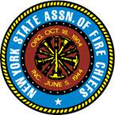

2025 Seminar Series, Short-Handed Firefighting
34 years ago, this class was developed by Firefighter Andrew A. Fredericks. At that time, the fire service was starting to suffer from a shortage of members, especially but not limited to the volunteer ranks. Today, as we all know, departments across the nation have experienced a large drop-off in membership. With today’s hotter, faster-moving fires, it is imperative that we get on the road ASAP and are ready to mount an aggressive interior attack – especially where life-saving attempts must be carried out. This class will look at new apparatus and equipment designed to make our jobs less labor-intensive. In many places, where it used to take one or maybe two departments to handle the job at a single-family residence, now up to six departments are necessary due our diminished ranks. We must protect our residents and, just as important, our members and make sure everyone goes home.
Mike Healy has been a member of the Rockland County fire service for 54 years, serving with the Blauvelt F.D. for 14 years, followed by the Central Nyack F.D. for 40 years. He has served as a chief for three terms. Healy is currently the coordinator of education for the Rockland County Fire Training Center. Jeff Daniels is a 23-year fire service veteran. He served with the Air National Guard as a crash rescue firefighter for 17 years and was a member of the West Haverstraw Volunteer F.D. for 14 years. In 2002, he was hired as a NYS DMNA firefighter and served for over four years before being appointed to the FDNY. Daniels was assigned to Ladder Co. 39 for 12 years and was later an instructor for the FDNY Fire Academy. Currently, he is a member of Squad 61. He also teaches at the Rockland County Fire Training Center.
Coming to These Counties in 2025 (7:00 p.m. Starting Time):
Cortland (October 28) • Erie (October 8) • Fulton (September 9) • Jefferson (October 15) • Monroe (September 30) • Nassau (November 5) • Niagara (March 12) • Oneida (September 24) • Onondaga (February 18) • Orange (April 29) • Otsego (September 15) • Rensselaer (October 20) • Rockland (April 23) • St. Lawrence (March 24) • Suffolk (April 2) • Westchester (September 3)
$35 – NYSAFC members • $50 – non-members (per person)
REGISTER AT THIS LINK: https://www.nysfirechiefs.com/2025seminarseries

ASSOCIATION OF FIRE DISTRICTS OF THE STATE OF NEW YORK
Coming Attractions:
- October 2-4, 2025, Thursday - Saturday, Annual Meeting and Vendor Expo at the Saratoga Hilton and City Center, Saratoga Springs
- October 8-10, 2026, Annual Meeting and Vendor Expo at the Saratoga Hilton and City Center, Saratoga Springs

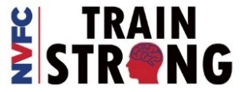
NATIONAL VOLUNTEER FIRE COUNCIL – TRAINING TIMES – COURSES/WEBINARS/EVENTS
LINK TO THE VIRTUAL CLASSROOM: https://virtualclassroom.nvfc.org/featured_courses

happen’n in the neighborhood

Harmony Corners Chicken Barbecue
Tickets available in advance, $16.00 per dinner
May 18th, Serving Ticket Holders between 3 & 6 PM
Drive through, take out only!
At the Harmony Corners Fire Station, Route 67, Charlton
Tickets available at: Mail N More, McConchie’s Campground, Nate’s Snowplow Repair, and Smith’s Pie Shop

Gansevoort Fire Department Breakfast
May 18th, at the Gansevoort Fire Station 1870 Route 32N, Gansevoort, NY
ALL YOU CAN EAT BUFFET! , Eggs made to order, omelets, pancakes, French Toast, scrambled eggs, bacon, sausage, biscuits with sausage and gravy, Fried Potatoes, toast, cereal, milk, coffee and orange juice.$12 adults, $10 seniors & military, $8 children 6-12.
ALSO: June 15th. The fire company thanks you for your support!!

Clifton Park Fire Department Breakfast
See you in October when we start up again.
general interest

Apparatus Innovations: Four New Innovations for 2025
Jeffery D. Gaskin
Backlogs at apparatus manufacturers still are causing extraordinarily long lead times. Rightly, manufacturers have concentrated on reducing the backlogs and improving delivery times, not on new rigs, generally.
On the other hand, product development programs that are in place at apparatus component and system suppliers seemingly are unhindered. In particular, four innovations that were on display at FDIC 2025 seem destined to put apparatus drivers and firefighters in better, safer circumstances.
CHASSIS-MOVEMENT DECREASE
After extensive research into certain fire departments’ problems with rear suspensions, Link Manufacturing developed the RespondAir heavy-duty air ride suspension. Designed specifically for fire apparatus, it’s available in single-axle (weight ratings of 30,000–35,000 lbs.) and tandem-axle (60,000–70,000 lbs.) configurations.
The RespondAir suspension is designed to be nontorque reactive, to reduce chassis movement during acceleration and braking.
The suspension’s V-Rod design provides greater lateral stability and reduces tail swing. The latter is a particularly useful feature on apparatus that have a long rear overhang.
The air system’s rapid-dump feature reduces an apparatus’ overall height, to make fitting vehicles into older firehouses that have a short bay door height easier. (Note: Always discuss this feature with your apparatus manufacturer’s engineers, because several variables must be considered when the system is discussed.)
Larger bushings than those that might be used on other suspensions distribute stress over an increased surface area to reduce maintenance and to lengthen service life, the company says. The RespondAir suspension is compatible with Dana and Meritor rear axle assemblies.
PUMP CONTROL CONFIGURATION
Fire Research’s ACE (Advanced Control Environment) multiplexed pumping system provides real-time control and automation of the fire pump, the company says.
Although the system (see photo on page 30) doesn’t replace the pump operator nor enable pump operators to leave their post, it allows departments to configure pump controls based on their operational needs. This streamlines pump operations and provides high levels of scalability and flexibility.
The ACE system can integrate a variety of valves, automate specific functions and enable full manual control of the pump. Furthermore, it protects against overheating, pump cavitation (formation and rapid collapse of vapor bubbles in a liquid) and pressure surges and can be used to manage discharge pressures, drafting and switching water sources. The goal is to improve safety and efficiency while protecting the pump.
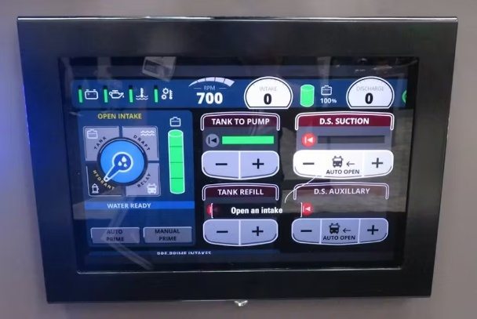
STREAM TARGETING
HEN Nozzles applied its blade capabilities to the newly designed Titan 1250 deck gun and Titan 500 turret. The open piping and electrical wires that typically are seen on master stream devices are built into the housing on these units, including about six inches of visible wiring to connect to the nozzle stream adjustment. The deck gun has an option to include a 2½-inch Turbo in-line throttling valve that allows the operator to adjust stream reach remotely or manually. According to the company, this modulates flow for varying distances, to allow an operator to target the stream without altering the deck gun elevation.
The deck gun and the turret are fully electrically operated, with built-in manual controls. The deck gun and allows 1,250 gpm. The 500-gpm turret mimics the deck gun in design and function. Also, the company is developing blade deck gun nozzles that will be compatible with existing manual and electric deck guns.
HANDWHEEL VALVE CONTROLLER
Innovative Controls is developing a new handwheel valve controller that will deliver a number of inventive design features. Smaller than that to which the fire service is accustomed, the controller will require less pump panel space. It will actuate either a cable or linkage that’s attached to the valve swing handle. Rotating the handwheel will retract or extend the linkage or cable, to open and close valves. By contrast, other handwheel actuators utilize a gear box that’s mounted on the valve. Built into the bezel assembly across the top will be eight LED indicators that show valve status: They display red when a valve is closed and green when it’s open. Although the indicators change their status one at a time, each pair will indicate one quarter of the valve’s movement. For example, two green lights will indicate that the valve is open 25 percent, four green lights will indicate that the valve is half open, and so forth.
laugh out loud!!

Why do banks leave vault doors open and then chain the pens on the counter tops?

Why is it that doctors and attorneys call what they do 'practice'?

classified employment opportunities

Greenfield Fire District is Hiring
The Greenfield Fire District is looking for a professional and highly-motivated person to perform a wide variety of functions relating to the material needs and possessions of the Greenfield Fire District. Must have good organization and communication skills, the ability to manage several projects simultaneously, and be flexible with work hours when necessary. Prior experience preferred and all candidates must have a clean driver’s license. Individuals residing within Fire District Boundaries preferred. Employment application and job description can be found on the district website at www.greenfieldfd.org. Applications, or cover letters & resumes, will be accepted until the position is filled, and should be sent to Joyce Petkus, District Administrator via email at Jpetkus@greenfieldfd.org or regular mail to Greenfield Fire District, P.O. Box 103 Greenfield Center, NY 12833.
CAFDA Officers and Directors
OFFICERS
President, Tom Rinaldi, Commissioner, Stillwater Fire District
1st Vice President, John Meehan, Commissioner West Crescent Fire District
2nd Vice President, Ellen Martin, Deputy Treasurer Clifton Park Fire District
DIRECTORS:
Les Bonesteel Commissioner Burnt Hills/Saratoga,
Fred Richards Commissioner Harmony Corners/Saratoga,
Joyce Petkus Treasurer Greenfield/Saratoga,
Ed Woehrle Commissioner Niskayuna #1/Schenectady
Art Hunsinger, Ex-Officio Member Clifton Park Fire District

APPOINTEES
Secretary Molly Jenkins, Region 1 Director, Assoc of Fire Districts, NYS
Treasurer: Tony Hill
Sargent at Arms: Tom Wood, Commissioner, Northumberland Fire District
Chaplain: Fred Richards, Commissioner, Harmony Corners Fire District
Legal Counsel: Greg Serio, Safety Officer, Verdoy Fire District
The Capital Area Association represents any fire district that wishes to join CAFDA. Fire District Officials include Commissioners, Treasurers, and Deputy Treasurers. Secretaries and Chiefs are also invited to participate!
Please advise your secretaries that all correspondence should be mailed to:
CAFDA PO Box 242 East Schodack, NY 12063
EMAIL TREASURER: TREASURER@CAFDA.NET
518-407-5020
EMAIL SECRETARY: SECRETARY@CAFDA.NET

Long Way to Travel? Zoom into the General Membership Meetings!
It’s our desire that every member fire district have the opportunity to attend Capital Area meetings. We know we cover a large area, in 8 counties and beyond, and wish to give all of our members a chance to participate in the general membership meetings. You have a voice, and we would like to hear it. Join us at our next meeting either in person or via Zoom. The link will be sent via constant contact prior to each general membership meeting. Thank you for being a member and we hope you will join us.
fire district resources - -the back page - - for you to follow up!

What are the duties and responsibilities of a Commissioner?
The Answer is posted on our web site at www.CAFDA.net

Capital Area BUSINESS PARTNER’S
Business Partner Applications Available At: WWW.CAFDA.NET
We invite our business partners to submit educational information to be included in this Bulletin for district commissioners and chief officers
We want to thank all of our Business Partners for renewing their partnership for 2025. You are invited to our monthly membership meeting and to any of our social events..
FIRE SERVICE LEGAL SERVICES


The D’Amato Law Group LLP
Gregory Serio, Partner
Alyssa B. Snyder, Partner
111 Washington Ave Suite 600
Albany, NY 12210
518.426.3800
Email: gserio@dlgny.com or
asnyder@dlgny.com
damatolawgroup.com
Monaco Cooper Lamme & Carr.PLLC
1881 Western Ave, Suite 200
Albany, NY 12203
Nicole Strippoli 518-941-9040
NSTRIPPOLI@MCLCLAW.COM
ttps://mclclaw.com

HANNIGAN LAW FIRM PLLC
388 Kenwood Avenue
Delmar, New York 12054
P: (518) 869-9911
F: (518) 869-9915
www.hannigan.pro
Fire/EMS –Municipal Law

Whiteman Osterman & Hanna LLP
Bond Counsel
Robert J. McLaughlin, Partner
One Commerce Plaza, Albany, NY 12260
518-487-7697 Cell 518-813-6333
mclaughlin@woh.com
www.woh.com
Ducharme, Clark & Sovern, LLP
Jack Clark, Fire District Attorney
646 Plank Rd. Clifton Park, NY 12065
518-373-1482
Ducharmeclark.com

FIRE STATION & FACILITIES ARCHITECTS AND ENENGINEERS


n.lobosco@ctmale.com

Architecture/Engineering/Code Services
Melissa Smith
Senior Marketing Manager
518-439-8235
4 British American Blvd
Latham, NY 12110
www.labellapc.com

Managed IT Services
Cloud Telephone Services


Ryan Sapienza
Project Manager/Technology Consultant
518-754-4623
Service 518-869-3614
930 Albany Shaker Rd, Latham, NY 12110


Architects & Engineers
433 River Street, Suite 8002
Troy, NY 12180
518-765-5105
Dennis Ross, Practice Leader
www.H2M.com

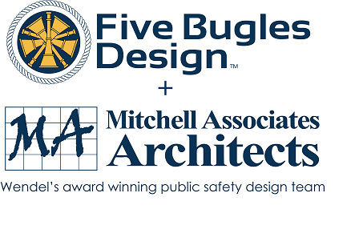
Wendel, Centerpointe Corporate Park, 375 Essjay Road, Suite 200, Williamsville, NY 14221 716.688.0766
Amy Numrich, MBA
Digital Marketing & Events Specialist
anumrich@wendelcompanies.com

Shawn Corp, Principle
15 Cider Mill Way, Saratoga Springs, NY
518.322.1386
www.reveal-ad.com

FIRE SERVICE INSURANCE


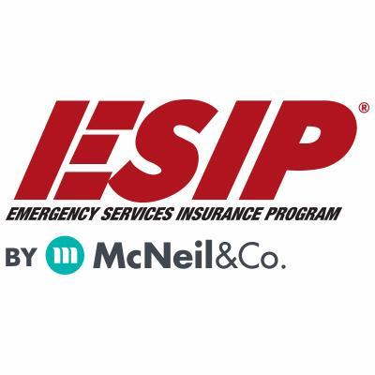
Tony Blackwell, Territory Sales Manager
800-822-3747 ext 530
ablackwell@mcneilandcompany.com

Roy Denny
Executive VP & COO
One Blue Hill Plaza – 16th Floor
PO Box 1609
Pearl River, NY 10965
845-352-8855x7099
Cell 845.608.4989
rdenny@fdmny.com
VFBL/Workers’ Comp Coverage

Haughey Insurance Agency
850 State Route 50
Burnt Hills, NY 12027
518-399-1583
www.haugheyagency.com


Pat Daglio
pdaglio@vfis.com
717.819.3072

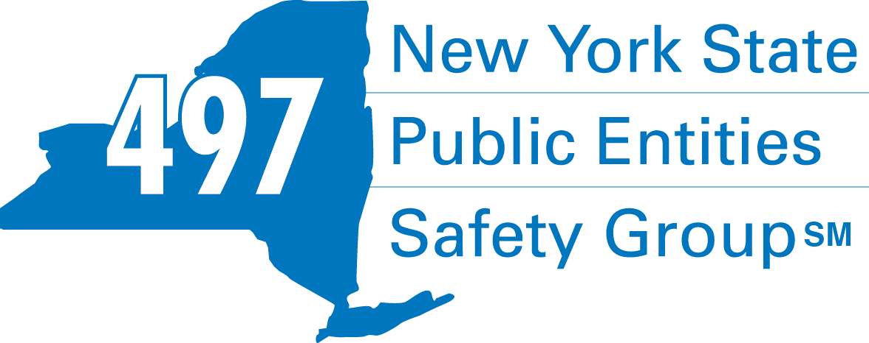
Fleury Risk Management
28 Corporate Drive, Suite 104
Clifton Park, NY 12065
518.478.6314
https://www.fleuryrisk.com/nysgroup497
VFBL Insurances Services

FIRE SERVICE FINANCIAL SERVICES AND LOSAP MANAGEMENT

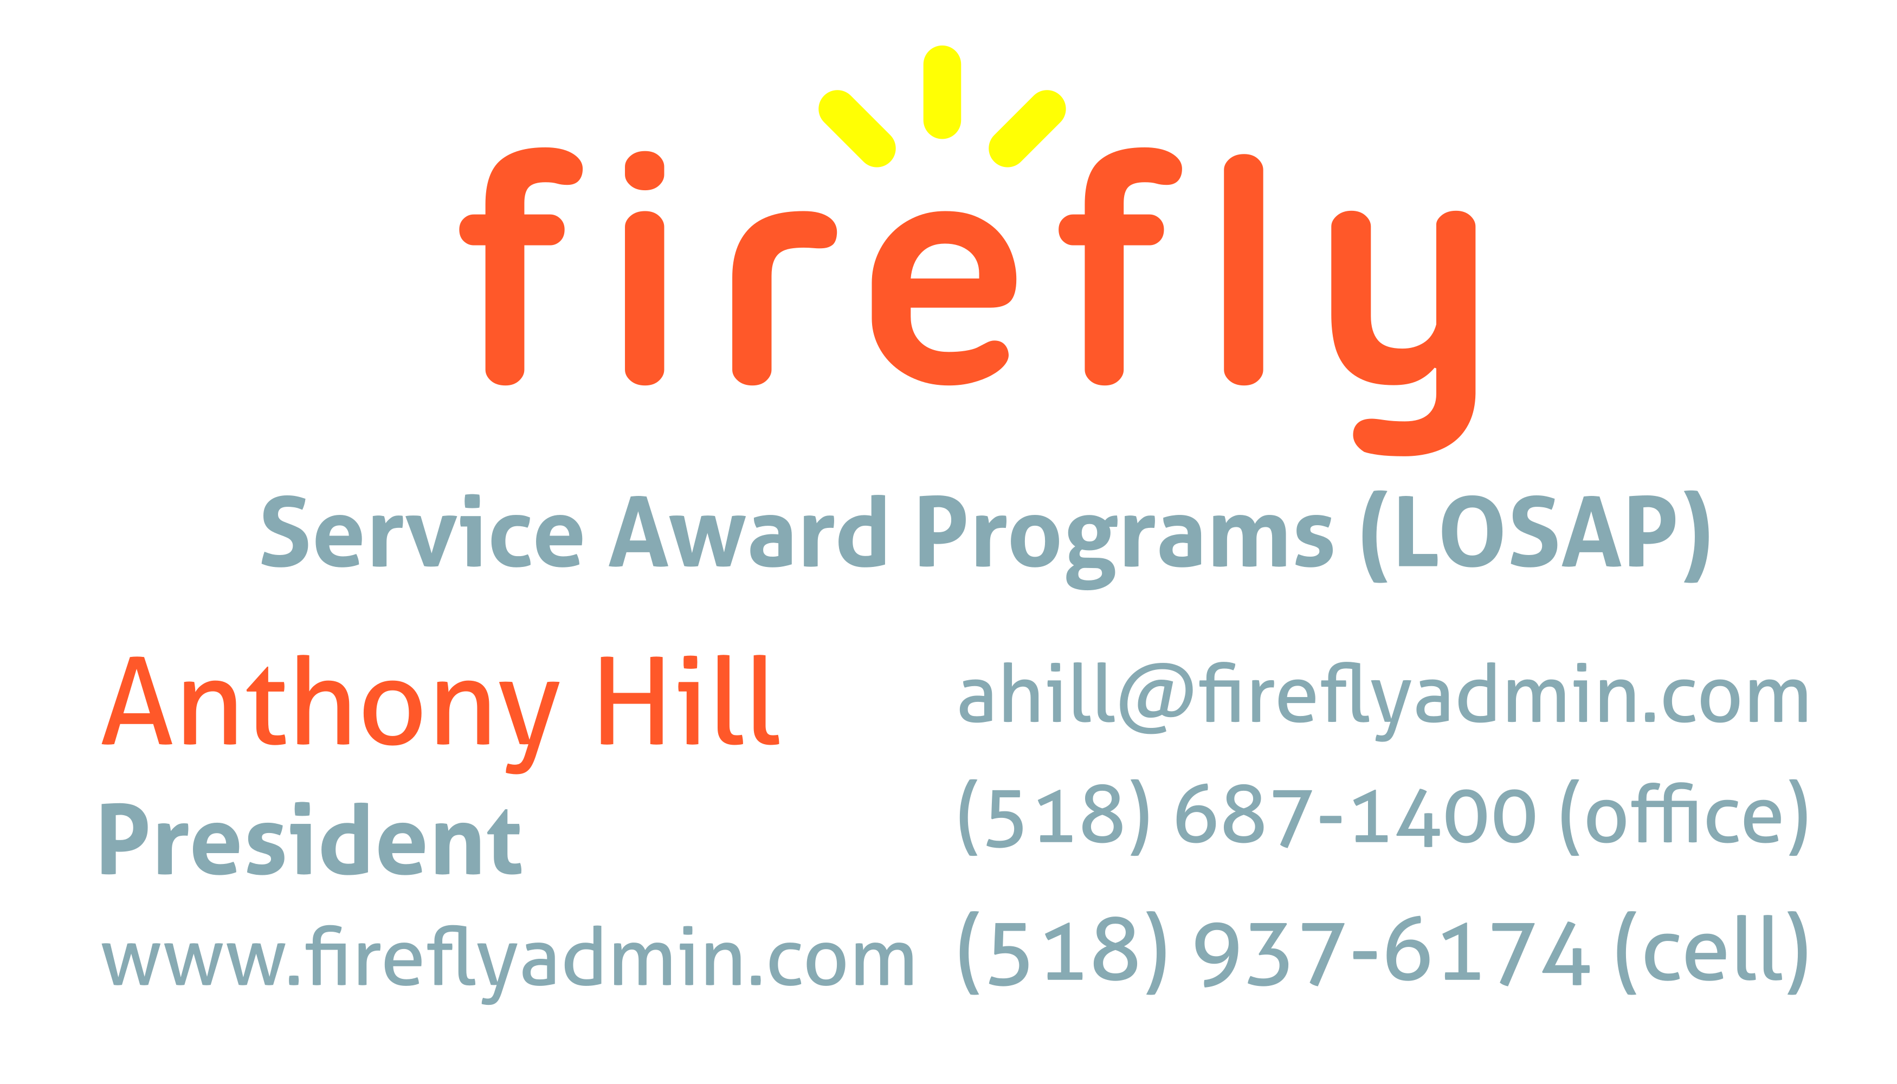

518-432-5087
838-433-7304 cell
www.thelosapgroup.com.
nikki.haskins@rbc.com
455 Patroon Creek Blvd, suite 200, Albany NY 12206
UBS Financial Advisors
Ralph Lemme, CFP
8 Southwoods Blvd Suite 207
Albany, NY 12211
518.445.1667

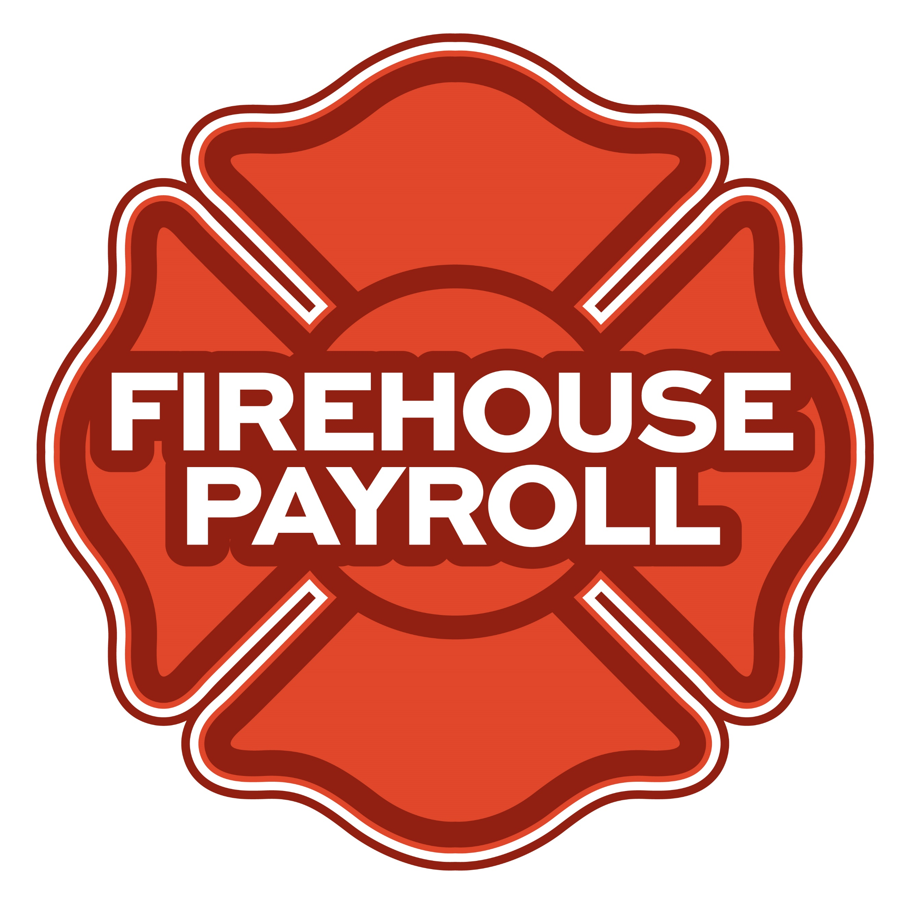
Jeremy Hartnett
302-483-7699
jeremy@firehousepayroll.com
payroll-pension reporting-tax filing
direct deposits-timekeeping-HR Services

Nicole Meeker
Manager of Business Development & Accts
518-394-7894
Cell 607-423-4811
www.penflexinc.com
nmeeker@penflexinc.com
DRYER VENT CLEANING
FIRE EQ TESTING
FULL-SERVICE FIRE EQUIPMENT


www.jeromefire.com
Breathing Air Comp Maintenance,
Air Quality Tests and Repairs
Russell Jerome
315-699-4533 Office
Ready Rack Extractor/Washers
Full Line of Fire Equipment
8721 Caughdenoy Rd, Clay, NY 13041
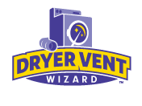DRYER VENT WIZARD
JORDAN CATINO
8 NAPA COURT, SCHENECTADY, NY 12309
518-344-0664
SARATOGADRYERVENT.COM
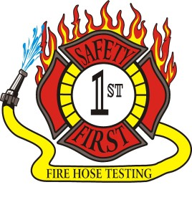Safety First Equipment Testing
99 Glass Lake Road
Averill Park, NY 12018
518-674-8363
www.safetyfirstfirehose.com
HOSE, APPLIANCE & LADDER TESTING
Safety1hose@gmail.com

FIRE STATION HVAC AND PLUMBING SERVICES
FIRE DEPT COMPUTER MANAGEMENT
FIRE STATION TELECOMMUNICATIONS

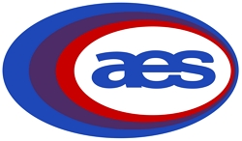
Alltek Energy Systems, Inc.
Construction-Fabrication-Power & Controls
Planning Service
24/7 Service
518-238-2600
Waterford, New York
www.alltekenergy.com
White Wolf Computer, LLC
4 Normanskill Blvd. Suite 410, Delmar, NY 12054
(518) 459-9653
Managed Services
Cloud Hosting Solutions
Telephone Data Cabling
Backup Disaster Recovery
Web Design Services
Telecommunications equipment supplier offering voice and data services, and IT and security systems.
930 Albany Shaker Rd. Suite 102, Latham, NY 12110
518-869-3571
www.Northeast-is.com

FIRE SERVICE LIGHTING SYSTEMS, REPAIRS, STRIPPING
FIRE COMPANY FUND RAISING
FIRE APPARATUS


Vehicle Repair, Warning Light Packages, Body Shop
78 Freemans Bridge Road, Glenville
518-377-5555
Veteran Owned Business
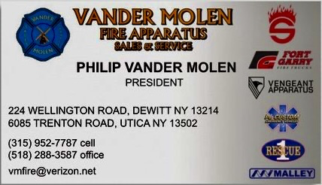
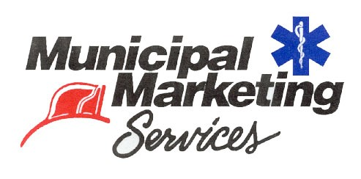
Lloyd Fox, Account Executive
34 Garner Road, Averill Park, NY 12018
Lfox8@nycap.rr.com
518-810-7819
www.funddrive.com

FIRE DISTRICT CPA/AUDITS/FINANCIAL SERVICES


Zoriana M. Stawnychy
973.283.0024
zoriana@stawnychyfinancial.com
135 Kinnelon Road Suite 101
Kinnelon, NJ 07405
Serving fire districts in New York State


Robert V. Gramuglia, CPA
1 Pine West Plaza Suite 107, Albany NY 12205
518.452.8055 or 518.859.5851cell
Email: rgramuglia@BGCPA.net


518-459-6700
10 British-American Blvd, Latham, NY 12110
www.bstco.com
Brendan Kennedy ext 356



Accounting, Consulting & IT Security
1581 Franklin Ave. Mineola, NY 11501
Kyle Brengel, Managing Partner
516-472-7345
kbrengel@gblny.com

11 British American Blvd, Latham, NY 12110
518-785-0134
Queensbury Office 518-792-6595
http://www.mmbaccounting.com
Alan W. Clink, CPA aclink@mmb-co.com
Heather R. Lewis, CPA hlewis@mmb-co.com

FIRE STATION PEST CONTROL


518-300-4732
431 New Karner Rd Suite 170
Albany, NY 12205
https://fox-pest.com/albany-ny

JOHN M. LESNIEWSKI
Assistant Vice President and
Senior Business Banking Officer
Fulton/Montgomery Markets
12 Fremont Street, Gloversville, NY 12078
P: 518.775-5205 | M: 518.848-0612
NMLS ID 915694
www.nbtbank.com
BANKING/FIRE SERVICE FUNDING SOURCES

David Farstad, VP-Municipal Banking
652 Albany-Shaker Road, Albany NY 12211
Ph: 518-730-3120
Cell: 518-506-0075
farstadd@pioneerbanking.com
Don McCormack
425 Main Street Catskill, NY 12414
www.tbogc.com
518.943.2600 X607
donaldm@tbogc.com
Specializing in Fire Service Financing

Ballston Spa National Bank
PO Box 70
Ballston Spa, NY 12020
Deborah JR O’Connor
518.363.8119
Deborah.oconnor@bsnb.com

The Weekly Capital Bulletin is reaching well over 650+ subscribed fire district members and now other members of the fire service on a regular basis.
This is a service of CAFDA through the effort of Tom Rinaldi who can be reached at tom@rinaldi1.com for comments and content contributions are always welcome.

BECOME A MEMBER OF CAFDA!
The Capital Area Association has voted to amend its By-laws to allow both individual and regional or county Fire District Associations to join. The updated By-laws are posted to the CAFDA.NET website.
Individual membership fee will be $50 annually, fire district association fees will be $300 annually.
Download THE APPLICATION available on the home page at CAFDA.NET
MEMBERSHIP IN THE CAPITAL AREA FIRE DISTRICTS ASSOCIATION (CAFDA)
Would you like to join Capital Area Fire Districts Association along with 100 members in 14 counties? Individuals, fire district associations, fire protection districts and Village departments are all eligible for membership.
Annual dues (January 1st to December 31st) shall be as follows and shall be based on the annual budget of the Fire District/Organization;
$0 to $200,000: $50
$200,001 to $400,000: $100
$400,001 to $600,000: $200
$600,001 plus: $300
Individuals $50.00 or Other County or Regional Associations $300 annually.
Business Partners: $100.00 annual member fee

If You, Your Fire District or Department is not a Member of CAFDA You Can be?
Individuals can be members of CAFDA. The annual membership fee is $50, which will provide you access to this Bulletin, attendance at meetings and social gatherings. Provides networking with other fire district officials and a source of the constant barrage of information related to today’s fire service.
FOR A MEMBERSHIP APPLICATION OR A BUSINESS PARTNER APPLICATION GO TO THE FOLLOWING LINK:
https://cafda.net/membership-info/
Capital Area Fire Districts AssociaTion
SAve the dates!
CAFDA has been busy, and 2025 is shaping up to be a great year!

commissioner training
AVERILL PARK FIRE DISTRICT | Saturday, February 1, 2025 Snow Date: Sunday, February 2, 2025
CLIFTON PARK FIRE DISTRICT | Saturday, March 1,2025 Snow Date: Sunday, March 2, 2025
BERKSHIRE FIRE DISTRICT | Saturday, March 29, 2025 Snow Date: Sunday, March 30, 2025
WARRENSBURG FIRE DISTRICT | Saturday, April 5, 2025 Snow Date: Sunday, April 6, 2025

OTHER training OPPORTUNITIES
FINANCIAL TRAINING FOR FIRE DISTRICT OFFICIALS | Fulton-Montgomery Community College Thurs-Fri. March 13-14, 2025 2805 State Hgwy. 67, Johnstown
FINANCIAL TRAINING FOR FIRE DISTRICT OFFICIALS | Brighton Fire District Tues–Wed. March 25-26, 2025 3100 East Avenue, Rochester
CAFDA CONFERENCE | Fort William Henry Hotel & Thurs-Sat. April 10-12, 2025 Conference Center, Lake George
ANNUAL FALL WORKSHOP | Verdoy Fire District Saturday, November 1, 2025 988 Troy-Schenectady Road, Latham

social events
OFFICER INSTALLATION DINNER | Century House, Latham Saturday, March 8, 2025
DAY AT THE RACES! | Saratoga Race Course, Saratoga Springs Friday, August 8, 2025

meetings – Clifton Park Fire District & Zoom
General Membership Meeting | 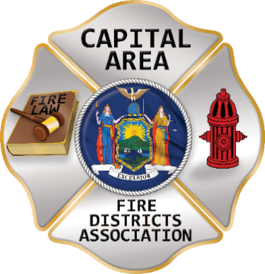  Saturday, January 4, 2025
General Membership Meeting | Thursday, February 13, 2025
General Membership Meeting | Wednesday March 5, 2025
Board of Directors Meeting | Thursday, April 3, 2025
General Membership Meeting | Thursday, May 8, 2025
General Membership Meeting | Thursday, June 12, 2025
Board of Directors Meeting | Thursday, August 14, 2025
General Membership Meeting | Thursday, September 11, 2025
General Membership Meeting | Thursday, October 9, 2025
General Membership Meeting | Thursday, November 13, 2025

for more registration information
Website | www.CAFDA.net

GO TO THE FOLLOWING WEB SITE TO REGISTER AND LEARN ABOUT CONFERENCE ‘25
https://cafda.net/event/cafda-conference-2/

Dave Denniston Reports on a Successful Visit to Washington, D.C.
Could not be prouder than to be part of the current team as we laid the foundation for groundbreaking collaboration between the US Secretary of Labor, OSHA, IAFF, and NVFC. We all agreed to roll up our sleeves and finish crafting the Emergency Response Standard. This new rule will be a labor of love that protects our mutual volunteer and career first responders with a standard that is reasonable, and both economically and technically feasible.
The passion in this room was unsurpassed and I am confident the group will leave a fire service for the next generations that is safer and better than the one we found. Thank you for all the hard work that got us this far and the work of additional others that will be invited to help us in this process moving forward.

The Latest Information in relation to the Proposed OSHA ER Standard
#1. Post Hearing Comments on Behalf of FASNY (control/click to open this document)
#2. April 2025 Proposed OSHA 1910.156 (control/click to open this document)
In an earlier post on the CAFDA.net web site the position of FASNY was misunderstood and incorrectly stated, to be clear it is FASNY's position that if and only if the Proposed OSHA ER Standard were adopted "as written" then volunteer firefighters should be exempt. A copy of FASNY's position on replacing the current standard are published with the thanks to FASNY's Legal Council Tim Hannigan. Please take the time to read it
(#1) Highlights of the April 2025 proposal is a wish list of negotiable items. Understand that since the comment period is OVER, these wish list items could only come to reality if the construct of the Proposed Standard started all over again.
1) Remove the incorporated by reference NFPA standards. Place appropriate wording directly into the rule itself. Reference the NFPA (and other) standards as industry best practices and encourage their use in the required AHJ policies and procedures.
2) Use the proposed rule below for combination and career departments with populations greater than 25,000.
3) For populations greater than 100,000 use the current OSHA proposal, the proposed standard below or a combination of the 2.
4) Develop a reasonable timeline to phase in the new rule
5) Require a periodic review of the new standard to ensure current best practices and technologies are incorporated.
It is unknown with the appointment of the new Labor Secretary what the next steps in this process are, we can only hope that reason and common sense will prevail.
It has also been learned that one of the creators of the proposed standard was employed by the IAFF as their health and safety person for 20 years.

OSHA Issued The Following Statement Regarding Its Emergency Response Rulemaking And Volunteer Emergency Responders:
OSHA’s rulemaking on Emergency Response is focused on providing long overdue protections to emergency responders. The agency has tremendous respect for both the work that emergency responders do and their unique role providing essential public safety services to every community in America. This statement describes the rulemaking’s applicability to volunteer responders.
On February 5, 2024, OSHA published the Notice of Proposed Rulemaking (NPRM), Emergency Response Standard. While OSHA does not directly cover volunteer emergency responders, some OSHA State Plans treat volunteers as employees under state law, which is how a federal proposed standard could affect volunteer responders in those State Plan states.
In the NPRM, OSHA preliminarily determined, based on the limited evidence available to it at the time, that the proposed rule would be economically feasible for volunteer organizations. OSHA had sought information about the potential impact of the rule on volunteer organizations, but it did not have sufficient evidence to show that the rule would be infeasible for these organizations.
Therefore, in accordance with the requirements of the Occupational Safety and Health Act of 1970, the proposal did not provide special allowances for the volunteer organizations that could be affected in some states. At the same time, the agency requested commenters’ input on whether the proposed rule would be feasible for these entities. OSHA received that input during the extended comment period from February 5, 2024 through July 22, 2024.
OSHA has received comments in response to the NPRM from many stakeholders, including volunteer emergency responders, fire chiefs, trade organizations, and members of Congress, which raise serious concerns about the economic feasibility of the proposed standard for volunteer fire departments. OSHA takes these concerns seriously. The comments submitted to the rulemaking docket provide crucial information that the agency did not have earlier in the rulemaking process. This new information will help the agency make the necessary determinations about whether the proposed standard is feasible for volunteer organizations.
OSHA is committed to taking steps in any final standard, consistent with the rulemaking record, to assess and minimize detrimental effects on volunteer fire departments. If supported by the record, this may include excluding voluntary emergency response organizations entirely based on these feasibility concerns.
[EDITOR’S NOTE: IN OTHER WORDS, YOU STILL NEED TO MAKE THE CASE AS TO WHY THIS PROPOSED STANDARD WILL NEGATIVELY AFFECT YOUR FIRE DEPARTMENT OPERATION!!!!]
While the initial comment period has closed, OSHA strongly encourages stakeholders to continue to provide information and data relevant to this question at the public rulemaking hearing scheduled to begin on November 12, 2024, and during the post-hearing comment period. Instructions for how to participate in the hearing are available on the Emergency Response rulemaking webpage, www.osha.gov/emergency-response/rulemaking. Once the rulemaking record is complete, OSHA will review all the information received and determine the appropriate approach to take with respect to volunteer organizations.
OSHA created an advisory committee working group to help the agency craft a proposed standard so that stakeholders would have a direct hand in the process. That working group included representatives from labor and management; career, volunteer and industrial responders; as well as several other important stakeholder communities. OSHA included both career and volunteer responders in the working group because some OSHA State Plans treat volunteers as employees under state law, and a federal proposed standard could affect both groups in those states. The agency’s intention has always been to work collaboratively with the emergency response community to find win-win solutions that ensure both responder safety and public safety.
[EDITOR’S NOTE: ALTHOUGH THE NVFC WAS REPRESENTED ON THE WORKING GROUP MANY OF THE PROPOSED CHANGES CAME FROM INDUSTRY AND LABOR, WITH MANY OF THE SUGGESTIONS BY OTHER MEMBERS OF THE GROUP BEING DISCARDED OR IGNORED! TIME FOR YOU TO GET ANGRY AND SPEAK UP.]

