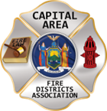
THE BULLETIN
April 4th, 2026

The Voice of CAFDA since 2004
Editor, Tom Rinaldi – tom@rinaldi1.com since 2014
When you see **, highly recommended article
ANNUAL CAFDA CONFERENCE
See additions to the schedule!!
Welcome to CAFDA Conference 2026!
We are excited to be able to offer you this LOCAL training opportunity right here in the beautiful Lake George area!
Should you have any questions, please contact Secretary@CAFDA.net

CONFERENCE DETAILS
CAFDA Conference 2026
Thursday, April 9 - Saturday, April 11, 2026
Fort William Henry Hotel & Conference Center
48 Canada Street, Lake George, NY

OVERNIGHT ACCOMODATION RESERVATION INFORMATION AT THE FORT WILLIAM HENRY HOTEL AND CONFERENCE CENTER
Room reservations are the responsibility of the Attendee*
Telephone Reservations only at 800-234-0267 or (Local) 518-668-3081
Group Code: CAFDA Conference
Rates: $154 Deluxe, $174 Premium/Grand
*If tax exempt, documentation (i.e. ST-129) must be presented at time of check- in

CONFERENCE SCHEDULE

NOTE: WE HAVE ADDED A PRESENTATION BY THE NYS DEPARTMENT OF LABOR – PREVAILING WAGE RATES
Conference Registration Fees:
CAFDA Members: $85/day/attendee (includes meals* as noted in above schedule) – OR –
$170 for full (3-day) conference.
Non-Members: $105/day/attendee (includes meals* as noted in above schedule) –OR –
$210 for full (3-day) conference.
Guest of Attendee: $30 per day for meals (includes meals* as noted in above schedule) - OR – $70 for full conference.
*Vendor Show & Cocktail/Dinner Reception also included if attending Friday

CAFDA Conference 2026 Schedule - UPDATED 4/3/2026
Day/Date NEW TIMES Topic/Event
Thursday, April 9, 2026 7:30 AM Registration/Breakfast
8:30 am - 9:45 am Best Practices for Social Media & Public Information Officers:
Art Hunsinger
10:00 am - 11:15 am The Legalities of Purchasing and the Procurement Audit
Érina Fitzgerald: Senior Attorney, OSC Division of Legal Services
Leslie Richard: Auditor 2, OSC Division of Local Government/School Accountability
11:30 am - 12:30 pm Understanding Prevailing Wage
Mark Sanford, Supervising Investigator, Dept. Of Labor
12:30 pm - 1:15 pm Lunch & Conference Welcome
1:15 pm - 2:45 pm Policies, Procedures, Guidelines and the Law - Sorting Them Out
Lee Price
3:00 pm - 4:30 pm Understanding and Navigating VFBL
Alex Dell, Senior Partner, Law Firm of Alex Dell
5:30 - 7:30 pm Holiday Inn Cocktail Reception sponsored by Amsure/VFIS/Quick Response

Friday, April 10, 2026 8:00 AM Registration/Breakfast
8:45 am - 10:15 am Leasing vs. Bonding
Robert McLaughlin
10:30 am - 12:00 pm The 6th Commissioner - Good or Bad?
Greg Serio, CAFDA Counsel, Amy Speach, BCSFD Secretary, AFDSNY Speaker
12:00 pm - 12:45 pm Lunch & Conference Welcome
12:45 pm - 2:45 pm Dealing with Disciplinary Issues; Mock GML 209L Hearing
Greg Serio, CAFDA Counsel
3:00 pm - 7:00 pm Vendor Show & Cocktail/Dinner Reception at the Lake George Holiday Inn

Saturday, April 11, 2026 8:00 AM Registration/Breakfast Begins
8:30 am - 9:15 am Tax Certiorari - What the Heck is it and How it Affects Fire Districts
Greg Serio, CAFDA Counsel
9:30 - 11:00 am Ask the Experts Panel
Greg Serio, Alyssa Snyder, Bob McLoughlin, Alex Dell
11:00 AM Conference Farewell!
REGISTER ON-LINE AT CAFDA.NET/CAFDA-CONFERENCE/
pay by credit card at: https://cafda.net/cafda-conference/
For payment inquiries, please contact Treasurer@cafda.net

Can’t attend the CAFDA Conference…
but want to hang with the vendors, meet new people,
listen to music and eat some great food?
“Vendor space is almost sold out”
The Details:
CAFDA Conference 2026
The Carriage House
Fort William Henry Hotel & Conference Center
48 Canada Street, Lake George, NY
Friday, April 10, 2026
3 – 7 pm
$30 per person (No Refunds)
(Includes entry to the show & bar/cocktail/dinner fare including carving stations)
Register and pay online at www.cafda.net

Registration w/Payment must be received no later than April 1, 2026
For Inquiries, please email Secretary@CAFDA.net
2026 CAFDA Conference Vendor Show & Cocktail/Dinner

BONUS EVENT!
Firehouse Mixer
Thursday, April 9th
5:30 PM – 7:30 PM
Lake George Holiday Inn
We’ll have a wide range of food available—so come hungry! Each attendee will receive two complimentary drink tickets, with additional drinks available via cash bar (cash only).
Beer will be $3 and cocktails $5.
We’ll also have door prizes from all three partnering companies throughout the evening.
Right outside the event space is TR’s Bar & Grill, and we’re working on confirming potential drink specials there following the event
Generously sponsored by Amsure Insurance
CAPITAL SHORT TAKES
- This week the fire service in Saratoga County morns the loss of someone who was larger than life itself, a friend, a teacher, a leader, a husband, a dad, a Chief. Lou Pasquarell Jr. may you rest in eternal peace, you were a legend and we were glad to know you. Our condolences to Lou’s family and to his fire service family.
- Be sure to read this week’s article on page 16, The Greatest Threat Facing the Volunteer Fire Service is Math
- Go to the last page of this document for Vendor Registration.
- We have a member looking for contact information on; “Who Services Your Fire Apparatus” in the hope of obtaining more competitive pricing. Please help out a fellow commissioner and let our friend from the north country know who services your vehicles, lgarsod25@gmail.com Thanks.
- See information on Prevailing Wage Rates and how they apply to Fire Districts on our website at CAFDA.net.
- At the CAFDA Conference ’26, the NYS-DOL will provide a presentation for attendees on the subject of Prevailing Wage Rates on Thursday Morning April 9th.
- We will keep working to both cut down the size but keep you informed.
- With the conclusion of Commissioner Training, CAFDA thanks all of the fire departments who provided training space and food to the participants. We’ll do it again next year.
- Remember NO BULLETIN on April 11th, see you in person at the conference.
TRAINING OPPORTUNTIES:

From CAFDA

Join us at the NEXT GENERAL MEMBERSHIP MEETING Thursday May 14th features dinner for attendees. Please join us.
ZOOM LINK FOR THE May MEETING at 7pm: https://us06web.zoom.us/j/86413237058?pwd=MauWziwckK2pyIWGVwYGUqxQLCwzHq.1

CAFDA IS HAPPY TO ANNOUNCE THE DATES FOR CONFERENCE ’26 IN HISTORIC LAKE GEORGE, go to CAFDA.net for on-line registration and credit card use.

April 9th, 10th and 11th, 2026 hope many of you plan on joining us, see the details on the last page.

CAFDA TRAINING AND EVENT DATES
Day/Date | Time | Type | Location | Notes
FY 2026
Thursday, April 2, 2026 | 7:00 PM | Board of Directors Meeting | Clifton Park
Saturday, April 4, 2026 | 8:00 AM | Commissioner Training | Warrensburg
Thursday, April 9 - Saturday April 11, 2026 | All Day | CAFDA Conference | Fort William Henry Conference Center | Lake George
Thursday, May 14, 2026 | 7:00 PM | General Membership Mtg. | Clifton Park
Thursday, June 11, 2026 | 7:00 PM | General Membership Mtg. | Clifton Park
July, 2026 | NO MEETING
Friday, August 7, 2026 | 1:00 PM | Membership Activity | Saratoga Race Course | NYRA Day at the Races!
Thursday, August 13, 2026 | 7:00 PM | Board of Directors Meeting | Clifton Park
Thursday, September 10, 2026 | 7:00 PM | General Membership Mtg. | Clifton Park
Thursday, October 8, 2026 | 7:00 PM | General Membership Mtg. | Clifton Park | Officers/Director Nominations
Saturday, November 7, 2026 | 8:00 AM | Annual Fall Workshop | Verdoy
Thursday, November 12, 2026 | 7:00 PM | General Membership Mtg. | Clifton Park | Officer/Director Elections
DECEMBER 2026 | NO MEETING
FY 2027
Saturday, January 2, 2027 | 9:00 AM | General Membership Mtg. | Clifton Park | Organizational/Morning Meeting
Thursday, April 8 - Saturday April 10, 2027 |  | CAFDA Conference ‘27 | Fort William Henry Conference Center | Lake George
Thursday, April 6 - Saturday April 8, 2028 |  | CAFDA Conference ‘28 | Fort William Henry Conference Center | Lake George

From Other Organizations

NYSAFC is Bringing Hands-On Training to Your Area!
FIRE BEHAVIOR ON THE INSIDE
REGISTRATION: https://www.nysfirechiefs.com/firebehavior
FLASHOVER
REGISTRATION: https://www.nysfirechiefs.com/flashover

Rural Water Supply Operations Seminar: Moving Big Water with No Hydrants
Pittstown Fire Dept, & the Rensselaer County Fire Chiefs Association
Saturday and Sunday, April 18th & 19th, 8:00am to 4:30pm
Pittstown Fire Dept. 134 Parker School Road, Johnsonville, NY 12094
For more information contact Pittstown Fire at 518-663-5773 leave a message or at car1station25@gmail.com

NYSAFC 2026 Seminar Series “Dangerous Spaces: Challenges and Tactics When Dealing with Garage and Basement Fires” With Chief/Commissioner Michael Lombardo (Buffalo Fire Department)
https://www.nysfirechiefs.com/2026seminarseries
Pre-registration is encouraged. On-site registration will be accepted if space permits.
Note: A 3% service fee will be applied if paying by credit card.
2026 Dates and Locations are available at the website for this series.
LEGISLATIVE HIGHLIGHTS

From Albany

The 2026 Issues of United Concern are posted on the CAFDA.net website.

Bill you don’t want to pass, just think how confusing this will be for poll workers
Bill A10817 introduced by Josh Jensen, who represents the 134th Assembly district, which includes the towns of Greece, Ogden, and Parma and the villages of Spencerport and Hilton in Monroe County.
AN ACT to amend the town law, in relation to requiring fire district elections occur on the same day as school board elections and require such elections be run by the county board of elections; and to repeal certain provisions of such law relating thereto.
- The county board of elections shall determine where the election takes place!!
- Polls shall be open from 7am until 9pm
- County BOEs will provide absentee ballots!
- Elections will take place in MAY!
- School district boundaries and fire district boundaries are not contiguous.
From Washington

See the Congressional Fire Services Institute at: cfsi.org
Educating Members of Congress About Fire & Life Safety Issues Since 1989
From Federal DOL/OSHA
See the latest from DOL/OSHA at CAFDA.net website.
FIRE DISTRICT FINANCIAL NEWS

Local Government and School Accountability Contact Information:
Phone: (518) 474-4037; Email: localgov@osc.ny.gov
Address: Office of the State Comptroller, Division of Local Government and School Accountability
110 State Street, 12th Floor; Albany, NY 12236

NYS-OSC Fire Service Audits
Woodbourne Fire District Audit Follow Up
Purpose of Review
The purpose of our review was to assess the Woodbourne Fire District’s (District) progress, as of November 2025, in implementing our recommendations in the audit report Woodbourne Fire District – Board Oversight (2023M-98), released in December 2023.
The audit determined that the Board of Fire Commissioners (Board) did not:
- Ensure the Treasurer/Secretary (Treasurer) maintained basic accounting records and reports or provided regular financial reports to the Board.
- Perform a thorough audit of all claims prior to payment
- Adopt realistic budgets or maintain reasonable levels of fund balance. The District’s December 31, 2022 fund balance was enough to fund nearly two and a half years of expenditures.
- Develop and adopt policies and procedures for the District’s financial operations, including controls for wire transfers, online banking, investments, procurement, travel and conferences, fund balance, reserves, credit card use and capital assets.
- Transparently set aside funds for future building and equipment needs.
The audit included 10 recommendations to help the Board improve its oversight of the District’s financial activities.
Background
The District provides fire protection and emergency services to the Town of Fallsburg in Sullivan County. The elected five-member Board governs the District and is responsible for its overall financial management and safeguarding resources. The Board-appointed Treasurer is the chief fiscal officer and is responsible for receiving, disbursing, transferring and accounting for all District funds and preparing financial reports.
Results of Review
Based on our limited procedures, the District fully implemented three recommendations, partially implemented four recommendations, and did not implement three recommendations. Until all recommendations are implemented, the Board cannot ensure District assets are fully safeguarded.
COMPLETE REPORT HERE:
https://www.osc.ny.gov/files/local-government/audits/2026/pdf/woodbourne-fire-district-2023-98-f.pdf

Plainville Fire District - Audit Follow Up
Purpose of Review
The purpose of our review was to assess the Plainville Fire District’s (District) progress, as of October 2025, in implementing our recommendations in the audit report Plainville Fire District – Board Oversight (2021M-91), released in October 2021.
The audit determined that the Board of Fire Commissioners (Board) did not:
- Adopt transparent or realistic budgets. Budgets underestimated transfers to reserves and overestimated appropriations.
- Adopt a fund balance policy or develop multiyear financial and capital plans.
- Ensure the Treasurer filed annual financial reports, for 2018 through 2020.
- Ensure the Treasurer’s records were audited each year, as required.
- Develop and adopt policies and procedures for the District’s financial operations, including controls for wire transfers, online banking, investments, procurement, travel and conferences, fund balance, reserves, credit card use and capital assets.
- Audit and approve all claims prior to payment when required. We tested claims totaling $289,700 and found claims totaling $41,300 were improperly paid prior to Board audit and approval.
The audit included eight recommendations to help the Board improve its oversight of the District’s financial activities.
Background
The District is in the Town of Lysander in Onondaga County. An elected five-member Board governs the District and is responsible for its overall financial management. The Board-appointed Treasurer is the chief fiscal officer and is responsible for receiving, having custody of, disbursing and accounting for District funds and preparing periodic financial reports
Results of Review
Based on our limited procedures, the Board fully implemented four recommendations, partially implemented three, and did not implement one. Until all recommendations are implemented, the Board cannot ensure District assets are safeguarded.
READ THE FULL REPORT HERE:
https://www.osc.ny.gov/files/local-government/audits/2026/pdf/plainville-fire-district-2021-91-f.pdf
THE FIRE CHIEF’S OFFICE

When flexibility undermines the chain of command
Zach Freiwald
In many government agencies and corporate environments, the word flexibility has become a euphemism for overextension, ambiguity and burnout. While intended to promote adaptability, its overuse often signals a breakdown in prioritization, decision-making and clear chain of command.
For long-time employees, being asked to “be flexible” can trigger frustration, anxiety and a sense of being undervalued or misused.
Let’s consider what this looks like at the 30,000-foot level as well as ground level — the real-world impact on firefighters.
The weaponization of “flexibility”
In practice, flexibility has become synonymous with vague directives like “do more with less,” often accompanied by buzzwords like leveraging, collaboration and cross-pollination. These terms, once meaningful, have been diluted through overuse. As a result, they now often signal a lack of direction rather than innovation.
This linguistic drift reflects deeper organizational issues: the inability to prioritize, the failure to make timely decisions, and the erosion of clearly defined authority. Employees are left to navigate a maze of competing demands without guidance on which path best uses their time and capabilities.
Real-world example: During preparations for a busy fire season, when I was already buried in fuels mitigation planning, readiness work and several ongoing projects, my supervisor added another slew of additional tasks to my plate and told me to “just be flexible with it.” I already track my workload in a spreadsheet that lists all major assignments, estimated work hours, and deadlines and according to that spreadsheet, and I could see that I was overbooked for nearly three months within that planning year. When I laid this out and asked which task I could postpone, hand off or drop to make room for the new assignment, I got a blank stare and a frustrated look in return. No direction, no prioritization. They simply walked away, leaving me with the pressure to somehow absorb more work without any guidance.
For a while, I tried to make it work, but the math didn’t change as I still didn’t have three extra months hidden somewhere. So I went back with a written breakdown — the spreadsheet, the hours, the timelines and the operational risks of continuing to overload critical tasks. That documentation finally forced the conversation that should have happened from the start. Two assignments were reassigned, deadlines were adjusted, and the remaining work was realigned so it fit within my capacity. Things improved not because I was “flexible,” but because I pushed for clarity and put real numbers behind the boundaries I needed to set.
How to reduce the impact: When told to “be flexible,” ask for specifics: Flexible in what way? Toward which goal? Push for clarity on expectations and priorities. If none is provided, document what you believe the priorities are and request confirmation. Use your calendar as a boundary-setting tool. Block time for core duties and protect it from vague or shifting requests.
THE BURDEN OF TEAM OVERLOAD
At one point in my career, I was assigned to as many as 15 different working teams on top of my regular duties. While the level of involvement varied, the top five teams alone consumed 25–50% of my weekly work time. That time commitment fluctuated with seasonal demands and project timelines, but the impact was consistent: I was stretched thin.
Two or three of those teams were arguably essential to my role, but even then, they often required the kind of sustained attention that should have been assigned to a dedicated specialist. The remaining teams, while less demanding, still required time and mental bandwidth, often without clear direction or prioritization from leadership.
Real-world example: A couple years ago, I was added to a growing list of internal teams as well as several short-term working groups that were supposed to require only “minimal input.” However, once I was actually in them, it became obvious that minimal input meant weekly meetings, document reviews, ongoing taskings and multi-step follow-ups. None of that was visible from the outside, and it was clear no one realized how demanding these teams actually were. Meanwhile, my core responsibilities kept stacking up.
Beyond the workload, what made this such a challenge was the quiet way the pressure built. No single assignment felt unreasonable on its own, and it would appear easy for others to assume I had room/time. Unfortunately, each new task chipped away at the margins, and I could feel myself constantly shifting between groups, trying to keep up while losing time for the core duties that keep the fire program functioning. It was not dramatic. It was a steady, creeping sense that the more I tried to stay ahead, the more the gap widened.
How to reduce the impact: Ask your supervisor to rank your team assignments or confirm which ones take precedence. If that’s not possible, track your time and show how much is being consumed by “team” work versus core duties, creating leverage for renegotiating commitments. Set limits where you can, and don’t be afraid to decline new team assignments unless something else is removed from your plate.
THE MYTH OF EQUAL PARTNERSHIPS
Working with external partners and cooperators is often framed as a strategic advantage — and it can be. But like any relationship, it requires time, trust and mutual investment. A good agreement is more than paperwork; it’s built on understanding what your partners are doing, how you can support each other, and what each party is realistically capable of.
The expectation that one person can maintain meaningful relationships with many partners is unrealistic unless time is specifically carved out for that purpose. Prioritization becomes essential but rarely is guidance provided on how to do it.
Real-world example: My program works with a wide range of partners, including state and municipal departments that share mutual aid, conservation and land management groups, federal cooperators, and even small volunteer agencies that operate around our area. On paper and without honest conversations, these relationships are treated as equally important. In reality, the level of involvement varies drastically.
The expectation is that I would actively maintain over a dozen of these partnerships. Some of them required in-the-field site visits, multi-agency pre-project walk-throughs, detailed reviews of proposals, and regular updates to ensure grant or agreement requirements were being met. Others needed me at monthly planning calls or wanted me to assist with their own fuels or readiness concerns. Management above me saw these as simple relationship maintenance tasks. What they did not see was that each of these partners expected meaningful time, steady communication, and follow-through on commitments.
The personal impact came from knowing these cooperators rely on me in real ways. I did not want to shortchange anyone, especially the partners who show up consistently during fire season. Still, with so many relationships treated as equal priorities, it became impossible to give the most critical ones the attention they deserved.
How to reduce the impact: Create a simple matrix of your partnerships: Who contributes the most? Who has legal or financial obligations? Who’s just a shared-interest group? Use this to focus your time on relationships that produce tangible outcomes. Communicate your bandwidth to both leadership and partners and be honest about what you can realistically support.
ROLE CONFUSION AND ANXIETY
Whether on internal teams or in external partnerships, role confusion is a persistent issue. It comes from all directions with unclear expectations from leadership, overlapping responsibilities, and ambiguous authority. This confusion creates anxiety and undermines both individual performance and team cohesion.
When roles aren’t clearly defined, people hesitate to act. They second-guess decisions. They worry about overstepping or underperforming. And in the absence of clarity, the chain of command becomes diluted, replaced by a fog of well-intentioned but poorly coordinated activity.
Real-world example: During the early planning stages for a multi-agency prescribed burn, I was asked to participate in an initial meeting and told my role would be to “support operations,” but that was not defined. The burn was planned for a piece of ground that was not in my jurisdiction, which made the lack of clarity even more noticeable. When the first planning meeting started, everyone had a different understanding of why I was there. Some people assumed I was taking the lead on operational pieces, even potentially to be the burn boss. Others believed I was present only as a technical advisor. A few believed I was supposed to help coordinate communication between the agencies involved. None of this had been discussed beforehand.
Because the roles were unclear, we never reached the original intent of the meeting. Instead, we spent the entire session sorting out who was responsible for what, who was deemed the lead agency, and whether additional personnel needed to be brought in to close gaps. Every time we tried to move forward, we had to pause and revisit basic questions about authority and expectations. It was impossible to make real progress until those foundational issues were addressed. This lack of clarity at the first step set the entire project on a tone of confusion and disorganization, and that feeling stayed with the group long after the first meeting ended.
How to reduce the impact: Clarify your role early. Ask: Am I here to lead, support or advise? Don’t assume, confirm. In meetings or emails, state your role explicitly: “As the operations lead, I’ll focus on ….” If no one is assigned as lead, suggest a rotating chair or designate someone to coordinate. Structure doesn’t limit flexibility. It enables it.
THE PATH FORWARD: RECLAIMING CLARITY
The solution isn’t to eliminate flexibility; it’s to use it with intention. That starts with spending the time to truly prioritize objectives, internal teams and external partnerships. It means defining roles clearly, setting boundaries and empowering people to focus on where they can have the greatest impact.
Define your non-negotiables — the parts of your job that can’t be compromised — and protect them. When asked to take on something new, ask: Does this align with my core duties? Will it displace something more important? Speak up early. Don’t wait until you’re overwhelmed. Raise concerns when the first signs of overload appear.
7 SITUATIONS WHERE “FLEXIBILITY” CAN UNDERMINE THE CHAIN OF COMMAND
To further put this into perspective, let’s review seven common situations where being flexible can quietly erode the chain of command — and what to watch out for:
- Ad hoc tasking without clear delegation: You’re asked to take on a new initiative but no formal authority is delegated. You start making decisions, only to be overridden later by someone higher up who wasn’t looped in. Why it matters: This undermines your credibility and creates confusion about who’s actually in charge.
- Cross-functional teams with no defined lead: You’re placed on a multi-agency or interdepartmental team with no clear leadership. Everyone is told to collaborate, but no one is empowered to make final decisions. Why it matters: Without a designated lead, decisions stall, accountability disappears, and the team becomes ineffective.
- “Flexible” reporting to multiple supervisors: You’re told you now report to several people depending on the project. Each has different priorities and none of them coordinate. Why it matters: You’re stuck in a tug-of-war, unsure whose direction to follow. This leads to burnout and poor performance.
- Role creep through “flexible” job descriptions: You’re hired for one job but told to “be flexible” about taking on unrelated duties, often without training, support or recognition. Why it matters: This leads to role confusion, inefficiency and resentment. It also dilutes your ability to do your core job well.
- Overcommitment to internal teams: You’re assigned to multiple internal teams, with no guidance on which ones take priority. You’re told they’re all important and expected to juggle them. Why it matters: Without prioritization, your time is fragmented, and your impact is diminished. Essential duties suffer.
- Partnerships without capacity or prioritization: You’re expected to maintain relationships with numerous external partners, but no time is carved out to do it meaningfully and no one tells you which ones matter most. Why it matters: You end up spreading yourself too thin, and key partnerships suffer while less critical ones drain your time.
- Informal authority in emergency situations: Someone outside the formal command structure starts giving orders under the guise of ‘just helping out’ during an incident. Why it matters: This creates safety risks, conflicting instructions, and a breakdown in incident command protocols.
FINAL THOUGHTS
Flexibility without structure isn’t a strength; it’s a liability. Clear roles, defined authority and deliberate prioritization are essential to maintaining an effective chain of command. But for the individual caught in the middle, the real challenge is navigating ambiguity without burning out. When leadership fails to set boundaries, it falls on you to ask the hard questions, seek clarity and protect your time. No one else will do it for you.
THE ATTORNEY’S OFFICE

HOT TOPIC

Click on this PDF to see notes from DOL related to Prevailing Wage Rates for Construction, Article 8
PREVAILING WAGE RATE NOTES OPEN THIS LINK:
https://cafda.net/information-on-the-nys-dol-prevailing-wage-rates-for-fire-districts/

Three Howe, TX, Firefighters Charged with Sexual Encounters with Junior Member
Sexual encounters with a junior firefighter have led to criminal charges against three Texas firefighters.
The alleged incident occurred in 2022 while the 16-year-old was a junior member of Howe Volunteer Fire Department. Two were placed on leave from their full-time jobs at the Allen and Irving Fire Departments while another resigned from the Melissa Fire Department hours before his arrest. Howe Firefighter David Perez-Glass, 33, is accused of sexually assaulting the underage girl repeatedly between January 2022 and January 2023. The incidents occurred at the fire station and a storage facility, charging documents revealed.
Court documents also revealed that when a Howe firefighter, a witness to the abuse, complained to officers about Perez-Glass' "inappropriate sexual advances" she was chastised for "jumping the chain of command." Howe Director of Public Safety Jake Sullivan wrote in a statement: "There was immediate attention and response" upon learning of the allegations..." The Howe Police Department turned the investigation over to the Texas Rangers.

New York Judge Restores Fire Company President Pending Hearing in Governance Dispute
Curt Varone
An Albany County Supreme Court justice has issued temporary relief in an Article 78 proceeding filed by Schuyler Heights Fire Company, Inc., its president Jeffrey Belschwinder, and former company president Elijah Jenkins against the Board of Fire Commissioners of the Schuyler Heights Fire District and the Schuyler Heights Fire District, in a dispute over disciplinary authority and control of fire company governance.
The petition, filed March 12, 2026, challenges a series of actions taken by the district and commissioners following disciplinary proceedings involving Jenkins. According to the petition, Jenkins had been removed as both a firefighter and as president of the fire company; barred from the fire company for three years; and stripped of his firematic rank of lieutenant. The petition further alleges that after Jenkins’ removal, Belschwinder—who succeeded him as company president—was suspended as both a member and president, and that the district then issued directives affecting how the fire company could conduct meetings, access records, and manage internal affairs.
The petition does not dispute that the commissioners have statutory authority over district operations, district facilities, volunteer membership approvals, and disciplinary proceedings where authorized by Town Law. Instead, the filing frames the dispute as a line-drawing question: whether the commissioners crossed from lawful disciplinary authority into control of matters reserved to the fire company as a separate not-for-profit corporation, including when and how meetings are conducted, the election of officers, and the maintenance of internal records.
Among the actions challenged are the disciplinary determination that removed Jenkins, a February 2, 2026 directive related to guests in the firehouse, a February 18, 2026 meeting and lounge policy, and a February 19, 2026 notice suspending Belschwinder. The petition asks the court to vacate those actions and declare that the district may exercise only those powers expressly granted by Town Law, General Municipal Law, and other applicable statutes.
The petition also alleges that the disciplinary determination against Jenkins was procedurally defective because, although a hearing was conducted under General Municipal Law § 209-l, the commissioners allegedly did not attend the hearing and instead adopted the hearing officer’s recommendation without independently reviewing the evidence.
In seeking emergency relief, the petition asserted that the commissioners’ actions had displaced the fire company’s elected leadership and threatened its ability to continue operating as an independent volunteer fire company.
On March 19, 2026, Justice Denise A. Hartman signed an Order to Show Cause with Temporary Restraining Order. The order restored Belschwinder to active membership and to his office as president of the fire company pending further proceedings. The order also provided that Acting Chief Engineer Kenneth Keefer, Sr. would remain in that role unless and until a subsequent election is held.
The court further ordered that Schuyler Heights Fire Company and its members are to have access to and use of the fire hall for fire company operations and governance, with official meetings to be held on the first floor of the fire hall. At the same time, the order specifies that nothing in it prevents the district from carrying out ordinary district operations, emergency response functions, or lawful statutory responsibilities.
The respondents were directed to file answering papers by March 30, 2026, with reply papers due by April 3, 2026, the date set for further proceedings in Albany County Supreme Court.
HERE IS A LINK TO THE ORDER:
https://firelawblog.com/wp-content/uploads/2026/03/903003_26_Schuyler_Heights_Fire_v_Schuyler_Heights_Fire__ORDER_TO_SHOW_CAUSE_42.pdf
Stay tuned for more to come!
POSITIVE OUTCOMES AND CHALLENGES FOR THE FIRE SERVICE

POSITIVE OUTCOMES
None identified this week.

FIRE SERVICE CHALLENGES

Communities file complaint against fire truck manufacturers in Green Bay federal court
Several communities across the country consolidated and filed a new complaint this month in federal court in Green Bay. They are seeking potential class action certification against fire truck manufacturers, including Oshkosh Corp. and its subsidiary Pierce Manufacturing. The city of La Crosse and the city of Milwaukee are among the 14 plaintiffs. The group alleges, since 2016, the manufacturers restricted supply, raised prices, and exchanged sensitive information to coordinate what it is calling a scheme. The defendants, including Oshkosh Corp., REV Group, and Rosenbauer, have all denied the allegations in previous court filings.

Brush Truck Catches Fire Inside MO Station
Firefighters in Cole County, Missouri, responded to heavy smoke and flames coming from a brush truck inside one of the bays at a fire station early Saturday, March 21, 2026, Russellville/Lohman Fire Protection District.
Fire Station 1, located on 5424 Route AA in Russellville, Missouri, serves as headquarters for the Russellville/Lohman Fire Protection District.
According to the district, apparatus inside the station were not immediately accessible due to conditions. An interior fire attack was initiated, and the fire was brought under control within 15 minutes. The fire district said there were no reported injuries.
“This station houses multiple apparatus, including engines, tankers, and brush units, along with training and administrative areas,” the district said. “All equipment will be thoroughly inspected to ensure it is safe for continued service.”
The Department Press Release:
“At 5:20 a.m. this morning, crews were dispatched to Fire Station 1 (5423 Route AA), which serves as headquarters for the Russellville/Lohman Fire District.
“Personnel arrived within five minutes to find heavy smoke and flames coming from a brush truck inside one of the bays. Due to conditions, apparatus inside the station were not immediately accessible.
“An aggressive interior fire attack was initiated, and the fire was brought under control within approximately 15 minutes.
“Automatic aid was provided by Cole County Fire. We appreciate their quick response and assistance on scene.
“This station houses multiple apparatus, including engines, tankers, and brush units, along with training and administrative areas. All equipment will be thoroughly inspected to ensure it is safe for continued service.
“All of the apparatus will be thoroughly inspected before being used. No injuries were reported.
“Due to the current situation, automatic aid is in place from surrounding fire departments to help cover the district with emergency calls. Thank you to all personnel for their rapid response and teamwork. We would also like to thank the Russellville Lohman Auxiliary and the outpouring of support from the community.”

Four Volunteer Fire Departments Abandon Mediation in Norwich (CT) Fire Dispute
The Yantic, Taftville, Laurel Hill and Occum volunteer fire departments announced Thursday that they will not move forward with mediation efforts to resolve the two lawsuits they’ve filed against the city.
Justin May, the spokesperson hired by the four departments amid their ongoing feud with the city, released a statement Thursday afternoon on behalf of the departments.
The statement said despite the departments’ best efforts, the city, led by City Manager John Salomone and City Fire Chief Sam Wilson, has not come to the table in good faith, and has not presented any meaningful solutions for the volunteer departments and Norwich taxpayers.”
Since the shutdown, the city department has been operating a makeshift substation in Yantic at the 50 Clinton Ave. Public Works garage, staffed at all times by two paid firefighters and a paid lieutenant, who stay in a trailer in the parking lot. The cost of the substation is estimated at $100,000 a month.
FIREFIGHTER HEALTH AND SAFETY – PROTECTING OUR OWN
Due to the Govt shut down, no new stats this week!
In 2025 we experienced 78 LODDs reported nationally.!

FIRE SERVICE FATALITIES OR DIBILITATING INJURIES
- Mt. Morris Township, MI, Fire Chief Seriously Injured in Ambulance Crash. Fire Chief Elmer Wilson, who suffered multiple back and neck fractures, has a long road to recovery. The ambulance was hit by a Chevrolet Silverado that failed to stop at a stop sign, according to Michigan State Police. After spinal surgery, he was placed on a ventilator after suffering a collapsed lung and pneumonia.
- A firefighter was hospitalized Tuesday afternoon after crews rescued a man from a fire at a large home in Agawam, MA, according to fire officials. He is in stable condition as reported by the hospital.

FIRE APPARATUS ACCIDENTS
- Another Byron Township, MI, Fire Rig Struck on Highway. A tanker hit on an interstate in February remains out of service, while the Byron Township vehicle struck this week was damaged. Both incidents had things in common -- no firefighters were hurt and the civilian drivers were suspected of being under the influence of alcohol.
- One person was transported to a hospital after a crash involving a fire truck and an SUV in Batavia, Ohio on Thursday afternoon. According to OSHP, the fire truck was preparing to turn its lights on to be dispatched, when the SUV went in front of the truck, leading to the crash.
- Nashville, Tennessee, firefighter was hospitalized after suffering a medical emergency while driving Fire Engine 36 crashing into a chiropractor’s office. The apparatus was returning from a call when the driver swerved off the road into a shed, through a telephone pole, then crossed both lanes of traffic, the report said. The engine hit two parked cars before coming to a stop inside the building. The injured firefighter was taken to Vanderbilt Hospital. He is in good condition and is expected to make a full recovery.
- A North Patchogue Fire Department truck and a Mercedes were involved in a crash in East Patchogue on Thursday morning, Suffolk police said. The fire truck was traveling, with lights and sirens activated, when a 2001 Mercedes, being driven by an 88-year-old North Patchogue woman, tried to make a left-hand turn in front of the apparatus causing the vehicles to collid, according to police. No one was hurt

FIREFIGHTERS FALLING THROUGH
- A Livonia, MI firefighter fell through the floor of a home while battling a fire which began in the basement and fortunately the firefighter was not seriously injured.
THE LATEST ON THE CHANGING FIRE SERVICE

**Power struggle in volunteer firefighter ranks
Randi F. Marshall - Newsday Opinion Piece
Political power struggles aren't uncommon for New York State.
But the latest battlefield may seem a bit unusual.
Volunteer firefighters have long said they've seen a reduction in their numbers over the last two-plus decades. Even now, everyone seems to agree that there's a problem, as the number of volunteer firefighters has fallen from 120,000 to about 80,000 in the last 25 years or so. But the extent and seriousness of that problem — and how to solve it — remain areas of enormous disagreement even among the various associations that include volunteer firefighters as their members. And now, it's spilling over into the internal politics of those organizations — and onto the political stage in Albany, too.
It's even impacting the upcoming elections for the volunteer firefighters' largest association — the Firefighters Association of the State of New York, or FASNY.
Earlier this month, some fire chiefs, commissioners and coordinators held an "emergency" news conference in which they called the situation "a historic collapse in volunteer firefighting staffing [that] has created a public safety crisis." They're seeking "nominal compensation" that, they say, should be up to the individual fire districts to determine and dole out.
Among the groups behind that effort: The Association of Fire Districts of New York, the New York State Association of Fire Chiefs, the New York State Fire Coordinators Association and the Long Island Firefighters Legislative Committee.
Missing from that coalition, however, is FASNY, which has about 40,000 members statewide.
"People need to understand one fundamental thing: There is no public safety crisis in the state of New York, no matter where you are," FASNY secretary John D'Alessandro, who serves as a volunteer firefighter, told The Point. "That's not to say there are not departments around the state, on Long Island and everywhere else that could use more people. But ... there's been the creation of a public hysteria that the volunteer fire service is in collapse. The data does not show that and it's not helping to solve the recruitment and retention problem."
But Ralph Raymond, the Association of Fire Districts' second vice president and a commissioner with the North Massapequa Fire District, said the downward volunteer trend is "alarming."
Beyond arguing over just how concerning the issue is, the fire leaders also disagree on how to address it.
Raymond and his coalition are advocating for legislation in Albany that would give fire districts the option of providing nominal compensation, giving each district the discretion to determine how to divvy out such funds — and how much to give.
"I think it would be irresponsible for me to put guidelines on it," Raymond said. "I think it's irresponsible for an organization to dictate a program and more or less shove it down the throat of a fire district and tell them how to run their program. If you leave it up to the fire district, they'll do what's best for their district."
But D'Alessandro said he's worried that smaller districts could suffer under that proposal, instead recommending that the state establish a fund, with adequate auditing and checks and balances.
"If we provide nominal compensation, it has to be done equally and equitably across the state of New York," D'Alessandro said, noting that some departments wouldn't be able to afford such compensation on their own. "We can't do it in a way that creates the Wild West where bigger departments are going to start gobbling up smaller departments."
The disagreement is leading to a potential fight for FASNY's leadership positions, some of which will be up for election this summer. Until now, sources said, there's been a "gentleman's agreement" that those who held a position in one of the other organizations wouldn't run for a top FASNY role, because it could create conflicts of interest. And usually, there's not even a competition for the seats, as there's typically a line of succession where the first vice president tends to run for president, while the second vice president runs for first vice president, and so on. But for the first time in recent memory, multiple officeholders in the other dissenting groups have requested a nominating petition for a FASNY position. To run, they'd need to garner 25 signatures of FASNY members.
Raymond told The Point that he was among those who requested a petition, but has since decided not to run.
And Raymond said he's still hoping to find common ground with FASNY in the broader effort to spur volunteer firefighter retention and recruitment.
"I still would love them to jump on board with us and help us, and create ways to fund it and policies and procedures to make it better," Raymond said. "I still welcome it."
Meanwhile, the fight is playing out in Albany, where multiple bills attempt to address the volunteer retention issue. Member of Assembly Michaelle Solages told The Point she has sponsored legislation to allow nominal compensation that's handled by the districts, adding that appropriate audits and guardrails would be in place.
"I'm trying to find a solution," Solages said. "This is getting to a crisis level, and we don't need longer wait times or a fire to happen without a response. We've got to fix this. I truly think we can incentivize people to volunteer or donate their time. I think we need to use every tool in our toolbox in order to solve this."

Lawrence, NJ Firefighters Will Now Be On Duty 24/7; Here’s What’s Changing
The Lawrence Township Fire Department will expand its weekday staffing to around-the-clock coverage beginning in April, township officials said.
Effective April 13, career firefighters will be on duty Monday through Friday, 24 hours a day, replacing the current schedule of 8 a.m. to 4 p.m.
The change is designed to strengthen emergency response and ensure consistent fire protection during weekdays, according to the township.
Volunteer firefighters will continue to staff weekend shifts and will remain available seven days a week, 24 hours a day, responding to emergencies and supporting fire operations alongside career personnel.
Public Safety Director Chris Longo said the department’s career staff is trained and prepared to respond to a wide range of emergencies, and emphasized that the transition does not diminish the role of volunteers.
“The Township greatly values the service of our volunteer firefighters and sincerely appreciates their dedication and commitment to protecting our community,” Longo said.
FIRE APPARATUS

Frame Corrosion Service Guide
The Fire Apparatus Manufacturers’ Association (FAMA) has produced a series of Buyers Guides and Service Guides designed to educate an apparatus committee on available products and technologies without going into details on a specific brand or manufacturer.
The Buyers Guides and Service Guides are all available for free download at www.fama.org under the Fire Service Resources area.
TC080 Service Guide-Frame Corrosion is a practical handbook that explains why fire apparatus frames rust, what makes corrosion worse, and—most importantly—what departments can do to prevent expensive and sometimes dangerous damage. Fire trucks work in environments that are much tougher than most people realize. They’re constantly exposed to moisture, road grime, and chemicals, especially during the winter. Over time, all of that takes a toll on the metal frame underneath the truck. This guide breaks down these issues in a straightforward way and provides clear advice on how departments can stay ahead of corrosion rather than reacting to it after the fact.
The guide begins by explaining what corrosion actually is. In simple terms, corrosion is metal breaking down because of a chemical reaction with things in the environment— mainly water, oxygen, and salts. There are a few different types of corrosion, and understanding them helps crews recognize what they’re seeing under the truck.
- Galvanic corrosion happens when two different metals are touching and are also exposed to moisture or salty water. One metal becomes the “donor” and deteriorates faster, almost like a sacrificial lamb. Many people are familiar with this concept from water pumps with sacrificial anodes that intentionally corrode instead of letting more important components be damaged.
- Uniform corrosion is more evenly spread out over a surface-classic rust on steel rails, for example.
- Localized corrosion, such as pitting, is sneakier. It creates deep, concentrated pockets of damage that may not be visible at first glance, making it one of the more dangerous forms.
A major theme in the guide is the role road chemicals play in speeding up corrosion. For decades, road crews mainly used regular rock salt (sodium chloride) for melting ice. It wasn’t great for vehicles, but it was predictable. Over the years, though, states and municipalities have shifted to more potent chemicals like magnesium chloride and calcium chloride. These chemicals work better in low temperatures and melt ice faster-but from a corrosion standpoint, they’re bad news. Unlike rock salt, which tends to sit on surfaces, magnesium chloride and calcium chloride soak into tiny gaps and crevices. Once they get inside these spaces, they stay active for a long time and reactivate whenever they encounter moisture, even just humidity. That means a truck might drive through treated roads in January and the chemicals could still be eating away at the frame months later. For departments near the coasts, airborne salt creates a similar problem all year long.
Because the environment is so tough on apparatus, the guide strongly recommends that departments consider corrosion protection when ordering new trucks. One of the best ways to protect frames is through hot-dip galvanizing. In this process, the frame rails are dipped into molten zinc, which bonds to the steel and forms a protective layer. The zinc itself corrodes before the steel does, creating a long-lasting barrier that stands up well to moisture and salt. Some departments also choose to add a topcoat over the galvanized metal for extra protection. Another option is polyurea coatings— similar to what’s used for truck bedliners. These coatings create tough, impact-resistant layers that help protect against road debris, which can chip paint and expose bare metal. The more protection you can build into the frame from the start, the fewer problems you’ll face later.
Even with the best protective coatings, though, regular cleaning is absolutely essential. The guide emphasizes that corrosion often starts not because of catastrophic exposure but because chemicals stay on the frame too long. To combat this, fire departments need a consistent cleaning schedule. During winter months, the recommendation is to wash the undercarriage after every storm where deicing chemicals were used and at least every 10 days regardless of storms. Departments near oceans should wash every 15 days all year long. Conduct an initial rinse to knock off the heavy buildup, applying a mild detergent and then thoroughly washing with warm water. The wash should focus on areas where chemicals tend to hide—between frame rails and liners, around suspension brackets, and at the connection points of cross members. A surprising but important point is that some flaking or peeling of paint during cleaning is actually helpful. That peeling paint can hide moisture and salts beneath it, so removing it exposes the true surface and lets you deal with the real problem.
After washing, the apparatus must be dried thoroughly. Moisture trapped in crevices can create the perfect environment for corrosion to continue. Using compressed air or an electric blower can dramatically speed up the drying process. The guide also recommends using water-displacing products like WD-40 in areas where moisture tends to collect. These products push out water and lay down a thin protective layer. Crews must avoid spraying lubricants on brake components or sensitive plastics, but for most metal surfaces, this step offers inexpensive and effective short-term protection.
If corrosion or coating damage is noticed during a wash, the guide explains how departments should address it. The basic repair process includes cleaning and drying the area, sanding or blasting the rust down to clean metal, applying a rust-preventing primer, and then adding a finish coat. Once the paint dries, an undercoating—whether soft film, oil- based, or polyurea—can be applied for protection. These repairs are not complicated, but they do need to be done correctly and promptly. Ignoring small spots of corrosion allows them to worsen quickly, especially in environments with regular exposure to salts.
Sometimes corrosion goes beyond just surface issues, and the guide provides criteria for more serious assessments. If frame metal loss is suspected, the guide recommends cleaning the area thoroughly and measuring the thickness of the steel using calipers or ultrasonic gauges. This measurement is compared to the original thickness to determine how much material has been lost. If the loss is under 33%, the frame usually can be treated and reprotected without structural reinforcement. However, if loss exceeds 33%, repairs become more involved. At that stage, the guide recommends installing fishplates—essentially steel reinforcements bolted to the damaged area— to restore strength. The type of fishplate and its placement depend on whether the damage affects the frame flange or the web. In cases of extensive corrosion, contact the apparatus manufacturer for guidance on whether the frame can be safely repaired or if replacement is necessary.
Corrosion will always be a threat, but it doesn’t have to become a crisis. With proper planning during apparatus specification, regular cleaning routines, and prompt repairs when damage starts to show, departments can significantly extend the life of their apparatus frames. Staying on top of corrosion isn’t glamorous work, but it’s essential for safety, reliability, and controlling longterm costs. The TC080 Service Guide-Frame Corrosion helps departments stay ahead of the problem rather than reacting to it after the damage is already done.
The FAMA Service Guide on Frame Corrosion was prepared by the FAMA Chassis Subcommittee.

THE BUILDING AND FIRE CODE ISSUES – WEEKLY REPORT ON FIRE FATALITIES
The New ICC Code-NYS Edition went into effect on December 31st 2025 although the implementation of the energy code provisions have been withdrawn until further notice.
WITH THE SHUT DOWN OF DHS, STATS FOR THIS WEEK HAVE NOT BEEN COMPILED
GREEN ENERGY AND THE IMPACT ON THE FIRE SERVICE

More than 6,000 gallons of water used in EV fire at New Hampshire toll plaza, firefighters say
After an electric car crashed into the Bedford tolls and burst into flames Tuesday, fire departments in New Hampshire said they have several methods to handle EV fires.
Officials said each fire is handled on a case-by-case basis, depending on the best fire suppression method. Litchfield Fire Chief Doug Nicoll said there were roughly 8,000 battery cells underneath the vehicle involved in Tuesday’s crash.
Nicoll responded to the Bedford fire and said his department is still working to determine the best ways to contain and extinguish EV fires.
“They used a fire blanket yesterday. There are pros and cons to everything,” Nicoll said. “The fire blanket worked. However, there are also other methods, like using copious amounts of water.”
After the fire blanket was applied, the vehicle was removed to Bailey’s Towing auto yard in Merrimack. Officials said the wreckage and batteries could continue burning for several weeks. In the meantime, the blanket remains on top of the car.
NEIGHBOR’S HELPING NEIGHBORS, thank you for your support!!

Gansevoort Fire Department Breakfast
Sunday April 19th Breakfast will be served starting at 8AM

Clifton Park Fire Department Breakfast
Next Breakfast in April 12th from 8 to 11am

Speigletown Fire Department Breakfast 2nd Sunday of each month
Sunday April 12th from 7:30 to 11:30, $10 adults, $5 children, under 5 free.

Cancer Benefit Firefighter’s Ball
The Saratoga County Fire Officer’s Association is sponsoring a benefit to create a cancer fund to assist firefighters in Saratoga County. The Ball will be held on May 9th location TBA, to include finger foods, music and a cash bar all for a donation of $30 per person. Sponsors are needed.
GENERAL INTEREST TO ALL

Donations of Used AED Equipment Needed
" If any department is moving to surplus AED equipment, Greg Serio from Verdoy FD would like to inquire about a donation of that equipment to a program in which he is involved in the Dominican Republic. The Dominican Dental Mission Project provides dental care for Dominicans in rural and mountainous regions of the country each summer and Chief Serio serves as technical and emergency medical support for the dentists and volunteers of the program. The region where the DDMP operates--the province of San Jose de Ocoa--already has a connection to the American fire service as an engine from the Hazleton, PA FD was donated to the Ocoa FD through a Dominican FF who serves on the Hazleton department.
If anyone has equipment that is still in good working order, he asks that you reach out to him by calling/texting to 518.365.9242. Thank you for your support of this worthwhile project."

This is a must-read article and then you will start to understand the real issue, it’s not you!!!

****The Greatest Threat Facing the Volunteer Fire Service is Math, Not Recruitment
Mark Lambert
KEY TAKEAWAYS
- Volunteer fire departments have seen a 25% decline in membership since 1984, while call volumes have tripled.
- The traditional small-town volunteer model is misaligned with modern demands, including all-hazard responses, and EMS responsibilities.
- Expanding regional responses and mutual aid increase complexity, making trust and cohesion harder to maintain among volunteers.
The greatest threat facing the volunteer fire service may surprise many people. It is not recruitment. It is math.
It is the simple arithmetic of fewer available people against ever-rising demands. The numbers are stark: according to the NFPA, the United States had nearly 898,000 volunteer firefighters in 1984, the first year the agency began tracking the figure. By 2020, that number had fallen to approximately 677,000, a decline of more than 25 percent, while the U.S. population grew by 40 percent over the same period. The number of calls that fire departments respond to each year have tripled since the 1980s. That is not a motivation problem or recruitment problem. That is math.
The volunteer fire service is labor model built for a society that no longer exists: a society without long interstate commutes, dual-income households, non-stop service economies, EMS-heavy call volumes, mandatory credentialing, and the expectation that small-town departments will function as all-hazard emergency response agencies.
We keep talking as if the crisis is motivational, but I believe strongly that it is not.
The easy explanation is that young people simply do not want to serve. Every generation judges the next, and I understand the temptation. But the central problem is not a moral failure of the younger generation. It is that the system they are being asked to join has become structurally misaligned with the world they live in. They may want flexibility, clearer pathways, and organizations that respect their time, and they are not wrong to want those things. But even a perfectly welcoming fire department cannot overcome a system level labor shortage combined with expanding mission demands.
The volunteer fire service was born in a different America. Benjamin Franklin’s Union Fire Company, the model that seeded the proud tradition of the American volunteer firefighter, was formally established in Philadelphia in 1736. It was local, small, and rooted in a world where work and home were close together, labor was community based, and neighbors could reasonably be expected to drop what they were doing and respond. Franklin intentionally limited membership, perhaps to keep the organization local and effective, suggesting an intuitive understanding that organizations work best when they remain human in scale.
That model worked. It worked for a very long time. In parts of America, it still receives that deep respect. Volunteer firefighters protected communities for generations, often with little recognition and less money. They did not fail the country. The country changed around them.
Through the 19th and 20th centuries, more was assigned to the fire service. What was once primarily a community fire brigade became, in many places, an all-hazards emergency response agency. Downed trees, vehicle crashes, EMS assists, hazardous materials, wildland incidents, technical rescue and traffic control. Following the Sept. 11 terror attacks on the United States, the fire service adopted homeland security command systems. To maintain the ability to volunteer, firefighter have increased training requirements. Departments themselves require credentialing, compliance, documentation and there is insurance pressure. All of that continued to expand while the supply of local volunteer labor shrank.
The EMS shift alone tells the story. Survey after survey of volunteer departments shows EMS calls now vastly outnumber fire calls, often by ratios of two or three to one. Volunteer departments were never staffed, scheduled, or trained with that call profile in mind. The honest result is that a volunteer who joined to fight fires now spends most of the time responding to medical emergencies, often during the workday, when most members are unavailable.
Now, a quarter of the way through the 21st Century, the cracks that began to show decades ago have widened into a full crisis. Rural population decline took root as mechanization reduced the need for local labor, highways lengthened commutes, and dual-income households became have almost become mandatory. At the same time, volunteer fire departments made up the difference by doing more with less.
This is the real story that volunteer fire departments face today.
If a system requires members to work full-time jobs, commute farther, raise families amid rising costs, complete growing amounts of training, respond to more non-fire incidents, absorb more compliance burdens, and still behave as though they live in a small, 19th Century town, then the problem is not that the next generation lacks character. The problem is that the institution has become badly mismatched to the world it inhabits.
In other words, this is not primarily a recruitment problem. It is a design problem.
Yes, recruitment matters. And, leadership matters, along with a department's culture. Departments that are welcoming, organized, flexible, and mission-driven will always do better than departments that are cliquish, stagnant, or hostile to newcomers. But even the best local culture cannot fully overcome a system-level labor shortage combined with expanding mission demands.
We are trying to solve a design flaw with a membership drive.
That is why short-term enthusiasm so often fails to become long-term stability. Interest rises after major events. Public spirit surges. New members come through the door. Then ordinary life returns, and the arithmetic reasserts itself. The jobs are still there. The commute is still there. The calls are still there. The training hours are still there. The EMS burden is still there. The people are still fewer than the system requires.
The deeper structural problem is not merely one of numbers but of human scale and network fragility.
Franklin seemed to have understood something that we would only later formalize: organizations work best at a human scale. Small volunteer departments can still function remarkably well when they remain rooted in trust, familiarity, and shared obligation. But the demands of the 21st Century have forced these small groups into larger, more complex networks of mutual aid, regional dependency, interoperability requirements, and multi-agency coordination. As those larger networks grow, trust, communication, and cohesion become harder to sustain.
Compounding this is a second reality: the burden is not distributed evenly. In practice, a small number of people, departments, and mutual-aid partners increasingly carry a disproportionate share of the load. Some departments become hubs while others become dependent. The system can appear functional while it is ultimately becoming brittle. Lose a few core people, add a few more daytime gaps and increase the non-fire workload. Then, stretch mutual aid a little farther and eventually the system does not bend. It starts to fracture.
That is not a failure of values. It is what happens when a human-scale organization is forced to carry a burden larger than its social and operational structure can sustain. That is where the public conversation needs to mature.
Rural America still deserves fire protection. Small towns still deserve a rapid response from trained personnel in a functioning emergency system. Respecting the tradition of volunteerism does not require pretending that the old structure remains viable everywhere. They are not the same things.
If we truly care about preserving fire protection in rural communities, then we have to stop comforting ourselves with the idea that one more recruitment poster, one more slogan about service, or one more lecture about how younger generations do not want to work will solve this. It will not.
The volunteer fire service is under strain not because Americans suddenly became careless people, but because we placed a 21st Century emergency burden on top of an 18th Century labor foundation and kept pretending the mismatch was temporary. Simply put, it is not.
The question now is not whether the old model can be stretched a little farther. In many places, communities are already answering it and departments and counties are moving, quietly but steadily toward hybrid models: paid-on-call systems that compensate volunteers for their time, county-level staffing arrangements that place a small number of career personnel alongside volunteer crews to cover daytime gaps, and regional mutual-aid agreements that distribute the burden more evenly across neighboring jurisdictions. None of these are failures of volunteerism. They are honest responses to today's reality.
No single model will fit every community. But the conversation must begin with what a community can sustain, not with a nostalgic baseline that no longer exists.
The volunteer fire service did not break faith with America. America changed the terms of the bargain and left local fire departments and the communities they protect to absorb the consequences.

Firefighters in one California county testing sound wave technology to battle fires
The San Bernardino County Fire Department tested new technology on Monday designed to help suppress fires by using sound waves. The live demonstration, which was conducted with Sonic Fire Tech, showcased the cutting-edge system that was developed by former NASA acoustics engineers.
“This technology works without water or chemicals, creating a protective zone that can stop ignition in milliseconds while avoiding the collateral damage often seen with traditional suppression methods,” a news release from SBCoFD said. “From autonomous early detection to rapid suppression, tools like these have the potential to reduce fire damage before it starts, especially in wildfire-prone areas.”
Remington Hotchkis, the Chief Commercialization Officer for Sonic Fire Tech, said that all fires need oxygen to burn, and that their technology breaks it up instead of completely removing it, which could end up being dangerous.
“We vibrate the oxygen at a rate where fire can’t consume it, and it breaks the chemical reaction,” Hotchkis said. “We use infrasound, which are sound waves that are inaudible to the human ear.” Firefighters said that the technology can also be applied inside homes and businesses and could help stop fires like kitchen or appliance fires in their earliest stages.

TAKE A MOMENT TO SMILE

Just as the graveside service finished, there was a distant lightning bolt accompanied by a tremendous rumbling of thunder. The little old man looked at the pastor and calmly said, “Well she’s there and it’s his problem now!”

CLASSIFIED

Bought Community Fire District, Station Keeper/Maintenance Person
The Boght Community Fire District has a full-time hourly position available for a professional and highly motivated person to perform custodial services and to maintain fire district buildings, grounds and equipment. Must have good communication skills, the ability to manage several projects simultaneously, and be flexible with work hours when necessary. Prior experience preferred. All candidates must have a current active status as a volunteer firefighter.
Full time hours at 40 hours per week, starting at $20/hour, commensurate with experience. Benefits available to include health, dental, and life insurance. Vacation, personal, sick time, paid holidays, and NYS Retirement.
Please submit application and resume with cover letter to District Secretary Alicia Hodges at office@boghtfire.org , by fax at (518)785-0311 or by mail to Boght Community Fire District, 8 Preston Drive, Cohoes, NY 12047.
Qualifications/Requirements:
• 21 years of age or older
• Minimum High School diploma or equivalent
• Relevant work or experience
• Basic knowledge and abilities to perform general maintenance, including but not limited to light carpentry, light plumbing, light electrical, painting, the ability to maintain and use hand and power tools, cleaning and yard work, in addition to be able to maintain and repair small gas engines
• Basic computer skills
• Able to lift objects weighing 70 lbs. or greater
• Pass District Physical, drug screen, and background check
• Willing to respond for emergencies and snow removal
• Must possess and maintain a valid NYS Driver’s license, with a good driving record
• CPR/AED trained
Duties and Responsibilities:
• Performs work under the direction of the District Administrative Supervisor and Commissioner in charge of Personnel.
• Maintain Fire District buildings, grounds and equipment.
o Mowing, landscaping, trimming of bushes and trees
o Removal of snow and ice. Snow and ice removal to be done off hours during snow storms. Salting as needed.
o Minor carpentry, plumbing, electrical, painting, general repairs/maintenance
o Maintaining and repairing equipment
o Custodial type services including but not limited to: mopping, vacuuming, washing, scrubbing, cleaning windows, buffing, carpet cleaning, garbage removal.
o Assist with set up and break down for District, Fire Company, and Auxiliary meetings or as
requested.
• Fire Apparatus and Equipment
o Clean, fuel, maintain, perform daily truck/equipment checks, and transport apparatus and equipment as necessary
o Perform minor apparatus/equipment repairs
o Assist in coordination of various equipment testing i.e., hose, ladder, pump.
o Maintain EMS stock with current expiration dates
o Upon request, participate in community outreach events, i.e., Fire Prevention
o Any additional tasks as requested by Chief Officers.
• Within one (1) year of hire date, must be a qualified driver on all District vehicles. Training will be provided
on District time.
• Any and all other duties as assigned by the District Administrative Supervisor and/or Board of
Commissioners
WHO ARE YOUR CAFDA OFFICERS AND DIRECTORS FOR 2026?
OFFICERS
President, Tom Rinaldi, Commissioner, Stillwater Fire District
1st Vice President, Ellen Martin, Deputy Treasurer Clifton Park Fire District
DIRECTORS:
Les Bonesteel Past Commissioner, Burnt Hills/Saratoga,
Skip Smith, Commissioner, West Crescent/Saratoga
Joyce Petkus Treasurer Greenfield/Saratoga,
Ed Woehrle Commissioner Niskayuna #1/Schenectady
Art Hunsinger, Ex-Officio Member Clifton Park Fire District.
We would consider expanding the number of Directors if individuals from other counties would volunteer to participate!!

APPOINTEES
Secretary Molly Jenkins, Region 1 Director, Assoc of Fire Districts, NYS
Treasurer: Tony Hill
Sargent at Arms: Tom Wood, Commissioner, Northumberland Fire District
Chaplain: Dane Fagan
Legal Counsel: Greg Serio, Safety Officer, Verdoy Fire District
The Capital Area Association represents any fire district that wishes to join CAFDA. Fire District Officials include Commissioners, Treasurers, and Deputy Treasurers. Secretaries and Chiefs are also invited to join in!
If your Fire District is a member, you are a member!!

Please advise your secretaries that all correspondence should be mailed to:
All correspondence & Capital Area Fire Districts Association Mailing Address should be directed to:
CAFDA PO Box 242 East Schodack, NY 12063 or EMAIL: SECRETARY@CAFDA.NET
Financial issues should be addressed to: TREASURER@CAFDA.NET
518-407-5020

Wish to become a member of CAFDA, go to CAFDA.net/membership to apply.

Capital Area BUSINESS PARTNER’S
Business Partner Applications Available At: WWW.CAFDA.NET
Businesses not renewed by April 1st will find that ads will disappear from the Bulletin & Website. Thank you for your support.
Green Boarder = not yet renewed for ‘26
We invite our business partners to submit educational information to be included in this Bulletin for district commissioners and chief officers
We want to thank all of our Business Partners for renewing their partnership for 2026. You are invited to our monthly membership meeting and to any of our social events..
FIRE SERVICE LEGAL SERVICES


The D’Amato Law Group LLP
Gregory Serio, Partner
Alyssa B. Snyder, Partner
111 Washington Ave Suite 600
Albany, NY 12210
518.426.3800
Email: gserio@dlgny.com or
asnyder@dlgny.com
damatolawgroup.com

Whiteman Osterman & Hanna LLP
Bond Counsel
Robert J. McLaughlin, Partner
One Commerce Plaza, Albany, NY 12260
518-487-7697 Cell 518-813-6333
mclaughlin@woh.com
www.woh.com

Monaco Cooper Lamme & Carr.PLLC
1881 Western Ave, Suite 200 Albany, NY 12203
Nicole Strippoli 518-941-9040
NSTRIPPOLI@MCLCLAW.COM
https://mclclaw.com

Ducharme, Clark & Sovern, LLP
Jack Clark, Fire District Attorney
646 Plank Rd. Clifton Park, NY 12065
518-373-1482
Ducharmeclark.com

FIRE STATION & FACILITIES ARCHITECTS AND ENENGINEERS


n.lobosco@ctmale.com

Architecture/Engineering/Code Services
Melissa Smith – mlsmith@labellapc.com
Senior Marketing Manager
518-903-8394
4 British American Blvd
Latham, NY 12110
www.labellapc.com

Managed IT Services
Cloud Telephone Services


Ryan Sapienza
Project Manager/Technology Consultant
518-754-4623
Service 518-869-3614
930 Albany Shaker Rd, Latham, NY 12110


Architects & Engineers
433 River Street, Suite 8002
Troy, NY 12180
518-765-5105
Dennis Ross, Practice Leader
www.H2M.com


Wendel, Centerpointe Corporate Park, 375 Essjay Road, Suite 200, Williamsville, NY 14221 716.688.0766
Amy Numrich, MBA
Digital Marketing & Events Specialist
anumrich@wendelcompanies.com

Haughey Insurance Agency
850 State Route 50
Burnt Hills, NY 12027
518-399-1583
www.haugheyagency.com
FIRE SERVICE INSURANCE
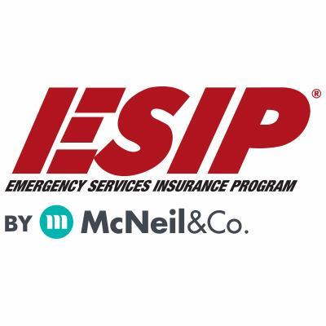
Tony Blackwell, Territory Sales Manager
800-822-3747 ext 530
ablackwell@mcneilandcompany.com
Aurora Inc. Insurance
120 Broadway
Albany, NY 12204
518-449-3180
aurorainsurance.com
Michael May, Broker
mmay@aurorainsurance.com

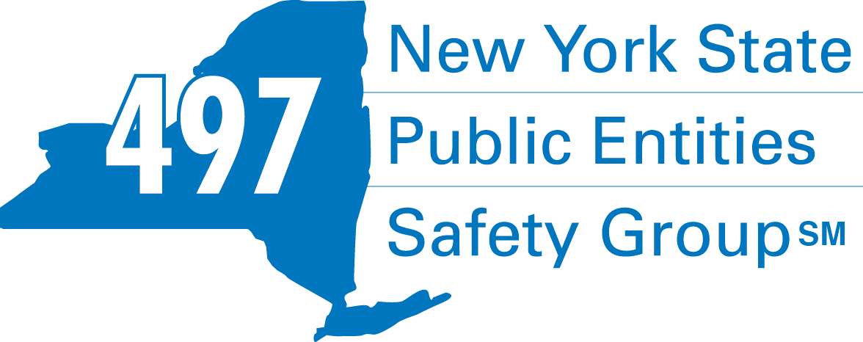
Fleury Risk Management
28 Corporate Drive, Suite 104
Clifton Park, NY 12065
518.478.6314
https://www.fleuryrisk.com/nysgroup497
VFBL Insurances Services
Stephan Petras
Marketing Representative
One Blue Hill Plaza – 16th Floor
PO Box 1609
Pearl River, NY 10965
845-352-8855x7099
329-236-3505
spetras@fdmny.com
VFBL/Workers’ Comp Coverage


Pat Daglio
pdaglio@vfis.com
717.819.3072




8 British American Blvd., Latham, NY 12110
518.272.6120
full-service insurance brokerage for business, benefits, and personal coverage

Dignum & Bame Insurance
98B Troy Road
East Greenbush, NY 12061
518.479.2004
Katherine Henry
Kate.henry@nfp.com

FIRE SERVICE FINANCIAL SERVICES AND LOSAP MANAGEMENT


518-432-5087
838-433-7304 cell
www.thelosapgroup.com.
nikki.haskins@rbc.com
455 Patroon Creek Blvd, suite 200, Albany NY 12206
UBS Financial Advisors
Ralph Lemme, CFP
Ralph.lemme@ubs.com
8 Southwoods Blvd Suite 207
Albany, NY 12211
518.445.1667

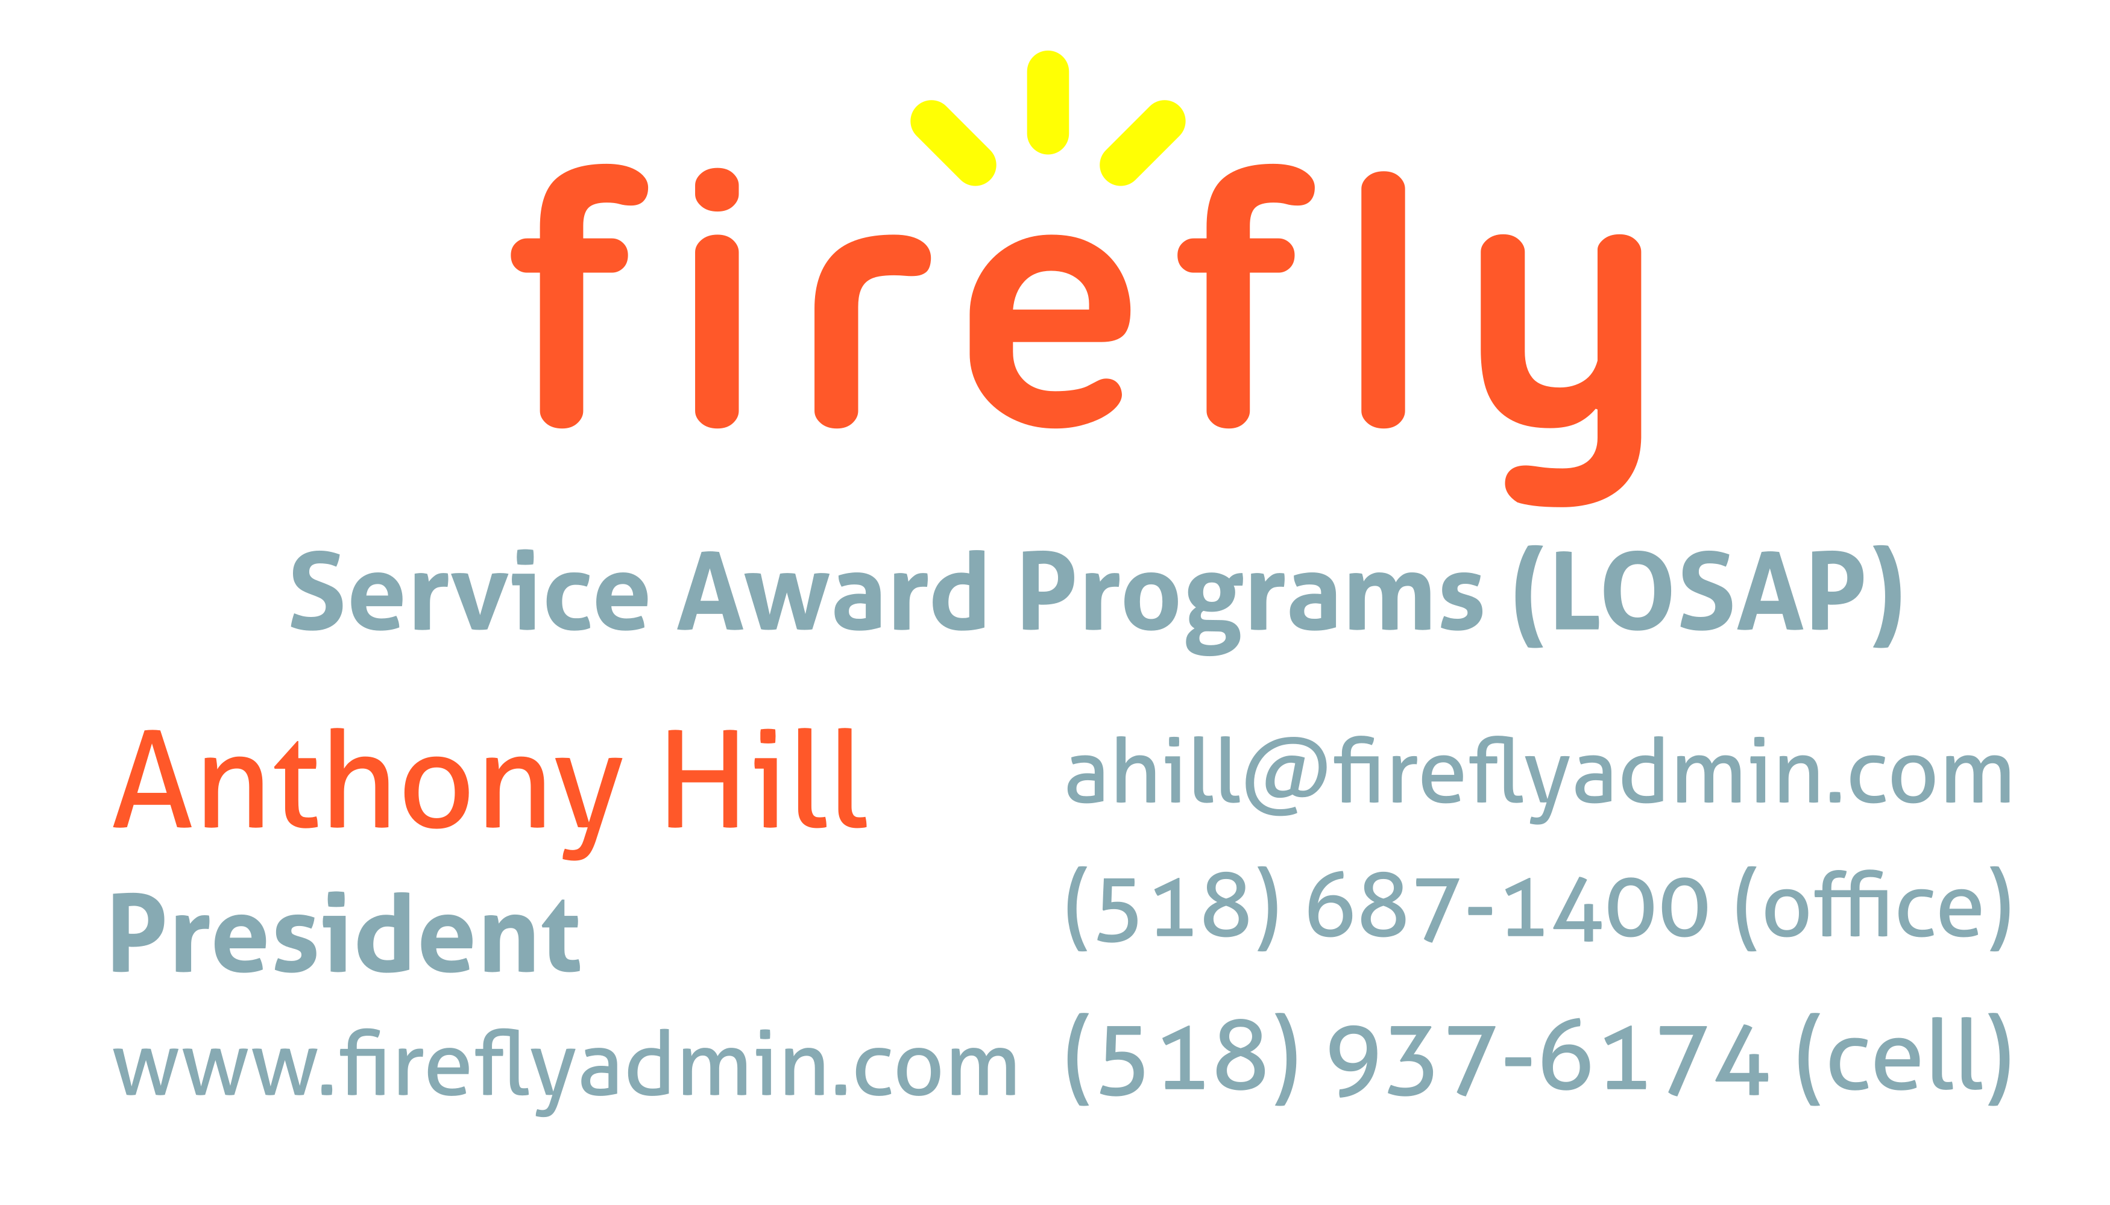

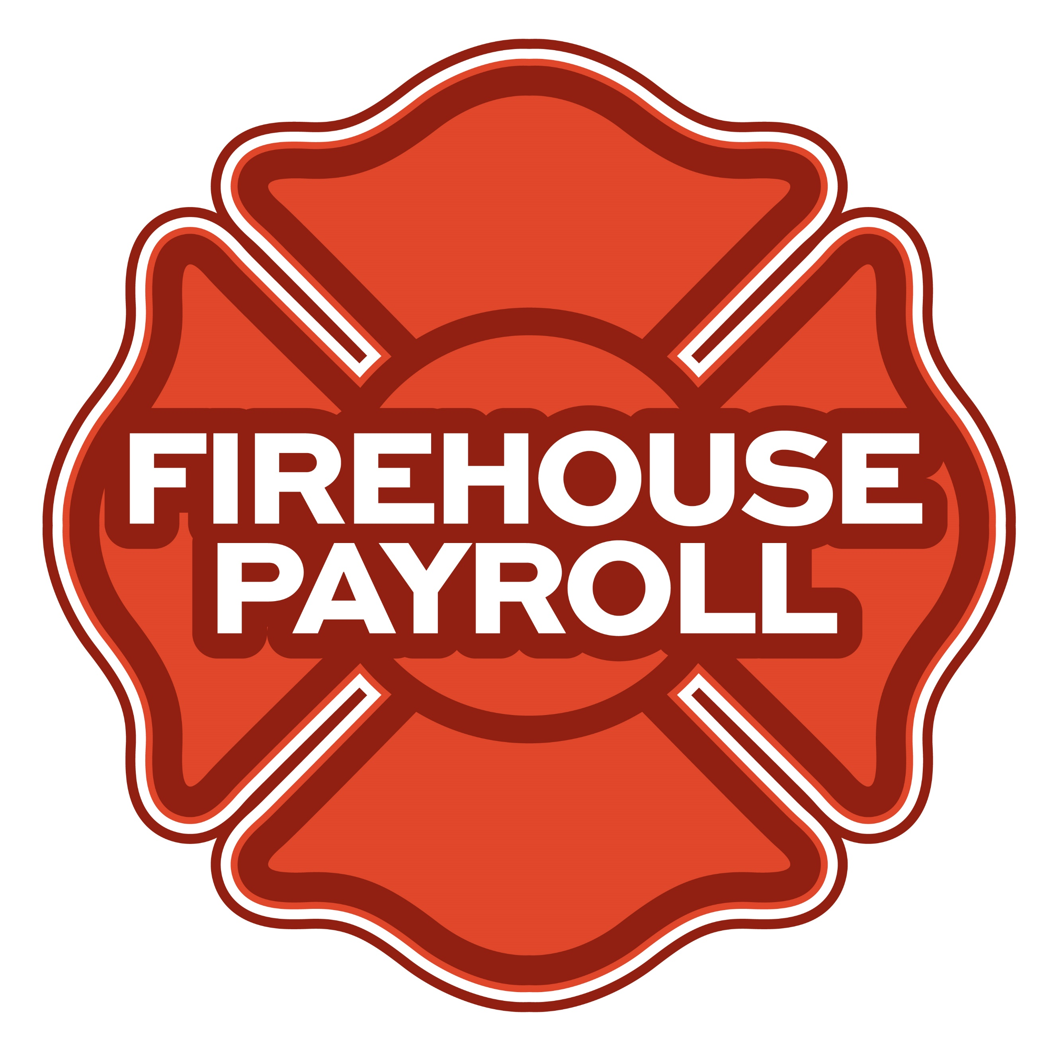
Jeremy Hartnett
824 Philadelphia Pike, Wilmington, DE 19809
302-483-7699
jeremy@firehousepayroll.com
payroll-pension reporting-tax filing
direct deposits-timekeeping-HR Services

Nicole Meeker
Manager of Business Development & Accts
518-394-7894
Cell 607-423-4811
www.penflexinc.com
nmeeker@penflexinc.com

www.jeromefire.com
Breathing Air Comp Maintenance,
Air Quality Tests and Repairs
Russell Jerome
315-699-4533 Office
Ready Rack Extractor/Washers
Full Line of Fire Equipment
8721 Caughdenoy Rd, Clay, NY 13041
FULL-SERVICE FIRE EQUIPMENT
DRYER VENT CLEANING

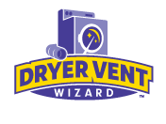DRYER VENT WIZARD
JORDAN CATINO
8 NAPA COURT, SCHENECTADY, NY 12309
518-344-0664
SARATOGADRYERVENT.COM
jcatino@dryerventwizard.com

FIRE EQUIPMENT TESTING
FIRE DEPT COMPUTER MANAGEMENT & REPAIR

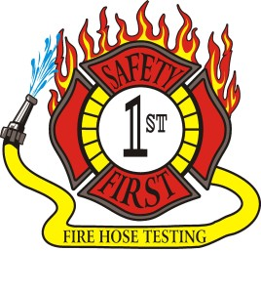Safety First Equipment Testing
99 Glass Lake Road
Averill Park, NY 12018
518-892-5860
www.safetyfirstfirehose.com
HOSE, APPLIANCE & LADDER TESTING
Safety1hose@gmail.com
White Wolf Computer, LLC
4 Normanskill Blvd. Suite 410, Delmar, NY 12054
(518) 459-9653
Managed Services
Cloud Hosting Solutions
Telephone Data Cabling
Backup Disaster Recovery
Web Design Services

PRINTING AND MAIL SERVICES
FIRE COMPANY FUND RAISING


518.371.4649
12 FIRE ROAD, CLIFTON PARK, NY 12065
printproduction@aol.com
one stop print shop and full service mailing house
No project large or small, we can’t handle

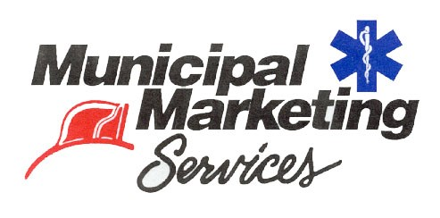
Lloyd Fox, Account Executive
34 Garner Road, Averill Park, NY 12018
Lfox8@nycap.rr.com
518-810-7819
www.funddrive.com

FIRE SERVICE EQUIPMENT
FIRE APPARATUS/SERVICE

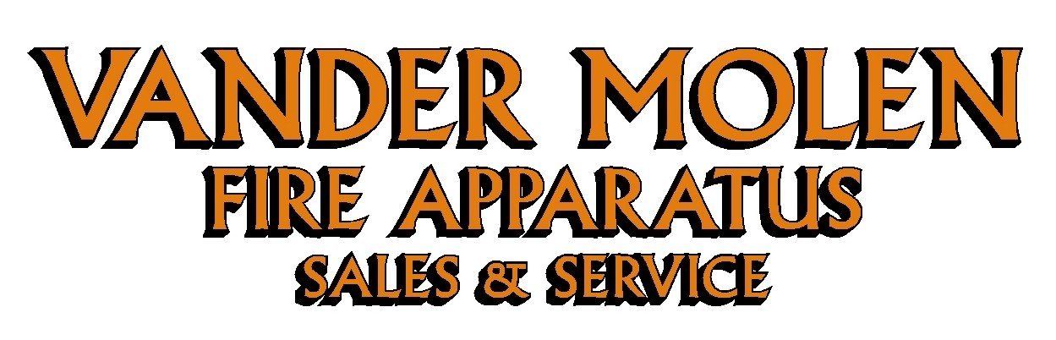
Mike Bonesteel
Warranty & Safety Manager
518-288-3587 X101
Cell 518-926-0451
After Hours 680-800-5015
1 Super 50 Way, Ballston Lake, NY 12019
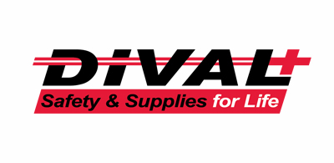
Timmy Kimball
518-925-2786
www.divalsafety.com
Testing-Safety-Promotional Services-Respiratory Solutions
Facility Safety-Fall Protection-Training
60 Cohoes Ave, Green Island NY 12183

FIRE DISTRICT CPA/AUDITS/FINANCIAL SERVICES


518-459-6700
10 British-American Blvd, Latham, NY 12110
www.bstco.com
Brendan Kennedy ext 356


Aaron Hahn
1 Pine West Plaza Suite 107, Albany NY 12205
518.452.8055x17 or 518-452-9055
Email: ahahn@bgcpa.net

Zoriana M. Stawnychy
973.283.0024
zoriana@stawnychyfinancial.com
135 Kinnelon Road Suite 101
Kinnelon, NJ 07405
Serving fire districts in New York State



Accounting, Consulting & IT Security
1581 Franklin Ave. Mineola, NY 11501
Kyle Brengel, Managing Partner
516-472-7345
kbrengel@gblny.com


11 British American Blvd, Latham, NY 12110
518-785-0134
Queensbury Office 518-792-6595
http://www.mmbaccounting.com
Alan W. Clink, CPA aclink@mmb-co.com
Heather R. Lewis, CPA hlewis@mmb-co.com

JOHN M. LESNIEWSKI
Assistant Vice President and
Senior Business Banking Officer
Fulton/Montgomery Markets
12 Fremont Street, Gloversville, NY 12078
P: 518.775-5205 | M: 518.848-0612
NMLS ID 915694
www.nbtbank.com
425 Main Street Catskill, NY 12414
www.tbogc.com
518.943.2600 X2198
Joe Rothrock – josephr@tbogc.com
Specializing in Fire Service & EMS Financing

David Farstad, VP-Municipal Banking
652 Albany-Shaker Road, Albany NY 12211
Ph: 518-730-3120
Cell: 518-506-0075
farstadd@pioneerbanking.com


The Arrow Family of Companies
Corporate HQ 250 Glen Street
Glens Falls, NY 12801
518-793-4121
Business Banking Services
Arrowbank.com
Hero Mortgage Program Supporting First Responders Available

The Weekly Capital Bulletin is reaching well over 700+ subscribed fire district members and now other members of the fire service on a regular basis.
This is a service of CAFDA through the effort of Tom Rinaldi who can be reached at tom@rinaldi1.com for comments and content contributions are always welcome.

CAFDA Vendor/Sponsor Application Form
Welcome Vendors/Sponsors & thank you for your interest!
Please complete & return this form with your payment to:
CAFDA
P.O. Box 242
East Schodack, NY 12063. Should you have any questions, please contact Art Hunsinger at 518-376-3751 or arttv19@gmail.com.
CONFERENCE DETAILS CAFDA Conference 2026 Thursday, April 9 through – Saturday, April 11, 2026 Fort William Henry Hotel & Conference Center 48 Canada Street, Lake George, NY
OVERNIGHT ACCOMODATION RESERVATION INFORMATION Room reservations are the responsibility of the Vendor* Telephone Reservations only at 800-234-0267 or (Local) 518-668-3081 Group Code: CAFDA Conference Rates: $154 Deluxe, $174 Premium/Grand *If tax exempt, documentation (i.e. ST-129) must be presented at time of check- in
VENDOR SHOW DETAILS Friday, April 10th 3:00 – 7:00 PM (Vendors may begin setup after 12:00 pm) Please Check One:
- VENDOR Only: $400: Includes one 8’ table w/white tablecloth & two chairs (power if requested) and two tickets to the Friday Night Cocktail/Dinner Reception

- EVENT Sponsor: Contributions over $400 and up to $1,499: Includes one 8’ table w/white tablecloth & two chairs (power if requested), and two tickets to Friday Night Coctail/Dinner Reception PLUS advertising as a Conference Event Sponsor

- TITLE Sponsor: Contributions at/over $1,500: Includes one 8’ table & two chairs w/white tablecloth (power if requested), and four tickets to Friday Night Coctail/Dinner Reception PLUS advertising as a Conference Title Sponsor with premium signage

- Outside Space: Available for additional display (space limited): $100 Please Provide Display Specifications___________________________________________________

- Additional Tickets to Vendor Show & Cocktail/Dinner Reception available at $30.00/ticket. # Requested____
Name of Business/Organization:____________________________________________________
Contact Name: _______________________________________________________________
Phone: _______________________________Email: _________________________________
Do you require POWER: YES______ NO_____
CLEAN UP: Vendors are responsible for their booth area during and after the event.
Signature:___________________________________________________ Date:____________

