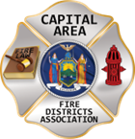
THE BULLETIN
February 14TH, 2026

The Voice of CAFDA since 2004
Editor, Tom Rinaldi – tom@rinaldi1.com since 2014
When you see **, highly recommended article
CAPITAL SHORT TAKES
- See the CAFDA annual calendar of events on page 2.
- Thank You to VP Ellen Martin for presiding over the February meeting.
- This week’s Legislative ScoreCard covers all the updates to fire service-related legislation for the second half of the 25/26 legislative session. See what might affect you in the new year.
- BMW North America is recalling nearly 90,000 vehicles due to an engine starter issue, the U.S. National Highway Traffic Safety Administration, those recalls affected certain 2019–2025 vehicles across six models, including the 2020 340i, X6, 2020–2025 840i, 2020–2022 740Li, and 2019–2020 X7 and X5.
- Congratulations to Alplaus Fire Department, Glenville Fire District #2 on the addition of their new engine.
- Pierce Manufacturing Inc., an Oshkosh Corporation business, announced a new phase of strategic facility enhancements at its Bradenton, Florida location, building on recently announced investments at its Appleton, Wisconsin manufacturing campus. In total, Pierce is investing approximately $150 million across its facilities including approximately $70 million invested to date. Pierce has also added 800 new U.S. jobs and is still hiring.
- Jaguar Land Rover is recalling nearly 2,300 electric SUVs in the U.S. over concerns that a high-voltage battery may overheat, increasing the risk of fire, the National Highway Traffic Safety Administration (NHTSA) announced.
CAFDA EDUCATIONAL OFFERINGS: CAFDA.NET

Join us at the NEXT GENERAL MEMBERSHIP MEETING Thursday March 5th features dinner for attendees. Please join us.
ZOOM LINK FOR THE March MEETING at 7pm:

CAFDA IS HAPPY TO ANNOUNCE THE DATES FOR CONFERENCE ’26 IN HISTORIC LAKE GEORGE, watch CAFDA.net for registration coming soon!

April 9th, 10th and 11th, 2026 plan on joining us.

CAFDA will be offering two Fire Service Financial training 2 day sessions in 2026
Much needed two-day fire service financial training, learn to do it right, brought to you by CAFDA & NYS-OSC.
This year being held at Rombout Fire Department, Fishkill, Dutchess County on March 13th & 14th and at McNeil Insurance in Cortland, Cortland County at on March 27th & 28th. Training is provided by trainers from the Office of the State Comptroller. Continental Breakfast and Lunch will be included.

REGISTRATION IS OPEN FOR FINANCIAL TRAINING ON-LINE AT CAFDA.NET

Commissioner Training will be held at 6 locations in 2026 including:

Verdoy, Saturday February 21st,

Clifton Park, Saturday March 7th,

Niagara Engine Co #6 in Schoharie, Saturday March 21st,

Berkshire Fire District, Gloversville, Saturday March 28th and

Warrensburg Fire District, Saturday April 4th.

The Day after the scheduled date (Sunday) has been reserved as a snow day if necessary.

Open to all newly elected commissioners and Chiefs. This training is required under Town Law Section 176-e. $85 for members, $95 for non-members includes continental breakfast and lunch.
REGISTRATION IS OPEN FOR COMMISSIONER TRAINING ON-LINE AT CAFDA.NET

All correspondence & Capital Area Fire Districts Association Mailing Address should be directed to:
CAFDA PO Box 242 East Schodack, NY 12063 or EMAIL: SECRETARY@CAFDA.NET
Financial issues should be addressed to: TREASURER@CAFDA.NET
LEGISLATIVE NEWS FROM THE STATE CAPITAL

Fire Service Related Proposals Included in the Governor’s Budget Submittal
- Community Paramedicine and Hospital at Home (HMH Part K): The Executive proposal extends the authorization of currently operating community-based paramedicine programs until April 1, 2030, sets the number of allowed programs in the state to 99, and expands the scope of practice of paramedics to include administering vaccines under non-patient specific orders from a physician or nurse practitioner. This proposal also codifies the Acute Hospital Care at Home program into state law, which would allow the program to expand to other hospitals. This program is already in certain healthcare facilities under federal authorization. It also authorizes DOH to establish rates for services. Fiscal Impact: The Executive Budget does not provide a fiscal estimate for this proposal.
- Article VII - Miscellaneous Extend the Suspension of the Cell Surcharge Revenue Transfer to the Emergency Services Revolving Loan Fund (PPGG Part B): The Executive Budget proposes to extend the existing suspension of the $1.5 million annual transfer from the Public Safety Communications Account to the Emergency Services Revolving Loan Fund to assist local governments, fire districts, and not-for- profit fire/ambulance in financing emergency response equipment and related capital needs. The Executive Budget proposes to extend the existing suspension through State Fiscal Year 2029-30, which allows for local emergency services-related grants instead. Current law suspends the annual transfer of $1.5 million in funding by two fiscal years and currently applies through State Fiscal Year 2025-26. This suspension has been regularly extended by two fiscal years since 2011. Fiscal Impact: The Executive proposal did not provide a fiscal estimate for this proposal.
- Division of Homeland Security and Emergency Services (DHSES) The Executive Budget proposes All Funds appropriations of $9.25 billion, a net increase of $163.9 million or l.8 percent compared to SFY 2025-26. The Executive Budget proposes a total increase of $192 million offset by $28 million in reductions. The Executive Budget proposal supports a workforce of 770 FTEs, unchanged compared to SFY 2025-26.
  - The Executive Budget proposes the following:
  - • $150 million increase in Capital funding to support Centralized State Emergency Operation Center (SEOC) Facility in Albany County.
  - • $26.2 million increase to support nonpersonal services expenses of disaster assistance operations, providing a total of $33.8 million in SFY 2026-27.
  - • $7.5 million increase in State Operations to support contractual and personal services
  - • $5 million increase in Capital funding to support equipment to expand Statewide Urban Search and Rescue capabilities.
  - • $2.7 million increase to support operations of the Office of Fire Prevention and Control, providing a total of $11.7 million in SFY 2026-27.
  - • $1.2 million increase in federal funding to support personal services in the Emergency Management program.
  - • $25 million decrease in Capital funding due to the discontinuation of one-time Volunteer Fire Infrastructure and Response Grant (V-FIRE), which will be funded through re appropriations in SFY 2026-27.
  - • $2.3 million decrease due to the elimination of legislative grants, which includes:
    - $1.5 million decrease for Red Cross Emergency Response Preparedness, bringing total available funding to $3.3 million in SFY 2026-27.
    - $750,000 decrease for the New York State Professional Fire Fighters Association
    - $50,000 decrease for the Maynard Fire Department
- Developing a Comprehensive Plan for Drones (PPGG Part D): The Executive Budget proposes establishing a new crime of Unlawful Use of a Drone, in varying degrees, and creating a drone registry. It creates restricted flight zones around: concerts, protests, parades, festivals, sporting events, large public gatherings, police stations, fire departments, emergency services dispatch stations, state, local, or federal correctional facilities, and “critical infrastructure”; it effectively establishes "no-fly" zones across the State. “Critical infrastructure” under this proposal includes an extensive list of sites including locations such as petroleum refineries, power plants, chemical facilities and certain enclosed water treatment centers. To enforce this provision, law enforcement agencies are explicitly authorized to identify, seize, and neutralize drones that are considered "credible threats."
- Health Capital Funds: The Executive Budget proposes an All Funds appropriation of $1.4 billion for Capital Projects, a net decrease of $141 million or 9 percent compared to SFY 2025-26. The Executive Budget proposes the following: $3.2 million in new funding for emergency medical services modernization.
- Office of Addiction Services and Supports (OASAS) $1 million increase to support the development of a First Responders Behavioral Health Center of Excellence, which will provide support services for emergency response agencies across the State.

Information, All in the Fire Service Need to Understand – How does it all happen?
Posting by Dave Denniston
On December 6th, 2025, the major fire service organizations representing volunteer firefighters in NYS met in Albany, NY with the NY Fire Administrator and our Lobbyists to discuss and ratify the "Issues of United concerns". Discussions focused on challenges faced by the fire service and legislative initiatives that the organizations felt would help the volunteer fire service continue to be viable and protect our communities. I participated in these discussions as an active volunteer firefighter here in NY, and as VP of the Association of Fire Districts of the State of NY. I can only speak for myself, but I felt these discussions were heartfelt and produced solid options that can be used as tools to shore up the continued concerns and significant drop in volunteer firefighter numbers across the state. It was clear to me at this meeting that no one solution would fit all departments or solve all of the concerns alone. The group voted on each proposal, and the 2026 list of United Concerns was developed. The list does not include every item that was discussed but represents the items that the majority of the collective group felt had the most potential and opportunity to actually be passed by the elected officials.
These solutions were a group effort of all the organizations that participated in the process. While there now seems to be other proposals and ideas out there, I have to wonder why we are deviating from the collective efforts of all involved in that process.
Many have asked what they can do to help these efforts. I ask you to read the 2026 Issues of United Concerns and urge the fire service organizations and elected officials to move forward and prioritize these seven concepts that were voted on and recommended that day.
Unfortunately, there is no single initiative that will work the same for everyone. There is no single initiative that is perfect. There is no single initiative that will benefit everyone the same and be guaranteed not to cause anyone some discomfort or challenges.
These 7 initiatives are a solid start and foundation to offer a path forward to help move us toward the future of emergency response here in NYS. Please consider endorsing them and asking others to join us in these efforts. Together, we can and will make this happen. Separately, we will continue to watch the current model struggle to protect our communities.
Please share and help distribute this list. If you would like to add your name, logo, department, or organization to the list of supporters, please let us know and we would be happy to add you to the documents that we plan to present in Albany during the month of March. Please help us help you.

2026 Issues of United Concern
After a meeting of the fire service organizations including County Coordinators, Fire Districts, Fire Chiefs, Fire Police and FASNY, the following are the legislative initiatives for 2026.
- Increase VFBL Payments, reach parity with workman’s comp payments. [A1849 Steck & No Same As at this time.]
An act to amend the volunteer firefighters' benefit law and the volunteer ambulance workers' benefit law, in relation to increasing the amount of certain benefits. These benefits have not been updated in decades, with most compensation thresholds last revised in the 1990s. As a result, they no longer adequately reflect current economic realities. This legislation seeks to modernize and enhance these benefits to ensure they provide appropriate and meaningful support to those who risk their lives in service to others.
- Designate EMS as an essential service [A1989 Oberacker & No Same As at this time.]
An act to amend the general municipal law and the public health law, in relation to emergency medical services. The goal of the legislation is to provide a county-by-county assessment that will provide a roadmap for statewide improvements in providing EMS service going forward. The process can be matched with efforts to develop a statewide plan that matches the variety of ways services are provided throughout New York.
- The First Responder PEER Support Act [S5407A Harckham & A7285A Burdick]
An act to amend the mental hygiene law, in relation to the "First
Responder Peer Support Program Act". Modeled after the highly successful Joseph P. Dwyer Veterans Peer to Peer Support Program, which was launched in 2012, this bill would establish a First Responder Peer Support Program. This program would focus on prioritizing the mental well-being of the state's first responders. By enacting this bill we can ensure that first responders have access to the necessary systems to address some of the challenges they face.
- Increase the income tax credits for first responders. [S6233 Martinez/A6790 McMahon] also [S1123 Oberacker/A1064 Angelino] also [A28 Burdick/No Same As]
An act to amend the tax law and the real property tax law, in relation to tax credits for volunteer firefighters and volunteer ambulance workers. A taxpayer who serves as an active volunteer firefighter or ambulance worker shall be allowed a credit against their state taxes equal to $800. For married couple who file a joint return and both individually qualify, they shall be allowed a credit of $1600.
Legislation would also remove the prohibition to take the property tax exemption in addition to the income tax exemption.
- Enable more progressive fire service delivery options, including agency structure, supplemental support and provide nominal compensation to first responders. [need specifics, no sponsor at this time.]
Volunteer and on-call emergency responders should be able to receive compensation as determined by the AHJ for the time that they dedicate to being available or responding to incidents. At this time volunteers are in danger of losing their volunteer status by language currently in the VFBL statutes, which needs to be removed to provide the AHJ the option of providing monetary incentives for volunteers. In addition alternative fire service provider models should be optional to varying levels of government.
- Amend the EMS billing law [no sponsor at this time, need specific language]
Amend the law to allow EMS agencies to bill for mutual aid transports. Currently agencies are not permitted to bill for calls which have been mutual aided to them.
- State Retirement Service Credit as a recruitment/retention incentive [S7021 Ryan/A7432 Eachus]
An act to amend the retirement and social security law, in relation to establishing a retirement service credit for volunteer fire or emergency service. Section 1 of this bill would allow a member, upon application to a public retirement system, to achieve one year of service credit for every five years of volunteer fire or emergency service in the State, not to exceed three years of total service credit; available to such member any time before retirement.
OTHER AREAS OF CONCERN THAT MAY BE ADDRESSED GIVEN THE TIME AND ATTENTION OF THE LEGISLATORS DURING THE SESSION.
- Support the joint NVFC, IAFF task force working with DOL/OSHA to propose a viable solution to the 191.156 update, including the removal of the NFPA standards incorporated by reference.
- Publishing Official Notice Modernization; this initiative would update how public and legal notices are transmitted to the public with the demise of local newspapers. For instance, modernization would allow governmental entities to publish notices via online platforms.
- Convene a work group to come up with viable solutions to the issue of compensation for volunteers as well as fire service delivery options, including agency structure and consolidation of services. Specifically remove the prohibition by the counties to provide fire service as an optional solution.

New York Volunteer Fire Departments Eligible for Grants
Two funding options are available: $20 million for construction and renovation projects and $5 million for fire service equipment projects.
GO TO THIS LINK FOR INFORMATION AND APPLICATION:
https://www.dhses.ny.gov/state-funded-programs
The application deadline is February 25, 2026, by 5:00 pm

New York’s first responders to benefit from $38M emergency communications upgrade
Governor Kathy Hochul announced more than $38 million in state funding to enhance emergency communications for first responders across New York.
The funding will support 17 counties and New York City through the Statewide Interoperable Communications Grant program.
“Saving a life can come down to one call, and our first responders need to have the most reliable emergency communications systems to help their fellow New Yorkers during their most critical moments,” Hochul said.
The program aims to improve radio tower infrastructure, ensuring clear communication during emergencies.
The Division of Homeland Security and Emergency Services will administer the funds, which are part of the Combined 2024 & 2025 Statewide Interoperable Communications Grant Targeted Program.
[EDITOR’S NOTE: THESE FUNDS WERE SKIMMED OFF BY THE STATE UNDER THE PREVIOUS CUOMO ADMINISTRATION, NOW THEY ARE BEING GENEROUS AND GIVING LOCALATIES BACK A FRACTION OF WHAT WAS COLLECTED AND SQUIRRLED AWAY IN THE GENERAL FUND]
NATIONAL FIRE SERVICE ORGANIZATION NEWS

About CFSI
Whether you are a member of the fire and emergency services, a public safety coalition, or the fire service industry, the United States Congress is more aware of your concerns because of the Congressional Fire Services Institute (CFSI). Established in 1989 as a nonprofit, nonpartisan policy institute, CFSI is designed to educate members of Congress about the needs and challenges of our nation’s fire and emergency services to help them understand how the federal government can support the needs of our local first responders.

About The NVFC
The National Volunteer Fire Council (NVFC) is the leading nonprofit membership association representing the interests of the volunteer fire, EMS, and rescue services. The NVFC serves as the voice of the volunteer in the national arena and provides critical resources, programs, education, and advocacy for first responders across the nation.
Our Vision
The NVFC strengthens volunteer and combination fire and emergency medical services to advance excellence, ensure safer communities, and enhance the quality of life across America.
Our Mission
The NVFC unites and supports volunteer and combination fire and EMS organizations through education, advocacy, leadership development, and collaboration. Guided by professionalism and innovation, we provide the tools and resources needed to protect communities, advance responder health and safety, and prepare leaders for the future.
What We Do
The NVFC accomplishes its mission and provides meaningful support to fire and EMS organizations through a wide range of services and programs:
- Representing the interests of the volunteer fire, emergency medical, and rescue services at the U.S. Congress, federal agencies, and national standards setting committees
- Focusing on health and safety
- Helping departments recruit and retain Fire Service and EMS/Rescue personnel
- Providing training on topics that matter to you
- Assisting departments in establishing support programs
- Fostering the next generation of firefighters
Offering an array of programs to support the volunteer emergency services

Legislative Update: DHS Funding Extension Creates Uncertainty for Fire Programs
On February 4, President Trump signed legislation funding most federal government operations through the remainder of fiscal year 2026. However, funding for the Department of Homeland Security (DHS) was only extended through February 13 as Congress continues negotiations related to Immigration and Customs Enforcement (ICE) policies and operations.
This short-term extension provides lawmakers additional time to reach an agreement but also creates the potential for a lapse in DHS funding if a resolution is not reached by the deadline. As a result, key fire service programs administered through DHS, including the U.S. Fire Administration, SAFER grants, Assistance to Firefighters Grants, and the National Fire Academy, remain vulnerable to the outcome of these negotiations.
The National Volunteer Fire Council will continue to monitor the situation closely and advocate for stable, long-term funding for these critical programs that support the nation’s fire and emergency services.
THE LATEST NEWS FROM DOL/OSHA

Joe Maruca’s Answer to FASNY
Joe is a member of the OSHA task force and a firefighter in Barnstable, MA
Thank you for providing detailed feedback on behalf of FASNY. Philosophically I agree with your position that volunteers should be exempt (from the OSHA Standard), however, I don’t believe that politically we can win that point. I think a more pragmatic and technocratic position is required (that volunteers be covered by the proposed standard). But I’d like to address different aspect of exempting volunteers regarding combination fire departments.
A fire department with one career firefighter (or a career chief) will fall within OSHA even if its volunteers are exempt. This means doing all the required administrative work, and spending the money, to comply with pre-plans, community risk analysis, SOPs, vehicle maintenance, facilities maintenance, risk management plans, emergency response plans, incident operations, and incident management. These areas simply can’t be run on dual tracks within the same department. The cost and effort to do these for one career firefighter is the same as doing them for the whole department, including the volunteers. So even with an exemption for volunteers, the result is still burdensome.
There are three areas where an exemption for volunteers might prove valuable for combination departments. They are training, PPE, and medical exams.
If volunteers are exempt and the career firefighter isn’t, then the department only has to provide one annual or bi-annual medical exam for its career firefighter. This saves a great deal of money and administrative effort, and it allows the department to provide medical exams for volunteers based upon its own determination of need.
Training presents a similar cost and administrative savings, but it might create a union-volunteer problem if the volunteers aren’t getting the same training as the career firefighters. As chief of a combination department (5 career & 45 volunteers) I have experienced this. For a combination to work and to help preserve the volunteers, everyone (career & volunteer) train together. If volunteers don’t get the same training as career firefighters, the union will declare them unfit and unsafe and drive them away. If career firefighters get extra training that the volunteers don’t get, then the volunteers get mad, feel like second-class members of the department, and quit.
Similarly, legally having to give compliant PPE to the career members and having the option of giving non-compliant or cheaper PPE (which will be viewed as substandard) to the volunteers may allow departments to save some money in the short-term, but the long-term effect is a morale killer and the volunteers quit.
Yes, this is a combination fire department problem. Why should we care about combination fire department problems? Combination departments are growing. They have increased by 26% over the past 20 years. Volunteer departments have decreased in those years, and the shift is from volunteer to combo. The number of volunteers in combination departments is growing, and they need our support and advocacy. I would love to hear from others on this. It would be useful to know how other state’s feel about this.

Clarification Update
It has been confirmed that the International Association of Fire Chiefs (IAFC) remains part of the standard revision conversation and were signatories on the letter to remove the word for word NFPA Standards and give authority to the AHJ for enforcement of the final standard.

OSHA’s Emergency Response Standard Remains Under Review
Curt Varone
The Occupational Safety and Health Administration’s effort to replace its 1980-era Fire Brigades standard remains in the rulemaking process, with no final regulation issued. OSHA formally proposed the new rule—titled the Emergency Response Standard—on February 5, 2024. The proposal would modernize 29 C.F.R. § 1910.156, which has governed fire brigades for more than four decades, by expanding its scope to cover a broad range of emergency response personnel.
Following publication of the Notice of Proposed Rulemaking, OSHA opened a public comment period that was extended several times due to the volume of responses. The comment period closed on July 22, 2024. OSHA later convened an informal public hearing, which began on November 12, 2024, and accepted additional written submissions through January 17, 2025.
Since then, the agency has been reviewing the testimony, comments, and data submitted during the rulemaking process. According to OSHA’s regulatory agenda and its Emergency Response Rulemaking page, the proposed rule remains under analysis. No final rule has been drafted or published, and the existing Fire Brigades standard continues to govern until OSHA completes the process.
The proposed Emergency Response Standard would significantly expand OSHA’s regulatory framework for responders. Rather than limiting coverage to industrial and private fire brigades, the proposal would bring firefighters, EMS personnel, technical rescue teams, and other responders under a single comprehensive standard. It would incorporate updated requirements for emergency response plans, hazard assessments, personal protective equipment, medical and behavioral-health evaluations, and training aligned with contemporary consensus standards.
The scope of the proposal drew extensive attention from the fire service, particularly from volunteer and smaller departments. Many commenters expressed concern about the feasibility of compliance, prompting OSHA to acknowledge that economic impacts on volunteer organizations require further review. In a September 2024 statement, OSHA indicated it would evaluate the applicability of the final rule to volunteers based on the record developed during the hearing and comment periods.
Despite the interest surrounding the proposal, OSHA has not indicated when a final rule might be issued. The new regulation remains at the proposed stage, and the agency’s review is ongoing. For now, the Emergency Response Standard has not been adopted, and the 1910.156 Fire Brigades standard remains in effect. Here is a statement from OSHA:
- OSHA is reviewing and evaluating all the comments and data submitted by stakeholders and the transcripts from the hearing. This important step in the rulemaking process helps guide the agency as it considers how to proceed with the rulemaking.
Here is a link to OSHA’s current position on the Emergency Response Standard.
https://www.osha.gov/emergency-response/rulemaking

The Latest from Dave Denniston:
As was briefly discussed on the recent NYS Fire Service Council zoom meeting, the group is still in serious discussions and are attempting to formulate an update to the Emergency Service Standard that is not as intrusive as the original proposal. The NFPA standards will NOT be adopted by reference and there is consideration for a modification to the standard for communities with fewer than a population of 5K. A more formal briefing is pending from Chairman Denniston. We thank him for his dedication to this process.

IT IS TIME TO MOVE FORWARD WITH A WORKABLE OSHA 1910.156 REVISION
Dave Denniston, 1st VP AFDSNY
As the process to update OSHA 1910.156 continues, it is important that we understand where we have been, and options for the process moving forward. Since the proposed rule was published for review 18 months ago, there has been a significant amount of input and feedback from stakeholders addressing possible concerns about the economic and technical feasibility of the proposal. Stakeholders from across the country participated in the process and offered suggestions. One of the early possible solutions suggested was to simply exempt volunteers, and other parties, from the proposed rule as written. The mindset was that if it didn’t affect “us” it was not our problem. While this concept appeared to be a quick solution, it fell short of addressing the true needs or problems.
The real issue at hand is that the proposed rule as written had challenges for everyone and you would be hard pressed to find any department, career, combination, or volunteer, that could meet the intent of the standard. The proposed standard also took a one-size-fits-all approach. We know that the emergency service agencies across this country are very different. They have different resources, different exposures, different concerns, and different levels of risk. It is true that emergencies, fires, and hazards are the same regardless of the type of responder. What is different is the likeliness that a particular event will occur in any jurisdiction. Local jurisdictions must be required, and empowered, to address significant risk, and the needs of a community, at a local and state level with just enough federal oversight to give it teeth and ensure safety for all of our responders. The bottom line is that the current 1910.156 is outdated and needs significant revision to address the needs and safety concerns of today’s first responders. The proposed standard, as written, went too far in trying to address these needs. What we need is a middle ground solution that is designed to relieve significant risk and does so at a level that is economically and technically feasible for local communities, organizations, and the municipalities that govern and fund them.
Some are asking why simply exempting the volunteers is not in the best interest of volunteers across the country. First, by exempting the volunteers, we are failing to address the growing concerns and exposures facing this group of responders. Second, the largest growth area for most of our local fire departments is a move toward combination and career departments. How would it be possible to have one set of rules apply to part of an organization and not the other? Does it make sense to have volunteer responders face one set of rules, while career responders on the same truck follow another? Are we not all responding to the same emergencies with the same exposures? The approach of exempting volunteers would add both confusion and resentment moving forward. The third part of the issue is that the standard, as written, is just as problematic for the communities that have career departments as it is for those that only have volunteers. We need a standard that brings us all together, not one that drives us further apart.
So, what do the solutions look like? Where should OSHA and the Department of Labor go from here? After pouring through the thousands of comments brought forth during the process, an opportunity is right in front of us. There were a multitude of comments throughout the process that carried common themes. By using logical outgrowth of the process, OSHA now has the opportunity to massage the rule into one that we all can live with, and provide the level of safety they are tasked to provide the workers of this country.
It is now in OSHA’s hands to finalize the rule as proposed, make logical changes, scrap it, or go back to the drawing board. During the process, OSHA continuously asked for proposed solutions, and many excellent solutions were entered into the record from those that participated. We would suggest that OSHA and the Department of Labor use the extensive input from the process to make necessary changes to the document and work to finalize the rule. A rule that meets the intent of reducing significant risk in a manner that is reasonable and responsible for our first responders and communities.
Using logical outgrowth, OSHA now has the opportunity to remove the incorporated NFPA standards. Many of the participants and the NFPA itself asked for this to be done in their comments. The incorporation of those standards brought many of the pain points organizations were concerned about. The NFPA standards instead should be used as a tool for compliance, not a weapon of enforcement. By removing the incorporation of dozens of NFPA standards, the rule would also become far less confusing and economically infeasible. The next step is to transfer as much of the obligation of providing safety down to the local jurisdiction and state levels as possible. These are the people that know the nuances of the local responders and hazards in any given area. This, too, was supported by the comments throughout the process. The third opportunity is rather than exempting anyone, to build a baseline standard that applies and protects everyone, and then increase the requirements where the data shows increased exposure and risks. All of these changes are supported by the logical outgrowth requirements and would alleviate most of the pain points addressed by the participants of the process.
Regardless of the solution, we would be remiss if we failed to realize there will be opposition to any action taken moving forward. We also need to realize that any solution, or even no solution at all, will have pain points for some that it will affect. It has often been said that firefighters hate two things, change and the way things currently are. Hopefully, we realize that we are at a historic time, with an amazing opportunity to get this right. This process has been fair and offered plenty of opportunities for those interested in participating to make their opinions and feelings known. It is time to move the ball over the goal line and continue to work together for the betterment of emergency services in this country.
I encourage you to speak to your local elected officials. Let them know there is a workable solution right in front of us, and ask them to encourage the Department of Labor and OSHA to continue this opportunity and finalize a reasonable OSHA 1910.156 that applies to all fire departments, regardless of the composition of their staff.
FIRE DISTRICT FINANCIAL NEWS

Local Government and School Accountability Contact Information:
Phone: (518) 474-4037; Email: localgov@osc.ny.gov
Address: Office of the State Comptroller, Division of Local Government and School Accountability
110 State Street, 12th Floor; Albany, NY 12236

Grant Writing for the Fire and Emergency Services
This course educates fire and emergency services personnel on how to write a successful grant narrative in an effort to secure funding for their local fire/EMS department. Students will also be introduced to a variety of funding opportunities, including government and private grants.
NVFC VIRTUAL CLASSROOM TRAINING:
https://virtualclassroom.nvfc.org/products/grant-writing-for-the-fire-and-emergency-services#tab-product_tab_contents__4

NYS-OSC Fire Service Audits
No audits this week.

THE FIRE CHIEF’S OFFICE

Choosing the right altitude: Blending strategic and tactical leadership
Brian Schaeffer
Every chief needs to learn when to stay at 30,000 feet and when to get into the weeds.
There comes a moment in every fire chief’s tenure — whether it’s during a line-of-duty death investigation, a contentious labor negotiation or a multi-alarm fire — when the decision must be made: Do I stay at the strategic level or do I step into the tactical details? That moment, often subtle and unfolding in real time, defines the tension between leading from the top of the hill and leading from inside the fight. It’s a dilemma that doesn’t just test our knowledge or experience — it reveals the depth of our leadership maturity.
We’ve all known chiefs who live too high in the clouds, untethered from the realities of operations, unaware of the pressures facing crews in the street or the administrative hurdles slowing progress. On the other end, some chiefs can’t resist pulling hoselines or editing policies word by word, leaving no room for subordinate leaders to learn, grow or own outcomes. Both extremes are unsustainable. One creates confusion and the other breeds dependency.
The challenge for a fire chief isn’t whether to be strategic or tactical; it’s learning when and how to move between the two with clarity and purpose.
FROM 30,000 FEET TO IN THE WEEDS
Just like a CEO or top organizational position, strategic ownership never leaves the fire chief. We are accountable for the vision, the mission and the condition of the organization at every level. That responsibility cannot be delegated. However, tactical execution belongs to the professionals we’ve hired, trained and empowered to act. That trust is foundational, but it must be informed by awareness.
Knowing when to zoom in is not a sign of weakness or micromanagement. It’s a function of context. Suppose the organization is facing a pivotal challenge. In that case, whether it’s a funding crisis, a recruitment failure or an operational breakdown, the chief may need to step in, ask hard questions and walk alongside the team to stabilize the foundation — then, when conditions permit, zoom back out and return authority to the appropriate levels.
This “altitude shift” requires emotional intelligence, clear communication and steady leadership presence.
STAYING GROUNDED WHILE SEEING AHEAD
Success as a fire chief comes from learning when to lead from the front, when to support from behind, and how to do both without disrupting the rhythm of those around you. That flexibility requires us to have strong self-awareness, trust in the team and a deep sense of the organization’s pulse. The reality is messy and fluid. It will change with time and circumstance, making it sometimes turbulent and nearly impossible to navigate.
Strategic leadership requires us to look ahead, anticipate potential barriers and prepare for change well in advance of its arrival. But that doesn’t mean retreating to an office or surrounding ourselves with plans, graphs and assumptions. The most respected leaders in the fire service are the ones who remain operationally relevant, not because they run calls or handle every detail but because they stay connected. They show up. They walk the bay floors. They sit at kitchen tables. They listen not to respond but to understand.
When our people see that we care enough to be present — not to critique or inspect, but to support — they begin to trust that our strategic decisions aren’t made in isolation. That trust matters, especially when difficult choices have to be made down the road. That’s the job, and those decisions are rarely easy.
It’s equally important to know when not to step in. A leader who intervenes every time something feels off robs the organization of their leaders’ ability to grow through experience. Delegation doesn’t mean disengagement, but it does require discipline. By giving our people room to lead, we also accept the reality that mistakes may occur. Those moments, when properly supported, often become the most valuable opportunities for development.
On the other hand, when the situation carries high consequences — like when the stakes involve public trust, firefighter safety or organizational reputation — our visibility and presence are non-negotiable. That doesn’t mean taking control, but it does mean being available, removing obstacles and providing real-time support. A chief who is absent during critical junctures will find that their authority erodes quickly, regardless of how sound the strategy might be on paper.
The rhythm of leadership in the fire chief position is not steady but rather dynamic. The pace changes, the environment shifts, and what your people need from you today may be very different from what they’ll need tomorrow. Our job is to stay in tune, to adjust and to never get too comfortable at any one altitude. After all, we lead best when we stay rooted in reality, grounded in relationships and anchored by the purpose that brought us to the job in the first place.
The fire chief doesn’t have the luxury of choosing one lens and staying there. Our leadership must flex, refocus and adapt as the environment demands. That is especially true in today’s public safety landscape, where operational complexity, political pressures and workforce expectations collide daily. We are expected to see the whole picture while remaining aware of the details frame by frame.
THE DUAL BURDEN OF COMMAND IN SMALLER SYSTEMS
While the ideal balance between strategy and tactics is often discussed in binary terms, the reality for many fire chiefs, particularly in mid-sized or smaller agencies, is far more complex. In these environments, the fire chief isn’t just the architect of vision. They’re also frequently the duty officer, the public information officer, the training director and sometimes the board’s secretary.
For those positions, there is no luxury of separation. The same leader who testifies before the legislative body about next year’s capital improvement plan may also be the first to arrive at a structure fire later that evening, coordinating the initial attack while simultaneously thinking through the political and staffing implications of the incident. This isn’t a flaw of the system; it’s a reality of the role. And for many, it’s where the leadership craft can make or break their effectiveness.
The danger really lies in ignoring the cost of constantly shifting between those roles. Operating with a foot in both worlds demands acute self-awareness. If we’re not careful, the operational urgency that dominates our daily calendars can begin to erode the long-range thinking that the organization needs from us. Conversely, living only in the abstract and being preoccupied with plans, data and politics will disconnect us from the credibility that comes from showing up in a real-time when it matters most.
Harvard’s Ron Heifetz, in his work on adaptive leadership, points to this tension. He argues that effective leaders must learn to “get on the balcony” to rise above the dance floor and see the larger patterns at play while still being willing to step back onto the floor when necessary. That movement, in and out of the action, allows leaders to stay responsive without becoming reactive and visionary without becoming detached.
In the fire service, that balance is more than theoretical. Our people know when we’re engaged and when we’ve drifted. They know when we’re showing up to understand versus when we’re appearing to direct. Presence must be genuine, and timing is crucial. Some moments demand your full attention, and there are times when stepping back is the most powerful statement of trust you can make in your team’s competence.
There’s no universal rule for when to step in or out, but there is discipline to checking in with yourself. Are you defaulting to the comfort of tactics because strategy feels intangible? Are you clinging to the safety of vision because the operational messiness of today is harder to face? Neither posture, in isolation, will serve the organization well.
The best chiefs that I’ve learned from can talk on the radio and to the state legislature with equal comfort. They know when to take the buggy to the call and when to stay behind to build the next five years. They don’t romanticize the fireground, nor do they become enamored with titles. They lead in real time, guided by presence, timing and relevance.
LEADING WHERE IT COUNTS
So, whether you’re leading a department of 20 volunteers or 2,000, the expectations don’t change. Strategy matters. So does action. The strength of a fire chief is rooted in their ability to move between both with intent. This isn’t balance for the sake of balance. It’s awareness of when your team needs vision and when they need proximity. When they need silence and when they need your voice. When they need a leader on the balcony and when they need one in the street.
The one thing we all realize when we leave shift work is that there will always be more work than hours in the day. For the fire chief, the pace of change will continue to accelerate, and that list or stack of work will never disappear. But if we stay rooted in our mission, grounded in service and responsive to the needs of our people, we can lead with the kind of clarity that outlasts our tenure. The kind that doesn’t just move the organization forward but makes it stronger long after we’re gone.
That is the work. And it’s worth every step.
THE ATTORNEY’S OFFICE

**LEGISLATIVE UPDATE: NEW CYBERSECURITY TRAINING LAW
In Chapter 177 of the Laws 2025 the Legislature and the Governor have amended the General Municipal Law, the Executive Law and the State Technology Law in relation to municipal cybersecurity incident reporting and exempting such reports from Freedom of Information Law requirements. They also set new standards for cybersecurity awareness training for government employees, data protection standards, and cybersecurity protection. The sponsors of these new laws noted that their purpose is to have the Division of Homeland Security and Emergency Services [“DHSES”] “provide information, guidance and training on cybersecurity issues to local governments and public authorities, establish certain reporting requirements for cybersecurity incidents and ransomware attacks, and establish a framework for state agencies to respond to cybersecurity incidents.”
This is critical legislation that must be considered and implemented by local government entities that utilize information technology to serve the public. In other words, it applies to all local governments, including fire districts.
Section one of the bill adds a new Article 19-c to the General Municipal Law that requires municipal corporations and public authorities to report to the Department of Homeland Security and Emergency Services (DHSES):
• any cybersecurity incidents within seventy-two hours after such municipal corporation believes that the cybersecurity incident has occurred; and
• notice of any ransom payment made in connection with a cybersecurity incident within twenty-four hours, followed by a written description within thirty days as to why the ransom payment was necessary, alternatives considered, and all diligence preformed to find alternatives and ensure compliance with the law.
Section three of the bill amends the State Technology Law to require that all employees of the state, and a county, city, town, village, or special district who use technology as a part of their official job duties take a annual cybersecurity awareness training during compensated working hours beginning in 2026. The state Office of Information Technology Services shall be required to make a free training available for use by county, city, town, village, or special district but employees can meet the annual training requirement through other training programs and will not be required to complete the training provided by the office.
It does appear that new mandatory annual cybersecurity training requirement will be a necessary addition to your other training programs for fire district personnel. The requirement for training becomes effective on January 1, 2026. Some commentators may point out that the statutory language in the new law may raise questions on whether the training is mandatory for fire district personnel, but we would submit that the danger in not having your personnel take the annual training when it is made available by New York State is not worth the risk of opting out of the training.
[ON-LINE COURSES ARE AVAILABLE FROM MCNEIL RISK MANAGEMENT, CYBER SECURITY, WEBINAR CYBER SECURITY FOR YOUR ORGANIZATION AND DEFENSIVE COMPUTING AT: https://training.mcneilandcompany.com/Classroom.aspx OR CHECK WITH YOUR INSURANCE CARRIER TO SEE IF THEY PROVIDE CYBER SECURITY TRAINING]

For information only and not for the purpose of providing legal advice. The opinions expressed are the opinions of the individual author at the time the facts were presented and based on the law then applicable. The information contained in these opinions is not guaranteed to be up to date. The information provided is not legal advice. Since legal advice must be tailored to the specific circumstances of each case, and laws are constantly changing, nothing on this site should be used as a substitute for the advice of competent legal counsel. The authors assume no responsibility to any person who relies on information contained herein and disclaim all liability in respect to such information. You should not act upon information in this publication without seeking professional counsel from an attorney admitted to practice in your jurisdiction.
POSITIVE OUTCOMES AND CHALLENGES FOR THE FIRE SERVICE

POSITIVE OUTCOMES

FIRE SERVICE CHALLENGES

Firefighters, Teachers, and Police Work in Miami (FL) but Can’t Afford to Live There
Norma Huembes, Miami Herald
Michael Henry, born and raised in Miami-Dade County, has received a competitive salary and benefits for his work as a South Broward firefighter for the past two years. However, he must live more than 100 miles away from the place he commutes to every day to save lives.
“A few years ago, I thought about buying a house in Miami, but I simply couldn’t,” says Henry. “I didn’t want to go further into debt just to say I owned a home.”
The firefighter explains that although his job guarantees him a regular income, “less than 10% of my colleagues live in the city. Most rent or move to more distant areas. It’s frustrating because you work here, but you can’t afford to stay.”
In Miami-Dade County, the median price of a home increased by more than 80%, from $370,000 to $675,000, between summer 2019 and summer 2025, according to monthly reports from the Miami Association of Realtors.
Henry and his family ended up moving to Port St. Lucie, nearly two hours away. “We found something more affordable there and a quieter environment for our daughter. The cost of living is more reasonable, even though I now drive a longer distance.”
According to November and October data from Ziprecruiter, the median annual salaries for firefighters and police officers in Miami-Dade County are around $60,000, while for teachers, they do not reach $50,000 per year.
“It’s not that we don’t earn well, it’s that the market is out of control,” he comments.
In an optimal scenario, to buy a $675,000 house, a Miami-Dade teacher, police officer or firefighter would need to have saved at least $60,000. They could then pay 6.5% upfront and invest the remainder, about $20,000, in closing costs. They would be left with a loan of $634,500, over 30 years with a 6.5% interest rate. That would mean a monthly payment of $4,000.
A police officer or firefighter, with an annual salary of $60,000 would be investing 80% of their monthly income to cover housing. That would leave them with $1,000 per month for all other expenses. The teacher, with a $50,000 salary, would dedicate almost all their salary, 96%, to paying for the house, with only $167 left per month to cover taxes, Social Security and other expenses.
“I’m tired of moving every year,” confessed an elementary school teacher in Hialeah who requested anonymity. “I don’t have family here, I can’t buy a house, and rents are rising faster than my salary. I’m seriously considering moving to another state.”
RETENTION AND RECRUITMENT
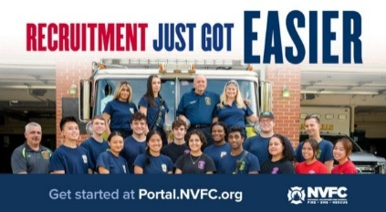
Does your fire or EMS department need more volunteers? The National Volunteer Fire Council (NVFC) is here to help! Use the FREE department portal from the NVFC’s Make Me A Firefighter campaign to access tools and resources to help you find and keep volunteers.
GET STARTED NOW AT THIS LINK:
https://tracking.police1.com/t/9495565/187515077/7816037/1/1006865/?b44ed14b=YmY5NWQ4NzktNWRmOC00MWJkLTkzMDctNzg0Y2VhZTNjMzYy&x=1ee5e8f9

FIREFIGHTER HEALTH AND SAFETY – PROTECTING OUR OWN
4
LINE OF DUTY FIREFIGHTER DEATHS FOR 2026
In 2025 we experienced 78 LODDs reported nationally.!

FIRE SERVICE FATALITIES OR DIBILITATING INJURIES
- A Los Angeles Fire Department firefighter sustained injuries after falling from a ladder while battling a house fire in the Arlington Heights neighborhood, officials said..
- White Level, North Carolina Firefighter/Safety Officer Dale Malone, 66, died after suffering a medical emergency in a department vehicle.
- .

FIRE APPARATUS ACCIDENTS
- Ambulance Crash on Mississippi Highway Leaves Patient Dead, EMS Crew Hurt. The Pafford, Mississippi EMS ambulance was hit head-on by a pickup truck headed south in the northbound lanes of I-55.
- A fire department pumper truck responding to a mutual aid call for a large brush fire in Stewartville, Alabama was destroyed in a single-vehicle crash earlier this week. The driver, who was the only passenger was not seriously injured. The engine was essentially destroyed.
- A firetruck, South Metro Engine 17 of South Metro Fire Rescue, Denver, Colorado, was involved in a motor vehicle crash in Highlands Ranch.
- Two people were taken to the hospital following a crash involving a Sonoma County, CA Fire District fire engine. Two people were taken to the hospital, and no firefighters were injured.
- Three firefighters were taken to the hospital after colliding with a vehicle at an intersection while on the way to a fire call at the Ross Park Mall.
- Multiple people are hurt following a crash involving a fire truck in the Juniata Park section of Philadelphia. The female driver of the SUV and two child passengers were taken to a hospital for treatment.

FIREFIGHTERS FALLING THROUGH
- .
FIRE APPARATUS

**The Impact of New EPA Emission Mandates for Fire Apparatus Diesel Engines
Jeffery D. Gaskin
KEY TAKEAWAYS
- The Environmental Protection Agency’s 2027 mandates regarding diesel engines, which focus on emission control systems and hardware, will have the biggest effect on apparatus design since 2010.
- 2027 diesel engines will generate the heat that’s required for selective catalytic reduction (SCR) solely with electricity, using a 48-volt DC, liquid-cooled alternator. The alternator will take up space that previously was occupied by the power steering pump, air compressor and 12-volt DC alternator, which will require the latter components to be moved.
- Engine doghouses will change in conjunction with the 2027 EPA emission mandates, although those changes aren’t defined completely at this time.
For the past couple of years, the major focus of fire apparatus purchasers and manufacturers has been the looming introduction of Environmental Protection Agency 2027 emission-compliant diesel engines. This process began with the 2007 emission mandates, and evolving diesel emission standards over the past 20 years drove many changes to the diesel engine and emission controls, some more visible to the user than others.
The 2027 changes that are required by the EPA, which focus on emission control systems and hardware, will have the biggest effect on apparatus design since 2010.
EMISSION CONTROL SYSTEM
L9 and X12 engines will be discontinued and replaced with two versions of a completely new X10 engine. The medium-horsepower/medium-torque version of the X10 will have horsepower, torque rating and performance curves that mirror that of the L9 engine (450 maximum hp/1,250 ft.-lbs. of torque). The high-horsepower/high-torque version of the X10 (450 maximum hp/1,650 ft.-lbs. of torque) will replace the X12 engine. Power and torque curves still are being finalized for this version, along with other changes, so that the engine matches the outgoing X12.
An X15 engine still will be available, but it will be a different version of the X15 that currently is available.
The actual engine change date is Jan. 1, 2027, but any new apparatus that’s ordered now probably will be fitted with a 2027-compliant engine because of the current order backlog.
The technology and function of the emission control system won’t change. For clarity, regeneration is the self-cleaning cycle for diesel particulate filter (DPF) and is performed as needed to remove filtered particulate matter and to maintain flow through the exhaust system. Selective catalytic reduction (SCR) chemically converts oxides of nitrogen (NOx) into gases that are less harmful to the environment, utilizing diesel exhaust fluid (DEF) and/or heat. SCR takes place whenever the engine is running.
Because EPA mandates are to lower emissions with a large emphasis on NOx reduction, operational and design changes to the emission control system will be necessary. Currently, when extra heat is needed for SCR, it’s created by dosing raw diesel fuel into the exhaust system. The 2027 engines will generate the additional heat that’s needed for the SCR process solely with electricity, using a 48-volt DC, liquid-cooled alternator. This is a sealed unit that’s used exclusively by the emission control system. This alternator takes up space that previously was occupied by other mission-critical components (power steering pump, air compressor, 12-volt DC alternator, etc.), which will require moving those components and changes to the engine tunnel.
The SCR and the DPF, both of which are housed currently in a single canister, will be separated into two units, similar to the 2010 engines. Both units will be significantly longer, and the SCR will become a side-by-side unit that has been described as peanut-shaped.
HEAT MANAGEMENT
The hardware changes and additions that are noted above present real design challenges for all apparatus manufacturers. Since fire apparatus engines are packaged into tight little boxes in the middle of the cab assembly, cooling the engines in custom fire chassis always has been difficult. It’s very complicated to move the needed cubic footage of airflow for proper cooling. It’s even more challenging to control the turboboosted charge air temperature. Fire pumps, front suctions, torque boxes and outrigger/jack support assemblies compound design challenges and further complicate fitting all of the firefighting components into the chassis with the vehicle operational components.
Engine doghouses also will change. As is the case with so many elements of this process, those exact changes aren’t defined completely. Expect to see a bump-out to accommodate hardware that’s relocated to accommodate the 48-volt emission control power supply. I saw one photograph of a new-style doghouse that has a step-out at the rear where it meets the cab floor.
Physically, the new engines won’t get much larger. I believe that the bigger problem will be heat management, which will dictate the form and size of the new engine enclosures.
Changes in the exhaust system hardware will present bigger challenges. Fire apparatus manufacturers must follow design and layout protocols from the engine manufacturers, and all layout options must be approved. Engines must be put into cabs and given extensive testing to see whether operational temperatures can be maintained in compliance with specifications. Consider that for a minute: These engines that are mounted in the cab and chassis assemblies must be capable of pumping at capacity while the engine and emission control system maintains coolant temperature, engine oil temperature, charge air temperature, transmission temperature, and emission control system function and temperature whether it’s a July afternoon in Phoenix or a January night in Alaska.
EFFECTS OF THE CHANGES
At the Fire Apparatus Manufacturers’ Association Apparatus Symposium in October 2025, there was an excellent presentation on some of the effects of these changes. Although far from extensive, the presentation discussed many of the challenges for both engine manufacturers and cab and chassis manufacturers. It also covered some of the adjustments that we might see. Some of the information that follows is from that conference, while some is from discussions that I had with others in the industry.
- Expect to see changes to battery boxes and DEF tanks and possibly some cab layout changes. Specifics will vary from manufacturer to manufacturer.
- Spartan will discontinue the cabs that have the 67½- and 74-inch cab-to-axle measurements; it will continue to manufacture the cab that has the 70-inch cab-to-axle measurement and will add a 77-inch cab-to-axle version.
- With the exhaust system running along the right-side chassis rails, one expert believes that the R-1 compartment floor will be approximately 6–8 inches higher than that of current offerings.
WORK IN PROCESS
Because this is an incomplete picture of the changes and their effects, I contacted representatives of multiple manufacturers, including Faisal Naveed, who is the business unit director for cab, chassis & electrical at Pierce Manufacturing. Pierce’s team responded with some additional information:
- “The minimum ‘combined’ front body/pumphouse will be 45 inches, which is similar to what it is today. For example, if a 34-inch pumphouse is required, there will be a required 11-inch speedlay.”
- Pierce expects “very minimal impact to the cab itself. The only changes known right now pertain to small changes to the engine doghouse shape/dimensions and some possible impacts to some storage compartment option dimensions.”
- I didn’t receive a specific answer about whether front suction still will be 5-inch piping or whether it would be reduced, but Pierce stated that it expects the front suctions to be “the same as we have today.”
Although it can be frustrating to have so few definitive details, it isn’t an indication that anything is wrong. The testing process for these 2027 engines is extraordinarily comprehensive, must be done in each cab and chassis combination for each version of the engine that’s offered, and can’t begin until cab and chassis manufacturers receive engines.
Understandably, manufacturers don’t want to provide information that might later be disproved nor say that they will discontinue a feature that turns out to be compliant when testing is done.
I strongly believe that this information will change as the year and the testing cycles progress and fervently hope that we learn more from cab and chassis manufacturers soon.
THE CHANGING FIRE SERVICE

N.J. fire department only had 2 firefighters to respond to a fire call at a 10-story residential high-rise
Matthew Enuco, NJ.com
Ongoing staffing issues in Collingswood’s fire department created a delayed response at a recent fire call to a high-rise residential building, according to officials.
The fire company only had two firefighters to respond to a fire call at Parkview Towers, a 10-story residential high-rise, at 3:45 p.m. on Jan. 18 for a reported fire, placing almost 1,000 residents at risk, officials from the local union said in a social media post.
Camden County’s local International Association of Fire Fighters said in a recent Facebook post that the department had four firefighters on duty but only two could respond to the fire.
Four firefighters were on duty at the time of the call, but two firefighters were dedicated to EMS services, a staffing and response issue that was the subject of a legal dispute between borough commissioners and the town. The two firefighters dedicated to EMS were already responding to a call, according to the post.
Once at the scene, Collingswood firefighters could not appropriately respond to the incident and had to wait for another company to respond, according to the post.
The incident ended up being smoke from a cooking fire, but officials said the outcome was pure luck. “If this had been a working fire, a rescue scenario or a rapidly escalating emergency, the outcome could have been catastrophic,” the post said.
Capt. Julian D’Alonzo of the Collingswood Fire Department said Monday night at the Borough Commission meeting that the department’s staffing issues are complicated by staffing both an ambulance and the department’s fire trucks. [NOT THE ONLY DEPARTMENT DOING THIS!!]
The department’s firefighters are assigned to fire calls when there are no EMS calls, leaving the department unable to respond to EMS calls while firefighters respond to a fire call, he explained.
And when firefighters respond to an EMS call when there’s a report of a fire, the department is left short staffed to respond, D’Alonzo continued.
“This is not enough to safely or effectively manage fires, rescues, or any other life-threatening incidents,” D’Alonzo said.
In Collingswood, other departments respond to fire calls under mutual aid agreements, but D’Alonzo said those agreements were designed as backup, not to replace the borough’s own fire coverage.
Collingswood has a total of 17 full-time firefighters, including the chief and a captain. A total of four firefighters and one administrator are assigned to each shift to cover both fire and EMS calls, Collingswood Fire Chief Geoff Joyce told NJ Advance Media.
The department paid out over 3,400 hours in overtime last year to cover paid-time off and two firefighters that took family leaves, according to Joyce. Even after paying that much overtime, the department still had 1,785 hours during the year where shifts only had four firefighters, Joyce said.
The fire department has used part-time staffers to fill scheduling gaps since 2016, but many have left for full-time positions where they don’t have the added responsibility of EMS coverage, according to Joyce.
Collingswood receives over 4,000 calls for emergency services per year, well above area averages of 1,500 calls annually in neighboring departments with similar staffing levels, Joyce said. The borough has a population of over 14,300 residents and includes a variety of structures including high-rise apartment buildings, mixed-use store fronts, industrial centers and single-family homes.
Collingswood has dealt with this type of staffing issue for years, but it appeared to be resolved in December after borough commissioners approved a resolution to outsource EMS services to Virtua Health EMS in December.
But Commissioner James Maley filed a lawsuit in December claiming the new mayor, Daniela Solano Ward, should have recused herself from casting the deciding vote in awarding the EMS contract based on a conflict of interest, saying her husband worked as a doctor for Virtua.
Maley had spent over two decades as Collingswood’s mayor until last year when Solano Ward took over.
“It’s a problem that is not unique to Collingswood but it is something that has been ignored in the past,” Deputy Mayor Amy Henderson Riley said.
Collingswood and Maley settled the case on Jan. 16 and agreed to rescind the resolution awarding EMS services to Virtua. As a condition of the settlement, Ward must recuse herself from future EMS evaluations. The settlement also included a condition for the borough to adopt a public process and hire a consultant to review whether outsources EMS services is necessary.
“Doing nothing is no longer acceptable,” Riley said. “We will see what the recommendations of a neutral third party are and move forward.”
At Monday’s commission meeting, Maley said the borough hopes to approve a Request for Proposals for a consultant by the end of February and award a contract by March or April.
Reached Wednesday, Maley did not comment further on the union’s social media post or Joyce’s statement.
Joyce said he was happy to hear the borough was hiring a consultant to investigate the department’s needs.
“Our staffing situation is dire and we are not the only community in the state and nation facing these issues,” Joyce added.

Volunteer Fire Company Balking Unified Command Shut Down in Norwich, CT
Dan Drainville, The Day, New London CT
The city has shut down the Yantic Fire Engine Co. No. 1, one of the city's five volunteer departments, stating that the 179-year-old department has not complied with the city's Unified Command" directive.
The directive, which was announced last August by City Manager John Salomone and City Fire Chief Sam Wilson, was designed to unify the paid and volunteer fire services, by decreasing fragmentation between the paid and volunteer staff. In addition to establishing a new command structure with Wilson at the top, the directive standardized training, communications and emergency response protocols for both paid and volunteer fire services in the city.
But, not all volunteer departments have agreed with the directive, and the way it's been implemented. Yantic has led that charge.
"I think the root of the problem is we don't want to be under this Norwich fire service umbrella, and again, we want to retain our autonomy," Yantic Volunteer Chief Bobby Allen said, standing next to trucks inside the department Tuesday afternoon. "We have our officers. We run our district, our section of Norwich."
On Monday night, at 7:31 p.m., Salomone sent an email to Allen stating that if he did not sign an agreement by 10 a.m. Tuesday stating that he would comply with the directive, the Yantic department would face enforcement action.
This included removing the department from 911 emergency responses, freezing its funding and reallocating its fire equipment, which is owned by the city.
The first two of those enforcement actions have occurred, Salomone and Wilson said Tuesday. City fire personnel attempted to get into the Yantic Fire Department Tuesday to repossess the fire trucks, but were locked out.
The Yantic district is now being covered by city firefighters, Wilson and Salomone said.
"We put a staffed engine company out, centrally, in the Yantic District," Wilson said. "So they’re going to be more centrally located. And then they’re also staffing out there, which is not something that Yantic typically provides. They’re a volunteer organization. So, there’s actually been an increase in coverage out in that community.
Salomone said the Yantic department can resolve the issue by signing the agreement. The Yantic department though has just filed a lawsuit challenging the city's action.

FOLLOW UP:
Daniel Drainville, The Day, New London, CN
Norwich — City employees with a police escort on Wednesday repossessed fire trucks being used by Yantic Fire Engine. Co. No. 1, a volunteer fire company that was shut down by the city a day earlier.
Around 1:42 p.m., a green public works van, a Norwich police car and a black SUV pulled up outside the firehouse. Out of the SUV climbed City of Norwich Fire Chief Sam Wilson, who promptly fixed his white Bell hat atop his head. At the same time, Sgt. Rich Cannata exited his cruiser, which was parked on the side of Yantic Lane opposite the fire house. Wilson walked up to the green van, and ushered out eight public works employees.
Together, the public works employees, and Wilson, walked toward five pieces of fire apparatus — three engines, one rescue truck and a squad truck. About an hour beforehand, Yantic volunteers had moven them from their usual place in the fire house engine bays, to the parking lot, in anticipation of the city's arrival.
Chief Wilson did a quick count of the vehicles before going over to shake the hand of Yantic Volunteer Chief Bobby Allen. Allen later summarized Wilson's greeting to him in three words: It's not personal."
Wilson then moved his SUV from the side of the road, and the public works employees, together drove the five vehicles out of the parking lot, down Yantic Lane, and out of sight. They were followed by Wilson and Cannata, creating a convoy.
On Tuesday, the city shut down the Yantic department, over failure to comply with the city's "Unified Command" directive, which, announced last summer, aimed to unify the city's fire services, by decreasing fragmentation between the paid and volunteer staff. In addition to establishing a new command structure with Wilson at the top, the directive standardized training, communications and emergency response protocols for both paid and volunteer fire services in the city.
The city said Yantic had not complied with that directive, and that therefore would face removal from the 911 system, loss of access to city funds, and have the city-owned trucks repossessed and redistributed amongst other departments.
City firefighters are now operating a substation in Yantic, with one fire engine staffed by an officer and two firefighters at a time, out of the Public Works garage on Clinton Avenue.
As employees reclaimed the trucks from Yantic, Wilson, could not say where the trucks will go to. He said first, the city will first take an inventory, and that will be followed by what he referred to as the "reallocation."
Earlier in the day, just after noon, Allen had been served a court-ordered injunction by a U.S. Court Marshal, ordering the return of the fire apparatus to the city.
“Well, they want our trucks,” Allen said, his black readers on, summarizing the court papers he just read.
Shortly afterwards, Allen was on the phone with City Manager John Salomone. The conversation was brief. Allen had said he'd leave the trucks out in the parking lot, to which Salomone agreed.
All morning, TV news reporters filed in and out of the station.
At 7 p.m. Wednesday night, more than 100 current or former volunteer personnel, their families and friends, and residents who support the volunteer fire service, packed a Public Safety Commission meeting held at the former Chelsea Groton Bank building at 300 Main St.
During a lengthy public comment period, they protested the decision to shut down Yantic, and the city directive. Many lambasted Wilson, who sat in the front row and often gazed down at a yellow legal pad of notes on his lap.
Several speakers referred to the decision to close the station as "bullying," or "strong-arm" tactics. They raised public safety concerns of all varieties, and concerns over taxes.
Kaitlyn O’Connell, who lives across the street from Backus Hospital, said she was a former Yantic firefighter of 11 years, and her father served as chief for 13 years.
"This isn't just about taking away fire trucks. It's not about just taking away people's safety. This is about family," she said. "I really, really implore you to rethink this. And to come back together. Because no matter what, the number one thing this should be about, is saving lives. That is the number one and top priority.
This is a developing story.
THE BUILDING AND FIRE CODE ISSUES – WEEKLY REPORT ON FIRE FATALITIES
The New ICC Code-NYS Edition went into effect on December 31st 2025 although the implementation of the energy code provisions have been withdrawn until further notice.

HOME FIRE FATALITIES REPORTED BY THE MEDIA FROM THE US FIRE ADMINISTRATION FOR 2026
Fire Deaths in 1&2 Family Dwellings in NYS | 12
Last fire death 2/11/26 Bellmore, Nassau Co., Male 70
Fire Deaths in any type of Dwelling in NYS | 22
Fire Deaths in 1&2 Family Dwellings Nationally | 198
Top 3 States with the greatest 1&2 Family Deaths | #1 OH & TX/13
 | #2 NY & GA/12
 | #3 WA/11
Civilian home fire fatalities in 2026: 357
Both the states of Maryland and California as well as Wash. DC require sprinklers in 1&2 family dwellings.
According to realtors and builders only old homes burn, so sprinklers are not needed in new homes: so my question to you is; when does a new home become an old home?

OSHA Fines MA Assisted Living Facility for 13 Safety Violations After Deadly Fire
Hadley Barndollar – masslive.com
The federal Occupational Safety and Health Administration has fined the operator of Gabriel House assisted living more than $180,000 for 13 citations, including 11 deemed “serious.”
Ten people were killed by a five-alarm fire that ripped through the Fall River assisted living facility on the night of July 13, 2025. It was the deadliest fire in Massachusetts in more than 40 years, exposing major gaps in fire safety and emergency preparedness across assisted living and state oversight of the industry.
OSHA, which began its on-site investigation in August, issued the workplace safety citations on Dec. 30, 2025 to Gabriel Care Inc., the business operator of Gabriel House that is owned by Dennis Etzkorn. Etzkorn formally contested all 13 citations and the monetary penalties on Jan. 21.
The citations include:
- Trip and fall hazards throughout the building, including various items on floors blocking access
- Stair height hazards
- Exits that weren’t wide enough, as well as a blocked exit ramp
- Exits that were not clearly marked
- Lack of employee training for “safe and orderly evacuation”
- Fire prevention and evacuation drills were not reviewed with employees
- Exposed electrical wiring
- Exposure to highly flammable fuel
- OSHA logs from 2020, 2022 and 2023 not signed by company executive
The $186,778 in OSHA fines come as a state Appeals Court judge last month denied an effort by Etzkorn to access his property insurance money to rehab the building, the Fall River Herald News recently reported.
Etzkorn was seeking access to $6 million in insurance money that the many plaintiffs suing him have attached to their civil lawsuits. The Herald News reported his attorneys argued the 261 Oliver St. building will fall into ruin without the funds.
Etzkorn did not have liability insurance, and it’s not required in Massachusetts that assisted living operators do. He is currently facing 12 personal injury or wrongful death lawsuits filed in Bristol County Superior Court by Gabriel House fire survivors and relatives of the deceased.
All of the suits assert negligence, claiming the sprinkler system was known to be defective and that the assisted living facility was not properly managed, supervised or inspected.
Etzkorn and his attorneys have denied the lawsuit claims. His spokesperson did not immediately return a request for comment Friday on the OSHA citations.
Last month, the state’s Assisted Living Residences Commission delivered final recommendations to Gov. Maura Healey and lawmakers for industry reforms intended to “strengthen safety, transparency, consumer protection and affordability.” The commission’s focus shifted to emergency preparedness and fire safety after the Gabriel House fire last July.
The state’s investigation into the fire — headed by the Bristol County Attorney’s Office and Department of Fire Services — remains ongoing.
GREEN ENERGY AND THE IMPACT ON THE FIRE SERVICE

Trapped Tesla Driver’s 911 Call: ‘It’s on Fire. Help Please’
Dana Hull & Madlin Mekelburg, Bloomberg News
Samuel Tremblett pleaded with a 911 operator to be rescued from his burning Tesla Inc. Model Y SUV after a crash in October: “I can’t get out, please help me.”
The transcript of the 20-year-old’s emergency call was included in a lawsuit filed Wednesday, the latest to allege that a driver or passenger died after they were unable to open the electrically powered doors on their Tesla vehicle after a crash.
“It’s on fire. Help please,” Tremblett said, according to the lawsuit. “I am going to die.”
Details of the crash were previously reported by Bloomberg News as part of a wide-ranging investigation into the hazards of electric door systems, which can fail and trap occupants inside vehicles, particularly after a crash. The reporting uncovered at least 15 deaths in a dozen incidents over the past decade in which occupants or rescuers were unable to open the doors of a Tesla that had crashed and caught fire.
After Tremblett survived the initial impact of the collision, which occurred in a town about 30 miles outside of Boston, his remains were found in the back seat, according to a police report of the incident.
“Unable to open the doors, Mr. Tremblett was trapped in the Tesla vehicle and died from thermal injuries and smoke inhalation before he was able to be rescued,” according to the complaint filed Wednesday in Massachusetts federal court.
Tesla didn’t immediately respond to a request for comment.
A top Tesla executive said in September that the company was working on a redesign of its door handles. In December, Tesla updated its website to say that after a serious collision is detected, hazard lights will turn on to increase visibility and “doors will automatically unlock for emergency access.”
Tesla is facing multiple lawsuits over crashes that allegedly involved door-related entrapment, including cases filed last year in Washington state and Wisconsin.
The company was sued in October over claims that defects in the doors of a crashed Cybertruck in Piedmont, California, made it a “death trap” by preventing three college students from escaping before they died of smoke inhalation.
Tesla vehicles have two batteries: a low-voltage battery that operates interior functions like windows, doors and the touchscreen, and the high-voltage pack that propels the car. If the low-voltage battery dies or is disabled, the doors may not unlock and must be operated manually from the inside. While there are mechanical releases inside Teslas, many owners and passengers are unfamiliar with where they’re located or how to operate them.
Global scrutiny
Electric handles — which were popularized by Tesla and are now found in dozens of models from many automakers — have attracted global scrutiny in recent months. China issued new safety rules banning concealed exterior handles and requiring mechanical releases, while European regulators have said they intend to accelerate rulemaking on the matter.
In September, days after Bloomberg’s initial investigation into Tesla’s handles, the National Highway Traffic Safety Administration disclosed that it was probing possible defects in certain Model Y SUVs, citing incidents in which exterior handles stopped working and trapped children and other occupants inside. In December, NHTSA said it would evaluate a request for a defect probe that was filed by a Georgia man who had to kick his way out of his burning Model 3 sedan.
A U.S. lawmaker in January proposed legislation that would require manual door releases in new cars as well as means for first responders to gain access to vehicles when power is lost.
SHARE THE OPPORTUNITIES


Working Shorthanded Preparing for Responses When We Need More People ESIP WEBINAR SERIES
In this webinar, we will look at the ever-growing problem of responding to emergencies with shortened numbers of personnel. We’ll discuss ways to combat this challenge and offer suggestions to improve the issue.
Presenters: Dave Denniston, SVP Risk Management & Lee Price, RM Training Supervisor
WEDNESDAY 2/18/26 at 7:00PM REGISTER AT THE FOLLOWING LINK:
https://us.list-manage.com/JDvt7Rkw-C6?e=781e9a2c81&c2id=df3ef39abf096be1508115a6ea1a79c8

State Chief’s Scholarship Program
Applications are now being accepted for the NYSAFC Scholarship Program and the Chief Neil McNeight Hands-On Training Award. Nominations are being accepted for the Chief Fred Singer Fire Educator of the Year Award, James Wright Public Education Award, and New York State Fire Chief of the Year Awards. Please note changes to the Scholarship Program for 2026. Three $1,000 scholarship awards will be granted in memory of Chief Ward Bohner and his wife, Janice Bohner, Chief Anthony Messina, and Chief James Hare. The deadline for submitting required materials is April 1, 2026. Eligibility criteria is available in the Application & Nomination Package. GO TO THIS LINK FOR MORE INFORMATION: https://www.nysfirechiefs.com/awards

NYSAFC is Bringing Hands-On Training to Your Area!
BEYOND THE BASICS
Dutchess County
March 28-29, 2026
Host: New Hackensack Fire District
REGISTRATION: https://www.nysfirechiefs.com/beyondthebasics
FIRE BEHAVIOR ON THE INSIDE
Clinton County • April 11-12, 2026
Host: Peru Fire Department
Ulster County • May 30-31, 2026
Host: Glasco Fire Company
REGISTRATION: https://www.nysfirechiefs.com/firebehavior
FLASHOVER
Albany County • September 26-27, 2026
Host: East Berne Volunteer Fire Company
REGISTRATION: https://www.nysfirechiefs.com/flashover

Attendee and Exhibitor Registration is Open for the NYSAFC Annual Conference & Expo
The association's 120th Annual Conference & FIRE 2026 Expo will be held June 10-13 in Syracuse. Changes for 2026 include reduced conference Full Term Registration fees ($50 for association Individual Members and $100 for non-members), a new Hands-On Training course – “Initial Attack: First-Due Company Operations,” and new event hours on Thursday. Free One Day Tickets for the expo will once again be available from exhibitors!

Rural Water Supply Operations Seminar: Moving Big Water with No Hydrants
Pittstown Fire Dept, & the Rensselaer County Fire Chiefs Association
Saturday and Sunday, April 18th & 19th, 8:00am to 4:30pm
Pittstown Fire Dept. 134 Parker School Road, Johnsonville, NY 12094
For more information contact Pittstown Fire at 518-663-5773 leave a message or at car1station25@gmail.com

NYSAFC 2026 Seminar Series “Dangerous Spaces: Challenges and Tactics When Dealing with Garage and Basement Fires” With Chief/Commissioner Michael Lombardo (Buffalo Fire Department)
Three-Hour Seminar:
Some of the most dangerous fires we deal with are often looked at as routine: the basement fire and the garage fire. Basement fires are probably the most overlooked killer of firefighters engaged in combat firefighting in much of the U.S. The construction, layout, fire load, and access present difficult and dangerous challenges at below grade fires. From the incident commander to the firefighter on the nozzle, we must all recognize and be able to deal with these challenges. Huge migration to the suburbs starting with the arrival of the Baby Boomer generation saw the explosion of the attached garage. Many older cities never had the available space for homes to feature an attached garage or have any garage at all. The tremendous fuel load that is constantly evolving presents danger for occupants and firefighters alike. This class will address these challenges and alternative strategies and tactics that can be deployed to deal with these dangerous spaces.
Registration Fee:
$35 per person – NYSAFC Individual and Department Members
$50 per person – Non-Members
Pre-registration is encouraged. On-site registration will be accepted if space permits.
Note: A 3% service fee will be applied if paying by credit card.
2026 Dates and Locations:
Seminar begins at 7:00 p.m. at all sites. Registration area opens at 6:30 p.m.
February 18 – Herkimer County
Newport Fire Department • 7370 Main Street • Newport, NY 13416
March 3 – Schenectady County
SUNY Schenectady Community College • Stockade Building • Room 101 • 78 Washington Avenue • Schenectady, NY 12305
September 10 – Fulton County
Berkshire Fire Department • 320 Steele Avenue Ext. • Gloversville, NY 12078
September 16 – Saratoga County
Saratoga County Public Safety Building • 6012 County Farm Road • Ballston Spa, NY 120
September 22 – Dutchess County
Pleasant Valley Fire District • Station 1 • 1619 Main Street • Pleasant Valley, NY 12569

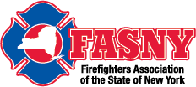

Risk Control in Emergency Services, Are You the Problem or The Solution!
Date & Time Thursday Feb 12, 2026 07:00 PM
This dynamic and interactive webinar is designed for all field personnel, supervisory staff and training officers to provide an understanding of how each individual Emergency Responder within an organization plays an integral and vitally important role in overall risk reduction. Sound risk reduction aids in the creation of a safety culture within the organization. Additional topics include written policies, rules and regulations, as well as equal and equitable enforcement.
REGISTER AT THIS LINK:
https://fasny.zoom.us/webinar/register/WN_17ooxpkhSruFZv6ty7e7iw#/registration

NEIGHBOR’S HELPING NEIGHBORS

Gansevoort Fire Department Breakfast
The fire company thanks you for your support!! Breakfast will be served starting at 8AM Sunday March 15th

Clifton Park Fire Department Breakfast
Thank you for your support! Next Breakfast in April TBA from 8 to 11am

Speigletown Fire Department Breakfast 2nd Sunday of each month
Sunday March 8th from 7:30 to 11:30, $10 adults, $5 children, under 5 free.
GENERAL INTEREST TO ALL

**Getting Started with Cooperative Buying: A Step-by-Step Guide for Fire Chiefs
Bill DeMars
Fire departments today face the challenges of stretching budgets while providing the highest level of service to their communities. An effective strategy to optimize procurement processes and maximize resource allocation is through cooperative buying. Cooperative procurement offers fire departments the advantage of buying in bulk, leveraging the purchasing power of multiple entities to secure better pricing and contract terms. Whether you are new to cooperative buying or looking to refine your process, this step-by-step guide will help fire chiefs get started effectively.
1. Understand Cooperative Procurement
At its core, cooperative buying (or cooperative purchasing) involves several entities coming together to purchase goods or services collectively. By pooling resources, fire departments can achieve cost savings and efficiency improvements. Start by familiarizing yourself with how cooperative purchasing functions and how it can benefit your department specifically.
2. Research Cooperative Purchasing Organizations
Several cooperative purchasing organizations exist, each offering different products, services, and benefits. When selecting a cooperative, consider the following:
- Reputation and Legitimacy: Research the cooperative’s history, reviews, and other users’ experiences.
- Offerings: Ensure the cooperative offers contracts pertinent to fire department needs, such as fire apparatus, safety equipment, and facilities maintenance services.
- Ease of Use: Consider how user-friendly the cooperative’s processes and systems are.
- Membership Requirements: Understand what is required to become a member – documentation, fees, and other stipulations.
3. Evaluate and Choose the Right Cooperative
Once you’ve gathered information on multiple cooperatives, evaluate them using a scoring system to compare your needs against the organizations’ offerings and terms. Engage with several cooperatives to ask questions and gain clarifications. Consider strategies that align with department goals. Selecting the right cooperative involves weighing factors such as cost savings, product availability, customer service, and ease of transaction.
4. Seek Legal and Managerial Approvals
Before enrolling, consult with legal advisors to review cooperative agreements and contracts to ensure they comply with state and local procurement laws and regulations. Garner management’s approval, presenting clear information on how the cooperative’s offerings align with departmental needs and strategic objectives.
5. Complete Membership Enrollment
Once a suitable cooperative is chosen, complete the enrollment process, which may include:
- Submitting required paperwork and authorizations
- Meeting eligibility criteria
- Registering your department as a member
- Paying any applicable fees
Keep track of any deadlines and documentation requirements throughout this process.
6. Train Staff and Implement Processes
Integrate cooperative purchasing processes within your department’s operations:
- Provide training for procurement staff on how to access and use the cooperative platform effectively.
- Establish protocols for evaluating contracts, ordering, and managing deliveries.
- Ensure accountability by defining roles and responsibilities regarding cooperative purchasing decisions.
7. Leverage Available Resources and Support
Utilize any support and resources offered by the cooperative. Many organizations provide customer service support, webinars, training sessions, and purchasing tools that can help your department maximize the effectiveness of cooperative buying.
8. Monitor and Evaluate Effectiveness
Regularly assess the outcomes and benefits of cooperative purchasing on your department:
- Track cost savings and return on investment.
- Seek feedback from procurement teams and stakeholders.
- Adjust processes and training based on what’s working well and where to improve.
9. Stay Informed and Engage in the Community
Cooperative purchasing is a dynamic field. Stay up to date with industry trends, new opportunities, and enhancements to cooperative services. Engage with professional networks, conferences, and cooperative member events to expand knowledge and discover best practices.
Conclusion
Cooperative buying offers a significant opportunity for fire departments to leverage collective purchasing power to gain efficiencies and cost savings. By following this guide, fire chiefs can ensure their departments are well equipped to start and excel in using cooperative procurement effectively, enhancing their operational capabilities and resource management in service to their communities.
TAKE A MOMENT TO SMILE

Being a little older, I’m very fortunate to have someone call and check on me everyday. He is from India and is very concerned about my car warranty!!

CLASSIFIED

Opening for Part Time Fire District Treasurer/Deputy Secretary
The Greenfield Fire District is currently seeking qualified applicants for the position of part time Fire District Treasurer/Deputy Secretary. Prior experience and individuals residing within Fire District Boundaries given preference. Complete job description and qualifications can be found on the Greenfield Fire District website at: www.greenfieldfd.org. Cover letter/current resume can be mailed to Greenfield Fire District, attn. Joyce Petkus, P.O. Box 103, Greenfield Center, NY 12833, or emailed to Treasurer@greenfieldfd.org, and will be accepted until the position is filled.
CAFDA OFFICERS AND DIRECTORS 2026
OFFICERS
President, Tom Rinaldi, Commissioner, Stillwater Fire District
1st Vice President, Ellen Martin, Deputy Treasurer Clifton Park Fire District
DIRECTORS:
Les Bonesteel Past Commissioner, Burnt Hills/Saratoga,
Skip Smith, Commissioner, West Crescent/Saratoga
Joyce Petkus Treasurer Greenfield/Saratoga,
Ed Woehrle Commissioner Niskayuna #1/Schenectady
Art Hunsinger, Ex-Officio Member Clifton Park Fire District.
We would consider expanding the number of Directors if individuals from other counties would volunteer to participate!!

APPOINTEES
Secretary Molly Jenkins, Region 1 Director, Assoc of Fire Districts, NYS
Treasurer: Tony Hill
Sargent at Arms: Tom Wood, Commissioner, Northumberland Fire District
Chaplain: Dane Fagan
Legal Counsel: Greg Serio, Safety Officer, Verdoy Fire District
The Capital Area Association represents any fire district that wishes to join CAFDA. Fire District Officials include Commissioners, Treasurers, and Deputy Treasurers. Secretaries and Chiefs are also invited to participate!
Please advise your secretaries that all correspondence should be mailed to:
CAFDA PO Box 242 East Schodack, NY 12063
EMAIL TREASURER: TREASURER@CAFDA.NET
518-407-5020
EMAIL SECRETARY: SECRETARY@CAFDA.NET

Long Way to Travel? Zoom into the General Membership Meetings!
It’s our desire that every member fire district have the opportunity to attend Capital Area meetings. We know we cover a large area, in 8 counties and beyond, and wish to give all of our members a chance to participate in the general membership meetings. You have a voice, and we would like to hear it. Join us at our next meeting either in person or via Zoom. The link will be sent via constant contact prior to each general membership meeting. Thank you for being a member and we hope you will join us.

Capital Area BUSINESS PARTNER’S
Business Partner Applications Available At: WWW.CAFDA.NET
WELCOME DIVAL SAFETY EQUIPMENT
Green Boarder = not yet renewed for ‘26
We invite our business partners to submit educational information to be included in this Bulletin for district commissioners and chief officers
We want to thank all of our Business Partners for renewing their partnership for 2026. You are invited to our monthly membership meeting and to any of our social events..
FIRE SERVICE LEGAL SERVICES

Monaco Cooper Lamme & Carr.PLLC
1881 Western Ave, Suite 200
Albany, NY 12203
Nicole Strippoli 518-941-9040
NSTRIPPOLI@MCLCLAW.COM
https://mclclaw.com


The D’Amato Law Group LLP
Gregory Serio, Partner
Alyssa B. Snyder, Partner
111 Washington Ave Suite 600
Albany, NY 12210
518.426.3800
Email: gserio@dlgny.com or
asnyder@dlgny.com
damatolawgroup.com

HAWKINS DELAFIELD & WOOD LLP
William J. Jackson, Partner
1160 Pittsford-Victor Road, M2-11
Pittsford, NY 14534
585-645-1184
Fire Service Bond Attorneys
www.hawkins.com

Whiteman Osterman & Hanna LLP
Bond Counsel
Robert J. McLaughlin, Partner
One Commerce Plaza, Albany, NY 12260
518-487-7697 Cell 518-813-6333
mclaughlin@woh.com
www.woh.com
Ducharme, Clark & Sovern, LLP
Jack Clark, Fire District Attorney
646 Plank Rd. Clifton Park, NY 12065
518-373-1482
Ducharmeclark.com
HANNIGAN LAW FIRM PLLC
388 Kenwood Avenue
Delmar, New York 12054
P: (518) 869-9911
F: (518) 869-9915
www.hannigan.pro
Fire/EMS –Municipal Law

FIRE STATION & FACILITIES ARCHITECTS AND ENENGINEERS


n.lobosco@ctmale.com
Shawn Corp, Principle
15 Cider Mill Way, Saratoga Springs, NY
518.322.1386
www.reveal-ad.com


Architecture/Engineering/Code Services
Melissa Smith – mlsmith@labellapc.com
Senior Marketing Manager
518-903-8394
4 British American Blvd
Latham, NY 12110
www.labellapc.com


Architects & Engineers
433 River Street, Suite 8002
Troy, NY 12180
518-765-5105
Dennis Ross, Practice Leader
www.H2M.com

Managed IT Services
Cloud Telephone Services

Wendel, Centerpointe Corporate Park, 375 Essjay Road, Suite 200, Williamsville, NY 14221 716.688.0766
Amy Numrich, MBA
Digital Marketing & Events Specialist
anumrich@wendelcompanies.com


Ryan Sapienza
Project Manager/Technology Consultant
518-754-4623
Service 518-869-3614
930 Albany Shaker Rd, Latham, NY 12110

Haughey Insurance Agency
850 State Route 50
Burnt Hills, NY 12027
518-399-1583
www.haugheyagency.com
FIRE SERVICE INSURANCE
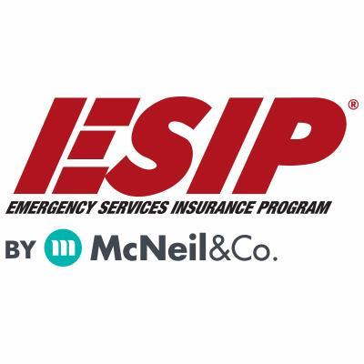
Tony Blackwell, Territory Sales Manager
800-822-3747 ext 530
ablackwell@mcneilandcompany.com
Aurora Inc. Insurance
120 Broadway
Albany, NY 12204
518-449-3180
aurorainsurance.com
Michael May, Broker
mmay@aurorainsurance.com

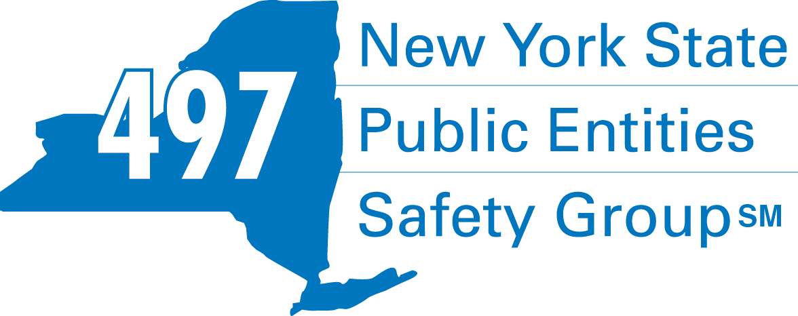
Fleury Risk Management
28 Corporate Drive, Suite 104
Clifton Park, NY 12065
518.478.6314
https://www.fleuryrisk.com/nysgroup497
VFBL Insurances Services
Stephan Petras
Marketing Representative
One Blue Hill Plaza – 16th Floor
PO Box 1609
Pearl River, NY 10965
845-352-8855x7099
329-236-3505
spetras@fdmny.com
VFBL/Workers’ Comp Coverage


Pat Daglio
pdaglio@vfis.com
717.819.3072

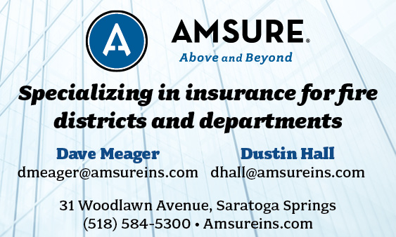

FIRE SERVICE FINANCIAL SERVICES AND LOSAP MANAGEMENT


518-432-5087
838-433-7304 cell
www.thelosapgroup.com.
nikki.haskins@rbc.com
455 Patroon Creek Blvd, suite 200, Albany NY 12206
UBS Financial Advisors
Ralph Lemme, CFP
8 Southwoods Blvd Suite 207
Albany, NY 12211
518.445.1667

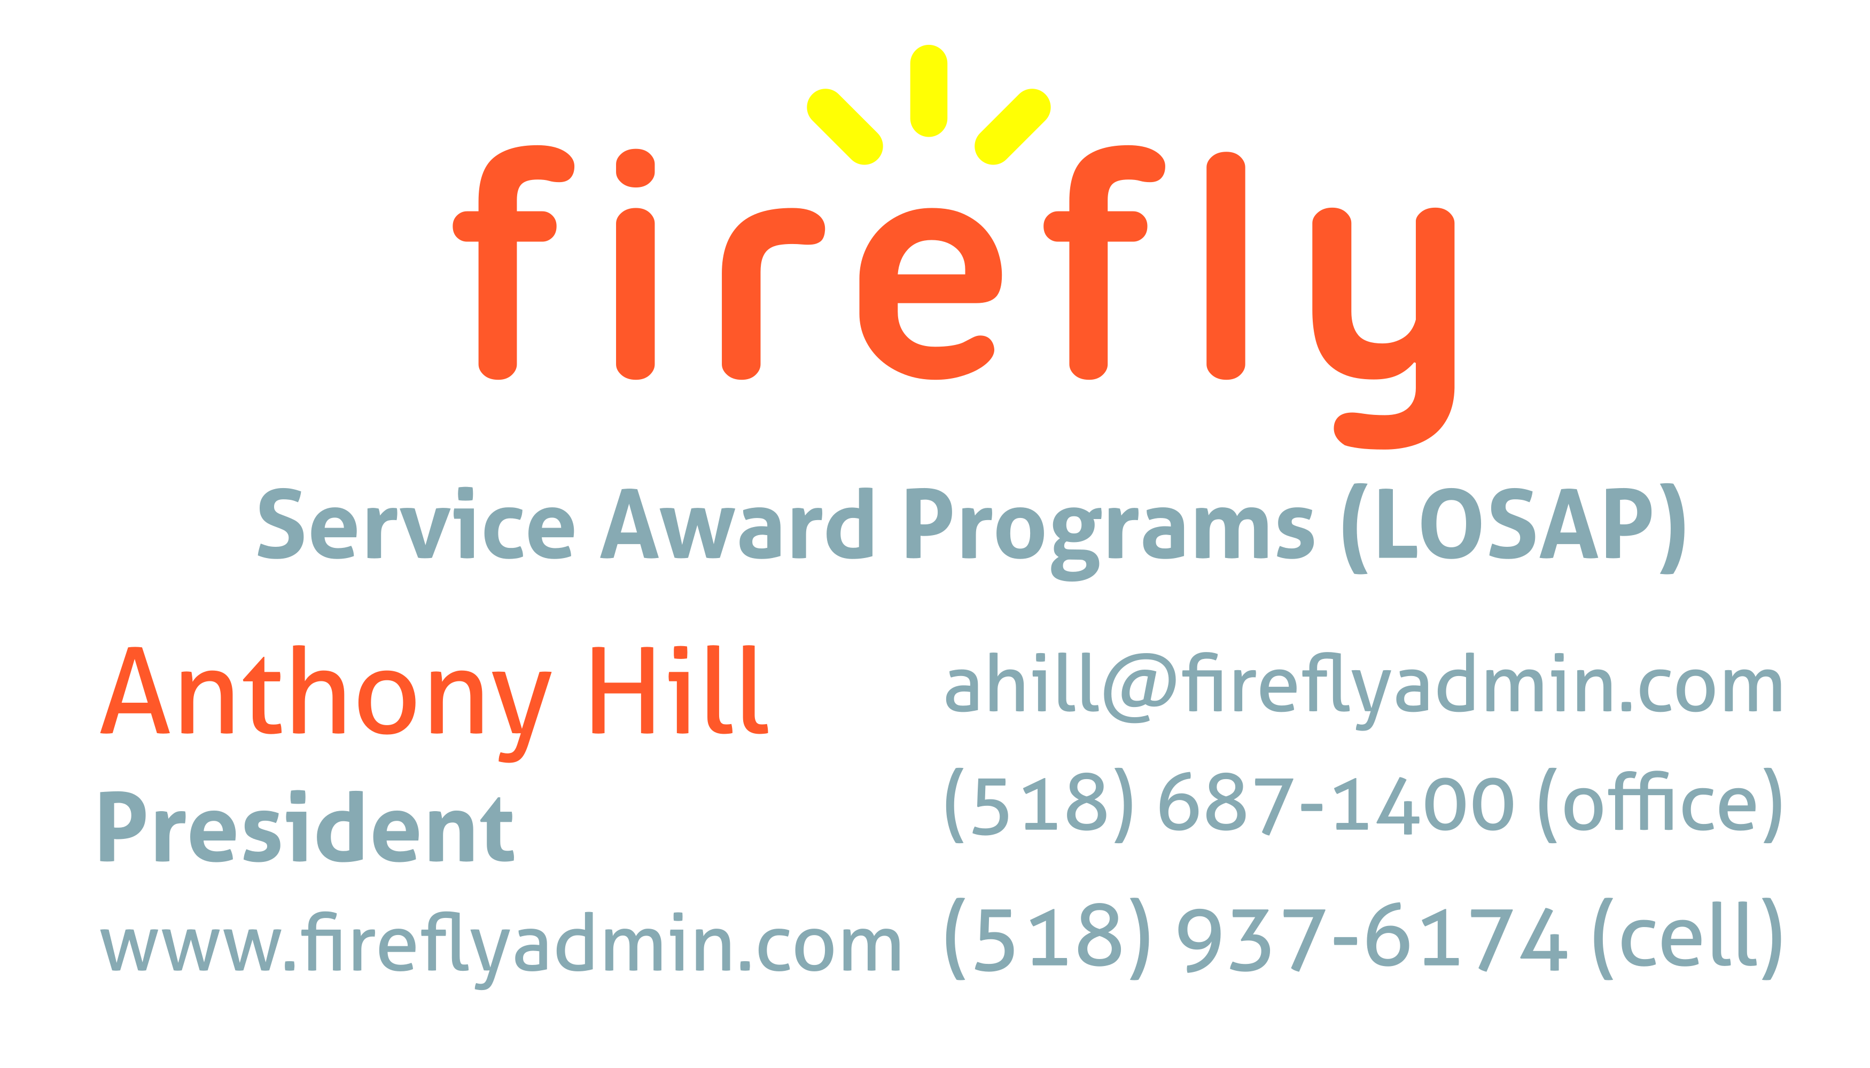


Nicole Meeker
Manager of Business Development & Accts
518-394-7894
Cell 607-423-4811
www.penflexinc.com
nmeeker@penflexinc.com
FIRE EQ TESTING
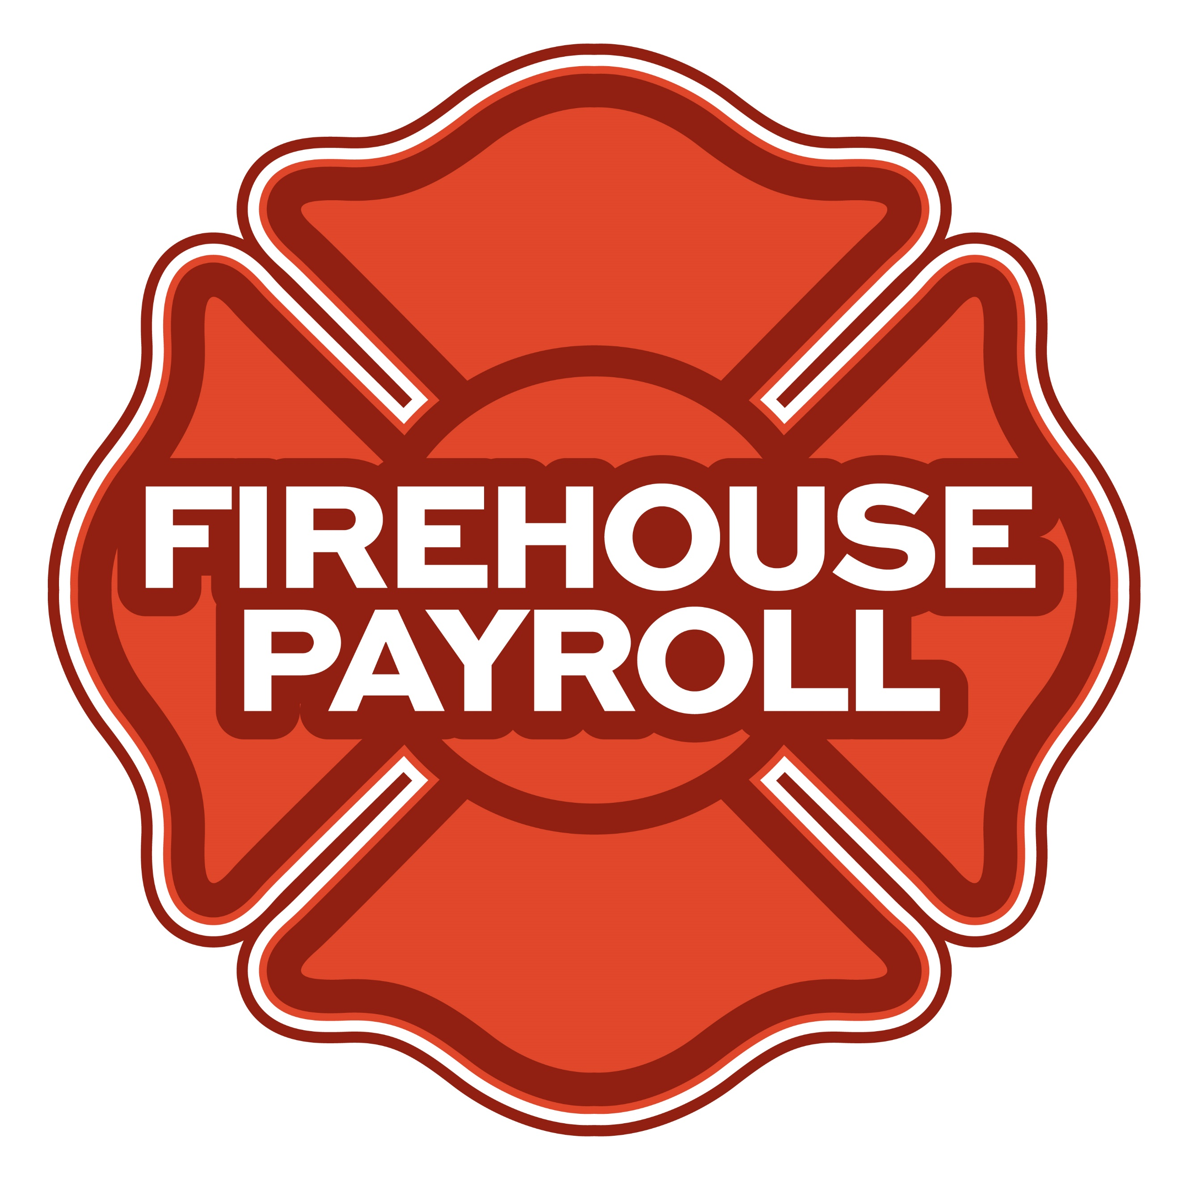
Jeremy Hartnett
302-483-7699
jeremy@firehousepayroll.com
payroll-pension reporting-tax filing
direct deposits-timekeeping-HR Services
FULL-SERVICE FIRE EQUIPMENT
DRYER VENT CLEANING

www.jeromefire.com
Breathing Air Comp Maintenance,
Air Quality Tests and Repairs
Russell Jerome
315-699-4533 Office
Ready Rack Extractor/Washers
Full Line of Fire Equipment
8721 Caughdenoy Rd, Clay, NY 13041

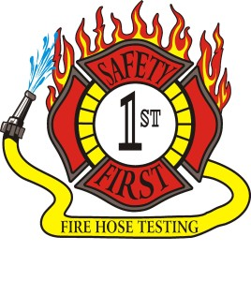Safety First Equipment Testing
99 Glass Lake Road
Averill Park, NY 12018
518-674-8363
www.safetyfirstfirehose.com
HOSE, APPLIANCE & LADDER TESTING
Safety1hose@gmail.com
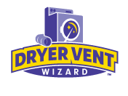DRYER VENT WIZARD
JORDAN CATINO
8 NAPA COURT, SCHENECTADY, NY 12309
518-344-0664
SARATOGADRYERVENT.COM
jcatino@dryerventwizard.com

FIRE DEPT COMPUTER MANAGEMENT & REPAIR

White Wolf Computer, LLC
4 Normanskill Blvd. Suite 410, Delmar, NY 12054
(518) 459-9653
Managed Services
Cloud Hosting Solutions
Telephone Data Cabling
Backup Disaster Recovery
Web Design Services

FIRE COMPANY FUND RAISING

FIRE STATION PEST CONTROL

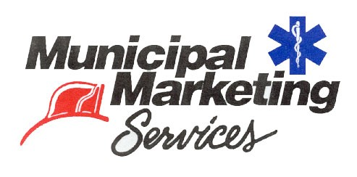
Lloyd Fox, Account Executive
34 Garner Road, Averill Park, NY 12018
Lfox8@nycap.rr.com
518-810-7819
www.funddrive.com

518-300-4732
431 New Karner Rd Suite 170
Albany, NY 12205
https://fox-pest.com/albany-ny

FIRE SAFETY EQUIPMENT
FIRE APPARATUS/SERVICE

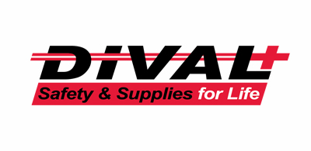
Timmy Kimball
518-925-2786
www.divalsafety.com
Testing-Safety-Promotional Services-Respiratory Solutions
Facility Safety-Fall Protection-Training
60 Cohoes Ave, Green Island NY 12183
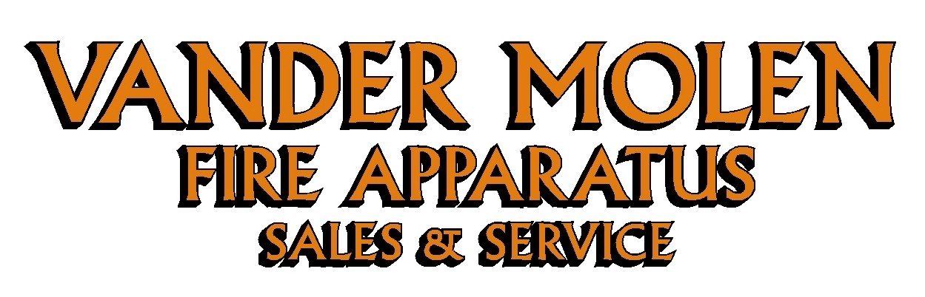
Mike Bonesteel
Warranty & Safety Manager
518-288-3587 X101
Cell 518-926-0451
After Hours 680-800-5015
1 Super 50 Way, Ballston Lake, NY 12019

FIRE DISTRICT CPA/AUDITS/FINANCIAL SERVICES


Zoriana M. Stawnychy
973.283.0024
zoriana@stawnychyfinancial.com
135 Kinnelon Road Suite 101
Kinnelon, NJ 07405
Serving fire districts in New York State


518-459-6700
10 British-American Blvd, Latham, NY 12110
www.bstco.com
Brendan Kennedy ext 356


Robert V. Gramuglia, CPA
1 Pine West Plaza Suite 107, Albany NY 12205
518.452.8055 or 518.859.5851cell
Email: rgramuglia@BGCPA.net



Accounting, Consulting & IT Security
1581 Franklin Ave. Mineola, NY 11501
Kyle Brengel, Managing Partner
516-472-7345
kbrengel@gblny.com


11 British American Blvd, Latham, NY 12110
518-785-0134
Queensbury Office 518-792-6595
http://www.mmbaccounting.com
Alan W. Clink, CPA aclink@mmb-co.com
Heather R. Lewis, CPA hlewis@mmb-co.com

Don McCormack
425 Main Street Catskill, NY 12414
www.tbogc.com
518.943.2600 X607
donaldm@tbogc.com
Specializing in Fire Service Financing


David Farstad, VP-Municipal Banking
652 Albany-Shaker Road, Albany NY 12211
Ph: 518-730-3120
Cell: 518-506-0075
farstadd@pioneerbanking.com
JOHN M. LESNIEWSKI
Assistant Vice President and
Senior Business Banking Officer
Fulton/Montgomery Markets
12 Fremont Street, Gloversville, NY 12078
P: 518.775-5205 | M: 518.848-0612
NMLS ID 915694
www.nbtbank.com


The Arrow Family of Companies
Corporate HQ 250 Glen Street
Glens Falls, NY 12801
518-793-4121
Business Banking Services
Arrowbank.com
Hero Mortgage Program Supporting First Responders Available

The Weekly Capital Bulletin is reaching well over 700+ subscribed fire district members and now other members of the fire service on a regular basis.
This is a service of CAFDA through the effort of Tom Rinaldi who can be reached at tom@rinaldi1.com for comments and content contributions are always welcome.

BECOME A MEMBER OF CAFDA!
The Capital Area Association has voted to amend its By-laws to allow both individual and regional or county Fire District Associations to join. The updated By-laws are posted to the CAFDA.NET website.
Individual membership fee will be $50 annually, fire district association fees will be $300 annually.
Download THE APPLICATION available on the home page at CAFDA.NET
MEMBERSHIP IN THE CAPITAL AREA FIRE DISTRICTS ASSOCIATION (CAFDA)
Would you like to join Capital Area Fire Districts Association along with 100 members in 14 counties? Individuals, fire district associations, fire protection districts and Village departments are all eligible for membership.
Annual dues (January 1st to December 31st) shall be as follows and shall be based on the annual budget of the Fire District/Organization;
$0 to $200,000: $50
$200,001 to $400,000: $100
$400,001 to $600,000: $200
$600,001 plus: $300
Individuals $50.00 or Other County or Regional Associations $300 annually.
Business Partners: $100.00 annual member fee

If You, Your Fire District or Department is not a Member of CAFDA You Can be?
Individuals can be members of CAFDA. The annual membership fee is $50, which will provide you access to this Bulletin, attendance at meetings and social gatherings. Provides networking with other fire district officials and a source of the constant barrage of information related to today’s fire service.
FOR A MEMBERSHIP APPLICATION OR A BUSINESS PARTNER APPLICATION GO TO THE FOLLOWING LINK:
https://cafda.net/membership-info/

