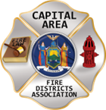
THE BULLETIN
February 28th, 2026

The Voice of CAFDA since 2004
Editor, Tom Rinaldi – tom@rinaldi1.com since 2014
When you see **, highly recommended article
CAPITAL SHORT TAKES
- Go to the last page of this document for Conference ’26 Registration and for Vendor Registration.
- The Assistance to Firefighters Grant (AFG), Staffing for Adequate Fire and Emergency Response (SAFER), and Fire Prevention and Safety (FP&S) programs are all expected to open together soon, with a longer application window of six to eight weeks instead of the usual four.
- See the course offering in March in Fishkill and 2nd session below::::
- This week’s Legislative ScoreCard covers all the updates to fire service-related legislation for the second half of the 25/26 legislative session. See what might affect you in the new year.
- Berne VFD had an alarm activation at their station on Saturday February 21st, upon arrival they discovered they indeed had a working fire in their apparatus bay, mutual aid departments assisted with extinguishment, more information to come. Been there done that several years ago at our station 4, working fire detection and alarm systems are a must in all fire stations, it’s a common occurrence.
CAFDA EDUCATIONAL OFFERINGS: CAFDA.NET

Join us at the NEXT GENERAL MEMBERSHIP MEETING Thursday March 5th features dinner for attendees. Please join us.
ZOOM LINK FOR THE March MEETING at 7pm:

CAFDA IS HAPPY TO ANNOUNCE THE DATES FOR CONFERENCE ’26 IN HISTORIC LAKE GEORGE, watch CAFDA.net for registration coming soon!

April 9th, 10th and 11th, 2026 plan on joining us.

CAFDA will be offering two Fire Service Financial training 2 day sessions in 2026
Much needed two-day fire service financial training, learn to do it right, brought to you by CAFDA & NYS-OSC.
This year being held at Rombout Fire Department, Fishkill, Dutchess County on March 13th & 14th and at McNeil Insurance in Cortland, Cortland County at on March 27th & 28th. Training is provided by trainers from the Office of the State Comptroller. Continental Breakfast and Lunch will be included.

REGISTRATION IS OPEN FOR FINANCIAL TRAINING ON-LINE AT CAFDA.NET

Commissioner Training will be held at 6 locations in 2026 including:

Clifton Park, Saturday March 7th

Niagara Engine Co #6 in Schoharie, Saturday March 21st,

Berkshire Fire District, Gloversville, Saturday March 28th and

Warrensburg Fire District, Saturday April 4th.

The Day after the scheduled date (Sunday) has been reserved as a snow day if necessary.

Open to all newly elected commissioners and Chiefs. This training is required under Town Law Section 176-e. $85 for members, $95 for non-members includes continental breakfast and lunch.
REGISTRATION IS OPEN FOR COMMISSIONER TRAINING ON-LINE AT CAFDA.NET

All correspondence & Capital Area Fire Districts Association Mailing Address should be directed to:
CAFDA PO Box 242 East Schodack, NY 12063 or EMAIL: SECRETARY@CAFDA.NET
Financial issues should be addressed to: TREASURER@CAFDA.NET
LEGISLATIVE NEWS FROM THE STATE CAPITAL

Make Your Voice Heard in Albany on March 11! - NYSAFC Members and All Fire/EMS Responders
Join your colleagues at our annual government affairs day to see how state legislation affects you and your department. Speak directly to lawmakers about the issues that matter most to New York's fire and emergency medical services.
WHERE:
Hyatt Place Albany/Downtown
82 Montgomery Street
Albany, NY 12207
AGENDA:
7:00 – 9:30 a.m. Breakfast briefing @ Hyatt Place Albany/Downtown
10:00 a.m. – 3:00 p.m. Meetings with legislators @ Legislative Office Building
Lunch will be provided.
LODGING:
Members can make their own reservations at the Hyatt Place Albany/Downtown or other hotels in the area.
RSVP BY MARCH 5:
Please respond promptly and provide all information requested so meetings can be scheduled with your representatives. Submit this form to register.
REMINDERS:
Class A uniforms are recommended. You will pass through security upon entering the LOB. Weapons, including pocket knives, utility tools, etc. are prohibited.
RSVP HERE BY MARCH 5TH
https://ygc8ha5ab.cc.rs6.net/tn.jsp?f=001fc9vyDEFfM3vu-jKhBNJT3Dz1cN--G90Y0fzezxkAp_QL_-SjYpJOhyDZqjvJd4i5iH5AJ1iv6fHvpnMbdi_Yk04czrgMZpfrQoxxdff5ZrlFIY1LyiSumULU62jP0bgNwpLydnB-dR_HYWZCXqDW8xKc3BiZs69slpYwbIFPuTGuuY5QXIDqA==&c=UAu21MzwnQpE_hvv0capARGOo99SfgF33rrPSwX6nob7K3P8TFFakw==&ch=7NxKNJozXCogJRw0aENuBHMJeWqjphEMz8J2olMALcNb0FynsitQaw==

Information, All in the Fire Service Need to Understand – How does it all happen?
Posting by Dave Denniston
On December 6th, 2025, the major fire service organizations representing volunteer firefighters in NYS met in Albany, NY with the NY Fire Administrator and our Lobbyists to discuss and ratify the "Issues of United concerns". Discussions focused on challenges faced by the fire service and legislative initiatives that the organizations felt would help the volunteer fire service continue to be viable and protect our communities. I participated in these discussions as an active volunteer firefighter here in NY, and as VP of the Association of Fire Districts of the State of NY. I can only speak for myself, but I felt these discussions were heartfelt and produced solid options that can be used as tools to shore up the continued concerns and significant drop in volunteer firefighter numbers across the state. It was clear to me at this meeting that no one solution would fit all departments or solve all of the concerns alone. The group voted on each proposal, and the 2026 list of United Concerns was developed. The list does not include every item that was discussed but represents the items that the majority of the collective group felt had the most potential and opportunity to actually be passed by the elected officials.
These solutions were a group effort of all the organizations that participated in the process. While there now seems to be other proposals and ideas out there, I have to wonder why we are deviating from the collective efforts of all involved in that process.
Many have asked what they can do to help these efforts. I ask you to read the 2026 Issues of United Concerns and urge the fire service organizations and elected officials to move forward and prioritize these seven concepts that were voted on and recommended that day.
Unfortunately, there is no single initiative that will work the same for everyone. There is no single initiative that is perfect. There is no single initiative that will benefit everyone the same and be guaranteed not to cause anyone some discomfort or challenges.
These 7 initiatives are a solid start and foundation to offer a path forward to help move us toward the future of emergency response here in NYS. Please consider endorsing them and asking others to join us in these efforts. Together, we can and will make this happen. Separately, we will continue to watch the current model struggle to protect our communities.
Please share and help distribute this list. If you would like to add your name, logo, department, or organization to the list of supporters, please let us know and we would be happy to add you to the documents that we plan to present in Albany during the month of March. Please help us help you.

2026 Issues of United Concern
After a meeting of the fire service organizations including County Coordinators, Fire Districts, Fire Chiefs, Fire Police and FASNY, the following are the legislative initiatives for 2026.
- Increase VFBL Payments, reach parity with workman’s comp payments. [A1849 Steck & No Same As at this time.]
An act to amend the volunteer firefighters' benefit law and the volunteer ambulance workers' benefit law, in relation to increasing the amount of certain benefits. These benefits have not been updated in decades, with most compensation thresholds last revised in the 1990s. As a result, they no longer adequately reflect current economic realities. This legislation seeks to modernize and enhance these benefits to ensure they provide appropriate and meaningful support to those who risk their lives in service to others.
- Designate EMS as an essential service [A1989 Oberacker & No Same As at this time.]
An act to amend the general municipal law and the public health law, in relation to emergency medical services. The goal of the legislation is to provide a county-by-county assessment that will provide a roadmap for statewide improvements in providing EMS service going forward. The process can be matched with efforts to develop a statewide plan that matches the variety of ways services are provided throughout New York.
- The First Responder PEER Support Act [S5407A Harckham & A7285A Burdick]
An act to amend the mental hygiene law, in relation to the "First
Responder Peer Support Program Act". Modeled after the highly successful Joseph P. Dwyer Veterans Peer to Peer Support Program, which was launched in 2012, this bill would establish a First Responder Peer Support Program. This program would focus on prioritizing the mental well-being of the state's first responders. By enacting this bill we can ensure that first responders have access to the necessary systems to address some of the challenges they face.
- Increase the income tax credits for first responders. [S6233 Martinez/A6790 McMahon] also [S1123 Oberacker/A1064 Angelino] also [A28 Burdick/No Same As]
An act to amend the tax law and the real property tax law, in relation to tax credits for volunteer firefighters and volunteer ambulance workers. A taxpayer who serves as an active volunteer firefighter or ambulance worker shall be allowed a credit against their state taxes equal to $800. For married couple who file a joint return and both individually qualify, they shall be allowed a credit of $1600.
Legislation would also remove the prohibition to take the property tax exemption in addition to the income tax exemption.
- Enable more progressive fire service delivery options, including agency structure, supplemental support and provide nominal compensation to first responders. [need specifics, no sponsor at this time.]
Volunteer and on-call emergency responders should be able to receive compensation as determined by the AHJ for the time that they dedicate to being available or responding to incidents. At this time volunteers are in danger of losing their volunteer status by language currently in the VFBL statutes, which needs to be removed to provide the AHJ the option of providing monetary incentives for volunteers. In addition alternative fire service provider models should be optional to varying levels of government.
- Amend the EMS billing law [no sponsor at this time, need specific language]
Amend the law to allow EMS agencies to bill for mutual aid transports. Currently agencies are not permitted to bill for calls which have been mutual aided to them.
- State Retirement Service Credit as a recruitment/retention incentive [S7021 Ryan/A7432 Eachus]
An act to amend the retirement and social security law, in relation to establishing a retirement service credit for volunteer fire or emergency service. Section 1 of this bill would allow a member, upon application to a public retirement system, to achieve one year of service credit for every five years of volunteer fire or emergency service in the State, not to exceed three years of total service credit; available to such member any time before retirement.
OTHER AREAS OF CONCERN THAT MAY BE ADDRESSED GIVEN THE TIME AND ATTENTION OF THE LEGISLATORS DURING THE SESSION.
- Support the joint NVFC, IAFF task force working with DOL/OSHA to propose a viable solution to the 191.156 update, including the removal of the NFPA standards incorporated by reference.
- Publishing Official Notice Modernization; this initiative would update how public and legal notices are transmitted to the public with the demise of local newspapers. For instance, modernization would allow governmental entities to publish notices via online platforms.
- Convene a work group to come up with viable solutions to the issue of compensation for volunteers as well as fire service delivery options, including agency structure and consolidation of services. Specifically remove the prohibition by the counties to provide fire service as an optional solution.

NATIONAL FIRE SERVICE ORGANIZATION NEWS

About CFSI
Whether you are a member of the fire and emergency services, a public safety coalition, or the fire service industry, the United States Congress is more aware of your concerns because of the Congressional Fire Services Institute (CFSI). Established in 1989 as a nonprofit, nonpartisan policy institute, CFSI is designed to educate members of Congress about the needs and challenges of our nation’s fire and emergency services to help them understand how the federal government can support the needs of our local first responders.

About The NVFC
The National Volunteer Fire Council (NVFC) is the leading nonprofit membership association representing the interests of the volunteer fire, EMS, and rescue services. The NVFC serves as the voice of the volunteer in the national arena and provides critical resources, programs, education, and advocacy for first responders across the nation.
Our Vision
The NVFC strengthens volunteer and combination fire and emergency medical services to advance excellence, ensure safer communities, and enhance the quality of life across America.
Our Mission
The NVFC unites and supports volunteer and combination fire and EMS organizations through education, advocacy, leadership development, and collaboration. Guided by professionalism and innovation, we provide the tools and resources needed to protect communities, advance responder health and safety, and prepare leaders for the future.
What We Do
The NVFC accomplishes its mission and provides meaningful support to fire and EMS organizations through a wide range of services and programs:
- Representing the interests of the volunteer fire, emergency medical, and rescue services at the U.S. Congress, federal agencies, and national standards setting committees
- Focusing on health and safety
- Helping departments recruit and retain Fire Service and EMS/Rescue personnel
- Providing training on topics that matter to you
- Assisting departments in establishing support programs
- Fostering the next generation of firefighters
Offering an array of programs to support the volunteer emergency services
THE LATEST NEWS FROM DOL/OSHA

Joe Maruca’s Answer to FASNY
Joe is a member of the OSHA task force and a firefighter in Barnstable, MA
Thank you for providing detailed feedback on behalf of FASNY. Philosophically I agree with your position that volunteers should be exempt (from the OSHA Standard), however, I don’t believe that politically we can win that point. I think a more pragmatic and technocratic position is required (that volunteers be covered by the proposed standard). But I’d like to address different aspect of exempting volunteers regarding combination fire departments.
A fire department with one career firefighter (or a career chief) will fall within OSHA even if its volunteers are exempt. This means doing all the required administrative work, and spending the money, to comply with pre-plans, community risk analysis, SOPs, vehicle maintenance, facilities maintenance, risk management plans, emergency response plans, incident operations, and incident management. These areas simply can’t be run on dual tracks within the same department. The cost and effort to do these for one career firefighter is the same as doing them for the whole department, including the volunteers. So even with an exemption for volunteers, the result is still burdensome.
There are three areas where an exemption for volunteers might prove valuable for combination departments. They are training, PPE, and medical exams.
If volunteers are exempt and the career firefighter isn’t, then the department only has to provide one annual or bi-annual medical exam for its career firefighter. This saves a great deal of money and administrative effort, and it allows the department to provide medical exams for volunteers based upon its own determination of need.
Training presents a similar cost and administrative savings, but it might create a union-volunteer problem if the volunteers aren’t getting the same training as the career firefighters. As chief of a combination department (5 career & 45 volunteers) I have experienced this. For a combination to work and to help preserve the volunteers, everyone (career & volunteer) train together. If volunteers don’t get the same training as career firefighters, the union will declare them unfit and unsafe and drive them away. If career firefighters get extra training that the volunteers don’t get, then the volunteers get mad, feel like second-class members of the department, and quit.
Similarly, legally having to give compliant PPE to the career members and having the option of giving non-compliant or cheaper PPE (which will be viewed as substandard) to the volunteers may allow departments to save some money in the short-term, but the long-term effect is a morale killer and the volunteers quit.
Yes, this is a combination fire department problem. Why should we care about combination fire department problems? Combination departments are growing. They have increased by 26% over the past 20 years. Volunteer departments have decreased in those years, and the shift is from volunteer to combo. The number of volunteers in combination departments is growing, and they need our support and advocacy. I would love to hear from others on this. It would be useful to know how other state’s feel about this.

OSHA’s Emergency Response Standard Remains Under Review
Curt Varone
The Occupational Safety and Health Administration’s effort to replace its 1980-era Fire Brigades standard remains in the rulemaking process, with no final regulation issued. OSHA formally proposed the new rule—titled the Emergency Response Standard—on February 5, 2024. The proposal would modernize 29 C.F.R. § 1910.156, which has governed fire brigades for more than four decades, by expanding its scope to cover a broad range of emergency response personnel.
Following publication of the Notice of Proposed Rulemaking, OSHA opened a public comment period that was extended several times due to the volume of responses. The comment period closed on July 22, 2024. OSHA later convened an informal public hearing, which began on November 12, 2024, and accepted additional written submissions through January 17, 2025.
Since then, the agency has been reviewing the testimony, comments, and data submitted during the rulemaking process. According to OSHA’s regulatory agenda and its Emergency Response Rulemaking page, the proposed rule remains under analysis. No final rule has been drafted or published, and the existing Fire Brigades standard continues to govern until OSHA completes the process.
The proposed Emergency Response Standard would significantly expand OSHA’s regulatory framework for responders. Rather than limiting coverage to industrial and private fire brigades, the proposal would bring firefighters, EMS personnel, technical rescue teams, and other responders under a single comprehensive standard. It would incorporate updated requirements for emergency response plans, hazard assessments, personal protective equipment, medical and behavioral-health evaluations, and training aligned with contemporary consensus standards.
The scope of the proposal drew extensive attention from the fire service, particularly from volunteer and smaller departments. Many commenters expressed concern about the feasibility of compliance, prompting OSHA to acknowledge that economic impacts on volunteer organizations require further review. In a September 2024 statement, OSHA indicated it would evaluate the applicability of the final rule to volunteers based on the record developed during the hearing and comment periods.
Despite the interest surrounding the proposal, OSHA has not indicated when a final rule might be issued. The new regulation remains at the proposed stage, and the agency’s review is ongoing. For now, the Emergency Response Standard has not been adopted, and the 1910.156 Fire Brigades standard remains in effect. Here is a statement from OSHA:
- OSHA is reviewing and evaluating all the comments and data submitted by stakeholders and the transcripts from the hearing. This important step in the rulemaking process helps guide the agency as it considers how to proceed with the rulemaking.
Here is a link to OSHA’s current position on the Emergency Response Standard.
https://www.osha.gov/emergency-response/rulemaking

IT IS TIME TO MOVE FORWARD WITH A WORKABLE OSHA 1910.156 REVISION
Dave Denniston, 1st VP AFDSNY
As the process to update OSHA 1910.156 continues, it is important that we understand where we have been, and options for the process moving forward. Since the proposed rule was published for review 18 months ago, there has been a significant amount of input and feedback from stakeholders addressing possible concerns about the economic and technical feasibility of the proposal. Stakeholders from across the country participated in the process and offered suggestions. One of the early possible solutions suggested was to simply exempt volunteers, and other parties, from the proposed rule as written. The mindset was that if it didn’t affect “us” it was not our problem. While this concept appeared to be a quick solution, it fell short of addressing the true needs or problems.
The real issue at hand is that the proposed rule as written had challenges for everyone and you would be hard pressed to find any department, career, combination, or volunteer, that could meet the intent of the standard. The proposed standard also took a one-size-fits-all approach. We know that the emergency service agencies across this country are very different. They have different resources, different exposures, different concerns, and different levels of risk. It is true that emergencies, fires, and hazards are the same regardless of the type of responder. What is different is the likeliness that a particular event will occur in any jurisdiction. Local jurisdictions must be required, and empowered, to address significant risk, and the needs of a community, at a local and state level with just enough federal oversight to give it teeth and ensure safety for all of our responders. The bottom line is that the current 1910.156 is outdated and needs significant revision to address the needs and safety concerns of today’s first responders. The proposed standard, as written, went too far in trying to address these needs. What we need is a middle ground solution that is designed to relieve significant risk and does so at a level that is economically and technically feasible for local communities, organizations, and the municipalities that govern and fund them.
Some are asking why simply exempting the volunteers is not in the best interest of volunteers across the country. First, by exempting the volunteers, we are failing to address the growing concerns and exposures facing this group of responders. Second, the largest growth area for most of our local fire departments is a move toward combination and career departments. How would it be possible to have one set of rules apply to part of an organization and not the other? Does it make sense to have volunteer responders face one set of rules, while career responders on the same truck follow another? Are we not all responding to the same emergencies with the same exposures? The approach of exempting volunteers would add both confusion and resentment moving forward. The third part of the issue is that the standard, as written, is just as problematic for the communities that have career departments as it is for those that only have volunteers. We need a standard that brings us all together, not one that drives us further apart.
So, what do the solutions look like? Where should OSHA and the Department of Labor go from here? After pouring through the thousands of comments brought forth during the process, an opportunity is right in front of us. There were a multitude of comments throughout the process that carried common themes. By using logical outgrowth of the process, OSHA now has the opportunity to massage the rule into one that we all can live with, and provide the level of safety they are tasked to provide the workers of this country.
It is now in OSHA’s hands to finalize the rule as proposed, make logical changes, scrap it, or go back to the drawing board. During the process, OSHA continuously asked for proposed solutions, and many excellent solutions were entered into the record from those that participated. We would suggest that OSHA and the Department of Labor use the extensive input from the process to make necessary changes to the document and work to finalize the rule. A rule that meets the intent of reducing significant risk in a manner that is reasonable and responsible for our first responders and communities.
Using logical outgrowth, OSHA now has the opportunity to remove the incorporated NFPA standards. Many of the participants and the NFPA itself asked for this to be done in their comments. The incorporation of those standards brought many of the pain points organizations were concerned about. The NFPA standards instead should be used as a tool for compliance, not a weapon of enforcement. By removing the incorporation of dozens of NFPA standards, the rule would also become far less confusing and economically infeasible. The next step is to transfer as much of the obligation of providing safety down to the local jurisdiction and state levels as possible. These are the people that know the nuances of the local responders and hazards in any given area. This, too, was supported by the comments throughout the process. The third opportunity is rather than exempting anyone, to build a baseline standard that applies and protects everyone, and then increase the requirements where the data shows increased exposure and risks. All of these changes are supported by the logical outgrowth requirements and would alleviate most of the pain points addressed by the participants of the process.
Regardless of the solution, we would be remiss if we failed to realize there will be opposition to any action taken moving forward. We also need to realize that any solution, or even no solution at all, will have pain points for some that it will affect. It has often been said that firefighters hate two things, change and the way things currently are. Hopefully, we realize that we are at a historic time, with an amazing opportunity to get this right. This process has been fair and offered plenty of opportunities for those interested in participating to make their opinions and feelings known. It is time to move the ball over the goal line and continue to work together for the betterment of emergency services in this country.
I encourage you to speak to your local elected officials. Let them know there is a workable solution right in front of us, and ask them to encourage the Department of Labor and OSHA to continue this opportunity and finalize a reasonable OSHA 1910.156 that applies to all fire departments, regardless of the composition of their staff.
FIRE DISTRICT FINANCIAL NEWS

Local Government and School Accountability Contact Information:
Phone: (518) 474-4037; Email: localgov@osc.ny.gov
Address: Office of the State Comptroller, Division of Local Government and School Accountability
110 State Street, 12th Floor; Albany, NY 12236

NYS-OSC Fire Service Audits

Comptroller Finds Issues In Ashville Fire District Audit
[THIS IS AN EXAMPLE OF A NEWS ARTICLE WHEN A FIRE DISTRICT DOES NOT COMPLY WITH SOUND FINANCIAL PRACTICE!]
STOW – An audit from State Comptroller Tom DiNapoli’s office recently found some errors in the way in which the Ashville Fire District, Chautauqua County went about purchasing equipment.
The audit pointed out procedures that were not done in compliance with state regulations, and offers a total of 11 recommendations. District officials noted the steps that are already being put in place, as well as the corrective actions that are being taken where possible.
The audit was performed over the period from Jan. 1, 2024 to May 28, 2025, with the research extending back to August 2021 to cover purchases that were still being paid on within the audit period. The purpose of the audit was to determine if the district’s Board of Commissioners had completed the purchase in full compliance with state law and if proper oversight on the purchases was provided. After the completion of the audit, DiNapoli’s office found that the board did not demonstrate that the purchases were completed within the parameters of state law, and that proper oversight of the purchases was also not shown.
One of these bidding instances was for a custom pumper, which occurred back in September 2021. At this time, the board awarded a bid which totaled $407,700. However, the district would end up paying the vendor about $63,500 more than this due to 43 change orders that were not included in the original bid specifications. The board would approve 42 of these 43 change orders in January 2024, after the vendor had made the modifications and had the product ready to ship.
“One of the change orders the Chairman approved was for a $6,700 vendor surcharge that increased the price due to pandemic-related supply shortages Despite pressure to pay the additional surcharge, the district was under no contractual obligation to pay this additional amount due to supply shortages Therefore, the additional payment (i e , surcharge) was an unnecessary expense and unfair to the other bidders who were unaware that the contract included an opportunity to adjust prices based on market conditions,” said the Comptroller’s audit.
The Comptroller’s Office took issue with recent truck purchases made by the district as well, including a mini-pumper totaling about $325,000. The company possessed this truck after another department had put in a cancellation order. The vendor valued the truck at about $390,000, but fire officials were unable to provide examples of due diligence when determining if the offer was fair. Additionally, the only bid that was received was from the vendor that offered this sale. While the bid specification noted that a delivery timeframe had to be listed, the district’s legal notice requested availability “for immediate delivery” The audit stated that this could have unfairly limited other vendors from bidding, as the trucks are typically manufactured after they are ordered.
The audit also found that the board did not perform proper oversight for multiple payments, which resulted in the district overpaying about $6,500. The first instance of this occurred in October, 2021. At this time the chairman has signed a vendor agreement for a new pumper, which would include a total of $5,200 of discounts if the district complied with specific delivery and down payment options. While the board complied with these options, an error caused them to not be applied. The board ended up paying the bill without first properly auditing the itemized breakdown, and before even receiving it. The second instance occurred in September, 2022, about when the downpayment was being made for the pumper. In this case, the total paid between the down payment and the lease-purchase agreement was $1,300 more than the bid award.
Additionally, the audit found that the district’s purchasing policy has not been updated recently enough, and therefore is out of compliance with state law. Specifically, the board purchasing policy included procedures for contracts under $10,000 and public works contracts under $20,000, and noted that any amount in excess of these will be subject to NYS regulations. Currently, these thresholds should have been higher, hence the push to update this policy.
Dave Foster, Current commissioners board trustee, and previous chair, spoke on the audit, and detailed how the district plans to correct these mistakes. Foster first noted that the purchasing policy will be updated in the first quarter of this year. Foster also spoke on the overpayments that were made by the district.
“They give you some incentives that they’re supposed to discount you on. And those things were missed by our board, and our treasurer, and then secretary,” said Foster. “When they say there wasn’t enough oversight, in all cases, we weren’t reconciling to the best degree that we could when payments were made.”
Foster stated that, though problems have occurred with the recent large purchases, any large purchase is reviewed to ensure the most complete specifications possible are made. Foster then noted that the board will need to thoroughly discuss and approve any changes after the order. Lastly, Foster noted that the department will take greater care in the final review of invoices and finalized bills, to ensure that only the proper charges are listed and paid on.
“From the beginning we were in full support of the audit process, and we did our best to answer the questions the best we can,” said Foster. “We feel confident that, for the next project that would come along, that we would have better oversight, and just better communication and reconciling.”

THE FIRE CHIEF’S OFFICE

**Home Run Leadership: When the Fire Chief Goes Bananas
Matthew Kearney
KEY TAKAWAYS
- A clear vision is often lacking in fire departments, leading to confusion and a lack of direction among crews.
- Change in fire service culture is necessary and should be driven by bold vision and innovation rather than adherence to outdated traditions.
- Transforming the fire service requires courage and a commitment to prioritizing the well-being of firefighters over political pressures.
The smell of coffee drifts through the kitchen as gear checks begin and the crew settles into their usual seats at the table. The conversation picks up, quiet at first, then gradually becomes louder, more cynical.
“Another firefighter got written up over something petty.”
“Command staff are chasing headlines instead of solutions.”
A captain’s living in a hotel again after another fight at home.”
What sounds like a typical firehouse banter is something much heavier. This is what the job has become in too many departments: low morale, broken trust, and leadership more concerned with politics and self-preservation than purpose.
The kitchen table, once the beating heart of the firehouse, shows evidence of the cracks in our culture. The laughter is hollow. Sarcasm, sharp. Every joke hides a deeper fatigue. Every story carries the weight of disappointment. And behind every quiet stare is a firefighter silently asking: What has this department become?
Go to any fire conference and one message rings out—leadership is the issue. It’s in the keynote, the hallway talks, the quiet conversations over coffee. Crews are burned out, trust is gone, and mental health is at the breaking point.
Chief David Rhodes didn’t hold back during his FDIC keynote. He said what many are thinking but few are willing to say out loud: the fire service keeps talking about post-traumatic stress disorder because it’s tied to the calls, things outside our control. But the real problem? The stress that comes from within. From poor leadership. From favoritism, exclusion, and the slow grind of organizational dysfunction.
He made it clear—this is the conversation we need to be having. Not just about calls that haunt us, but about the leadership failures that wear us down, day after day.
We don’t need another policy. We need a culture shift.
And sometimes, the best lessons in leadership come from outside our own walls.
GOING BANANAS
Meet Jesse Cole.
He’s the creator and founder of the Savannah Bananas, a baseball team that turned a broken, forgotten franchise into the most exciting show in sports. His story might sound like a fairy tale now, but it started with failure, doubt, and desperation. And for today’s fire service, staggering under low morale, fractured trust, and fading purpose, there’s a lot we can learn from Jesse Cole’s early years.
When Jesse took over, the Savannah Bananas weren’t just boring—they were forgotten, with no identity, no energy, and no one in the stands. Sound familiar? Across the fire service, departments are facing the same quiet collapse: low morale, no clear direction, and crews who no longer know what they stand for or why it matters. When leadership stays silent, culture doesn’t just drift, it disappears.
But Jesse Cole saw something more. He had a vision for what could be, and he went all in. With energy, creativity, and an unshakable belief in people, he rebuilt the culture from the ground up. Not through rules or policies, but through joy, connection, and an unwavering focus on putting people first.
If we want to bring pride back to the kitchen table, we’d be wise to take a page from Jesse Cole’s playbook: lead with vision, have relentless innovation and courage and lastly always, always put your people first.
THE VISION
Knock on the door of any firehouse, East Coast or West, big city or small town, and ask a simple question: Where is your department going? Odds are you’ll get blank stares, shrugged shoulders, and few vague guesses. Ten different answers from as many different firefighters, none of which came directly from leadership.
It’s not that firefighters don’t care about the future of their department. Quite the opposite. Most of them care deeply. But the truth is, few departments have a clearly defined vision, and even fewer have communicated it in a way that resonates from the chief’s office, down to the newest probationary firefighter. In the absence of direction, crews are left to craft their own understanding of the mission, an understanding built not on inspiration or shared purpose, but on fragments and assumptions. When there’s no vision, there’s no direction. And without direction, there is no drive.
Today’s firefighters are hungry for clarity. They want to know what they’re working toward. They want to feel connected to something bigger than just the next call or training drill. And they’re not looking for a politically polished mission statement that checks boxes at city hall. They’re looking for something bold, emotional, and real. Something they can believe in. Something they can fight for.
That kind of clarity starts at the top. Not with policies, but with vision. The kind of vision that sees past the daily noise and keeps the team focused on a higher purpose. And to find an example of what that looks like, you don’t need to look inside the fire service. You can look at a man in a yellow tuxedo who completely changed the game of baseball.
Jesse didn’t try to patch the cracks or freshen up the logo. He started with vision. But not just any vision, one that was so bold, so clear, and so emotionally charged that it couldn’t be ignored. He didn’t say, “Let’s make baseball better.” He said, “We’re going to create the most fun, fan-focused experience in all of sports.” That was the mission. And every decision from that point forward, no matter how unconventional, was aligned with it.
His employees didn’t have to guess what they were showing up for. They felt it. They lived it. It gave them something to believe in and something to build together.
Compare that to the vague mission statements we often hear in the fire service: “We want to be the best department in the region.” It sounds nice, but it’s meaningless without definition. What does best look like? Best by what standard? Best to whom?
Now imagine a fire chief stepping up with emotion behind him and saying, “We will be the go-to agency for training excellence, technical expertise, and operational leadership at every incident.” That’s a vision. It sets a target, defines a path, and rallies the organization behind a common cause.
But vision isn’t a one-time speech at the annual banquet. It must be reinforced through consistent communication, genuine connection, and a shared understanding of how every individual contributes to the mission. When firefighters know the “why” behind the training, the discipline, the push for excellence, they begin to own the vision themselves. That’s when culture starts to shift.
CHANGES
Vision always meets resistance. You’ll see the eye rolls. “That’ll never work here.” Jesse Cole heard the same when he named his team the Savannah Bananas—silence, backlash, even hate mail. But he didn’t flinch. He believed in the mission, and that belief spread. It turned doubt into buy-in, laughter into loyalty, and built a culture no one saw coming. Real change is uncomfortable—but when vision is real, it moves people.
For Jesse Cole, relentless innovation and courage aren’t just leadership traits, they’re the foundation of everything he’s built. Because of that mindset, the Savannah Bananas didn’t merely survive as another minor league team, they exploded into a national movement.
Cole broke every traditional rule of baseball. He eliminated bunting. He enforced a strict time limit on games. He added dad-bod dance squads and choreographed routines between innings. Coaches were mic’d up. Players danced on the field. And fans weren’t just spectators—they were part of the show. It wasn’t chaos. It was intentional. Jesse saw the hard truth that most ignored: baseball was losing its audience. The product is no longer connected with the people. And rather than cling to the sacred traditions of “how it’s always been,” he reimagined what the game could be.
That’s exactly the kind of thinking the fire service needs today.
We’re still running systems designed decades ago, systems that once served us well but now prioritize tradition over effectiveness. Many departments cling to outdated training models (just look at the resistance to low-pressure hose), rigid promotional processes, and a cultural hierarchy that stifles innovation.
If Jesse Cole were a fire chief, his legacy wouldn’t be built on polished speeches or safe decisions. He’d be known for relentless innovation, even when the critics got loud. And they will get loud. Because culture change is noisy. But if fire chiefs truly want to improve their crews, their stations, and their departments, they must stay committed to their vision, just like Jesse stayed committed to the name “Bananas.”
THE SHADOW OF FAILURE
Finally, true innovation means being willing to fail forward, both publicly and loudly.
In the fire service, many chiefs are promoted with only a few years left on the job. You’ll hear it at the kitchen table: “He’s just riding it out.” But legacy doesn’t come from coasting to retirement. Legacy is built when a fire chief remembers the promise they made back when they were a rookie, when a salty senior firefighter told them, “Leave this place better than you found it.”
To live that out, today’s chiefs must understand that not every idea will work. In fact, some will crash and burn. But that’s the price of progress. Like Jesse Cole, they can’t hide from failure. They must use it as fuel. Jesse experimented constantly, failed publicly, and evolved relentlessly.
The fire service doesn’t need more managers with gold brass. It needs visionaries in bunker gear. Leaders who are bold enough to break outdated rules, courageous enough to take the hits, and humble enough to fail out loud.
Because just like Banana Ball, the future of the fire service won’t be saved by tradition. It’ll be saved by those bold enough to reimagine it.
IT’S ABOUT PEOPLE
We talk a lot about tradition, tactics, and performance—but not nearly enough about the people who carry them out. Behind every nozzle, rig, and helmet is the heartbeat of this job. And right now, that heartbeat is fading. Recruitment is down. Burnout is up. Loyalty is slipping. Rookies we used to mentor are now just names on a roster on day 366. Somewhere along the way, we lost sight of our greatest asset—our people.
That’s where Jesse Cole’s leadership philosophy becomes a roadmap.
As the visionary behind the Savannah Bananas, Jesse built an empire not by focusing on the product, but by pouring into the people who brought it to life. His belief in putting people first should be center stage for every fire service leader who wants to rebuild trust, pride, and unity from the inside out.
Like Jesse, fire chiefs and command staff need to listen more than they talk. They need to leave the comfort of their offices, step into the station, and walk the floor—not to critique, but to understand. Not to show how much they know, but to see where their people shine, and where they struggle.
Fire chiefs don’t need to teach search techniques if their last fire was more than a decade ago. That’s not leadership. Leadership is watching your crews operate, identifying individual strengths and gaps, and creating space for growth. It’s about building others, not proving yourself.
Just as Jesse Cole gives his team room to grow, fail, and create, so must fire service leaders. That means handing over the whiteboard, the drill plan, and the floor to your firefighters, especially when their ideas don’t match yours. Especially when they challenge tradition. Progress doesn’t come from comfort. It comes from letting go of control and trusting your people to lead.
This is where fire service leadership often falters. We worry about optics, politics, and public pressure. But putting your people first means protecting the culture, even when it’s unpopular. It means defending your firefighters at city hall. It means backing their decisions at press conferences. It means holding the line when the camera is rolling and the council is frowning—because your crew knows the truth, and they need to know you’ve got their back.
WHAT’S AT STAKE
Jesse once said, “Normal gets normal results. Why not be different? Why not lead with love, not fear?” That mindset transformed empty seats into sellout crowds. It turned skeptics into believers. And it turned a dying brand into one of the most talked-about movements in sports.
If he can do that with baseball, we can do the same with the fire service.
Culture change is hard. It’s uncomfortable. It will be met with resistance. But if we want to bring pride back to the kitchen table, if we want to lead departments our people believe in again, it starts with bold vision, relentless courage, and a daily decision to put our firefighters first.
The question isn’t whether the fire service can be saved.
The question is whether we’re brave enough to lead it there.
THE ATTORNEY’S OFFICE

**LEGISLATIVE UPDATE: NEW CYBERSECURITY TRAINING LAW
In Chapter 177 of the Laws 2025 the Legislature and the Governor have amended the General Municipal Law, the Executive Law and the State Technology Law in relation to municipal cybersecurity incident reporting and exempting such reports from Freedom of Information Law requirements. They also set new standards for cybersecurity awareness training for government employees, data protection standards, and cybersecurity protection. The sponsors of these new laws noted that their purpose is to have the Division of Homeland Security and Emergency Services [“DHSES”] “provide information, guidance and training on cybersecurity issues to local governments and public authorities, establish certain reporting requirements for cybersecurity incidents and ransomware attacks, and establish a framework for state agencies to respond to cybersecurity incidents.”
This is critical legislation that must be considered and implemented by local government entities that utilize information technology to serve the public. In other words, it applies to all local governments, including fire districts.
Section one of the bill adds a new Article 19-c to the General Municipal Law that requires municipal corporations and public authorities to report to the Department of Homeland Security and Emergency Services (DHSES):
• any cybersecurity incidents within seventy-two hours after such municipal corporation believes that the cybersecurity incident has occurred; and
• notice of any ransom payment made in connection with a cybersecurity incident within twenty-four hours, followed by a written description within thirty days as to why the ransom payment was necessary, alternatives considered, and all diligence preformed to find alternatives and ensure compliance with the law.
Section three of the bill amends the State Technology Law to require that all employees of the state, and a county, city, town, village, or special district who use technology as a part of their official job duties take a annual cybersecurity awareness training during compensated working hours beginning in 2026. The state Office of Information Technology Services shall be required to make a free training available for use by county, city, town, village, or special district but employees can meet the annual training requirement through other training programs and will not be required to complete the training provided by the office.
It does appear that new mandatory annual cybersecurity training requirement will be a necessary addition to your other training programs for fire district personnel. The requirement for training becomes effective on January 1, 2026. Some commentators may point out that the statutory language in the new law may raise questions on whether the training is mandatory for fire district personnel, but we would submit that the danger in not having your personnel take the annual training when it is made available by New York State is not worth the risk of opting out of the training.
[ON-LINE COURSES ARE AVAILABLE FROM MCNEIL RISK MANAGEMENT, CYBER SECURITY, WEBINAR CYBER SECURITY FOR YOUR ORGANIZATION AND DEFENSIVE COMPUTING AT: https://training.mcneilandcompany.com/Classroom.aspx OR CHECK WITH YOUR INSURANCE CARRIER TO SEE IF THEY PROVIDE CYBER SECURITY TRAINING]

The Poland Joint Fire District Will Not Dissolve
Nolay Hyman
The votes have been tallied and residents in several municipalities have decided to keep the Poland Joint Fire District intact.
211 residents voted yes, while 654 voted no to dissolve the district.
In August 2025, the Poland Fire District cut ties with the Poland Fire Company citing performance, training and personnel issues. As a result, the fire company cannot respond to calls.
The Poland Fire District is responsible for providing fire protection in parts of the towns of Ohio, Newport, Deerfield, Norway and Russia.
The Fire Company wanted to create a new Fire District with a board member from each town. The Fire Company went to the state supreme court to be reinstated so they could provide services. The judge reserved the decision until after the vote took place. More to come…

The Backstory
Residents of Poland are currently without a local fire department following a decision made by the Poland Fire District. The district voted to terminate services with the Poland Fire Department due to concerns over extended response times, low membership and poor membership retention. In a statement, the fire district said the department was not providing necessary firefighter training documents and paperwork required to secure insurance. Fire coverage for Poland will now be provided by Newport, Barneveld, Remsen and Deerfield.
The fire district removed a fire truck from the firehouse and police were sent to the department to maintain order. The district is expected to take possession of a second truck.

Leaders to Meet with Volunteer Fire Companies in Norwich, CT, amid Closure
Norwich officials will meet with leaders from four volunteer fire companies after they closed one company after they did not sign a formal response agreement.
Dan Drainville, The Day, New London
The city and four volunteer fire companies have announced they plan to hold a meeting Monday to discuss a path forward on the Unified Command policy.
The meeting would take place nearly three weeks after the city shut down Yantic Fire Engine Co. No. 1 and repossessed its five trucks after Yantic did not sign an agreement to comply with the policy, which was announced in August 2025 and established via executive orders from City Fire Chief Sam Wilson.
The 179-year-old fire company has now seen its city funding cut off and access to emergency notification systems suspended.
Earlier this week, an attorney working on behalf of four of the city's five volunteer companies — Taftville, Yantic, Occum and Laurel Hill — sued the city, alleging Wilson and City Manager John Salomone exceeded their authority under the City Charter in establishing the policy.
The shutdown, the policy, and the two city officials have been heavily criticized by supporters of the volunteer companies, some of whom have called for Salomone and Wilson's resignations. The four volunteer companies and the city have each hired public relations firms to handle their statements on the controversy.
Wilson and Salomone said Monday's meeting would be the first time all parties have come to the table together since Yantic was shut down.
It's unknown exactly what will be discussed at the meeting, which will be held behind closed doors and not open to the press.
Salomone said the meeting doesn't "have an agenda per se, other than a discussion on the issues and to see where we can move forward." He said the city wants to come to some sort of joint agreement, and is hopeful the volunteers want that too.
"That's up to them, to see where they want to go," he said.
Representatives on both sides say the fact that the meeting is happening represents an important step toward resolving their issues.
In a joint statement Thursday from the city and the four volunteer companies, they said they have been encouraged by progress made in recent communications, and that the meeting is meant to engage in a "good faith discussion regarding our next steps."
"This meeting represents a positive development in the spirit of collaboration," the statement read. "We look forward to working together to ensure the continued safety and well-being of the Norwich community through our shared commitment to public service."
Justin May, a spokesperson representing the volunteer companies, said he couldn't comment on what his clients would discuss at the meeting, but issued the following statement:
"The Norwich Volunteer Fire Departments are and have always been willing to sit down with the City of Norwich to begin dialogue and work toward a timely resolution that puts residents’ safety first, while respecting the City Charter and the long tradition of volunteer service in our community. We are hopeful they are willing to do the same and look forward to our meeting."
Salomone, too, said the city was always open to that discussion.
"Some of it got lost in the fog, so to speak," he said.
Yantic and its supporters frequently have referenced how quickly the city issued an ultimatum to sign the agreement.
On Feb. 9 at 7:32 p.m., the city's corporation counsel sent the agreement to the Yantic department asking that it be signed by 10 a.m. the following day.
Yantic Chief Bobby Allen, along with critics of the shutdown and others with the department, have argued it would have been nearly impossible for Yantic to get its members together and sign the agreement in less than 15 hours.
Meanwhile, Salomone had argued that if the department had notified him that it was trying to get its people ready to sign, it may not have avoided the shutdown but could have worked things out sooner.
Salomone, on Thursday, said that could've "avoided all this... we could've had a dialogue going."
Salomone, who's been in the city about a decade, and Wilson, who's been on the job for a year, have maintained that the long-fragmented fire services were in need of organization. This led to the policy, which aims to standardize training, communications and emergency response protocols for both paid and volunteer fire services in the city, and deem a clear structure of command at fire scenes, with Wilson at the top, followed by battalion chiefs and volunteer chiefs.
On the day of the shutdown, Wilson, without getting into specific instances before a court hearing, said the areas where Yantic had failed to comply with that policy constituted operational hazards.
And Salomone, on Thursday, said he still believes Unified Command is the right thing.
"I certainly haven't changed my position on that," he said.
Wilson stands behind it too. The city chief on Thursday said he hopes that the volunteers realize that Unified Command and all of the directives he and Salomone have put in place are "for the safety and benefit of the citizens."
"It strengthens us as a fire department in our service-forward agency for the entire city of Norwich," he added.
Though the meeting will be private, the City Manager's Office said it looks forward to sharing another update when it's able.
"This is a positive step in the right direction, and I hope everyone utilizes this opportunity to find a solution-based approach, Mayor Swarnjit Singh said, reiterating that strong fire services in the city must include both paid and volunteer firefighters.

For information only and not for the purpose of providing legal advice. The opinions expressed are the opinions of the individual author at the time the facts were presented and based on the law then applicable. The information contained in these opinions is not guaranteed to be up to date. The information provided is not legal advice. Since legal advice must be tailored to the specific circumstances of each case, and laws are constantly changing, nothing on this site should be used as a substitute for the advice of competent legal counsel. The authors assume no responsibility to any person who relies on information contained herein and disclaim all liability in respect to such information. You should not act upon information in this publication without seeking professional counsel from an attorney admitted to practice in your jurisdiction.
POSITIVE OUTCOMES AND CHALLENGES FOR THE FIRE SERVICE

POSITIVE OUTCOMES

FIRE SERVICE CHALLENGES

Charlotte’s first electric fire truck is out of commission after a month
Joe Bruno
A little more than a month after the Charlotte Fire Department held a ceremony celebrating the city’s first all-electric fire station and fire truck, the city’s electric fire truck is in the shop.
A spokesperson for Charlotte Fire confirmed to Channel 9 that the city’s electric fire engine is currently out of service while warrant-related items are being addressed. “As with any newly delivered, highly specialized apparatus incorporating emerging technology, minor adjustments and corrections are handled in coordination with the manufacturer under warranty,” a Charlotte Fire spokesperson said.

RETENTION AND RECRUITMENT
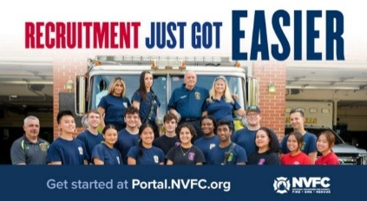
Does your fire or EMS department need more volunteers? The National Volunteer Fire Council (NVFC) is here to help! Use the FREE department portal from the NVFC’s Make Me A Firefighter campaign to access tools and resources to help you find and keep volunteers.
GET STARTED NOW AT THIS LINK:
https://tracking.police1.com/t/9495565/187515077/7816037/1/1006865/?b44ed14b=YmY5NWQ4NzktNWRmOC00MWJkLTkzMDctNzg0Y2VhZTNjMzYy&x=1ee5e8f9
FIREFIGHTER HEALTH AND SAFETY – PROTECTING OUR OWN
Due to the Govt shut down, no new stats this week!
4
LINE OF DUTY FIREFIGHTER DEATHS FOR 2026
In 2025 we experienced 78 LODDs reported nationally.!

FIRE SERVICE FATALITIES OR DIBILITATING INJURIES
- A Wilson Borough, PA firefighter who fell off a ladder at a three-alarm fire in Easton Friday suffered multiple fractures. Just after calling a Mayday due to being low on air, Robert “Bobby” Lewullis bailed out and was climbing down a ground ladder from the third floor when he fell about 20 feet. The U.S. Marine Corps veteran, who suffered a broken back in the fall, remains hospitalized.
- The death of a Detroit firefighter after working a 24-hour shift in January has been ruled a line-of-duty death. Patrick “Pat” Trout, a 12-year veteran of the Detroit Fire Department, died Jan. 5 at his home after finishing his shift earlier that day from a subarachnoid hemorrhage.

FIRE APPARATUS ACCIDENTS
- A Byron Township Michigan firetruck responding to a car crash in the Byron Township-area Saturday night was hit by an alleged drunk driver according to Michigan State Police. Significant damage was inflicted on the tandem tender/tanker.
- A San Antonio fire engine was involved in a major collision Friday morning on the city’s west side, according to authorities. Officials at least six vehicles, including a Bill Miller Bar-B-Q box delivery truck, were involved in the crash. The collision was described by fire officials as a “sideways glancing blow” that caused both the box truck and the fire engine to lose control in the middle of the intersection, the engine is now out of service for repair.
- A vehicle crashed into a Chicago ladder truck that was blocking lanes on I-57 at the scene of an MVC.

FIREFIGHTERS FALLING THROUGH
- .
FIRE APPARATUS

Lessons from the Shop Floor: What Every Officer Should Know About Their Apparatus
Michael Huber
Every firefighter relies on his fire apparatus without a second thought, until the day it doesn’t cooperate. The maintenance shop may not wear turnout gear, but its work is as vital to operations as any suppression crew’s.
Behind those closed bay doors, technicians diagnose, repair, and rebuild the very lifelines that carry us to the scene. Yet, as any technician will tell you, many of the problems they fix could have been prevented, or at least caught early, with better care and communication from the end user.
The relationship between operations and maintenance is one of the most important, and most overlooked, partnerships in the fire service. Here are a few lessons from the shop floor that every officer should know about their apparatus.
THE APPARATUS IS PART OF YOUR CREW
Treat the rig like a member of your company. Just as you learn the strengths and weaknesses of each firefighter, you should know your apparatus just as well.
Every vehicle has a personality—the slight vibration under load, the way the pump sounds at idle, and how the transmission shifts when it’s cold. When something feels off, trust your instincts.
A small air leak or a weak battery can become a major problem fast. Officers who take ownership of their rigs—and encourage their crews to do the same—catch issues early and keep the fleet reliable.
DAILY CHECKS ARE MORE THAN A CHECKBOX
Done right, daily checks are an early warning system—not just paperwork. Technicians repeatedly stress that the simplest maintenance is the most important: the daily and weekly checks performed at the station. Unfortunately, those checks can often become routine to the point of ritual, and crews can become complacent.
Thorough inspections detect problems before they sideline your company. A small coolant loss, uneven tire wear, and a hesitant starter are clues worth acting on. Set the tone that checks matter. Companies that take apparatus checks seriously see fewer failures and, as a result, less downtime.
COMMUNICATE CLEARLY WITH THE SHOP
The fastest way to delay a repair is with a vague service request:
- “Truck won’t start.”
- “The light is out.”
- “It’s making a funny noise.”
When you report an issue, be specific by providing the following:
- Unit number and location of the problem.
- When and how often the problem occurs.
- Any patterns (weather, load, warm-up time).
- Steps already taken.
Photos or short videos are especially helpful. Think of it as a handoff to a team- mate—the better the information, the faster the fix.
Whether repairs are submitted through paperwork or the computer system, a simple phone call for critical items can save significant time and frustration down the road.
PREVENTIVE MAINTENANCE HAS A PURPOSE
Preventive maintenance (PM) is not optional. It’s the foundation of fleet reliability. It’s easy to become frustrated when the shop pulls your frontline rig for a service interval during a busy week, but those few hours in the bay prevent days or weeks out of service later. I absolutely understand that no one wants to change into a reserve unit, but it is a necessary evil.
Officers can help by planning around PM schedules, ensuring units arrive on time, and communicating upcoming operational needs. Skipping maintenance never saves time. It only defers the breakdown.
ELECTRONICS RULE THE MODERN RIG
Modern fire apparatus are more complex than ever. Multiplex wiring, idle reduction systems, and power management modules mean the smallest voltage drop can shut down critical functions.
Encourage your crews to do the following:
- Power down unnecessary devices when parked.
- Wait for full system boot-up before operating electronics.
- Report battery and charging issues immediately.
These habits reduce strain on systems and give technicians cleaner data to work from.
TREAT RESERVE APPARATUS LIKE FIRST-LINE UNITS
When your first-out rig goes down, the reserve steps in—often for longer than expected. A neglected reserve quickly becomes a liability. In a large municipal fleet, one of the most frustrating things is the lack of care and attention the field gives reserve apparatus. Most crews do not feel the impact until they need a reserve apparatus and nothing is available.
Conduct a full check just as you would your assigned unit. Note discrepancies, communicate them, and leave the reserve in better condition than you found it. The next company that needs it will thank you, and you may even be a part of that company tomorrow.
THE SHOP IS YOUR PARTNER, NOT YOUR ADVERSARY
Both sides share the same mission: keeping the community safe. It’s easy for tension to build between operations and maintenance. Crews feel frustrated when rigs are out of service; technicians feel pressure to do more with less.
Building mutual respect goes a long way. Officers who visit the shop, introduce themselves, and ask questions often find repairs happen faster and communication improves. And, an occasional box of donuts certainly doesn’t hurt.
Remember: The shop isn’t keeping your rig from you. They’re keeping it safe for you.
PRIDE STARTS AT THE COMPANY LEVEL
A clean, organized apparatus reflects pride and professionalism. Officers set the tone.
When the crew wipes down the cab, keeps compartments squared away, and reports issues immediately, it shows respect for both the equipment and the people who maintain it. That pride directly affects performance. A well-kept rig runs better, lasts longer, and reinforces a culture of readiness.
SHARED RESPONSIBILITY KEEPS THE FLEET ROLLING
Apparatus maintenance isn’t just a logistics function; it’s a safety function. A reliable fleet allows firefighters to focus on the mission instead of the machinery. A company officer’s influence over apparatus readiness is enormous. Understand how your rig works, communicate clearly, respect the shop’s process, and set the expectation that your company takes pride in every piece of equipment it operates.
After all, every fire starts and ends with the turn of a key or the push of a button or switch—and the professionals in the shop are the ones who make sure that the apparatus always work.
THE CHANGING FIRE SERVICE

Virginia Beach (VA) Ambulances Without Lights and Sirens?
John Buzbee, The Virginian Pilot
A policy change officials hope will curb unnecessary risk to the response of medical emergencies means that the lights and sirens of many ambulances are going dark and silent.
The change, which took effect at the start of November, is based on research cited by city officials that found responses by emergency medical services were not significantly helped by using lights and sirens. In a majority of cases, the research suggests, responding without using either has proven to be the safest option.
“There’s a time and place it’s appropriate,” said Virginia Beach EMS Chief Jason Stroud. “It does not save as much time as people think.”
The difference in response time for Virginia Beach EMS was found to be between 2 and 3 minutes, he said. The risk of traffic accidents nearly doubled while lights shined and sirens blared.
Operating with increased risk that saves just a few minutes doesn’t usually outweigh the possible danger to other motorists. Stroud said most calls aren’t helped by those extra few minutes saved anyway.
Now over a month in, the changes appear to be successful and has been met with staff support. Stroud said the response can be upgraded to use lights and siren, based on the case and circumstances, like severity of an injury or age of a patient.
Just 27 EMS calls were upgraded in November, Stroud said. In two-thirds of those cases, the patient refused transport. Virginia Beach EMS responds to around 58,000 emergency calls per year, with 42,000 or so requiring a trip to a hospital.
Stroud said he encourages dispatchers to err on the side of caution and to use their discretion in upgrading a call.
“We have always allowed crews to respond without lights and sirens to lower priority incidents. This just now requires it, instead of leaving it to provider discretion,” Ali Weatherton-Shook, Virginia Beach public information liaison, said in an emailed statement. “Virginia Beach EMS has not been immune to ambulance accidents, and have had two this year requiring providers to be taken to the hospital.”
Vehicle crashes in the wake of a rushing ambulance are heightened and can delay other first responders, Stroud said.
Ambulances are barred by the city from exceeding 20 miles an hour over the posted speed limit. They are required to abide by the limits posted in school zones. On roads with a speed limit of 25 miles per hour, ambulance aren’t allowed to exceed that limit by 10 miles per hour. Virginia Beach EMS personnel take advantage devices that can control traffic lights.
The new policy does not apply to private ambulances operating within Virginia Beach; Stroud said private ambulances operating on the city’s behalf through a partnership program, however, are subject to it.
Weatherton-Shook said the policy change will not impact other departments, like police and fire, whom already have systems for when and when not to use lights and sirens. Motorists should react to first responders using lights and sirens as they had before, by slowing down and pulling to the shoulder of the road. Stroud said no change in behavior is needed if an ambulance without its lights on is encountered.
Virginia Beach joins other metros, like Raleigh and Charlette in North Carolina and Fort Worth in Texas, in limiting the usage of lights and sirens for its ambulances, outside of responding to calls deemed critical.
THE BUILDING AND FIRE CODE ISSUES – WEEKLY REPORT ON FIRE FATALITIES
The New ICC Code-NYS Edition went into effect on December 31st 2025 although the implementation of the energy code provisions have been withdrawn until further notice.

WITH THE SHUT DOWN OF DHS, STATS FOR THIS WEEK HAVE NOT BEEN COMPILED
Fire Deaths in 1&2 Family Dwellings in NYS | 12
Last fire death 2/11/26 Bellmore, Nassau Co., Male 70
Fire Deaths in any type of Dwelling in NYS | 22
Fire Deaths in 1&2 Family Dwellings Nationally | 198
Top 3 States with the greatest 1&2 Family Deaths | #1 OH & TX/13
 | #2 NY & GA/12
 | #3 WA/11
Civilian home fire fatalities in 2026: 357
Both the states of Maryland and California as well as Wash. DC require sprinklers in 1&2 family dwellings.
According to realtors and builders only old homes burn, so sprinklers are not needed in new homes: so my question to you is; when does a new home become an old home?

GREEN ENERGY AND THE IMPACT ON THE FIRE SERVICE

NY Hearing Draws More Concerns About Battery Storage Plan
William J. Kemble – Daily Freeman
TOWN OF ULSTER, N.Y. – Eleven speakers at a second hearing on Terra-Gen’s proposed 250-megawatt lithium-ion battery facility at the site of Coleman High School raised doubts about the company’s plan.
On Tuesday, Feb. 24, the new comments were added to concerns raised by 23 people the evening before.
The choice by Terra-Gen to use the 15-acre parcel at 430 Hurley Ave. for a 300-unit array of 14-foot-tall lithium-ion battery containers is being proposed because it is across the road from a significant Central Hudson substation. Company representatives have said the location makes the project less expensive, and they said their savings would be passed onto customers because it will allow the electricity Terra-Gen purchases for their rechargeable batteries to be resold at a less expensive rate. [and you believe this?]
However, some speakers considered the plan to be out of place and a risk that is not worth the savings.
“The project site is located in close proximity to existing residential uses and a portion of the parcel is zoned for residential development,” said Sherry Tesler, who lives in an apartment complex that is only about 472 feet from the project’s parcel.
Other nearby dwellings include an adjacent parcel with a single-family house only 154 feet away; another at 571 feet; a second apartment complex that is 562 feet away; another four residential properties off of Hurley Ave. are between 760 and 1,040 feet; the Spring Lake mobile home park is 430 feet away; and in the city of Kingston residents on Fairview Ave. are between 960 and 2,281feet from the property. Non-residential properties in close proximity are two churches, one at about 333 feet and the other at about 555 feet, while there is an elementary school at 2,027 feet and a middle school at 2,254 feet from the proposed site.
Tesler said she wants the scoping document to include an “evaluation of the compatibility of a large-scale industrial energy facility” and an “assessment of the project’s consistency with the town’s comprehensive plan and long-term land use objectives and the evaluation of how the project’s industrial character, security features, and continuous operations may affect the surrounding neighborhood character.”
Resident Brian Freer said some discrepancies needed clarification, including whether Terra-Gen’s contention that the project is classified as a “utility company structure” is based on a town determination or the applicant’s own interpretation.
“The applicant’s project narrative states that a zoning interpretation letter was issued on March 18, 2025 … but the town has formally certified through (state Freedom of Information) requests that no separate zoning interpretation, written determinations, or final zoning interpretations were issued by the building inspector,” he said.
“The town further indicates that the only document referenced is applicant correspondence, countersigned by the code enforcement officer, which the town did not characterize as a finalized zoning determination,” Freer said. “Under (state draft environmental impact statement rules), the DEIS must reflect an accurate project description and regulatory project description. … When zoning classification is unresolved, that uncertainty should be disclosed and analyzed rather than assumed.”
Some speakers also wanted the scoping document to include concerns about fire risks and doubts about having enough trained firefighters ready to respond. Resident Janet Cross echoed doubts that Ulster’s unpaid fire volunteers can sustainably deal with the unconventional lithium-ion fires.
“Because lithium-ion battery incidents may require extended operational periods and specialized response actions, the (scoping document) should evaluate whether local emergency resource responses can be sustained over the duration of a credible worst case … fire, explosion, and thermal runaway scenarios,” she said.
Cross also voiced concerns that Terra-Gen’s repeated statements that the project will meet standards set by the state are not enough to say that the project will be safe.
“Compliance with applicable design standards, certifications, or fire protection codes does not eliminate the potential for prolonged incidents or off-site impacts and does not substitute for analysis of realistic consequence scenarios and response capability,” she said.
SHARE THE OPPORTUNITIES

State Chief’s Scholarship Program
Applications are now being accepted for the NYSAFC Scholarship Program and the Chief Neil McNeight Hands-On Training Award. Nominations are being accepted for the Chief Fred Singer Fire Educator of the Year Award, James Wright Public Education Award, and New York State Fire Chief of the Year Awards. Please note changes to the Scholarship Program for 2026. Three $1,000 scholarship awards will be granted in memory of Chief Ward Bohner and his wife, Janice Bohner, Chief Anthony Messina, and Chief James Hare. The deadline for submitting required materials is April 1, 2026. Eligibility criteria is available in the Application & Nomination Package. GO TO THIS LINK FOR MORE INFORMATION: https://www.nysfirechiefs.com/awards

NYSAFC is Bringing Hands-On Training to Your Area!
BEYOND THE BASICS
Dutchess County
March 28-29, 2026
Host: New Hackensack Fire District
REGISTRATION: https://www.nysfirechiefs.com/beyondthebasics
FIRE BEHAVIOR ON THE INSIDE
Clinton County • April 11-12, 2026
Host: Peru Fire Department
Ulster County • May 30-31, 2026
Host: Glasco Fire Company
REGISTRATION: https://www.nysfirechiefs.com/firebehavior
FLASHOVER
Albany County • September 26-27, 2026
Host: East Berne Volunteer Fire Company
REGISTRATION: https://www.nysfirechiefs.com/flashover

Attendee and Exhibitor Registration is Open for the NYSAFC Annual Conference & Expo
The association's 120th Annual Conference & FIRE 2026 Expo will be held June 10-13 in Syracuse. Changes for 2026 include reduced conference Full Term Registration fees ($50 for association Individual Members and $100 for non-members), a new Hands-On Training course – “Initial Attack: First-Due Company Operations,” and new event hours on Thursday. Free One Day Tickets for the expo will once again be available from exhibitors!

Rural Water Supply Operations Seminar: Moving Big Water with No Hydrants
Pittstown Fire Dept, & the Rensselaer County Fire Chiefs Association
Saturday and Sunday, April 18th & 19th, 8:00am to 4:30pm
Pittstown Fire Dept. 134 Parker School Road, Johnsonville, NY 12094
For more information contact Pittstown Fire at 518-663-5773 leave a message or at car1station25@gmail.com

NYSAFC 2026 Seminar Series “Dangerous Spaces: Challenges and Tactics When Dealing with Garage and Basement Fires” With Chief/Commissioner Michael Lombardo (Buffalo Fire Department)
Three-Hour Seminar:
Some of the most dangerous fires we deal with are often looked at as routine: the basement fire and the garage fire. Basement fires are probably the most overlooked killer of firefighters engaged in combat firefighting in much of the U.S. The construction, layout, fire load, and access present difficult and dangerous challenges at below grade fires. From the incident commander to the firefighter on the nozzle, we must all recognize and be able to deal with these challenges. Huge migration to the suburbs starting with the arrival of the Baby Boomer generation saw the explosion of the attached garage. Many older cities never had the available space for homes to feature an attached garage or have any garage at all. The tremendous fuel load that is constantly evolving presents danger for occupants and firefighters alike. This class will address these challenges and alternative strategies and tactics that can be deployed to deal with these dangerous spaces.
Registration Fee:
$35 per person – NYSAFC Individual and Department Members
$50 per person – Non-Members
Pre-registration is encouraged. On-site registration will be accepted if space permits.
Note: A 3% service fee will be applied if paying by credit card.
2026 Dates and Locations:
Seminar begins at 7:00 p.m. at all sites. Registration area opens at 6:30 p.m.
March 3 – Schenectady County
SUNY Schenectady Community College • Stockade Building • Room 101 • 78 Washington Avenue • Schenectady, NY 12305
September 10 – Fulton County
Berkshire Fire Department • 320 Steele Avenue Ext. • Gloversville, NY 12078
September 16 – Saratoga County
Saratoga County Public Safety Building • 6012 County Farm Road • Ballston Spa, NY 120
September 22 – Dutchess County
Pleasant Valley Fire District • Station 1 • 1619 Main Street • Pleasant Valley, NY 12569

NEIGHBOR’S HELPING NEIGHBORS

Gansevoort Fire Department Breakfast
The fire company thanks you for your support!! Breakfast will be served starting at 8AM Sunday March 15th

Clifton Park Fire Department Breakfast
Thank you for your support! Next Breakfast in April TBA from 8 to 11am

Speigletown Fire Department Breakfast 2nd Sunday of each month
Sunday March 8th from 7:30 to 11:30, $10 adults, $5 children, under 5 free.
GENERAL INTEREST TO ALL

FDNY Planning Special Events for 25th Anniversary of 9/11 Attack
Roni Jacobson, Leonard Greene, - NY Daily News
For many New Yorkers, the 9/11 attack feels like it happened just yesterday, but nearly 25 years have passed since the terrorist strike, and the FDNY wants to commemorate next year’s anniversary with a little something extra.
Along with the traditional somber reading of the victims’ names at Ground Zero, ceremony organizers on Tuesday announced plans for a commemorative podcast, a 9/11 25th anniversary emblem and a pre-9/11 service to honor firefighters who died that day and those who have died since from toxin-related ailments.
“It is hard to grasp that 25 years have passed since this department’s darkest days,” said the city’s outgoing Fire Commissioner Robert Tucker. “While a quarter of a century has passed, still, in many ways, it feels like yesterday.”
Tucker will likely attend the ceremonies, but he won’t be in charge. He resigned, effective Dec. 19, after Mayor-elect Zohran Mamdani won election, and there is no guarantee the new administration will stick to Tucker’s grand plan.
“I don’t see why they wouldn’t,” Tucker said at a news conference at the Staten Island University Hospital Community Park, home of the Staten Island FerryHawks. “I think that the department and the families deserve nothing less.”
Tucker said the baseball stadium, with more than 7,000 seats, will host a service on Sept. 9 next year to honor the 343 FDNY members who perished when hijacked planes tore into the twin towers on Sept. 11, 2001, and the more than 400 who have died since from 9/11-related illnesses.
Tucker said he is hoping for a packed house.
“We chose this place for its significance and for its beauty,” Tucker said. “This wonderful ‘Postcards’ memorial was the city’s first monument to 9/11, and it’s really just steps away. We think the clear view of lower Manhattan and that skyline behind me will provide comfort to the FDNY community.”
“We expect every seat in this stadium to be filled, and we will work hard to ensure every detail is handled with care.”
Other details include a a short film about FDNY Chaplain Father Mychal Judge, a Catholic priest who was recognized as the first victim of the attack.
Judge rushed to the site after planes struck the World Trade Center, and was killed while offering prayers and comforting victims.
Tucker also said the FDNY would release a special podcast series hosted by actor Gary Sinise, whose nonprofit foundation honors fallen firefighters and supports their families.
“The podcast series,” Tucker said, “will focus on the bravery and survival of firefighters in their own words.”
TAKE A MOMENT TO SMILE

What did scientists conclude when they found bones on the moon??
The cow didn’t make it….

CLASSIFIED
Empty this week.

CAFDA OFFICERS AND DIRECTORS 2026
OFFICERS
President, Tom Rinaldi, Commissioner, Stillwater Fire District
1st Vice President, Ellen Martin, Deputy Treasurer Clifton Park Fire District
DIRECTORS:
Les Bonesteel Past Commissioner, Burnt Hills/Saratoga,
Skip Smith, Commissioner, West Crescent/Saratoga
Joyce Petkus Treasurer Greenfield/Saratoga,
Ed Woehrle Commissioner Niskayuna #1/Schenectady
Art Hunsinger, Ex-Officio Member Clifton Park Fire District.
We would consider expanding the number of Directors if individuals from other counties would volunteer to participate!!

APPOINTEES
Secretary Molly Jenkins, Region 1 Director, Assoc of Fire Districts, NYS
Treasurer: Tony Hill
Sargent at Arms: Tom Wood, Commissioner, Northumberland Fire District
Chaplain: Dane Fagan
Legal Counsel: Greg Serio, Safety Officer, Verdoy Fire District
The Capital Area Association represents any fire district that wishes to join CAFDA. Fire District Officials include Commissioners, Treasurers, and Deputy Treasurers. Secretaries and Chiefs are also invited to participate!
Please advise your secretaries that all correspondence should be mailed to:
CAFDA PO Box 242 East Schodack, NY 12063
EMAIL TREASURER: TREASURER@CAFDA.NET
518-407-5020
EMAIL SECRETARY: SECRETARY@CAFDA.NET

Long Way to Travel? Zoom into the General Membership Meetings!
It’s our desire that every member fire district have the opportunity to attend Capital Area meetings. We know we cover a large area, in 8 counties and beyond, and wish to give all of our members a chance to participate in the general membership meetings. You have a voice, and we would like to hear it. Join us at our next meeting either in person or via Zoom. The link will be sent via constant contact prior to each general membership meeting. Thank you for being a member and we hope you will join us.

Capital Area BUSINESS PARTNER’S
Business Partner Applications Available At: WWW.CAFDA.NET
WELCOME DIVAL SAFETY EQUIPMENT
Green Boarder = not yet renewed for ‘26
We invite our business partners to submit educational information to be included in this Bulletin for district commissioners and chief officers
We want to thank all of our Business Partners for renewing their partnership for 2026. You are invited to our monthly membership meeting and to any of our social events..
FIRE SERVICE LEGAL SERVICES


Monaco Cooper Lamme & Carr.PLLC
1881 Western Ave, Suite 200 Albany, NY 12203
Nicole Strippoli 518-941-9040
NSTRIPPOLI@MCLCLAW.COM
https://mclclaw.com

The D’Amato Law Group LLP
Gregory Serio, Partner
Alyssa B. Snyder, Partner
111 Washington Ave Suite 600
Albany, NY 12210
518.426.3800
Email: gserio@dlgny.com or
asnyder@dlgny.com
damatolawgroup.com

HAWKINS DELAFIELD & WOOD LLP
William J. Jackson, Partner
1160 Pittsford-Victor Road, M2-11
Pittsford, NY 14534
585-645-1184
Fire Service Bond Attorneys
www.hawkins.com

Whiteman Osterman & Hanna LLP
Bond Counsel
Robert J. McLaughlin, Partner
One Commerce Plaza, Albany, NY 12260
518-487-7697 Cell 518-813-6333
mclaughlin@woh.com
www.woh.com
Ducharme, Clark & Sovern, LLP
Jack Clark, Fire District Attorney
646 Plank Rd. Clifton Park, NY 12065
518-373-1482
Ducharmeclark.com
HANNIGAN LAW FIRM PLLC
388 Kenwood Avenue
Delmar, New York 12054
P: (518) 869-9911
F: (518) 869-9915
www.hannigan.pro
Fire/EMS –Municipal Law

FIRE STATION & FACILITIES ARCHITECTS AND ENENGINEERS


n.lobosco@ctmale.com
Shawn Corp, Principle
15 Cider Mill Way, Saratoga Springs, NY
518.322.1386
www.reveal-ad.com


Architecture/Engineering/Code Services
Melissa Smith – mlsmith@labellapc.com
Senior Marketing Manager
518-903-8394
4 British American Blvd
Latham, NY 12110
www.labellapc.com


Architects & Engineers
433 River Street, Suite 8002
Troy, NY 12180
518-765-5105
Dennis Ross, Practice Leader
www.H2M.com

Managed IT Services
Cloud Telephone Services

Wendel, Centerpointe Corporate Park, 375 Essjay Road, Suite 200, Williamsville, NY 14221 716.688.0766
Amy Numrich, MBA
Digital Marketing & Events Specialist
anumrich@wendelcompanies.com


Ryan Sapienza
Project Manager/Technology Consultant
518-754-4623
Service 518-869-3614
930 Albany Shaker Rd, Latham, NY 12110

Haughey Insurance Agency
850 State Route 50
Burnt Hills, NY 12027
518-399-1583
www.haugheyagency.com
FIRE SERVICE INSURANCE
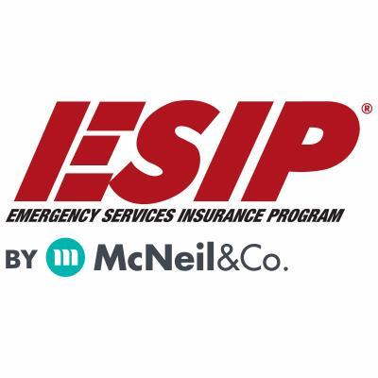
Tony Blackwell, Territory Sales Manager
800-822-3747 ext 530
ablackwell@mcneilandcompany.com
Aurora Inc. Insurance
120 Broadway
Albany, NY 12204
518-449-3180
aurorainsurance.com
Michael May, Broker
mmay@aurorainsurance.com

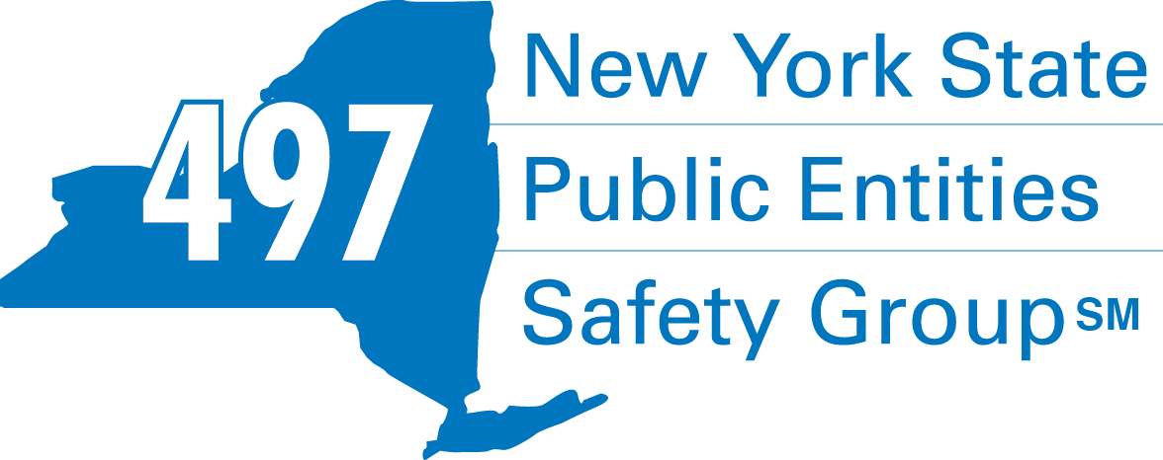
Fleury Risk Management
28 Corporate Drive, Suite 104
Clifton Park, NY 12065
518.478.6314
https://www.fleuryrisk.com/nysgroup497
VFBL Insurances Services
Stephan Petras
Marketing Representative
One Blue Hill Plaza – 16th Floor
PO Box 1609
Pearl River, NY 10965
845-352-8855x7099
329-236-3505
spetras@fdmny.com
VFBL/Workers’ Comp Coverage


Pat Daglio
pdaglio@vfis.com
717.819.3072

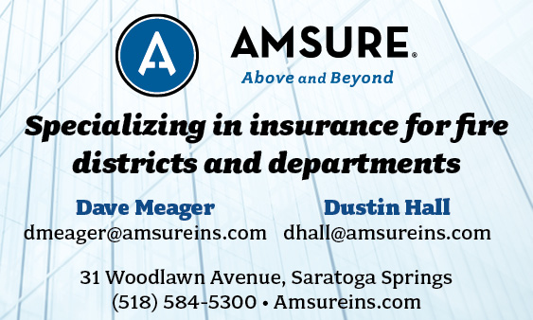

FIRE SERVICE FINANCIAL SERVICES AND LOSAP MANAGEMENT


518-432-5087
838-433-7304 cell
www.thelosapgroup.com.
nikki.haskins@rbc.com
455 Patroon Creek Blvd, suite 200, Albany NY 12206
UBS Financial Advisors
Ralph Lemme, CFP
8 Southwoods Blvd Suite 207
Albany, NY 12211
518.445.1667

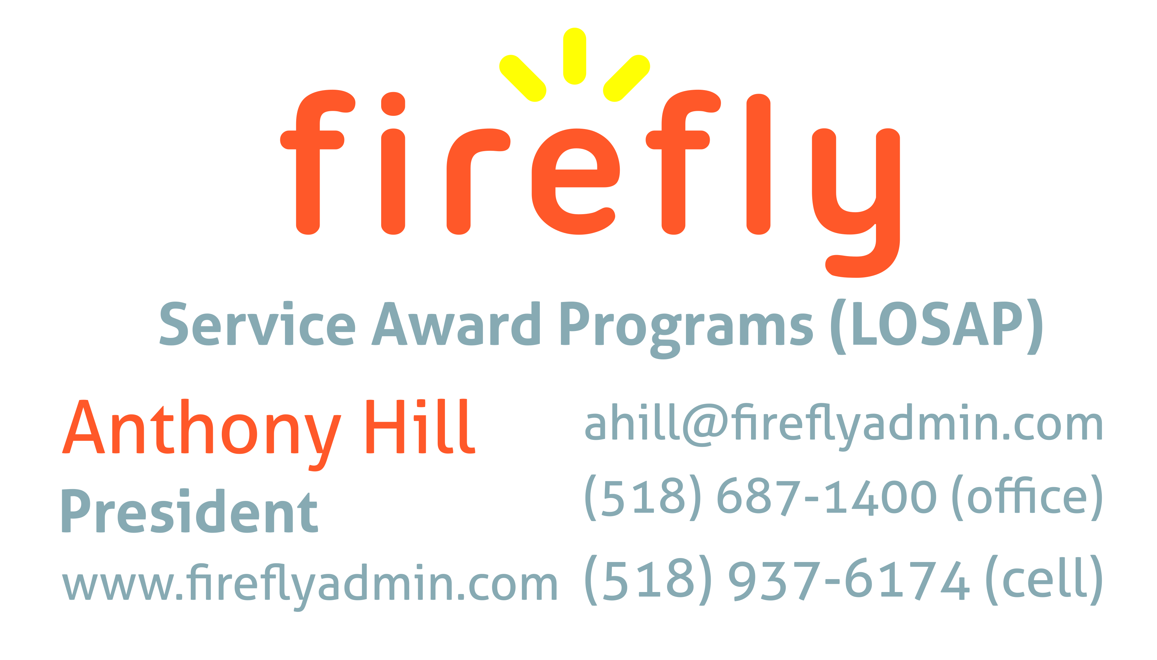


Nicole Meeker
Manager of Business Development & Accts
518-394-7894
Cell 607-423-4811
www.penflexinc.com
nmeeker@penflexinc.com
FIRE EQ TESTING
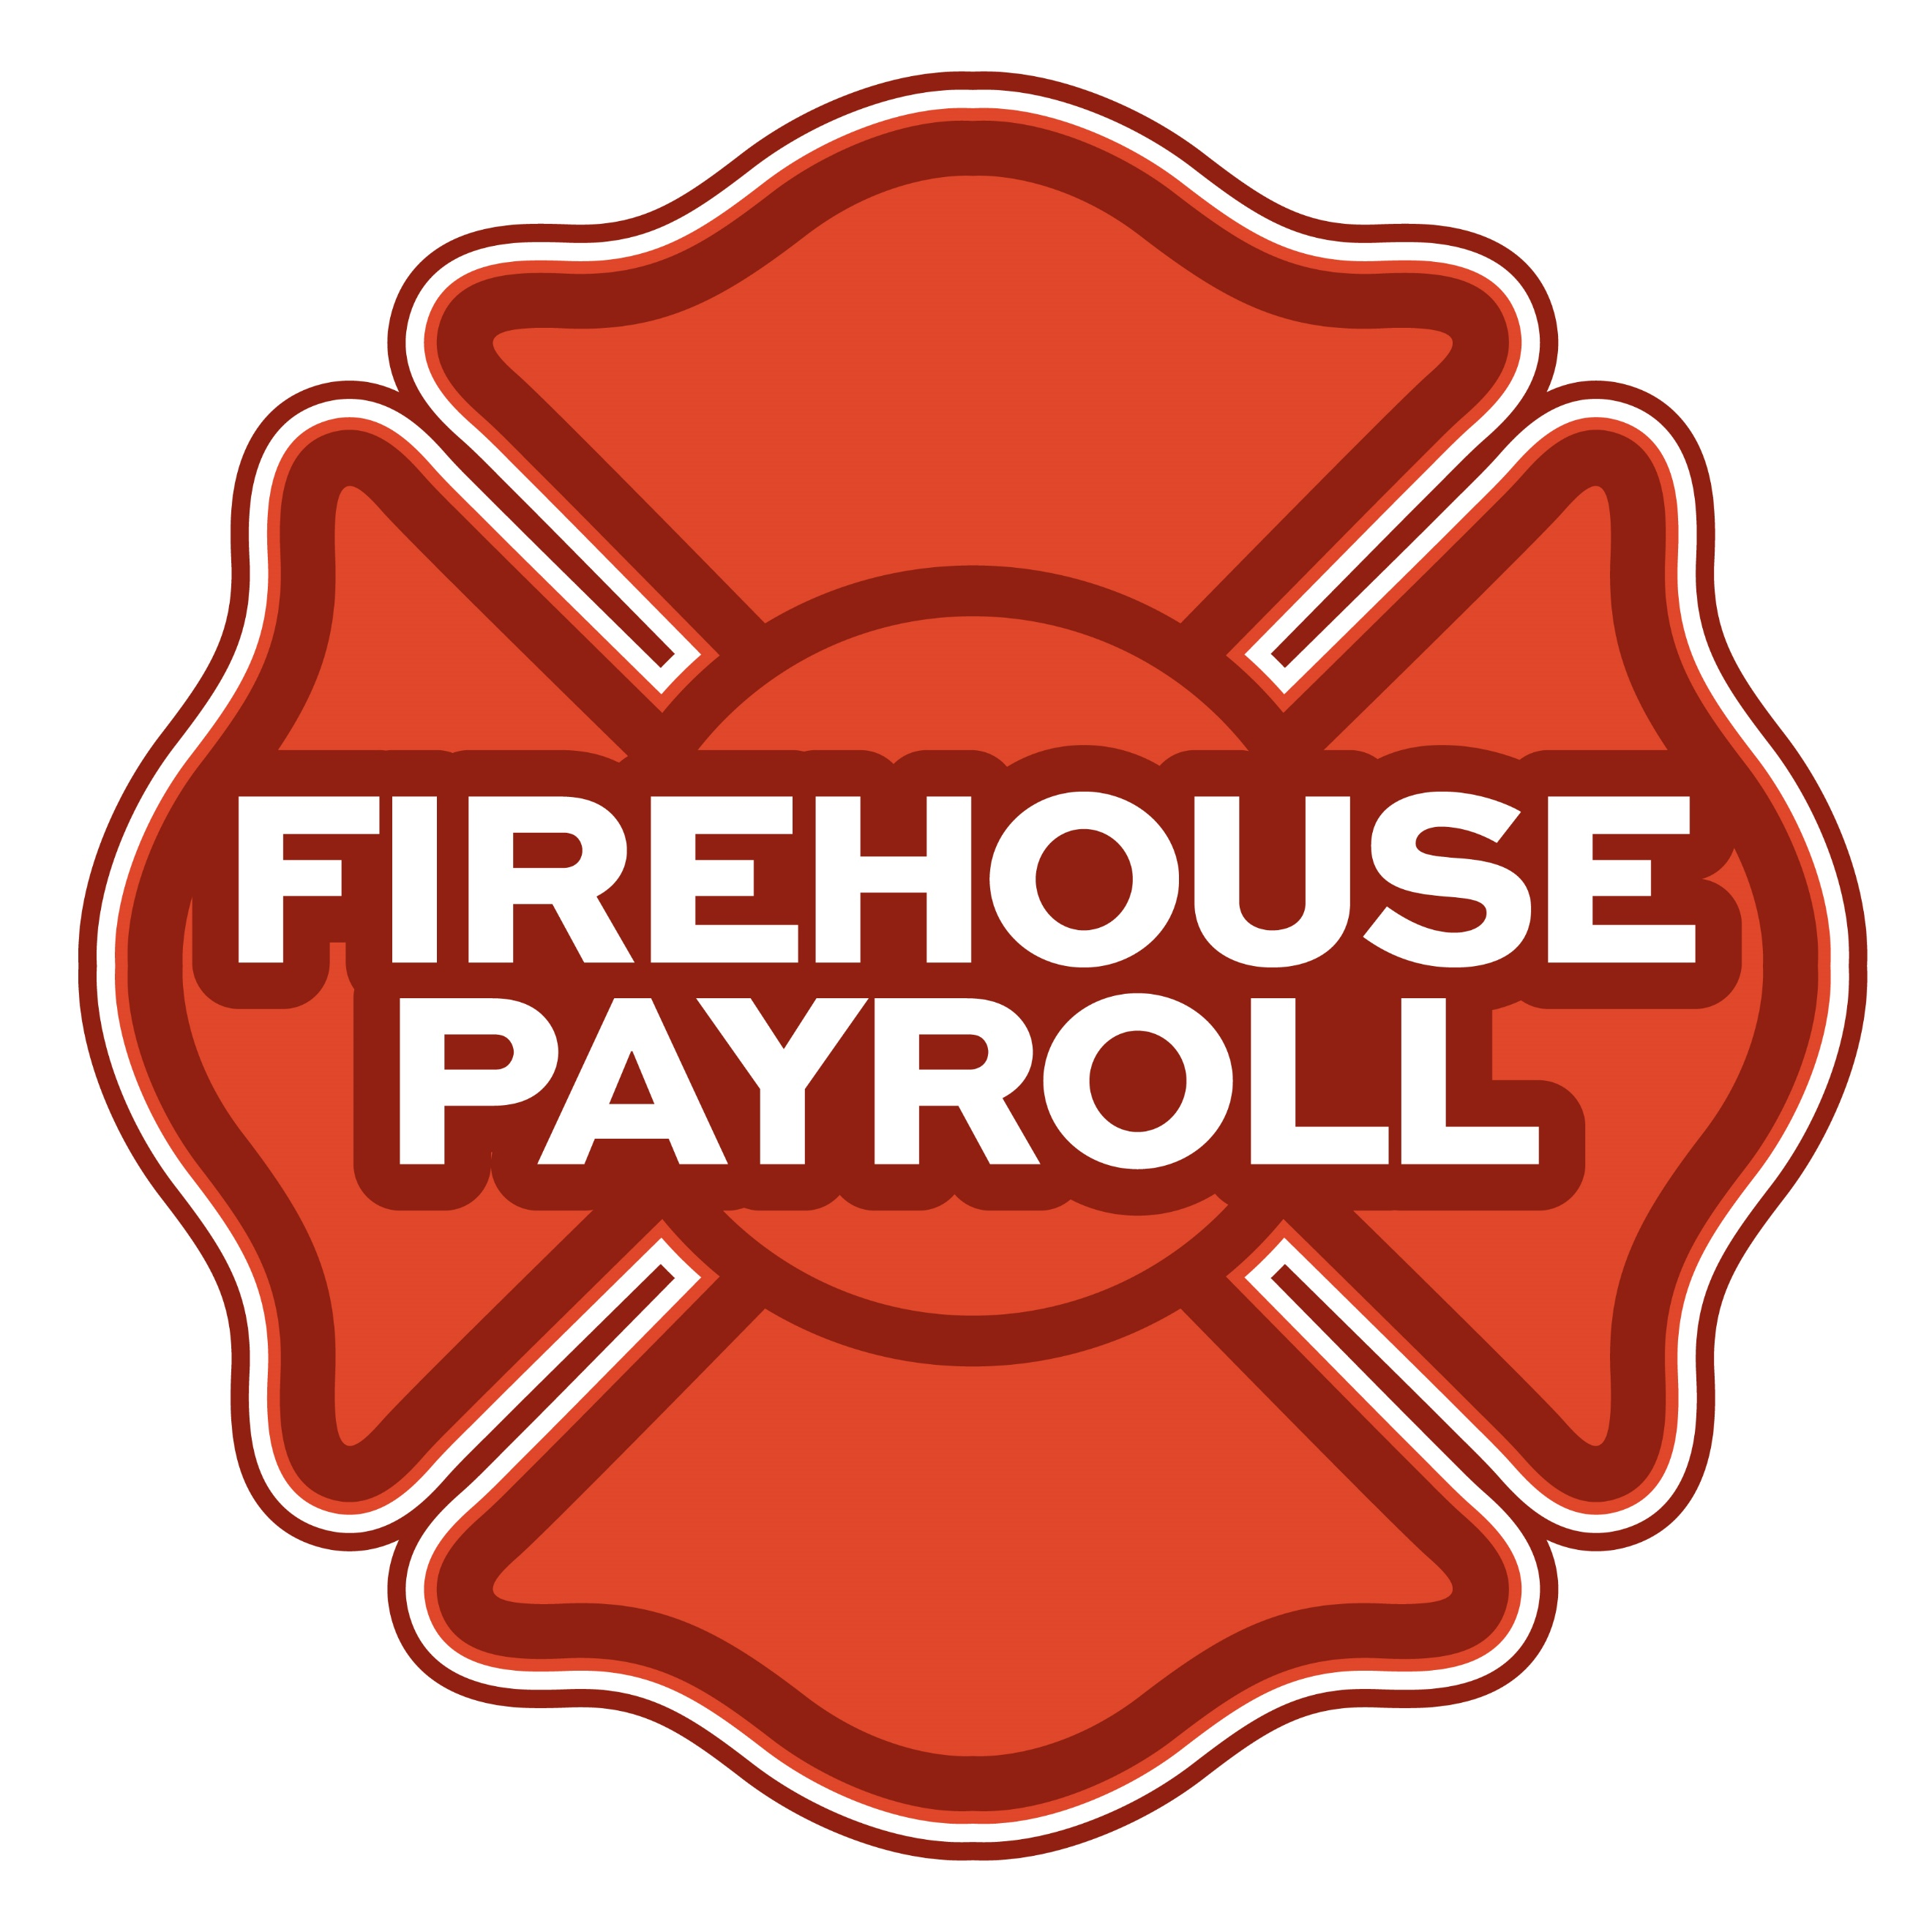
Jeremy Hartnett
302-483-7699
jeremy@firehousepayroll.com
payroll-pension reporting-tax filing
direct deposits-timekeeping-HR Services
FULL-SERVICE FIRE EQUIPMENT
DRYER VENT CLEANING

www.jeromefire.com
Breathing Air Comp Maintenance,
Air Quality Tests and Repairs
Russell Jerome
315-699-4533 Office
Ready Rack Extractor/Washers
Full Line of Fire Equipment
8721 Caughdenoy Rd, Clay, NY 13041

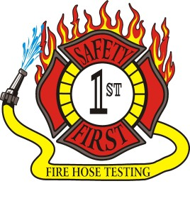Safety First Equipment Testing
99 Glass Lake Road
Averill Park, NY 12018
518-674-8363
www.safetyfirstfirehose.com
HOSE, APPLIANCE & LADDER TESTING
Safety1hose@gmail.com
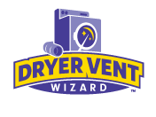DRYER VENT WIZARD
JORDAN CATINO
8 NAPA COURT, SCHENECTADY, NY 12309
518-344-0664
SARATOGADRYERVENT.COM
jcatino@dryerventwizard.com

FIRE DEPT COMPUTER MANAGEMENT & REPAIR

White Wolf Computer, LLC
4 Normanskill Blvd. Suite 410, Delmar, NY 12054
(518) 459-9653
Managed Services
Cloud Hosting Solutions
Telephone Data Cabling
Backup Disaster Recovery
Web Design Services

FIRE COMPANY FUND RAISING

FIRE STATION PEST CONTROL

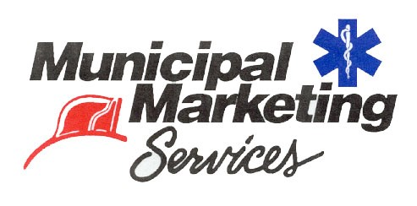
Lloyd Fox, Account Executive
34 Garner Road, Averill Park, NY 12018
Lfox8@nycap.rr.com
518-810-7819
www.funddrive.com

518-300-4732
431 New Karner Rd Suite 170
Albany, NY 12205
https://fox-pest.com/albany-ny

FIRE SAFETY EQUIPMENT
FIRE APPARATUS/SERVICE

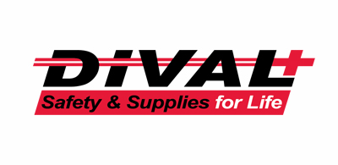
Timmy Kimball
518-925-2786
www.divalsafety.com
Testing-Safety-Promotional Services-Respiratory Solutions
Facility Safety-Fall Protection-Training
60 Cohoes Ave, Green Island NY 12183
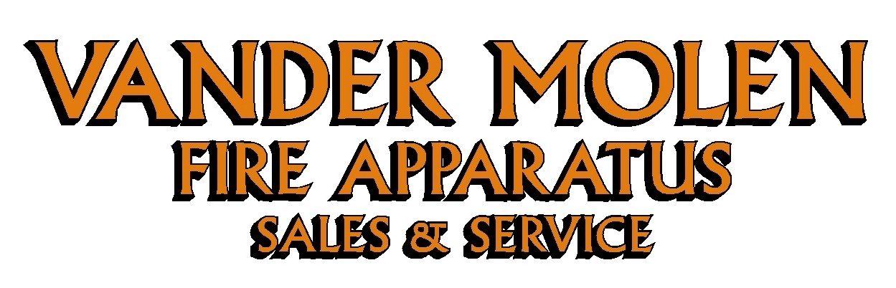
Mike Bonesteel
Warranty & Safety Manager
518-288-3587 X101
Cell 518-926-0451
After Hours 680-800-5015
1 Super 50 Way, Ballston Lake, NY 12019

FIRE DISTRICT CPA/AUDITS/FINANCIAL SERVICES


Zoriana M. Stawnychy
973.283.0024
zoriana@stawnychyfinancial.com
135 Kinnelon Road Suite 101
Kinnelon, NJ 07405
Serving fire districts in New York State


518-459-6700
10 British-American Blvd, Latham, NY 12110
www.bstco.com
Brendan Kennedy ext 356
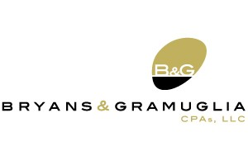

Aaron Hahn
1 Pine West Plaza Suite 107, Albany NY 12205
518.452.8055x17 or 518-452-9055
Email: ahahn@bgcpa.net



Accounting, Consulting & IT Security
1581 Franklin Ave. Mineola, NY 11501
Kyle Brengel, Managing Partner
516-472-7345
kbrengel@gblny.com


11 British American Blvd, Latham, NY 12110
518-785-0134
Queensbury Office 518-792-6595
http://www.mmbaccounting.com
Alan W. Clink, CPA aclink@mmb-co.com
Heather R. Lewis, CPA hlewis@mmb-co.com

425 Main Street Catskill, NY 12414
www.tbogc.com
518.943.2600 X2198
Joe Rothrock – josephr@tbogc.com
Specializing in Fire Service & EMS Financing

David Farstad, VP-Municipal Banking
652 Albany-Shaker Road, Albany NY 12211
Ph: 518-730-3120
Cell: 518-506-0075
farstadd@pioneerbanking.com
JOHN M. LESNIEWSKI
Assistant Vice President and
Senior Business Banking Officer
Fulton/Montgomery Markets
12 Fremont Street, Gloversville, NY 12078
P: 518.775-5205 | M: 518.848-0612
NMLS ID 915694
www.nbtbank.com


The Arrow Family of Companies
Corporate HQ 250 Glen Street
Glens Falls, NY 12801
518-793-4121
Business Banking Services
Arrowbank.com
Hero Mortgage Program Supporting First Responders Available

The Weekly Capital Bulletin is reaching well over 700+ subscribed fire district members and now other members of the fire service on a regular basis.
This is a service of CAFDA through the effort of Tom Rinaldi who can be reached at tom@rinaldi1.com for comments and content contributions are always welcome.

BECOME A MEMBER OF CAFDA!
The Capital Area Association has voted to amend its By-laws to allow both individual and regional or county Fire District Associations to join. The updated By-laws are posted to the CAFDA.NET website.
Individual membership fee will be $50 annually, fire district association fees will be $300 annually.
Download THE APPLICATION available on the home page at CAFDA.NET
MEMBERSHIP IN THE CAPITAL AREA FIRE DISTRICTS ASSOCIATION (CAFDA)
Would you like to join Capital Area Fire Districts Association along with 100 members in 14 counties? Individuals, fire district associations, fire protection districts and Village departments are all eligible for membership.
Annual dues (January 1st to December 31st) shall be as follows and shall be based on the annual budget of the Fire District/Organization;
$0 to $200,000: $50
$200,001 to $400,000: $100
$400,001 to $600,000: $200
$600,001 plus: $300
Individuals $50.00 or Other County or Regional Associations $300 annually.
Business Partners: $100.00 annual member fee

If You, Your Fire District or Department is not a Member of CAFDA You Can be?
Individuals can be members of CAFDA. The annual membership fee is $50, which will provide you access to this Bulletin, attendance at meetings and social gatherings. Provides networking with other fire district officials and a source of the constant barrage of information related to today’s fire service.
FOR A MEMBERSHIP APPLICATION OR A BUSINESS PARTNER APPLICATION GO TO THE FOLLOWING LINK:
https://cafda.net/membership-info/

ANNUAL CAFDA CONFERENCE
Welcome to CAFDA Conference 2026!
We are excited to be able to offer you this LOCAL training opportunity right here in the beautiful Lake George area!
Should you have any questions, please contact Secretary@CAFDA.net

CONFERENCE DETAILS
CAFDA Conference 2026
Thursday, April 9 - Saturday, April 11, 2026
Fort William Henry Hotel & Conference Center
48 Canada Street, Lake George, NY

OVERNIGHT ACCOMODATION RESERVATION INFORMATION AT THE FORT WILLIAM HENRY HOTEL AND CONFERENCE CENTER
Room reservations are the responsibility of the Attendee*
Telephone Reservations only at 800-234-0267 or (Local) 518-668-3081
Group Code: CAFDA Conference
Rates: $154 Deluxe, $174 Premium/Grand
*If tax exempt, documentation (i.e. ST-129) must be presented at time of check- in

CONFERENCE SCHEDULE
Thursday, April 9, 2026 | 8:00 am | Registration/Breakfast
 | 9:00 am - 10:30 am | Best Practices for Social Media & Public Information Officers  Art Hunsinger, CAFDA
 | 10:45 am - 12:15 pm | The Legalities of Purchasing and the Procurement Audit  Erina Fitzgerald, Senior Attorney & Leslie Richards, Auditor 2 - OSC
 | 12:15 pm - 1:00 pm | Lunch & Conference Welcome
 | 1:00 pm - 2:30 pm | Policies, Procedures, Guidelines & the Law – Sorting Them Out  Dave Denniston/Lee Price
 | 2:45 pm – 4:15 pm | Understanding and Navigating VFBL  Attorney, Alex Dell
Friday, April 10, 2026 | 8:00 am | Registration/Breakfast
 | 8:45 am - 10:15 am | Leasing vs. Bonding  Robert McLaughlin
 | 10:30 am - 12:00 pm | The 6th Commissioner – Good or Bad?  Greg Serio, CAFDA Counsel & Amy Speach, BCS Fire District Secretary
 | 12:00 pm - 12:45 pm | Lunch & Conference Welcome
 | 12:45 pm – 2:45 pm | Dealing with Disciplinary Issues; Mock GML 209L Hearing  Greg Serio, CAFDA Counsel
 | 3:00 pm - 7:00 pm | Vendor Show & Cocktail/Dinner Reception
Saturday, April 11, 2026 | 8:00 am | Registration/Breakfast
 | 8:30 am – 9:15 am | Tax Certiorari – What the Heck Is It & How Does It Affect Fire Districts  Greg Serio, CAFDA Counsel
 | 9:30 am - 11:00 am | Ask the Experts! Panel
 | 11:00 am | Conference Farewell
Conference Registration Fees:
CAFDA Members: $85/day/attendee (includes meals* as noted in above schedule) – OR –
$170 for full (3-day) conference.
Non-Members: $105/day/attendee (includes meals* as noted in above schedule) –OR –
$210 for full (3-day) conference.
Guest of Attendee: $30 per day for meals (includes meals* as noted in above schedule) - OR – $70 for full conference.
*Vendor Show & Cocktail/Dinner Reception also included if attending Friday

REGISTER ON-LINE AT CAFDA.NET/CAFDA-CONFERENCE/
pay by credit card at: https://cafda.net/cafda-conference/
For payment inquiries, please contact Treasurer@cafda.net

CAFDA Vendor/Sponsor Application Form
Welcome Vendors/Sponsors & thank you for your interest!
Please complete & return this form with your payment to:
CAFDA
P.O. Box 242
East Schodack, NY 12063. Should you have any questions, please contact Art Hunsinger at 518-376-3751 or arttv19@gmail.com.
CONFERENCE DETAILS CAFDA Conference 2026 Thursday, April 9 through – Saturday, April 11, 2026 Fort William Henry Hotel & Conference Center 48 Canada Street, Lake George, NY
OVERNIGHT ACCOMODATION RESERVATION INFORMATION Room reservations are the responsibility of the Vendor* Telephone Reservations only at 800-234-0267 or (Local) 518-668-3081 Group Code: CAFDA Conference Rates: $154 Deluxe, $174 Premium/Grand *If tax exempt, documentation (i.e. ST-129) must be presented at time of check- in
VENDOR SHOW DETAILS Friday, April 10th 3:00 – 7:00 PM (Vendors may begin setup after 12:00 pm) Please Check One:
- VENDOR Only: $400: Includes one 8’ table w/white tablecloth & two chairs (power if requested) and two tickets to the Friday Night Cocktail/Dinner Reception

- EVENT Sponsor: Contributions over $400 and up to $1,499: Includes one 8’ table w/white tablecloth & two chairs (power if requested), and two tickets to Friday Night Coctail/Dinner Reception PLUS advertising as a Conference Event Sponsor

- TITLE Sponsor: Contributions at/over $1,500: Includes one 8’ table & two chairs w/white tablecloth (power if requested), and four tickets to Friday Night Coctail/Dinner Reception PLUS advertising as a Conference Title Sponsor with premium signage

- Outside Space: Available for additional display (space limited): $100 Please Provide Display Specifications___________________________________________________

- Additional Tickets to Vendor Show & Cocktail/Dinner Reception available at $30.00/ticket. # Requested____
Name of Business/Organization:____________________________________________________
Contact Name: _______________________________________________________________
Phone: _______________________________Email: _________________________________
Do you require POWER: YES______ NO_____
CLEAN UP: Vendors are responsible for their booth area during and after the event.
Signature:___________________________________________________ Date:____________

