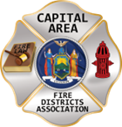
THE BULLETIN
February 7TH, 2026

The Voice of CAFDA since 2004
Editor, Tom Rinaldi – tom@rinaldi1.com since 2014
When you see **, highly recommended article
CAPITAL SHORTS
- Great commissioner’s training class at Averill Park today, thank you Averill Park for your hospitality, use of your facility and the food. Next class will be in Verdoy on February 21st, seats still available. Go to CAFDA.net for registration.
- See the CAFDA annual calendar of events on page 2.
- This week’s Legislative ScoreCard covers all the updates to fire service-related legislation for the second half of the 25/26 legislative session. See what might affect you in the new year.
- The Association of Fire Districts of the State of New York is pleased to offer the Ned Carter Memorial Scholarship Award for High School Seniors. These scholarships are named in honor of Past President Edward ‘Ned’ Carter, and all deceased past presidents of the Association. In keeping with Ned’s lifelong dedication to community service and helping others, four, onetime $1,500 scholarships will be presented to graduating high school seniors who will be pursuing a career in a community services related discipline. Who's eligible? *All applicants MUST be a FIREFIGHTER or, JR FIREFIGHTER/EXPLORER or, be RELATED TO A FIREFIGHTER, or BE RELATED TO A FIREDISTRICT COMMISSIONER, DISTRICT SECRETARY, DISTRICT TREASURER, DISTRICT DEPUTY TREASURER, DISTRICT ADMINISTRATOR/MANAGER. The Fire Department/District MUST be a current member in good standing with AFDSNY. SUBMIT AN ON-LINE APPLICATION HERE: https://mms.afdsny.org/members/form_edit.php?org_id=FDNY&fid=8091763
CAFDA EDUCATIONAL OFFERINGS: CAFDA.NET

Join us at the NEXT GENERAL MEMBERSHIP MEETING Thursday February 12th features dinner for attendees. Please join us.
ZOOM LINK FOR THE January MEETING at 7pm: https://us06web.zoom.us/j/87557673207?pwd=aqxchRgsVkhNzwjpTH58D1b7vRujHN.1

CAFDA IS HAPPY TO ANNOUNCE THE DATES FOR CONFERENCE ’26 IN HISTORIC LAKE GEORGE,

April 9th, 10th and 11th, 2026 plan on joining us.

CAFDA will be offering two Fire Service Financial training 2 day sessions in 2026
Much needed two-day fire service financial training, learn to do it right, brought to you by CAFDA & NYS-OSC.
This year being held at Rombout Fire Department, Fishkill, Dutchess County on March 13th & 14th and at McNeil Insurance in Cortland, Cortland County at on March 27th & 28th. Training is provided by trainers from the Office of the State Comptroller. Continental Breakfast and Lunch will be included.

REGISTRATION IS OPEN FOR FINANCIAL TRAINING ON-LINE AT CAFDA.NET

Commissioner Training will be held at 6 locations in 2026 including:

Averill Park, Saturday February 7th,

Verdoy, Saturday February 21st,

Clifton Park, Saturday March 7th,

Niagara Engine Co #6 in Schoharie, Saturday March 21st,

Berkshire Fire District, Gloversville, Saturday March 28th and

Warrensburg Fire District, Saturday April 4th.

The Day after the scheduled date (Sunday) has been reserved as a snow day if necessary.

Open to all newly elected commissioners and Chiefs. This training is required under Town Law Section 176-e. $85 for members, $95 for non-members includes continental breakfast and lunch.
REGISTRATION IS OPEN FOR COMMISSIONER TRAINING ON-LINE AT CAFDA.NET

All correspondence & Capital Area Fire Districts Association Mailing Address should be directed to:
CAFDA PO Box 242 East Schodack, NY 12063 or EMAIL: SECRETARY@CAFDA.NET
Financial issues should be addressed to: TREASURER@CAFDA.NET
LEGISLATIVE NEWS FROM THE STATE CAPITAL

Fire Service Related Proposals Included in the Governor’s Budget Submittal
- Community Paramedicine and Hospital at Home (HMH Part K): The Executive proposal extends the authorization of currently operating community-based paramedicine programs until April 1, 2030, sets the number of allowed programs in the state to 99, and expands the scope of practice of paramedics to include administering vaccines under non-patient specific orders from a physician or nurse practitioner. This proposal also codifies the Acute Hospital Care at Home program into state law, which would allow the program to expand to other hospitals. This program is already in certain healthcare facilities under federal authorization. It also authorizes DOH to establish rates for services. Fiscal Impact: The Executive Budget does not provide a fiscal estimate for this proposal.
- Article VII - Miscellaneous Extend the Suspension of the Cell Surcharge Revenue Transfer to the Emergency Services Revolving Loan Fund (PPGG Part B): The Executive Budget proposes to extend the existing suspension of the $1.5 million annual transfer from the Public Safety Communications Account to the Emergency Services Revolving Loan Fund to assist local governments, fire districts, and not-for- profit fire/ambulance in financing emergency response equipment and related capital needs. The Executive Budget proposes to extend the existing suspension through State Fiscal Year 2029-30, which allows for local emergency services-related grants instead. Current law suspends the annual transfer of $1.5 million in funding by two fiscal years and currently applies through State Fiscal Year 2025-26. This suspension has been regularly extended by two fiscal years since 2011. Fiscal Impact: The Executive proposal did not provide a fiscal estimate for this proposal.
- Division of Homeland Security and Emergency Services (DHSES) The Executive Budget proposes All Funds appropriations of $9.25 billion, a net increase of $163.9 million or l.8 percent compared to SFY 2025-26. The Executive Budget proposes a total increase of $192 million offset by $28 million in reductions. The Executive Budget proposal supports a workforce of 770 FTEs, unchanged compared to SFY 2025-26.
  - The Executive Budget proposes the following:
  - • $150 million increase in Capital funding to support Centralized State Emergency Operation Center (SEOC) Facility in Albany County.
  - • $26.2 million increase to support nonpersonal services expenses of disaster assistance operations, providing a total of $33.8 million in SFY 2026-27.
  - • $7.5 million increase in State Operations to support contractual and personal services
  - • $5 million increase in Capital funding to support equipment to expand Statewide Urban Search and Rescue capabilities.
  - • $2.7 million increase to support operations of the Office of Fire Prevention and Control, providing a total of $11.7 million in SFY 2026-27.
  - • $1.2 million increase in federal funding to support personal services in the Emergency Management program.
  - • $25 million decrease in Capital funding due to the discontinuation of one-time Volunteer Fire Infrastructure and Response Grant (V-FIRE), which will be funded through re appropriations in SFY 2026-27.
  - • $2.3 million decrease due to the elimination of legislative grants, which includes:
    - $1.5 million decrease for Red Cross Emergency Response Preparedness, bringing total available funding to $3.3 million in SFY 2026-27.
    - $750,000 decrease for the New York State Professional Fire Fighters Association
    - $50,000 decrease for the Maynard Fire Department
- Developing a Comprehensive Plan for Drones (PPGG Part D): The Executive Budget proposes establishing a new crime of Unlawful Use of a Drone, in varying degrees, and creating a drone registry. It creates restricted flight zones around: concerts, protests, parades, festivals, sporting events, large public gatherings, police stations, fire departments, emergency services dispatch stations, state, local, or federal correctional facilities, and “critical infrastructure”; it effectively establishes "no-fly" zones across the State. “Critical infrastructure” under this proposal includes an extensive list of sites including locations such as petroleum refineries, power plants, chemical facilities and certain enclosed water treatment centers. To enforce this provision, law enforcement agencies are explicitly authorized to identify, seize, and neutralize drones that are considered "credible threats."
- Health Capital Funds: The Executive Budget proposes an All Funds appropriation of $1.4 billion for Capital Projects, a net decrease of $141 million or 9 percent compared to SFY 2025-26. The Executive Budget proposes the following: $3.2 million in new funding for emergency medical services modernization.
- Office of Addiction Services and Supports (OASAS) $1 million increase to support the development of a First Responders Behavioral Health Center of Excellence, which will provide support services for emergency response agencies across the State.

2026 Issues of United Concern
After a meeting of the fire service organizations including County Coordinators, Fire Districts, Fire Chiefs, Fire Police and FASNY, the following are the legislative initiatives for 2026.
- Increase VFBL Payments, reach parity with workman’s comp payments. [A1849 Steck & No Same As at this time.]
An act to amend the volunteer firefighters' benefit law and the volunteer ambulance workers' benefit law, in relation to increasing the amount of certain benefits. These benefits have not been updated in decades, with most compensation thresholds last revised in the 1990s. As a result, they no longer adequately reflect current economic realities. This legislation seeks to modernize and enhance these benefits to ensure they provide appropriate and meaningful support to those who risk their lives in service to others.
- Designate EMS as an essential service [A1989 Oberacker & No Same As at this time.]
An act to amend the general municipal law and the public health law, in relation to emergency medical services. The goal of the legislation is to provide a county-by-county assessment that will provide a roadmap for statewide improvements in providing EMS service going forward. The process can be matched with efforts to develop a statewide plan that matches the variety of ways services are provided throughout New York.
- The First Responder PEER Support Act [S5407A Harckham & A7285A Burdick]
An act to amend the mental hygiene law, in relation to the "First
Responder Peer Support Program Act". Modeled after the highly successful Joseph P. Dwyer Veterans Peer to Peer Support Program, which was launched in 2012, this bill would establish a First Responder Peer Support Program. This program would focus on prioritizing the mental well-being of the state's first responders. By enacting this bill we can ensure that first responders have access to the necessary systems to address some of the challenges they face.
- Increase the income tax credits for first responders. [S6233 Martinez/A6790 McMahon] also [S1123 Oberacker/A1064 Angelino] also [A28 Burdick/No Same As]
An act to amend the tax law and the real property tax law, in relation to tax credits for volunteer firefighters and volunteer ambulance workers. A taxpayer who serves as an active volunteer firefighter or ambulance worker shall be allowed a credit against their state taxes equal to $800. For married couple who file a joint return and both individually qualify, they shall be allowed a credit of $1600.
Legislation would also remove the prohibition to take the property tax exemption in addition to the income tax exemption.
- Enable more progressive fire service delivery options, including agency structure, supplemental support and provide nominal compensation to first responders. [need specifics, no sponsor at this time.]
Volunteer and on-call emergency responders should be able to receive compensation as determined by the AHJ for the time that they dedicate to being available or responding to incidents. At this time volunteers are in danger of losing their volunteer status by language currently in the VFBL statutes, which needs to be removed to provide the AHJ the option of providing monetary incentives for volunteers. In addition alternative fire service provider models should be optional to varying levels of government.
- Amend the EMS billing law [no sponsor at this time, need specific language]
Amend the law to allow EMS agencies to bill for mutual aid transports. Currently agencies are not permitted to bill for calls which have been mutual aided to them.
- State Retirement Service Credit as a recruitment/retention incentive [S7021 Ryan/A7432 Eachus]
An act to amend the retirement and social security law, in relation to establishing a retirement service credit for volunteer fire or emergency service. Section 1 of this bill would allow a member, upon application to a public retirement system, to achieve one year of service credit for every five years of volunteer fire or emergency service in the State, not to exceed three years of total service credit; available to such member any time before retirement.
OTHER AREAS OF CONCERN THAT MAY BE ADDRESSED GIVEN THE TIME AND ATTENTION OF THE LEGISLATORS DURING THE SESSION.
- Support the joint NVFC, IAFF task force working with DOL/OSHA to propose a viable solution to the 191.156 update, including the removal of the NFPA standards incorporated by reference.
- Publishing Official Notice Modernization; this initiative would update how public and legal notices are transmitted to the public with the demise of local newspapers. For instance, modernization would allow governmental entities to publish notices via online platforms.
- Convene a work group to come up with viable solutions to the issue of compensation for volunteers as well as fire service delivery options, including agency structure and consolidation of services. Specifically remove the prohibition by the counties to provide fire service as an optional solution.

New York Volunteer Fire Departments Eligible for Grants
Two funding options are available: $20 million for construction and renovation projects and $5 million for fire service equipment projects.
GO TO THIS LINK FOR INFORMATION AND APPLICATION:
https://www.dhses.ny.gov/state-funded-programs
The application deadline is February 25, 2026, by 5:00 pm

New York’s first responders to benefit from $38M emergency communications upgrade
Governor Kathy Hochul announced more than $38 million in state funding to enhance emergency communications for first responders across New York.
The funding will support 17 counties and New York City through the Statewide Interoperable Communications Grant program.
“Saving a life can come down to one call, and our first responders need to have the most reliable emergency communications systems to help their fellow New Yorkers during their most critical moments,” Hochul said.
The program aims to improve radio tower infrastructure, ensuring clear communication during emergencies.
The Division of Homeland Security and Emergency Services will administer the funds, which are part of the Combined 2024 & 2025 Statewide Interoperable Communications Grant Targeted Program.
[EDITOR’S NOTE: THESE FUNDS WERE SKIMMED OFF BY THE STATE UNDER THE PREVIOUS CUOMO ADMINISTRATION, NOW THEY ARE BEING GENEROUS AND GIVING LOCALATIES BACK A FRACTION OF WHAT WAS COLLECTED AND SQUIRRLED AWAY IN THE GENERAL FUND]
NATIONAL FIRE SERVICE ORGANIZATION NEWS

About CFSI
Whether you are a member of the fire and emergency services, a public safety coalition, or the fire service industry, the United States Congress is more aware of your concerns because of the Congressional Fire Services Institute (CFSI). Established in 1989 as a nonprofit, nonpartisan policy institute, CFSI is designed to educate members of Congress about the needs and challenges of our nation’s fire and emergency services to help them understand how the federal government can support the needs of our local first responders.

About The NVFC
The National Volunteer Fire Council (NVFC) is the leading nonprofit membership association representing the interests of the volunteer fire, EMS, and rescue services. The NVFC serves as the voice of the volunteer in the national arena and provides critical resources, programs, education, and advocacy for first responders across the nation.
Our Vision
The NVFC strengthens volunteer and combination fire and emergency medical services to advance excellence, ensure safer communities, and enhance the quality of life across America.
Our Mission
The NVFC unites and supports volunteer and combination fire and EMS organizations through education, advocacy, leadership development, and collaboration. Guided by professionalism and innovation, we provide the tools and resources needed to protect communities, advance responder health and safety, and prepare leaders for the future.
What We Do
The NVFC accomplishes its mission and provides meaningful support to fire and EMS organizations through a wide range of services and programs:
- Representing the interests of the volunteer fire, emergency medical, and rescue services at the U.S. Congress, federal agencies, and national standards setting committees
- Focusing on health and safety
- Helping departments recruit and retain Fire Service and EMS/Rescue personnel
- Providing training on topics that matter to you
- Assisting departments in establishing support programs
- Fostering the next generation of firefighters
Offering an array of programs to support the volunteer emergency services


Updated Course Now Available
The National Volunteer Fire Council (NVFC) is pleased to announce the release of the updated course, Electric Vehicle Safety: An Awareness Level Training. Taking an estimated 1.5 hours to complete, this on-demand, self-paced course introduces first responders to hybrid and electric vehicles (EV), shares data and resources relating to EV response, and equips first responders with the knowledge and tools to respond more safely when a hybrid or electric vehicle is involved in an incident.
Updated information includes:
- Improved clarity on electrical shock risks
- Expanded fire suppression and extinguishment techniques
- Strengthened guidance on battery disconnection and de-energization
- Additional PPE and hazmat considerations
- Enhanced EV identification and response best practices
- Addition of EV infrastructure and charging station fire risks
- Updated references
With the number of EVs on the roadways increasing, it is important for emergency responders to understand the unique aspects of incidents involving these types of vehicles. Take this training now and share with your crew to enhance safety and improve response.
REGISTER AT THIS LINK:
https://nvfc.informz.net/z/cjUucD9taT00NTk5MjcwJnA9MSZ1PTQ1OTYxMzI3OSZsaT01NDQzNzg4Ng/index.html
This course is available free to all for a limited time.
THE LATEST NEWS FROM DOL/OSHA

Clarification Update
It has been confirmed that the International Association of Fire Chiefs (IAFC) remains part of the standard revision conversation and were signatories on the letter to remove the word for word NFPA Standards and give authority to the AHJ for enforcement of the final standard.

OSHA’s Emergency Response Standard Remains Under Review
Curt Varone
The Occupational Safety and Health Administration’s effort to replace its 1980-era Fire Brigades standard remains in the rulemaking process, with no final regulation issued. OSHA formally proposed the new rule—titled the Emergency Response Standard—on February 5, 2024. The proposal would modernize 29 C.F.R. § 1910.156, which has governed fire brigades for more than four decades, by expanding its scope to cover a broad range of emergency response personnel.
Following publication of the Notice of Proposed Rulemaking, OSHA opened a public comment period that was extended several times due to the volume of responses. The comment period closed on July 22, 2024. OSHA later convened an informal public hearing, which began on November 12, 2024, and accepted additional written submissions through January 17, 2025.
Since then, the agency has been reviewing the testimony, comments, and data submitted during the rulemaking process. According to OSHA’s regulatory agenda and its Emergency Response Rulemaking page, the proposed rule remains under analysis. No final rule has been drafted or published, and the existing Fire Brigades standard continues to govern until OSHA completes the process.
The proposed Emergency Response Standard would significantly expand OSHA’s regulatory framework for responders. Rather than limiting coverage to industrial and private fire brigades, the proposal would bring firefighters, EMS personnel, technical rescue teams, and other responders under a single comprehensive standard. It would incorporate updated requirements for emergency response plans, hazard assessments, personal protective equipment, medical and behavioral-health evaluations, and training aligned with contemporary consensus standards.
The scope of the proposal drew extensive attention from the fire service, particularly from volunteer and smaller departments. Many commenters expressed concern about the feasibility of compliance, prompting OSHA to acknowledge that economic impacts on volunteer organizations require further review. In a September 2024 statement, OSHA indicated it would evaluate the applicability of the final rule to volunteers based on the record developed during the hearing and comment periods.
Despite the interest surrounding the proposal, OSHA has not indicated when a final rule might be issued. The new regulation remains at the proposed stage, and the agency’s review is ongoing. For now, the Emergency Response Standard has not been adopted, and the 1910.156 Fire Brigades standard remains in effect. Here is a statement from OSHA:
- OSHA is reviewing and evaluating all the comments and data submitted by stakeholders and the transcripts from the hearing. This important step in the rulemaking process helps guide the agency as it considers how to proceed with the rulemaking.
Here is a link to OSHA’s current position on the Emergency Response Standard.
https://www.osha.gov/emergency-response/rulemaking

The Latest from Dave Denniston:
As was briefly discussed on the recent NYS Fire Service Council zoom meeting, the group is still in serious discussions and are attempting to formulate an update to the Emergency Service Standard that is not as intrusive as the original proposal. The NFPA standards will NOT be adopted by reference and there is consideration for a modification to the standard for communities with fewer than a population of 5K. A more formal briefing is pending from Chairman Denniston. We thank him for his dedication to this process.

IT IS TIME TO MOVE FORWARD WITH A WORKABLE OSHA 1910.156 REVISION
Dave Denniston, 1st VP AFDSNY
As the process to update OSHA 1910.156 continues, it is important that we understand where we have been, and options for the process moving forward. Since the proposed rule was published for review 18 months ago, there has been a significant amount of input and feedback from stakeholders addressing possible concerns about the economic and technical feasibility of the proposal. Stakeholders from across the country participated in the process and offered suggestions. One of the early possible solutions suggested was to simply exempt volunteers, and other parties, from the proposed rule as written. The mindset was that if it didn’t affect “us” it was not our problem. While this concept appeared to be a quick solution, it fell short of addressing the true needs or problems.
The real issue at hand is that the proposed rule as written had challenges for everyone and you would be hard pressed to find any department, career, combination, or volunteer, that could meet the intent of the standard. The proposed standard also took a one-size-fits-all approach. We know that the emergency service agencies across this country are very different. They have different resources, different exposures, different concerns, and different levels of risk. It is true that emergencies, fires, and hazards are the same regardless of the type of responder. What is different is the likeliness that a particular event will occur in any jurisdiction. Local jurisdictions must be required, and empowered, to address significant risk, and the needs of a community, at a local and state level with just enough federal oversight to give it teeth and ensure safety for all of our responders. The bottom line is that the current 1910.156 is outdated and needs significant revision to address the needs and safety concerns of today’s first responders. The proposed standard, as written, went too far in trying to address these needs. What we need is a middle ground solution that is designed to relieve significant risk and does so at a level that is economically and technically feasible for local communities, organizations, and the municipalities that govern and fund them.
Some are asking why simply exempting the volunteers is not in the best interest of volunteers across the country. First, by exempting the volunteers, we are failing to address the growing concerns and exposures facing this group of responders. Second, the largest growth area for most of our local fire departments is a move toward combination and career departments. How would it be possible to have one set of rules apply to part of an organization and not the other? Does it make sense to have volunteer responders face one set of rules, while career responders on the same truck follow another? Are we not all responding to the same emergencies with the same exposures? The approach of exempting volunteers would add both confusion and resentment moving forward. The third part of the issue is that the standard, as written, is just as problematic for the communities that have career departments as it is for those that only have volunteers. We need a standard that brings us all together, not one that drives us further apart.
So, what do the solutions look like? Where should OSHA and the Department of Labor go from here? After pouring through the thousands of comments brought forth during the process, an opportunity is right in front of us. There were a multitude of comments throughout the process that carried common themes. By using logical outgrowth of the process, OSHA now has the opportunity to massage the rule into one that we all can live with, and provide the level of safety they are tasked to provide the workers of this country.
It is now in OSHA’s hands to finalize the rule as proposed, make logical changes, scrap it, or go back to the drawing board. During the process, OSHA continuously asked for proposed solutions, and many excellent solutions were entered into the record from those that participated. We would suggest that OSHA and the Department of Labor use the extensive input from the process to make necessary changes to the document and work to finalize the rule. A rule that meets the intent of reducing significant risk in a manner that is reasonable and responsible for our first responders and communities.
Using logical outgrowth, OSHA now has the opportunity to remove the incorporated NFPA standards. Many of the participants and the NFPA itself asked for this to be done in their comments. The incorporation of those standards brought many of the pain points organizations were concerned about. The NFPA standards instead should be used as a tool for compliance, not a weapon of enforcement. By removing the incorporation of dozens of NFPA standards, the rule would also become far less confusing and economically infeasible. The next step is to transfer as much of the obligation of providing safety down to the local jurisdiction and state levels as possible. These are the people that know the nuances of the local responders and hazards in any given area. This, too, was supported by the comments throughout the process. The third opportunity is rather than exempting anyone, to build a baseline standard that applies and protects everyone, and then increase the requirements where the data shows increased exposure and risks. All of these changes are supported by the logical outgrowth requirements and would alleviate most of the pain points addressed by the participants of the process.
Regardless of the solution, we would be remiss if we failed to realize there will be opposition to any action taken moving forward. We also need to realize that any solution, or even no solution at all, will have pain points for some that it will affect. It has often been said that firefighters hate two things, change and the way things currently are. Hopefully, we realize that we are at a historic time, with an amazing opportunity to get this right. This process has been fair and offered plenty of opportunities for those interested in participating to make their opinions and feelings known. It is time to move the ball over the goal line and continue to work together for the betterment of emergency services in this country.
I encourage you to speak to your local elected officials. Let them know there is a workable solution right in front of us, and ask them to encourage the Department of Labor and OSHA to continue this opportunity and finalize a reasonable OSHA 1910.156 that applies to all fire departments, regardless of the composition of their staff.
FIRE DISTRICT FINANCIAL NEWS

Local Government and School Accountability Contact Information:
Phone: (518) 474-4037; Email: localgov@osc.ny.gov
Address: Office of the State Comptroller, Division of Local Government and School Accountability
110 State Street, 12th Floor; Albany, NY 12236

NYS-OSC Fire Service Audits
CANEADEA FIRE DISTRICT, Allegany County – TREASURER’S RECORDS AND REPORTS
Audit Objective
Did the Caneadea Fire District (District) Secretary/Treasurer (Treasurer) record and report financial transactions in a timely and accurate manner?
Audit Period
January 1, 2023 – June 30, 2025
Understanding the Audit Area
A fire district’s treasurer should record and report financial transactions in a timely and accurate manner to enable informed decision-making by the board of fire commissioners, prevent fraud or misappropriation of funds, comply with reporting requirements and maintain public trust. Accurate and timely records are essential for establishing financial accountability and proper financial management, oversight by the board of fire commissioners and taxpayers, and the protection of public funds.
The District’s average annual budgeted appropriations for the 2023, 2024 and 2025 fiscal years was $206,086.
Audit Summary
The Treasurer did not record and report all financial transactions in a timely and accurate manner. As a result, adequate financial records were not maintained and there was an increased risk that improper or unauthorized activity could have occurred without detection or correction. Although our testing did not identify any improper or unauthorized activity, the Board of Fire Commissioners (Board) did not have sufficient information to effectively oversee the District’s financial operations and make informed decisions because financial records and reports were incomplete and inaccurate. If the Board had performed an effective annual audit of the Treasurer’s records, the errors and omissions we identified might have been detected and corrected.
Specifically, the Treasurer did not:
- Maintain a complete and accurate checkbook register (register) with sufficient detail such as transaction dates, types or descriptions.
- Always prepare and submit accurate bank reconciliations to the Board.
The report includes four recommendations that, if implemented, would improve the Treasurer’s records and reporting. District officials generally agreed with our recommendations
READ THE COMPLETE REPORT HERE:
https://www.osc.ny.gov/files/local-government/audits/2026/pdf/caneadea-fire-district-2025-118.pdf
THE FIRE CHIEF’S OFFICE

**Building Better Leaders
Tyrral Quinn
Leadership in the fire service isn’t forged in isolation nor born solely through promotion. It’s built intentionally, through example, education and mentorship. Far too often, departments confuse time served with wisdom earned or, worse, mistake rank for readiness. The result? A cycle of reactive management rather than proactive leadership.
If we want better outcomes for our people and the citizens who we serve, we must build better leaders—not just officers. That means fostering critical thinkers, investing in mentorship, teaching the differences between managing resources and leading people, and empowering every rank with purpose. It’s a matter of stewardship. If we don’t grow our people, we fail our future.
STEWARDSHIP: LEADING FOR TOMORROW, NOT JUST TODAY
Stewardship isn’t glamorous. It doesn’t get applause. However, it’s the heartbeat of leadership. It’s the quiet, unseen work of preparing others to succeed, of protecting both your people and the mission, even when it costs you convenience, credit or comfort.
True stewards know that their influence should outlive their title. They don’t hoard knowledge nor gatekeep experience. Instead, they train successors. They give freely, knowing that their legacy won’t be found in a badge but in the confidence, competence and character of those who they leave behind.
I’ve seen firsthand how stewardship can transform a crew, a shift, a station and even an entire department. When we deliberately invest in leadership at every level, we create a culture of ownership, where firefighters, engineers, lieutenants and chiefs all understand their role in shaping the future. This approach sharpens the tools that are in our leadership toolbox and refines the mindset of emerging leaders. It allows young officers and aspiring mentors to test ideas, build trust and lead with purpose long before they ever pin on bars or bugles.
CRITICAL THINKING AND THE MYTH OF RANK = READINESS
In too many departments, promotions are treated like finish lines, rewards for time served rather than investments in future leadership. However, a gold badge doesn’t grant wisdom, and rank without readiness is a dangerous thing. It leaves new officers unprepared, unsupported and uncertain. Worse still, it sets a precedent: that authority can be earned without accountability, and that leadership is about title, not action.
Critical thinking is the antidote. It teaches our people not just what to do but why. It gives them the tools to assess, adapt and make sound decisions under pressure. In the fire service, that might mean recognizing when standard operating procedures must be adjusted on the fly or when tradition is harming—not helping—our mission. It might mean pausing long enough to ask, “Is this the best decision for the team?” rather than simply, “What’s always been done?”
We must develop thinkers, not just doers. Long before they test for rank, we must mentor our firefighters to think in the ways that leaders think. If we aren’t preparing them to take our place—if we aren’t deliberately teaching them to question, refine and own their decision-making—then we aren’t leading. We just are recycling the same cycle, hoping for a different result.
At its core, leadership is about decision-making, and the worst decision that you can make is none at all. Indecision paralyzes progress and puts lives at risk—on and off of the fireground. When leaders choose not to decide, they surrender control to the chaos of the moment. The incident then dictates their actions, instead of the other way around.
On the other hand, making the wrong decision still can be a step forward. You can see the results, course-correct and learn. You can reanalyze, regroup and refocus your efforts. However, you can’t do that when you’re frozen by fear of failure. That’s why we must cultivate mental agility. We must teach future leaders how to trust their instincts, listen to their crew and move with intention—even in uncertainty.
If we aren’t mentoring them to think critically, adapt quickly and own their decisions long before they’re promoted, then we aren’t developing leaders. We’re manufacturing rank. That’s a liability that we can’t afford.
TRANSFORMATIONAL VS. TRANSACTIONAL
Leadership isn’t one-size-fits-all. In the fire service, we need both transformational and transactional leaders, but we must understand when and how to use each approach. The difference lies in motive and method.
Transactional leadership is built on structure, rules and task completion. It’s necessary in high-stakes, high-tempo environments where clarity and compliance save lives. A fireground incident requires swift communication, chain-of-command accountability and tactical discipline. At its best, transactional leadership is efficient, focused and action-oriented.
Transformational leadership builds organizations. It inspires, empowers and lifts people beyond their current role. Transformational leaders connect the daily grind to a deeper mission. They develop individuals, challenge complacency and set the tone for long-term culture. They don’t just enforce expectations; they raise them.
The best leaders know when to switch gears. They might be transactional on scene of a working fire then pivot to transformational leadership in the kitchen afterward, using the moment to reflect, coach and mentor. This duality—this ability to lead both in crisis and in calm—is what separates true leaders from mere managers.
Many departments mistakenly create managers, not leaders. Managers track metrics, enforce policy and keep the system running. However, leadership requires vision. It demands emotional intelligence, the willingness to serve others and the humility to admit mistakes. A manager might preserve the status quo, but a leader builds something better.
We must develop our people to do both but never let them confuse the two. When the smoke clears, it isn’t the checklist that stays with a crew; it’s how they were led through it.
MENTORSHIP AS THE CORNERSTONE
Mentorship is the most enduring and most powerful leadership tool that we have in the fire service. Titles might change, policies evolve and crews rotate, but the lessons that are passed down from one firefighter to another shape the culture more than any manual ever will.
True mentorship isn’t about telling someone what to do; it’s about showing them how to think. It’s being present, observant and invested. It’s correcting without demeaning, guiding without controlling, letting others fail safely, then helping them understand why, so they’re sharper next time.
Some of the best leaders who I’ve worked under were the ones who saw potential and refused to let it go to waste. They offered their time, their wisdom and their presence. They made space for questions. They modeled calm under pressure. They never stopped learning themselves.
Mentorship also isn’t just top-down. A seasoned captain can learn just as much from a curious rookie if the captain is humble enough to listen. Every exchange—on the training ground, at the kitchen table, in the cab—can be a teaching moment.
Departments that prioritize mentorship create leaders at all levels. They don’t just fill positions; they prepare people. They understand that the best succession plan is built one conversation at a time, one opportunity at a time, one firefighter at a time.
If we want better leaders, we must become better first.
LEGACY IS BUILT, NOT BESTOWED
Leadership isn’t granted with a badge or a promotion. It’s forged through service, sacrifice and a relentless commitment to growth. If we want to build better leaders, we must do more than assign rank. We must invest in stewardship, teach decision-making, develop emotional intelligence and commit to mentorship.
The fire service doesn’t need more managers to maintain the status quo. It needs transformational leaders who can adapt, empower and leave behind a culture that’s stronger than the one that they inherited.
Every shift is a classroom. Every firehouse is a leadership academy. Every call is a test, not just of tactics, but of values.
If we want our departments to thrive long after we’re gone, we must lead with purpose today. The legacy that we leave won’t be written in our titles. It’ll be etched in the leaders who we helped to shape.
THE ATTORNEY’S OFFICE
If several fire districts consolidate what happens to the reserve funds from those districts consolidating?
The consolidated entity takes over the reserve fund as an asset of one of the entities that has been consolidated; All rights, privileges and franchises of each component local government entity and all assets, real and personal property, books, records, papers, seals and equipment, as well as other things in action, belonging to each component local government entity shall be deemed as transferred to and vested in the consolidated local government entity without further act or deed. General Municipal Law § 765
There might be an issue as to the consolidated reserves being new reserve funds needing the approval of a mandatory referendum in order to be created under General Municipal Law §6-g.

For information only and not for the purpose of providing legal advice. The opinions expressed are the opinions of the individual author at the time the facts were presented and based on the law then applicable. The information contained in these opinions is not guaranteed to be up to date. The information provided is not legal advice. Since legal advice must be tailored to the specific circumstances of each case, and laws are constantly changing, nothing on this site should be used as a substitute for the advice of competent legal counsel. The authors assume no responsibility to any person who relies on information contained herein and disclaim all liability in respect to such information. You should not act upon information in this publication without seeking professional counsel from an attorney admitted to practice in your jurisdiction.
POSITIVE OUTCOMES AND CHALLENGES FOR THE FIRE SERVICE

POSITIVE OUTCOMES
No Report this week.

FIRE SERVICE CHALLENGES

Medina leaders weigh selling new $1.7M ladder truck that won't fit in firehouse
Daniel Finkelstein
Concerns are mounting over the future of a critical tool for the Medina Fire Department.
After the department's ladder truck fell into disrepair, firefighters have been without one for months — but taxpayers footed the bill for a new one, which is expected to arrive in February.
"Right now, (the truck) is in New York," said Steven Miller, president of Medina Professional Firefighters IAFF Local 2161. "It came from, I believe, Wisconsin, and it is currently in the city of Tonawanda getting worked on."
However, the truck is too tall to park inside the department's current firehouse on Main Street. Firefighters want to expand the building to make it work.
"Our existing structure has a doorway of 10 foot, 6 inches," Miller said. "The new bay would have 13-foot doors, so that would also be adding onto the taxes, including the ladder truck."
Raising taxes is why some village leaders instead want to sell the new truck before it even arrives.
The proposals were front and center at Thursday's Medina Village Board meeting, where dozens of taxpayers also weighed in.
"I don't want to see us lose the fire service or lose a ladder truck," said Medina resident Luanne Moriarty. "We need one."
"It's tough," Miller said. "Obviously, there's some people against it, but not that, per se, they don't want us to have a ladder truck, it's the cost and taxes."
Without a ladder truck of their own, firefighters said the public risks waiting much longer for critical services in an emergency.
"It would be heartbreak, disappointment and disservice to the community," Miller said. "It's an important piece of what we do as firefighters and protecting our village."
"I like the service, so I don't mind paying for them," Moriarty said. "We have to look into the future. Fires are going to happen. We have a lot of large, older homes and structures in our community."
The new truck was purchased years ago at a cost of about $1.7 million.

'Let the Building Burn,' Franklin County, PA, Fire Chief Told Amid Hydrant Flap
Zahriah Balentine, pennlive.com
A Franklin County, Pennsylvania fire department warned residents Tuesday they may be left without reliable fire protection after the borough’s water authority told fire crews they can no longer use hydrants.
The MMP&W Volunteer Fire Company posted the announcement Tuesday on Facebook after crews responded to a barn fire that destroyed a structure and killed several animals.
The company said firefighters faced severe water supply restrictions due to frozen draft sites and were forced to rely on hydrants.
That led to a call from the Mercersburg Water Authority chairman, who reportedly told the fire chief that crews can no longer use its municipal hydrants “under any circumstances,” emphasizing that the water system cannot support firefighting operations, the statement said.
Fire officials noted that multiple people heard the comments.
When the fire company asked what they were supposed to do instead of using the hydrants, the chairman reportedly said they should “let the building burn” and that “it is only one building,” apparently referencing to the barn fire.
The Facebook post detailing the comments outraged residents and fire department advocates who reached out to Sen. Doug Mastriano and New Antrim Township Administrator Chris Ardinger. The pair intervened with Mercersburg, leading to meetings Tuesday night and Wednesday morning with officials from the council and authority.
The water authority did not return PennLive’s inquiries on Wednesday, but the fire department posted an update on Facebook saying the authority backtracked on the demands. The post said firefighters could use the hydrants and promised to try to place as little strain on the system as possible during emergency operations.
The original announcement caused many concerns from residents on Facebook about fire safety and water supply, with one person asking why the fire company didn’t use a “brand new 3,500 gallon tanker” during the barn fire.
A fire official responded to the comment, saying the tanker wasn’t at the scene because the volunteer department didn’t have enough people to staff it, which is an issue with fire departments across Pennsylvania and the nation.
MMP&W argued that denying emergency water access and failing to plan for fire protection puts the public at risk.
“MMP&W fully understands that the water system has challenges and limitations,” the fire company said in a statement. “We have consistently attempted to operate within the constraints placed upon us, adapting tactics and planning wherever possible. However, blatant neglect of fire protection planning and the outright denial of emergency water access is not acceptable.”
The fire company serves Mercersburg, Montgomery, Peters and Warren townships, according to its Facebook page.
The fire company also cited longstanding concerns, such as the removal of a fire hydrant and a general lack of communication and coordination.
Fire officials said they plan to attend the next town council and authority meetings to request appropriate action be taken over the initial demand to stop using hydrants. In the meantime, they assured residents: “If a fire happens in our area, make no mistakes, we will be there to help you, and all available resources will be used.”

Follow Up Report:
The letter, sent by Mercersburg Water Authority's chairman to a local fire department, was not a reflection of the utility, officials said. The borough noted the water authority operates independently from borough council, and that statements made by Twine do not represent the borough’s official position. The water authority also said “Twine (the Chairman) does not speak for the whole of the Authority,” adding that his comments reflected a personal opinion rather than the water authority’s position. The council’s statement said council members will work collaboratively with the fire company, the water authority, and other stakeholders to ensure firefighters have the resources needed to protect life and property.

Engine Essentials: Cold-Weather Operations
Jonathan Hall
Cold weather can seriously hamper fire attack efforts. It can affect everything from the apparatus to attack lines to members’ footing. In most jurisdictions, fire duty seems to increase as the temperature drops.
Whether your climate has sustained cold weather or simply cold snaps, plans must be in place to minimize the effects on the fireground.
PREPARATION
As with any time of year, it’s important to know the weather forecast. As the temperature begins to drop, supplies should be placed on the apparatus to help to ensure the safety and comfort of members.
Freezing temperatures can quickly turn the fireground into a skating rink, causing members to slip and fall. Buckets of sand and/or salt should be placed on the apparatus. Spreading sand and/or salt on scene is a simple precaution to help to avoid injuries, particularly for apparatus operators, who often encounter ice that built up around the engine.
For longer-duration incidents, public works may need to respond with salt trucks.
Members should place cold-weather bags on the apparatus. A typical cold-weather bag consists of gloves, hoods, socks, T-shirts, chemical hand warmers and winter hats. Having dry equipment to change into can minimize the discomfort on prolonged incidents or when responding from one incident to the next.
PUMPS: WET OR DRY?
Departments must consider how they store their pumps. The two options are wet or dry, and they both have advantages and disadvantages.
Departments must weigh their options and consider jurisdiction-specific factors, such as response times, the durations of runs and nonfire uses of the apparatus. Departments must adopt a standardized approach to ensure fireground function and to prevent damage to the pump.
Many departments opt to run wet pumps year-round. Wet pumps are a simple option, because members are used to operating that way in warmer weather. That said, directives must be in place to recirculate water in the pump while on scene or while exposed to the elements when the temperature drops below a designated level. The process involves simply opening the tank-to-pump valve, partially opening the tank refill valve and placing the apparatus in “pump.”
The advantages to this method include not having to drain the pump; members don’t wrongly assume the pump is dry; and there’s no delay/need to prime the pump when on scene.
The major disadvantages include the potential for water to freeze prior to arrival at a fire and members forgetting to recirculate water when exposed to cold temperatures.
In theory, dry pumps have the advantage of no water being in the pump that can freeze. This might be critical for departments that have long distances to travel as part of their response area. During these long responses, particularly in extremely cold conditions, water in the pump can freeze prior to arrival.
There are several disadvantages to running a dry pump. The major concern is the pump not being fully drained or a leaky tank-to-pump valve. If methodical care and maintenance isn’t taken, members will wrongly assume that the pump is dry when it isn’t. This assumption can cause the pump body to freeze and crack or the pump not to function on the fireground. A small amount of water can be worse than a pump full of water, because a small amount freezes more quickly than a full pump does.
Care must be taken to ensure that valves don’t leak, that the pump is fully drained and that the main drain is opened periodically to confirm that the pump is dry.
Apparatus manufacturers offer additional cold-weather pump options, such as pump house heaters and belly pans. Department’s must analyze their response area’s climate to see whether these are worthwhile additions to their specs.
Pump heaters are supplemental heater cores/elements that are installed in the upper area of the pump house. These heaters help to keep the small-diameter lines that go to the gauges from freezing. The heaters do little to prevent the water that’s in the pump from freezing.
Belly pans, or heat shields, are removeable metal sheets that are installed at the bottom of the pump house. When speced properly, the engine exhaust runs above the belly pans in the pump house. The metal pans reflect and retain the heat from the exhaust.
PLUMBING
Because the majority of discharge plumbing is located past the valve—or before the valve in the case of intakes—recirculating water in the pump does little to prevent any water in these pipes from freezing.
Drains for all discharges and intakes should be opened periodically, including after each use, to ensure that no water is in the piping. Once the water stops draining, the drain should be closed to keep it from potentially freezing in the open position.
Caps that are on intakes and discharges should be removed periodically to ensure that no water is retained in the piping, particularly in the elbows.
WATER SUPPLY
Obtaining a positive source of water can be difficult during the wintertime. In particuar, hydrants can be frozen or buried in snow, which hinders operations.
Having hydrant maps can make locating a buried hydrant easier as well as aid in finding the next closest operational hydrant in a case when the selected hydrant is out of service.
Members should shovel out hydrants in their district when heavy snowfall occurs. Shovels should be easily accessible on the apparatus in case hydrants must be shoveled out when on scene.
With the high probability of a frozen or buried hydrant, engine company officers should be prepared for the likelihood of operating off tank water for a longer duration than typically and plan their attack accordingly. Incident commanders (ICs) must consider additional resources early in the incident if the hydrant is out of service or buried. Additional engine companies might be needed to establish a relay from the nearest operational hydrant.
Some departments opt for specialty thawing equipment for hydrants, for example, a propane torch that’s used to warm the hydrant and melt the accumulated ice. A road flare is a more readably available, albeit slower, option.
If the hydrant barrel isn’t completely frozen—thus, blocking the discharges—circulating warm tank water through the hydrant is a quicker option than using thawing equipment. This is done by hooking from an apparatus discharge to a discharge on the hydrant and hooking from a second hydrant discharge to an intake on the apparatus. Water is then pumped through the hydrant, which causes it to thaw.
It’s important to remember that none of these options is fast, and a more distant water supply should be considered the primary option.
Dump lines are additional water supply safety concerns. When hooked to a hydrant and the tank fill valve is in the open position, the tank will overflow once full. In warm weather, this isn’t a serious concern, but in the cold, it quickly creates an ice rink around the apparatus. The remedy isn’t as simple as closing the tank fill valve when the tank is full, because water must continue to circulate to keep the pump and supply lines from freezing. A dump line can be used to alleviate this problem. The dump line is simply a booster line or length of hose that’s run to a yard or nearby sewer to allow water to move through the system.
FIRE ATTACK
Fires during the wintertime might be larger on arrival than is the case during warm weather as a result of slower travel speeds that are required to arrive safely. Hose stretches can take longer as a result of snow and ice. Smaller-diameter handlines freeze faster, which can hamper suppression operations.
Members must be prepared for partially or completely frozen handlines. With smooth bore nozzles, the ice often simply passes through the orifice. With fog nozzles, the pattern selector might have to be turned to the flush position to allow the ice to pass. For larger ice pieces, water flow passing by the ice often is enough to melt them.
With the potential for ice to obstruct the attack line, backup lines should be a high priority in particularly frigid conditions.
Similar to pumps and supply lines, water must flow to prevent the hose and/or nozzle from freezing. The bale of the nozzle should be kept partially open to allow water to flow when the line isn’t in use for prolonged periods. The nozzle can be placed in a sink or bathtub or out an open window to prevent water damage.
AFTER THE FIRE
Once the fire is extinguished and the IC begins to release companies, attack lines should be shut off and drained to prevent freezing. After draining, while still pliable, the hose should quickly be folded for transport back to the firehouse or loaded back on the apparatus. Nozzles should be opened to drain any water that might remain in the ball valve to prevent freezing and potential damage or malfunction.
The water supply should be shut down, and supply hose should be treated in the same manner as the attack hose.
After the hydrant is shut and hoses are disconnected, members should place an ungloved hand over a discharge to ensure that the dry hydrant is draining properly. Follow your department’s procedure, or notify the water department, if there are concerns about the hydrant not draining.
Fire pumps should be left to recirculate on scene while the companies pick up. Drains for inlets and discharges should be opened, and water should be drained. It’s important to remember to close these once the water stops draining.
Caps on inlets and discharges should be removed to ensure that no water built up behind the caps. The final step: Restore the pump to the method the department has selected, wet or dry.
PREPARE
Cold weather can present serious hazards that can greatly impede operations if members aren’t prepared. Departments must analyze their climate, response area and equipment to determine the best cold-weather procedures to adopt. Engine company personnel must be diligent with inspections of their equipment, response district and following best practices on the fireground. As always, companies must train and find solutions to worst-case cold-weather scenarios.
RETENTION AND RECRUITMENT
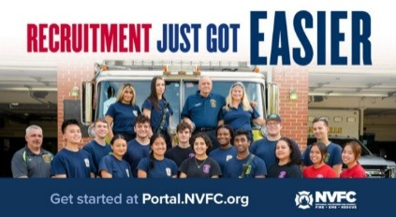
Does your fire or EMS department need more volunteers? The National Volunteer Fire Council (NVFC) is here to help! Use the FREE department portal from the NVFC’s Make Me A Firefighter campaign to access tools and resources to help you find and keep volunteers.
GET STARTED NOW AT THIS LINK:
https://tracking.police1.com/t/9495565/187515077/7816037/1/1006865/?b44ed14b=YmY5NWQ4NzktNWRmOC00MWJkLTkzMDctNzg0Y2VhZTNjMzYy&x=1ee5e8f9

FIREFIGHTER HEALTH AND SAFETY – PROTECTING OUR OWN
2
LINE OF DUTY FIREFIGHTER DEATHS FOR 2026
In 2025 we experienced 78 LODDs reported nationally.!

FIRE SERVICE FATALITIES OR DIBILITATING INJURIES
- An off-duty Ocean City firefighter/Parsonsburg volunteer forced entry at a working residential fire and located a victim but was overcome by heavy smoke; he was flown to a Baltimore-area hospital in stable condition.
- D. C. Safety Battalion Chief Keith T. Long reportedly collapsed during a department function and died. He was a 38 year member and a former officer with Oxon Hill VFD in adjacent Prince Georges County.
- A veteran South Jersey firefighter Howard Bennett, died Thursday after becoming trapped beneath the icy waters of a Camden Waterfront marina while working on a department boat

FIRE APPARATUS ACCIDENTS
- The Nelson County, Kentucky Sheriff’s Office announced on Thursday that an investigation was underway after a semi-truck allegedly hit a Northeast Nelson fire truck. No injuries were reported.
- A Provincetown, Massachusetts Fire engine reportedly collided with a utility pole about 11 AM Monday as it was returning from a medical response, no injuries were reported accept to the engine.
- A Lake Country, Wisconsin Fire and Rescue truck rolled onto its side at a roundabout while responding to an apartment fire on Feb. 1, according to Chief Matthew Fennig. The driver and only person in the apparatus was not injured since he was wearing his seat belt.
- Two fire apparatus were seriously damaged after rolling over on icy roads in freezing rain in Central Alberta, Canada on Friday night. A pumper from Lamont County Emergency Services and east of Namao, a tandem tanker landed upside down. There were no serious injuries.

Firefighters Falling Through
- No reports this week.
FIRE APPARATUS

Community-Based Apparatus Needs Assessment
Tom Shand
There are many challenges that apparatus committees face when developing bid specifications for new units, including vehicle size, interior cab layout, fire pump rating, and water tank and hosebed capacities along with the tools and equipment that need to be carried. Aerial devices have various offerings with respect to vertical height, horizontal reach, rated tip load, outrigger stance and ground ladder configurations.
At times, the amount of variations and options are overwhelming and can result in poor decisions at the point of purchase.
Depending on the department’s fleet replacement plan and the anticipated life cycle for the apparatus, frontline units can be expected to provide at least 10 years of service—in some cases, considerably more. With this in mind, it is imperative early in the design process to determine and analyze the mission of the vehicle. Apparatus must be capable of safely operating in the response area along with carrying the personnel, tools and equipment to support fire/rescue incidents that you’re likely to encounter.
SAFETY AND PERFORMANCE
Apparatus safety and performance should be at the forefront of any discussions about a vehicle’s overall design. One of the first factors to consider is community demographics. A 15-year-old vehicle that worked well for the department might be worthy of a repeat performance; however, it is unlikely that your community looks the same as it did in 2005. Roadways now have dedicated bike and bus lanes, roundabouts and heavier traffic patterns that affect our response routes. Many communities adopted minimum building set back requirements, including green space landscaping, which affects apparatus positioning and often limits access to one side of the structure.
Fire station access also should be considered, to verify apparatus bay door and interior clearances, ramp angles and roadway impediments that could restrict apparatus movements from the station. If the apparatus committee has any doubt as to a new vehicle's maneuverability, the committee should have a similar size and weight apparatus brought to the department to validate the capabilities of the vehicle with respect to front axle cramp angle, wall-to-wall turning radius, and approach and departure angles. It sounds rather straightforward, yet each year we hear about fire departments that acquire units that don’t fit into their station’s apparatus bays or are restricted from accessing parts of the response area because of roadway and bridge weight restrictions.
Many fire departments rely on multipurpose units to provide service delivery in their response areas. The result is that many pieces of fire apparatus, regardless of type, have become larger in size. Basic dimensions, such as overall length, overall height and the in-service weights of units, have become so large that the body configuration makes it difficult or unsafe to work from. Although NFPA 1901: Standard for Automotive Fire Apparatus provides some excellent guidelines, there is nothing in the standard that prevents an apparatus committee to specify a vehicle that would be too large, tall or heavy with respect to the operating conditions and demographics in the community.
When discussing the initial cost of the apparatus, you also must consider the life cycle operational costs for the heavier vehicle, which will affect tire wear, suspension components and potential limited access to equipment that’s stored in upper body compartments. Most importantly, location of properly located fixed steps, access ladders and handrails must be considered in the overall design of the vehicle. Simply put, what looks great on paper on the blueprint might not work well once the completed apparatus is delivered and placed into service.
Let’s consider your department’s deployment strategies with respect to apparatus response patterns to various types of incidents. Many organizations use GPS or other mapping programs to alert the closest staffed units, particularly for EMS incidents, which in many jurisdictions make up the large majority of all calls. During a recent fire service conference, several attendees discussed their department’s use of all suppression units to deliver paramedic-level EMS service in their community. The effect of running an 84,000-lb. rear-mount aerial tower to low-priority EMS calls, along with other responses that result in more than 3,500 annual responses, will result in increased maintenance and repair costs along with a reduction in the planned 15-year life cycle.
Engine company apparatus dimensions, including overall length, wheelbase and height, are driven by several factors, including cab seating, pump panel width, and water and foam tank capacities, along with the desired compartment layout and hosebed. A change in any one of these areas can affect adversely vehicle maneuverability, center of gravity and axle ratings. When developing specifications for any new apparatus, it is incumbent upon the fire department to develop a complete inventory of tools and equipment, including all hoseloads, which will be included in the bid documents. Included with this inventory will be the anticipated weight of this equipment. This protects the interests of the organization, because your equipment inventory might weigh considerably more than the allowances that are provided in NFPA 1901 for the different types of apparatus. Additionally, the fire department should require a detailed weight analysis for the apparatus as proposed by each manufacturer to ensure that the unit is built to carry your equipment with a margin for additional equipment that might be placed onto the apparatus during its life cycle.
The height of the rear hosebed on many engine units has increased because of the need to carry more equipment for any type of incident. Full-depth body compartments typically require a rectangular water tank; with everything else being equal, a combination rescue-engine apparatus that has a 750-gallon water tank will have a higher hose body than a unit that has a T-shaped water tank. Flat-back style bodies, while offering additional enclosed compartment space, can limit the available options for stepping arrangements for access to the hosebed area. Apparatus committees should review the availability and fire flows that are available from the public water supply when they determine the appropriate size of the water tank and the desired hosebed height from the ground. Using a combination of body length, tank dimensions and hosebed layout, there are opportunities to lower the hosebed and provide safe access to this area.
A visit to any local fire apparatus and equipment show might reinforce the notion that a moderate-wheelbase engine that’s outfitted with a rescue-engine body, a 1,000-gallon water tank, a generator, a light tower and the latest foam system technology will work for your department. Just because the apparatus will fit into the available space in the station doesn’t mean that it will perform well within the response district. The apparatus committee carefully should plan the overall layout of the apparatus and then add components that will enhance the mission of the vehicle.
task requires addressing issues within the department’s apparatus committee, as well as among the chief officers, and reaching out to municipal stakeholders who affect regulations for building and zoning requirements. In the past decade, there has been a dramatic increase in the size of residential structures amid the introduction of lightweight building materials. A 10,000-square-foot, three-story home no longer can be considered a routine structural fire when the alarm comes in to your communications center. In many situations, access to the structure for aerial apparatus precludes use of the aerial device and increases the reliance on ground ladders to cover all four sides of the building. What appears to be a two-story home on sides one, two and four actually might be three or four stories at the rear of the building.
With so many kinds of aerial devices—rear-mounted aerial ladder, tractor-drawn aerial ladder, mid-mounted tower ladder, rear-mounted aerial tower—what do you choose? Doing a community-based aerial-needs assessment might be appropriate at this point to help to define the mission of the vehicle.
So, let’s say, as the apparatus committee, you determined a need for more than the NFPA-minimum 115 feet of ground ladders. Now, which style of aerial device and body configuration lends itself to the capability to carry the maximum number of portable ladders? What tower design leads to maximum payload of portable ladders? If your response district or the fire station has an overall height limitation, then a rear-mounted aerial tower might not be the best choice to meet your operational needs.
Mid-mounted tower ladders were developed for departments that have apparatus bay doors that are smaller than 11 feet and were built principally without a fire pump or water tank to maximize the equipment and ground ladder complements with a single-axle configuration. Over time, tandem-axle apparatus became more prevalent, which resulted in more quint units, where the size of the water tank and of the hosebed dictated the space that is available for ground ladders. This resulted in many quint apparatus that carry only two extension ladders.
Engine company apparatus bumpers provide space for front-suction piping, attack line discharges, hosewells and recessed audible warning devices. Note the recessed front-suction hosewell on the right side the apparatus and short handrails on the cab face. Each desired component affects front axle weights and the angle of approach, which should be evaluated during the specification process.
During your assessment of the structural conditions in the response district, evaluate the number of buildings where access to your current or planned aerial apparatus would be limited and then seek out the number and appropriate working length of ground ladders that you would need to protect not only potentially trapped occupants but department personnel as well. It isn’t uncommon for a well-designed truck company to carry 240–280 feet of portable ground ladders with tractor-drawn ladder units having more than 300 feet of ground ladders.
Perhaps the apparatus committee determines that the new aerial device must carry more than the NFPA-minimum of 2,500 pounds of equipment. Getting an accurate count of tools and equipment is critical in the design phase, not only to avoid an overweight condition but also to keep the vehicle in balance. Any model of quint apparatus can be subject to overloading if the tool and equipment cache is greater than what the apparatus manufacturer projected during the initial design process. Ensure that your department provides a detailed listing of the anticipated hose, tools and equipment that are planned to be carried on the vehicle to your apparatus sales representative. Next, ask for a detailed weight analysis for review and approval by all parties prior to contract to confirm that the apparatus design will meet your needs.
Consider these concepts during the initial design process of your engine and ladder company apparatus. Defining the mission of the vehicle and melding this with the operational needs of the fire department while staying within the organization’s fleet replacement plan will go a long way to ensuring a safe and well-designed apparatus. Your fire department and community deserve nothing.

Fire Department SWOT Analysis
Many of you reached out to Dave Denniston asking about the SWOT analysis for your fire department. It all starts with a Community Vulnerability Assessment. Our communities have changed dramatically in the past 40 years and yet we have not changed the way we function, train, or equip ourselves. 40 years ago, my community was made up of small family dairy farms. Today you would be hard pressed to find a single one. The types of calls we respond to, and hazards we respond to, are completely different than they were 40 years and yet our fleet of vehicles, membership requirements, equipment and training look very similar to what they did back then.
No one else is going to save the fire service for us and if our elected officials do, they’ll make a mess of it. We need to roll up our sleeves, get to the table, and figure it out ourselves. We must continue to advocate for new tools and resources but none of them alone will save us. Change is not an option; it is a necessity. Let's get to work! Together, we have the expertise to get this done.
We can no longer ignore the elephant in the room. The current fire service delivery model has not kept up with the times. As we travel across the state, the same message is shared by attendees at meetings from Long Island to the North Country and from Albany to Buffalo. We are not going to recruit our way out of this. We need new initiatives and tools, and we need them now.
Not only have our departments fallen behind the times, but our organizations also continue to function like it was 25 to 100 years ago as well. Our traditional conferences and tradeshows no longer draw large crowds. Our antiquated processes cannot react to real time needs. Our egos and pride have gotten in the way. We are not proactively attracting young leaders and use our processes to discourage them from even trying. We chase away anyone with fresh ideas because we are scared of the unknown or afraid we won't be seen as the hero. It is time to wake up, time to have serious discussions and time to speak up. Every department and organization needs to do an immediate SWOT analysis. What are your strengths, what are your weaknesses? What are your opportunities, and what are your threats. When you are done, ask your neighbors to do the same, and then meet with them at one table and work towards solutions to help each other.
None of us will solve this alone. It is no longer about the logo on the T-shirt, the color of the trucks, or the trophies in the case. It is about survival. Eight departments in NYS closed their doors in 2025. If we fail to take action, that will only be the tip of the iceberg. If we work TOGETHER, we can help stop the bleed. Please use your voice before it is too late. Thank you to all those in Onondaga, Onedia, Rockland, Orange, Sullivan, Broome, Long Island, and countless other counties that have done just that in the past few weeks. Hopefully people are listening.
THE BUILDING AND FIRE CODE ISSUES – WEEKLY REPORT ON FIRE FATALITIES
The New ICC Code-NYS Edition went into effect on December 31st 2025 although the implementation of the energy code provisions have been withdrawn until further notice.

HOME FIRE FATALITIES REPORTED BY THE MEDIA FROM THE US FIRE ADMINISTRATION FOR 2026
Fire Deaths in 1&2 Family Dwellings in NYS | 7
Last fire death 1/31/26 Bath, Steuben Co. Male, 35
Fire Deaths in any type of Dwelling in NYS | 16
Fire Deaths in 1&2 Family Dwellings Nationally | 161
Top 3 States with the greatest 1&2 Family Deaths | #1 TX/14
 | #2 OH/11
 | #3 GA/10
Civilian home fire fatalities in 2026: 291
Both the states of Maryland and California as well as Wash. DC require sprinklers in 1&2 family dwellings.
According to realtors and builders only old homes burn, so sprinklers are not needed in new homes: so my question to you is; when does a new home become an old home?

GREEN ENERGY AND THE IMPACT ON THE FIRE SERVICE

Sparks Fly over MA Battery Storage Project
Peter Currier, The Lowell MA, Sun
Members of the Select Board and Board of Health clashed in a joint meeting Thursday evening as the two boards met for a discussion on a controversial battery storage project proposed for Hillman Street.
The proposal covers a 4.3-acre area of already developed land in the area of 73 Hillman St., where 125 megawatts would be stored in batteries housed in separate containers, which proponent East Point Energy says in its project page can power nearly 125,000 homes for four hours.
Residents in the area of the proposed battery site, many of whom live in the neighboring Emerald Court neighborhood, have been voicing opposition to the plan since last year. With an upcoming Feb. 6 deadline for concerned residents to submit questions or comments to the state’s Energy Facilities Siting Board about the proposed site, the Select Board and Board of Health met for a public dialogue.
As Town Manager John Curran put it, though, the town has little decision-making power in projects like these. The Energy Facilities Siting Board has the ultimate say in approving the project, but the town and its individual boards and departments can petition to be interveners in the proposal. Curran said the town intends to use the host community agreement tool to create conditions and concessions more favorable to the town and nearby residents.
“Taking a purely adversarial position on this project will deny the town the opportunity to incorporate more safety conditions through this process,” said Curran.
The host community agreement includes items like an agreement over a 20-year period that the annual payment in lieu of taxes would be a minimum of $2 million to the town plus a 1% Community Preservation Act surcharge. Curran said those figures are likely to rise with the value of the project, but at a minimum it would bring the town $40 million over that 20-year period.
The host community agreement also included safety standards and emergency preparedness measures, like a dedicated 30,000-gallon water supply for fires, a requirement for multiple entry points rated for large fire apparatuses, an alarm and emergency notification system with backup power and a plan for decommissioning the site with a decommissioning bond of between $3 million and $6 million required by Hillman Energy Center LLC.
“If the project is never completed they still have to cover decommissioning, if the project is abandoned they still have to cover decommissioning,” said Curran.
One concern among residents has been the effect such a facility would have on their own property values, which Curran said was accounted for in the host community agreement with the inclusion of a $50,000 fund paid into by Hillman Energy Center and controlled by the town. The fund, Curran said, would be meant for residents within an area of 650 square feet around the facility who make claims of a direct property value impact to their homes from the facility. If claims are paid out, Hillman Energy Center would be perpetually responsible for replenishing the fund, Curran said.
Hillman Energy Center will also be responsible for applying for any required permitting for the project and is agreeing to on-site inspections and reviews by a third-party fire safety expert.
With fire safety and preparedness one of the top concerns for neighbors opposing the project, Select Board member Richard Russo asked proponents about what happens in the first 15 minutes after a fire breaks out in a facility like the one being proposed.
Mike Nicholas, a fire safety expert hired by the town, said an alarm would quickly be triggered, which would alert a central station that contacts local emergency dispatch.
“The Fire Department begins their dispatch, they show up on scene. There should be a response station or incident command post they can go to, a safe distance from the site, and they are able to see the optics of what is going on in that fire alarm panel,” said Nicholas.
The readings on that panel, Nicholas said, would inform the responding firefighters of what kind of incident they are dealing with.
“I may have smoke detectors going off and no gas, and my assumption at that point is I probably have an electrical fire. If I have gas detection showing up, I am starting to think there is some sort of thermal event involving the battery,” said Nicholas.
While this is happening, site representatives are automatically being informed of the incident at the battery site so they can respond themselves. The site is also designed in such a way that Nicholas said would make it more difficult for a fire to spread between different battery enclosures, so in many cases a fire can stay contained to a single enclosure.
“At that point we are simply managing the incident. We want the enclosure that is involved to consume itself in the fire, it burns off the stranded energy and it is a shorter duration incident,” said Nicholas.
In incidents of battery fires in California, Nicholas said there has been “universally” no impact to the air and water off site.
Select Board Chair Mark Kratman addressed the room, and said this process has been something town leadership and the residents are not used to, and that it has been “exhausting.”
“For us to be able to negotiate these things and to take your health and safety into consideration, we have to stay neutral so we can go in and we can fight for these types of things and make sure all the health and safety protocols are put in place,” said Kratman. “I would love to see every one of you up at the State House for the siting meeting, when they are going to be making this decision, because I think it will make a difference for what goes on.”
Members of the Board of Health were skeptical of the safety of the project.
“I can’t get away from the fact that there should be somebody on site,” said Board of Health member George Ferdinand.
Board of Health Chair Melissa Braga questioned the scope of the property value fund, and why Hillman Energy Center would not be willing to extend the eligible radius to 1,000 feet if they are confident the facility will not negatively impact nearby property values.
Special Counsel Jeffrey Bernstein said extending it would be possible in theory, but Hillman Energy Center would then have to prepare itself financially for a worst-case scenario, which could be significantly more expensive when extending the area outward.
Braga also questioned whether the Board of Health was being shut out of access to a $250,000 fund put forward by Hillman Energy Center to reimburse intervening groups for experts they retain to speak on the project and its impacts. Curran responded by saying the money is budgeted for the town.
“And in theory we should all be swimming in the same direction,” said Curran. “If there is something the Board of Health wants to investigate, or have access to these experts, reach out to me and we’ll see if that is a possibility. This document is written for the town, and we’re all members of the town. It is not an exclusion of the Board of Health.”
“Unless we don’t go with what the town wants, or unless it is something that is different in our opinion with the town, correct?,” Braga responded.
“What is clear is the town will not fund two attorneys with two opposing positions,” said Curran.
“So the Board of Health, yes, is part of the town, but only if we don’t ask questions,” said Braga, drawing applause from the audience.
The contention between participants in the meeting rose from there, with Braga and Curran going back and forth about the funding and any supposed conditions attached to it. Select Board member James Mackey jumped in to Curran’s defense, telling Braga he “was taking all this flak for decisions this board has made.”
Later, Braga asked Curran what process the Board of Health should follow if they are seeking legal guidance and if Curran would assist them. Curran began to say they had already been doing that, when Select Board member Richard Russo interjected.
“Let’s be honest, you just don’t like what you’re hearing,” Russo said to Braga, who immediately responded.
“It’s not that I don’t like what I hear, it’s that when we had to petition to intervene, that took a long time,” said Braga, pointing to a level of “non-responsiveness” her board has received from the rest of the town on the matter.
Russo argued that all the boards are on equal footing, because no entity in town is actually making any decision on this proposal, only the Energy Facilities Siting Board.
“The only thing we are trying to do is trying to protect, and trying to provide safety precautions, and all the things everybody in this room is probably going to be mentioning over the next hour to hour and a half,” said Russo.
Residents’ concerns
After more arguing between boards, residents finally got a chance to speak. The first to rise was William Martel, whose house is right across the street from the proposed site on Clinton Street, just 40 feet away from where a 30-foot wall would be build on the edge of the site.
“There is going to be a constant buzzing sound 24/7, enough to drive you crazy,” said Martel. “But my biggest fear is going to bed and never waking up. My house is in the danger zone, and some of these gasses the meters can’t even test for. If something goes wrong, I’ve been told word goes to Texas first, and after the Fire Department would be notified. How long would that take? How would I be notified? What are you going to do to assure my safety if this site goes in?”
After him was Dawn Sheehan, whose family owns much of the land in the area, who expressed concern over the potential spread of a particularly dangerous chemical if a fire were to occur: hydrogen fluoride.
“We have paid, out of our own pockets, for third-party expert testing,” said Sheehan. “You have said if we had data, to bring it to you, it is now literally staring you right in the face. This hydrogen fluoride can go half a mile.”
Nicholas responded to Sheehan’s claims by saying any hydrogenated gases dispersing from a battery would be “racing to the moon at about 45 miles an hour,” but there are too many variables to consider in any given case.
“So in an outdoor environment with wind conditions, relative humidity, temperature, when you do any plume analysis, the resulting analysis is only as good as your input values,” said Nicholas.
After several residents spoke on the issue, mainly with concerns or in opposition to the project, members of both boards were given one more opportunity to speak. Board of Health member Susan Amato spoke directly to the discourse that unfolded during the meeting.
“I never want to see the disrespect I’ve seen tonight at this meeting. It doesn’t matter who believes in what or who wants what, and I believe we are all on the same the side somehow,” said Amato.
Braga and Russo both apologized for their words during the meeting, and expressed a willingness to continue working together and communicating on the issue.
The Select Board will have a vote on the host community agreement in a meeting Wednesday. The town will submit discovery to the Energy Facilities Siting Board, which is due Feb. 6. The board will then conduct evidentiary hearings, with briefs and replies from all parties su
INFORMATION FROM THE NYS FIRE SERVICE ALLIANCE

State Chief’s Scholarship Program
Applications are now being accepted for the NYSAFC Scholarship Program and the Chief Neil McNeight Hands-On Training Award. Nominations are being accepted for the Chief Fred Singer Fire Educator of the Year Award, James Wright Public Education Award, and New York State Fire Chief of the Year Awards. Please note changes to the Scholarship Program for 2026. Three $1,000 scholarship awards will be granted in memory of Chief Ward Bohner and his wife, Janice Bohner, Chief Anthony Messina, and Chief James Hare. The deadline for submitting required materials is April 1, 2026. Eligibility criteria is available in the Application & Nomination Package. GO TO THIS LINK FOR MORE INFORMATION: https://www.nysfirechiefs.com/awards

Attendee and Exhibitor Registration is Open for the NYSAFC Annual Conference & Expo
The association's 120th Annual Conference & FIRE 2026 Expo will be held June 10-13 in Syracuse. Changes for 2026 include reduced conference Full Term Registration fees ($50 for association Individual Members and $100 for non-members), a new Hands-On Training course – “Initial Attack: First-Due Company Operations,” and new event hours on Thursday. Free One Day Tickets for the expo will once again be available from exhibitors!

Rural Water Supply Operations Seminar: Moving Big Water with No Hydrants
Pittstown Fire Dept, & the Rensselaer County Fire Chiefs Association
Saturday and Sunday, April 18th & 19th, 8:00am to 4:30pm
Pittstown Fire Dept. 134 Parker School Road, Johnsonville, NY 12094
For more information contact Pittstown Fire at 518-663-5773 leave a message or at car1station25@gmail.com

NYSAFC 2026 Seminar Series “Dangerous Spaces: Challenges and Tactics When Dealing with Garage and Basement Fires” With Chief/Commissioner Michael Lombardo (Buffalo Fire Department)
Three-Hour Seminar:
Some of the most dangerous fires we deal with are often looked at as routine: the basement fire and the garage fire. Basement fires are probably the most overlooked killer of firefighters engaged in combat firefighting in much of the U.S. The construction, layout, fire load, and access present difficult and dangerous challenges at below grade fires. From the incident commander to the firefighter on the nozzle, we must all recognize and be able to deal with these challenges. Huge migration to the suburbs starting with the arrival of the Baby Boomer generation saw the explosion of the attached garage. Many older cities never had the available space for homes to feature an attached garage or have any garage at all. The tremendous fuel load that is constantly evolving presents danger for occupants and firefighters alike. This class will address these challenges and alternative strategies and tactics that can be deployed to deal with these dangerous spaces.
Registration Fee:
$35 per person – NYSAFC Individual and Department Members
$50 per person – Non-Members
Pre-registration is encouraged. On-site registration will be accepted if space permits.
Note: A 3% service fee will be applied if paying by credit card.
2026 Dates and Locations:
Seminar begins at 7:00 p.m. at all sites. Registration area opens at 6:30 p.m.
February 18 – Herkimer County
Newport Fire Department • 7370 Main Street • Newport, NY 13416
March 3 – Schenectady County
SUNY Schenectady Community College • Stockade Building • Room 101 • 78 Washington Avenue • Schenectady, NY 12305
September 10 – Fulton County
Berkshire Fire Department • 320 Steele Avenue Ext. • Gloversville, NY 12078
September 16 – Saratoga County
Saratoga County Public Safety Building • 6012 County Farm Road • Ballston Spa, NY 120
September 22 – Dutchess County
Pleasant Valley Fire District • Station 1 • 1619 Main Street • Pleasant Valley, NY 12569

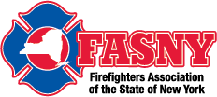

Risk Control in Emergency Services, Are You the Problem or The Solution!
Date & Time Thursday Feb 12, 2026 07:00 PM
This dynamic and interactive webinar is designed for all field personnel, supervisory staff and training officers to provide an understanding of how each individual Emergency Responder within an organization plays an integral and vitally important role in overall risk reduction. Sound risk reduction aids in the creation of a safety culture within the organization. Additional topics include written policies, rules and regulations, as well as equal and equitable enforcement.
REGISTER AT THIS LINK:
https://fasny.zoom.us/webinar/register/WN_17ooxpkhSruFZv6ty7e7iw#/registration

NEIGHBOR’S HELPING NEIGHBORS

Gansevoort Fire Department Breakfast
The fire company thanks you for your support!! Breakfast will be served starting at 8AM Sunday February 15th

Clifton Park Fire Department Breakfast
Thank you for your support! Sunday April from 8 to 11am

Speigletown Fire Department Breakfast 2nd Sunday of each month
Sunday February 8th from 7:30 to 11:30, $10 adults, $5 children, under 5 free.
GENERAL INTEREST TO ALL

North Charleston, SC, Fire Museum to Close after Apparatus Owners Reclaim Fire Trucks
Peter Matthews
Officials said that the North Charleston Fire Museum will shut down next week after owners of the museum's nearly two fire apparatus on display have decided to sell their vehicles.
The fire apparatus were listed on auction house RM Sotheby's website earlier this week, ABCNews4.com reports.
The museum opened in 2007 with a collection of over 20 fire apparatus on a long-term loan. The museum had the largest collection of restored American LaFrance fire apparatus in the country.
When American LaFrance opened a factory in nearby Moncks Corner, they helped open the museum, but American LaFrance shut down in 2014.
North Charleston officials said that, without the fire apparatus collection, they would no longer be able to operate.
The museum remains open until Feb. 14 and officials said admission will be free.
[EDITOR’S NOTE: THIS IS VERY UNFORTUNATE BECAUSE THIS MUSEUM WAS HEAVY ON INTERATCTIVE FIRE SAFETY EDUCATION ESPECIALLY FOR YOUNG PEOPLE, A REAL LOSS TO THE COMMUNITY.]
TAKE A MOMENT TO SMILE

It’s ok to mix peas and corn but don’t call porn!!

CLASSIFIED

Opening for Part Time Fire District Treasurer/Deputy Secretary
The Greenfield Fire District is currently seeking qualified applicants for the position of part time Fire District Treasurer/Deputy Secretary. Prior experience and individuals residing within Fire District Boundaries given preference. Complete job description and qualifications can be found on the Greenfield Fire District website at: www.greenfieldfd.org. Cover letter/current resume can be mailed to Greenfield Fire District, attn. Joyce Petkus, P.O. Box 103, Greenfield Center, NY 12833, or emailed to Treasurer@greenfieldfd.org, and will be accepted until the position is filled.
CAFDA OFFICERS AND DIRECTORS 2026
OFFICERS
President, Tom Rinaldi, Commissioner, Stillwater Fire District
1st Vice President, Ellen Martin, Deputy Treasurer Clifton Park Fire District
DIRECTORS:
Les Bonesteel Past Commissioner, Burnt Hills/Saratoga,
Skip Smith, Commissioner, West Crescent/Saratoga
Joyce Petkus Treasurer Greenfield/Saratoga,
Ed Woehrle Commissioner Niskayuna #1/Schenectady
Art Hunsinger, Ex-Officio Member Clifton Park Fire District.
We would consider expanding the number of Directors if individuals from other counties would volunteer to participate!!

APPOINTEES
Secretary Molly Jenkins, Region 1 Director, Assoc of Fire Districts, NYS
Treasurer: Tony Hill
Sargent at Arms: Tom Wood, Commissioner, Northumberland Fire District
Chaplain: Dane Fagan
Legal Counsel: Greg Serio, Safety Officer, Verdoy Fire District
The Capital Area Association represents any fire district that wishes to join CAFDA. Fire District Officials include Commissioners, Treasurers, and Deputy Treasurers. Secretaries and Chiefs are also invited to participate!
Please advise your secretaries that all correspondence should be mailed to:
CAFDA PO Box 242 East Schodack, NY 12063
EMAIL TREASURER: TREASURER@CAFDA.NET
518-407-5020
EMAIL SECRETARY: SECRETARY@CAFDA.NET

Long Way to Travel? Zoom into the General Membership Meetings!
It’s our desire that every member fire district have the opportunity to attend Capital Area meetings. We know we cover a large area, in 8 counties and beyond, and wish to give all of our members a chance to participate in the general membership meetings. You have a voice, and we would like to hear it. Join us at our next meeting either in person or via Zoom. The link will be sent via constant contact prior to each general membership meeting. Thank you for being a member and we hope you will join us.

Capital Area BUSINESS PARTNER’S
Business Partner Applications Available At: WWW.CAFDA.NET
WELCOME DIVAL SAFETY EQUIPMENT
Green Boarder = not yet renewed for ‘26
We invite our business partners to submit educational information to be included in this Bulletin for district commissioners and chief officers
We want to thank all of our Business Partners for renewing their partnership for 2026. You are invited to our monthly membership meeting and to any of our social events..
FIRE SERVICE LEGAL SERVICES

Monaco Cooper Lamme & Carr.PLLC
1881 Western Ave, Suite 200
Albany, NY 12203
Nicole Strippoli 518-941-9040
NSTRIPPOLI@MCLCLAW.COM
https://mclclaw.com


The D’Amato Law Group LLP
Gregory Serio, Partner
Alyssa B. Snyder, Partner
111 Washington Ave Suite 600
Albany, NY 12210
518.426.3800
Email: gserio@dlgny.com or
asnyder@dlgny.com
damatolawgroup.com

HAWKINS DELAFIELD & WOOD LLP
William J. Jackson, Partner
1160 Pittsford-Victor Road, M2-11
Pittsford, NY 14534
585-645-1184
Fire Service Bond Attorneys
www.hawkins.com

Whiteman Osterman & Hanna LLP
Bond Counsel
Robert J. McLaughlin, Partner
One Commerce Plaza, Albany, NY 12260
518-487-7697 Cell 518-813-6333
mclaughlin@woh.com
www.woh.com
Ducharme, Clark & Sovern, LLP
Jack Clark, Fire District Attorney
646 Plank Rd. Clifton Park, NY 12065
518-373-1482
Ducharmeclark.com
HANNIGAN LAW FIRM PLLC
388 Kenwood Avenue
Delmar, New York 12054
P: (518) 869-9911
F: (518) 869-9915
www.hannigan.pro
Fire/EMS –Municipal Law

FIRE STATION & FACILITIES ARCHITECTS AND ENENGINEERS


n.lobosco@ctmale.com
Shawn Corp, Principle
15 Cider Mill Way, Saratoga Springs, NY
518.322.1386
www.reveal-ad.com


Architecture/Engineering/Code Services
Melissa Smith – mlsmith@labellapc.com
Senior Marketing Manager
518-903-8394
4 British American Blvd
Latham, NY 12110
www.labellapc.com


Architects & Engineers
433 River Street, Suite 8002
Troy, NY 12180
518-765-5105
Dennis Ross, Practice Leader
www.H2M.com

Managed IT Services
Cloud Telephone Services

Wendel, Centerpointe Corporate Park, 375 Essjay Road, Suite 200, Williamsville, NY 14221 716.688.0766
Amy Numrich, MBA
Digital Marketing & Events Specialist
anumrich@wendelcompanies.com


Ryan Sapienza
Project Manager/Technology Consultant
518-754-4623
Service 518-869-3614
930 Albany Shaker Rd, Latham, NY 12110

Haughey Insurance Agency
850 State Route 50
Burnt Hills, NY 12027
518-399-1583
www.haugheyagency.com
FIRE SERVICE INSURANCE
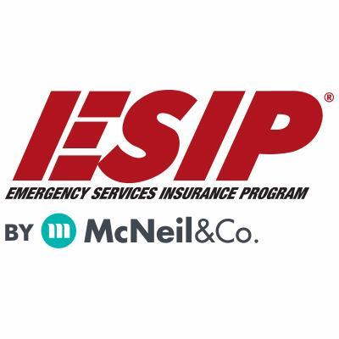
Tony Blackwell, Territory Sales Manager
800-822-3747 ext 530
ablackwell@mcneilandcompany.com
Aurora Inc. Insurance
120 Broadway
Albany, NY 12204
518-449-3180
aurorainsurance.com
Michael May, Broker
mmay@aurorainsurance.com

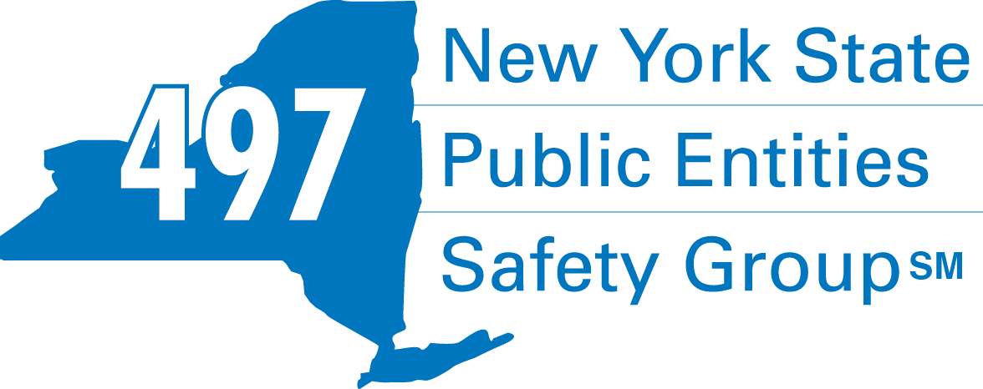
Fleury Risk Management
28 Corporate Drive, Suite 104
Clifton Park, NY 12065
518.478.6314
https://www.fleuryrisk.com/nysgroup497
VFBL Insurances Services
Stephan Petras
Marketing Representative
One Blue Hill Plaza – 16th Floor
PO Box 1609
Pearl River, NY 10965
845-352-8855x7099
329-236-3505
spetras@fdmny.com
VFBL/Workers’ Comp Coverage


Pat Daglio
pdaglio@vfis.com
717.819.3072

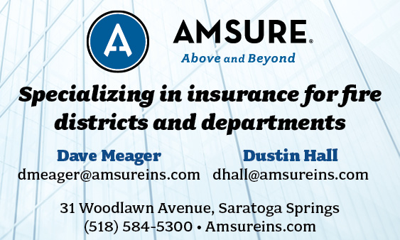

FIRE SERVICE FINANCIAL SERVICES AND LOSAP MANAGEMENT


518-432-5087
838-433-7304 cell
www.thelosapgroup.com.
nikki.haskins@rbc.com
455 Patroon Creek Blvd, suite 200, Albany NY 12206
UBS Financial Advisors
Ralph Lemme, CFP
8 Southwoods Blvd Suite 207
Albany, NY 12211
518.445.1667

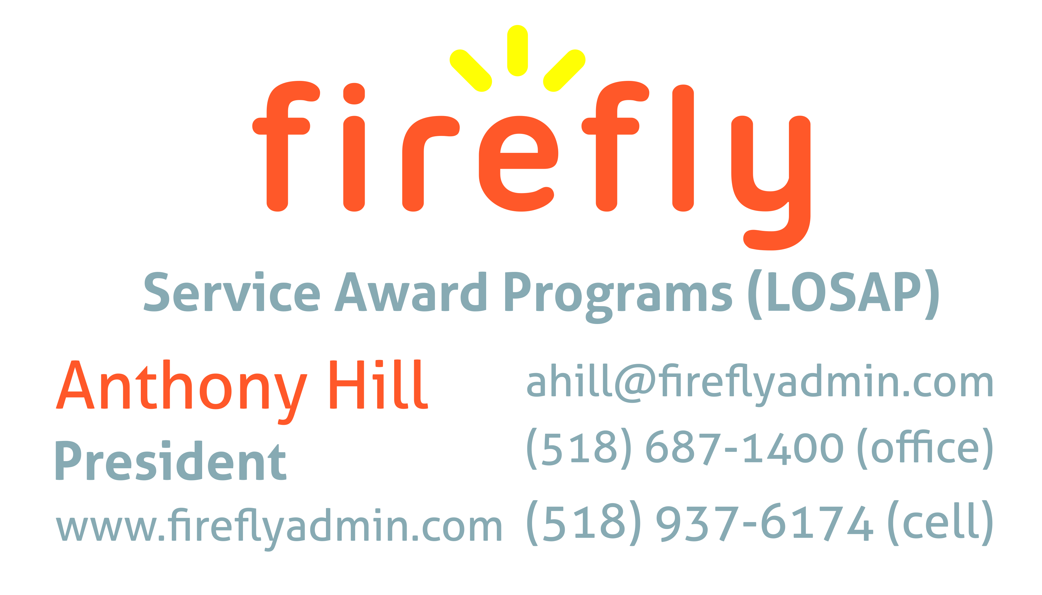


Nicole Meeker
Manager of Business Development & Accts
518-394-7894
Cell 607-423-4811
www.penflexinc.com
nmeeker@penflexinc.com
FIRE EQ TESTING
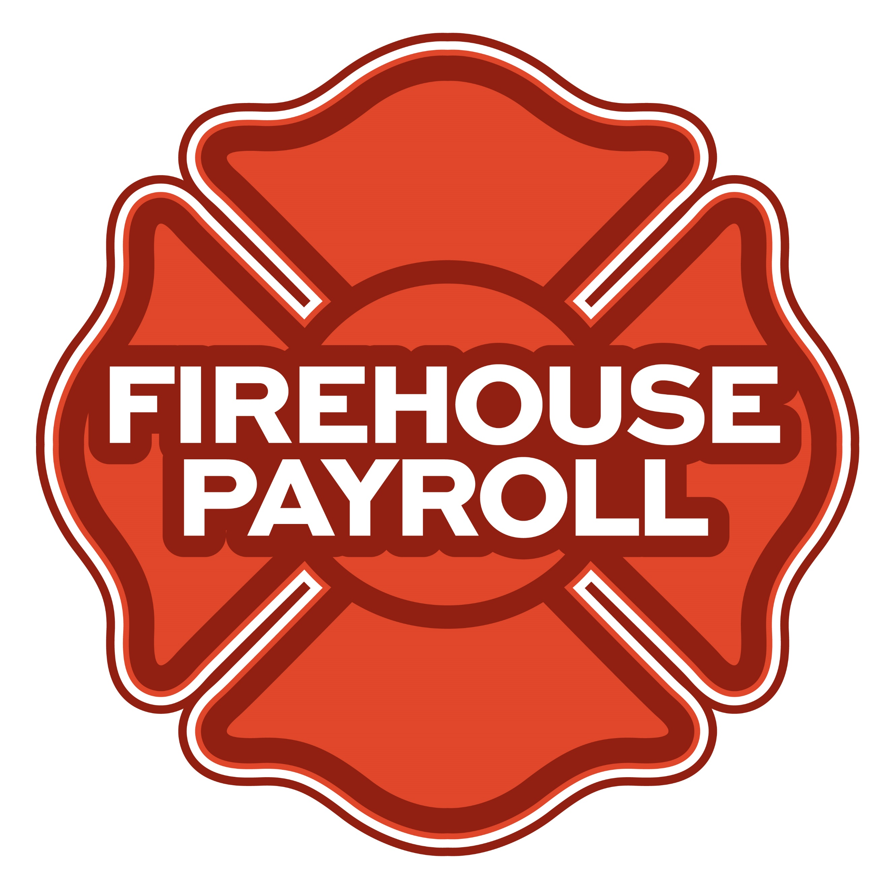
Jeremy Hartnett
302-483-7699
jeremy@firehousepayroll.com
payroll-pension reporting-tax filing
direct deposits-timekeeping-HR Services
FULL-SERVICE FIRE EQUIPMENT
DRYER VENT CLEANING

www.jeromefire.com
Breathing Air Comp Maintenance,
Air Quality Tests and Repairs
Russell Jerome
315-699-4533 Office
Ready Rack Extractor/Washers
Full Line of Fire Equipment
8721 Caughdenoy Rd, Clay, NY 13041

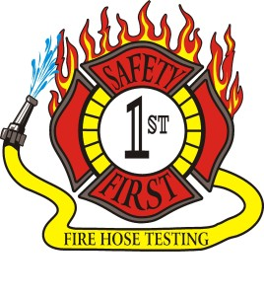Safety First Equipment Testing
99 Glass Lake Road
Averill Park, NY 12018
518-674-8363
www.safetyfirstfirehose.com
HOSE, APPLIANCE & LADDER TESTING
Safety1hose@gmail.com
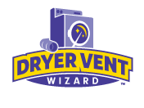DRYER VENT WIZARD
JORDAN CATINO
8 NAPA COURT, SCHENECTADY, NY 12309
518-344-0664
SARATOGADRYERVENT.COM
jcatino@dryerventwizard.com

FIRE DEPT COMPUTER MANAGEMENT & REPAIR

White Wolf Computer, LLC
4 Normanskill Blvd. Suite 410, Delmar, NY 12054
(518) 459-9653
Managed Services
Cloud Hosting Solutions
Telephone Data Cabling
Backup Disaster Recovery
Web Design Services

FIRE COMPANY FUND RAISING

FIRE STATION PEST CONTROL

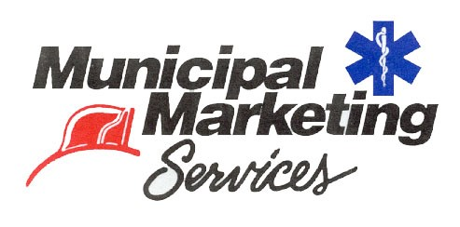
Lloyd Fox, Account Executive
34 Garner Road, Averill Park, NY 12018
Lfox8@nycap.rr.com
518-810-7819
www.funddrive.com

518-300-4732
431 New Karner Rd Suite 170
Albany, NY 12205
https://fox-pest.com/albany-ny

FIRE SAFETY EQUIPMENT
FIRE APPARATUS/SERVICE

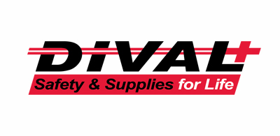
Timmy Kimball
518-925-2786
www.divalsafety.com
Testing-Safety-Promotional Services-Respiratory Solutions
Facility Safety-Fall Protection-Training
60 Cohoes Ave, Green Island NY 12183
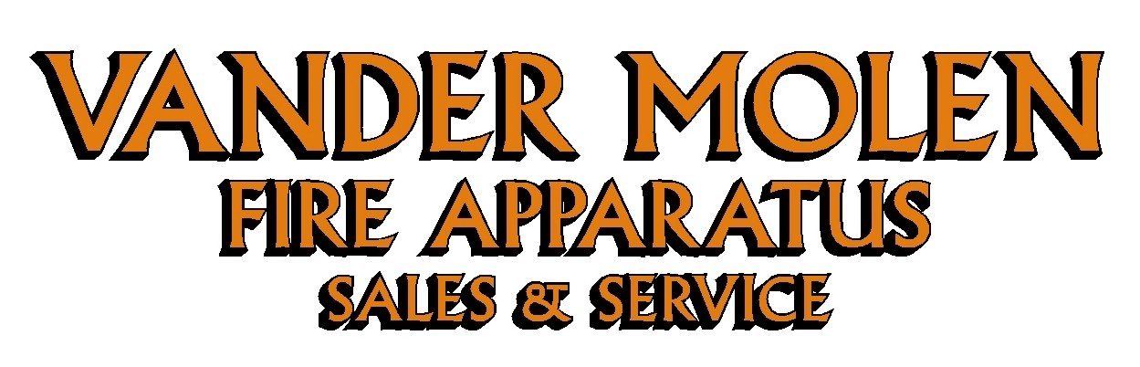
Mike Bonesteel
Warranty & Safety Manager
518-288-3587 X101
Cell 518-926-0451
After Hours 680-800-5015
1 Super 50 Way, Ballston Lake, NY 12019

FIRE DISTRICT CPA/AUDITS/FINANCIAL SERVICES


Zoriana M. Stawnychy
973.283.0024
zoriana@stawnychyfinancial.com
135 Kinnelon Road Suite 101
Kinnelon, NJ 07405
Serving fire districts in New York State


518-459-6700
10 British-American Blvd, Latham, NY 12110
www.bstco.com
Brendan Kennedy ext 356


Robert V. Gramuglia, CPA
1 Pine West Plaza Suite 107, Albany NY 12205
518.452.8055 or 518.859.5851cell
Email: rgramuglia@BGCPA.net



Accounting, Consulting & IT Security
1581 Franklin Ave. Mineola, NY 11501
Kyle Brengel, Managing Partner
516-472-7345
kbrengel@gblny.com


11 British American Blvd, Latham, NY 12110
518-785-0134
Queensbury Office 518-792-6595
http://www.mmbaccounting.com
Alan W. Clink, CPA aclink@mmb-co.com
Heather R. Lewis, CPA hlewis@mmb-co.com

Don McCormack
425 Main Street Catskill, NY 12414
www.tbogc.com
518.943.2600 X607
donaldm@tbogc.com
Specializing in Fire Service Financing


David Farstad, VP-Municipal Banking
652 Albany-Shaker Road, Albany NY 12211
Ph: 518-730-3120
Cell: 518-506-0075
farstadd@pioneerbanking.com
JOHN M. LESNIEWSKI
Assistant Vice President and
Senior Business Banking Officer
Fulton/Montgomery Markets
12 Fremont Street, Gloversville, NY 12078
P: 518.775-5205 | M: 518.848-0612
NMLS ID 915694
www.nbtbank.com


The Arrow Family of Companies
Corporate HQ 250 Glen Street
Glens Falls, NY 12801
518-793-4121
Business Banking Services
Arrowbank.com
Hero Mortgage Program Supporting First Responders Available

The Weekly Capital Bulletin is reaching well over 700+ subscribed fire district members and now other members of the fire service on a regular basis.
This is a service of CAFDA through the effort of Tom Rinaldi who can be reached at tom@rinaldi1.com for comments and content contributions are always welcome.

BECOME A MEMBER OF CAFDA!
The Capital Area Association has voted to amend its By-laws to allow both individual and regional or county Fire District Associations to join. The updated By-laws are posted to the CAFDA.NET website.
Individual membership fee will be $50 annually, fire district association fees will be $300 annually.
Download THE APPLICATION available on the home page at CAFDA.NET
MEMBERSHIP IN THE CAPITAL AREA FIRE DISTRICTS ASSOCIATION (CAFDA)
Would you like to join Capital Area Fire Districts Association along with 100 members in 14 counties? Individuals, fire district associations, fire protection districts and Village departments are all eligible for membership.
Annual dues (January 1st to December 31st) shall be as follows and shall be based on the annual budget of the Fire District/Organization;
$0 to $200,000: $50
$200,001 to $400,000: $100
$400,001 to $600,000: $200
$600,001 plus: $300
Individuals $50.00 or Other County or Regional Associations $300 annually.
Business Partners: $100.00 annual member fee

If You, Your Fire District or Department is not a Member of CAFDA You Can be?
Individuals can be members of CAFDA. The annual membership fee is $50, which will provide you access to this Bulletin, attendance at meetings and social gatherings. Provides networking with other fire district officials and a source of the constant barrage of information related to today’s fire service.
FOR A MEMBERSHIP APPLICATION OR A BUSINESS PARTNER APPLICATION GO TO THE FOLLOWING LINK:
https://cafda.net/membership-info/

