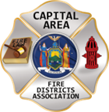
THE BULLETIN
January 31, 2026

The Voice of CAFDA since 2004
Editor, Tom Rinaldi – tom@rinaldi1.com since 2014
When you see **, highly recommended article
CAPITAL SHORTS
- This Edition of The Bulletin is dedicated to the memory of Ron Berti, past commissioner at Averill Park Fire District and all-around nice guy who lived an interesting life and kept us all smiling. You will be missed.
- The application deadline for the V-fire grant program is February 25th more information at: https://www.dhses.ny.gov/system/files/documents/2025/12/fy2025-2026-v-fire-rfa-final-12.18.25.pdf
- See the CAFDA annual calendar of events on page 2.
- This week’s Legislative ScoreCard covers all the updates to fire service-related legislation for the second half of the 25/26 legislative session. See what might affect you in the new year.
- A Ford recall tied to engine block heaters matters now because winter habits—plugging in overnight—can quietly create the exact conditions that raise fire risk. The issue is that this recall is specifically about the engine block heater system: the part that gets energized when the vehicle is plugged into household power. According to the National Highway Traffic Safety Administration (NHTSA) and Ford, certain block heaters may crack and allow coolant to leak, which can create an electrical short when the heater is plugged in. The affected population includes certain Ford Focus, Ford Escape, Ford Explorer, and Lincoln MKC vehicles—again, with the key qualifier being vehicles equipped with the block heater system in question.
- Volkswagen Group of America Inc. will recall more than 44,000 cars due to the risk that the high-voltage battery may overheat and cause a fire. The National Highway Traffic Safety Administration (NHTSA) recall covers 43,881 Volkswagen ID.4 electric SUVs from the 2023 to 2025 model years. An additional 670 ID.4 vehicles from the 2023 to 2024 model years are also being recalled because the high-voltage battery cell modules may contain misaligned electrodes that can result in a battery fire. Owners of the 670 cars are advised to park outside immediately after charging, according to NHTSA. Owners should also not leave their vehicles charging indoors overnight until the recall repair is complete.
- Congratulations to Ballston Lake Fire Department on placing their new air boat in service.
- Applications are now being accepted for the NYSAFC Scholarship Program and the Chief Neil McNeight Hands-On Training Award. Nominations are being accepted for the Chief Fred Singer Fire Educator of the Year Award, James Wright Public Education Award, and New York State Fire Chief of the Year Awards. Please note changes to the Scholarship Program for 2026. Three $1,000 scholarship awards will be granted in memory of Chief Ward Bohner and his wife, Janice Bohner, Chief Anthony Messina, and Chief James Hare. The deadline for submitting required materials is April 1, 2026. Eligibility criteria is available in the Application & Nomination Package. GO TO THIS LINK FOR MORE INFORMATION: https://www.nysfirechiefs.com/awards
CAFDA EDUCATIONAL OFFERINGS: CAFDA.NET

Join us at the NEXT GENERAL MEMBERSHIP MEETING Thursday February 12th features dinner for attendees. Please join us.
ZOOM LINK FOR THE January MEETING at 7pm: https://us06web.zoom.us/j/87557673207?pwd=aqxchRgsVkhNzwjpTH58D1b7vRujHN.1

CAFDA IS HAPPY TO ANNOUNCE THE DATES FOR CONFERENCE ’26 IN HISTORIC LAKE GEORGE,

April 9th, 10th and 11th, 2026 plan on joining us.

CAFDA will be offering two Fire Service Financial training 2 day sessions in 2026
Much needed two-day fire service financial training, learn to do it right, brought to you by CAFDA & NYS-OSC.
This year being held at Rombout Fire Department, Fishkill, Dutchess County on March 13th & 14th and at McNeil Insurance in Cortland, Cortland County at on March 27th & 28th. Training is provided by trainers from the Office of the State Comptroller. Continental Breakfast and Lunch will be included.

REGISTRATION IS OPEN FOR FINANCIAL TRAINING ON-LINE AT CAFDA.NET

Commissioner Training will be held at 6 locations in 2026 including:

Averill Park, Saturday February 7th,

Verdoy, Saturday February 21st,

Clifton Park, Saturday March 7th,

Niagara Engine Co #6 in Schoharie, Saturday March 21st,

Berkshire Fire District, Gloversville, Saturday March 28th and

Warrensburg Fire District, Saturday April 4th.

The Day after the scheduled date (Sunday) has been reserved as a snow day if necessary.

Open to all newly elected commissioners and Chiefs. This training is required under Town Law Section 176-e. $85 for members, $95 for non-members includes continental breakfast and lunch.
REGISTRATION IS OPEN FOR COMMISSIONER TRAINING ON-LINE AT CAFDA.NET

All correspondence & Capital Area Fire Districts Association Mailing Address should be directed to:
CAFDA PO Box 242 East Schodack, NY 12063 or EMAIL: SECRETARY@CAFDA.NET
Financial issues should be addressed to: TREASURER@CAFDA.NET
LEGISLATIVE NEWS FROM THE STATE CAPITAL

2026 Issues of United Concern
After a meeting of the fire service organizations including County Coordinators, Fire Districts, Fire Chiefs, Fire Police and FASNY, the following are the legislative initiatives for 2026.
- Increase VFBL Payments, reach parity with workman’s comp payments. [A1849 Steck & No Same As at this time.]
An act to amend the volunteer firefighters' benefit law and the volunteer ambulance workers' benefit law, in relation to increasing the amount of certain benefits. These benefits have not been updated in decades, with most compensation thresholds last revised in the 1990s. As a result, they no longer adequately reflect current economic realities. This legislation seeks to modernize and enhance these benefits to ensure they provide appropriate and meaningful support to those who risk their lives in service to others.
- Designate EMS as an essential service [A1989 Oberacker & No Same As at this time.]
An act to amend the general municipal law and the public health law, in relation to emergency medical services. The goal of the legislation is to provide a county-by-county assessment that will provide a roadmap for statewide improvements in providing EMS service going forward. The process can be matched with efforts to develop a statewide plan that matches the variety of ways services are provided throughout New York.
- The First Responder PEER Support Act [S5407A Harckham & A7285A Burdick]
An act to amend the mental hygiene law, in relation to the "First
Responder Peer Support Program Act". Modeled after the highly successful Joseph P. Dwyer Veterans Peer to Peer Support Program, which was launched in 2012, this bill would establish a First Responder Peer Support Program. This program would focus on prioritizing the mental well-being of the state's first responders. By enacting this bill we can ensure that first responders have access to the necessary systems to address some of the challenges they face.
- Increase the income tax credits for first responders. [S6233 Martinez/A6790 McMahon] also [S1123 Oberacker/A1064 Angelino] also [A28 Burdick/No Same As]
An act to amend the tax law and the real property tax law, in relation to tax credits for volunteer firefighters and volunteer ambulance workers. A taxpayer who serves as an active volunteer firefighter or ambulance worker shall be allowed a credit against their state taxes equal to $800. For married couple who file a joint return and both individually qualify, they shall be allowed a credit of $1600.
Legislation would also remove the prohibition to take the property tax exemption in addition to the income tax exemption.
- Enable more progressive fire service delivery options, including agency structure, supplemental support and provide nominal compensation to first responders. [need specifics, no sponsor at this time.]
Volunteer and on-call emergency responders should be able to receive compensation as determined by the AHJ for the time that they dedicate to being available or responding to incidents. At this time volunteers are in danger of losing their volunteer status by language currently in the VFBL statutes, which needs to be removed to provide the AHJ the option of providing monetary incentives for volunteers. In addition alternative fire service provider models should be optional to varying levels of government.
- Amend the EMS billing law [no sponsor at this time, need specific language]
Amend the law to allow EMS agencies to bill for mutual aid transports. Currently agencies are not permitted to bill for calls which have been mutual aided to them.
- State Retirement Service Credit as a recruitment/retention incentive [S7021 Ryan/A7432 Eachus]
An act to amend the retirement and social security law, in relation to establishing a retirement service credit for volunteer fire or emergency service. Section 1 of this bill would allow a member, upon application to a public retirement system, to achieve one year of service credit for every five years of volunteer fire or emergency service in the State, not to exceed three years of total service credit; available to such member any time before retirement.
OTHER AREAS OF CONCERN THAT MAY BE ADDRESSED GIVEN THE TIME AND ATTENTION OF THE LEGISLATORS DURING THE SESSION.
- Support the joint NVFC, IAFF task force working with DOL/OSHA to propose a viable solution to the 191.156 update, including the removal of the NFPA standards incorporated by reference.
- Publishing Official Notice Modernization; this initiative would update how public and legal notices are transmitted to the public with the demise of local newspapers. For instance, modernization would allow governmental entities to publish notices via online platforms.
- Convene a work group to come up with viable solutions to the issue of compensation for volunteers as well as fire service delivery options, including agency structure and consolidation of services. Specifically remove the prohibition by the counties to provide fire service as an optional solution.

New York Volunteer Fire Departments Eligible for Grants
Two funding options are available: $20 million for construction and renovation projects and $5 million for fire service equipment projects.
GO TO THIS LINK FOR INFORMATION AND APPLICATION:
https://www.dhses.ny.gov/state-funded-programs

New York’s first responders to benefit from $38M emergency communications upgrade
Governor Kathy Hochul announced more than $38 million in state funding to enhance emergency communications for first responders across New York.
The funding will support 17 counties and New York City through the Statewide Interoperable Communications Grant program.
“Saving a life can come down to one call, and our first responders need to have the most reliable emergency communications systems to help their fellow New Yorkers during their most critical moments,” Hochul said.
The program aims to improve radio tower infrastructure, ensuring clear communication during emergencies.
The Division of Homeland Security and Emergency Services will administer the funds, which are part of the Combined 2024 & 2025 Statewide Interoperable Communications Grant Targeted Program.
[EDITOR’S NOTE: THESE FUNDS WERE SKIMMED OFF BY THE STATE UNDER THE PREVIOUS CUOMO ADMINISTRATION, NOW THEY ARE BEING GENEROUS AND GIVING LOCALATIES BACK A FRACTION OF WHAT WAS COLLECTED AND SQUIRRLED AWAY IN THE GENERAL FUND]

Riverhead first responders request fewer service years for tax break allowance
Ana Borruto
Riverhead first responders are asking the Riverhead Town Board to aid in membership retention by considering a possible reduction in the number of service years volunteers would need to qualify for a 10% property tax break.
Under the New York State Real Property Tax Law, the Riverhead Town code allows volunteer fire department members and ambulance workers who reside in the town and have served for at least five years to receive the tax exemption. Councilman Ken Rothwell, along with fire and ambulance officials, recommended lowering the threshold to two years at the Town Board’s Jan. 8 work session.
The choice to permit the tax break after a specific number of service years is a local option, which means individual counties, cities, towns, villages, school districts and fire districts must adopt their own laws or resolutions in order to offer it.
“The two years is where most of the firefighters and EMT personnel, I think, [are] our younger generation that’s coming in, and they’re the ones that are starting out, and just getting married and purchasing a house,” Mr. Rothwell said. “Why make them wait five years before they can get any type of benefit?”
Riverhead Town attorney Erik Howard confirmed that changing from five to two years for the tax break would be a simple amendment to the current town code. A resolution will likely be passed at the Jan. 21 Town Board meeting to schedule a public hearing on the matter for the first meeting in February.
The goal would be to adopt the amended local law before the March 1 deadline for volunteer firefighters and ambulance personnel to submit the required 466-a form for the tax exemption, town assessor Laverne Tennenberg said at the work session.
“Our guys have been working extremely hard this year,” said Chief Piotr Kurzyna of the Riverhead Fire Department. “The more guys we get, and we can give something back to them, we work a lot harder. I know expenses are going up, it’s a hard cost, but people are moving here, so if we can get people who are dedicated to helping others … it makes us better.”
Area fire departments received a record-breaking number of emergency calls in 2025. Riverhead Fire District commissioner Timothy Murphy said volunteers responded to several “newsworthy” blazes as well, such as the incidents at Wells Farm and Crown Recycling. However, those are just two blazes out of the 1,456 alarms, including 11 working fires, they responded to this year.
LEGISLATIVE NEWS FROM WASHINGTON

About CFSI
Whether you are a member of the fire and emergency services, a public safety coalition, or the fire service industry, the United States Congress is more aware of your concerns because of the Congressional Fire Services Institute (CFSI). Established in 1989 as a nonprofit, nonpartisan policy institute, CFSI is designed to educate members of Congress about the needs and challenges of our nation’s fire and emergency services to help them understand how the federal government can support the needs of our local first responders.

About The NVFC
The National Volunteer Fire Council (NVFC) is the leading nonprofit membership association representing the interests of the volunteer fire, EMS, and rescue services. The NVFC serves as the voice of the volunteer in the national arena and provides critical resources, programs, education, and advocacy for first responders across the nation.
Our Vision
The NVFC strengthens volunteer and combination fire and emergency medical services to advance excellence, ensure safer communities, and enhance the quality of life across America.
Our Mission
The NVFC unites and supports volunteer and combination fire and EMS organizations through education, advocacy, leadership development, and collaboration. Guided by professionalism and innovation, we provide the tools and resources needed to protect communities, advance responder health and safety, and prepare leaders for the future.
What We Do
The NVFC accomplishes its mission and provides meaningful support to fire and EMS organizations through a wide range of services and programs:
- Representing the interests of the volunteer fire, emergency medical, and rescue services at the U.S. Congress, federal agencies, and national standards setting committees
- Focusing on health and safety
- Helping departments recruit and retain Fire Service and EMS/Rescue personnel
- Providing training on topics that matter to you
- Assisting departments in establishing support programs
- Fostering the next generation of firefighters
Offering an array of programs to support the volunteer emergency services

THE LATEST NEWS FROM DOL/OSHA

Clarification Update
It has been confirmed that the International Association of Fire Chiefs (IAFC) remains part of the standard revision conversation and were signatories on the letter to remove the word for word NFPA Standards and give authority to the AHJ for enforcement of the final standard.

OSHA’s Emergency Response Standard Remains Under Review
Curt Varone
The Occupational Safety and Health Administration’s effort to replace its 1980-era Fire Brigades standard remains in the rulemaking process, with no final regulation issued. OSHA formally proposed the new rule—titled the Emergency Response Standard—on February 5, 2024. The proposal would modernize 29 C.F.R. § 1910.156, which has governed fire brigades for more than four decades, by expanding its scope to cover a broad range of emergency response personnel.
Following publication of the Notice of Proposed Rulemaking, OSHA opened a public comment period that was extended several times due to the volume of responses. The comment period closed on July 22, 2024. OSHA later convened an informal public hearing, which began on November 12, 2024, and accepted additional written submissions through January 17, 2025.
Since then, the agency has been reviewing the testimony, comments, and data submitted during the rulemaking process. According to OSHA’s regulatory agenda and its Emergency Response Rulemaking page, the proposed rule remains under analysis. No final rule has been drafted or published, and the existing Fire Brigades standard continues to govern until OSHA completes the process.
The proposed Emergency Response Standard would significantly expand OSHA’s regulatory framework for responders. Rather than limiting coverage to industrial and private fire brigades, the proposal would bring firefighters, EMS personnel, technical rescue teams, and other responders under a single comprehensive standard. It would incorporate updated requirements for emergency response plans, hazard assessments, personal protective equipment, medical and behavioral-health evaluations, and training aligned with contemporary consensus standards.
The scope of the proposal drew extensive attention from the fire service, particularly from volunteer and smaller departments. Many commenters expressed concern about the feasibility of compliance, prompting OSHA to acknowledge that economic impacts on volunteer organizations require further review. In a September 2024 statement, OSHA indicated it would evaluate the applicability of the final rule to volunteers based on the record developed during the hearing and comment periods.
Despite the interest surrounding the proposal, OSHA has not indicated when a final rule might be issued. The new regulation remains at the proposed stage, and the agency’s review is ongoing. For now, the Emergency Response Standard has not been adopted, and the 1910.156 Fire Brigades standard remains in effect. Here is a statement from OSHA:
- OSHA is reviewing and evaluating all the comments and data submitted by stakeholders and the transcripts from the hearing. This important step in the rulemaking process helps guide the agency as it considers how to proceed with the rulemaking.
Here is a link to OSHA’s current position on the Emergency Response Standard.
https://www.osha.gov/emergency-response/rulemaking

The Latest from Dave Denniston:
As was briefly discussed on the recent NYS Fire Service Council zoom meeting, the group is still in serious discussions and are attempting to formulate an update to the Emergency Service Standard that is not as intrusive as the original proposal. The NFPA standards will NOT be adopted by reference and there is consideration for a modification to the standard for communities with fewer than a population of 5K. A more formal briefing is pending from Chairman Denniston. We thank him for his dedication to this process.

By Dave Denniston NVFC OSHA 1910.156 Taskforce Chair
The NVFC continues to meet with the IAFC and (The IAFC has pulled out of the meetings) IAFF as we wait for next steps from the Department of Labor and OSHA. There have been significant changes in leadership at these organizations. We are under the belief that they continue to digest the large volume of information and feedback offered during the process and are modifying the proposed standard into something that is much more agreeable. The proposed standard as written does not work for anyone, volunteer, combination, or career departments. All three organizations agree significant changes are needed from the proposal. We anticipate that they will craft a new standard that is technically and economically feasible using what is referred to as logical outgrowth from the process. The representatives from the IAFC, NVFC, and IAFF all agree that the best of all worlds would be to remove the NFPA standards by reference, bring a lot of the regulations back to the control of the home state and authority having jurisdiction, and make logical requirements that will help protect our first responders. We continue to monitor progress and are ready to pursue the next steps if the process does not yield a document that we can all live with. We have also voiced our opposition to a pure exemption of volunteer firefighters as we feel that the move would be counterproductive and further divide the two major factions of our emergency services. We have long fought for parity in items such as presumptive heart, cancer coverage, workers compensation benefits, equal representation, and firefighter safety. To simply exempt the volunteer fire service would be a huge disservice to these initiatives and leave combination departments in an extremely awkward, if not unmanageable situation. It would also be extremely difficult for municipalities to manage with two different sets of rules.
The three organizations are also hard at work building resources to support emergency services organizations moving forward. These resources include training, sample emergency action plans, risk management plans, community assessment forms, sample policies, and advocacy materials. The right tools will aid everything from a small rural volunteer department with a $50K budget all the way up to the large municipal all-career city department, and everything in-between. We are very excited by the working relationship being built by these national organizations and all involved in the process feel we are seeing ground-breaking results. If you have any questions or concerns about the process, we encourage you to reach out and get involved in the discussions. I can be reached at 607-423-1636 or ddenniston@afdsny.org. By working together, we can help build a fire service that will serve us well for years to come.

IT IS TIME TO MOVE FORWARD WITH A WORKABLE OSHA 1910.156 REVISION
Dave Denniston, 1st VP AFDSNY
As the process to update OSHA 1910.156 continues, it is important that we understand where we have been, and options for the process moving forward. Since the proposed rule was published for review 18 months ago, there has been a significant amount of input and feedback from stakeholders addressing possible concerns about the economic and technical feasibility of the proposal. Stakeholders from across the country participated in the process and offered suggestions. One of the early possible solutions suggested was to simply exempt volunteers, and other parties, from the proposed rule as written. The mindset was that if it didn’t affect “us” it was not our problem. While this concept appeared to be a quick solution, it fell short of addressing the true needs or problems.
The real issue at hand is that the proposed rule as written had challenges for everyone and you would be hard pressed to find any department, career, combination, or volunteer, that could meet the intent of the standard. The proposed standard also took a one-size-fits-all approach. We know that the emergency service agencies across this country are very different. They have different resources, different exposures, different concerns, and different levels of risk. It is true that emergencies, fires, and hazards are the same regardless of the type of responder. What is different is the likeliness that a particular event will occur in any jurisdiction. Local jurisdictions must be required, and empowered, to address significant risk, and the needs of a community, at a local and state level with just enough federal oversight to give it teeth and ensure safety for all of our responders. The bottom line is that the current 1910.156 is outdated and needs significant revision to address the needs and safety concerns of today’s first responders. The proposed standard, as written, went too far in trying to address these needs. What we need is a middle ground solution that is designed to relieve significant risk and does so at a level that is economically and technically feasible for local communities, organizations, and the municipalities that govern and fund them.
Some are asking why simply exempting the volunteers is not in the best interest of volunteers across the country. First, by exempting the volunteers, we are failing to address the growing concerns and exposures facing this group of responders. Second, the largest growth area for most of our local fire departments is a move toward combination and career departments. How would it be possible to have one set of rules apply to part of an organization and not the other? Does it make sense to have volunteer responders face one set of rules, while career responders on the same truck follow another? Are we not all responding to the same emergencies with the same exposures? The approach of exempting volunteers would add both confusion and resentment moving forward. The third part of the issue is that the standard, as written, is just as problematic for the communities that have career departments as it is for those that only have volunteers. We need a standard that brings us all together, not one that drives us further apart.
So, what do the solutions look like? Where should OSHA and the Department of Labor go from here? After pouring through the thousands of comments brought forth during the process, an opportunity is right in front of us. There were a multitude of comments throughout the process that carried common themes. By using logical outgrowth of the process, OSHA now has the opportunity to massage the rule into one that we all can live with, and provide the level of safety they are tasked to provide the workers of this country.
It is now in OSHA’s hands to finalize the rule as proposed, make logical changes, scrap it, or go back to the drawing board. During the process, OSHA continuously asked for proposed solutions, and many excellent solutions were entered into the record from those that participated. We would suggest that OSHA and the Department of Labor use the extensive input from the process to make necessary changes to the document and work to finalize the rule. A rule that meets the intent of reducing significant risk in a manner that is reasonable and responsible for our first responders and communities.
Using logical outgrowth, OSHA now has the opportunity to remove the incorporated NFPA standards. Many of the participants and the NFPA itself asked for this to be done in their comments. The incorporation of those standards brought many of the pain points organizations were concerned about. The NFPA standards instead should be used as a tool for compliance, not a weapon of enforcement. By removing the incorporation of dozens of NFPA standards, the rule would also become far less confusing and economically infeasible. The next step is to transfer as much of the obligation of providing safety down to the local jurisdiction and state levels as possible. These are the people that know the nuances of the local responders and hazards in any given area. This, too, was supported by the comments throughout the process. The third opportunity is rather than exempting anyone, to build a baseline standard that applies and protects everyone, and then increase the requirements where the data shows increased exposure and risks. All of these changes are supported by the logical outgrowth requirements and would alleviate most of the pain points addressed by the participants of the process.
Regardless of the solution, we would be remiss if we failed to realize there will be opposition to any action taken moving forward. We also need to realize that any solution, or even no solution at all, will have pain points for some that it will affect. It has often been said that firefighters hate two things, change and the way things currently are. Hopefully, we realize that we are at a historic time, with an amazing opportunity to get this right. This process has been fair and offered plenty of opportunities for those interested in participating to make their opinions and feelings known. It is time to move the ball over the goal line and continue to work together for the betterment of emergency services in this country.
I encourage you to speak to your local elected officials. Let them know there is a workable solution right in front of us, and ask them to encourage the Department of Labor and OSHA to continue this opportunity and finalize a reasonable OSHA 1910.156 that applies to all fire departments, regardless of the composition of their staff.
FIRE DISTRICT FINANCIAL NEWS

Local Government and School Accountability Contact Information:
Phone: (518) 474-4037; Email: localgov@osc.ny.gov
Address: Office of the State Comptroller, Division of Local Government and School Accountability
110 State Street, 12th Floor; Albany, NY 12236

NYS-OSC Fire Service Audits
Quiet this week.

Monterey Fire Department president accused of stealing department funds
Felix Day
The president and interim treasurer of the Monterey Volunteer Fire Department has been arrested for reportedly stealing more than $3,000 from the department, according to state and county officials.
New York State Comptroller Thomas P. DiNapoli, Schuyler County District Attorney Jeremy Hourihan, and New York State Police Superintendent Steven G. James announced the arrest of 49-year-old Kelly Groves of Beaver Dams.
Groves, who served as president and interim treasurer of the Monterey Volunteer Fire Department, was charged with grand larceny in the third degree, a felony.
Officials said the theft occurred between 2018 and 2022, when Groves is accused of withdrawing cash from the department’s bank account and making personal purchases using the department’s debit card. Investigators say the stolen amount exceeded $3,000.
According to DiNapoli’s office, Groves also failed to deposit cash collected from department fundraisers and member dues for three years, from 2019 through 2021. A forensic analysis determined Groves withdrew nearly $20,000 from department accounts but was only able to provide receipts for less than $5,000 of those withdrawals.
THE FIRE CHIEF’S OFFICE

**Raising the Standard: Fire Service Leaders Need More than Experience
Alex Zielinski
There’s a persistent idea in the fire service that some things can’t be taught. That leadership somehow springs full formed from years riding in the rig and learning on the job. This notion is comforting to old habits but dangerous to modern fire departments. Baseline leadership training and certification are not academic luxuries, but essential tools. They establish a consistent, measurable standard of competency that protects firefighters, improves decision making, and raises organizational performance.
THE PROBLEM, AND WHY IT MATTERS
I had recent conversations with two different fire chiefs discussing training and certification that were nearly identical. While I’d like to believe these perspectives are isolated, the fact that two chiefs from different regions and background share them suggests a persistent trend in the fire service. The mindset is not unique; it’s a recurring theme nationwide.
The seasoned chief says, “I’ve been chief for 30 years and I don’t have a fire officer certificate! That certificate doesn’t prove anything to me! I want to know if you can do the job!” By “the job” he meant incident command and the day-to-day leadership expected of battalion chiefs. That argument is familiar: years of experience equal competence, certification is optional, and if you’ve been around long enough, you should be exempt from formal training.
A certification isn’t a magic pill. Assuming that the certificate holder can be dropped into your command structure or department and instantly adapt to your operation or improve a dysfunctional program is foolish. It may take less time to get these members up to speed, but that’s no different than attending a district fire academy—you still need to come back to your home department and get the unique details of how your department operates.
That thinking is where risk creeps in. Experience is invaluable and on-the-job learning shapes judgment, but experience alone is inconsistent, uneven, and unstandardized. Two people with the same years of service can have vastly different exposure to the same incident types, policies, and leadership challenges. Certification provides a baseline that experience alone cannot guarantee.
WHAT FIRE OFFICER I ACTUALLY TEACHES
Fire Officer I is a baseline leadership certificate with practical and measurable outcomes. At a high level, it covers:
- Leadership and supervision fundamentals, including communication, motivation, delegation, and coaching.
- Organizational structure and administration, including policies, staffing, and resource management.
- Human resources (HR) and legal responsibilities such as performance evaluations, discipline, and personnel safety.
- Incident command and decision making, including size-up, tactical decision making, transfer of command, and accountability.
- Health, safety, and risk management, emphasizing crew safety, accountability systems, and hazard recognition.
- Training program management and development, including lesson planning, instruction methods, and evaluation.
Fire Officer I combines classroom knowledge with skills evaluation and written testing so that learners demonstrate both theory and practice. That combination matters because leadership is both strategic and operational.
BEYOND THE COMPANY OFFICER
You can keep going – What Fire Officer II, III, and IV Teaches
Advanced Fire Officer levels build upon the foundational leadership skills of Fire Officer I, expanding into strategic thinking and organizational and executive level competencies. Together, they prepare higher-ranking leaders and department administrators to lead with vision, manage complex operations, and shape the future of their organizations. At a high level, they cover:
- Advanced Leadership and Management
Emphasizes strategic leadership, ethical decision-making, conflict resolution, and organizational change. Officers learn to lead across divisions, mentor future leaders, and foster a culture of accountability and innovation.
- Organizational Strategy and Administration
Focuses on long-term planning, budgeting, policy development, and interagency coordination. Officers are trained to align departmental goals with community needs and relevant standards and laws.
- Human and Labor Relations
This includes workforce planning or staffing, labor law, union relations, diversity and inclusion, and high-level personnel management. Officers learn to navigate complex HR scenarios and promote a healthy organization.
- Emergency Management and Complex Incident Command
Expands on incident command to include multi-agency coordination, disaster planning, and large-scale incident management. Officers are prepared to lead during high-risk, high-impact events with a strategic mindset. A “strategic mindset” means shifting focus from individual tasks to overall incident resolution. As rank increases, leaders must trust their teams to execute order while they concentrate on managing the broader operation and outcomes—especially during complex incidents.
- Risk Reduction and Community Engagement
This introduces community risk assessment, public education strategies, and stakeholder engagement. Officers learn to integrate prevention and outreach into departmental operations rather than the siloed approach where suppression personnel and their responsibilities happen separate from prevention and education personnel and activities.
- Training Program Oversight and Accreditation
This shifts from individual instruction or developing isolated training events to program-level oversight including curriculum development, accreditation standards, and performance metrics. Officers ensure training programs meet operational and strategic needs.
- Executive-Level Communication and Governance
Develops a leader’s skills in public speaking, media relations, report writing, and political navigation. Officers are equipped to represent their departments to government authorities, the public, and outside agencies.
Although this is a summary of several Fire Officer levels, it stresses the importance of continued professional development for those in command and administrative roles. For the continued growth of our agencies, it’s important that we’re equipped to lead not just crews, but entire organizations.
The point is not to exalt certifications over experience, but to stress that both extremes are questionable: Collecting 50 certifications with two minutes of real-world experience is just as bad as collecting two certifications with 50 years of real-world experience. We need a balance of both!
WHY CERTIFICATION MATTERS MORE THAN SOME LIKE TO ADMIT
- Consistency across the organization. Certification establishes a minimum standard. It creates a department-wide expectation. When promotions or assignments require a known baseline, supervisors know what to expect from personnel and can assign responsibilities reliably. Like National Registry for EMS certifications, we have a universal understanding of what a certificate holder has learned, no matter if they took the training in New York or California, or in two different cities within your state.
- Measurable competency. Written exams and skills evaluations force the student to demonstrate knowledge and ability against accepted standards. This is more objective than relying on anecdotal recollection of incidents or a supervisor’s impression alone.
- Safer decisions on the fireground. Leadership failures manifest in tactical errors, missed accountability, and breakdowns in safety systems. Training in incident command, risk management, and communication is directly linked to safer outcomes.
- Bridging theory and practice. Experience gives exposure and education organizes exposure into a framework that can improve repeatable decision making under stress. Certification formalizes and validates this framework.
- Professional credibility. When leaders hold recognized credentials, they strengthen trust with partner agencies, labor groups, and the communities they serve. That credibility matters in mutual aid and interagency operations regardless of whether you’re a rural volunteer department, a suburban agency staffed with part-time personnel and volunteers, or a full-time industrial department.
- Compliance with governing policies and law. The safety world expects that workers experience training before they perform a task or use equipment. The Occupational Safety and Health Administration requires employees to be trained and competent for assigned tasks. The fire service is one of the few professions that still tolerates the “learn on the job and figure it out” mentality for leadership positions. This tolerance invites preventable mistakes that we can see in our own organizations, neighboring departments, or in near-miss and fatality reports.
Handing an untrained person a stethoscope and sphygmomanometer and expecting an accurate blood pressure is no different than expecting decisive and inspiring leadership from an officer. They might find resources online, a useful video, but the result could be one of several thousand possible outcomes—it’s as though we’re playing the lottery if we’re hoping for a single specific outcome while offering no system or standard. We can’t simply want to be the best. We need to define what that means and give tools and resources to make it possible.
ADDRESSING COMMON OBJECTIONS
“I learned on the job, and I turned out fine.”
Turning out “fine” is not a defensible standard when people’s lives are at stake. Individual success stories are outliers that don’t scale into consistent organization performance. Combining numbers from the National Fire Protection Association for North America and the European Public Service Union for estimates of Europe, we can estimate that the total number of firefighters in North America and Europe is approximately 2.3 million. Sometimes we can forget that we are one of 2.3 million. We might also assume that something works or doesn’t work because a handful of firefighters have had a particular experience. When something works or is a standard across a larger number in a population, you start building consensus and can start to see the value in it. Sure, something that we’re all doing might not work for you in your department because of your unique environment and staffing, but what’s more likely is that there are tools and knowledge to be had and you could be applying these useful resources to your unique situation. All those firefighters would probably argue that they/we are all in unique situations.
“Certification is only for municipal departments.”
Leadership principles are universal. Whether you protect a refinery, campus, or city block, you still manage people, resources, risk, and community expectations. Certifying leaders creates a common language and expectation across all settings.
“I’d be teaching this; I wouldn’t learn anything.”
You can only evaluate something you’ve done yourself once you’ve held the baseline in common with your team. Leading by example requires subject-matter humility: teach from a place of experience plus a tested baseline, not experience alone. Research consistently shows that even experienced professionals benefit from formal education and training. Adult learning theory shows us that structured programs can further understanding, more easily introduce new perspectives, and reinforce best practices, even for seasoned leaders.
“We can judge leadership by experience and interviews.”
Interviews and experience are part of a holistic evaluation, but they are subjective. Adding certification reduces election bias, documents baseline capability, and compliments interviews with objective evidence. The certification—yes, that piece of paper—makes your experience more tangible and less about interpretation and opinion.
TRAINING DOES NOT REPLACE EXPERIENCE; IT AMPLIFIES IT
Think of technical skills. Nobody expects and inexperienced recruit to be the best and fastest primary searcher without training and practice. We require EMT or paramedic training before allowing clinical decision making. Why would leadership be any different? Training and certification do not produce robotic leaders. They provide a foundation on which adaptive and creative leaders grow. The best leaders blend their tested knowledge with their experience—that’s what makes them great.
Practical Steps to Improve Department Development
- Make baseline certification a promotion requirement. Require Fire Officer I for first-line supervisory promotions and provide time and tuition support if needed.
- Build department training pathways. Map experience, mentorship, and certification into a defined career development plan.
- Use blended learning. Pair classroom certification with scenario-based, high-reliability team training that reflects your local hazards.
- Measure outcomes. Track incident metrics, near misses, and leadership performance before and after implementing certification requirements. Tracking retention rates and promotion successes before and after implementing certification requirements can be a powerful tool in measuring success.
- Lead by example. Encourage senior leaders to earn or audit the appropriate Fire Officer certification level to model the value of continuous learning and improvement.
TAKE ACTION—DON’T SETTLE
Stop treating leadership training as the optional feature on new car. Commit to a simple standard. Require baseline leadership certification for supervisory roles and invest in the training necessary to get people there. Support those candidates with mentorship, practical exercises, and opportunities to apply new skills under supervision. If your department still leans on “they’ll figure it out,” change the culture now. The community expects competent leadership. Your crew deserve predictable standards. Your decisions may save lives.
The fire service values experience for good reason. Experience should be celebrated and embraced. But when experience is used as an excuse to avoid standardization, testing, and deliberate development, the organization pays the price. Fire Officer I and similar certifications are not a replacement for lived expertise; they are the agreed-upon foundation that makes experience reliable, transferable. Build your leaders the same way you build your technical experts: with training, measured practice, validated competence, and continuous improvement.
THE ATTORNEY’S OFFICE

Legal liability in municipal fire department operations
George Woods Jr.
Municipal fire departments perform essential public safety functions that frequently require rapid decision-making under hazardous conditions. While many jurisdictions afford fire departments and their personnel certain statutory immunities, those protections are not absolute. Legal liability may arise when actions or omissions are alleged to fall outside the scope of immunity, involve negligence or violate established standards of care.
Here we’ll examine legal liability risks associated with three operational areas of particular concern for public fire departments: patient transport, assisting patients in tight or confined spaces (such as bathrooms) and entering traffic intersections during emergency responses.
GENERAL LEGAL FRAMEWORK
Municipal fire departments generally operate as governmental entities, and their employees act as agents of the municipality. Liability exposure typically arises under tort law, including claims of negligence, gross negligence or wrongful death. While sovereign or governmental immunity may shield municipalities and their employees from certain claims, immunity often does not apply where conduct is reckless, willful or outside statutory protections. Additionally, immunity statutes frequently distinguish between discretionary acts (which are often protected) and ministerial acts (which may not be). Fire departments must therefore ensure that personnel adhere to established policies, recognized professional standards and applicable statutes. Failure to do so can expose both individual responders and the municipality to civil liability.
PATIENT TRANSPORT LIABILITY
There are two primary types of patient transport liability:
Duty of care during transport
When a fire department undertakes patient transport, whether through an EMS division or as a first responder assisting another agency, it establishes a duty of care to the patient. This duty includes providing care consistent with the responder’s training, protocols and accepted medical standards. Liability may arise if a patient is injured during transport due to improper lifting techniques, failure to secure the patient to a stretcher, inadequate monitoring or delayed transport. Claims often allege negligence, asserting that responders failed to act as reasonably prudent professionals under similar circumstances.
Vehicle operation and transport decisions
Patient transport also involves liability related to vehicle operation. Excessive speed, failure to use restraints, or improper use of lights and sirens can increase the risk of accidents. While emergency vehicle statutes may permit certain traffic exemptions, these exemptions are typically conditioned on operating with “due regard” for the safety of others. If a collision occurs and it is determined that responders acted recklessly or ignored department policy, immunity may be lost.
Additionally, decisions regarding destination hospitals, refusal of transport or transfer of care can create legal exposure if not properly documented and aligned with protocols.
CONFINED SPA4CES LIABILITY
There are two primary factors affecting liability with regards to assisting patients in tight or confined spaces:
Increased risk of injury
Assisting patients in tight spaces, such as bathrooms, bedrooms, or narrow hallways, presents heightened risks for both patients and responders. Slips, falls, and musculoskeletal injuries are common sources of litigation. Patients may allege that improper movement, inadequate personnel, or failure to use appropriate equipment resulted in injury.
Fire departments must recognize that confined-space patient assistance often involves foreseeable risks. Courts may evaluate whether responders took reasonable precautions, including calling for additional personnel, using lifting aids or modifying the environment when feasible.
Scene management and environmental hazards
Bathrooms and similar spaces often contain wet surfaces, limited lighting, and obstacles that increase injury risk. Failure to identify and mitigate these hazards may support a negligence claim. Liability may also arise if responders rush patient movement without adequate stabilization, particularly in cases involving suspected spinal injuries or frail patients.
Documentation is especially important in these scenarios. Accurate records demonstrating assessment, decision-making and adherence to protocol can be critical in defending against claims.
TRAFFIC INTERSECTIONS LIABILITY
Our last major category involves two key factors related to entering traffic intersections during emergency response:
EMERGENCY VEHICLE PRIVILEGES AND LIMITATIONS
Fire apparatus entering intersections during emergency responses present one of the most significant liability risks to municipalities. Although emergency vehicle operators are often granted statutory privileges, such as proceeding through red lights or stop signs, these privileges are not unconditional. Operators are generally required to slow down, ensure the intersection is clear and operate with due regard for public safety.
COLLISIONS AND THIRD-PARTY CLAIMS
Intersection collisions frequently result in serious injuries or fatalities, leading to substantial civil claims. Plaintiffs may allege that the fire department failed to properly train drivers, enforce policies or discipline unsafe behavior. Even when another driver is partially at fault, municipalities may face liability under comparative negligence principles.
Courts often scrutinize whether lights and sirens were activated, whether the vehicle slowed appropriately and whether the operator followed departmental policies. Deviations from established procedures can significantly undermine immunity defenses.
RISK MANAGEMENT AND MITIGATION
To reduce legal exposure, municipal fire departments should prioritize several comprehensive risk management strategies:
- Clear policies and standard operating procedures for patient handling, transport and emergency vehicle operation.
- Regular training and certification for EMS care, lifting techniques and emergency driving.
- Use of appropriate equipment, such as powered stretchers and patient movement aids.
- Thorough documentation of incidents, assessments and decisions.
- Ongoing review of incidents and near misses to identify trends and corrective actions.
FINAL THOUGHTS
While municipal fire departments perform inherently dangerous and essential public functions, legal liability remains an ever-present concern. Patient transport, assistance in tight spaces and emergency intersection entry are operational areas with elevated risk. By understanding the legal principles governing liability and implementing strong policies, training and oversight, municipalities can better protect the public, their personnel and themselves from preventable harm and costly litigation.

For information only and not for the purpose of providing legal advice. The opinions expressed are the opinions of the individual author at the time the facts were presented and based on the law then applicable. The information contained in these opinions is not guaranteed to be up to date. The information provided is not legal advice. Since legal advice must be tailored to the specific circumstances of each case, and laws are constantly changing, nothing on this site should be used as a substitute for the advice of competent legal counsel. The authors assume no responsibility to any person who relies on information contained herein and disclaim all liability in respect to such information. You should not act upon information in this publication without seeking professional counsel from an attorney admitted to practice in your jurisdiction.
POSITIVE OUTCOMES AND CHALLENGES FOR THE FIRE SERVICE

POSITIVE OUTCOMES

Volunteer surge helps save Minn. fire department from possible closure
Renee Berg, The Free Press
When staff with the 229-person town of Pemberton let it be known their volunteer fire department was at risk of closure, the community responded in spades.
The fire department has five fully invested volunteers and needs another 10 to 12, said City Clerk Kathy Grinnell. She took to mailing notices to residents who live within 15 miles of Pemberton, posting on the city’s social media channels and on the city’s website publicizing that the town was desperately in need of fire department volunteers. In just a week, she saw a huge shift in interest.
“We had a lot of rough moments, a lot of despair and discouragement,” Grinnell said. “And it was a sad reality that got us to this point where we had to let it be known that we were facing closure if we didn’t get some good applicants. So many people within one week stepped up. I got so excited that this turned around in one week. It’s a beautiful thing.”
Pemberton now has almost as many applicants as needed to continue offering services to the community. Grinnell received four solid applications and heard from the neighboring Waldorf volunteer fire department that four of their members plan to join Pemberton’s team.
“Everything would need to be changed if our fire department closed,” she said. “It would affect response times. Instead we have a lot of people calling. I’ve been so busy answering phone calls. People want to save this fire department. It’s heartwarming to see.”
Pemberton isn’t the only small town in south-central Minnesota searching for fire department volunteers. Regional fire chiefs report they’re on the hunt, too.
Fire Chief Bill Fitzloff said he is down two firefighters in St. Clair but he has 12 firefighters who “could retire at any time.” Wells could use five volunteers.
In Waldorf, Fire Chief Marcus McDonough said: “It’s a revolving door. We’re always looking, I guess you could say.”
It’s an ongoing tough sell to recruit volunteers, area fire chiefs said. Whereas he once had a wait list for volunteer firefighters, Fitzloff now has none.
Grinnell said “it takes a special person” to join the Pemberton volunteer fire department, which goes on as many as 30 calls a year. Fitzloff agreed it is a demanding role.
“People don’t have the time like they used to,” he said. “It does take a lot of time to be a volunteer firefighter. You need medical training and fire training. I don’t know the answer.”
Guy Kimpton, fire chief in Wells, agreed with Fitzloff, saying it’s a time-consuming pursuit. “It’s tough to get the younger generation to volunteer,” he said. “Twenty-five years ago, we’d have seven or eight people apply for one position. Now we don’t have anybody apply.” He said people also aren’t settling in small towns as they once did in former generations so the applicant pool is lessened.
Marcus McDonough, fire chief in Waldorf, said training requirements are a dealbreaker, too.
Volunteering with small town fire departments is, however, fulfilling work, those interviewed said. The fire department, Grinnell said, is a crucial part of every community.
Kimpton said he recently honored five firefighters with lifesaver awards stemming from a Nov. 30 medical call they went on in Wells. A 33-year-old man had a heart attack and they saved him.
“It’s very rewarding,” he said. “People are looking for ways to give back to their community. They wish they could do something. This is one way they could do it.”
He also mentioned a modest state-funded retirement package as a benefit for volunteer firefighters. McDonough said people have to “have a heart in it or do the right thing.” He said if more community members don’t step up, small towns might have to resort to being served by a countywide fire department instead of the current setup with volunteer fire departments per town.
That, he said, would have negative repercussions for those needing a medical or fire response. “What will happen in Pemberton, if the department goes away, when it comes to the EMS side of things, seconds matter,” he said. “Instead of it being a five-minute response, it turns into a 20-minute response. That can mean life or death.”
Thankfully, the Pemberton community has stepped up, Grinnell said. She’s relieved. “We had to put it out there and really get people thinking about how important this is,” she said. “We can’t wait until it’s gone and wish for it to be back. It’s worth saving. It’s the glue that holds the community together.

FIRE SERVICE CHALLENGES
No report this week.
RETENTION AND RECRUITMENT
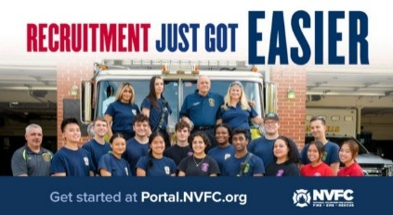
Does your fire or EMS department need more volunteers? The National Volunteer Fire Council (NVFC) is here to help! Use the FREE department portal from the NVFC’s Make Me A Firefighter campaign to access tools and resources to help you find and keep volunteers.
Get started:
- Register for free at portal.nvfc.org.
- Post your volunteer opportunities so potential recruits can find and connect with your department at MakeMeAFirefighter.org.
- Customize recruitment materials with your department’s details using the materials generator.
- Share your message with ready-to-use flyers, PSAs, social media content, and videos.
- Track your applicants and follow up with ease using the recruit tracking tool.
Plus, access additional resources to help with recruitment and retention, including:
- “What to Expect” Guide for the Families of New Recruits
- Volunteer Retention Research Report
- Volunteer Value Calculators
- Recruitment and Retention Guide
- Recruitment and Retention Online Training
- And Much More!
GET STARTED NOW AT THIS LINK:
https://tracking.police1.com/t/9495565/187515077/7816037/1/1006865/?b44ed14b=YmY5NWQ4NzktNWRmOC00MWJkLTkzMDctNzg0Y2VhZTNjMzYy&x=1ee5e8f9

FIREFIGHTER HEALTH AND SAFETY – PROTECTING OUR OWN
1
LINE OF DUTY FIREFIGHTER DEATHS FOR 2026
In 2025 we experienced 78 LODDs reported nationally.!

Cardiovascular Events Leading Cause of Firefighter Deaths in 2025
Susan Nicol
Cardiovascular events continue to be the leading cause of death of the nation’s firefighters.
Of the 76 who gave the ultimate sacrifice last year, half suffered cardiac issues with stress and overexertion as key factors, according to data compiled by the U.S. Fire Administration.
Records also show of the 42 of the 72 firefighters who died in 2024 also suffered cardiovascular events.
Of those who died, 35 were career firefighters, while 34 were volunteers. Others were paid on-call, part-time, wildland contract and part-time wildland.
The top causes of injuries included 13 vehicle collisions (including aircraft); 7 struck by incidents; 4 falls, and 2 collapses.
Research showed 75 percent of firefighters who perished were 41 and over.
Twenty-five firefighters who died were between 51 to 60 while 18 who perished were 61 and over. Fourteen who gave the ultimate sacrifice were 41 to 50; and 10 were 31 to 40.

FIRE SERVICE FATALITIES OR DIBILITATING INJURIES
- Firefighter/EMT Brittany Hathaway suffered a medical emergency as she prepared to respond to an EMS call last Tuesday, at the Cliff Gila, New Mexico Fire Department. She was taken to a local hospital and then flown to a specialty care center in El Paso where she died on Thursday.
- As he recovers after passing out at a structure fire, Tehuacana, Texas, Fire Chief Aaron Woodall vows things at his department are changing immediately. Within seconds of telling his crew he didn't feel well, Woodall collapsed. I had smoke inhalation, carbon monoxide poisoning and a little flare up with my heart that caused an issue, adding he wasn't wearing an SCBA while performing overhaul in the house.

FIRE APPARATUS ACCIDENTS
- A Boles (MO) Fire Protection District rescue-pumper was struck by a tractor trailer on Interstate 44 Sunday, Jan. 25, 2026. As the second arriving apparatus was slowing to complete its stop, the pumper was struck in the passenger rear. The two firefighters who were in the rig were seated with their seat belts fastened. The single occupant in the tractor trailer was uninjured.
- A firetruck responding to a working house fire in Woodland, PA was involved in a crash that left the driver pinned inside. The truck reportedly slipped on the ice and left the road. The driver was taken to the hospital with severe pain in multiple areas. The engine has significant damage having struck a tree.
- A Wentworth, New Hampshire fire truck will need minor repairs after trouble on icy roads, upon returning from a fire call the apparatus hit a patch of ice and slid into a ditch, no one was injured.
- A North Coffee, Tennessee Volunteer firetruck was involved in a crash the caused the truck to land on its side on Jan. 26 while responding to a working structure fire, one passenger was transported for treatment.
- While responding to the scene with lights and sirens activated, Rescue Engine 92 from Bay District VFD in southern Maryland hit ice causing the engine to lose control and strike a utility pole, before coming to a rest in the snow covered median, one firefighter was transported and treated for non-life-threatening injuries.
- A West Fargo, North Dakota Rescue 75 collided with another vehicle Monday afternoon while responding to an emergency call, sending one person to the hospital. No firefighters were injured, the driver of the vehicle was transported to a local hospital.

Firefighters Falling Through
- During a 2 alarm residential fire in Hull, MA, one of the mutual aid firefighters fell from the first floor to the basement while working on the fire but managed to avoid injury.
- Helmet cam video posted by Smith County Emergency Services District 2 shows a rookie firefighter falling through a floor while crews battled a structure fire. “Are you through the floor?” one firefighter asked. “Yes, sir,” the rookie politely responded before pulling himself out of the hole.
- A firefighter was injured after falling through an attic floor onto the second floor during an attic fire in Davenport, Iowa. The firefighter was rescued from the building and taken to a local hospital for treatment of minor injuries. Officials said the firefighter was released several hours later.
FIRE APPARATUS

Define Apparatus Usage and Apparatus Replacement
Bill Adams
Asking if fire apparatus replacement is keeping pace with apparatus usage is an interesting topic. There are two nouns (subjects) in the sentence—apparatus replacement and apparatus usage. Both are susceptible to multiple interpretations. Without establishing a common definition for each, expect to receive wildly different and possibly conflicting answers to the question. It’ll be like opening a Pandora’s box. Early Greek mythology described opening Pandora’s box as unleashing curses on mankind. Today it is commonly referred to as opening a can of worms. It is hard to make an objective analysis without being on the same page.
DUAL DEFINITIONS
What is meant by apparatus replacement? It could be when the authority having jurisdiction (AHJ) is willing to purchase a replacement rig when the fire department deems it necessary to do so. Another could be when the fire department has been authorized to replace an existing rig, but the apparatus manufacturer cannot deliver one in a timely manner.
What is meant by apparatus usage? It could mean a rig has reached a predetermined retirement or “remove-from-active-service” age recommended by outside entities such as the National Fire Protection Association (NFPA) or professional consultants. It could also mean exceeding the maximum criteria established by each fire department or AHJ such as age, mileage, and maintenance costs. In departments with extraordinarily heavy call volumes, an apparatus can just become mechanically worn out.
Another consideration, albeit a hard sell to bean counters, is the rig to be replaced may not possess or be capable of being updated to incorporate innovative and desirable firematic features found on today’s apparatus. Included could be upgrading to newer hose sizes and quantities, types of hoselays and methods of deployment, increasing tank capacities/foam capabilities, adding equipment deemed necessary to carry, and so on. Perhaps easier to sell to politicos is the fact older apparatus may not be capable of being updated with current mandated “life safety” features.
ANSWER
I doubt there is a universally correct answer to the editor’s question. Depending on the Website accessed, there are around 30,000 fire departments in the United States. The figures were accessed from the National Fire Department Registry, the NFPA, and the National Volunteer Fire Council. Every fire department and each political subdivision in which they are located—and financed by—can have their own interpretations and answers. Fire apparatus manufacturers can also. Keep an open mind; purchasers want to buy, and manufacturers want to sell.
Pandora’s can of worms can be turned into a hornet’s nest when considering personal and possibly overly biased agendas of vociferous fire department members, apparatus vendors, fiscally-fixated taxpayers, and opinionated commentators. Trust but verify.
To the best of my knowledge, there are no written laws or legal requirements mandating retiring or replacing fire apparatus. Common sense, while sometimes a lost commodity, should reign supreme in such a decision. Whether apparatus replacement is keeping pace with usage is subject to individual interpretation of the two hard-to-define terms mentioned earlier.
WHOSE FAULT?
Beware of the blame game. In my opinion, actual as well as purported supply chain and labor disruptions from the COVID-19 pandemic should have been resolved or dissipated by now. Do not be overly influenced by potentially biased politicians, social media, as well as writers and commentators alluding that delayed fire apparatus production (aka replacement) is, or could be, the fault of corporate mergers.
People playing the “who to blame game” might have personal agendas that could be politically or even nefariously oriented. I’m not taking sides. Purchasers should refrain from doing so also. However, it is fair to question each manufacturer why they have extended delivery times.
NFPA
Commentary about apparatus replacement and usage wouldn’t be complete without referencing two NFPA standards. One is NFPA 1900, Standard for Aircraft Rescue and Firefighting Vehicles, Automotive Fire Apparatus, Wildland Fire Apparatus, and Automotive Ambulances. Its Annex F titled “Guidelines for First-Line and Reserve Apparatus (NFPA 1901)” starts with: “To maximize firefighter capabilities and minimize risk of injuries, it is important that fire apparatus be equipped with the latest safety features and operating capabilities.”
The NFPA’s reasoning to replace apparatus is covered in Annex F’s subsections titled “Evaluating Fire Apparatus,” “Upgrading Fire Apparatus,” and “Proper Maintenance or Replacing Fire Apparatus.” If the AHJ is reluctant to replace an apparatus, Annex F provides some compelling reasons to do so.
The other applicable standard is NFPA 1910, Standard for the Inspection, Maintenance, Refurbishment, Testing, of In-Service Emergency Vehicles and Marine Firefighting Vessels. I have not read this new “consolidated” document. I surmise it is no different than all other NFPA standards—a nationwide accepted voluntary consensus standard defining minimum requirements and making recommendations.
The NFPA makes note under all of its annexes: “This annex is not part of the requirements of this NFPA document but is included for informational purposes only.” All NFPA standards have no legal teeth unless a political subdivision has adopted them by law or if two parties have incorporated adherence into a legal contract. The NFPA has no control over the availability of apparatus in the marketplace—nor should it.
TWO POSSIBILITIES-NOT ACCUSATIONS
Purchasers should take into consideration that OEMs must be profitable to stay in business. It is feasible some may modify product offerings to do so. Inadvertently, they might limit or even eliminate the availability of what some purchasers may consider as common replacement apparatus.
Individual members of a purchasing committee, or a member of the fire department hierarchy, or even politicians may want to leave a legacy by purchasing— or not purchasing—a fire truck. They could skew answering the apparatus replacement and usage question to their own benefit. Buyer beware!
THE EVER-CHANGING FIRE SERVICE

Historic New York volunteer firefighter shortage drops Long Island to crisis levels, officials warn
Carolyn Gusoff
Fire departments across New York are warning about a "historic collapse" in volunteer firefighter staffing, which they say is causing a public safety crisis.
Long Island's volunteer firefighter ranks are shrinking to what officials call crisis levels, but any potential fix will take a change in the law.
NEW YORK DOWN THOUSANDS OF VOLUNTEER FIREFIGHTERS
New York has 80,000 volunteer firefighters, a steep drop from 120,000 five years ago.
"When the public calls 911, they expect a firetruck or an ambulance to show up out front immediately, and when we can't get the volunteers down to the department to do that, we gotta figure out how to bolster their ranks," said David Denniston, with the Association of Fire Districts of the State of New York.
In Nassau County, Floral Park Center Fire Department closed weeks ago, while other departments are pooling manpower to get firetrucks and ambulances out the door.
"At least a half a dozen departments that have closed down throughout New York State last year alone because of membership," said Ralph Raymond, of the New York State Association of Fire Districts.
A house fire Friday in Mineola required five departments to respond to put it out.
"The problem is it takes more fire departments to be alerted now," Nassau Fire Marshal Mike Uttaro said.
AN OUTDATED SYSTEM, OFFICIALS SAY
Volunteer firefighting dates back centuries in New York, but officials says it's outdated and time to start paying.
"He has to work, she has to work, we gotta get a babysitter. Why can't we give a little stipend?" said Bill Theis, of the Long Island Legislative Chairman.
"It could be minimum wage. It could be an allotment for standing by," Raymond said.
Fire commissioners need approval from Albany for nominal pay, which is already offered to volunteer firefighters in New Jersey and Connecticut.
The alternative?
"It would be $5 billion in the State of New York to have paid firemen," Theis said.
Each fire district would have to figure out how to come up with the money.
Fire commissioners say they do not want state or county takeovers of their departments, but they do want the tools to keep community fire departments serving and saving lives.

New Fire Department Coming to Deerfield Beach, FL, Amid Break-up
Rafael Olmeda, South Florida Sun Sentinel
Deerfield Beach resident Matt Castillo was not expecting his new hometown’s government to take such a drastic step.
A recent arrival to the coastal city of 87,000, Castillo was satisfied with knowing law enforcement, fire rescue and emergency medical services were in the hands of the Broward Sheriff’s Office, with a 35-year track record of service that no one seemed to be complaining about. But when the City Commission voted this week to cut ties with BSO, it was a decision ripe for second-guessing.
Other cities that have made a similar decision are sending messages of encouragement to Deerfield Beach, assuring them that there is life after BSO and that it actually looks pretty good. Some officials are questioning the rosy projections of the city’s consultants, and Broward Sheriff Gregory Tony accused the commission of ignoring its residents and their needs.
“This misinformed decision poses great public safety concerns,” Tony said in his first public reaction to the decision Wednesday night. “Despite being presented with facts and deficiencies in its flawed feasibility study, members of the City Commission voted not to renew its contract with BSO. The Commission also ignored the voice of the people, which was consistent with an independent poll indicating 75% of Deerfield Beach voters supported the city renewing its contract.”
For Deerfield Beach, the independent Center for Public Safety’s projection of anywhere between $250 million and $900 million in savings over a 20-year period was too tempting to turn down. “It’s not just that we trust our consultant,” Mayor Todd Drosky said after the vote. “I have confidence in our city manager and staff going forward. I know this is in the best interest of Deerfield Beach long-term.”
Castillo was not as trusting. “I personally have zero trust in the city to do the right thing,” he said, criticizing officials for holding information sessions leading up to the vote without answering the toughest questions about how much it will cost in the short and long runs.
Steve Bertuccio, president of Local 4321 of the International Association of Firefighters, representing 800 BSO firefighters and paramedics, said the city would be in for a fight if it tried to realize its cost savings on the backs of its first responders.
“It’s not realistic,” he said. “They’re not going to save that much money unless they either cut personnel or they cut salaries and benefits by extreme amounts. And why is anyone going from BSO to Deerfield unless they’re willing to pay more? And if they do end up paying more, why not just pay the sheriff what he wanted?”
Tony prematurely terminated the department’s contract with the city in September when officials refused to give in to his demand for a substantial funding increase. When the contract expired, the city had a decision to make: establish its own independent police and fire-rescue operations or reach a new deal with the Sheriff’s Office, which has served Deerfield Beach since 1990.
The city chose independence.
The last city to do that was Pembroke Park in 2022. Police Chief Daniel DeCoursey said in an interview Friday that the town has been able to court new officers with a generous salary ($90,000 a year for officers with a decade of experience, plus a $20,000 signing bonus) and mutual-aid agreements with BSO, Hollywood and Hallandale Beach.
Deerfield Beach will need to hire seven times as many officers in two years to serve its population, DeCoursey said. And it won’t be easy.
“They’re going to need to figure out how many people from BSO are going to be willing to transfer,” he said. “It’s not guaranteed that they’ll just stick with their city rather than BSO.”
Deerfield will also need to factor in numerous startup costs, from vehicles and equipment to training, radios and computers. Expect little cooperation from BSO, he warned.
Southwest Ranches broke off from BSO 10 years ago. Unlike Pembroke Park and Deerfield Beach, the small southwest Broward town decided to hitch its fortunes to the Davie Police Department.
“Once we realized the initial cost of setting up independent departments, plus occasional needs like a SWAT unit, dive unit, K-9 and equestrian, we figured our best move was to contract with Davie,” said Southwest Ranches Mayor Steve Breitkreuz. “It wasn’t that BSO was providing bad service. It’s just that their cost increases did not seem reasonable.”
That was the same reasoning behind the decision made by Deerfield and Pembroke Park.
Deerfield Beach has a year and eight months to turn its rebellion against BSO into reality. Cost savings won’t be enough to redeem the decision in some residents’ eyes.
“I really thought cooler heads would prevail,” said Bertuccio, who had hoped commissioners would accept Tony’s offer of a two-year extension coupled with an independent study. When they didn’t, Bertuccio said he slumped in his chair. “No one brags about having the cheapest fire and police.”
THE BUILDING AND FIRE CODE ISSUES – WEEKLY REPORT ON FIRE FATALITIES
The New ICC Code-NYS Edition went into effect on December 31st 2025 although the implementation of the energy code provisions have been withdrawn until further notice.

HOME FIRE FATALITIES REPORTED BY THE MEDIA FROM THE US FIRE ADMINISTRATION FOR 2026
Fire Deaths in 1&2 Family Dwellings in NYS | 6
Last fire death 1/21/26 Leray, Jefferson Co. Female, 44
Fire Deaths in any type of Dwelling in NYS | 13
Fire Deaths in 1&2 Family Dwellings Nationally | 131
Top 3 States with the greatest 1&2 Family Deaths | #1 OH/11
 | #2 TX/8
 | #3 KY, VA, MN/7
Civilian home fire fatalities in 2026: 232
Both the states of Maryland and California as well as Wash. DC require sprinklers in 1&2 family dwellings.
According to realtors and builders only old homes burn, so sprinklers are not needed in new homes: so my question to you is; when does a new home become an old home?

GREEN ENERGY AND THE IMPACT ON THE FIRE SERVICE

CA House Fire May Have Been Caused by Lithium-Ion Batteries
A Petaluma family has been displaced after their single-family home near Petaluma Municipal Airport was partially burned in a fire that may have been caused by malfunctioning lithium-ion batteries, fire officials said.
Officials determined the fire began in a tool shed, which spread from there to the back of the home and then up into the attic. The shed and its contents were destroyed, but damage inside the home was limited.

NY Battery Storage Planned for ‘Remote Site’
TOWN OF ULSTER, N.Y. – Terra-Gen officials have used the term “remote” to describe the location of a proposed 250-megawatt lithium-ion battery facility at the site of the former Coleman High School, which includes 300 lithium-ion battery containers.
Terra-Gen has proposed a 250-megawatt lithium-ion battery energy storage facility on 12 of the 15 acres at the 430 Hurley Ave. site of the former John A. Coleman Catholic High School, which is across the road from the recently updated Central Hudson substation.

Altoona Pennsylvania Scooter Battery Fire
The Alpha Fire Company was dispatched to Easterly Parkway at almost 7 a.m. Wednesday morning, for reports of an electric scooter that had caught on fire inside an apartment. The scooter was moved outside before crews arrived and was found to be on fire in the yard, with heavy smoke conditions reported inside the building. Crews conducted primary searches and found a small fire in the apartment of origin. Those on scene ventilated the building, working to clear the area for just over an hour.
TRAINING FOR YOUR OFFICERS AND MEMBERS

Attendee and Exhibitor Registration is Open for the NYSAFC Annual Conference & Expo
The association's 120th Annual Conference & FIRE 2026 Expo will be held June 10-13 in Syracuse. Changes for 2026 include reduced conference Full Term Registration fees ($50 for association Individual Members and $100 for non-members), a new Hands-On Training course – “Initial Attack: First-Due Company Operations,” and new event hours on Thursday. Free One Day Tickets for the expo will once again be available from exhibitors!

Rural Water Supply Operations Seminar: Moving Big Water with No Hydrants
Pittstown Fire Dept, & the Rensselaer County Fire Chiefs Association
Saturday and Sunday, April 18th & 19th, 8:00am to 4:30pm
Pittstown Fire Dept. 134 Parker School Road, Johnsonville, NY 12094
For more information contact Pittstown Fire at 518-663-5773 leave a message or at car1station25@gmail.com


Updated Course Now Available
The National Volunteer Fire Council (NVFC) is pleased to announce the release of the updated course, Electric Vehicle Safety: An Awareness Level Training. Taking an estimated 1.5 hours to complete, this on-demand, self-paced course introduces first responders to hybrid and electric vehicles (EV), shares data and resources relating to EV response, and equips first responders with the knowledge and tools to respond more safely when a hybrid or electric vehicle is involved in an incident.
Updated information includes:
- Improved clarity on electrical shock risks
- Expanded fire suppression and extinguishment techniques
- Strengthened guidance on battery disconnection and de-energization
- Additional PPE and hazmat considerations
- Enhanced EV identification and response best practices
- Addition of EV infrastructure and charging station fire risks
- Updated references
With the number of EVs on the roadways increasing, it is important for emergency responders to understand the unique aspects of incidents involving these types of vehicles. Take this training now and share with your crew to enhance safety and improve response.
REGISTER AT THIS LINK:
https://nvfc.informz.net/z/cjUucD9taT00NTk5MjcwJnA9MSZ1PTQ1OTYxMzI3OSZsaT01NDQzNzg4Ng/index.html
This course is available free to all for a limited time.

NYSAFC 2026 Seminar Series “Dangerous Spaces: Challenges and Tactics When Dealing with Garage and Basement Fires” With Chief/Commissioner Michael Lombardo (Buffalo Fire Department)
Three-Hour Seminar:
Some of the most dangerous fires we deal with are often looked at as routine: the basement fire and the garage fire. Basement fires are probably the most overlooked killer of firefighters engaged in combat firefighting in much of the U.S. The construction, layout, fire load, and access present difficult and dangerous challenges at below grade fires. From the incident commander to the firefighter on the nozzle, we must all recognize and be able to deal with these challenges. Huge migration to the suburbs starting with the arrival of the Baby Boomer generation saw the explosion of the attached garage. Many older cities never had the available space for homes to feature an attached garage or have any garage at all. The tremendous fuel load that is constantly evolving presents danger for occupants and firefighters alike. This class will address these challenges and alternative strategies and tactics that can be deployed to deal with these dangerous spaces.
Registration Fee:
$35 per person – NYSAFC Individual and Department Members
$50 per person – Non-Members
Pre-registration is encouraged. On-site registration will be accepted if space permits.
Note: A 3% service fee will be applied if paying by credit card.
2026 Dates and Locations:
Seminar begins at 7:00 p.m. at all sites. Registration area opens at 6:30 p.m.
February 18 – Herkimer County
Newport Fire Department • 7370 Main Street • Newport, NY 13416
March 3 – Schenectady County
SUNY Schenectady Community College • Stockade Building • Room 101 • 78 Washington Avenue • Schenectady, NY 12305
September 10 – Fulton County
Berkshire Fire Department • 320 Steele Avenue Ext. • Gloversville, NY 12078
September 16 – Saratoga County
Saratoga County Public Safety Building • 6012 County Farm Road • Ballston Spa, NY 120
September 22 – Dutchess County
Pleasant Valley Fire District • Station 1 • 1619 Main Street • Pleasant Valley, NY 12569

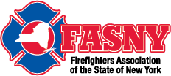

Risk Control in Emergency Services, Are You the Problem or The Solution!
Date & Time Thursday Feb 12, 2026 07:00 PM
This dynamic and interactive webinar is designed for all field personnel, supervisory staff and training officers to provide an understanding of how each individual Emergency Responder within an organization plays an integral and vitally important role in overall risk reduction. Sound risk reduction aids in the creation of a safety culture within the organization. Additional topics include written policies, rules and regulations, as well as equal and equitable enforcement.
REGISTER AT THIS LINK:
https://fasny.zoom.us/webinar/register/WN_17ooxpkhSruFZv6ty7e7iw#/registration

Attend an NVFC Training Near You!
The NVFC hosts in-person trainings at locations across the country on topics including hazardous materials response, electric vehicle response, leadership, fire service culture, and much more. View upcoming courses here. Don’t see a training near you? Consider hosting a training at your department or regional event. View a listing of available courses and request a training here.

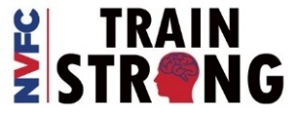
NATIONAL VOLUNTEER FIRE COUNCIL – TRAINING TIMES – COURSES/WEBINARS/EVENTS
LINK TO THE VIRTUAL CLASSROOM: https://virtualclassroom.nvfc.org/featured_courses

NEIGHBOR’S HELPING NEIGHBORS

Gansevoort Fire Department Breakfast
The fire company thanks you for your support!! Breakfast will be served starting at 8AM Sunday February 15th

Clifton Park Fire Department Breakfast
Thank you for your support! Sunday February 1st from 8 to 11am

Speigletown Fire Department Breakfast 2nd Sunday of each month
Sunday February 8th from 7:30 to 11:30, $10 adults, $5 children, under 5 free.
GENERAL INTEREST TO ALL

Culture Check: Is Your Fire Department Okay?
Chase Sargent
This won’t be an exciting article on truck, engine, or rescue company operations—it’s a discussion of culture. That said, without a solid cultural foundation, your operational capabilities, tactics, applications, and even your approach to safety are compromised.
We all have A-shift, B-shift and C-shift fire departments. We will never get rid of that completely, nor do we want to. However, like any sports team, you must have a playbook that everyone understands and can execute. The entire organization, regardless of shift or personnel should always be on the same page when it comes to mission, values, and culture.
CULTURE HAPPENS, WHETHER YOU WANT IT TO OR NOT
Every organization has a culture—some good, some not so good. Organizational culture encompasses the shared norms, values, and behaviors that are acceptable and practiced as part of our everyday organizational engagement and work. Culture is directly reflected in the behaviors of our members, their approach to customer service, their operational behavior on the fireground and EMS operations, and the process and approach we take as individuals by which we interact with our team, our organizational family, and our community and customers. Our cultural norms should always reflect a commitment to professional behavior, on and off duty. Regardless of the type of day we are having as individuals, we should not violate our cultural, social or operational norms.
An organization gets the behavior it rewards. Therefore, if you accept a poor or dangerous culture, you should expect bad things to happen. If you embrace a culture of change, progressive evaluation, people-oriented operations, safety, survival, training, fairness, and respect of all your members, you are on your way to creating a great organization.
GARBAGE IN, GARBAGE OUT
Culture is a strange creature that can be manipulated for good or bad. There are cultures that nurture and accept poor performance, unsafe practices, racism, misogynistic behavior, homophobia, and operational failures due to practices that are unacceptable or questionable based on the tactical and strategical priorities of any operation. There are certainly cultures that literally kill our members, in the most extreme circumstances; otherwise, however, they undermine our organization and its standing in the community. Bad culture and its outcomes reflect on individual members, the department and the municipality you work for.
CULTURE AND SAFETY
I understand just how dangerous the fire service can be. I am in no way espousing a culture of “no risk,’ which is a given part of our job. With great risk comes great reward. Poorly calculated risks or risks that are not trained for result in tragedy. Operational cultural norms should be based on data and facts, not “I think that it might be too dangerous.” Hell yes it dangerous—it’s the fire service. If you want safe, be an accountant or an insurance salesman.
For example, some chief officers are concerned about vent-enter-search (VES) operations, yet there is no evidence that firefighters are killed performing this highly risky yet necessary operation. According to research by my good friend Chief Dennis Reilly, the last known fatalities for a VES operation was in 1945 in London and New York City. Don’t declare something dangerous or unacceptable when you don’t have the data or facts to support your declaration.
BEWARE INFILTRATION
When we go to work for a fire department, we are expected to follow and embrace the cultural norms of the department. Although we may all have our own political, social, or cultural beliefs, they have no business inside the firehouse. Don’t show up for work at the firehouse with a Confederate flag flying off your truck. Don’t show up with a “Don’t send a girl to do a man’s job” bumper sticker. Don’t expect to be able to harass or racially intimidate people. Don’t sexually harass anyone or use language that reflects prejudice or lack of cultural understanding. Don’t preach or proselytize your religious beliefs in the firehouse.
When we allow individuals or groups of individuals to establish their own culture outside our organizational norms, we have Infiltration. Infiltration is the process of allowing and condoning cultural deviation either by affiliation or by ignoring what is.
When this occurs, it is a virus and must be eradicated quickly. If apparatus are racing each other to intersections and the company officer or front seat allows it, that’s infiltration. If we allow harassment, racism, or horseplay in the firehouse, that’s infiltration. If we fail to follow our operational policies on the fireground or in the firehouse, that’s infiltration.
BE INTENTIONAL
Every organization has a culture. The question should always be: Is this the culture we want or deserve? What expectations do we have of our members, and what expectations do they have of the organization? Culture is critical to success, and it must be cultivated consciously, else it will devolve to the lowest accepted practices. Fire service leaders must take an active role in forming an agency’s culture. You must nurture it, mold it, respect it, and create something that you will be proud to pass on to the next generation of leaders.
TAKE A MOMENT TO SMILE

Respect old people. They graduated using only books, brains and bravery without Google, Wikipedia or even wi-fi!!

CLASSIFIED

Opening for Part Time Fire District Treasurer/Deputy Secretary
The Greenfield Fire District is currently seeking qualified applicants for the position of part time Fire District Treasurer/Deputy Secretary. Prior experience and individuals residing within Fire District Boundaries given preference. Complete job description and qualifications can be found on the Greenfield Fire District website at: www.greenfieldfd.org. Cover letter/current resume can be mailed to Greenfield Fire District, attn. Joyce Petkus, P.O. Box 103, Greenfield Center, NY 12833, or emailed to Treasurer@greenfieldfd.org, and will be accepted until the position is filled.
CAFDA OFFICERS AND DIRECTORS 2026
OFFICERS
President, Tom Rinaldi, Commissioner, Stillwater Fire District
1st Vice President, Ellen Martin, Deputy Treasurer Clifton Park Fire District
DIRECTORS:
Les Bonesteel Past Commissioner, Burnt Hills/Saratoga,
Skip Smith, Commissioner, West Crescent/Saratoga
Joyce Petkus Treasurer Greenfield/Saratoga,
Ed Woehrle Commissioner Niskayuna #1/Schenectady
Art Hunsinger, Ex-Officio Member Clifton Park Fire District.
We would consider expanding the number of Directors if individuals from other counties would volunteer to participate!!

APPOINTEES
Secretary Molly Jenkins, Region 1 Director, Assoc of Fire Districts, NYS
Treasurer: Tony Hill
Sargent at Arms: Tom Wood, Commissioner, Northumberland Fire District
Chaplain: Dane Fagan
Legal Counsel: Greg Serio, Safety Officer, Verdoy Fire District
The Capital Area Association represents any fire district that wishes to join CAFDA. Fire District Officials include Commissioners, Treasurers, and Deputy Treasurers. Secretaries and Chiefs are also invited to participate!
Please advise your secretaries that all correspondence should be mailed to:
CAFDA PO Box 242 East Schodack, NY 12063
EMAIL TREASURER: TREASURER@CAFDA.NET
518-407-5020
EMAIL SECRETARY: SECRETARY@CAFDA.NET

Long Way to Travel? Zoom into the General Membership Meetings!
It’s our desire that every member fire district have the opportunity to attend Capital Area meetings. We know we cover a large area, in 8 counties and beyond, and wish to give all of our members a chance to participate in the general membership meetings. You have a voice, and we would like to hear it. Join us at our next meeting either in person or via Zoom. The link will be sent via constant contact prior to each general membership meeting. Thank you for being a member and we hope you will join us.

Capital Area BUSINESS PARTNER’S
Business Partner Applications Available At: WWW.CAFDA.NET
WELCOME DIVAL SAFETY EQUIPMENT
Green Boarder = not yet renewed for ‘26
We invite our business partners to submit educational information to be included in this Bulletin for district commissioners and chief officers
We want to thank all of our Business Partners for renewing their partnership for 2026. You are invited to our monthly membership meeting and to any of our social events..
FIRE SERVICE LEGAL SERVICES

Monaco Cooper Lamme & Carr.PLLC
1881 Western Ave, Suite 200
Albany, NY 12203
Nicole Strippoli 518-941-9040
NSTRIPPOLI@MCLCLAW.COM
https://mclclaw.com


The D’Amato Law Group LLP
Gregory Serio, Partner
Alyssa B. Snyder, Partner
111 Washington Ave Suite 600
Albany, NY 12210
518.426.3800
Email: gserio@dlgny.com or
asnyder@dlgny.com
damatolawgroup.com

HAWKINS DELAFIELD & WOOD LLP
William J. Jackson, Partner
1160 Pittsford-Victor Road, M2-11
Pittsford, NY 14534
585-645-1184
Fire Service Bond Attorneys
www.hawkins.com

Whiteman Osterman & Hanna LLP
Bond Counsel
Robert J. McLaughlin, Partner
One Commerce Plaza, Albany, NY 12260
518-487-7697 Cell 518-813-6333
mclaughlin@woh.com
www.woh.com
Ducharme, Clark & Sovern, LLP
Jack Clark, Fire District Attorney
646 Plank Rd. Clifton Park, NY 12065
518-373-1482
Ducharmeclark.com
HANNIGAN LAW FIRM PLLC
388 Kenwood Avenue
Delmar, New York 12054
P: (518) 869-9911
F: (518) 869-9915
www.hannigan.pro
Fire/EMS –Municipal Law

FIRE STATION & FACILITIES ARCHITECTS AND ENENGINEERS


n.lobosco@ctmale.com
Shawn Corp, Principle
15 Cider Mill Way, Saratoga Springs, NY
518.322.1386
www.reveal-ad.com


Architecture/Engineering/Code Services
Melissa Smith – mlsmith@labellapc.com
Senior Marketing Manager
518-903-8394
4 British American Blvd
Latham, NY 12110
www.labellapc.com


Architects & Engineers
433 River Street, Suite 8002
Troy, NY 12180
518-765-5105
Dennis Ross, Practice Leader
www.H2M.com

Managed IT Services
Cloud Telephone Services

Wendel, Centerpointe Corporate Park, 375 Essjay Road, Suite 200, Williamsville, NY 14221 716.688.0766
Amy Numrich, MBA
Digital Marketing & Events Specialist
anumrich@wendelcompanies.com


Ryan Sapienza
Project Manager/Technology Consultant
518-754-4623
Service 518-869-3614
930 Albany Shaker Rd, Latham, NY 12110

Haughey Insurance Agency
850 State Route 50
Burnt Hills, NY 12027
518-399-1583
www.haugheyagency.com
FIRE SERVICE INSURANCE
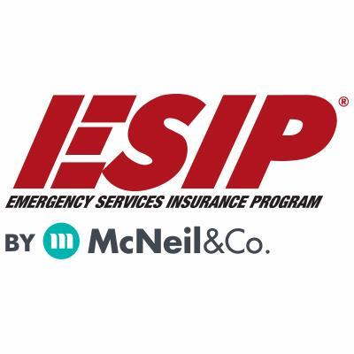
Tony Blackwell, Territory Sales Manager
800-822-3747 ext 530
ablackwell@mcneilandcompany.com
Aurora Inc. Insurance
120 Broadway
Albany, NY 12204
518-449-3180
aurorainsurance.com
Michael May, Broker
mmay@aurorainsurance.com

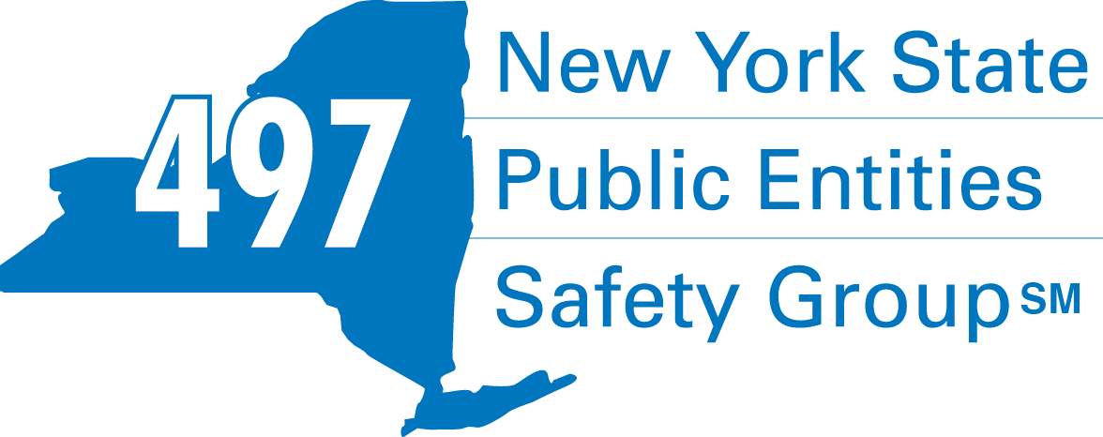
Fleury Risk Management
28 Corporate Drive, Suite 104
Clifton Park, NY 12065
518.478.6314
https://www.fleuryrisk.com/nysgroup497
VFBL Insurances Services
Stephan Petras
Marketing Representative
One Blue Hill Plaza – 16th Floor
PO Box 1609
Pearl River, NY 10965
845-352-8855x7099
329-236-3505
spetras@fdmny.com
VFBL/Workers’ Comp Coverage


Pat Daglio
pdaglio@vfis.com
717.819.3072

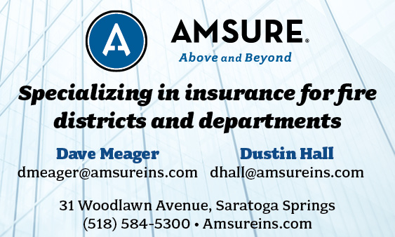

FIRE SERVICE FINANCIAL SERVICES AND LOSAP MANAGEMENT


518-432-5087
838-433-7304 cell
www.thelosapgroup.com.
nikki.haskins@rbc.com
455 Patroon Creek Blvd, suite 200, Albany NY 12206
UBS Financial Advisors
Ralph Lemme, CFP
8 Southwoods Blvd Suite 207
Albany, NY 12211
518.445.1667

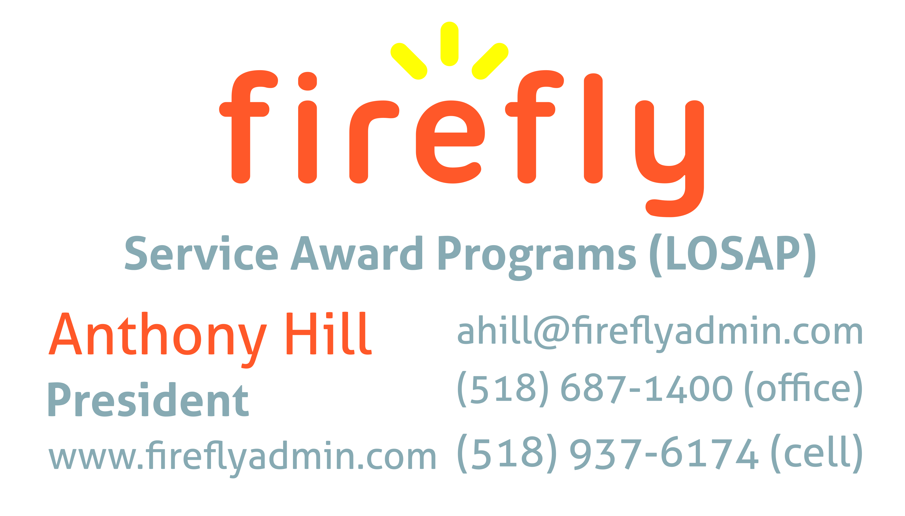


Nicole Meeker
Manager of Business Development & Accts
518-394-7894
Cell 607-423-4811
www.penflexinc.com
nmeeker@penflexinc.com
FIRE EQ TESTING
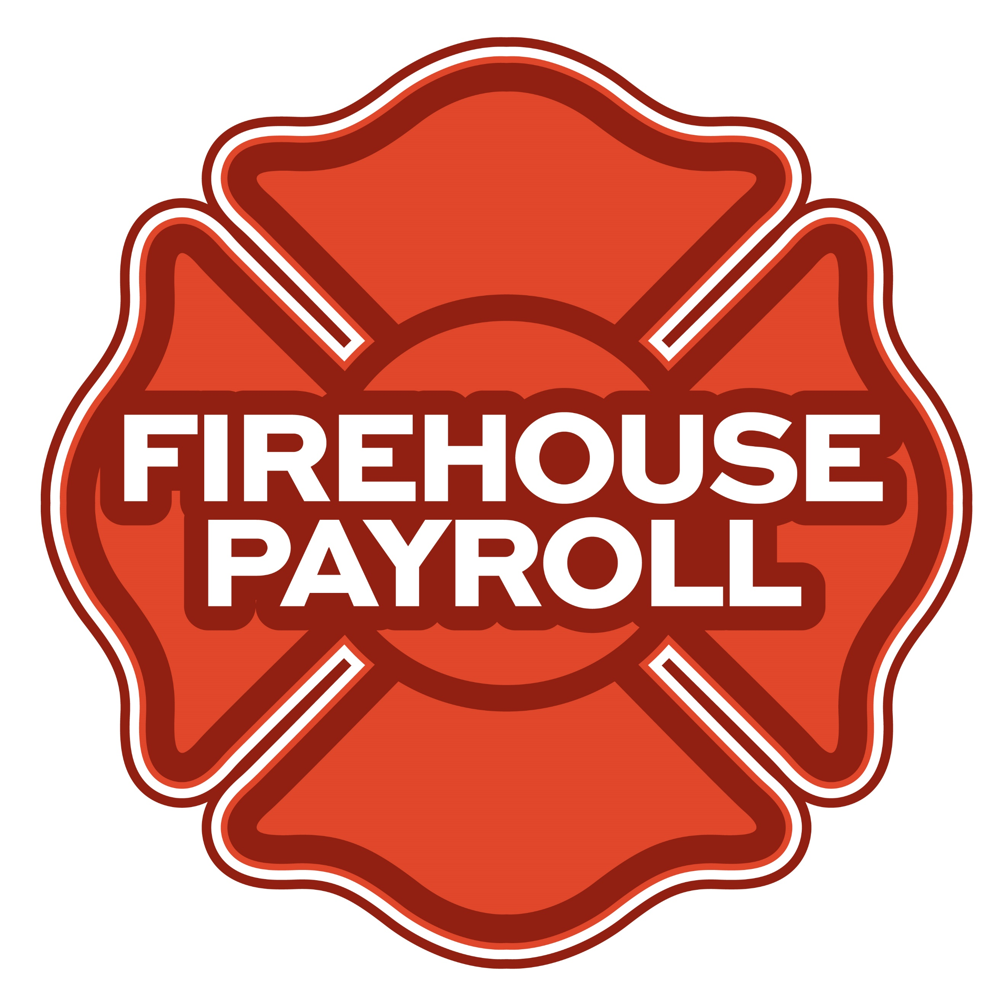
Jeremy Hartnett
302-483-7699
jeremy@firehousepayroll.com
payroll-pension reporting-tax filing
direct deposits-timekeeping-HR Services
FULL-SERVICE FIRE EQUIPMENT
DRYER VENT CLEANING
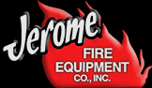
www.jeromefire.com
Breathing Air Comp Maintenance,
Air Quality Tests and Repairs
Russell Jerome
315-699-4533 Office
Ready Rack Extractor/Washers
Full Line of Fire Equipment
8721 Caughdenoy Rd, Clay, NY 13041

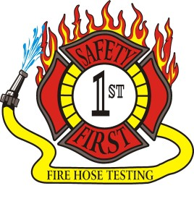Safety First Equipment Testing
99 Glass Lake Road
Averill Park, NY 12018
518-674-8363
www.safetyfirstfirehose.com
HOSE, APPLIANCE & LADDER TESTING
Safety1hose@gmail.com
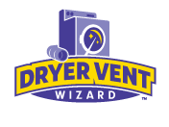DRYER VENT WIZARD
JORDAN CATINO
8 NAPA COURT, SCHENECTADY, NY 12309
518-344-0664
SARATOGADRYERVENT.COM
jcatino@dryerventwizard.com

FIRE DEPT COMPUTER MANAGEMENT & REPAIR

White Wolf Computer, LLC
4 Normanskill Blvd. Suite 410, Delmar, NY 12054
(518) 459-9653
Managed Services
Cloud Hosting Solutions
Telephone Data Cabling
Backup Disaster Recovery
Web Design Services

FIRE COMPANY FUND RAISING

FIRE STATION PEST CONTROL

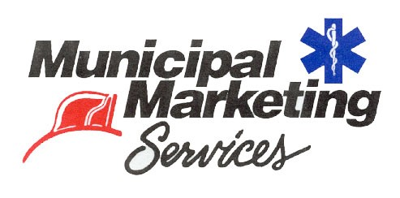
Lloyd Fox, Account Executive
34 Garner Road, Averill Park, NY 12018
Lfox8@nycap.rr.com
518-810-7819
www.funddrive.com

518-300-4732
431 New Karner Rd Suite 170
Albany, NY 12205
https://fox-pest.com/albany-ny

FIRE APPARATUS
FIRE SAFETY EQUIPMENT

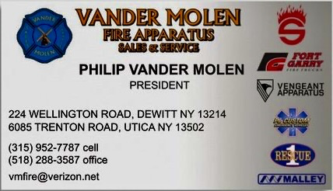
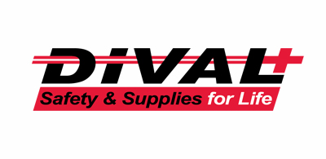
Timmy Kimball
518-925-2786
www.divalsafety.com
Testing-Safety-Promotional Services-Respiratory Solutions
Facility Safety-Fall Protection-Training
60 Cohoes Ave, Green Island NY 12183

FIRE DISTRICT CPA/AUDITS/FINANCIAL SERVICES


Zoriana M. Stawnychy
973.283.0024
zoriana@stawnychyfinancial.com
135 Kinnelon Road Suite 101
Kinnelon, NJ 07405
Serving fire districts in New York State


518-459-6700
10 British-American Blvd, Latham, NY 12110
www.bstco.com
Brendan Kennedy ext 356


Robert V. Gramuglia, CPA
1 Pine West Plaza Suite 107, Albany NY 12205
518.452.8055 or 518.859.5851cell
Email: rgramuglia@BGCPA.net



Accounting, Consulting & IT Security
1581 Franklin Ave. Mineola, NY 11501
Kyle Brengel, Managing Partner
516-472-7345
kbrengel@gblny.com


11 British American Blvd, Latham, NY 12110
518-785-0134
Queensbury Office 518-792-6595
http://www.mmbaccounting.com
Alan W. Clink, CPA aclink@mmb-co.com
Heather R. Lewis, CPA hlewis@mmb-co.com

Don McCormack
425 Main Street Catskill, NY 12414
www.tbogc.com
518.943.2600 X607
donaldm@tbogc.com
Specializing in Fire Service Financing


David Farstad, VP-Municipal Banking
652 Albany-Shaker Road, Albany NY 12211
Ph: 518-730-3120
Cell: 518-506-0075
farstadd@pioneerbanking.com
JOHN M. LESNIEWSKI
Assistant Vice President and
Senior Business Banking Officer
Fulton/Montgomery Markets
12 Fremont Street, Gloversville, NY 12078
P: 518.775-5205 | M: 518.848-0612
NMLS ID 915694
www.nbtbank.com


The Arrow Family of Companies
Corporate HQ 250 Glen Street
Glens Falls, NY 12801
518-793-4121
Business Banking Services
Arrowbank.com
Hero Mortgage Program Supporting First Responders Available

The Weekly Capital Bulletin is reaching well over 700+ subscribed fire district members and now other members of the fire service on a regular basis.
This is a service of CAFDA through the effort of Tom Rinaldi who can be reached at tom@rinaldi1.com for comments and content contributions are always welcome.

BECOME A MEMBER OF CAFDA!
The Capital Area Association has voted to amend its By-laws to allow both individual and regional or county Fire District Associations to join. The updated By-laws are posted to the CAFDA.NET website.
Individual membership fee will be $50 annually, fire district association fees will be $300 annually.
Download THE APPLICATION available on the home page at CAFDA.NET
MEMBERSHIP IN THE CAPITAL AREA FIRE DISTRICTS ASSOCIATION (CAFDA)
Would you like to join Capital Area Fire Districts Association along with 100 members in 14 counties? Individuals, fire district associations, fire protection districts and Village departments are all eligible for membership.
Annual dues (January 1st to December 31st) shall be as follows and shall be based on the annual budget of the Fire District/Organization;
$0 to $200,000: $50
$200,001 to $400,000: $100
$400,001 to $600,000: $200
$600,001 plus: $300
Individuals $50.00 or Other County or Regional Associations $300 annually.
Business Partners: $100.00 annual member fee

If You, Your Fire District or Department is not a Member of CAFDA You Can be?
Individuals can be members of CAFDA. The annual membership fee is $50, which will provide you access to this Bulletin, attendance at meetings and social gatherings. Provides networking with other fire district officials and a source of the constant barrage of information related to today’s fire service.
FOR A MEMBERSHIP APPLICATION OR A BUSINESS PARTNER APPLICATION GO TO THE FOLLOWING LINK:
https://cafda.net/membership-info/

