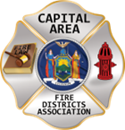
THE BULLETIN

The Voice of CAFDA since 2004
Editor, Tom Rinaldi – tom@rinaldi1.com
When you see **, highly recommended article
CAPITAL SHORTS
- IRS business mileage rate for 2026 72.5 cents per mile. `
- President Harry Truman once said, “It’s amazing what you can accomplish if you don’t care who gets the credit.”
- If you missed our first general membership meeting you missed a real event, great conversation about the future of the fire service and the need to DO something, not just talk about it.
- See the CAFDA annual calendar of events on page 2.
CAFDA NEWS & EDUCATIONAL OPPERTUNITIES: CAFDA.NET

Join us at the NEXT GENERAL MEMBERSHIP MEETING Thursday February 12th features dinner for attendees. Please join us.
ZOOM LINK FOR THE January MEETING at 7pm: https://us06web.zoom.us/j/87557673207?pwd=aqxchRgsVkhNzwjpTH58D1b7vRujHN.1

CAFDA IS HAPPY TO ANNOUNCE THE DATES FOR CONFERENCE ’26 IN HISTORIC LAKE GEORGE,

April 9th, 10th and 11th, 2026 plan on joining us.

CAFDA will be offering two Fire Service Financial training 2 day sessions in 2026
Much needed two-day fire service financial training, learn to do it right, brought to you by CAFDA & NYS-OSC.
This year being held at Rombout Fire Department, Fishkill, Dutchess County on March 13th & 14th and at McNeil Insurance in Cortland, Cortland County at on March 27th & 28th. Training is provided by trainers from the Office of the State Comptroller. Continental Breakfast and Lunch will be included.

REGISTRATION IS OPEN FOR FINANCIAL TRAINING ON-LINE AT CAFDA.NET

Commissioner Training will be held at 6 locations in 2026 including: Averill Park February 7th, Verdoy February 21st, Clifton Park March 7th, Niagara Engine Co #6 in Schoharie March 21st, Berkshire Fire District, Gloversville March 28th and Warrensburg Fire District April 4th. The Day after the scheduled dates has been reserved as a snow day if necessary. Open to all newly elected commissioners and Chiefs. This training is required under Town Law Section 176-e. $85 for members, $95 for non-members includes continental breakfast and lunch.
REGISTRATION IS OPEN FOR COMMISSIONER TRAINING ON-LINE AT CAFDA.NET

All correspondence & Capital Area Fire Districts Association Mailing Address should be directed to:
CAFDA PO Box 242 East Schodack, NY 12063 or EMAIL: SECRETARY@CAFDA.NET
Financial issues should be addressed to: TREASURER@CAFDA.NET
LEGISLATIVE NEWS FROM THE STATE CAPITAL

2026 Issues of United Concern
After a meeting of the fire service organizations including County Coordinators, Fire Districts, Fire Chiefs, Fire Police and FASNY, the following are the legislative initiatives for 2026.
- Increase VFBL Payments, reach parity with workman’s comp payments.
An act to amend the volunteer firefighters' benefit law and the volunteer ambulance workers' benefit law, in relation to increasing the amount of certain benefits. These benefits have not been updated in decades, with most compensation thresholds last revised in the 1990s. As a result, they no longer adequately reflect current economic realities. This legislation seeks to modernize and enhance these benefits to ensure they provide appropriate and meaningful support to those who risk their lives in service to others.
- Designate EMS as an essential service
An act to amend the general municipal law and the public health law, in relation to emergency medical services. The goal of the legislation is to provide a county-by-county assessment that will provide a roadmap for statewide improvements in providing EMS service going forward. The process can be matched with efforts to develop a statewide plan that matches the variety of ways services are provided throughout New York.
- The First Responder PEER Support Act
An act to amend the mental hygiene law, in relation to the "First
Responder Peer Support Program Act". Modeled after the highly successful Joseph P. Dwyer Veterans Peer to Peer Support Program, which was launched in 2012, this bill would establish a First Responder Peer Support Program. This program would focus on prioritizing the mental well-being of the state's first responders. By enacting this bill we can ensure that first responders have access to the necessary systems to address some of the challenges they face.
- Increase the income tax credits for first responders.
An act to amend the tax law and the real property tax law, in relation to tax credits for volunteer firefighters and volunteer ambulance workers. A taxpayer who serves as an active volunteer firefighter or ambulance worker shall be allowed a credit against their state taxes equal to $800. For married couple who file a joint return and both individually qualify, they shall be allowed a credit of $1600.
Legislation would also remove the prohibition to take the property tax exemption in addition to the income tax exemption.
- Enable more progressive fire service delivery options, including agency structure, supplemental support and provide nominal compensation to first responders.
Volunteer and on-call emergency responders should be able to receive compensation as determined by the AHJ for the time that they dedicate to being available or responding to incidents. At this time volunteers are in danger of losing their volunteer status by language currently in the VFBL statutes, which needs to be removed to provide the AHJ the option of providing monetary incentives for volunteers. In addition alternative fire service provider models should be optional to varying levels of government.
- Amend the EMS billing law
Amend the law to allow EMS agencies to bill for mutual aid transports. Currently agencies are not permitted to bill for calls which have been mutual aided to them.
- State Retirement Service Credit as a recruitment/retention incentive
An act to amend the retirement and social security law, in relation to establishing a retirement service credit for volunteer fire or emergency service. Section 1 of this bill would allow a member, upon application to a public retirement system, to achieve one year of service credit for every five years of volunteer fire or emergency service in the State, not to exceed three years of total service credit; available to such member any time before retirement.
OTHER AREAS OF CONCERN THAT MAY BE ADDRESSED GIVEN THE TIME AND ATTENTION OF THE LEGISLATORS DURING THE SESSION.
- Support the joint NVFC, IAFF task force working with DOL/OSHA to propose a viable solution to the 191.156 update, including the removal of the NFPA standards incorporated by reference.
- Publishing Official Notice Modernization; this initiative would update how public and legal notices are transmitted to the public with the demise of local newspapers. For instance, modernization would allow governmental entities to publish notices via online platforms.
- Convene a work group to come up with viable solutions to the issue of compensation for volunteers as well as fire service delivery options, including agency structure and consolidation of services. Specifically remove the prohibition by the counties to provide fire service as an optional solution.

New York Volunteer Fire Departments Eligible for Grants
Volunteer fire departments across New York State have a new opportunity to upgrade their facilities and equipment with $25 million in capital grants.
Gov. Kathy Hochul announced that the request for applications through the Volunteer Fire Infrastructure and Response Equipment Grant Program is now available.
The deadline to apply is Feb. 25, 2026.
The State Division of Homeland Security and Emergency Services, which administers the program, awarded the first round of funding in October 2024 to 88 entities across the State.
The program seeks to ensure fire stations and training facilities are safe and meet current building codes.
It also focuses on improving firefighter safety with equipment like personal protective equipment and decontamination supplies.
Two funding options are available: $20 million for construction and renovation projects and $5 million for fire service equipment projects.
GO TO THIS LINK FOR INFORMATION AND APPLICATION:
https://www.dhses.ny.gov/state-funded-programs

All fire service related legislation has either been signed or vetoed, please look at the ScoreCard for the final determination.

Are You PESH Prepared?
Fire Departments must keep a "Log and Summary of Occupational Injuries and Illnesses” even if the number is zero. They must post the Summary page (OSHA Form 300A), as required by OSHA, in the workplace on February 1. They must keep the Summary posted for three months. Forms are available at: https://www.osha.gov/recordkeeping/forms
LEGISLATIVE NEWS FROM WASHINGTON

CFSI Releases FEMA Reform Report
The Congressional Fire Services Institute (CFSI), together with its National Advisory Committee (NAC), released a comprehensive report titled FEMA Reform: Recommendations from America’s Fire and Emergency Services. The report outlines critical steps the federal government must take to strengthen national preparedness, enhance FEMA’s effectiveness, and support the nation’s one million firefighters and emergency medical services (EMS) personnel.
CFSI’s recommendations emphasize that America’s fire and emergency services are not only the backbone of local emergency response but constitute a critical national capability, recognized by the U.S. Department of Homeland Security as one of the nation’s 16 critical infrastructure sectors. Fire departments protect not only communities but also the critical infrastructure upon which the nation’s economy, security, and public health rely.
The report highlights several urgent needs, including:
- Elevating the U.S. Fire Administration (USFA) and expanding its role within FEMA.
- Strengthening FEMA’s Urban Search and Rescue (USAR) system and ensuring timely reimbursement to USAR task force teams for costs.
- Modernizing national fire data systems, particularly through the implementation of the National Emergency Response Information System (NERIS).
- Enhancing federal wildfire mitigation and response programs, including rapid post-fire assistance.
- Protecting and fully funding core FEMA grant programs, including AFG and SAFER, which provide essential equipment, staffing, training, and preparedness resources to local agencies.
As local fire departments and EMS agencies face increasing equipment and training costs, increasingly complex hazards, and strained budgets, sustained federal support is essential to America’s emergency response capabilities. With FEMA’s future being examined by Congress and the Administration, it is essential that the federal partnership with America’s fire and emergency services is strongly maintained. National resilience depends on local readiness. Any FEMA reforms must strengthen the federal commitment to the fire and emergency services that safeguard millions of Americans every day.

About CFSI
Whether you are a member of the fire and emergency services, a public safety coalition, or the fire service industry, the United States Congress is more aware of your concerns because of the Congressional Fire Services Institute (CFSI). Established in 1989 as a nonprofit, nonpartisan policy institute, CFSI is designed to educate members of Congress about the needs and challenges of our nation’s fire and emergency services to help them understand how the federal government can support the needs of our local first responders.

About The NVFC
The National Volunteer Fire Council (NVFC) is the leading nonprofit membership association representing the interests of the volunteer fire, EMS, and rescue services. The NVFC serves as the voice of the volunteer in the national arena and provides critical resources, programs, education, and advocacy for first responders across the nation.
Our Vision
The NVFC strengthens volunteer and combination fire and emergency medical services to advance excellence, ensure safer communities, and enhance the quality of life across America.
Our Mission
The NVFC unites and supports volunteer and combination fire and EMS organizations through education, advocacy, leadership development, and collaboration. Guided by professionalism and innovation, we provide the tools and resources needed to protect communities, advance responder health and safety, and prepare leaders for the future.
What We Do
The NVFC accomplishes its mission and provides meaningful support to fire and EMS organizations through a wide range of services and programs:
- Representing the interests of the volunteer fire, emergency medical, and rescue services at the U.S. Congress, federal agencies, and national standards setting committees
- Focusing on health and safety
- Helping departments recruit and retain Fire Service and EMS/Rescue personnel
- Providing training on topics that matter to you
- Assisting departments in establishing support programs
- Fostering the next generation of firefighters
- Offering an array of programs to support the volunteer emergency services
THE LATEST NEWS FROM DOL/OSHA

OSHA’s Emergency Response Standard Remains Under Review
Curt Varone
The Occupational Safety and Health Administration’s effort to replace its 1980-era Fire Brigades standard remains in the rulemaking process, with no final regulation issued. OSHA formally proposed the new rule—titled the Emergency Response Standard—on February 5, 2024. The proposal would modernize 29 C.F.R. § 1910.156, which has governed fire brigades for more than four decades, by expanding its scope to cover a broad range of emergency response personnel.
Following publication of the Notice of Proposed Rulemaking, OSHA opened a public comment period that was extended several times due to the volume of responses. The comment period closed on July 22, 2024. OSHA later convened an informal public hearing, which began on November 12, 2024, and accepted additional written submissions through January 17, 2025.
Since then, the agency has been reviewing the testimony, comments, and data submitted during the rulemaking process. According to OSHA’s regulatory agenda and its Emergency Response Rulemaking page, the proposed rule remains under analysis. No final rule has been drafted or published, and the existing Fire Brigades standard continues to govern until OSHA completes the process.
The proposed Emergency Response Standard would significantly expand OSHA’s regulatory framework for responders. Rather than limiting coverage to industrial and private fire brigades, the proposal would bring firefighters, EMS personnel, technical rescue teams, and other responders under a single comprehensive standard. It would incorporate updated requirements for emergency response plans, hazard assessments, personal protective equipment, medical and behavioral-health evaluations, and training aligned with contemporary consensus standards.
The scope of the proposal drew extensive attention from the fire service, particularly from volunteer and smaller departments. Many commenters expressed concern about the feasibility of compliance, prompting OSHA to acknowledge that economic impacts on volunteer organizations require further review. In a September 2024 statement, OSHA indicated it would evaluate the applicability of the final rule to volunteers based on the record developed during the hearing and comment periods.
Despite the interest surrounding the proposal, OSHA has not indicated when a final rule might be issued. The new regulation remains at the proposed stage, and the agency’s review is ongoing. For now, the Emergency Response Standard has not been adopted, and the 1910.156 Fire Brigades standard remains in effect. Here is a statement from OSHA:
- OSHA is reviewing and evaluating all the comments and data submitted by stakeholders and the transcripts from the hearing. This important step in the rulemaking process helps guide the agency as it considers how to proceed with the rulemaking.
Here is a link to OSHA’s current position on the Emergency Response Standard.
https://www.osha.gov/emergency-response/rulemaking

The Latest from Dave Denniston:
As was briefly discussed on the recent NYS Fire Service Council zoom meeting, the group is still in serious discussions and are attempting to formulate an update to the Emergency Service Standard that is not as intrusive as the original proposal. The NFPA standards will NOT be adopted by reference and there is consideration for a modification to the standard for communities with fewer than a population of 5K. A more formal briefing is pending from Chairman Denniston. We thank him for his dedication to this process.

By Dave Denniston NVFC OSHA 1910.156 Taskforce Chair
The NVFC continues to meet with the IAFC and (The IAFC has pulled out of the meetings) IAFF as we wait for next steps from the Department of Labor and OSHA. There have been significant changes in leadership at these organizations. We are under the belief that they continue to digest the large volume of information and feedback offered during the process and are modifying the proposed standard into something that is much more agreeable. The proposed standard as written does not work for anyone, volunteer, combination, or career departments. All three organizations agree significant changes are needed from the proposal. We anticipate that they will craft a new standard that is technically and economically feasible using what is referred to as logical outgrowth from the process. The representatives from the IAFC, NVFC, and IAFF all agree that the best of all worlds would be to remove the NFPA standards by reference, bring a lot of the regulations back to the control of the home state and authority having jurisdiction, and make logical requirements that will help protect our first responders. We continue to monitor progress and are ready to pursue the next steps if the process does not yield a document that we can all live with. We have also voiced our opposition to a pure exemption of volunteer firefighters as we feel that the move would be counterproductive and further divide the two major factions of our emergency services. We have long fought for parity in items such as presumptive heart, cancer coverage, workers compensation benefits, equal representation, and firefighter safety. To simply exempt the volunteer fire service would be a huge disservice to these initiatives and leave combination departments in an extremely awkward, if not unmanageable situation. It would also be extremely difficult for municipalities to manage with two different sets of rules.
The three organizations are also hard at work building resources to support emergency services organizations moving forward. These resources include training, sample emergency action plans, risk management plans, community assessment forms, sample policies, and advocacy materials. The right tools will aid everything from a small rural volunteer department with a $50K budget all the way up to the large municipal all-career city department, and everything in-between. We are very excited by the working relationship being built by these national organizations and all involved in the process feel we are seeing ground-breaking results. If you have any questions or concerns about the process, we encourage you to reach out and get involved in the discussions. I can be reached at 607-423-1636 or ddenniston@afdsny.org. By working together, we can help build a fire service that will serve us well for years to come.

IT IS TIME TO MOVE FORWARD WITH A WORKABLE OSHA 1910.156 REVISION
Dave Denniston, 1st VP AFDSNY
As the process to update OSHA 1910.156 continues, it is important that we understand where we have been, and options for the process moving forward. Since the proposed rule was published for review 18 months ago, there has been a significant amount of input and feedback from stakeholders addressing possible concerns about the economic and technical feasibility of the proposal. Stakeholders from across the country participated in the process and offered suggestions. One of the early possible solutions suggested was to simply exempt volunteers, and other parties, from the proposed rule as written. The mindset was that if it didn’t affect “us” it was not our problem. While this concept appeared to be a quick solution, it fell short of addressing the true needs or problems.
The real issue at hand is that the proposed rule as written had challenges for everyone and you would be hard pressed to find any department, career, combination, or volunteer, that could meet the intent of the standard. The proposed standard also took a one-size-fits-all approach. We know that the emergency service agencies across this country are very different. They have different resources, different exposures, different concerns, and different levels of risk. It is true that emergencies, fires, and hazards are the same regardless of the type of responder. What is different is the likeliness that a particular event will occur in any jurisdiction. Local jurisdictions must be required, and empowered, to address significant risk, and the needs of a community, at a local and state level with just enough federal oversight to give it teeth and ensure safety for all of our responders. The bottom line is that the current 1910.156 is outdated and needs significant revision to address the needs and safety concerns of today’s first responders. The proposed standard, as written, went too far in trying to address these needs. What we need is a middle ground solution that is designed to relieve significant risk and does so at a level that is economically and technically feasible for local communities, organizations, and the municipalities that govern and fund them.
Some are asking why simply exempting the volunteers is not in the best interest of volunteers across the country. First, by exempting the volunteers, we are failing to address the growing concerns and exposures facing this group of responders. Second, the largest growth area for most of our local fire departments is a move toward combination and career departments. How would it be possible to have one set of rules apply to part of an organization and not the other? Does it make sense to have volunteer responders face one set of rules, while career responders on the same truck follow another? Are we not all responding to the same emergencies with the same exposures? The approach of exempting volunteers would add both confusion and resentment moving forward. The third part of the issue is that the standard, as written, is just as problematic for the communities that have career departments as it is for those that only have volunteers. We need a standard that brings us all together, not one that drives us further apart.
So, what do the solutions look like? Where should OSHA and the Department of Labor go from here? After pouring through the thousands of comments brought forth during the process, an opportunity is right in front of us. There were a multitude of comments throughout the process that carried common themes. By using logical outgrowth of the process, OSHA now has the opportunity to massage the rule into one that we all can live with, and provide the level of safety they are tasked to provide the workers of this country.
It is now in OSHA’s hands to finalize the rule as proposed, make logical changes, scrap it, or go back to the drawing board. During the process, OSHA continuously asked for proposed solutions, and many excellent solutions were entered into the record from those that participated. We would suggest that OSHA and the Department of Labor use the extensive input from the process to make necessary changes to the document and work to finalize the rule. A rule that meets the intent of reducing significant risk in a manner that is reasonable and responsible for our first responders and communities.
Using logical outgrowth, OSHA now has the opportunity to remove the incorporated NFPA standards. Many of the participants and the NFPA itself asked for this to be done in their comments. The incorporation of those standards brought many of the pain points organizations were concerned about. The NFPA standards instead should be used as a tool for compliance, not a weapon of enforcement. By removing the incorporation of dozens of NFPA standards, the rule would also become far less confusing and economically infeasible. The next step is to transfer as much of the obligation of providing safety down to the local jurisdiction and state levels as possible. These are the people that know the nuances of the local responders and hazards in any given area. This, too, was supported by the comments throughout the process. The third opportunity is rather than exempting anyone, to build a baseline standard that applies and protects everyone, and then increase the requirements where the data shows increased exposure and risks. All of these changes are supported by the logical outgrowth requirements and would alleviate most of the pain points addressed by the participants of the process.
Regardless of the solution, we would be remiss if we failed to realize there will be opposition to any action taken moving forward. We also need to realize that any solution, or even no solution at all, will have pain points for some that it will affect. It has often been said that firefighters hate two things, change and the way things currently are. Hopefully, we realize that we are at a historic time, with an amazing opportunity to get this right. This process has been fair and offered plenty of opportunities for those interested in participating to make their opinions and feelings known. It is time to move the ball over the goal line and continue to work together for the betterment of emergency services in this country.
I encourage you to speak to your local elected officials. Let them know there is a workable solution right in front of us, and ask them to encourage the Department of Labor and OSHA to continue this opportunity and finalize a reasonable OSHA 1910.156 that applies to all fire departments, regardless of the composition of their staff.
FIRE DISTRICT FINANCIAL NEWS

Local Government and School Accountability Contact Information:
Phone: (518) 474-4037; Email: localgov@osc.ny.gov
Address: Office of the State Comptroller, Division of Local Government and School Accountability
110 State Street, 12th Floor; Albany, NY 12236

NYS-OSC Fire Service Audits

THE FIRE CHIEF’S OFFICE

‘Blurred vision’ makes for confused and apathetic members
Jason Caughey
For many years, fire service leaders have emphasized the need for departments to clearly define their mission and vision, and for many organizations, these elements have become central to their identity.
The good news: Most fire department websites prominently display their mission statement – typically a straightforward, tangible statement focused on operations, performance and service. Firefighters can get behind the mission statement, especially if it emphasizes an aggressive approach to serving the community.
But what about a vision statement? Do our members know the organization’s priorities and where we are headed long-term, or do we, as an organization, have “blurred vision”?
WHERE WE LOSE FOCUS
Fire service leaders are constantly bombarded with distractions that can divert our attention from reflecting on or making decisions about long-term goals. Regardless of whether these distractions stem from internal or external issues, fire chiefs can easily lose focus on the big picture. In fact, for some leaders, fire department vision is often the first topic to move to the back burner. Worse yet, others simply dissolve the entire topic, as they become so entangled in distractions that they are simply unable to create, enforce and embody the organizational vision.
So, how can leaders effectively develop and sustain the organizational vision?
NEAR-SIGHTED (LOCAL) SUPPORT
Vision is grounded in the local context, which means you cannot simply adopt another organization’s vision just because it seems appealing. After all, crafting a vision for an organization requires commitment from its members, meaning you should tap into their insight. The vision should align with your organizational values, but more importantly, it must resonate with the expectations and values of your community. Successful organizations create opportunities for their citizens to engage and contribute to the development of the mission and vision. Developing a vision that reflects the culture of your community is essential. For instance, if your vision is to establish an urban-style fire department in a rural area, success will be difficult to achieve. Keep it local, remain innovative, and foster a vision that is owned by both your members and the community.
FAR-SIGHTED (LONG-TERM) PLANS
It is important to understand that you will never fully realize your vision – that’s the point. Remember, vision differs significantly from goals. While goals are specific and attainable, a fire department’s vision is an ongoing pursuit, never fully accomplished but consistently pursued. Your vision statement should inspire your members to look ahead and imagine how we can improve. (Note: If you’ve achieved your vision, then you probably aren’t thinking big enough.)
All that being said, your vision must be realistic; unrealistic aspirations will only demoralize your members and create internal conflict. Your organization’s vision should closely align with its culture, and together, they profoundly influence your members and the service provided to the community more than any other aspect of the fire service.
ACHIEVING 20/20 VISION
Driving the growth of your department’s vision hinges on three key elements: communication, buy-in and reinforcement.
Leaders must consistently develop and cultivate the organization’s vision and mission, ensuring their actions reflect these guiding principles. Additionally, they must communicate the vision to members on a regular basis. Consistent messaging in all activities will help members remain aware of the organization’s priorities.
As noted, when members and the community embrace the vision, it becomes easier to nurture and expand upon the vision. The challenge lies in cultivating a vision amid distractions. Furthermore, it is crucial for leaders to uphold the organization’s mission and vision – aka “walk the walk.”
FINAL THOUGHTS
Serving in a leadership role means facing many large and ongoing challenges, and with the constant demand to achieve more with fewer resources, many leaders struggle to maintain their focus on their organizational vision. While it’s easy to see the impact of distractions, it is still essential that all leaders intentionally communicate and cultivate your vision at every stage of their tenure. Omitting any piece of the interconnected organizational puzzle that creates our culture – response, training, mission or vision – will cloud the members’ view of the future and lead to more challenges, namely retention, as your watch your members move to clearer pastures.
THE ATTORNEY’S OFFICE

Md. firefighters get green light for off-duty medical cannabis
Howard County firefighters will be permitted to use medical cannabis while off duty under an updated Fire and Rescue Services Substance Abuse Policy, County Executive Calvin Ball announced on Dec. 19. The agreement between the county and Howard County IAFF Local 2000 is the first major revision to the policy since 1991.
The revised policy takes effect Jan. 31, 2026, and permits uniformed members of the county Department of Fire and Rescue Services to use medical marijuana while off duty
Union leaders say medical cannabis could help firefighters manage chronic pain, sleep disorders, PTSD and other health conditions.
The change follows President Donald Trump’s decision to reclassify marijuana from Schedule I to Schedule III, as both medical and recreational cannabis are legal in Maryland.

The 5 Most Important Fire Department Law Cases of 2025
Curt Varone
KEY TAKEAWAYS
- Over the last year, Curt Varone found that five fire service lawsuits will have a long-term impact on fire department operaions, from training to immunity and fire apparatus purchasing.
- Utah’s legislative response to a court ruling limiting EMS immunity highlights the fragile nature of legal protections and the need for fire agencies to monitor and adapt to jurisdictional changes.
- A Virginia firefighter’s successful injunction against disciplinary action for off-duty medical cannabis use signals a shift toward recognizing lawful medical use.
Every year brings no shortage of lawsuits involving fire departments and firefighters. Some are shocking. Some are unusual. Some dominate headlines for a few days and then quietly fade. The cases that truly matter, however, are not always the most dramatic. They are the ones that reshape legal assumptions, expose systemic vulnerabilities, or alter how courts, legislatures, and fire departments think about risk, responsibility, and authority.
The following five cases stand out in 2025, not because they are the most sensational, but because they are the most consequential in the fire service. Together, they touch nearly every corner of fire law: line-of-duty death liability, governmental immunity, medical cannabis, antitrust exposure, and recruit safety. Each one of these fire service legal lawsuits carries lessons that can influence fire department policy, firefighter training, budgeting, and litigation strategy for years to come, if we are listening.
1. WIDOW OF ILLINOIS FIREFIGHTER AWARDED $31.5 MILLION IN WRONGFUL-DEATH TRIAL
In November 2025, a jury returned a $31.5 million verdict in favor of the widow of a Sterling, IL, firefighter who died in the line of duty. Lt. Garrett Ramos responded as part of a mutual aid crew to a house fire in nearby Rock Falls in 2021. He fell through a floor into the basement, and despite making two mayday calls, fireground commanders did not realize he was trapped until it was too late.
Ramos’ wife filed suit against the City of Rock Falls, and a jury concluded that the failures of those fire ground commanders were willful and wanton, and thus not subject to the immunity protection afforded to those who are merely negligent. The case is Ramos v. City of Rock Falls, and took place in Whiteside County Court.
While large verdicts are not unheard of, this one is significant because it reflects a willingness by juries to scrutinize fire department decision-making that deviates from National Fire Protection Association (NFPA) standards. Lt. Ramos’ death stemmed from operational decisions that the plaintiff argued were preventable through proper planning, supervision, and adherence to established safety practices. The defense emphasized the inherently dangerous nature of firefighting and the unpredictability of emergency scenes. The jury was unmoved.
What makes this case important is not just the dollar amount, but the signal it sends. Courts and juries have long been willing to distinguish between unavoidable risk and preventable harm. When a firefighter’s death can be traced to command decisions, policy failures, or ignored warnings, the deference traditionally afforded to fireground discretion diminishes sharply.
For fire departments, this case underscores the legal exposure tied to training, standard operating guidelines, and enforcement. The plaintiffs’ attorneys focus not simply on the fact that something went wrong; they focused on what should have been done differently, and why leadership failed to do it. The verdict also highlights the critical role of NFPA standards and expert testimony in translating fireground decisions into concepts jurors understand—risk assessment, foreseeability, and preventability.
2. UTAH LEGISLATURE MOVES TO RESTORE EMS IMMUNITY AFTER SUPREME COURT LIMITS IT
In another pivotal development, the Utah Supreme Court issued a decision narrowing the scope of statutory immunity for emergency medical services providers. The case, Armenta v. Unified Fire Authority, was brought by a patient who called 9-1-1, was not transported, and later suffered a massive heart attack. The Unified Fire Authority sought to have the case dismissed under the Utah Governmental Immunity Act (UGIA), since it only alleged negligence.
The Utah Supreme Court rejected that argument, concluding that immunity applied only when responding to a disaster, not to a simple medical call. The reaction was swift. Within weeks, the Utah Legislature moved to restore EMS immunity through statutory amendments, effectively overriding the court’s interpretation and reaffirming legislative intent to shield EMS providers from claims of ordinary negligence.
This sequence—court decision followed by legislative correction—is important for two reasons. First, it highlights how fragile immunity protections can be. Many fire and EMS agencies operate under the assumption that immunity statutes are settled law. This case demonstrates that a single appellate decision can upend that understanding overnight.
Second, it shows the tension that exists between courts and legislatures over how much protection emergency services should receive. For fire chiefs and municipal officials, the lesson is clear: immunity protection is not absolute, and it is not permanent. Departments should track appellate decisions closely, understand how immunity is defined in their state, and recognize that operational conduct may still be scrutinized even where immunity exists. Utah’s experience may foreshadow similar challenges—and legislative responses—in other states.
3. VIRGINIA FIREFIGHTER SECURES PRELIMINARY INJUNCTION ON MEDICAL CANNABIS OIL USE
A Virginia firefighter made national headlines in 2025 after securing a preliminary injunction preventing his department from disciplining him for off-duty use of medical cannabis oil prescribed for a medical condition. The injunction prohibits the Hanover County Fire & EMS Department from taking disciplinary action against firefighter David Morath.
In Morath v. Hanover County, the Circuit Court of Hanover County concluded that Morath had demonstrated a likelihood of success on the merits, particularly given Virginia’s medical cannabis protections and the absence of evidence that his use impaired job performance.
What makes this case especially important is how it fits into a broader, emerging legal consensus. Courts are increasingly distinguishing between lawful off-duty medical cannabis use and on-duty impairment. Blanket zero-tolerance policies, once considered legally safe, are now facing serious scrutiny.
This Virginia decision aligns closely with the holding in Giambrone v. Hillsborough County, a 2024 Florida case in which a firefighter prevailed after being terminated for lawful off-duty medical marijuana use. In Giambrone, the court rejected the county’s argument that federal marijuana law automatically justified discipline, emphasizing Florida’s constitutional protections for medical marijuana patients and the lack of evidence of workplace impairment.
Together, these cases reflect a consistent judicial theme: departments must show more than the mere presence of cannabis metabolites to justify adverse employment action. Fire departments retain the authority—and obligation—to prevent impairment on duty, but they can no longer rely on outdated assumptions about off-duty medical use.
For the fire service, this represents a fundamental shift. Policies must now balance safety, federal regulations, state medical cannabis laws, and disability protections. Departments that fail to modernize their policies risk costly litigation and injunctions that can limit managerial discretion.
4. LA CROSSE, WI, SUES FIRE APPARATUS MANUFACTURERS ALLEGING ANTITRUST CONSPIRACY
In a case with nationwide implications, the City of La Crosse, WI, filed suit against multiple fire apparatus manufacturers, alleging an antitrust conspiracy to artificially inflate prices and suppress competition in the fire truck market. The case, City of La Crosse v. Oshkosh Corporation et al, was filed in the U.S. District Court for the Eastern District of Wisconsin.
Fire departments across the country are already grappling with unprecedented apparatus costs, extended delivery timelines, and limited vendor options. This lawsuit challenges the underlying market forces behind those realities, asserting that they are not merely the result of supply chain pressures or increased regulatory requirements, but of coordinated conduct in violation of antitrust laws.
If successful, the case could reshape the fire apparatus industry. It could lead to damages, injunctive relief, and structural changes in how fire trucks are priced, marketed, and sold. Even if it does not prevail on the merits, the litigation itself is likely to force unprecedented disclosure of industry practices.
For fire chiefs and municipal purchasers, the importance of this case lies in its potential ripple effects. Apparatus procurement is one of the largest capital expenditures for fire departments. Any legal development that affects pricing transparency or competition directly impacts budgets, bond approvals, and long-term fleet planning.
This case also serves as a reminder that fire departments are not just public safety agencies—they are major market participants. Legal remedies needed to address market concerns may extend well beyond traditional employment or tort law.
5. FREDERICK COUNTY, MD, SUED FOR $50 MILLION IN DEATH OF FIRE RECRUIT
The final case to look at from 2025 involves a $50 million lawsuit filed against Frederick County, MD, following the death of a fire recruit during training in 2023. Recruit fatalities have always been among the most legally perilous incidents for fire departments, and this case illustrates why.
Ian Strickler died during a physical training session, which his family contends stems from a combination of extreme training conditions, inadequate medical oversight, and failures to recognize warning signs. The lawsuit alleges that the risks were foreseeable and that safeguards were either ignored or insufficient.
This case, Estate of Ian Thomas Strickler et al, v. Frederick County, et al., is important because it strikes at the heart of fire service culture. Firefighting is inherently physically demanding, and arduous training is often defended as essential preparation for the job. However, families of deceased firefighters, courts, and juries are unwilling to accept “that’s how we’ve always done it” as a legal defense.
Recruit training must be viewed through the same liability framework as other workplace activities: hazard identification, risk mitigation, supervision, and emergency response planning. Departments must be able to demonstrate not only that training needs to be rigorous, but that it is objectively reasonable in light of the risks.
The Frederick County case reinforces a trend seen nationwide. When recruits die, judges and juries will be tasked with answering hard questions about duty of care, institutional responsibility, and whether tradition outweighs safety. The answers to those questions will determine the outcome of litigation—and the future of training programs.
LOOKING AHEAD
Taken together, these five cases define the legal landscape facing the fire service in 2026. They reflect heightened accountability, evolving employment law, scrutiny of long-standing assumptions, and an expanding view of liability.
The message is not that the fire service is under attack. Rather, it is that courts, legislatures, and juries are demanding clearer justifications, better documentation, and more deliberate decision-making. Departments that understand these trends—and adapt proactively—will be far better positioned to navigate the legal challenges ahead.
As always, the most important cases are not the ones that make headlines for a day, but the ones that quietly change the rules.

For information only and not for the purpose of providing legal advice. The opinions expressed are the opinions of the individual author at the time the facts were presented and based on the law then applicable. The information contained in these opinions is not guaranteed to be up to date. The information provided is not legal advice. Since legal advice must be tailored to the specific circumstances of each case, and laws are constantly changing, nothing on this site should be used as a substitute for the advice of competent legal counsel. The authors assume no responsibility to any person who relies on information contained herein and disclaim all liability in respect to such information. You should not act upon information in this publication without seeking professional counsel from an attorney admitted to practice in your jurisdiction.
POSITIVE OUTCOMES AND CHALLENGES FOR THE FIRE SERVICE

POSITIVE OUTCOMES
Maybe next week!

FIRE SERVICE CHALLENGES

‘Doing a lot with very little': Union points to report in call to end cross-staffing in Md. fire department
Katharine Wilson, Capital Gazette
The Anne Arundel County Fire Department should hire additional staff members and rethink staffing methods to better meet national recommendations, according to a new report.
The department is using a “cross-staffing” method, which the report argues poses risks to safety and response times. Cross-staffing is the practice of assigning one team of firefighters to multiple vehicles, such as a fire engine and a medical unit, which leaves vehicles without a team to operate them.
The report could factor into the department’s budget request, as the county gears up for budget negotiations in the spring. Leaders of the fire union, Anne Arundel County Professional Fire Fighters, are urging the county to consider adding additional department staff in the next fiscal budget and to eventually end cross-staffing.
“Understaffing the fire department puts the safety of the communities and the firefighters at risk,” said Joe Addivinola, the president of the fire union. “Right now, we’re doing a lot with very little.”
The recently released 2024 Community Risk Assessment and Deployment Analysis Report on the county fire department was conducted by Emergency Services Consulting International, an independent group, and funded by the county as a result of union contract negotiations in 2023.
Most units in the department operate with three firefighters per apparatus, the report shows, below the National Fire Protection Association’s recommendation of four firefighters dedicated to each fire suppression resource. Fire suppression resources are fire engines, aerials, rescue squads and fireboats. The department has four-person staffing for three of the seven ladder trucks.
The county department always sends the national standards for the number of firefighters to every call for service, said department spokesperson Capt. Jenny Macallair. To accommodate the minimum staff required at incidents, the department has to send more vehicles to one incident than if each were fully staffed, she said, increasing the number of vehicles unavailable to take other calls for service.
“As our population and call volume grow, the system that has served us well is beginning to be stretched,” Macallair said. “The [report] provides a data-driven road map to prioritize future staffing and deployment decisions to maintain reliable response times, protect firefighter safety, and continue delivering the services our county and residents expect. This is not about correcting a failure; it is about planning responsibly for the future.”
The department also cross-staffs firefighter units between multiple vehicles, which also leaves vehicles without a team to operate them. While Macallair said she was not able to estimate how many firefighters were cross-staffed, Addivinola estimated that four to five stations have four firefighters at a time cross-staffed between two response vehicles.
Casey Cameron, the union vice president, said he is currently cross-staffed between a rescue truck and a fire truck. About 10 times a day, Cameron said he transitions between the two vehicles, requiring him to transfer his personal protective equipment and other gear between them, possibly delaying response times and risking leaving materials in the wrong vehicle.
“We still are providing the best service we can, and we still get the proper staffing on every call, but it’s taking more units and drawing units from other communities because we’re not staffed to the national standard,” Cameron said. “We’re still providing the best service we can; our members are still showing up. We do everything we can, but we could be doing a lot better.”
Every second counts, Addivinola said, especially as house fires are burning faster than before. People have about three minutes to escape a house, according to the International Association of Fire Fighters, as newer buildings with open floor plans and synthetic materials burn faster.
Macallair stressed that the minimum nationally required staff addresses each call for service, but acknowledged that the cross-staffing method that takes vehicles out of service can harm responses.
“While this approach allows us to meet incident-level standards, it can reduce system capacity and limit the ability of resources for simultaneous emergency or rapidly escalating emergencies,” she said.
Moving away from cross-staffing and staffing four firefighters per vehicle would lead to a department that’s “efficient and safer while ensuring more units remain in service,” Macallair said.
The department has agreements to respond to calls within the Annapolis Fire Department’s jurisdiction, which is similarly struggling under the national staffing standards, and the city also responds to calls in the county.
From Dec. 1, 2024, to Dec. 1, the county fire department received 84,791 calls for service, a vast majority of which are emergency medical services calls. Firefighters in the department are all emergency medical technician certified, and many are also paramedics.
The report recommended several staffing suggestions, including staffing four dedicated firefighters at all times with each fire suppression resource, fully staffing a fireboat, and staffing a special service resource like an aerial or rescue squad.
The county fire department has made staffing gains within the past few years, Addivinola said. The current county budget accounts for 927 firefighters, up from 853 in the 2019 fiscal budget. To fill emergent needs, he said, 150 roles would be needed. He acknowledges the high cost of that hiring, but called the understaffing a “ticking time bomb.”
“At some point we’re going to see something happen and I’m going to be that guy that says I told you so,” Addivinola said. “Minutes and seconds count when there’s a fire and there’s someone trapped inside.”
Anne Arundel County Executive Steuart Pittman is set to release his budget for the 2027 fiscal year in the spring, following budget negotiations. Pittmann’s office declined to comment for this story, deferring to the fire department, and said it would be premature to pinpoint specific budget items at this point in the process.
Fire Chief Trisha Wolford is “prioritizing all needs” in budget negotiations, according to Macallair. The chief will present to Pittman on the budget in the first week of March, Macallair said.

Hoses Run over Twice at York County, PA, Fire Scenes
Twice in one week, motorists drove over hose lines while firefighters were operating at incidents.
York Area United Fire and Rescue estimates the damage is more than $4,000.
"It delays us to be able to fight the fire. It causes an unsafe work environment for them and us, because when they run over that fire hose, they could crash the car and hurt themselves. They could pull the hose and hurt me or whoever else is at the active fire scene," Firefighter Lester Rhoads told WGAL.
RETENTION AND RECRUITMENT
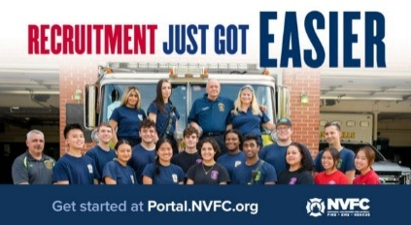
Does your fire or EMS department need more volunteers? The National Volunteer Fire Council (NVFC) is here to help! Use the FREE department portal from the NVFC’s Make Me A Firefighter campaign to access tools and resources to help you find and keep volunteers.
Get started:
- Register for free at portal.nvfc.org.
- Post your volunteer opportunities so potential recruits can find and connect with your department at MakeMeAFirefighter.org.
- Customize recruitment materials with your department’s details using the materials generator.
- Share your message with ready-to-use flyers, PSAs, social media content, and videos.
- Track your applicants and follow up with ease using the recruit tracking tool.
Plus, access additional resources to help with recruitment and retention, including:
- “What to Expect” Guide for the Families of New Recruits
- Volunteer Retention Research Report
- Volunteer Value Calculators
- Recruitment and Retention Guide
- Recruitment and Retention Online Training
- And Much More!
GET STARTED NOW AT THIS LINK:
https://tracking.police1.com/t/9495565/187515077/7816037/1/1006865/?b44ed14b=YmY5NWQ4NzktNWRmOC00MWJkLTkzMDctNzg0Y2VhZTNjMzYy&x=1ee5e8f9

Back to baseline: Resetting recruitment fundamentals
Jesse Schilling
For many fire departments, recruitment efforts simply were not an issue just a few years ago. Fast forward to the present day, and 90% of paid fire departments are struggling with bringing in new members. Volunteer departments are experiencing the same challenges, if not worse.
There are many theories about why the fire service is experiencing these issues. Headlines about pay, cancer, PTSD, suicide and COVID have become associated with the profession. Even though the headlines are not entirely wrong, they are often the loudest voices online, shaping how our profession is represented. Yet most of us in the profession would agree that it is still one of the greatest professions there is — and we would do it again.
So, how can we reignite the interest to drive people back to this career? It all starts with getting back to the basics.
5 BACK-TO-BASICS STEPS
Here we’ll review five basic concepts that you can start immediately to bring your recruitment efforts up to speed. But remember, this is not a one-and-done project. Recruitment is about playing the long game. What you start now needs to be maintained, and if you stay consistent, it will grow.
Step 1: Know your people
You will need to find the social butterfly or “town mayor” as your recruitment lead. Find that person who will happily interact with anyone and everyone and bring out the best in those they engage with. Many younger individuals are shy and timid; it takes a special person to make them feel comfortable and draw them out of their shell. Younger generations have had a unique experience over the past few years, so leaning on your most engaging, enthusiastic recruiters will make a meaningful difference in breaking through with them.
Step 2: Connect with community
Your lead will not be the only recruiter, of course. It’s imperative to identify those members with a passion and a niche in other areas related to recruitment, such as veterans or fitness communities, even fire/EMS service instructors. Leverage what your people are naturally good at and give them the space to use those strengths.
Some of you are already doing this; others are not. And if you are not, you can start this ASAP. Tapping into your community is key to recruitment. Seek out the career advisor at your local high school and determine when they will hold their next career expo. And if they don’t have them, determine when you can send in your recruitment team for a quick presentation. Then do the same thing with all of your local colleges and technical schools. After that, expand your radius within a reasonable distance because the departments around you are likely not reaching out to them.
Additionally, find your local Boys & Girls Club, Girls Inc., or any other youth programs in your area and start getting your team involved. This is a great opportunity to expand your CRR efforts as well. You can easily tie in home fire safety, CPR training or any of your community’s strategic CRR initiatives into your recruitment efforts.
I know that sounds like a lot of youth targeting, but remember, recruitment is a long game.
Step 3: Tap into academies
Now, let’s identify the people who are ready to start the job tomorrow. Where I live, there are approximately 40 schools across the region that have fire academies that students complete to become state-certified before they can get hired.
And much like the situation with high schools, you need to start connecting to all of those academies and find out when they are having career days where you can show off your department.
Step 4: Sell your department
This brings us to the most important question: Why should they work for you? This is where you need to highlight what makes your department stand out. Sounds easy, right? I have sat through other departments’ recruitment presentations, and I can tell you, it’s not. Whether it’s presenting to a high school, college or fire academy audience, it’s all about selling what makes you unique and relatable. If you have a collective bargaining agreement, pull out all of the high-value benefits and tell them. If you have the highest pay, best educational benefits, best schedule, show them. If you don’t, that’s fine, show them how your culture, your leadership, your people makes your organization a great place to work for.
Step 5: Address their concerns
Remember those issues I mentioned above that could scare off potential applicants? You need to make it clear how you are combating those issues. How are you working to prevent cancer in your department? How are you addressing PTSD? How are you addressing mental health challenges? It might seem like a lot, but if we fail to focus to address some of the perceptions about our profession’s most significant drawbacks, why would anyone want to become a firefighter? Show them the steps you are taking to create a fire department where they can be healthy and safe.
OPPORTUNITIES ARE EVERYWHERE
It’s important to keep an eye out for recruitment opportunities at all levels — local, regional and national.
For example, a few months ago, our department decided to have a recruitment booth at Fire-Rescue International. Not only was it a great place to meet and network with so many of you, but it was also an incredible opportunity to engage with the 7,000 teenagers from across the county who happened to be at the other convention hall, just a few escalators away.
One of our recruiters happened to notice that there was a massive youth group right next door and asked if she could bring some of our flyers to that event. So we walked over and started networking and meeting kids. The recruiter was passionate about engaging with the group, even though they weren’t from our area, to help promote the fire service as a whole. My role was to meet with the administration staff and network with them. If any kids were interested in a career as a firefighter, no matter where they lived, we would help them find the closest fire department and connect them.
START HERE
Remember, this is all about the basics — getting your department to baseline with recruitment efforts by getting your people engaged, connecting with your community, targeting academies, selling your department and tackling challenges head-on. And always remember to be adaptable to unique circumstances. Start here. The next part, retention, gets a little harder.
FIREFIGHTER HEALTH AND SAFETY – PROTECTING OUR OWN
0
LINE OF DUTY FIREFIGHTER DEATHS FOR 2026
In 2025 we experienced 76 LODDs reported nationally.!

FIRE SERVICE FATALITIES OR DIBILITATING INJURIES
- Cal Fire/Riverside County, California firefighter Danny Cook, 45 suffered a medical emergency while working a Nuevo working house fire.
- Hamilton Fire Chief David Haverdink, 74, was hit by a vehicle on a highway while assisting at an incident scene on Dec. 23. On Christmas, Haverdink died of his injuries at Michigan Health West,. Haverdink also was Allegan County Sheriff for eight years.
- A Yeadon, Pennsylvania firefighter was injured in a hit-and-run outside the firehouse while directing traffic for a returning fire truck backing into the station. Investigators said the firefighter was standing in the road blocking traffic when a car went around stopped vehicles and ran over the firefighter’s foot before continuing down the street. The firefighter was taken to the hospital and later released. Charges are pending against the driver.

FIRE APPARATUS ACCIDENTS
- .A Baltimore County Fire Department Battalion Chief vehicle was involved in a rollover crash while responding to an emergency call for a MVC with roll over in Pikesville, MD. One member of the Baltimore County Fire Department and one civilian were transported to a hospital with non-life-threatening injuries.
- In the early morning hours today, members of St Masry’s County, MD Station 9 were alerted to the smell of smoke within the firehouse. Upon investigation, firefighters discovered an active fire on the exterior of Tower 9, which was parked at the station. Personnel acted swiftly, deploying hose lines and bringing the fire under control before it could spread further. Following suppression efforts, firefighters conducted a thorough check of the apparatus and ventilated the building to ensure safety. Preliminary findings reveal the fire originated from the shoreline plug – the device used to maintain battery charge while the apparatus is parked. We believe an electrical short in the plug or its connection caused the fire. The incident resulted in minor damage to the tower, including damage to one of the tires.
- VALDOSTA, Ga. (WCTV) - Three Valdosta firefighters sustained minor injuries due to a crash that involved a Valdosta Fire Department (VFD) fire truck, per VFD. The crash occurred at about 8:25 a.m. Thursday, according to the department. The truck was headed toward a possible structure fire when the crash happened. “One of our Engines was involved in a single vehicle incident near the intersection of Gornto Road and North Oak Street,“ VFD said. Three firefighters had minor injuries and were taken to SGMC Health. Those firefighters have reportedly been released. The engine struck a pole and is totaled.

**Complacency: The Slow Erosion of “Giving a Damn” Related to Firefighter Cancer
Joe Scheumann
KEY TAKEAWAYS
- When members of a fire department—from the newest probationary firefighter to the most-seasoned chief—bypass safety procedures that minimize or eliminate the chances that fireground carcinogens stay attached to them and their gear, they pave the way for those omissions to become accepted practice.
- When seasoned firefighters cut corners when it comes to cancer-risk reduction, they not only endanger themselves, but they teach the younger generations that it’s OK to ignore the rules.
- To limit their cancer risk, firefighters must wear their gear correctly, clean their gear upon return from the fireground and shower after responding to a fire.
Let’s talk about a word that we don’t say often enough but see all too clearly: complacency. It’s defined as “A feeling of quiet pleasure or security, often unaware of potential danger or defect; self-satisfaction or smug satisfaction with an existing condition.” This virus infects the fire service silently and persistently. When it is left unchecked, it transforms motivated firefighters into recliner riders. That said, it doesn’t happen overnight. It’s a slow erosion, via everyday decisions:
- “Ah, we’ve been on this alarm three times already. You don’t need to wear an air pack.”
- Not checking your SCBA.
- Not wearing your gear properly.
- Half-hearted participation during training.
- Walking to the rig instead of running.
However, let’s consider another, more deadly classification of complacency—the kind that increases a firefighter’s cancer risk:
- Not wearing SCBA during overhaul.
- Not cleaning your gear after a fire.
- Not showering immediately after exposure.
- Wearing contaminated gear in living quarters.
- Not using a gear bag when transporting gear between stations.
- Leaving your hood unwashed for weeks.
- Thinking “It won’t happen to me.”
Every single one of these choices increases your long-term risk of cancer. When we normalize these behaviors, we aren’t just lazy; we’re shortening our career and potentially our life.
Cancer is a leading cause of firefighter deaths. We know the risks. We know the science. However, we let complacency win. That’s the very definition of normalization of deviance, which is a concept that Diane Vaughan coined. It describes how a deviation from safety standards, repeated enough times, becomes accepted practice.
We wouldn’t ignore a mayday call or stand around while a room flashes over. Why would we ignore the slow, invisible danger that claims so many of our own?
SLOW, SILENT EROSION THAT CAN KILL
Your choices—how you clean, store and wear your gear—don’t just affect you. They affect your crew, your family and the culture of your firehouse.
Senior firefighters, when you cut corners, you aren’t just risking your life. You’re teaching the younger generation that cutting corners is OK. You’re spreading the virus of complacency.
Ask yourself:
- Would you be more careful with your gear if your spouse or child could see the contamination on it?
- Would you shower more quickly if you knew that the toxins were measurable in your bloodstream after every fire?
- Would you stop wearing gear in the kitchen if you knew the cancer risk increased by exposure inside of the firehouse?
- What would your spouse, children or loved ones want you to do?
WHO OWNS THIS ISSUE?
From the newest probie to the most-seasoned chief, from the company officer to the department executive, if we allow these dangerous habits to persist—or, worse, model them—then we’re complicit in the outcome. We now allow the normalization of deviance.
We not only normalize the actions, but we normalize them into our culture.
WHAT IS THE REMEDY?
Do what’s right every single time, as opposed to doing what’s easy.
Wear your gear correctly. Clean your gear. Shower after a fire. Keep carcinogens out of the bunkroom. Train hard. Check your tools. Eat healthfully and work out. Never walk past something that isn’t right.
Finally, a disclaimer: I, Joe Scheumann, am guilty of being complacent in my career. I choose to fight it and do better. I am not without guilt as I typed this article. I am not perfect, and I hope that all of you will push me to be better, just as I hope that you’re open to me doing the same for you.
FIRE APPARATUS

City of Ann Arbor Files Antitrust Class Action Against Fire Truck Manufacturers
Curt Varone
The City of Ann Arbor, Michigan has joined a growing number of municipalities who have filed suit against the nation’s largest fire apparatus manufacturers, accusing them of engaging in a long-running conspiracy to suppress production and inflate the prices of fire trucks sold in the United States.
Ann Arbor filed suit on December 16, 2025 in the U.S. District Court for the Eastern District of Wisconsin naming Oshkosh Corporation (including Pierce Manufacturing), REV Group, Rosenbauer America, and the Fire Apparatus Manufacturers’ Association (FAMA) as defendants. The city seeks to represent municipalities and fire departments nationwide that purchased fire trucks during the alleged conspiracy period.
According to the complaint, the alleged conspiracy dates back to at least January 1, 2016, and continues to the present. Ann Arbor contends that the defendants—who collectively control between 70 and 80 percent of the U.S. fire truck market—agreed to limit production capacity, tolerate growing delivery backlogs, and coordinate pricing practices that resulted in dramatic price increases across all types of fire apparatus.
The lawsuit alleges that fire truck prices have roughly doubled over the past decade. A pumper that cost $500,000 in the mid-2010s is now alleged to cost $1 million or more, while ladder trucks that once sold for under $1 million now exceed $2 million. Ann Arbor states that its most recent fire apparatus purchase came in at approximately $2.38 million. At the same time, delivery times allegedly expanded from 12–18 months to as long as four years.
The complaint also focuses on production backlogs. Ann Arbor alleges that despite increased demand—particularly following the COVID-19 pandemic—manufacturers declined to expand production capacity. Instead, backlog figures reportedly surged into billions of dollars. The city claims these delays have forced departments to keep apparatus in service far beyond their expected life span, sometimes exceeding 25 or 30 years.
A central allegation in the lawsuit involves the Fire Apparatus Manufacturers’ Association. Ann Arbor claims that FAMA provided the structure through which competing manufacturers exchanged competitively sensitive information, including pricing, sales volume, backlog data, and production capacity. According to the complaint, FAMA’s members-only meetings, data-sharing committees, and quarterly reports allowed manufacturers to monitor one another’s behavior and avoid competing on price or delivery time.
The complaint alleges that FAMA’s Data & Research Committee collected proprietary information from manufacturers and redistributed it only to participating members, excluding fire departments and municipalities from access to the same information. Ann Arbor asserts that leadership roles within FAMA were routinely held by senior executives from the defendant manufacturers, further facilitating coordination.
Ann Arbor details its own purchases as examples of the alleged harm. The city bought apparatus through the Sourcewell cooperative purchasing program, placing orders with authorized dealers of Pierce and E-ONE. One Pierce pumper ordered in 2022 cost approximately $662,000, while a tiller aerial ordered in 2025 exceeded $2.3 million and had not yet been delivered at the time the lawsuit was filed. An E-ONE engine ordered in 2023 for $830,000 also remained undelivered more than two years later.
The lawsuit asserts multiple claims under federal and state antitrust laws, including Section 1 of the Sherman Act, and parallel antitrust statutes in more than 25 states. Ann Arbor seeks treble damages, injunctive relief, and other remedies, and has demanded a jury trial.
This case follows similar litigation filed earlier this year by the City of La Crosse, Wisconsin, which also alleged an industry-wide conspiracy among fire truck manufacturers to raise prices and restrict output. Additional lawsuits and investigations have been reported nationwide, as scrutiny continues to grow over rising apparatus costs, extended delivery timelines, and the consolidation of the fire apparatus manufacturing industry. According to Industrial Equipment News, other suits have been filed by Onalaska, Wisconsin, and fire departments in Pennsylvania, Maine and New York.
Update: By my count, according to my database, there have been at least eight (8) such suits filed as on 12/21/2025:
- La Crosse, WI
- Chelsea, MA
- Augusta ME
- Onalaska, WI
- Philadelphia, PA
- Roseland NJ
- Liberty, MO
- Ann Arbor, MI
FIRE STATIONS

Interior Design Strategies to Keep Fire Stations Functional for Decades
Rachael Grodzki
KEY TAKEAWAYS
- Materials used in the the design of fire stations should withstand daily wear, chemical exposure, and require minimal maintenance to ensure longevity and reduce lifecycle costs.
- Balance rugged operational zones with warm, residential-style living spaces using soundproofing, acoustic treatments, and comfortable finishes to support firefighter wellness.
- Plan for future modifications by selecting materials and infrastructure that are easy to replace or upgrade, minimizing disruption and costs over the building’s lifespan.
Designing the interior spaces of a fire station is unlike designing other buildings. These spaces must be built to withstand rigorous daily use and constructed for long-term resistance while providing a sense of comfort and community for the firefighters who live and work within them. As fire departments evolve and the operations of these facilities grow, it becomes essential to think beyond immediate needs. Futureproofing—or designing with durability, adaptability, and long-term functionality in mind—ensures that fire stations remain effective, welcoming, and cost-efficient for decades to come.
Longevity is an important consideration in fire station design. The station’s life expectancy is based upon many factors, including the quality of construction and its materials, and maintenance practices. When designing a facility where continuous operations are required with minimal disruptions, it is essential to consider the durability and adaptive uses of materials. With the average costs per square foot on the rise, finishes are often the first avenue for monetary savings. Initial costs should be weighed against lifecycle value. What saves money today may cost more money in repairs and renovations tomorrow.
BUILT FOR PURPOSE
A fundamental design principle in fire station architecture is that the form should be dictated by its intended function. Every area within the fire station is designed to meet specific functional requirements and should be tailored to support the department's operational needs for maximum efficiency, rather than being influenced by temporary trends.
Materials used in firematic zones, such as apparatus bays, decontamination rooms, and gear areas, must be heavy-duty, and washdown-capable, and able to withstand constant wear from bunker gear and equipment without compromising performance. Consider material choices that are long lasting, such as concrete masonry walls with epoxy paint coatings for cleanability paired with a seamless epoxy floor for protection against chemical spills, moisture resistance, and added grit for maximum slip resistance.
Longevity of materials is not only dependent on the composition of the material but understanding the maintenance requirements of the products being installed. During the material selection phase, it’s essential to ask your designer not only about performance but also about maintenance. Understanding which cleaning products are safe for each surface helps prevent damage that could lead to premature replacement. Even the most durable finishes can degrade quickly if exposed to harsh chemicals or improper care routines, turning a long-term investment into a short-term fix.
CREATING A HOME AWAY FROM HOME
While firematic zones demand hard washdown surfaces for safety and sanitation, not every space within the station should feel institutional. Living areas benefit from softer finishes, warmer materials, and more residential characteristics.
Living spaces such as bunk rooms, kitchens, and dayrooms serve as central areas within the station. It is important to ensure that finishes in these areas are both sufficiently durable to withstand frequent shift changes and designed to create a comfortable, non-institutional environment.
In living spaces, it’s important to introduce materials that provide both warmth and acoustic benefits tailored to the specific function of each area. For bunk rooms and private offices, designers should carefully evaluate adjacent spaces and implement preventative measures to manage sound transfer. Incorporating elements like carpeting, soft-surface furniture, and acoustic ceiling panels with high noise reduction coefficients can significantly reduce noise pollution, both from within the station and from external sources.
Features like dual roller shades with both light-filtering and blackout fabrics have been shown to influence sleep quality, which, in turn, can affect mental clarity during emergency response calls. These solutions not only enhance comfort but also help prevent makeshift DIY fixes by occupants trying to block out light. By addressing these needs proactively, designers can support wellness while preserving the integrity of the space.
These design principles were thoughtfully applied throughout the new fire headquarters for Greenfield, MA. Private living quarters and bunk rooms were strategically positioned with direct circulation paths to the apparatus bays, enabling rapid response times. Acoustic properties of materials were carefully reviewed prior to installation to ensure comfort and minimize noise disruptions. The living quarters feature an open-concept layout between the dayroom and kitchen, enhanced by warm wood tones introduced through acoustic ceilings and wall panels. Porcelain tiles were selected for durability under heavy foot traffic, while vibrant walk-off mats add color and help trap dirt and particulates—supporting both cleanliness and visual appeal.
Greenfield opted for individual walk-off mats that can be easily removed and cleaned through an off-site laundering service. Given the station’s usage levels and the maintenance demands of linear mat runs, this approach proved to be the most cost-effective and convenient solution. Individual mats also offer flexibility in placement and allow for quick visual refreshes—whether through color changes or updated logos. Alternatively, some stations prefer recessed walk-off mat systems for their superior ability to trap dirt and moisture while providing a seamless, flush appearance with surrounding flooring. Both options offer distinct advantages, and the right choice depends on the station’s operational needs and aesthetic goals
DESIGNING FOR CHANGE
During the installation of new materials or the construction of a new building, future modifications may not be a primary consideration following the initial investment. However, incorporating adaptability into the design process can substantially reduce the cost of future changes.
Choose materials that allow for easy replacement and flexible infrastructure. Luxury vinyl plank and carpet tiles, for example, come in various colors and sizes and can be individually replaced when damaged, reducing both disruption and cost.
Similarly, suspended ceiling systems provide acoustic benefits while allowing easy access to mechanical and electrical systems above. From standard two-foot-by-two-foot ceiling grids to linear wood planks, acoustic clouds, and metal panels, these systems offer both functional and aesthetic versatility. Making thoughtful choices upfront ensures that future updates or repairs are manageable and cost-effective.
Wall finishes can range from simple paint to applied graphics, wall panels, and modern wallcoverings — each offering different benefits in terms of durability, maintenance, and aesthetics. Painting remains the most flexible and cost-effective option, allowing for easy touch-ups and color changes. Wall panels, especially in high-impact areas like corners and corridors, provide durable protection and can often be replaced individually without disturbing the mounting system. Meanwhile, wallcoverings have evolved far beyond traditional wallpaper. Today’s vinyl-backed, bleach-cleanable surfaces are ideal for high-traffic zones, offering both visual appeal and easy maintenance.
Getting the material choices right from the beginning helps prevent early wear, but what’s right can differ depending on your climate, station layout, and department’s unique needs. What works well in one location may not be suitable for another. That’s why it’s critical for your designer to understand your station’s response patterns and how occupants use each space to make informed, context-sensitive material choices.
CONCLUSION
Designing a fire station for the future means more than meeting today’s needs; it’s about creating spaces that endure, adapt, and support the well-being of those who serve our communities. From firematic zones built for resilience and safety to living areas that foster rest and camaraderie, every material and layout decision plays a role in the station’s long-term success.
By prioritizing durability, ease of maintenance, and thoughtful adaptability, departments can avoid costly renovations and ensure their facilities remain functional and welcoming for decades. Futureproofing represents more than a design strategy; it signifies a dedication to ensuring the long-term sustainability, operational efficiency, and comfort of facilities that serve first responders each day.
THE EVER-CHANGING FIRE SERVICE
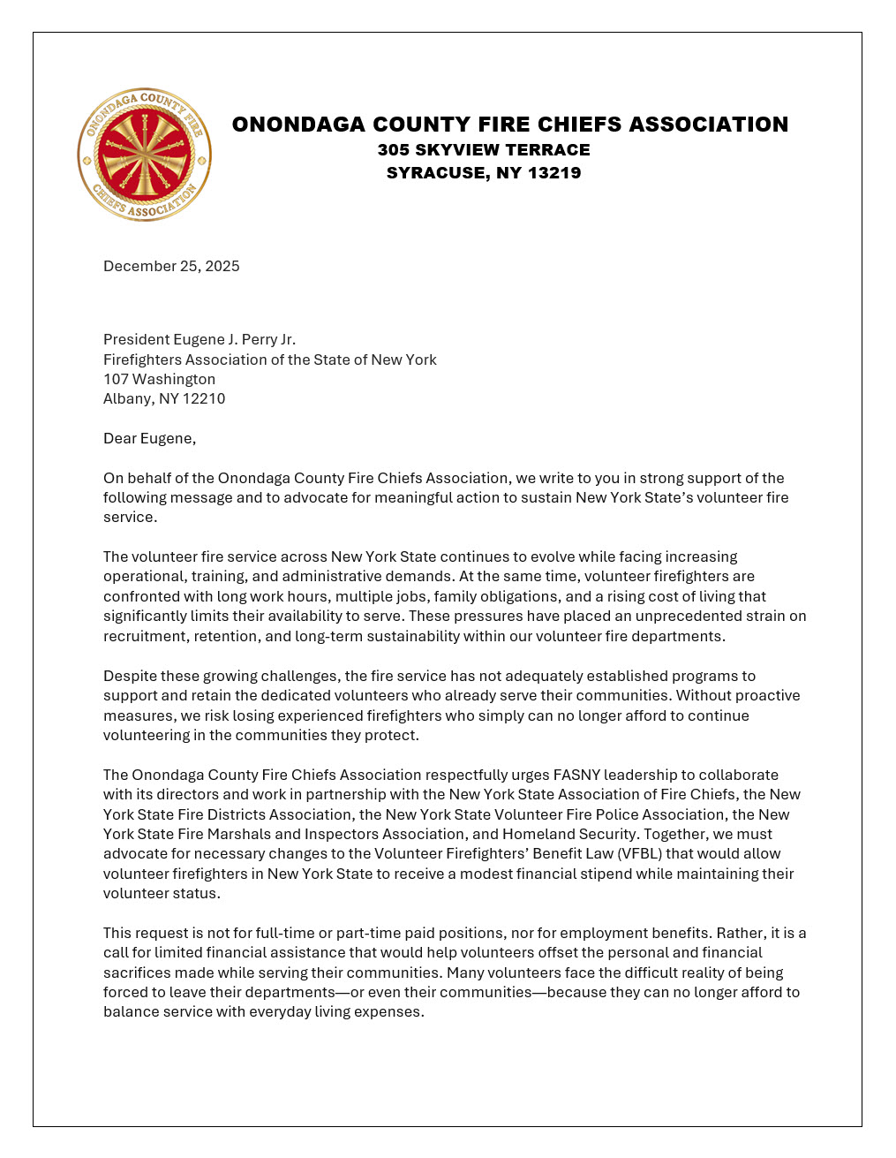
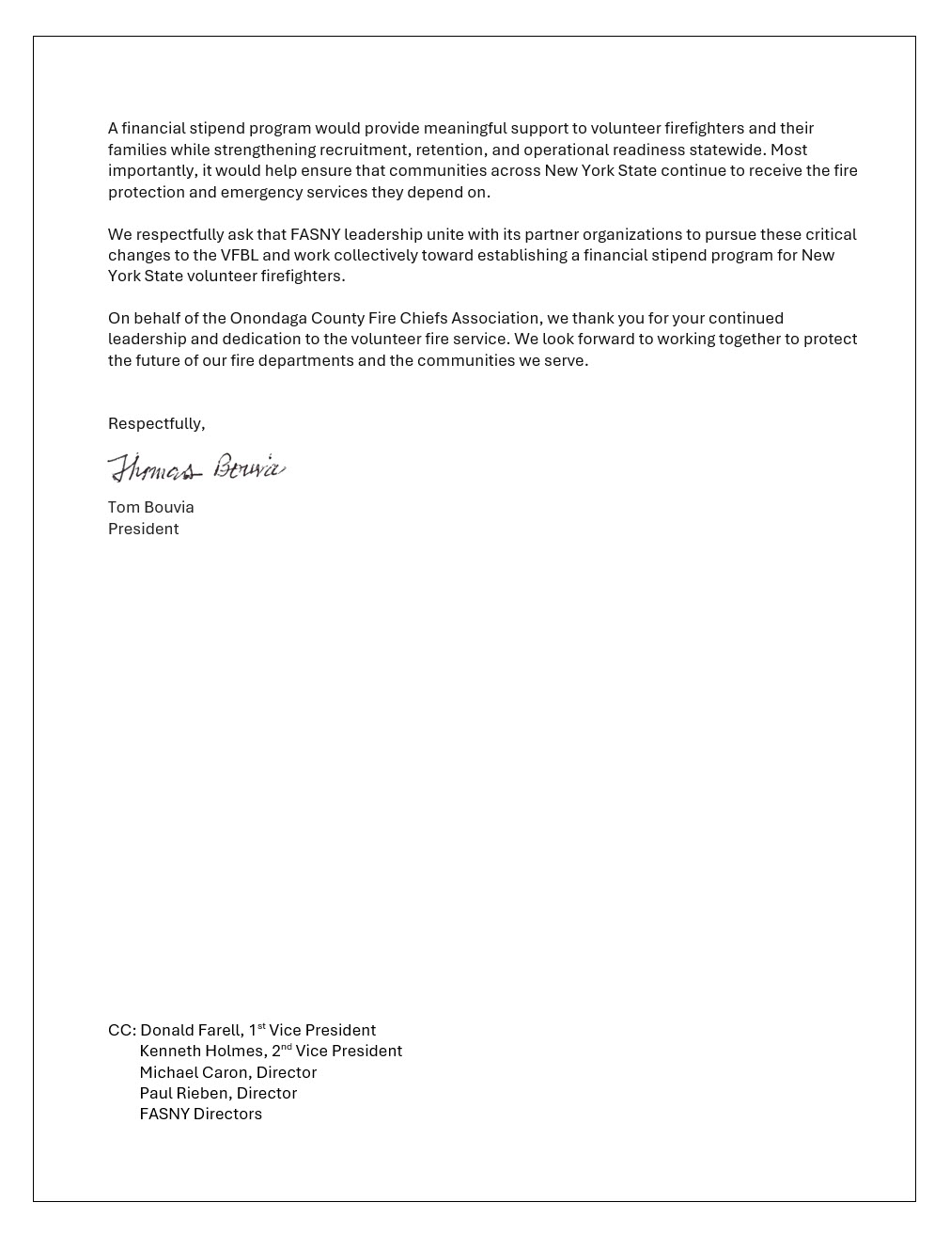
As you can see there is a disagreement within the fire service organizations in NYS, we cannot continue to TALK about change and expect it to happen. FASNY is not the only fire service representative group in the state although many think that’s the case. Time for ACTION not more hand wringing. Grow a backbone and stand up for the NYS Fire Service members. The fire service leadership has spent too much time TALKING about change has improved nothing, not one solution will work for everyone so a number of solutions need to be proposed that will allow fire departments to make the necessary changes that were committed to law nearly 100 years ago, yesterday’s choices will not solve today’s problems.

New Fire District Established in Livingston County
The new Eastside Fire District has been approved by the voters for the towns of Castile, Gainesville along with the Village of Silver Springs, effective June 1 of 2026. This fire district was dependent on the approval of five boards and the fire companies involved. The reasons for the consolidation included volunteer recruitment difficulties and administrative costs, it will result in better response and protection for the residents.

Floral Park Center Fire Company Ceases Operation
Regrettably, the Floral Park Centre Fire Company is announcing that, as of December 31st at 1159pm, we will no longer be existing as your local fire/emergency services agency. These services will then be handled by the New Hyde Park Fire District and the Nassau County Police ambulance. You can continue to dial 516-742-3300 or 911 for fire or medical emergencies
This decision was made due to the lack of staffing/volunteers and the prolonged failure of community members not joining the Company. It is also due to increased training requirements and expensive equipment purchases mandated by State and Federal agencies such as US OSHA and NYS PESH, guided by recommendations given by the Uniform Firefighters Association and National Fire Protection Association.
Putting all these factors into consideration, the decision was made that we could not continue to provide adequate services to our community/taxpayers.
We thank you for letting us provide you with 100 years of service.
THE BUILDING AND FIRE CODE ISSUES – WEEKLY REPORT ON FIRE FATALITIES
The New ICC Code-NYS Edition will go into effect on December 31st 2025 although the implementation of the energy code provisions have been withdrawn until further notice.

HOME FIRE FATALITIES REPORTED BY THE MEDIA FROM THE US FIRE ADMINISTRATION FOR 2026
Fire Deaths in 1&2 Family Dwellings in NYS | 0
Last fire death 11/25/25 West Winfield, Herkimer Co., female 82
Fire Deaths in any type of Dwelling in NYS | 0
Fire Deaths in 1&2 Family Dwellings Nationally | 1
Top 3 States with the greatest 1&2 Family Deaths | #1 SC/1
 | #2
 | #3
Civilian home fire fatalities in 2026: 6
Both the states of Maryland and California as well as Wash. DC require sprinklers in 1&2 family dwellings.
According to realtors and builders only old homes burn, so sprinklers are not needed in new homes: so my question to you is; when does a new home become an old home?

GREEN ENERGY AND THE IMPACT ON THE FIRE SERVICE

Lithium batteries spark Sullivan’s Island garage fire
SULLIVAN’S ISLAND, S.C. (WCBD) – Lithium batteries in a golf cart are believed to have sparked a morning garage fire on Sullivan’s Island. The fire was quickly extinguished, and damage was contained to the small garage and property inside the building. No injuries were reported.

Hydrogen cyanide detected in air samples after Warwick lithium-ion battery fire
Orange County, California officials have confirmed that hydrogen cyanide was detected in air-quality samples taken during a lithium-ion battery storage fire at a Convergent Energy and Power facility in Warwick earlier this month — one of three such fires connected to the company’s sites in the area over the last two years.
The fire broke out during heavy rain on Dec. 19 at the company’s 28 Church St. battery storage facility. According to Orange County emergency management officials, hydrogen cyanide was recorded at 0.5 parts per million at a meter placed just outside the facility while the fire was burning — about half of the maximum allowable amount under federal guidelines. Downwind monitors, they say, measured zero. Monitoring continued through Dec. 21 as battery temperatures dropped enough for crews to begin cleanup and investigation.
In 2023, two back-to-back incidents — one at the village site on Church Street and another at a Convergent facility located on Warwick school district property — involved weather-related water infiltration. During those fires, county officials confirmed “toxic chemicals” at levels considered safe but would not identify which ones.
TRAINING FOR YOUR OFFICERS AND MEMBERS

NYSAFC 2026 Seminar Series “Dangerous Spaces: Challenges and Tactics When Dealing with Garage and Basement Fires” With Chief/Commissioner Michael Lombardo (Buffalo Fire Department)
Three-Hour Seminar:
Some of the most dangerous fires we deal with are often looked at as routine: the basement fire and the garage fire. Basement fires are probably the most overlooked killer of firefighters engaged in combat firefighting in much of the U.S. The construction, layout, fire load, and access present difficult and dangerous challenges at below grade fires. From the incident commander to the firefighter on the nozzle, we must all recognize and be able to deal with these challenges. Huge migration to the suburbs starting with the arrival of the Baby Boomer generation saw the explosion of the attached garage. Many older cities never had the available space for homes to feature an attached garage or have any garage at all. The tremendous fuel load that is constantly evolving presents danger for occupants and firefighters alike. This class will address these challenges and alternative strategies and tactics that can be deployed to deal with these dangerous spaces.
Registration Fee:
$35 per person – NYSAFC Individual and Department Members
$50 per person – Non-Members
Pre-registration is encouraged. On-site registration will be accepted if space permits.
Note: A 3% service fee will be applied if paying by credit card.
2026 Dates and Locations:
Seminar begins at 7:00 p.m. at all sites. Registration area opens at 6:30 p.m.
February 18 – Herkimer County
Newport Fire Department • 7370 Main Street • Newport, NY 13416
March 3 – Schenectady County
SUNY Schenectady Community College • Stockade Building • Room 101 • 78 Washington Avenue • Schenectady, NY 12305
September 10 – Fulton County
Berkshire Fire Department • 320 Steele Avenue Ext. • Gloversville, NY 12078
September 16 – Saratoga County
Saratoga County Public Safety Building • 6012 County Farm Road • Ballston Spa, NY 120
September 22 – Dutchess County
Pleasant Valley Fire District • Station 1 • 1619 Main Street • Pleasant Valley, NY 12569

Attend an NVFC Training Near You!
The NVFC hosts in-person trainings at locations across the country on topics including hazardous materials response, electric vehicle response, leadership, fire service culture, and much more. View upcoming courses here. Don’t see a training near you? Consider hosting a training at your department or regional event. View a listing of available courses and request a training here.

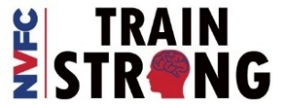
NATIONAL VOLUNTEER FIRE COUNCIL – TRAINING TIMES – COURSES/WEBINARS/EVENTS
LINK TO THE VIRTUAL CLASSROOM: https://virtualclassroom.nvfc.org/featured_courses

NEIGHBOR’S HELPING NEIGHBORS

Averill Park looking for specifications to bid a station vehicle exhaust system reply to apfdboard@gmail.com thank you.

Gansevoort Fire Department Breakfast
The fire company thanks you for your support!! Breakfast will be served starting at 8AM Sunday January 18th

Clifton Park Fire Department Breakfast
Thank you for your support! Sunday February 8th from 8 to 11am

Speigletown Fire Department Breakfast 2nd Sunday of each month
Sunday January 11th from 7:30 to 11:30, $10 adults, $5 children, under 5 free.
GENERAL INTEREST TO ALL

Logic Has Limits. Growth Doesn’t
Kory Pearn
Growth thrives on uncertainty, pushing past comfort zones and embracing the unknown
I’ve been asked a very similar question three times this past week. Different people, different conversations, same underlying curiosity. People keep asking how I’ve been able to navigate CRACKYL, how it started, how it keeps evolving, and how I’ve been willing to move without having everything perfectly mapped out first. The real question underneath all of it is how you step into something that doesn’t feel guaranteed. I’ve had fun answering those questions because none of the answers are complicated. There’s no secret formula or dramatic leap. Everything keeps circling back to growth and a willingness to stop protecting comfort.
Growth doesn’t happen by being safe. Growth happens when expectations rise faster than comfort. That idea has followed me most of my life, long before CRACKYL ever existed. I’ve always been more of an estimator than a precision planner. Finite numbers have never been my comfort zone. I’ve preferred working ranges, direction, and momentum over certainty. I don’t need every answer up front to begin moving.
Change is inevitable. We can embrace it, and try to direct it, or we can sit in our comfort zone, pretend it is not necessary, and wonder what happened.
THE DIFFERENCE BETWEEN RISK AND RECKLESSNESS
That approach isn’t reckless, it’s intentional. Over time, I’ve gotten comfortable not needing all the answers while also getting very good at identifying where the runway is. There’s a difference between blind risk and informed movement. Knowing how much room exists to adjust, pivot, or recover matters more than pretending certainty exists where it never really does.
Being a firefighter reinforces that mindset. Risk and reward are never theoretical. Every decision lives inside probability, consequence, and timing. When I looked at probability, it was fairly simple. The fire service isn’t going anywhere. Demand isn’t shrinking. Call volumes are only increasing. That made the idea of building something we’d never had before easier to step into.
WEIGHING THE COSTS AND BENEFITS
The consequences were clear. One outcome was falling on my face, being broke, and having nothing tangible to show for the effort. The other outcome was creating something viable that could support the people I work alongside, serve my peers, and help improve how we show up for a job we genuinely love. Both outcomes were real. Only one aligned with the responsibility I felt toward the profession and the people inside it.
Timing mattered just as much. Coming out of a pandemic, demand was there. Call volumes continued to climb. Burnout was becoming more prevalent, not less. Identity strain was showing up in new and familiar ways. Those numbers needed to go down. Firefighters needed a way back to their center of gravity, not just another way to push through. That missing element had existed for a long time. The moment to address it felt unavoidable.
Looking at all three together changed how the risk felt. It didn’t register as reckless. It felt calculated. I wouldn’t say I didn’t risk very much. I’d say the potential reward made the risk worth taking. Not trying would have carried its own cost.
BREAKING THE FEAR OF THE UNKNOWN
Most people don’t stall because they lack ability. They stall because they want the next level to feel familiar before stepping into it. They want certainty, proof, and reassurance; they won’t look foolish if it doesn’t work. Progress rarely waits for confidence to catch up. Certainty often slows movement, while curiosity keeps it alive.
There’s a form of useful ignorance that has to exist when you reach for something that feels unattainable. This isn’t carelessness. This is trust in process. Fear of the unknown shows up in every conversation about growth, even though the unknown is where patterns break and new capacity gets built. Curiosity doesn’t remove risk, but it expands the frontier of what’s possible.
Comfort carries a cost. The cost hides well because it looks responsible. It looks like patience, timing, and playing it smart. Standards quietly shrink to match the environment. Goals get edited down to what feels reasonable. Protection starts masquerading as discipline.
THE COMPOUND EFFECT OF GROWTH
The more you do things that don’t make sense yet, the more capable you become at operating without full visibility. That tolerance is where growth compounds. Not every idea turns into a win. Not every effort produces a visible result. Everything still sharpens judgment and expands range. Growth shows up in parenting, in friendships, and in choosing engagement over avoidance when it matters.
Uncertainty becomes the classroom. Surprise becomes the feedback. “That didn’t go how I expected” often marks the edge of something new. Chance matters, too. Chance favors presence. Opportunity tends to find people who stay in the room long enough for it to matter. Movement creates exposure. Exposure creates momentum.
Being at the table matters. You can’t win a hand you never sat down to play. You can’t be considered for what’s next if you refuse to show up for what’s in front of you. As we near the end of the year, thinking beyond what you already know creates space to learn what growth is asking of you internally, not externally.
THE COURAGE TO MOVE FORWARD
Stop forcing doors that keep resisting you. Closed doors are information, not rejection. Walk up to them anyway. Test them anyway. Discovery lives where certainty ends. Logic has limits. Growth doesn’t. Logic creates stability, but stability isn’t progress. Growth often starts before it feels justified.
This isn’t about external success. This is about internal demand. Internal demand creates patterns. Patterns create momentum. Momentum makes stagnation impossible.
The truth is that your life expands to match the standard you enforce, not the comfort you protect.
TAKE A MOMENT TO SMILE

There is a strange voice in my head saying, vacuum the floor, clean the house, wash the windows.
Good thing my mom taught me to never listen to strangers.

CLASSIFIED

Opening for Part Time Fire District Treasurer/Deputy Secretary
The Greenfield Fire District is currently seeking qualified applicants for the position of part time Fire District Treasurer/Deputy Secretary. Prior experience and individuals residing within Fire District Boundaries given preference. Complete job description and qualifications can be found on the Greenfield Fire District website at: www.greenfieldfd.org. Cover letter/current resume can be mailed to Greenfield Fire District, attn. Joyce Petkus, P.O. Box 103, Greenfield Center, NY 12833, or emailed to Treasurer@greenfieldfd.org, and will be accepted until the position is filled.
CAFDA OFFICERS AND DIRECTORS 2026
OFFICERS
President, Tom Rinaldi, Commissioner, Stillwater Fire District
1st Vice President, Ellen Martin, Deputy Treasurer Clifton Park Fire District
DIRECTORS:
Les Bonesteel Past Commissioner, Burnt Hills/Saratoga,
Skip Smith, Commissioner, West Crescent/Saratoga
Joyce Petkus Treasurer Greenfield/Saratoga,
Ed Woehrle Commissioner Niskayuna #1/Schenectady
Art Hunsinger, Ex-Officio Member Clifton Park Fire District

APPOINTEES
Secretary Molly Jenkins, Region 1 Director, Assoc of Fire Districts, NYS
Treasurer: Tony Hill
Sargent at Arms: Tom Wood, Commissioner, Northumberland Fire District
Chaplain: Dane Fagan
Legal Counsel: Greg Serio, Safety Officer, Verdoy Fire District
The Capital Area Association represents any fire district that wishes to join CAFDA. Fire District Officials include Commissioners, Treasurers, and Deputy Treasurers. Secretaries and Chiefs are also invited to participate!
Please advise your secretaries that all correspondence should be mailed to:
CAFDA PO Box 242 East Schodack, NY 12063
EMAIL TREASURER: TREASURER@CAFDA.NET
518-407-5020
EMAIL SECRETARY: SECRETARY@CAFDA.NET

Long Way to Travel? Zoom into the General Membership Meetings!
It’s our desire that every member fire district have the opportunity to attend Capital Area meetings. We know we cover a large area, in 8 counties and beyond, and wish to give all of our members a chance to participate in the general membership meetings. You have a voice, and we would like to hear it. Join us at our next meeting either in person or via Zoom. The link will be sent via constant contact prior to each general membership meeting. Thank you for being a member and we hope you will join us.

Capital Area BUSINESS PARTNER’S
Business Partner Applications Available At: WWW.CAFDA.NET
WELCOME DIVAL SAFETY EQUIPMENT
We invite our business partners to submit educational information to be included in this Bulletin for district commissioners and chief officers
We want to thank all of our Business Partners for renewing their partnership for 2025. You are invited to our monthly membership meeting and to any of our social events..
FIRE SERVICE LEGAL SERVICES


The D’Amato Law Group LLP
Gregory Serio, Partner
Alyssa B. Snyder, Partner
111 Washington Ave Suite 600
Albany, NY 12210
518.426.3800
Email: gserio@dlgny.com or
asnyder@dlgny.com
damatolawgroup.com

HAWKINS DELAFIELD & WOOD LLP
William J. Jackson, Partner
1160 Pittsford-Victor Road, M2-11
Pittsford, NY 14534
585-645-1184
Fire Service Bond Attorneys
www.hawkins.com
Monaco Cooper Lamme & Carr.PLLC
1881 Western Ave, Suite 200
Albany, NY 12203
Nicole Strippoli 518-941-9040
NSTRIPPOLI@MCLCLAW.COM
ttps://mclclaw.com

Whiteman Osterman & Hanna LLP
Bond Counsel
Robert J. McLaughlin, Partner
One Commerce Plaza, Albany, NY 12260
518-487-7697 Cell 518-813-6333
mclaughlin@woh.com
www.woh.com
HANNIGAN LAW FIRM PLLC
388 Kenwood Avenue
Delmar, New York 12054
P: (518) 869-9911
F: (518) 869-9915
www.hannigan.pro
Fire/EMS –Municipal Law
Ducharme, Clark & Sovern, LLP
Jack Clark, Fire District Attorney
646 Plank Rd. Clifton Park, NY 12065
518-373-1482
Ducharmeclark.com

FIRE STATION & FACILITIES ARCHITECTS AND ENENGINEERS


n.lobosco@ctmale.com
Shawn Corp, Principle
15 Cider Mill Way, Saratoga Springs, NY
518.322.1386
www.reveal-ad.com


Architecture/Engineering/Code Services
Melissa Smith
Senior Marketing Manager
518-439-8235
4 British American Blvd
Latham, NY 12110
www.labellapc.com


Architects & Engineers
433 River Street, Suite 8002
Troy, NY 12180
518-765-5105
Dennis Ross, Practice Leader
www.H2M.com

Managed IT Services
Cloud Telephone Services
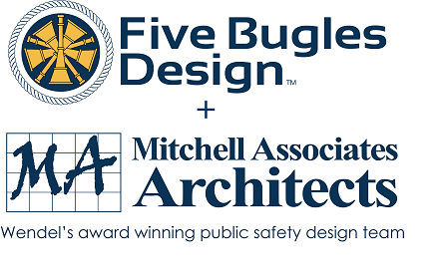
Wendel, Centerpointe Corporate Park, 375 Essjay Road, Suite 200, Williamsville, NY 14221 716.688.0766
Amy Numrich, MBA
Digital Marketing & Events Specialist
anumrich@wendelcompanies.com


Ryan Sapienza
Project Manager/Technology Consultant
518-754-4623
Service 518-869-3614
930 Albany Shaker Rd, Latham, NY 12110

Haughey Insurance Agency
850 State Route 50
Burnt Hills, NY 12027
518-399-1583
www.haugheyagency.com
FIRE SERVICE INSURANCE
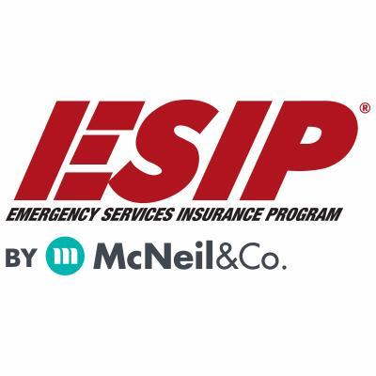
Tony Blackwell, Territory Sales Manager
800-822-3747 ext 530
ablackwell@mcneilandcompany.com
Aurora Inc. Insurance
120 Broadway
Albany, NY 12204
518-449-3180
aurorainsurance.com
Michael May, Broker
mmay@aurorainsurance.com

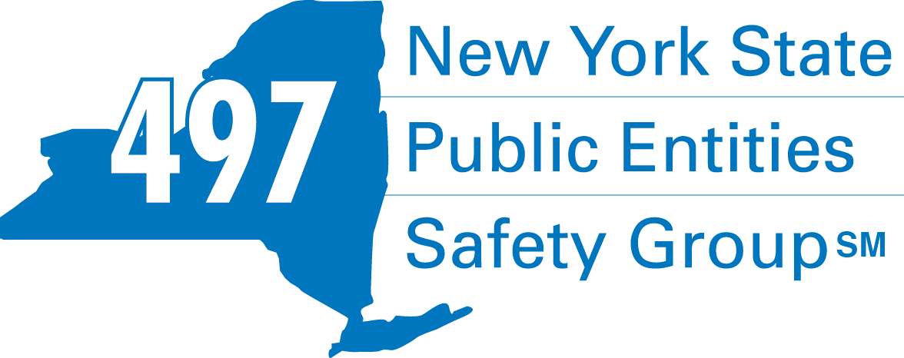
Fleury Risk Management
28 Corporate Drive, Suite 104
Clifton Park, NY 12065
518.478.6314
https://www.fleuryrisk.com/nysgroup497
VFBL Insurances Services
Stephan Petras
Marketing Representative
One Blue Hill Plaza – 16th Floor
PO Box 1609
Pearl River, NY 10965
845-352-8855x7099
329-236-3505
spetras@fdmny.com
VFBL/Workers’ Comp Coverage


Pat Daglio
pdaglio@vfis.com
717.819.3072

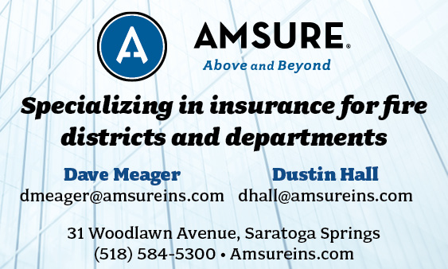

FIRE SERVICE FINANCIAL SERVICES AND LOSAP MANAGEMENT


518-432-5087
838-433-7304 cell
www.thelosapgroup.com.
nikki.haskins@rbc.com
455 Patroon Creek Blvd, suite 200, Albany NY 12206
UBS Financial Advisors
Ralph Lemme, CFP
8 Southwoods Blvd Suite 207
Albany, NY 12211
518.445.1667

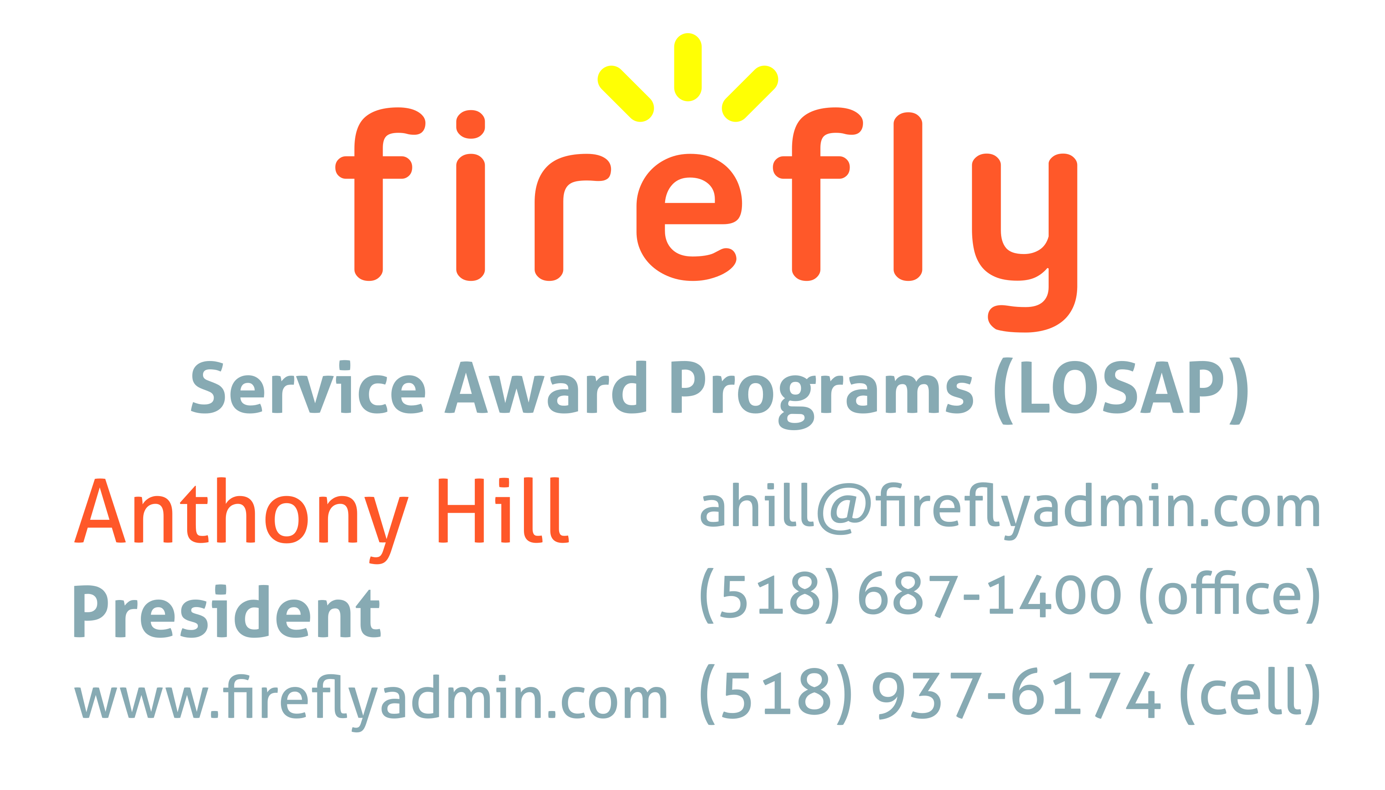

FULL-SERVICE FIRE EQUIPMENT
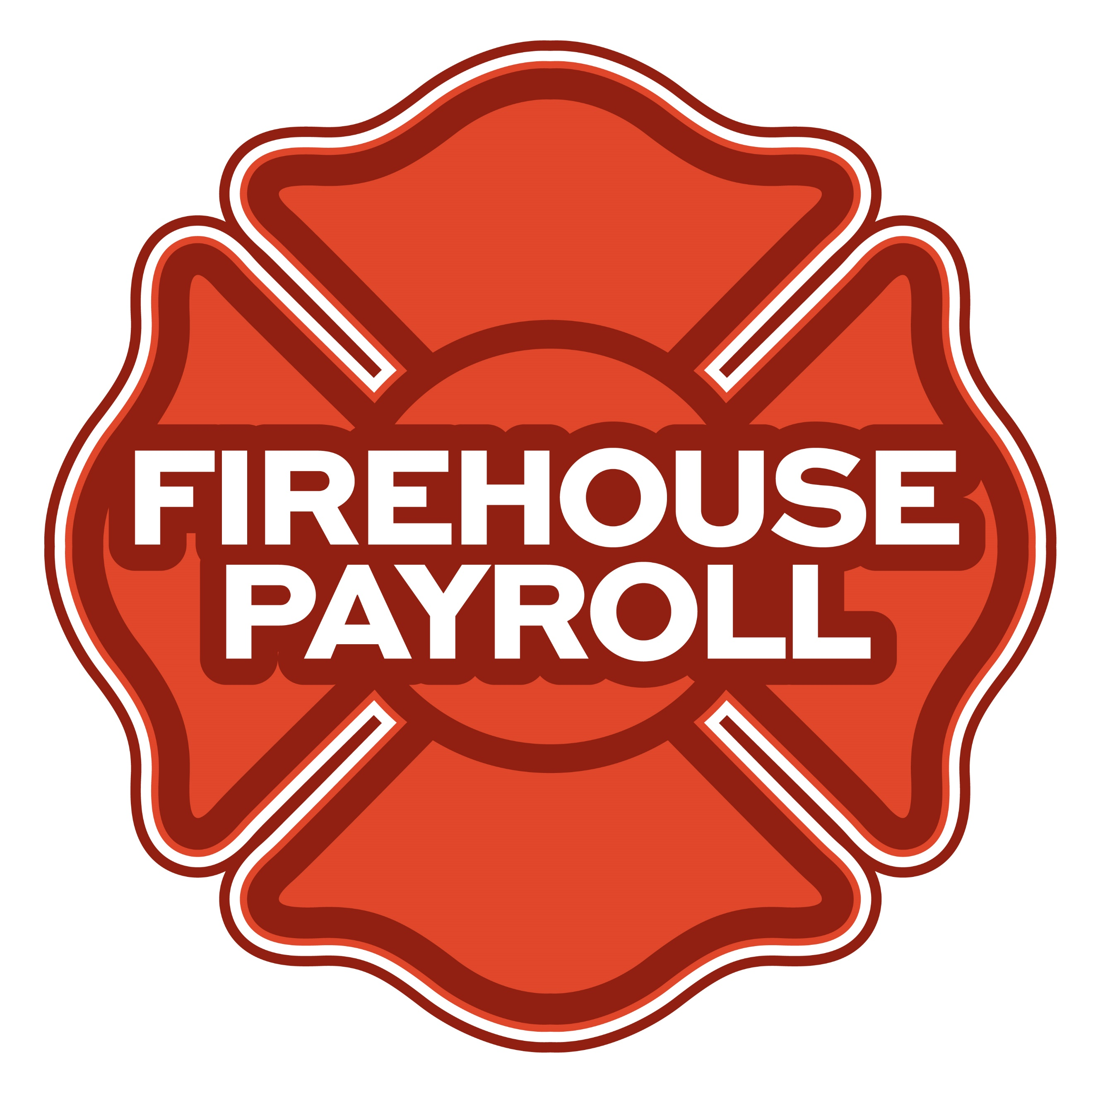
Jeremy Hartnett
302-483-7699
jeremy@firehousepayroll.com
payroll-pension reporting-tax filing
direct deposits-timekeeping-HR Services

Nicole Meeker
Manager of Business Development & Accts
518-394-7894
Cell 607-423-4811
www.penflexinc.com
nmeeker@penflexinc.com
FIRE EQ TESTING
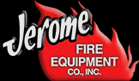
www.jeromefire.com
Breathing Air Comp Maintenance,
Air Quality Tests and Repairs
Russell Jerome
315-699-4533 Office
Ready Rack Extractor/Washers
Full Line of Fire Equipment
8721 Caughdenoy Rd, Clay, NY 13041
DRYER VENT CLEANING

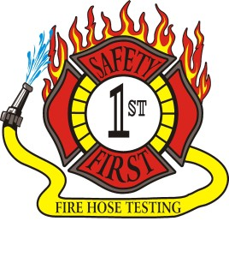Safety First Equipment Testing
99 Glass Lake Road
Averill Park, NY 12018
518-674-8363
www.safetyfirstfirehose.com
HOSE, APPLIANCE & LADDER TESTING
Safety1hose@gmail.com
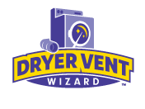DRYER VENT WIZARD
JORDAN CATINO
8 NAPA COURT, SCHENECTADY, NY 12309
518-344-0664
SARATOGADRYERVENT.COM

FIRE DEPT COMPUTER MANAGEMENT
FIRE STATION TELECOMMUNICATIONS
Telecommunications equipment supplier offering voice and data services, and IT and security systems.
930 Albany Shaker Rd. Suite 102, Latham, NY 12110
518-869-3571
www.Northeast-is.com
White Wolf Computer, LLC
4 Normanskill Blvd. Suite 410, Delmar, NY 12054
(518) 459-9653
Managed Services
Cloud Hosting Solutions
Telephone Data Cabling
Backup Disaster Recovery
Web Design Services

FIRE COMPANY FUND RAISING

FIRE STATION PEST CONTROL
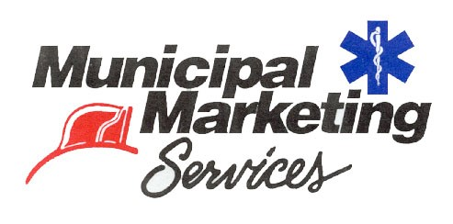
Lloyd Fox, Account Executive
34 Garner Road, Averill Park, NY 12018
Lfox8@nycap.rr.com
518-810-7819
www.funddrive.com


518-300-4732
431 New Karner Rd Suite 170
Albany, NY 12205
https://fox-pest.com/albany-ny

FIRE SAFETY EQUIPMENT
FIRE APPARATUS

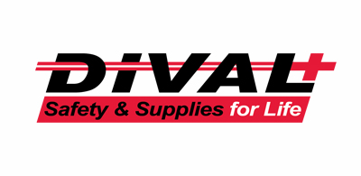
Timmy Kimball
518-925-2786
www.divalsafety.com
Testing-Safety-Promotional Services-Respiratory Solutions
Facility Safety-Fall Protection-Training
60 Cohoes Ave, Green Island NY 12183
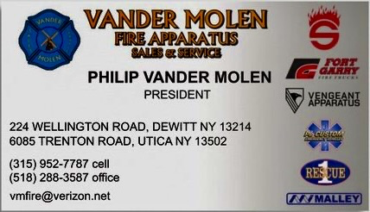

BANKING/FIRE SERVICE FUNDING SOURCES

JOHN M. LESNIEWSKI
Assistant Vice President and
Senior Business Banking Officer
Fulton/Montgomery Markets
12 Fremont Street, Gloversville, NY 12078
P: 518.775-5205 | M: 518.848-0612
NMLS ID 915694
www.nbtbank.com
Don McCormack
425 Main Street Catskill, NY 12414
www.tbogc.com
518.943.2600 X607
donaldm@tbogc.com
Specializing in Fire Service Financing


David Farstad, VP-Municipal Banking
652 Albany-Shaker Road, Albany NY 12211
Ph: 518-730-3120
Cell: 518-506-0075
farstadd@pioneerbanking.com

FIRE DISTRICT CPA/AUDITS/FINANCIAL SERVICES


Zoriana M. Stawnychy
973.283.0024
zoriana@stawnychyfinancial.com
135 Kinnelon Road Suite 101
Kinnelon, NJ 07405
Serving fire districts in New York State


518-459-6700
10 British-American Blvd, Latham, NY 12110
www.bstco.com
Brendan Kennedy ext 356


Robert V. Gramuglia, CPA
1 Pine West Plaza Suite 107, Albany NY 12205
518.452.8055 or 518.859.5851cell
Email: rgramuglia@BGCPA.net



Accounting, Consulting & IT Security
1581 Franklin Ave. Mineola, NY 11501
Kyle Brengel, Managing Partner
516-472-7345
kbrengel@gblny.com


11 British American Blvd, Latham, NY 12110
518-785-0134
Queensbury Office 518-792-6595
http://www.mmbaccounting.com
Alan W. Clink, CPA aclink@mmb-co.com
Heather R. Lewis, CPA hlewis@mmb-co.com

The Weekly Capital Bulletin is reaching well over 700+ subscribed fire district members and now other members of the fire service on a regular basis.
This is a service of CAFDA through the effort of Tom Rinaldi who can be reached at tom@rinaldi1.com for comments and content contributions are always welcome.

BECOME A MEMBER OF CAFDA!
The Capital Area Association has voted to amend its By-laws to allow both individual and regional or county Fire District Associations to join. The updated By-laws are posted to the CAFDA.NET website.
Individual membership fee will be $50 annually, fire district association fees will be $300 annually.
Download THE APPLICATION available on the home page at CAFDA.NET
MEMBERSHIP IN THE CAPITAL AREA FIRE DISTRICTS ASSOCIATION (CAFDA)
Would you like to join Capital Area Fire Districts Association along with 100 members in 14 counties? Individuals, fire district associations, fire protection districts and Village departments are all eligible for membership.
Annual dues (January 1st to December 31st) shall be as follows and shall be based on the annual budget of the Fire District/Organization;
$0 to $200,000: $50
$200,001 to $400,000: $100
$400,001 to $600,000: $200
$600,001 plus: $300
Individuals $50.00 or Other County or Regional Associations $300 annually.
Business Partners: $100.00 annual member fee

If You, Your Fire District or Department is not a Member of CAFDA You Can be?
Individuals can be members of CAFDA. The annual membership fee is $50, which will provide you access to this Bulletin, attendance at meetings and social gatherings. Provides networking with other fire district officials and a source of the constant barrage of information related to today’s fire service.
FOR A MEMBERSHIP APPLICATION OR A BUSINESS PARTNER APPLICATION GO TO THE FOLLOWING LINK:
https://cafda.net/membership-info/

for more registration information
Website | www.CAFDA.net

