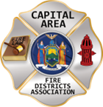
THE BULLETIN
March 14th, 2026

The Voice of CAFDA since 2004
Editor, Tom Rinaldi – tom@rinaldi1.com since 2014
When you see **, highly recommended article
CAPITAL SHORT TAKES
- Go to the last page of this document for Conference ’26 Registration and for Vendor Registration.
- Congratulations to Tony Cruz from Smithtown Fire Department on 50 years of service and many years of advocacy for firefighter health and cancer awareness.
- We have a member looking for contact information on; “Who Services Your Fire Apparatus” in the hope of obtaining more competitive pricing. Please help out a fellow commissioner and let our friend from the north country know who services your vehicles, lgarsod25@gmail.com Thanks.
- See information on Prevailing Wage Rates and how they apply to Fire Districts, In the Attorney’s Office. Also on our website at : https://cafda.net/wp-admin/post.php?post=5265&action=edit&classic-editor
- CAFDA is working with NYS-DOL to provide a web based presentation for fire districts on the subject of Prevailing Wage Rates.
CAFDA EDUCATIONAL OFFERINGS: CAFDA.NET

Join us at the NEXT GENERAL MEMBERSHIP MEETING Thursday May 14th features dinner for attendees. Please join us.
ZOOM LINK FOR THE May MEETING at 7pm: https://us06web.zoom.us/j/86413237058?pwd=MauWziwckK2pyIWGVwYGUqxQLCwzHq.1

CAFDA IS HAPPY TO ANNOUNCE THE DATES FOR CONFERENCE ’26 IN HISTORIC LAKE GEORGE, go to CAFDA.net for on-line registration and credit card use.

April 9th, 10th and 11th, 2026 hope many of you plan on joining us, see the details on the last page.

Commissioner Training will be held at 3 remaining locations in 2026 including:

Niagara Engine Co #6 in Schoharie, Saturday March 21st

Berkshire Fire District, Gloversville, Saturday March 28th and

Warrensburg Fire District, Saturday April 4th.

The Day after the scheduled date (Sunday) has been reserved as a snow day if necessary.

Open to all newly elected commissioners and Chiefs.

This training is required under Town Law Section 176-e. $85 for members, $95 for non-members includes continental breakfast and lunch. Chief officers are encouraged to attend.
REGISTRATION IS OPEN FOR COMMISSIONER TRAINING ON-LINE AT CAFDA.NET
If you were not able to attend the previous sessions and paid for the class, you are welcome to attend at any of the remaining locations. Just tell the staff at check in.
CAFDA TRAINING AND EVENT DATES
Day/Date | Time | Type | Location | Notes
FY 2026
Friday, March 13, 2026 | 8:00 AM | Financial Training for Fire District Officials | Fishkill | Rombout Fire District
Saturday, March 14, 2026 | 4:00 PM | Financial Training for Fire District Officials | Fishkill | Rombout Fire District
Saturday, March 21, 2026 | 8:00 AM | Commissioner Training | Schoharie | Snowdate - Sunday, March 22, 2026
Friday, March 27, 2026 | 8:00 AM | Financial Training for Fire District Officials | Cortland | The Hub, McNeil & Co.
Saturday, March 28, 2026 | 4:00 PM | Financial Training for Fire District Officials | Cortland | The Hub, McNeil & Co.
Saturday, March 28, 2026 | 8:00 AM | Commissioner Training | Berkshire | Snowdate - Sunday, March 29, 2026
Thursday, April 2, 2026 | 7:00 PM | Board of Directors Meeting | Clifton Park
Saturday, April 4, 2026 | 8:00 AM | Commissioner Training | Warrensburg | Snowdate - Sunday, April 5, 2026
Thursday, April 9 - Saturday April 11, 2026 | All Day | CAFDA Conference | Fort William Henry Conference Center | Lake George
Thursday, May 14, 2026 | 7:00 PM | General Membership Mtg. | Clifton Park
Thursday, June 11, 2026 | 7:00 PM | General Membership Mtg. | Clifton Park
July, 2026 | NO MEETING
Friday, August 7, 2026 | 1:00 PM | Membership Activity | Saratoga Race Course | NYRA Day at the Races!
Thursday, August 13, 2026 | 7:00 PM | Board of Directors Meeting | Clifton Park
Thursday, September 10, 2026 | 7:00 PM | General Membership Mtg. | Clifton Park
Thursday, October 8, 2026 | 7:00 PM | General Membership Mtg. | Clifton Park | Officers/Director Nominations
Saturday, November 7, 2026 | 8:00 AM | Annual Fall Workshop | Verdoy
Thursday, November 12, 2026 | 7:00 PM | General Membership Mtg. | Clifton Park | Officer/Director Elections
DECEMBER 2026 | NO MEETING
FY 2027
Saturday, January 2, 2027 | 9:00 AM | General Membership Mtg. | Clifton Park | Organizational/Morning Meeting
Thursday, April 8 - Saturday April 10, 2027 |  | CAFDA Conference ‘27 | Fort William Henry Conference Center | Lake George
Thursday, April 6 - Saturday April 8, 2028 |  | CAFDA Conference ‘28 | Fort William Henry Conference Center | Lake George
All correspondence & Capital Area Fire Districts Association Mailing Address should be directed to:
CAFDA PO Box 242 East Schodack, NY 12063 or EMAIL: SECRETARY@CAFDA.NET
Financial issues should be addressed to: TREASURER@CAFDA.NET
LEGISLATIVE NEWS FROM THE STATE CAPITAL

The 2026 Issues of United Concern are posted on the CAFDA.net website.
NATIONAL FIRE SERVICE ORGANIZATION NEWS
See the National Volunteer Fire Council at: https://www.nvfc.org/
The National Volunteer Fire Council (NVFC) is the only organization created solely to support volunteer firefighters, EMTs, and rescue personnel through a wide range of programs and benefits. Become a member of the NVFC to get what you need to be your best for you, your crew, and your community.

See the Congressional Fire Services Institute at: cfsi.org
Educating Members of Congress About Fire & Life Safety Issues Since 1989

THE LATEST NEWS FROM DOL/OSHA
See the latest from DOL/OSHA at CAFDA.net website.
FIRE DISTRICT FINANCIAL NEWS

Local Government and School Accountability Contact Information:
Phone: (518) 474-4037; Email: localgov@osc.ny.gov
Address: Office of the State Comptroller, Division of Local Government and School Accountability
110 State Street, 12th Floor; Albany, NY 12236

NYS-OSC Fire Service Audits
GREAT RIVER FIRE DISTRICT-TREASURER’S REPORTS
Audit Objective
Did the Great River Fire District, Suffolk County (District) Treasurer provide the Board of Fire Commissioners (Board) with complete and accurate financial reports?
Audit Period
January 1, 2024 – December 31, 2024
Understanding the Audit Area
A fire district treasurer should maintain complete and accurate accounting records to provide a board of fire commissioners with adequate reports for informed decision-making, legal compliance and accountability. These reports are essential for a board to monitor the fire district’s financial health, make sound fiscal decisions, and ensure that the fire district complies with various laws and maintains the public’s trust.
The District’s 2024 total budgeted appropriations were $419,735 and the District had four bank accounts with a combined balance of approximately $1 million as of December 31, 2024.
Audit Summary
The Treasurer did not always provide the Board with complete and accurate financial reports. As a result, the Board did not have adequate financial information it needed to properly monitor the District’s finances.
The Treasurer manually prepared financial reports which contained the following errors:
- An account balance report which was not structured in a format to provide the Board with adequate information. The Treasurer’s calculated book balances for the general fund checking account varied from the accounting record’s book balance by $12 to $4,701. The Treasurer did not provide the Board with information showing how she determined the calculated book balance.
- The listings of claims included in the Treasurer’s reports were inaccurate or incomplete for 28 claims totaling $4,464 of 279 claims totaling $340,597.
The report includes five recommendations that, if implemented, will improve the District’s financial activities. District officials generally agreed with our findings and indicated they have initiated corrective action, and their response is included in Appendix B.
Recommendations
The Board should:
1. Ensure the listing of claims is complete and contains all relevant information, such as check numbers, to ensure claims are authorized before payment by the Treasurer. The Treasurer should:
2. Pay claims after they are audited and authorized for payment by the Board.
3. Consider generating listings of claims and reports from the accounting software rather than preparing them manually.
4. Provide financial reports to the Board that include detailed statements of all money received, disbursed and reconciled.
5. Clearly demonstrate how cash balances were calculated on financial reports to the Board.
THE COMPLETE AUDIT REPORT HERE:
https://www.osc.ny.gov/files/local-government/audits/2026/pdf/great-river-fire-district-2025-125.pdf
THE FIRE CHIEF’S OFFICE

‘Now serving #47’: We’re not tickets at a deli counter
Michael Marra
Have you ever walked into work and felt like you’re just the next number being called? Like you’re not a firefighter with experience, pride and skin in the game but rather just another warm body getting plugged into a spot on the board?
“Now serving #47.”
That’s what it feels like when management starts treating us like tickets at a deli counter. You get moved without a conversation. Swapped out of your company without a heads-up. Asked to cover a shift with no thought to your schedule, your crew or your morale. No explanation, no respect — just next.
We’re not meat on a slicer. We’re not disposable. We’re firefighters. And if leadership can’t see that, then it’s on us — both the members on the floor and those in mid-level spots — to fix it.
WHAT YOU CAN DO AS A FIREFIGHTER
I’ve been there. We all have. Feeling like your voice doesn’t matter, like no one’s looking out for you. But you can’t let that be the end of it.
First, remember why you signed up. You didn’t join to be a number; you joined for the mission, for the brotherhood, and because you give a damn. That still matters.
Second, take care of your crew. If the top’s not doing it, then the bay is where it starts. Make your firehouse the kind of place where your team wants to be. Share knowledge, support each other and hold the line.
Third, speak up. I’m not saying start flipping tables. I’m saying don’t stay silent when something’s wrong. Have the conversation. Go through your union or your chain of command, but say something.
And finally, stay sharp. Train like someone’s life depends on it — because it does. Be the firefighter they can’t ignore.
PERCEPTION MATTERS
But here’s something we don’t talk about enough: How you look at the situation matters. Quit thinking “Why me?” when bad shit happens. We all get dealt rough hands — bad shifts, bad bosses, unfair decisions. But maybe start asking “Why me?” when great things happen. Because the truth is, you’re not a victim. You only think you are.
Most of the pain and burnout in this job doesn’t just come from what happens to us; it comes from how we dwell on it. If you’re always locked in on the negative, the unfair, the bad call or bad officer or bad schedule, you’ll start to believe that’s all there is. Don’t fall into that trap.
Shift your mindset. Start paying attention to what’s good. The crew you trust. The job you love. The fact that you get to make a difference every time that alarm hits.
Your life, your career — it’s a blessing. And when you start thinking that way, you’ll start showing up differently, for yourself and for your team.
WHAT MID-LEVEL OFFICERS NEED TO STEP UP AND DO
Now, if you wear a bugle — especially a single or double — you’ve got a choice. You can either be a pass-through for decisions or you can be a shield.
Be the shield.
You’re close enough to the guys to know when they’re frustrated, and close enough to the brass to speak up. So do it. Advocate for your people. Explain the “why” when things get shuffled around. Don’t just say, “because chief said so.” Be honest. Treat your crew like professionals, and they’ll respect you for it.
Furthermore, build pride in your crew. Give them a reason to want to be at that station. Make it a place where firefighters feel like they belong. That’s what builds buy-in. Not a memo. Not a policy change. Pride, purpose and people.
FINAL THOUGHTS
We’re not deli numbers. We’re firefighters. We train hard, we risk big, and we show up when no one else will. If management can’t see that, then it’s on us, especially those in the middle, to bring that humanity back into the firehouse.
The fire service is built on pride, not process. On brotherhood, not bureaucracy. On names, not numbers. So quit waiting for someone else to fix the culture. Start by fixing how you treat the guy next to you—and how you treat yourself.
THE ATTORNEY’S OFFICE

Click on this PDF to see notes from DOL related to Prevailing Wage Rates for Construction, Article 8
PREVAILING WAGE RATE NOTES OPEN THIS LINK:
https://cafda.net/wp-content/uploads/2026/03/DOL-Prevailing-wage-notes.pdf

FAQS RELATED TO ARTICLE 8 PREVAILING WAGE REQUIREMENTS ENFORCED BY THE NYS-DOL
What is Public Work?
A three-prong test is applied to determine whether a particular project is public work and subject to the prevailing wage requirements of Labor Law § 220 and article I, § 17 of the State Constitution. First, a public agency must be a party to a contract involving the employment of laborers, workmen, or mechanics. Second, the contract must concern a project that primarily involves construction-like labor and is paid for by public funds. Third, the primary objective or function of the work product must be the use or other benefit of the general public.
Who makes the determination whether a project is "Public Work"?
Generally, projects for construction, reconstruction or maintenance done on behalf of a public agency (entity) are public work. In instances where there is a question regarding whether this condition exists, the Bureau of Public Work and Prevailing Wage Enforcement will make a determination based on the project details.
Is "maintenance work" subject to Article 8?
Yes, maintenance work involving the employment of laborers, workers or mechanics is subject to Article 8. Building service workers, i.e., janitorial services, are covered under Article 9 of the New York State Labor Law.
What is a certified payroll?
Certified payrolls are original payrolls or transcripts thereof, subscribed and affirmed as true under the penalty of perjury.
Are contractors and subcontractors required to submit payroll records to the public owner?
"Every contractor, and subcontractor, shall submit to the department of jurisdiction within thirty days after issuance of its first payroll, and every thirty days thereafter, a transcript of the original payroll records, as provided by this Article, subscribed and affirmed as true..." (Section 220, subd 3-a)
How long are certified payroll records required to be kept by the contractor?
Contractors are required to maintain, for not less than six years, weekly certified payroll records. (Article 6, Section 195.4)

FAQS RELATED TO ARTICLE 9 BUILDING SERVICES CONTRACTS
What is a Building Service Contract?
A contract, in excess of $1,500.00, between a contractor and a public agency in which the principal purpose is to furnish services through the use of building service employees.
What occupations does a “building service employee” include?
A “building service employee” includes but is not limited, to, watchman, guard, doorman, building cleaner, porter, janitor, gardener, groundskeeper, stationary fireman, elevator operator and starter, window cleaner, and occupations relating to the collection of garbage or refuse, and to the transportation of office furniture and equipment, and the transportation and delivery of fossil fuel.
Does Article 9 cover maintenance to mechanical systems in a building?
No. Maintenance and repair to mechanical systems, which involves the employment of laborers, workers and mechanics, is subject to Article 8 prevailing rates, i.e., electrical, heating and plumbing systems.
Is the Article 9 prevailing rate determined annually?
Yes. Article 9 wage rates published in building service contract prevailing wage schedules requested on or after August 1, 2010, will be determined annually on July 1st and be in effect through June 30th of the following year.

NOTES ABOUT CERTIFIED PAYROLLS – ARTICLE 9 BUILDING SERVICE
• Must be signed and confirmed by the contractor as true, under penalty of perjury
• Must show the hours and days worked, the craft, trade or occupation, and the wages paid.
• Must include a record of supplemental benefits and to whom they are paid on behalf of the worker. A copy of the agreement under which such payments are made and all payments made thereunder must be maintained as well.
• Required to be maintained on the site of the work during all of the time that work under the contract is being performed.
• Must be maintained for three (3) years after project completion

NOTES ON DEPARTMENTS OF JURISDICTION RESPONSIBILITIES WHICH INCLUDES FIRE DISTRICTS
• Request PRC# and wage schedule (online at DOL website)
• Include project wage schedule in bid packet and awarded contract
• Verify contractors who bid on or commence work on a prevailing wage project are registered with the NYS Contractor Registry. Bids submitted by unregistered contractors are considered non-responsive. *Required as of December 30, 2024. For information and to view the Registry, visit: https://dol.ny.gov/public-work-contractor-and-subcontractor-registry-landing
• Submit a notice of award (PW-16 form) to BPW
• Notify BPW in writing of who will be responsible for collecting and reviewing certified payrolls and post said designation in a conspicuous location at the project site.
• Collect and review certified payrolls *As of December 31, 2025, contractors who submit certified payrolls to the Department of Labor electronically will not be required to submit them to the department of jurisdiction as well, pursuant to NYS LL § 220-J.2-a
• Submit a notice of completion/cancellation (PW-200 form) to BPW when project is completed or cancelled
POSITIVE OUTCOMES AND CHALLENGES FOR THE FIRE SERVICE

POSITIVE OUTCOMES
None reported.

FIRE SERVICE CHALLENGES

Wallace, NC, Fire Department Temporarily Disbanded, Reorganization Underway
Susan Nicol
The Wallace Fire Department was temporarily disbanded Monday by town officials who also dismissed the remaining volunteers.
After the fire chief 'retired' effective immediately last week, several volunteers walked away, WCTI reported.
During an emergency meeting, the remaining volunteers were dismissed by the town council. Current operating policies in the department also were abolished.
For now, crews from the Rose Hill and Teachey Fire Departments are filling the gap to handle emergency calls in the Wallace area. “Ongoing personnel issues had been going on for some time, affecting morale and hollowing out our volunteer corps. Volunteers are the heart and soul of all fire departments, especially here in Wallace. With the retirement of the previous chief and many looking to leave, council made the decision to step in and take a more proactive approach,” Town Manager Rob Taylor said.
The council also named Wayne Rich, a retired Wallace volunteer, to lead the department in the interim, while Archie Carter is the new assistant chief. Taylor hopes the department will be back up and responding soon.
FIREFIGHTER HEALTH AND SAFETY – PROTECTING OUR OWN
Due to the Govt shut down, no new stats this week!
In 2025 we experienced 78 LODDs reported nationally.!

FIRE SERVICE FATALITIES OR DIBILITATING INJURIES
- Richlandtown, PA Fire Police Officer Todd Koch suffered a medical emergency while responding and died of cardiac arrest despite immediate intervention.

FIRE APPARATUS ACCIDENTS
- A passenger vehicle struck a Rutherford County (TN) Sheriff’s Office SUV, which pushed it into a Murfreesboro Fire Rescue Department apparatus, the sheriff’s office reported on its Facebook page. First responders were at the scene of an earlier crash where a tractor-trailer overturned.
- Man 78 killed and 11 injured in chain-reaction crash involving FDNY Ladder 149 that collided with van while in route to emergency call. The owner of the van which was destroyed in the wreck is quoted as saying; “My van had a green light and the firefighter’s had a red. The firefighter’s truck was going very fast.” Five firefighters were taken to area hospitals in stable condition.
- Rescue crews freed a suspected drunken driver who had crashed into the back of a fire truck, police said. The fire truck was significantly damaged and will require repairs.

FIREFIGHTERS FALLING THROUGH
- A firefighter fell through the first floor into the basement and a mayday was called during a residential structure fire in Kansas City, KS. The firefighter was able to get out of the building on their own and was uninjured.

Fire Chief Considerations: Vehicle Accidents
Joseph Murray
According to the National Fire Protection Association (NFPA), fire department emergency vehicles were involved in approximately 16,900 collisions in 2024, resulting in an estimated 650 firefighter injuries during travel to or from emergency incidents. Additionally, 850 collisions resulted from firefighters responding with their personal vehicles, resulting in an additional 125 injuries.
Fire apparatus collisions, emergency scene roadside injuries, and emergency equipment failures continue to contribute substantially to firefighter injuries and fatalities as well as the overall liability of fire departments. Given the nature of the job, this shouldn’t be all that surprising. Every day, and often multiple times a day, firefighters must contend with the dangers and risks of responding to time-sensitive emergencies in heavy apparatus while navigating heavily trafficked roadways and operating on collision scenes as active traffic continues to pass.
While driver training and safe roadway operations are often emphasized in fire department training programs, the responsibility of the fire department fleet division is sometimes overlooked as part of risk reduction efforts. The fire department’s fleet division can play a vital role in vehicle collision prevention and improved firefighter safety. Proper management of the fire department’s fleet and equipment can impact safety outcomes as they relate to vehicle accidents through proper apparatus design, preventive maintenance, equipment readiness, operational support, and post-incident analysis.
PRIMARY VEHICLE-RELATED RISKS
Fire apparatus collisions can occur during emergency responses, nonemergency travel, and while apparatus are parked at an emergency scene. NFPA historical research has shown that thousands of apparatus collisions occur annually, often resulting in firefighter injuries. Intersection-related crashes are especially common, often caused by civilian motorists failing to yield or misjudging the speed and size of responding apparatus. Not only do fire apparatus collisions place firefighters and the public at risk, but they are also very costly. According to the National Safety Council, injuries resulting from vehicle accidents are among the costliest workplace incidents, with some data showing motor-vehicle crashes averaging around $91,433 per lost time in workers’ comp claims (2022-2023), often involving severe trauma like fractures or head and spinal injuries, which increase costs because of extensive medical care and lost wages. Total economic costs for all firefighter injuries are massive, but vehicle-related claims are particularly expensive per incident because of severity.
Another vehicle-related incident type that poses significant risk to firefighters is roadway response. Firefighters operating on the scene of motor vehicle collisions can face significant risk from moving traffic. Secondary crashes or collisions involving vehicles that strike firefighters or apparatus already on the scene are a well-documented and ongoing hazard. According to the National Highway Traffic Safety Administration (NHTSA), there are more than six million police-reported crashes annually in the United States, with nearly 41,000 fatalities in 2023. These statistics underscore the great risk our firefighters face when responding to vehicle accidents on the roadway.
DESIGN AND PROCUREMENT
Fire chiefs and their fleet division designees have the ultimate responsibility of ensuring fire apparatus are designed and maintained in a manner that maximizes the safety of the firefighters assigned to them. One of the most important tasks delegated to fleet division management is specifying and acquiring fire apparatus that meet operational needs while incorporating the most updated safety features. Given the fact that many fire departments use fire apparatus for significant periods of time, the decisions made during procurement can influence firefighter safety for decades.
It is imperative that the fleet division spend a significant amount of time researching important safety-related design considerations such as braking systems, electronic stability control, cab crashworthiness, seat belt enforcement systems, and the overall weight distribution of an apparatus. Apparatus that are poorly designed or overweight with high centers of gravity are much more susceptible to rollovers and losing control. Conversely, apparatus equipped with modern safety technologies significantly reduce crash risk and injury severity. It is imperative that fire departments conduct proper research and confirm that safety features are incorporated into the design of a vehicle prior to executing a contract to purchase.
Apparatus visibility can play a critical role in preventing apparatus-related crashes and struck-by incidents. It is important for the fleet division and apparatus specification committee to specify emergency lighting packages, reflective striping, and rear chevron patterns that improve vehicle visibility, particularly at night or during adverse weather conditions. Apparatus that are highly visible are far less likely to be involved in secondary collisions and provide better protection for firefighters operating on roadways.
PREVENTIVE ASSESSMENTS AND MAINTENANCE
Just as important as properly designing fire apparatus with essential safety features is implementing an effective preventive maintenance program. Proper preventive maintenance delivery is one of the most direct and impactful ways the fleet division can contribute to firefighter safety. Because of the emergent nature of the fire service, fire apparatus are often subjected to extreme operating conditions that can accelerate wear on critical components like braking systems, steering systems, suspension, and tires. Lack of preventive maintenance for these critical systems significantly increases risk and can result in catastrophic crashes during emergency response. Conversely, proper preventive maintenance can ensure proper braking performance, steering control, and vehicle stability—all of which are essential during emergency driving. In collaboration with their fleet divisions (or contracted fleet services), fire chiefs should establish routine inspection schedules, define service intervals, and develop repair protocols to identify mechanical issues before failure occurs.
Many fire departments throughout the nation are now using onboard fleet diagnostics and telematics systems to monitor vehicle performance and driving behavior. These systems can provide the fleet division with data on speed, braking, acceleration, and the mechanical health of a vehicle. When used appropriately, telematics can support the development of a culture of safety by identifying trends, guiding preventive maintenance programs, and identifying the need for targeted driver training.
OPERATIONAL SUPPORT EFFORTS
Because of the variety of fire apparatus purposes and designs, they can vary significantly in size, weight, and handling characteristics. In many fire departments, fleet division personnel often support driver/operator training through teaching apparatus familiarization, explaining system capabilities and limitations, and assisting with preservice inspections. This is an important fleet division contribution, as a better understanding of apparatus performance characteristics by the fire department’s drivers/operators can reduce the likelihood of operator error while driving or operating on an emergency scene.
Encourage collaboration between the fire department’s fleet, safety, and training divisions, with the goal of reducing apparatus collisions and improving firefighter safety. Fleet division personnel should collaborate with safety and training division officials to ensure alignment of apparatus capabilities within operational policies. This collaboration supports the development of comprehensive response protocols related to speed management, intersection operations, seat belt use, and emergency warning system activation.
EQUIPMENT PROCUREMENT AND READINESS
The fleet and equipment division also plays an integral role in procuring, maintaining, and testing critical rescue tools used at vehicle accident scenes including hydraulic and battery-powered extrication tools, stabilization struts, cribbing, lifting devices, and air bags. Equipment failure during vehicle extrication or rescue operations can delay patient care and increase firefighter risk because of prolonged exposure to roadway traffic and hazards. The fleet division can also help mitigate risk through routine inspection and maintenance services coordination to ensure that rescue tools are reliable and function reliably. The dependability of extrication and rescue tools can significantly reduce the amount of time firefighters spend operating on potentially dangerous vehicle accident scenes, thus improving the safety of vehicle occupants and first responders.
Proper fleet and equipment management also encompasses equipment used to protect firefighters at vehicle accident scenes and other roadway incidents. The fleet and equipment division should be one of the leading advocates for the use of proper personal protection equipment such as turnout gear, reflective vests, helmets, gloves, and eye protection.
The fleet and equipment division should also ensure the fleet is designed to carry roadway safety equipment like traffic cones, flares, arrow boards, portable lighting, and high-visibility barriers. Additionally, the fleet and equipment division should collaborate with other fire department divisions to develop protocols for their use. The fleet and equipment division should also ensure that roadway incident protection equipment is properly maintained and in working order and that all staff are trained in its proper use. The use of properly maintained scene protection equipment helps establish a safer work zone and reduces the likelihood of secondary collisions.
POST-ACCIDENT RESPONSE
When a fire apparatus is involved in a collision, the fleet and equipment division undertakes an important role in the post-incident response and investigation. Responsibilities include securing the vehicle, documenting damage, coordinating follow-up mechanical inspections, and determining whether mechanical factors contributed to the collision. The fleet and equipment division is also responsible for accurately documenting the conditions and causes of a collision in support of internal safety reviews, training improvements, potential litigation, and insurance proceedings.
Following an apparatus collision, fleet division personnel should collaborate with other command staff, safety, and training officers to analyze the circumstances leading to the incident and associated response. Lessons learned from these reviews can be extremely valuable and may lead to changes in maintenance practices, apparatus specifications, driver training programs, or operational policies, creating a continuous improvement cycle that further enhances the safety of firefighters.
RISK MANAGEMENT
An important goal of an effective fleet management program is reducing organizational risk and liability. The fleet and equipment division (or contract provider) must maintain inspection logs, comprehensive maintenance records, and compliance with nationally recognized standards to demonstrate due diligence and responsible fleet stewardship. Many effective fleet divisions work to align their operations with NFPA standards like NFPA 1900, Standard for Aircraft Rescue and Firefighting Vehicles, Automotive Fire Apparatus, Wildland Fire Apparatus, and Automotive Ambulances-, NFPA 1400, Standard on Fire Service Training; and NFPA 1910, Standard for the Inspection, Maintenance, Refurbishment, Testing, and Retirement of In-Service Emergency Vehicles and Marine Firefighting Vessels, to demonstrate their commitment to industry best practices. Adherence to these standards strengthens safety programs and supports legal defensibility.
LEADERSHIP SUPPORT
Commitment and demonstrated leadership from both the fire chief and the fleet division supervisor are essential to the success of fleet and equipment management programs. Adequate funding, staffing, and authority must be provided to ensure unsafe apparatus, equipment, and tools are removed from service when necessary. With adequate support and proper administration, a strong fleet program helps to reinforce a culture of professionalism, accountability, and safety throughout the entire fire department.
Apparatus collisions and roadway incidents continue to be major causes of firefighter injuries and fatalities. Addressing these risks requires a comprehensive approach extending beyond individual driver training activities and must include a robust fleet and equipment management program. Through strategic apparatus design, preventive maintenance, equipment readiness, operational support, and post-incident analysis, fire department fleet and equipment divisions directly contribute to the reduction of collisions, mitigation of injury severity, and enhancement of firefighter safety. Fire chiefs who prioritize fleet safety and invest in industry standard fleet management practices greatly enhance their department’s ability to fulfill their mission and ensure their firefighters return home safely.

Importance of Proper Physicals Noted by NIOSH after MD Firefighter LODD
Susan Nicol
On his second shift back on duty following hospitalization for a stroke, a Montgomery County Fire and Rescue lieutenant collapsed after throwing ladders at a house fire.
Despite immediate intervention, Lt. Christopher J. Higgins, 46, was pronounced dead at a local hospital.
During their probe of the Jan. 11, 2025 line-of-duty incident, NIOSH investigators learned that although Higgins was diagnosed with congestive heart failure while being treated for the stroke, the fire department's physician was never notified because he used shift substitution rather than medical leave for his recovery.
As result, a return-to-work medical evaluation was never conducted. A cardiologist had prescribed medications, but he feared it would end his career.
"Though it is not possible to determine conclusively if this contributed
to the fatality, the lack of a return-to-work medical evaluation by a provider with occupational health expertise was a missed opportunity for promotion of firefighter safety," investigators wrote in their report.
To reduce the risk of firefighter deaths, NIOSH made the following recomendations:
• Ensure that a physician familiar with the essential tasks of firefighting as outlined by the NFPA and the physiologic requirements to complete them safely signs off on return-to-work physicals.
• Evaluate department shift substitution and medical leave policies to ensure they are being applied appropriately.
• Promote effective fireground communication with all mutual aid companies to ensure critical radio traffic is understood and relayed to on-scene personnel for incident stabilization and safety.
• Continuously evaluate staffing and deployment strategy to plan for effective emergency response
• Work with automatic aid companies to establish a policy for clearing the fire scene following an incident of this nature.
FIRE APPARATUS

FA Viewpoints: Technical Rig Descriptions
Bill Adams & Ricky Riley
Writing fire apparatus specifications is not an easy task. For those departments that still do on their own, writing them concisely yet explicitly is the key. Can it be done? This month, we asked Bill Adams and Ricky Riley: Can purchasers shorten the technical description of the apparatus without compromising the purchasing committee’s requirements?
YES, BUT MANY PROBABLY WON’T
My answer to the editor’s question is, “Yes, purchasers absolutely can. However, it is highly unlikely many will do so.” My response is void of referencing the requirements and recommendations in National Fire Protection Association (NFPA) 1900, Standard for Aircraft Rescue and Firefighting Vehicles, Automotive Fire Apparatus, Wildland Fire Apparatus, and Automotive Ambulances—including the standard’s annexes.
My comments are based on my experiences selling and purchasing fire apparatus and authoring articles about apparatus purchasing since the 1970s. I am not an expert. To illustrate, a prediction I made in writing 15 years ago never came to fruition. It was: “This writer predicts the current industrywide specification format will be shortened and simplified. Abbreviated or bullet-type specifications, predominant in Europe, will soon become commonplace in the domestic market.” Not only I was wrong, I was dead wrong. Much to my chagrin, purchasing specifications have become much lengthier and, in my opinion, overly detailed. I still believe they can be shortened without compromising the committee’s requirements. There is no agenda. Rationalization is based on my experience in the fire service and industry.
EXAMPLES
Types of specifications. Generally accepted purchasing specification types are proprietary, performance, and generic (open). They are self-explanatory. I describe two additional types as educational and self-serving. They are often combined together and can be incorporated into the other three.
The educational specification says how a component part works and what it does. A part’s function, how it works, and whether it should be specified should have been evaluated and determined prior to writing a purchasing specification. You don’t have to justify that decision to prospective bidders. A harsh but true statement is: If you don’t know a part’s function and if you don’t know why you want it on your fire truck, maybe you don’t belong on the purchasing committee.
Self-serving specifications are designed for a manufacturer’s benefit. Component part manufacturers have their own recommended purchasing specifications for their products. Apparatus manufacturers and their dealers usually copy them verbatim into their specification software programs. It makes their job easier. Some self-serving specifications subtly try to eliminate competitive products. Most apparatus manufacturers write similar ones for the completed apparatus. Get over it. It is their job. It’s smart marketing. You can abbreviate them without compromising your technical requirements.
“Shall be provided.” Regardless of who or what entity writes the document, variations of the words “shall be provided” are repeated multiple times on almost every page. It is not necessary to repeat the same wording five or six hundred times in a document. I recommend stating it once at the beginning of the technical portion of the document.
NFPA-compliant. After many—but not all—requirements in purchasing documents are the words similar to or implying the product or requirement must be “NFPA-compliant.” It is unnecessary to keep repeating it. Say it once. It has probably already been said at the beginning of the specification! The reasoning for the hit-and-miss use of NFPA compliance and the preceding “shall be provided” terminology is mainly because of using the aforementioned component part manufacturers’ specifications.
Full sentences. Who said specification requirements must be written in full grammatically correct sentences? No one. You are not writing a college dissertation that will be graded for sentence structure and composition. After a generalized heading, component part numbers descriptions and locations, if necessary, can be listed. Try bullet points.
Sketches and diagrams. Purchasers require bidders to submit blueprints with their proposals. What’s good for the goose is good for the gander. There is nothing that prohibits a purchaser from putting a sketch, a diagram, or even a photograph of what they want in their purchasing specifications. Putting a requirement that a compartment layout, pump panel, or hosebed layout “must be identical” to an existing apparatus may dissuade out of-town vendors and manufacturers from participating in the bidding process. If a photograph is worth a thousand words, a sketch or diagram should be worth half as many.
POINTS TO PONDER
- When bidders keep asking for clarifications to what your specification requirements actually mean, whoever wrote the specs didn’t do a good job.
- If you don’t understand what you’ve written yourself, you’ve done an equally poor job.
- Cooperative purchasing programs may have lessened the desire for purchasers to educate themselves on “how to spec a truck.” There’s more to buying a fire truck than looking at a picture and saying you want one just like it.
- Be careful who helps you write purchasing specifications. Knowledgeable vendors can tell who wrote a spec and who it favors. They might not want to waste their time bidding.
- Some spec writers “might” influence prospective purchasers to write the most detailed and comprehensive document found in the Western Hemisphere. Purchasers could be intimidated into believing the process is so complicated it should be left to a professional to do it.
- Do not humiliate yourself when shortening specifications by inadvertently removing items like booster tank size, the number of seats, or even the transmission.
- Eliminate terminology that can’t be proven, evaluated, or compared such as heavy duty, fire service grade, best business practices. Adverbs and adjectives are not your friends.
- Use prebid conferences with vendors to evaluate your proposed abbreviated purchasing specifications prior to going to bid. It can save you grief and aggravation in the long haul.
- If you know whose rig you’re going to purchase and you “trust” them writing your purchasing specifications, save yourself and nonpreferred vendors some time and effort. Go for it (legally). You can still abbreviate proprietary specifications. Trust if you want, but verify you should.
- Regardless of the specification type written, the document should be as straightforward, plain, and understandable as possible to prospective bidders, the firefighters using it, and the authority having jurisdiction (AHJ) paying for it. Be prepared to answer if specification requirements are challenged by the AHJ or nonfavored vendors. It could possibly be in a public forum. Good luck.
THE LATEST ON THE CHANGING FIRE SERVICE
None found this week.
THE BUILDING AND FIRE CODE ISSUES – WEEKLY REPORT ON FIRE FATALITIES
The New ICC Code-NYS Edition went into effect on December 31st 2025 although the implementation of the energy code provisions have been withdrawn until further notice.

WITH THE SHUT DOWN OF DHS, STATS FOR THIS WEEK HAVE NOT BEEN COMPILED

Some Changes in NFPA 13 Automatic Sprinkler System Design and Installation
- New Vacuum System Concept: New provisions allow reduction of oxygen in piping through the use of vacuum systems for dry pipe and preaction sprinkler systems to reduce corrosion and enhance the lifespan of piping.
- Help Prevent Overdesign: Added clarification on supplemental sprinklers helps designers calculate a more exact water supply for better system efficiency and potential cost savings.
- Enhanced Installation Requirements: Updates include revised criteria for sloped ceilings, the omission of elevator hoistways (in most situations), and a new section on low-piled storage protection.
- ASCE/SEI and ASCE/S Alignment: Revisions to Chapter 18 include updates to load tables to incorporate seismic forces from piping and changes to seismic coefficient values to align with ASCE/SEI 7. Revisions to Annex E include modifications to conform with ASCE/S.
GREEN ENERGY AND THE IMPACT ON THE FIRE SERVICE

Wind turbine catches fire in Wayne County, PA
Haylee Hein
Fire crews were called to a wind turbine on fire on Monday evening. Viewers sent in photos of flames shooting from the turbine near Browndale. Browndale Fire Chief Debevec says the protocol for a wind turbine fire is to let it burn out on its own and make sure crews clear any falling debris from the turbine so it doesn't start a brush fire. Crews were on scene for about two hours to monitor the fire. No word yet on why the wind turbine caught on fire. A single large turbine can hold up to 800 gallons of gear oil, with additional oil often in the transformer. Oil is used to lubricate gears, maintain hydraulic functions for pitch and yaw control, and cool bearings.

Four electric buses catch fire in Williston, VT. loss estimated at over $2M
irefighters extinguished a late-night fire involving four electric school buses Wednesday, which had damages totaling at over $2 million in losses, says the Williston Fire Department.
Fire crews were dispatched to the scene, at Allen Brook School on Talcott Road after hearing about several buses on fire there. Firefighters say they arrived within three minutes of dispatch, which was at about 10:20 p.m.
There, they found four electric school buses ‘actively burning’, and immediately began suppression efforts. Fire officials note that the buses and their charging stations sustained signifigant damage, with a loss reportedly totaling at over $2 million.
The fire itself was quickly extinguished within five minutes of the department’s arrival. No injuries were reported.
Depute Chief Tim Gerry wrote in an official release that the crew is “grateful that no one was injured, and we will continue working with our partners as the investigation into the cause of this fire continues.”
The specific cause of this fire, as mentioned, is under investigation.
SHARE THE OPPORTUNITIES


Evolving Electrical Systems Responses, ESIP WEBINAR SERIES
With solar panels and battery storage popping up everywhere in our districts, we will take a closer look at how they work. We’ll break down the specific hazards these systems pose and what you need to keep in mind to stay safe when you're on scene.
Presenter: Lee Price, RM Training Supervisor
WEDNESDAY 3/18/26 AT 7PM
REGISTER AT THIS LINK:
https://mcneilandcompany.us8.list-manage.com/track/click?u=03596f243a9d922954ebaf15e&id=9734325a94&e=781e9a2c81

State Chief’s Scholarship Program
Applications are now being accepted for the NYSAFC Scholarship Program and the Chief Neil McNeight Hands-On Training Award. Nominations are being accepted for the Chief Fred Singer Fire Educator of the Year Award, James Wright Public Education Award, and New York State Fire Chief of the Year Awards. Please note changes to the Scholarship Program for 2026. Three $1,000 scholarship awards will be granted in memory of Chief Ward Bohner and his wife, Janice Bohner, Chief Anthony Messina, and Chief James Hare. The deadline for submitting required materials is April 1, 2026. Eligibility criteria is available in the Application & Nomination Package. GO TO THIS LINK FOR MORE INFORMATION: https://www.nysfirechiefs.com/awards

NYSAFC is Bringing Hands-On Training to Your Area!
BEYOND THE BASICS
Dutchess County
March 28-29, 2026
Host: New Hackensack Fire District
REGISTRATION: https://www.nysfirechiefs.com/beyondthebasics
FIRE BEHAVIOR ON THE INSIDE
Clinton County • April 11-12, 2026
Host: Peru Fire Department
Ulster County • May 30-31, 2026
Host: Glasco Fire Company
REGISTRATION: https://www.nysfirechiefs.com/firebehavior
FLASHOVER
Albany County • September 26-27, 2026
Host: East Berne Volunteer Fire Company
REGISTRATION: https://www.nysfirechiefs.com/flashover

Rural Water Supply Operations Seminar: Moving Big Water with No Hydrants
Pittstown Fire Dept, & the Rensselaer County Fire Chiefs Association
Saturday and Sunday, April 18th & 19th, 8:00am to 4:30pm
Pittstown Fire Dept. 134 Parker School Road, Johnsonville, NY 12094
For more information contact Pittstown Fire at 518-663-5773 leave a message or at car1station25@gmail.com

NYSAFC 2026 Seminar Series “Dangerous Spaces: Challenges and Tactics When Dealing with Garage and Basement Fires” With Chief/Commissioner Michael Lombardo (Buffalo Fire Department)
Three-Hour Seminar:
Some of the most dangerous fires we deal with are often looked at as routine: the basement fire and the garage fire. Basement fires are probably the most overlooked killer of firefighters engaged in combat firefighting in much of the U.S. The construction, layout, fire load, and access present difficult and dangerous challenges at below grade fires. From the incident commander to the firefighter on the nozzle, we must all recognize and be able to deal with these challenges. Huge migration to the suburbs starting with the arrival of the Baby Boomer generation saw the explosion of the attached garage. Many older cities never had the available space for homes to feature an attached garage or have any garage at all. The tremendous fuel load that is constantly evolving presents danger for occupants and firefighters alike. This class will address these challenges and alternative strategies and tactics that can be deployed to deal with these dangerous spaces.
Registration Fee:
$35 per person – NYSAFC Individual and Department Members
$50 per person – Non-Members
Pre-registration is encouraged. On-site registration will be accepted if space permits.
Note: A 3% service fee will be applied if paying by credit card.
2026 Dates and Locations:
Seminar begins at 7:00 p.m. at all sites. Registration area opens at 6:30 p.m.
September 10 – Fulton County
Berkshire Fire Department • 320 Steele Avenue Ext. • Gloversville, NY 12078
September 16 – Saratoga County
Saratoga County Public Safety Building • 6012 County Farm Road • Ballston Spa, NY 120
September 22 – Dutchess County
Pleasant Valley Fire District • Station 1 • 1619 Main Street • Pleasant Valley, NY 12569

NEIGHBOR’S HELPING NEIGHBORS, thank you for your support!!

Gansevoort Fire Department Breakfast
Sunday April 19th Breakfast will be served starting at 8AM

Clifton Park Fire Department Breakfast
Next Breakfast in April 12th from 8 to 11am

Speigletown Fire Department Breakfast 2nd Sunday of each month
Sunday April 12th from 7:30 to 11:30, $10 adults, $5 children, under 5 free.

Vischer Ferry Fire Department, Bi-Annual Breakfast
Sunday March 22nd All you can eat, $12.00 per person, eggs any style, pancakes, sausage, home fries, homemade applesauce, toast, OJ, coffee etc. Station 1, 360 Riverview Road from 8 til Noon.

Cancer Benefit Firefighter’s Ball
The Saratoga County Fire Officer’s Association is sponsoring a benefit to create a cancer fund to assist firefighters in Saratoga County. The Ball will be held on May 9th location TBA, to include finger foods, music and a cash bar all for a donation of $30 per person. Sponsors are needed.
GENERAL INTEREST TO ALL

From briefing to buy-in: 5 ways fire officers can lead with purpose
Kristopher T. Blume
Communication is consistently lauded as an essential gift for any leader. From the fireground to the firehouse, straightforward messaging can determine the difference between chaos and coordination, between confusion and clarity. However, in the modern fire service, leadership means much more than delivering information. It requires connection. Genuine leadership communication doesn’t just speak — it resonates. It doesn’t merely inform — it inspires. And in a vocation predicated on trust, mutual sacrifice and unspoken agreement, connection is not a luxury — it’s a matter of life and death.
FROM TRANSMISSION TO TRANSFORMATION
Far too often, leadership has become transactional: Deliver the message, document and move on. But fire service leadership should be about transformational impact, with the understanding that behind every firefighter is a person with experiences, fears and aspirations. The communication-to-connection change is the difference between telling a firefighter what to do and having them believe their effort matters.
Connection is meeting people where they are, personally, professionally and emotionally. It takes vulnerability, empathy and the ability to be present. This does not mean oversharing or emotional handholding but rather leading with authenticity and real concern. Loyalty and morale run deeper when firefighters recognize that people, rather than just personnel, stand behind them in leadership. Trust takes root.
HOW CONNECTION BUILDS CULTURE
In high-reliability organizations like the fire service, culture is everything. And culture is created not by slogans or policies but rather by the thousands of little moments of connection leaders either prioritize or miss altogether. Connection happens in the five-minute pre-shift conversation in the bay or around the kitchen table. It’s forged in hard after-action reviews where leaders listen more than lecture. It flourishes when chiefs walk stations without an agenda, ask real questions and stick around long enough to hear the real answers. When connection is the standard, communication changes the company. Psychological safety rises. Crews speak up without fear. Innovation flows upward. Teams don’t just comply — they commit.
THE COST OF DISCONNECTION
Leaders who ignore the relationship side of communication do so at more than just the peril of hurt feelings. Disconnection breeds disengagement. Stations go silent, there are eye rolls in meetings or passive resistance to initiatives. These actions signal something breaking down at a deeper level. In a business where lives are on the line, these are not soft failures — they’re operational risks. This is especially true in today’s changing fire service, with new generations of firefighters, mental health concerns and organizational pressures swirling. Firefighters are hungry for meaning. They want to be assured that their work matters, their leaders care and their voices are heard. In the absence of connection, even sincere communication is just another sound.
5 steps to leading with the intent to connect
So, how do you, as a leader, move from communicating to connecting?
- Be present. This isn’t a concert where you passively take in the sound; it’s a conversation, and it demands your full attention. Don’t just show up like a spectator, engage like a teammate. Be where your people are, mentally and emotionally.
- Demonstrate that you care. Inquire after the person, not the problem. Check-in with no agenda.
- Be consistent. Connection isn’t an event, it’s a beat. Incorporate it into your leadership practice.
- Lead authentically. Admit mistakes. Share your journey. Let others see the person behind the leadership.
- Model upstream thinking. Don’t expect problems to come to your desk. Go upstream, network early and lead proactively.
THE LEADERSHIP LEGACY OF CONNECTION
Every fire service leader will be judged on the totality of their actions and how they made people feel. The best leaders aren’t the ones who bark orders the loudest but rather the ones whose words are remembered long after they leave the room — because they didn’t just speak, they connected. The equation is simple: Talk with precision but lead with humanity. The next generation of firefighters doesn’t just listen — they watch, they feel deeply and they are deciding if they trust you. Don’t just inform them — inspire them.
TAKE A MOMENT TO SMILE

Still trying to get my head around the fact that “Take Out” can mean food, dating or murder. How can that be??

CLASSIFIED
None this week.
WHO ARE YOUR CAFDA OFFICERS AND DIRECTORS FOR 2026?
OFFICERS
President, Tom Rinaldi, Commissioner, Stillwater Fire District
1st Vice President, Ellen Martin, Deputy Treasurer Clifton Park Fire District
DIRECTORS:
Les Bonesteel Past Commissioner, Burnt Hills/Saratoga,
Skip Smith, Commissioner, West Crescent/Saratoga
Joyce Petkus Treasurer Greenfield/Saratoga,
Ed Woehrle Commissioner Niskayuna #1/Schenectady
Art Hunsinger, Ex-Officio Member Clifton Park Fire District.
We would consider expanding the number of Directors if individuals from other counties would volunteer to participate!!

APPOINTEES
Secretary Molly Jenkins, Region 1 Director, Assoc of Fire Districts, NYS
Treasurer: Tony Hill
Sargent at Arms: Tom Wood, Commissioner, Northumberland Fire District
Chaplain: Dane Fagan
Legal Counsel: Greg Serio, Safety Officer, Verdoy Fire District
The Capital Area Association represents any fire district that wishes to join CAFDA. Fire District Officials include Commissioners, Treasurers, and Deputy Treasurers. Secretaries and Chiefs are also invited to participate!
Please advise your secretaries that all correspondence should be mailed to:
CAFDA PO Box 242 East Schodack, NY 12063
EMAIL TREASURER: TREASURER@CAFDA.NET
518-407-5020

Wish to become a member of CAFDA, go to CAFDA.net/membership to apply.

Capital Area BUSINESS PARTNER’S
Business Partner Applications Available At: WWW.CAFDA.NET
WELCOME DIVAL SAFETY EQUIPMENT
Green Boarder = not yet renewed for ‘26
We invite our business partners to submit educational information to be included in this Bulletin for district commissioners and chief officers
We want to thank all of our Business Partners for renewing their partnership for 2026. You are invited to our monthly membership meeting and to any of our social events..
FIRE SERVICE LEGAL SERVICES


Monaco Cooper Lamme & Carr.PLLC
1881 Western Ave, Suite 200 Albany, NY 12203
Nicole Strippoli 518-941-9040
NSTRIPPOLI@MCLCLAW.COM
https://mclclaw.com

The D’Amato Law Group LLP
Gregory Serio, Partner
Alyssa B. Snyder, Partner
111 Washington Ave Suite 600
Albany, NY 12210
518.426.3800
Email: gserio@dlgny.com or
asnyder@dlgny.com
damatolawgroup.com

HAWKINS DELAFIELD & WOOD LLP
William J. Jackson, Partner
1160 Pittsford-Victor Road, M2-11
Pittsford, NY 14534
585-645-1184
Fire Service Bond Attorneys
www.hawkins.com

Whiteman Osterman & Hanna LLP
Bond Counsel
Robert J. McLaughlin, Partner
One Commerce Plaza, Albany, NY 12260
518-487-7697 Cell 518-813-6333
mclaughlin@woh.com
www.woh.com
Ducharme, Clark & Sovern, LLP
Jack Clark, Fire District Attorney
646 Plank Rd. Clifton Park, NY 12065
518-373-1482
Ducharmeclark.com
HANNIGAN LAW FIRM PLLC
388 Kenwood Avenue
Delmar, New York 12054
P: (518) 869-9911
F: (518) 869-9915
www.hannigan.pro
Fire/EMS –Municipal Law

FIRE STATION & FACILITIES ARCHITECTS AND ENENGINEERS


n.lobosco@ctmale.com
Shawn Corp, Principle
15 Cider Mill Way, Saratoga Springs, NY
518.322.1386
www.reveal-ad.com


Architecture/Engineering/Code Services
Melissa Smith – mlsmith@labellapc.com
Senior Marketing Manager
518-903-8394
4 British American Blvd
Latham, NY 12110
www.labellapc.com


Architects & Engineers
433 River Street, Suite 8002
Troy, NY 12180
518-765-5105
Dennis Ross, Practice Leader
www.H2M.com

Managed IT Services
Cloud Telephone Services

Wendel, Centerpointe Corporate Park, 375 Essjay Road, Suite 200, Williamsville, NY 14221 716.688.0766
Amy Numrich, MBA
Digital Marketing & Events Specialist
anumrich@wendelcompanies.com


Ryan Sapienza
Project Manager/Technology Consultant
518-754-4623
Service 518-869-3614
930 Albany Shaker Rd, Latham, NY 12110

FIRE SERVICE INSURANCE

Haughey Insurance Agency
850 State Route 50
Burnt Hills, NY 12027
518-399-1583
www.haugheyagency.com
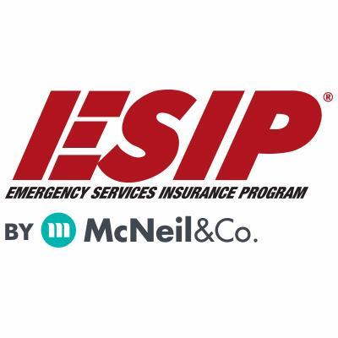
Tony Blackwell, Territory Sales Manager
800-822-3747 ext 530
ablackwell@mcneilandcompany.com
Aurora Inc. Insurance
120 Broadway
Albany, NY 12204
518-449-3180
aurorainsurance.com
Michael May, Broker
mmay@aurorainsurance.com

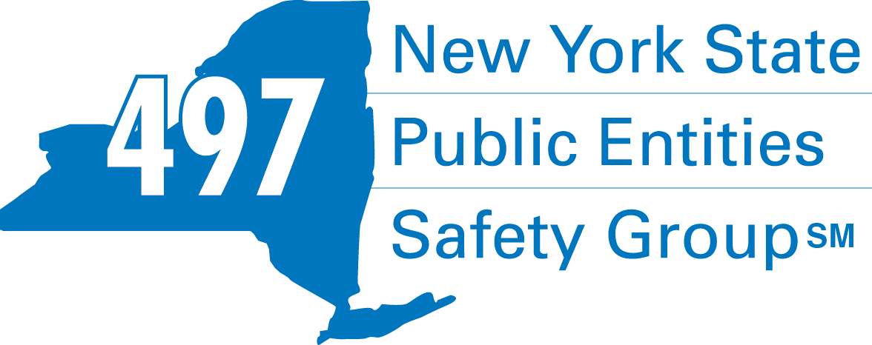
Fleury Risk Management
28 Corporate Drive, Suite 104
Clifton Park, NY 12065
518.478.6314
https://www.fleuryrisk.com/nysgroup497
VFBL Insurances Services
Stephan Petras
Marketing Representative
One Blue Hill Plaza – 16th Floor
PO Box 1609
Pearl River, NY 10965
845-352-8855x7099
329-236-3505
spetras@fdmny.com
VFBL/Workers’ Comp Coverage


Pat Daglio
pdaglio@vfis.com
717.819.3072

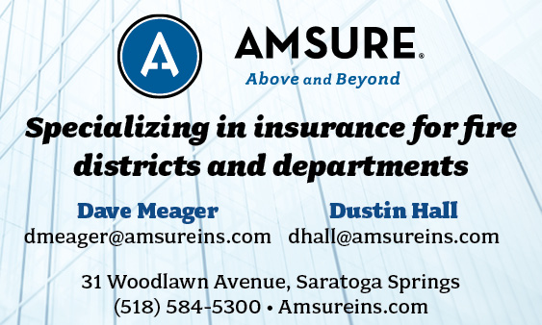

FIRE SERVICE FINANCIAL SERVICES AND LOSAP MANAGEMENT

UBS Financial Advisors
Ralph Lemme, CFP
Ralph.lemme@ubs.com
8 Southwoods Blvd Suite 207
Albany, NY 12211
518.445.1667

518-432-5087
838-433-7304 cell
www.thelosapgroup.com.
nikki.haskins@rbc.com
455 Patroon Creek Blvd, suite 200, Albany NY 12206

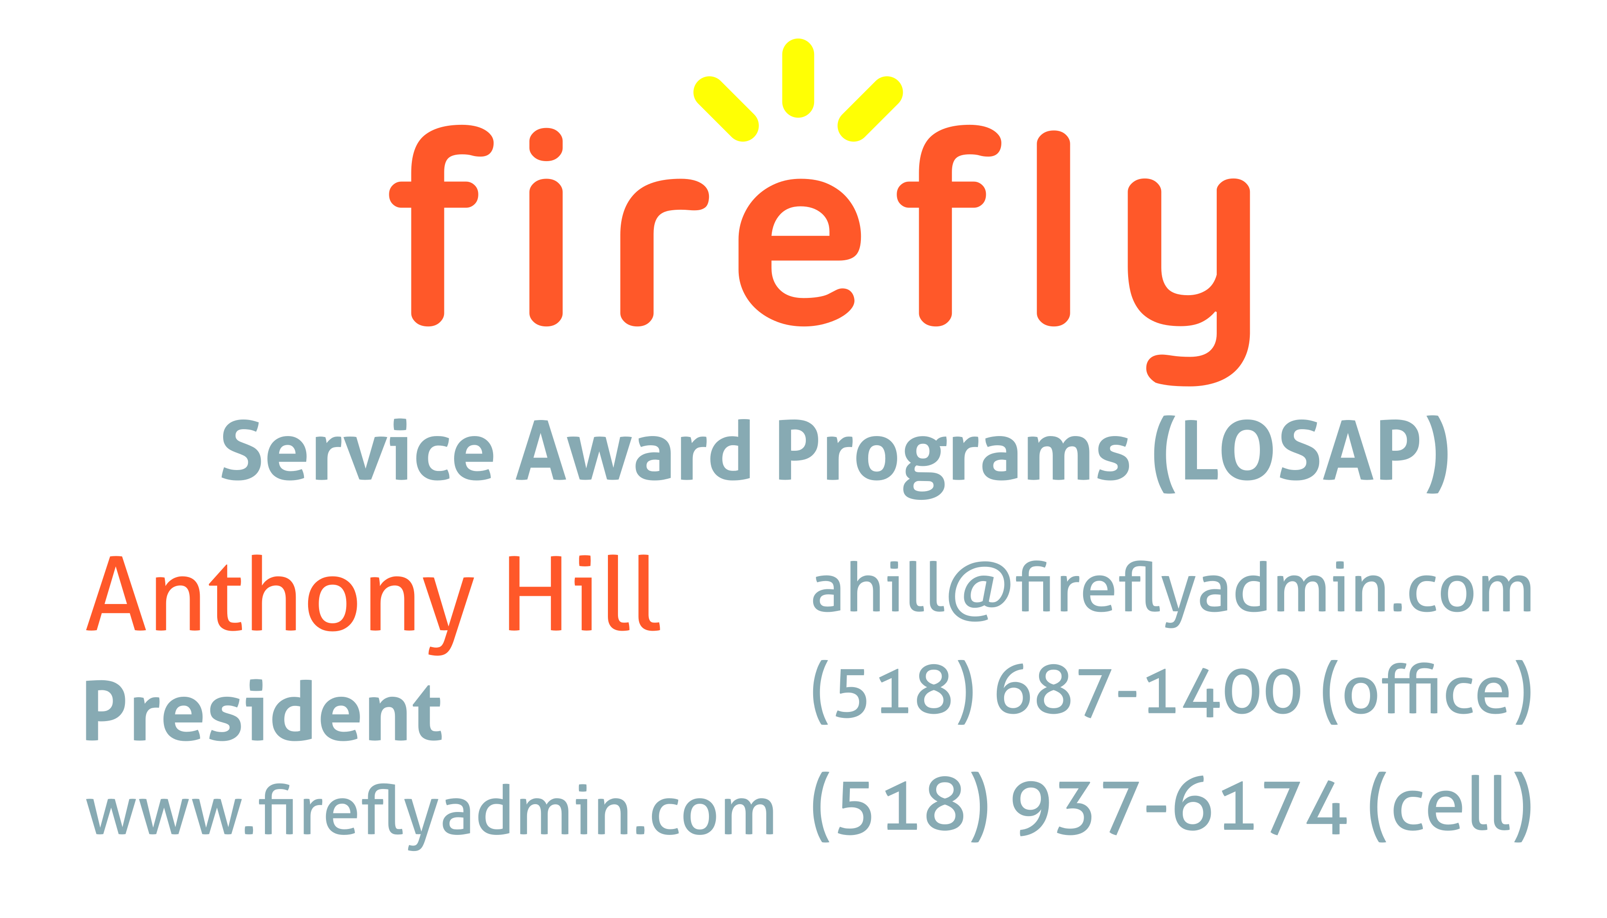


Nicole Meeker
Manager of Business Development & Accts
518-394-7894
Cell 607-423-4811
www.penflexinc.com
nmeeker@penflexinc.com
FIRE EQ TESTING
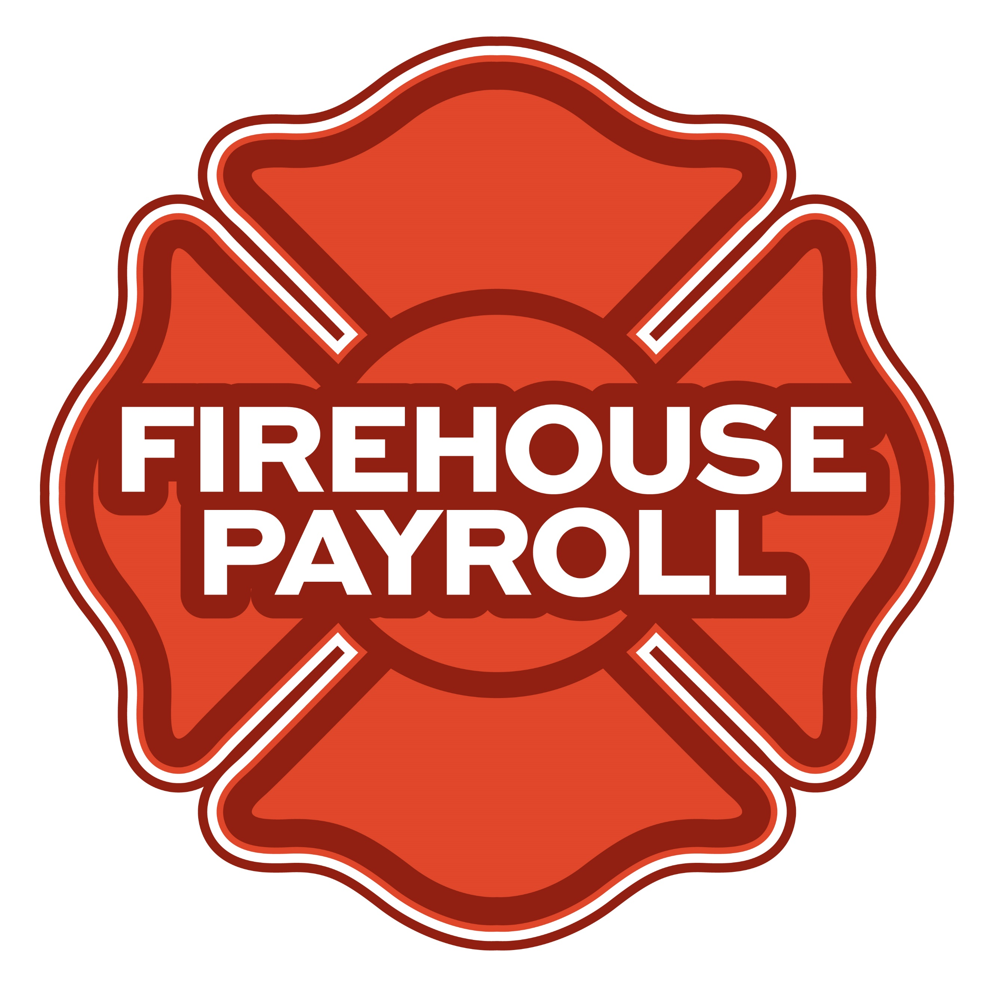
Jeremy Hartnett
824 Philadelphia Pike, Wilmington, DE 19809
302-483-7699
jeremy@firehousepayroll.com
payroll-pension reporting-tax filing
direct deposits-timekeeping-HR Services
FULL-SERVICE FIRE EQUIPMENT
DRYER VENT CLEANING
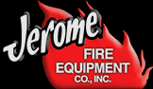
www.jeromefire.com
Breathing Air Comp Maintenance,
Air Quality Tests and Repairs
Russell Jerome
315-699-4533 Office
Ready Rack Extractor/Washers
Full Line of Fire Equipment
8721 Caughdenoy Rd, Clay, NY 13041

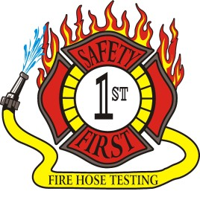Safety First Equipment Testing
99 Glass Lake Road
Averill Park, NY 12018
518-892-5860
www.safetyfirstfirehose.com
HOSE, APPLIANCE & LADDER TESTING
Safety1hose@gmail.com
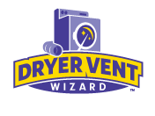DRYER VENT WIZARD
JORDAN CATINO
8 NAPA COURT, SCHENECTADY, NY 12309
518-344-0664
SARATOGADRYERVENT.COM
jcatino@dryerventwizard.com

FIRE DEPT COMPUTER MANAGEMENT & REPAIR

White Wolf Computer, LLC
4 Normanskill Blvd. Suite 410, Delmar, NY 12054
(518) 459-9653
Managed Services
Cloud Hosting Solutions
Telephone Data Cabling
Backup Disaster Recovery
Web Design Services

FIRE COMPANY FUND RAISING

FIRE STATION PEST CONTROL

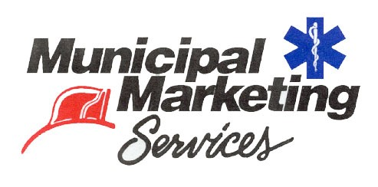
Lloyd Fox, Account Executive
34 Garner Road, Averill Park, NY 12018
Lfox8@nycap.rr.com
518-810-7819
www.funddrive.com

518-300-4732
431 New Karner Rd Suite 170
Albany, NY 12205
https://fox-pest.com/albany-ny

FIRE SAFETY EQUIPMENT
FIRE APPARATUS/SERVICE

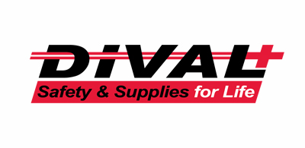
Timmy Kimball
518-925-2786
www.divalsafety.com
Testing-Safety-Promotional Services-Respiratory Solutions
Facility Safety-Fall Protection-Training
60 Cohoes Ave, Green Island NY 12183
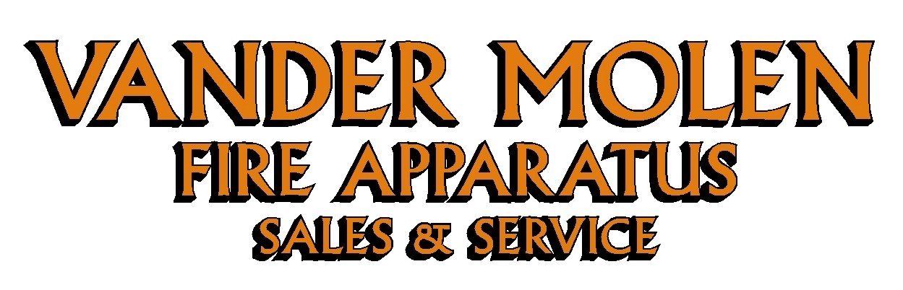
Mike Bonesteel
Warranty & Safety Manager
518-288-3587 X101
Cell 518-926-0451
After Hours 680-800-5015
1 Super 50 Way, Ballston Lake, NY 12019

FIRE DISTRICT CPA/AUDITS/FINANCIAL SERVICES


Zoriana M. Stawnychy
973.283.0024
zoriana@stawnychyfinancial.com
135 Kinnelon Road Suite 101
Kinnelon, NJ 07405
Serving fire districts in New York State
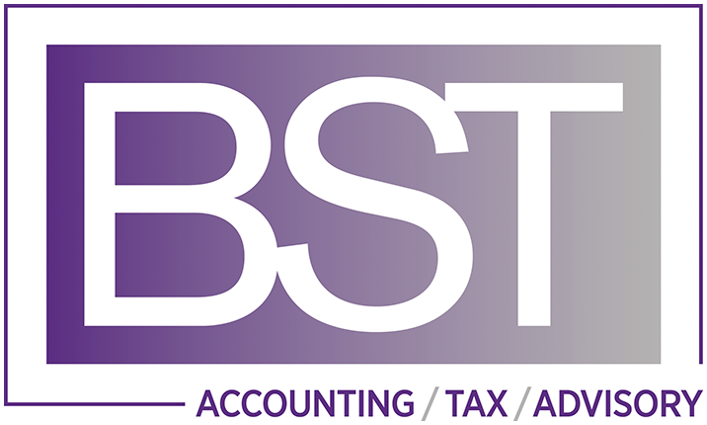

518-459-6700
10 British-American Blvd, Latham, NY 12110
www.bstco.com
Brendan Kennedy ext 356
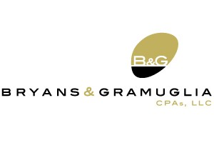

Aaron Hahn
1 Pine West Plaza Suite 107, Albany NY 12205
518.452.8055x17 or 518-452-9055
Email: ahahn@bgcpa.net



Accounting, Consulting & IT Security
1581 Franklin Ave. Mineola, NY 11501
Kyle Brengel, Managing Partner
516-472-7345
kbrengel@gblny.com


11 British American Blvd, Latham, NY 12110
518-785-0134
Queensbury Office 518-792-6595
http://www.mmbaccounting.com
Alan W. Clink, CPA aclink@mmb-co.com
Heather R. Lewis, CPA hlewis@mmb-co.com

425 Main Street Catskill, NY 12414
www.tbogc.com
518.943.2600 X2198
Joe Rothrock – josephr@tbogc.com
Specializing in Fire Service & EMS Financing

David Farstad, VP-Municipal Banking
652 Albany-Shaker Road, Albany NY 12211
Ph: 518-730-3120
Cell: 518-506-0075
farstadd@pioneerbanking.com
JOHN M. LESNIEWSKI
Assistant Vice President and
Senior Business Banking Officer
Fulton/Montgomery Markets
12 Fremont Street, Gloversville, NY 12078
P: 518.775-5205 | M: 518.848-0612
NMLS ID 915694
www.nbtbank.com


The Arrow Family of Companies
Corporate HQ 250 Glen Street
Glens Falls, NY 12801
518-793-4121
Business Banking Services
Arrowbank.com
Hero Mortgage Program Supporting First Responders Available

The Weekly Capital Bulletin is reaching well over 700+ subscribed fire district members and now other members of the fire service on a regular basis.
This is a service of CAFDA through the effort of Tom Rinaldi who can be reached at tom@rinaldi1.com for comments and content contributions are always welcome.

ANNUAL CAFDA CONFERENCE
Welcome to CAFDA Conference 2026!
We are excited to be able to offer you this LOCAL training opportunity right here in the beautiful Lake George area!
Should you have any questions, please contact Secretary@CAFDA.net

CONFERENCE DETAILS
CAFDA Conference 2026
Thursday, April 9 - Saturday, April 11, 2026
Fort William Henry Hotel & Conference Center
48 Canada Street, Lake George, NY

OVERNIGHT ACCOMODATION RESERVATION INFORMATION AT THE FORT WILLIAM HENRY HOTEL AND CONFERENCE CENTER
Room reservations are the responsibility of the Attendee*
Telephone Reservations only at 800-234-0267 or (Local) 518-668-3081
Group Code: CAFDA Conference
Rates: $154 Deluxe, $174 Premium/Grand
*If tax exempt, documentation (i.e. ST-129) must be presented at time of check- in

CONFERENCE SCHEDULE
Thursday, April 9, 2026 | 8:00 am | Registration/Breakfast
 | 9:00 am - 10:30 am | Best Practices for Social Media & Public Information Officers  Art Hunsinger, CAFDA
 | 10:45 am - 12:15 pm | The Legalities of Purchasing and the Procurement Audit  Erina Fitzgerald, Senior Attorney & Leslie Richards, Auditor 2 - OSC
 | 12:15 pm - 1:00 pm | Lunch & Conference Welcome
 | 1:00 pm - 2:30 pm | Policies, Procedures, Guidelines & the Law – Sorting Them Out  Dave Denniston/Lee Price
 | 2:45 pm – 4:15 pm | Understanding and Navigating VFBL  Attorney, Alex Dell
Friday, April 10, 2026 | 8:00 am | Registration/Breakfast
 | 8:45 am - 10:15 am | Leasing vs. Bonding  Robert McLaughlin
 | 10:30 am - 12:00 pm | The 6th Commissioner – Good or Bad?  Greg Serio, CAFDA Counsel & Amy Speach, BCS Fire District Secretary
 | 12:00 pm - 12:45 pm | Lunch & Conference Welcome
 | 12:45 pm – 2:45 pm | Dealing with Disciplinary Issues; Mock GML 209L Hearing  Greg Serio, CAFDA Counsel
 | 3:00 pm - 7:00 pm | Vendor Show & Cocktail/Dinner Reception
Saturday, April 11, 2026 | 8:00 am | Registration/Breakfast
 | 8:30 am – 9:15 am | Tax Certiorari – What the Heck Is It & How Does It Affect Fire Districts  Greg Serio, CAFDA Counsel
 | 9:30 am - 11:00 am | Ask the Experts! Panel
 | 11:00 am | Conference Farewell
Conference Registration Fees:
CAFDA Members: $85/day/attendee (includes meals* as noted in above schedule) – OR –
$170 for full (3-day) conference.
Non-Members: $105/day/attendee (includes meals* as noted in above schedule) –OR –
$210 for full (3-day) conference.
Guest of Attendee: $30 per day for meals (includes meals* as noted in above schedule) - OR – $70 for full conference.
*Vendor Show & Cocktail/Dinner Reception also included if attending Friday

REGISTER ON-LINE AT CAFDA.NET/CAFDA-CONFERENCE/
pay by credit card at: https://cafda.net/cafda-conference/
For payment inquiries, please contact Treasurer@cafda.net

CAFDA Vendor/Sponsor Application Form
Welcome Vendors/Sponsors & thank you for your interest!
Please complete & return this form with your payment to:
CAFDA
P.O. Box 242
East Schodack, NY 12063. Should you have any questions, please contact Art Hunsinger at 518-376-3751 or arttv19@gmail.com.
CONFERENCE DETAILS CAFDA Conference 2026 Thursday, April 9 through – Saturday, April 11, 2026 Fort William Henry Hotel & Conference Center 48 Canada Street, Lake George, NY
OVERNIGHT ACCOMODATION RESERVATION INFORMATION Room reservations are the responsibility of the Vendor* Telephone Reservations only at 800-234-0267 or (Local) 518-668-3081 Group Code: CAFDA Conference Rates: $154 Deluxe, $174 Premium/Grand *If tax exempt, documentation (i.e. ST-129) must be presented at time of check- in
VENDOR SHOW DETAILS Friday, April 10th 3:00 – 7:00 PM (Vendors may begin setup after 12:00 pm) Please Check One:
- VENDOR Only: $400: Includes one 8’ table w/white tablecloth & two chairs (power if requested) and two tickets to the Friday Night Cocktail/Dinner Reception

- EVENT Sponsor: Contributions over $400 and up to $1,499: Includes one 8’ table w/white tablecloth & two chairs (power if requested), and two tickets to Friday Night Coctail/Dinner Reception PLUS advertising as a Conference Event Sponsor

- TITLE Sponsor: Contributions at/over $1,500: Includes one 8’ table & two chairs w/white tablecloth (power if requested), and four tickets to Friday Night Coctail/Dinner Reception PLUS advertising as a Conference Title Sponsor with premium signage

- Outside Space: Available for additional display (space limited): $100 Please Provide Display Specifications___________________________________________________

- Additional Tickets to Vendor Show & Cocktail/Dinner Reception available at $30.00/ticket. # Requested____
Name of Business/Organization:____________________________________________________
Contact Name: _______________________________________________________________
Phone: _______________________________Email: _________________________________
Do you require POWER: YES______ NO_____
CLEAN UP: Vendors are responsible for their booth area during and after the event.
Signature:___________________________________________________ Date:____________

