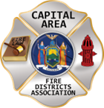
THE BULLETIN
March 14th, 2026

The Voice of CAFDA since 2004
Editor, Tom Rinaldi – tom@rinaldi1.com since 2014
When you see **, highly recommended article
CAPITAL SHORT TAKES
- The new slimmed down Bulletin, we have lost about 10 pages!!
- Go to the last page of this document for Conference ’26 Registration and for Vendor Registration.
CAFDA EDUCATIONAL OFFERINGS: CAFDA.NET

Join us at the NEXT GENERAL MEMBERSHIP MEETING Thursday May 14th features dinner for attendees. Please join us.
ZOOM LINK FOR THE May MEETING at 7pm: https://us06web.zoom.us/j/86413237058?pwd=MauWziwckK2pyIWGVwYGUqxQLCwzHq.1

CAFDA IS HAPPY TO ANNOUNCE THE DATES FOR CONFERENCE ’26 IN HISTORIC LAKE GEORGE, go to CAFDA.net for on-line registration and credit card use.

April 9th, 10th and 11th, 2026 hope many of you plan on joining us, see the details on the last page.

Commissioner Training will be held at 3 remaining locations in 2026 including:

Niagara Engine Co #6 in Schoharie, Saturday March 21st

Berkshire Fire District, Gloversville, Saturday March 28th and

Warrensburg Fire District, Saturday April 4th.

The Day after the scheduled date (Sunday) has been reserved as a snow day if necessary.

Open to all newly elected commissioners and Chiefs.

This training is required under Town Law Section 176-e. $85 for members, $95 for non-members includes continental breakfast and lunch. Chief officers are encouraged to attend.
REGISTRATION IS OPEN FOR COMMISSIONER TRAINING ON-LINE AT CAFDA.NET
If you were not able to attend the previous sessions and paid for the class, you are welcome to attend at any of the remaining locations. Just tell the staff at check in.
CAFDA TRAINING AND EVENT DATES
Day/Date | Time | Type | Location | Notes
FY 2026
Friday, March 13, 2026 | 8:00 AM | Financial Training for Fire District Officials | Fishkill | Rombout Fire District
Saturday, March 14, 2026 | 4:00 PM | Financial Training for Fire District Officials | Fishkill | Rombout Fire District
Saturday, March 21, 2026 | 8:00 AM | Commissioner Training | Schoharie | Snowdate - Sunday, March 22, 2026
Friday, March 27, 2026 | 8:00 AM | Financial Training for Fire District Officials | Cortland | The Hub, McNeil & Co.
Saturday, March 28, 2026 | 4:00 PM | Financial Training for Fire District Officials | Cortland | The Hub, McNeil & Co.
Saturday, March 28, 2026 | 8:00 AM | Commissioner Training | Berkshire | Snowdate - Sunday, March 29, 2026
Thursday, April 2, 2026 | 7:00 PM | Board of Directors Meeting | Clifton Park
Saturday, April 4, 2026 | 8:00 AM | Commissioner Training | Warrensburg | Snowdate - Sunday, April 5, 2026
Thursday, April 9 - Saturday April 11, 2026 | All Day | CAFDA Conference | Fort William Henry Conference Center | Lake George
Thursday, May 14, 2026 | 7:00 PM | General Membership Mtg. | Clifton Park
Thursday, June 11, 2026 | 7:00 PM | General Membership Mtg. | Clifton Park
July, 2026 | NO MEETING
Friday, August 7, 2026 | 1:00 PM | Membership Activity | Saratoga Race Course | NYRA Day at the Races!
Thursday, August 13, 2026 | 7:00 PM | Board of Directors Meeting | Clifton Park
Thursday, September 10, 2026 | 7:00 PM | General Membership Mtg. | Clifton Park
Thursday, October 8, 2026 | 7:00 PM | General Membership Mtg. | Clifton Park | Officers/Director Nominations
Saturday, November 7, 2026 | 8:00 AM | Annual Fall Workshop | Verdoy
Thursday, November 12, 2026 | 7:00 PM | General Membership Mtg. | Clifton Park | Officer/Director Elections
DECEMBER 2026 | NO MEETING
FY 2027
Saturday, January 2, 2027 | 9:00 AM | General Membership Mtg. | Clifton Park | Organizational/Morning Meeting
Thursday, April 8 - Saturday April 10, 2027 |  | CAFDA Conference ‘27 | Fort William Henry Conference Center | Lake George
Thursday, April 6 - Saturday April 8, 2028 |  | CAFDA Conference ‘28 | Fort William Henry Conference Center | Lake George
All correspondence & Capital Area Fire Districts Association Mailing Address should be directed to:
CAFDA PO Box 242 East Schodack, NY 12063 or EMAIL: SECRETARY@CAFDA.NET
Financial issues should be addressed to: TREASURER@CAFDA.NET
LEGISLATIVE NEWS FROM THE STATE CAPITAL

The 2026 Issues of United Concern are posted on the CAFDA.net website.
NATIONAL FIRE SERVICE ORGANIZATION NEWS
See the National Volunteer Fire Council at: https://www.nvfc.org/
The National Volunteer Fire Council (NVFC) is the only organization created solely to support volunteer firefighters, EMTs, and rescue personnel through a wide range of programs and benefits. Become a member of the NVFC to get what you need to be your best for you, your crew, and your community.

See the Congressional Fire Services Institute at: cfsi.org
Educating Members of Congress About Fire & Life Safety Issues Since 1989

THE LATEST NEWS FROM DOL/OSHA
See the latest from DOL/OSHA at CAFDA.net website.
FIRE DISTRICT FINANCIAL NEWS

Local Government and School Accountability Contact Information:
Phone: (518) 474-4037; Email: localgov@osc.ny.gov
Address: Office of the State Comptroller, Division of Local Government and School Accountability
110 State Street, 12th Floor; Albany, NY 12236

NYS-OSC Fire Service Audits
No Fire Service audits this week.
THE FIRE CHIEF’S OFFICE

THE ATTORNEY’S OFFICE

POSITIVE OUTCOMES AND CHALLENGES FOR THE FIRE SERVICE

POSITIVE OUTCOMES

FIRE SERVICE CHALLENGES

FIREFIGHTER HEALTH AND SAFETY – PROTECTING OUR OWN
Due to the Govt shut down, no new stats this week!
In 2025 we experienced 78 LODDs reported nationally.!

FIRE SERVICE FATALITIES OR DIBILITATING INJURIES
- .

FIRE APPARATUS ACCIDENTS
- .

FIREFIGHTERS FALLING THROUGH
- No reports noted this week.
FIRE APPARATUS

THE LATEST ON THE CHANGING FIRE SERVICE

THE BUILDING AND FIRE CODE ISSUES – WEEKLY REPORT ON FIRE FATALITIES
The New ICC Code-NYS Edition went into effect on December 31st 2025 although the implementation of the energy code provisions have been withdrawn until further notice.

WITH THE SHUT DOWN OF DHS, STATS FOR THIS WEEK HAVE NOT BEEN COMPILED

GREEN ENERGY AND THE IMPACT ON THE FIRE SERVICE

SHARE THE OPPORTUNITIES

State Chief’s Scholarship Program
Applications are now being accepted for the NYSAFC Scholarship Program and the Chief Neil McNeight Hands-On Training Award. Nominations are being accepted for the Chief Fred Singer Fire Educator of the Year Award, James Wright Public Education Award, and New York State Fire Chief of the Year Awards. Please note changes to the Scholarship Program for 2026. Three $1,000 scholarship awards will be granted in memory of Chief Ward Bohner and his wife, Janice Bohner, Chief Anthony Messina, and Chief James Hare. The deadline for submitting required materials is April 1, 2026. Eligibility criteria is available in the Application & Nomination Package. GO TO THIS LINK FOR MORE INFORMATION: https://www.nysfirechiefs.com/awards

NYSAFC is Bringing Hands-On Training to Your Area!
BEYOND THE BASICS
Dutchess County
March 28-29, 2026
Host: New Hackensack Fire District
REGISTRATION: https://www.nysfirechiefs.com/beyondthebasics
FIRE BEHAVIOR ON THE INSIDE
Clinton County • April 11-12, 2026
Host: Peru Fire Department
Ulster County • May 30-31, 2026
Host: Glasco Fire Company
REGISTRATION: https://www.nysfirechiefs.com/firebehavior
FLASHOVER
Albany County • September 26-27, 2026
Host: East Berne Volunteer Fire Company
REGISTRATION: https://www.nysfirechiefs.com/flashover

Rural Water Supply Operations Seminar: Moving Big Water with No Hydrants
Pittstown Fire Dept, & the Rensselaer County Fire Chiefs Association
Saturday and Sunday, April 18th & 19th, 8:00am to 4:30pm
Pittstown Fire Dept. 134 Parker School Road, Johnsonville, NY 12094
For more information contact Pittstown Fire at 518-663-5773 leave a message or at car1station25@gmail.com

NYSAFC 2026 Seminar Series “Dangerous Spaces: Challenges and Tactics When Dealing with Garage and Basement Fires” With Chief/Commissioner Michael Lombardo (Buffalo Fire Department)
Three-Hour Seminar:
Some of the most dangerous fires we deal with are often looked at as routine: the basement fire and the garage fire. Basement fires are probably the most overlooked killer of firefighters engaged in combat firefighting in much of the U.S. The construction, layout, fire load, and access present difficult and dangerous challenges at below grade fires. From the incident commander to the firefighter on the nozzle, we must all recognize and be able to deal with these challenges. Huge migration to the suburbs starting with the arrival of the Baby Boomer generation saw the explosion of the attached garage. Many older cities never had the available space for homes to feature an attached garage or have any garage at all. The tremendous fuel load that is constantly evolving presents danger for occupants and firefighters alike. This class will address these challenges and alternative strategies and tactics that can be deployed to deal with these dangerous spaces.
Registration Fee:
$35 per person – NYSAFC Individual and Department Members
$50 per person – Non-Members
Pre-registration is encouraged. On-site registration will be accepted if space permits.
Note: A 3% service fee will be applied if paying by credit card.
2026 Dates and Locations:
Seminar begins at 7:00 p.m. at all sites. Registration area opens at 6:30 p.m.
September 10 – Fulton County
Berkshire Fire Department • 320 Steele Avenue Ext. • Gloversville, NY 12078
September 16 – Saratoga County
Saratoga County Public Safety Building • 6012 County Farm Road • Ballston Spa, NY 120
September 22 – Dutchess County
Pleasant Valley Fire District • Station 1 • 1619 Main Street • Pleasant Valley, NY 12569

NEIGHBOR’S HELPING NEIGHBORS, thank you for your support!!

Gansevoort Fire Department Breakfast
Sunday April 19th Breakfast will be served starting at 8AM

Clifton Park Fire Department Breakfast
Next Breakfast in April 12th from 8 to 11am

Speigletown Fire Department Breakfast 2nd Sunday of each month
Sunday April 12th from 7:30 to 11:30, $10 adults, $5 children, under 5 free.

Vischer Ferry Fire Department, Bi-Annual Breakfast
Sunday March 22nd All you can eat, $12.00 per person, eggs any style, pancakes, sausage, home fries, homemade applesauce, toast, OJ, coffee etc. Station 1, 360 Riverview Road from 8 til Noon.

Cancer Benefit Firefighter’s Ball
The Saratoga County Fire Officer’s Association is sponsoring a benefit to create a cancer fund to assist firefighters in Saratoga County. The Ball will be held on May 9th location TBA, to include finger foods, music and a cash bar all for a donation of $30 per person. Sponsors are needed.
GENERAL INTEREST TO ALL

TAKE A MOMENT TO SMILE

CLASSIFIED
None this week.
WHO ARE YOUR CAFDA OFFICERS AND DIRECTORS FOR 2026?
OFFICERS
President, Tom Rinaldi, Commissioner, Stillwater Fire District
1st Vice President, Ellen Martin, Deputy Treasurer Clifton Park Fire District
DIRECTORS:
Les Bonesteel Past Commissioner, Burnt Hills/Saratoga,
Skip Smith, Commissioner, West Crescent/Saratoga
Joyce Petkus Treasurer Greenfield/Saratoga,
Ed Woehrle Commissioner Niskayuna #1/Schenectady
Art Hunsinger, Ex-Officio Member Clifton Park Fire District.
We would consider expanding the number of Directors if individuals from other counties would volunteer to participate!!

APPOINTEES
Secretary Molly Jenkins, Region 1 Director, Assoc of Fire Districts, NYS
Treasurer: Tony Hill
Sargent at Arms: Tom Wood, Commissioner, Northumberland Fire District
Chaplain: Dane Fagan
Legal Counsel: Greg Serio, Safety Officer, Verdoy Fire District
The Capital Area Association represents any fire district that wishes to join CAFDA. Fire District Officials include Commissioners, Treasurers, and Deputy Treasurers. Secretaries and Chiefs are also invited to participate!
Please advise your secretaries that all correspondence should be mailed to:
CAFDA PO Box 242 East Schodack, NY 12063
EMAIL TREASURER: TREASURER@CAFDA.NET
518-407-5020

Wish to become a member of CAFDA, go to CAFDA.net/membership to apply.

Capital Area BUSINESS PARTNER’S
Business Partner Applications Available At: WWW.CAFDA.NET
WELCOME DIVAL SAFETY EQUIPMENT
Green Boarder = not yet renewed for ‘26
We invite our business partners to submit educational information to be included in this Bulletin for district commissioners and chief officers
We want to thank all of our Business Partners for renewing their partnership for 2026. You are invited to our monthly membership meeting and to any of our social events..
FIRE SERVICE LEGAL SERVICES


Monaco Cooper Lamme & Carr.PLLC
1881 Western Ave, Suite 200 Albany, NY 12203
Nicole Strippoli 518-941-9040
NSTRIPPOLI@MCLCLAW.COM
https://mclclaw.com

The D’Amato Law Group LLP
Gregory Serio, Partner
Alyssa B. Snyder, Partner
111 Washington Ave Suite 600
Albany, NY 12210
518.426.3800
Email: gserio@dlgny.com or
asnyder@dlgny.com
damatolawgroup.com

HAWKINS DELAFIELD & WOOD LLP
William J. Jackson, Partner
1160 Pittsford-Victor Road, M2-11
Pittsford, NY 14534
585-645-1184
Fire Service Bond Attorneys
www.hawkins.com

Whiteman Osterman & Hanna LLP
Bond Counsel
Robert J. McLaughlin, Partner
One Commerce Plaza, Albany, NY 12260
518-487-7697 Cell 518-813-6333
mclaughlin@woh.com
www.woh.com
Ducharme, Clark & Sovern, LLP
Jack Clark, Fire District Attorney
646 Plank Rd. Clifton Park, NY 12065
518-373-1482
Ducharmeclark.com
HANNIGAN LAW FIRM PLLC
388 Kenwood Avenue
Delmar, New York 12054
P: (518) 869-9911
F: (518) 869-9915
www.hannigan.pro
Fire/EMS –Municipal Law

FIRE STATION & FACILITIES ARCHITECTS AND ENENGINEERS


n.lobosco@ctmale.com
Shawn Corp, Principle
15 Cider Mill Way, Saratoga Springs, NY
518.322.1386
www.reveal-ad.com


Architecture/Engineering/Code Services
Melissa Smith – mlsmith@labellapc.com
Senior Marketing Manager
518-903-8394
4 British American Blvd
Latham, NY 12110
www.labellapc.com


Architects & Engineers
433 River Street, Suite 8002
Troy, NY 12180
518-765-5105
Dennis Ross, Practice Leader
www.H2M.com

Managed IT Services
Cloud Telephone Services

Wendel, Centerpointe Corporate Park, 375 Essjay Road, Suite 200, Williamsville, NY 14221 716.688.0766
Amy Numrich, MBA
Digital Marketing & Events Specialist
anumrich@wendelcompanies.com


Ryan Sapienza
Project Manager/Technology Consultant
518-754-4623
Service 518-869-3614
930 Albany Shaker Rd, Latham, NY 12110

FIRE SERVICE INSURANCE

Haughey Insurance Agency
850 State Route 50
Burnt Hills, NY 12027
518-399-1583
www.haugheyagency.com
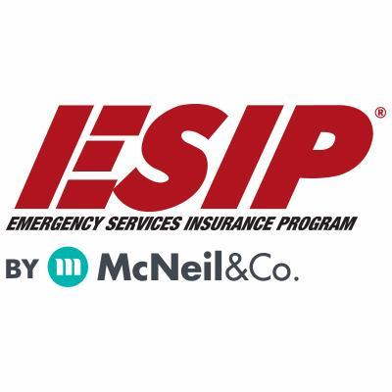
Tony Blackwell, Territory Sales Manager
800-822-3747 ext 530
ablackwell@mcneilandcompany.com
Aurora Inc. Insurance
120 Broadway
Albany, NY 12204
518-449-3180
aurorainsurance.com
Michael May, Broker
mmay@aurorainsurance.com

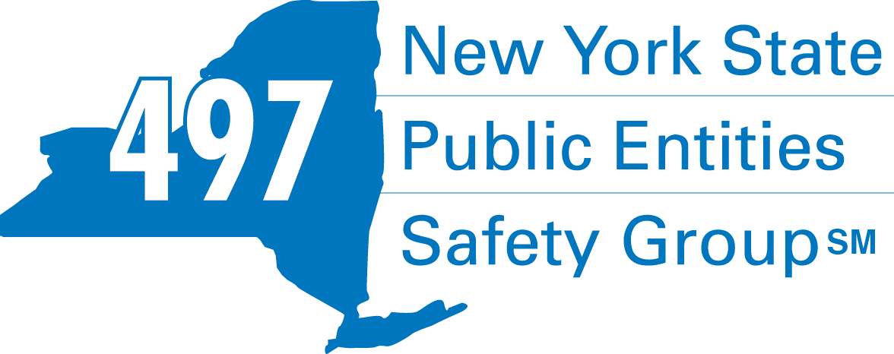
Fleury Risk Management
28 Corporate Drive, Suite 104
Clifton Park, NY 12065
518.478.6314
https://www.fleuryrisk.com/nysgroup497
VFBL Insurances Services
Stephan Petras
Marketing Representative
One Blue Hill Plaza – 16th Floor
PO Box 1609
Pearl River, NY 10965
845-352-8855x7099
329-236-3505
spetras@fdmny.com
VFBL/Workers’ Comp Coverage


Pat Daglio
pdaglio@vfis.com
717.819.3072

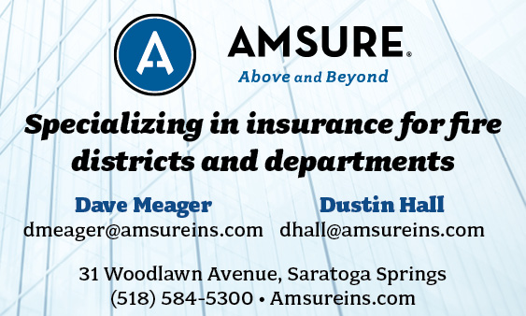

FIRE SERVICE FINANCIAL SERVICES AND LOSAP MANAGEMENT

UBS Financial Advisors
Ralph Lemme, CFP
Ralph.lemme@ubs.com
8 Southwoods Blvd Suite 207
Albany, NY 12211
518.445.1667
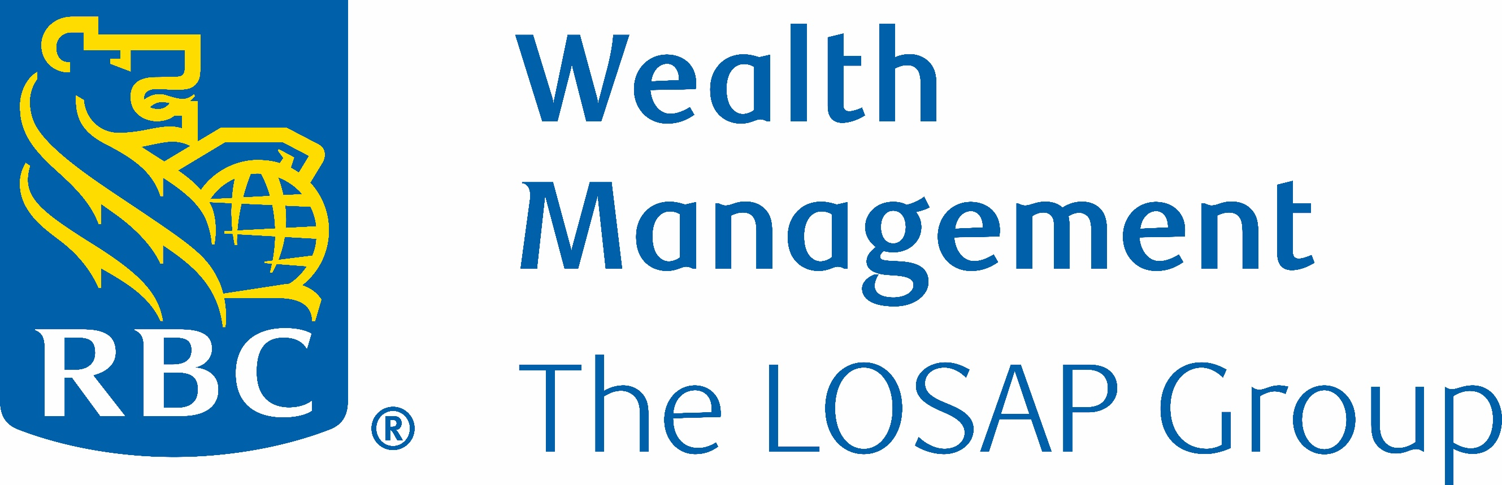
518-432-5087
838-433-7304 cell
www.thelosapgroup.com.
nikki.haskins@rbc.com
455 Patroon Creek Blvd, suite 200, Albany NY 12206

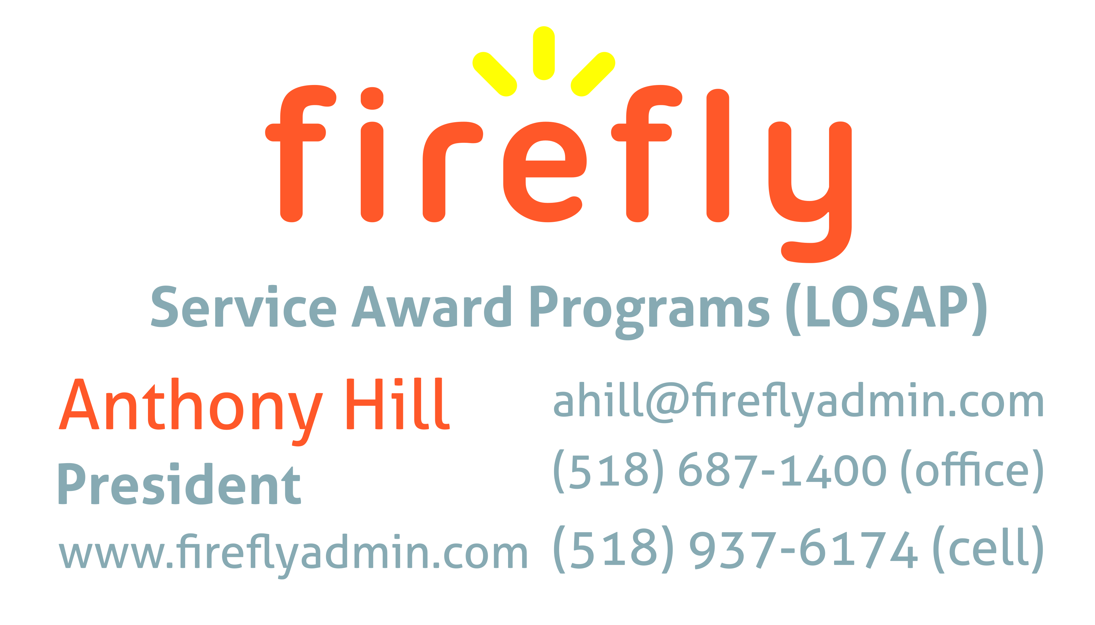


Nicole Meeker
Manager of Business Development & Accts
518-394-7894
Cell 607-423-4811
www.penflexinc.com
nmeeker@penflexinc.com
FIRE EQ TESTING
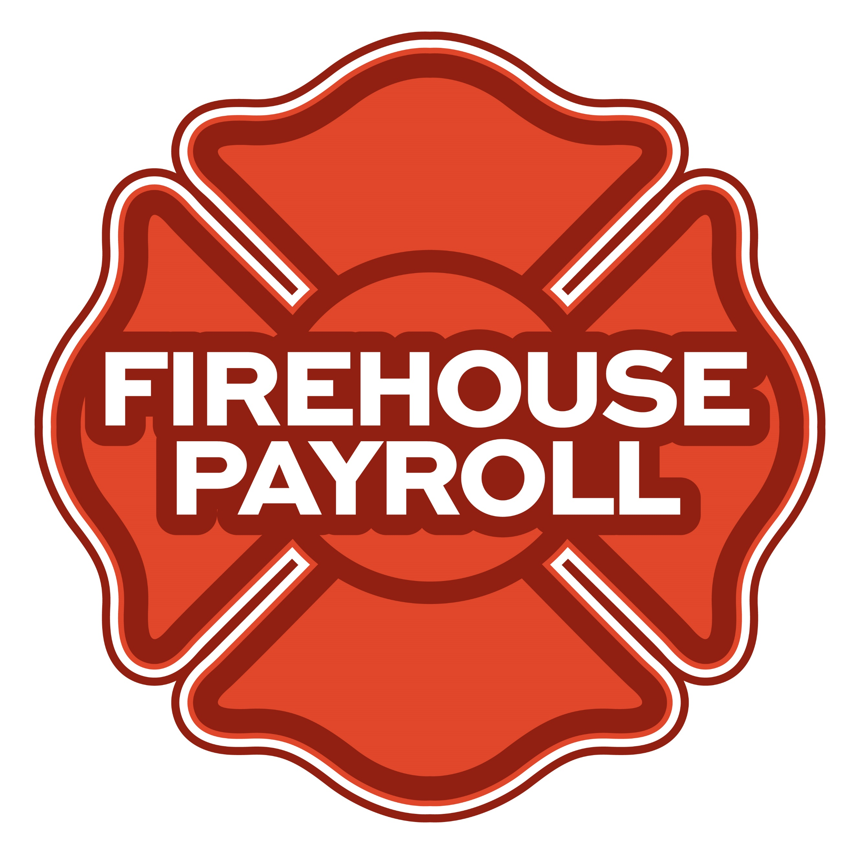
Jeremy Hartnett
824 Philadelphia Pike, Wilmington, DE 19809
302-483-7699
jeremy@firehousepayroll.com
payroll-pension reporting-tax filing
direct deposits-timekeeping-HR Services
FULL-SERVICE FIRE EQUIPMENT
DRYER VENT CLEANING

www.jeromefire.com
Breathing Air Comp Maintenance,
Air Quality Tests and Repairs
Russell Jerome
315-699-4533 Office
Ready Rack Extractor/Washers
Full Line of Fire Equipment
8721 Caughdenoy Rd, Clay, NY 13041

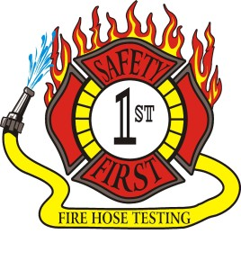Safety First Equipment Testing
99 Glass Lake Road
Averill Park, NY 12018
518-892-5860
www.safetyfirstfirehose.com
HOSE, APPLIANCE & LADDER TESTING
Safety1hose@gmail.com
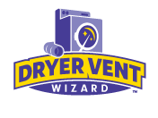DRYER VENT WIZARD
JORDAN CATINO
8 NAPA COURT, SCHENECTADY, NY 12309
518-344-0664
SARATOGADRYERVENT.COM
jcatino@dryerventwizard.com

FIRE DEPT COMPUTER MANAGEMENT & REPAIR

White Wolf Computer, LLC
4 Normanskill Blvd. Suite 410, Delmar, NY 12054
(518) 459-9653
Managed Services
Cloud Hosting Solutions
Telephone Data Cabling
Backup Disaster Recovery
Web Design Services

FIRE COMPANY FUND RAISING

FIRE STATION PEST CONTROL

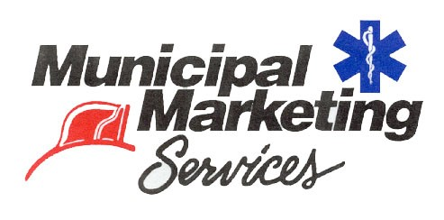
Lloyd Fox, Account Executive
34 Garner Road, Averill Park, NY 12018
Lfox8@nycap.rr.com
518-810-7819
www.funddrive.com

518-300-4732
431 New Karner Rd Suite 170
Albany, NY 12205
https://fox-pest.com/albany-ny

FIRE SAFETY EQUIPMENT
FIRE APPARATUS/SERVICE

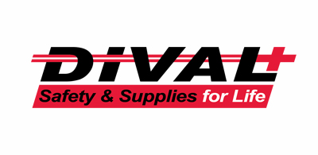
Timmy Kimball
518-925-2786
www.divalsafety.com
Testing-Safety-Promotional Services-Respiratory Solutions
Facility Safety-Fall Protection-Training
60 Cohoes Ave, Green Island NY 12183
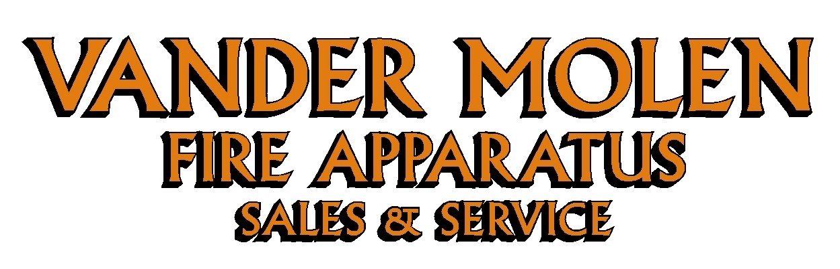
Mike Bonesteel
Warranty & Safety Manager
518-288-3587 X101
Cell 518-926-0451
After Hours 680-800-5015
1 Super 50 Way, Ballston Lake, NY 12019

FIRE DISTRICT CPA/AUDITS/FINANCIAL SERVICES


Zoriana M. Stawnychy
973.283.0024
zoriana@stawnychyfinancial.com
135 Kinnelon Road Suite 101
Kinnelon, NJ 07405
Serving fire districts in New York State
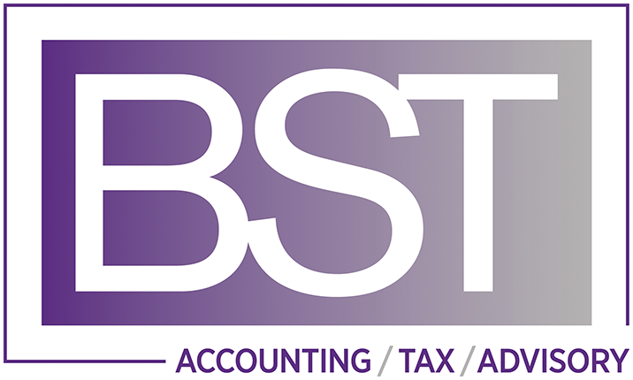

518-459-6700
10 British-American Blvd, Latham, NY 12110
www.bstco.com
Brendan Kennedy ext 356
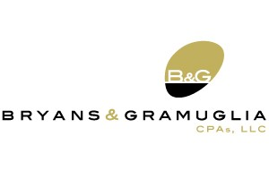

Aaron Hahn
1 Pine West Plaza Suite 107, Albany NY 12205
518.452.8055x17 or 518-452-9055
Email: ahahn@bgcpa.net



Accounting, Consulting & IT Security
1581 Franklin Ave. Mineola, NY 11501
Kyle Brengel, Managing Partner
516-472-7345
kbrengel@gblny.com


11 British American Blvd, Latham, NY 12110
518-785-0134
Queensbury Office 518-792-6595
http://www.mmbaccounting.com
Alan W. Clink, CPA aclink@mmb-co.com
Heather R. Lewis, CPA hlewis@mmb-co.com

425 Main Street Catskill, NY 12414
www.tbogc.com
518.943.2600 X2198
Joe Rothrock – josephr@tbogc.com
Specializing in Fire Service & EMS Financing

David Farstad, VP-Municipal Banking
652 Albany-Shaker Road, Albany NY 12211
Ph: 518-730-3120
Cell: 518-506-0075
farstadd@pioneerbanking.com
JOHN M. LESNIEWSKI
Assistant Vice President and
Senior Business Banking Officer
Fulton/Montgomery Markets
12 Fremont Street, Gloversville, NY 12078
P: 518.775-5205 | M: 518.848-0612
NMLS ID 915694
www.nbtbank.com


The Arrow Family of Companies
Corporate HQ 250 Glen Street
Glens Falls, NY 12801
518-793-4121
Business Banking Services
Arrowbank.com
Hero Mortgage Program Supporting First Responders Available

The Weekly Capital Bulletin is reaching well over 700+ subscribed fire district members and now other members of the fire service on a regular basis.
This is a service of CAFDA through the effort of Tom Rinaldi who can be reached at tom@rinaldi1.com for comments and content contributions are always welcome.

ANNUAL CAFDA CONFERENCE
Welcome to CAFDA Conference 2026!
We are excited to be able to offer you this LOCAL training opportunity right here in the beautiful Lake George area!
Should you have any questions, please contact Secretary@CAFDA.net

CONFERENCE DETAILS
CAFDA Conference 2026
Thursday, April 9 - Saturday, April 11, 2026
Fort William Henry Hotel & Conference Center
48 Canada Street, Lake George, NY

OVERNIGHT ACCOMODATION RESERVATION INFORMATION AT THE FORT WILLIAM HENRY HOTEL AND CONFERENCE CENTER
Room reservations are the responsibility of the Attendee*
Telephone Reservations only at 800-234-0267 or (Local) 518-668-3081
Group Code: CAFDA Conference
Rates: $154 Deluxe, $174 Premium/Grand
*If tax exempt, documentation (i.e. ST-129) must be presented at time of check- in

CONFERENCE SCHEDULE
Thursday, April 9, 2026 | 8:00 am | Registration/Breakfast
 | 9:00 am - 10:30 am | Best Practices for Social Media & Public Information Officers  Art Hunsinger, CAFDA
 | 10:45 am - 12:15 pm | The Legalities of Purchasing and the Procurement Audit  Erina Fitzgerald, Senior Attorney & Leslie Richards, Auditor 2 - OSC
 | 12:15 pm - 1:00 pm | Lunch & Conference Welcome
 | 1:00 pm - 2:30 pm | Policies, Procedures, Guidelines & the Law – Sorting Them Out  Dave Denniston/Lee Price
 | 2:45 pm – 4:15 pm | Understanding and Navigating VFBL  Attorney, Alex Dell
Friday, April 10, 2026 | 8:00 am | Registration/Breakfast
 | 8:45 am - 10:15 am | Leasing vs. Bonding  Robert McLaughlin
 | 10:30 am - 12:00 pm | The 6th Commissioner – Good or Bad?  Greg Serio, CAFDA Counsel & Amy Speach, BCS Fire District Secretary
 | 12:00 pm - 12:45 pm | Lunch & Conference Welcome
 | 12:45 pm – 2:45 pm | Dealing with Disciplinary Issues; Mock GML 209L Hearing  Greg Serio, CAFDA Counsel
 | 3:00 pm - 7:00 pm | Vendor Show & Cocktail/Dinner Reception
Saturday, April 11, 2026 | 8:00 am | Registration/Breakfast
 | 8:30 am – 9:15 am | Tax Certiorari – What the Heck Is It & How Does It Affect Fire Districts  Greg Serio, CAFDA Counsel
 | 9:30 am - 11:00 am | Ask the Experts! Panel
 | 11:00 am | Conference Farewell
Conference Registration Fees:
CAFDA Members: $85/day/attendee (includes meals* as noted in above schedule) – OR –
$170 for full (3-day) conference.
Non-Members: $105/day/attendee (includes meals* as noted in above schedule) –OR –
$210 for full (3-day) conference.
Guest of Attendee: $30 per day for meals (includes meals* as noted in above schedule) - OR – $70 for full conference.
*Vendor Show & Cocktail/Dinner Reception also included if attending Friday

REGISTER ON-LINE AT CAFDA.NET/CAFDA-CONFERENCE/
pay by credit card at: https://cafda.net/cafda-conference/
For payment inquiries, please contact Treasurer@cafda.net

CAFDA Vendor/Sponsor Application Form
Welcome Vendors/Sponsors & thank you for your interest!
Please complete & return this form with your payment to:
CAFDA
P.O. Box 242
East Schodack, NY 12063. Should you have any questions, please contact Art Hunsinger at 518-376-3751 or arttv19@gmail.com.
CONFERENCE DETAILS CAFDA Conference 2026 Thursday, April 9 through – Saturday, April 11, 2026 Fort William Henry Hotel & Conference Center 48 Canada Street, Lake George, NY
OVERNIGHT ACCOMODATION RESERVATION INFORMATION Room reservations are the responsibility of the Vendor* Telephone Reservations only at 800-234-0267 or (Local) 518-668-3081 Group Code: CAFDA Conference Rates: $154 Deluxe, $174 Premium/Grand *If tax exempt, documentation (i.e. ST-129) must be presented at time of check- in
VENDOR SHOW DETAILS Friday, April 10th 3:00 – 7:00 PM (Vendors may begin setup after 12:00 pm) Please Check One:
- VENDOR Only: $400: Includes one 8’ table w/white tablecloth & two chairs (power if requested) and two tickets to the Friday Night Cocktail/Dinner Reception

- EVENT Sponsor: Contributions over $400 and up to $1,499: Includes one 8’ table w/white tablecloth & two chairs (power if requested), and two tickets to Friday Night Coctail/Dinner Reception PLUS advertising as a Conference Event Sponsor

- TITLE Sponsor: Contributions at/over $1,500: Includes one 8’ table & two chairs w/white tablecloth (power if requested), and four tickets to Friday Night Coctail/Dinner Reception PLUS advertising as a Conference Title Sponsor with premium signage

- Outside Space: Available for additional display (space limited): $100 Please Provide Display Specifications___________________________________________________

- Additional Tickets to Vendor Show & Cocktail/Dinner Reception available at $30.00/ticket. # Requested____
Name of Business/Organization:____________________________________________________
Contact Name: _______________________________________________________________
Phone: _______________________________Email: _________________________________
Do you require POWER: YES______ NO_____
CLEAN UP: Vendors are responsible for their booth area during and after the event.
Signature:___________________________________________________ Date:____________

